Course Number: CPSC-5360

Course Title: Software Engineering

Submitted by:

* Adithya Narayanan (L20375088)
* Mohammed Sheikh (L20393633)

**State Chart Diagram**

**Introduction**

State-chart defines the behavior of instances of a given category. It shows the attainable states of associate object, the events it will observe, and its response to those events. State diagrams area unit composed of a finite range of states. Typically, it's used for describing the behavior of categories, however state-charts may additionally describe the behavior of different model entities like use-cases, actors, subsystems, operations, or methods. The abstract behavior is analyzed and pictured serial of events that would occur in one or additional attainable states. every diagram sometimes represents objects of one category and tracks the various states of its objects through the system.

**STATE CHART DIAGRAM**

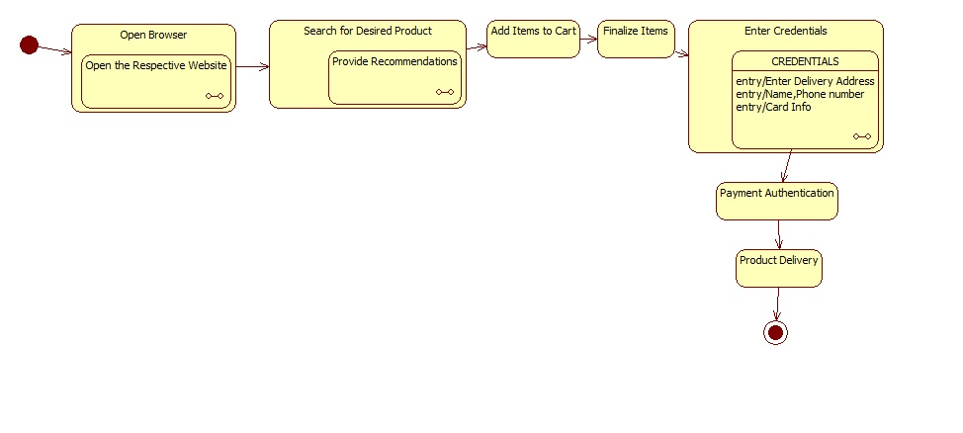

The design patterns which are useful for implementing the state chart diagram into Java code would be:

* **The State Pattern**: An object exhibits different behaviour. When its internal state changes, the object appears to have changed its class at run time.
* **The Singleton Pattern**: The Singleton design pattern ensures that only one instance of a class is created.

Use Cases: There would be two users in such a system. One would be the USER and another would be the SYSTEM. The user has the option of browsing from a range of products on the website and he could then add his desired products to a cart. After finalizing all the items, he enters the delivery address and makes a payment. After a successful payment the System verifies the order and the payment and then works towards delivering the product.

**USE CASE DIAGRAM:**

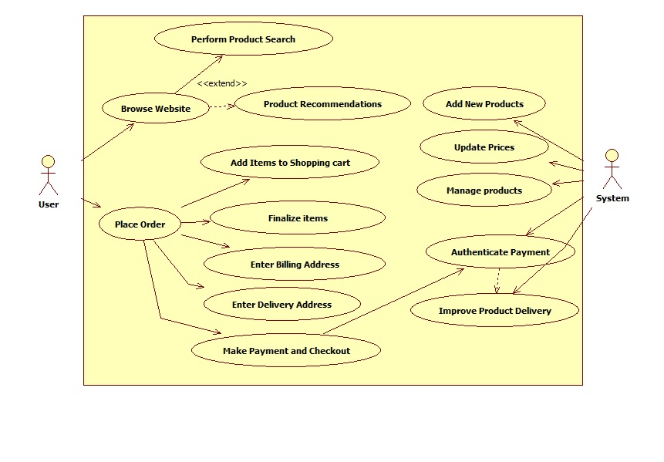

The Use Case Diagram gives way to the sequence diagram. The elements in the use case diagram make the sequence diagram. The events follow one after another just because a payment cannot happen before a product has been selected. The sequence diagram is as shown below:

**SEQUENCE DIAGRAM:**

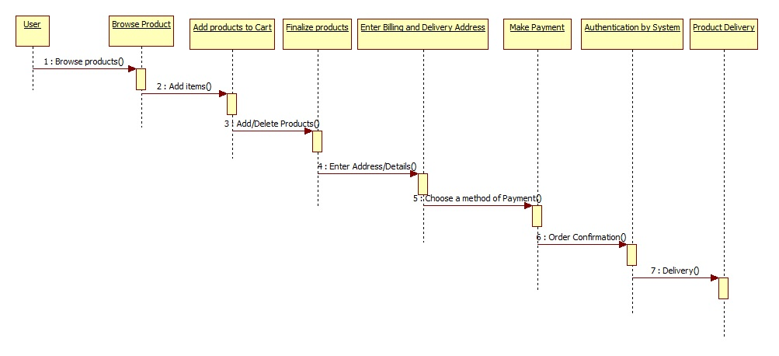

The web customer becomes a user when he logs into the System. He or She browses through the products and selects the desired ones and adds them to the cart. He views the cart and finalizes the products. Once that is done he adds his billing and delivery addresses. Chooses his desired delivery option and makes an authentic payment. The system in turn confirms his payment and goes ahead to deliver the product.