**US Accidents Visualizations**

***By Somendra, Pablo and Balaji***

**Visualization 1:**

**SPICE:**

WITH sev1 as(SELECT DISTINCT count(id) as Acc_Sev1, state

FROM us_accidents_dec_19_database.us_accident_v3

WHERE severity = 1

GROUP BY state),

sev2 as(SELECT DISTINCT count(id) as Acc_Sev2, state

FROM us_accidents_dec_19_database.us_accident_v3

WHERE severity = 2

GROUP BY state),

sev3 as(SELECT DISTINCT count(id) as Acc_Sev3, state

FROM us_accidents_dec_19_database.us_accident_v3

WHERE severity = 3

GROUP BY state),

sev4 as(SELECT DISTINCT count(id) as Acc_Sev4, state

FROM us_accidents_dec_19_database.us_accident_v3

WHERE severity = 4

GROUP BY state)

SELECT sev1.state, Acc_Sev1, Acc_Sev2, Acc_Sev3, Acc_Sev4

FROM sev1, sev2, sev3, sev4

WHERE sev1.state = sev2.state AND

sev2.state = sev3.state AND

sev3.state = sev4.state

ORDER BY sev1.state ASC;

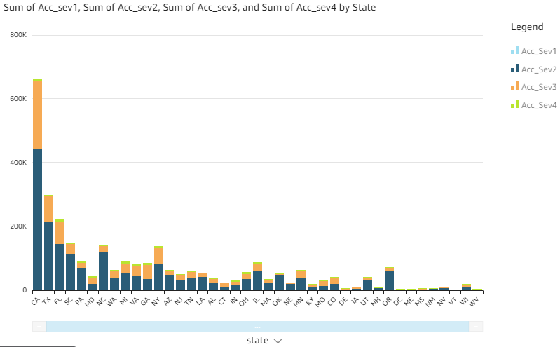

**Visualization 2:**

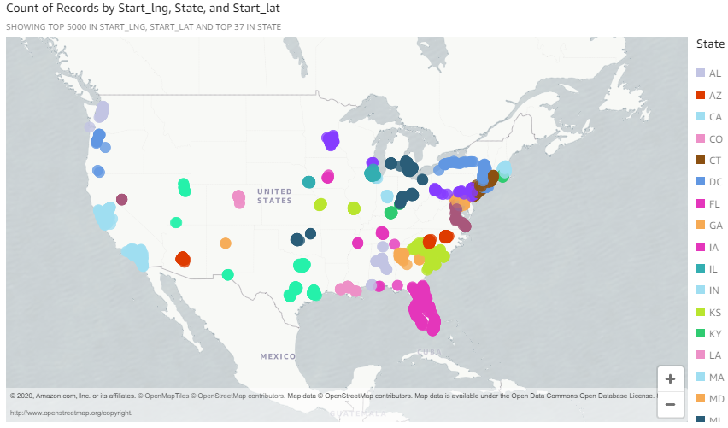

**Visualization 3:**

**SPICE:**

with cte AS (select

CASE

WHEN date_diff('minute', start_time, end_time)

BETWEEN 0

AND 59 THEN

'minutes'

WHEN date_diff('minute', start_time, end_time)

BETWEEN 60

AND 239 THEN

'hours'

WHEN date_diff('minute', start_time, end_time)

BETWEEN 240

AND 959 THEN

'4hours_16hours'

WHEN date_diff('minute', start_time, end_time)

BETWEEN 960

AND 1439 THEN

'16hours_24hours'

WHEN date_diff('minute', start_time, end_time) >= 1440 THEN

'days'

ELSE 'unknown'

END AS time_range, count(*) AS cnt

FROM us_accidents_dec_19_database.us_accident_v3

GROUP BY start_time, end_time)

SELECT time_range,

sum(cnt) AS count

FROM cte

GROUP BY time_range

ORDER BY count desc;

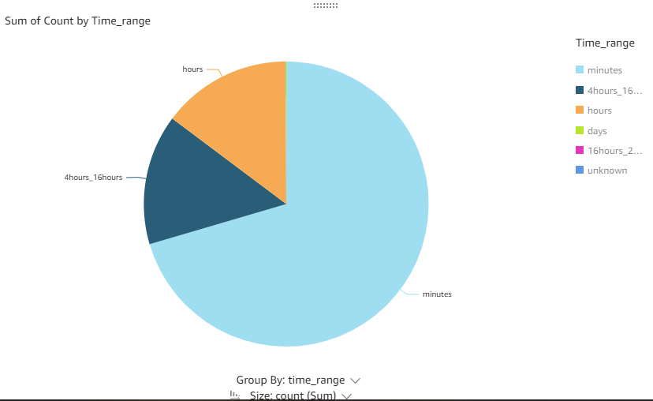

**Visualization 4:**

**SPICE:**

WITH sev1 as(SELECT DISTINCT count(id) as Acc_Sev1, weather_condition

FROM us_accidents_dec_19_database.us_accident_v3

WHERE severity = 1

GROUP BY weather_condition),

sev2 as(SELECT DISTINCT count(id) as Acc_Sev2, weather_condition

FROM us_accidents_dec_19_database.us_accident_v3

WHERE severity = 2

GROUP BY weather_condition),

sev3 as(SELECT DISTINCT count(id) as Acc_Sev3, weather_condition

FROM us_accidents_dec_19_database.us_accident_v3

WHERE severity = 3

GROUP BY weather_condition),

sev4 as(SELECT DISTINCT count(id) as Acc_Sev4, weather_condition

FROM us_accidents_dec_19_database.us_accident_v3

WHERE severity = 4

GROUP BY weather_condition)

SELECT sev1.weather_condition, Acc_Sev1, Acc_Sev2, Acc_Sev3, Acc_Sev4

FROM sev1, sev2, sev3, sev4

WHERE sev1.weather_condition = sev2.weather_condition AND

sev2.weather_condition = sev3.weather_condition AND

sev3.weather_condition = sev4.weather_condition

ORDER BY sev1.weather_condition ASC;

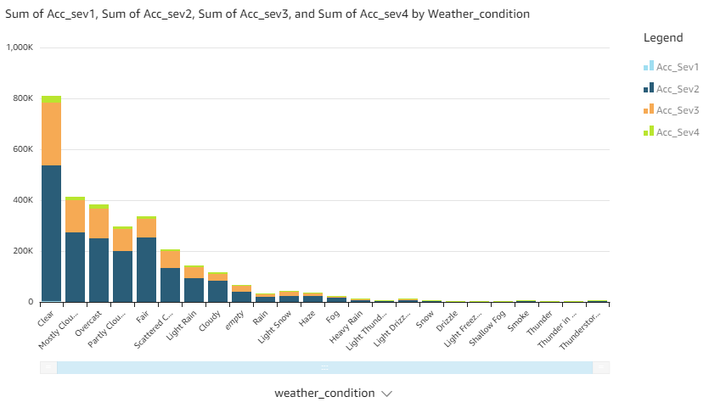

**Visualization 5:**

**SPICE:**

**temperature (weather_condition = ‘bad’)-**

select distinct temp_range_in_f, severity, weather_condn, count(*) over (partition by weather_condn, severity, temp_range_in_f) as cnt

from

(select

case

when temperature between -80 and -71 then 'aa-80 to -71'

when temperature between -70 and -61 then 'ab-70 to -61'

when temperature between -60 and -51 then 'ac-60 to -51'

when temperature between -50 and -41 then 'ad-50 to -41'

when temperature between -40 and -31 then 'ae-40 to -31'

when temperature between -30 and -21 then 'af-30 to -21'

when temperature between -20 and -11 then 'ag-20 to -11'

when temperature between -10 and -1 then 'ah-10 to -01'

when temperature between 0 and 9 then 'ai0 to 9'

when temperature between 10 and 19 then 'aj10 to 19'

when temperature between 20 and 29 then 'ak20 to 29'

when temperature between 30 and 39 then 'al30 to 39'

when temperature between 40 and 49 then 'am40 to 49'

when temperature between 50 and 59 then 'an50 to 59'

when temperature between 60 and 69 then 'ao60 to 69'

when temperature between 70 and 79 then 'ap70 to 79'

when temperature between 80 and 89 then 'aq80 to 89'

when temperature between 90 and 99 then 'ar90 to 99'

when temperature between 100 and 109 then 'as100 to 109'

when temperature between 110 and 119 then 'at110 to 119'

when temperature between 120 and 129 then 'au120 to 129'

when temperature between 130 and 139 then 'av130 to 139'

when temperature between 140 and 149 then 'aw140 to 149'

when temperature between 150 and 159 then 'ax150 to 159'

when temperature between 160 and 169 then 'ay160 to 169'

when temperature between 170 and 179 then 'az170 to 179'

else 'temperature unknown'

end as temp_range_in_f,

case

when weather_condition = 'Clear' then 'good'

when weather_condition = 'Cloudy' then 'good'

when weather_condition = 'Cloudy / Windy' then 'good'

when weather_condition = 'Drizzle' then 'good'

when weather_condition = 'Drizzle / Windy' then 'good'

when weather_condition = 'Fair' then 'good'

when weather_condition = 'Fair / Windy' then 'good'

when weather_condition = 'Haze' then 'good'

when weather_condition = 'Light Blowing Snow' then 'good'

when weather_condition = 'Light Drizzle' then 'good'

when weather_condition = 'Light Drizzle / Windy' then 'good'

when weather_condition = 'Light Fog' then 'good'

when weather_condition = 'Light Freezing Drizzle' then 'good'

when weather_condition = 'Light Freezing Fog' then 'good'

when weather_condition = 'Light Freezing Rain' then 'good'

when weather_condition = 'Light Freezing Rain / Windy' then 'good'

when weather_condition = 'Light Hail' then 'good'

when weather_condition = 'Light Haze' then 'good'

when weather_condition = 'Light Ice Pellets' then 'good'

when weather_condition = 'Light Rain' then 'good'

when weather_condition = 'Light Rain / Windy' then 'good'

when weather_condition = 'Light Rain Shower' then 'good'

when weather_condition = 'Light Rain Shower / Windy' then 'good'

when weather_condition = 'Light Rain Showers' then 'good'

when weather_condition = 'Light Sleet' then 'good'

when weather_condition = 'Light Snow' then 'good'

when weather_condition = 'Light Snow and Sleet' then 'good'

when weather_condition = 'Light Snow Grains' then 'good'

when weather_condition = 'Light Snow Shower' then 'good'

when weather_condition = 'Light Snow Showers' then 'good'

when weather_condition = 'Light Thunderstorms and Rain' then 'good'

when weather_condition = 'Light Thunderstorms and Snow' then 'good'

when weather_condition = 'Mist' then 'good'

when weather_condition = 'Mostly Cloudy' then 'good'

when weather_condition = 'Mostly Cloudy / Windy' then 'good'

when weather_condition = 'N/A Precipitation' then 'good'

when weather_condition = 'Overcast' then 'good'

when weather_condition = 'Partial Fog' then 'good'

when weather_condition = 'Partial Fog / Windy' then 'good'

when weather_condition = 'Partly Cloudy' then 'good'

when weather_condition = 'Partly Cloudy / Windy' then 'good'

when weather_condition = 'Patches of Fog' then 'good'

when weather_condition = 'Scattered Clouds' then 'good'

when weather_condition = 'Shallow Fog' then 'good'

when weather_condition = 'Showers in the Vicinity' then 'good'

when weather_condition = 'Small Hail' then 'good'

when weather_condition = 'Thunder in the Vicinity' then 'good'

else 'bad'

end as weather_condn, severity

from us_accidents_dec_19_database.us_accident_v3)

where temp_range_in_f <> 'temperature unknown'

order by temp_range_in_f, severity desc, weather_condn, cnt desc;

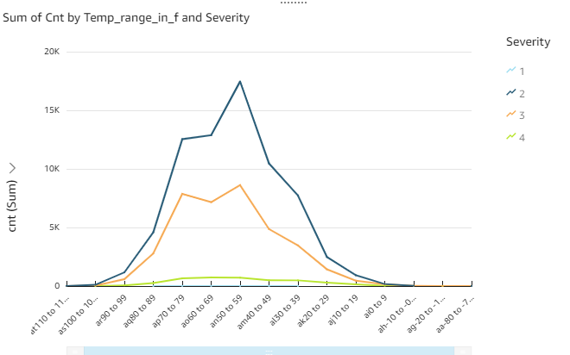

**temperature (weather_condition = ‘good’)-**

select distinct temp_range_in_f, severity, count(*) over (partition by weather_condn, severity, temp_range_in_f) as cnt

from

(select

case

when temperature between -80 and -71 then 'aa-80 to -71'

when temperature between -70 and -61 then 'ab-70 to -61'

when temperature between -60 and -51 then 'ac-60 to -51'

when temperature between -50 and -41 then 'ad-50 to -41'

when temperature between -40 and -31 then 'ae-40 to -31'

when temperature between -30 and -21 then 'af-30 to -21'

when temperature between -20 and -11 then 'ag-20 to -11'

when temperature between -10 and -1 then 'ah-10 to -01'

when temperature between 0 and 9 then 'ai0 to 9'

when temperature between 10 and 19 then 'aj10 to 19'

when temperature between 20 and 29 then 'ak20 to 29'

when temperature between 30 and 39 then 'al30 to 39'

when temperature between 40 and 49 then 'am40 to 49'

when temperature between 50 and 59 then 'an50 to 59'

when temperature between 60 and 69 then 'ao60 to 69'

when temperature between 70 and 79 then 'ap70 to 79'

when temperature between 80 and 89 then 'aq80 to 89'

when temperature between 90 and 99 then 'ar90 to 99'

when temperature between 100 and 109 then 'as100 to 109'

when temperature between 110 and 119 then 'at110 to 119'

when temperature between 120 and 129 then 'au120 to 129'

when temperature between 130 and 139 then 'av130 to 139'

when temperature between 140 and 149 then 'aw140 to 149'

when temperature between 150 and 159 then 'ax150 to 159'

when temperature between 160 and 169 then 'ay160 to 169'

when temperature between 170 and 179 then 'az170 to 179'

else 'temperature unknown'

end as temp_range_in_f,

case

when weather_condition = 'Clear' then 'good'

when weather_condition = 'Cloudy' then 'good'

when weather_condition = 'Cloudy / Windy' then 'good'

when weather_condition = 'Drizzle' then 'good'

when weather_condition = 'Drizzle / Windy' then 'good'

when weather_condition = 'Fair' then 'good'

when weather_condition = 'Fair / Windy' then 'good'

when weather_condition = 'Haze' then 'good'

when weather_condition = 'Light Blowing Snow' then 'good'

when weather_condition = 'Light Drizzle' then 'good'

when weather_condition = 'Light Drizzle / Windy' then 'good'

when weather_condition = 'Light Fog' then 'good'

when weather_condition = 'Light Freezing Drizzle' then 'good'

when weather_condition = 'Light Freezing Fog' then 'good'

when weather_condition = 'Light Freezing Rain' then 'good'

when weather_condition = 'Light Freezing Rain / Windy' then 'good'

when weather_condition = 'Light Hail' then 'good'

when weather_condition = 'Light Haze' then 'good'

when weather_condition = 'Light Ice Pellets' then 'good'

when weather_condition = 'Light Rain' then 'good'

when weather_condition = 'Light Rain / Windy' then 'good'

when weather_condition = 'Light Rain Shower' then 'good'

when weather_condition = 'Light Rain Shower / Windy' then 'good'

when weather_condition = 'Light Rain Showers' then 'good'

when weather_condition = 'Light Sleet' then 'good'

when weather_condition = 'Light Snow' then 'good'

when weather_condition = 'Light Snow and Sleet' then 'good'

when weather_condition = 'Light Snow Grains' then 'good'

when weather_condition = 'Light Snow Shower' then 'good'

when weather_condition = 'Light Snow Showers' then 'good'

when weather_condition = 'Light Thunderstorms and Rain' then 'good'

when weather_condition = 'Light Thunderstorms and Snow' then 'good'

when weather_condition = 'Mist' then 'good'

when weather_condition = 'Mostly Cloudy' then 'good'

when weather_condition = 'Mostly Cloudy / Windy' then 'good'

when weather_condition = 'N/A Precipitation' then 'good'

when weather_condition = 'Overcast' then 'good'

when weather_condition = 'Partial Fog' then 'good'

when weather_condition = 'Partial Fog / Windy' then 'good'

when weather_condition = 'Partly Cloudy' then 'good'

when weather_condition = 'Partly Cloudy / Windy' then 'good'

when weather_condition = 'Patches of Fog' then 'good'

when weather_condition = 'Scattered Clouds' then 'good'

when weather_condition = 'Shallow Fog' then 'good'

when weather_condition = 'Showers in the Vicinity' then 'good'

when weather_condition = 'Small Hail' then 'good'

when weather_condition = 'Thunder in the Vicinity' then 'good'

else 'bad'

end as weather_condn, severity

from us_accidents_dec_19_database.us_accident_v3)

where temp_range_in_f <> 'temperature unknown' and weather_condn = 'good'

order by temp_range_in_f, severity desc, cnt desc;

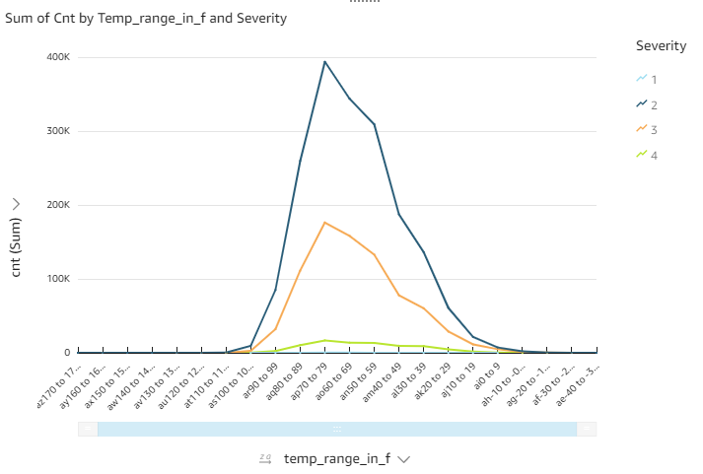

**Visualization 5:**

**SPICE:**

SELECT DISTINCT hour(start_time) AS hour,

severity,

count(*)

OVER (partition by severity, hour(start_time)) AS count

FROM us_accidents_dec_19_database.us_accident_v3

ORDER BY hour(start_time) desc, severity desc;

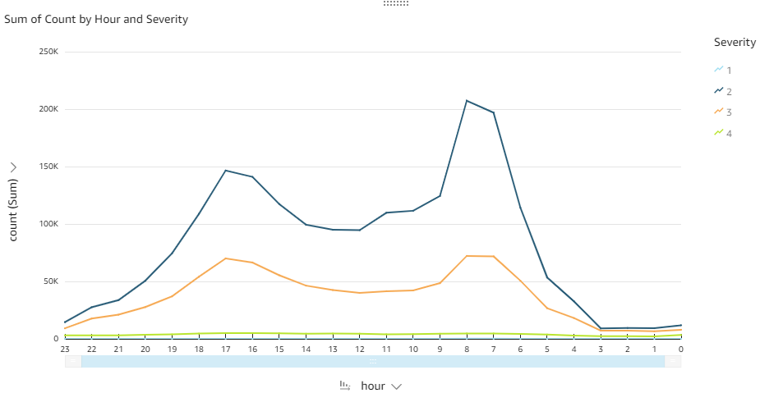

**Visualization 6:**

**SPICE (Count):**

SELECT severity,

avg(count) AS avg,

max(count) AS max,

stddev(count) AS stddev

FROM

(SELECT DISTINCT date(start_time) AS date,

severity,

count(*)

OVER (partition by severity, date(start_time)) AS count

FROM us_accidents_dec_19_database.us_accident_v3

ORDER BY date(start_time) desc, severity desc)

GROUP BY severity

ORDER BY severity;

## **Comment:** Not exactly. You should do: group by year(start_time), week(start_time), severity as on x axis we want to show year, week, severity combo.

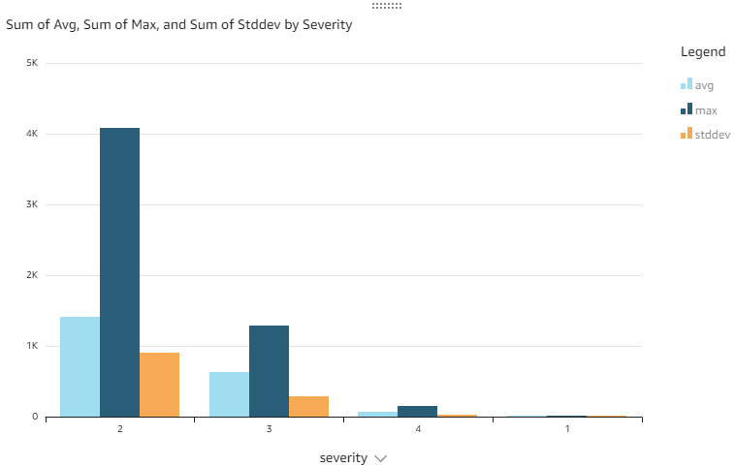

**SPICE (Distance):**

SELECT DISTINCT severity,

avg(distance)

OVER (partition by severity) as avg, max(distance)

OVER (partition by severity) as max, stddev(distance)

OVER (partition by severity) as stddev

FROM us_accidents_dec_19_database.us_accident_v3;

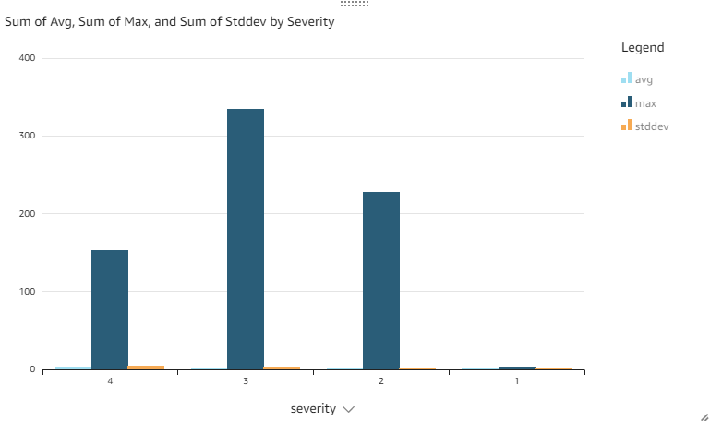

**Visualization 8:**

**Visualization 9:**

**Visualization 10:**

**SPICE:**

select Concept, sum(Frequency) as Freq from (with cte1 AS

(SELECT b.slno,

b.pattrn,

b.concpt,

cardinality(regexp_extract_all(lower(a.n_description),

lower(b.pattrn))) count

FROM base_corpus3 a

CROSS JOIN concept7 b

ORDER BY slno)

SELECT DISTINCT slno AS Serial_No,

concpt AS Concept,

pattrn AS Pattern,

sum(count)

OVER (partition by pattrn) AS Frequency

FROM cte1

ORDER BY slno) group by Concept;

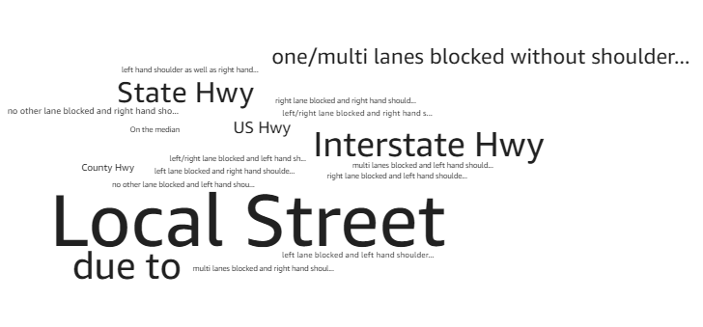

**Visualization 13:**