1. For each starting year (beginning at 1960) going up, generate a report of years of run until 2019 called Age (going up as 1, 2, 3 etc.) and number of TV Series that started on that year and ran for so many years and also the percentage for that start_year. Example report should look like:

|  |  |  |  |
| --- | --- | --- | --- |
| Start_year | Age(years) | Number_of_TVSeries | Percentage_start_year |
| 1960 | 1 | 7 | 85.72 |
| 1960 | 4 | 1 | 14.28 |
| 1965 | 2 | 5 | 71.42 |
| 2018 | 1 | 2 | 28.57 |

**Comment:** This report may be used to analyze trends in ages of TV_series along start_year.

**Query A**

with t2 AS (select startyear , (endyear - startyear) as age, count(startyear) as count  
from title_basics_new where startyear between 1960 and 2019 and endyear between 1960 and 2019 group by startyear , (endyear - startyear) order by startyear asc), t1 as (select startyear, count(startyear) as count2 from title_basics_new where titletype = 'tvEpisode' group by startyear)

select a.startyear, a.age, a.count as Number_of_TVSeries, cast(a.count as double)*100/b.count2 as percentage_start_year from t2 a inner join t1 b on a.startyear = b.startyear order by a.startyear

[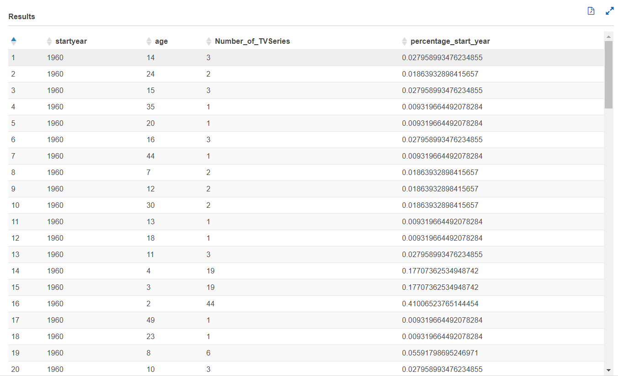](https://user-images.githubusercontent.com/46951312/74114733-5b196500-4b71-11ea-9c58-e20181f8b44f.png)

**Dear group, totally how many rows did you get in result? Was it too much data? Is your calculation right? Look at query for t1 where we need to apply limits for startyear and endyear etc. For each startyear like 1960 total percentage should add upto 1. Will it? Why are you using titletype = ‘tvepisode’? Are we not looking for ‘tvseries’? What happens if endyear is ‘\N’?**

1. Data inconsistency check: For each year (beginning at 1960) going up, generate a report of Number of movies that have alternative title but no original title. Example report should look like:

|  |  |
| --- | --- |
| Start_year | Number_of_movies |
| 1960 | 1 |
| 1990 | 4 |
| 1995 | 2 |
| 2018 | 1 |

**Comment:** This report may be used to analyze trends in inconsistency of data along year.

## Query B

select a.startYear, count(a.startYear) as Number_of_movies from title_basics_new a inner join  
title_akas_new b on a.tconst = b.titleId where a.startYear >=1960 and a.titleType = 'movie' and b.isOriginalTitle = 0 group by a.startyear order by a.startyear asc;

**Dear group, don’t we need to check if it is alternative title but the same movie has no original? Is it right with the way we are checking original?**

1. Data inconsistency check: For each year (beginning at 1960) going up, generate a report of Number of multi-lingual movies that have a second language title (or localized title) but no original title. Example report should look like:

|  |  |
| --- | --- |
| Start_year | Number_of_movies |
| 1960 | 1 |
| 1990 | 4 |
| 1995 | 2 |
| 2018 | 1 |

**Comment:** This report may be used to analyze trends in inconsistency of data along startYear.

## Query C

select a.startYear, count(distinct(b.titleId)) as Number_of_movies from title_basics_new a inner join  
title_akas_new b on a.tconst = b.titleId where a.startYear >=1960 and a.titletype = 'movie' and b.isOriginalTitle = 0 group by a.startyear order by a.startyear asc;

**Dear group, but its types have to have ‘imdbDisplay’ and number of languages have to be more than 1 and no original?**

1. Data inconsistency check: Verify that for each movie, endYear is always ‘\N’. For each year beginning at 1960 (if we have data) going up, generate a report of Number of movies that carry an endYear value not equal to ‘\N’. Example report should look like:

|  |  |
| --- | --- |
| Start_year | Number_of_movies |
| 1960 | 1 |
| 1990 | 4 |
| 1995 | 2 |
| 2018 | 1 |

**Comment:** This report may be used to analyze trends in inconsistency of data along startYear.

## Query D

select startyear, count(startyear) as Number_of_movies from title_basics_new where startyear>= 1960 and titletype = 'movie' and endyear is not null group by startyear order by startyear asc;

**Dear group, endyear is not ‘\N’ otherwise query is right.**

1. Limits check: For each year (beginning at 1960) going up, generate a report of minimum & maximum runtime for different types of movies such as ‘Documentary’, ‘Short’, ‘Animation’ (these are in title_akas_tsv.genres) **only**. Example report should look like:

|  |  |  |  |
| --- | --- | --- | --- |
| Start_year | Genre | Minimum_runtime (min) | Maximum_runtime (min) |
| 1960 | ‘Documentary’ | 4 | 7 |
| 1990 | ‘Animation’ | 40 | 64 |
| 1990 | ‘Short’ | 50 | 52 |
| 1990 | ‘Documentary’ | 3 | 5 |
| 1995 | ‘Documentary’ | 4 | 6 |
| 2018 | ‘Documentary’ | 5 | 8 |

**Comment:** This report may be used to analyze trends in run-time along startYear.

## Query E

select startyear, genre_1, min(runtimeminutes) as min_runtime, max(runtimeminutes) as max_runtime from title_basics_new CROSS JOIN UNNEST(genre) AS t(genre_1) where startyear >= 1960 and titletype = 'movie' group by startyear, genre_1 order by startyear asc;

**Dear group, don’t we need to filter only genres containing ‘Documentation’ or ‘Short’ or ‘Animation’ in addition?**

1. Consolidated Distribution over rating: We would like to plot the density of last five years’ (2015-2019) all **movies** against audience average rating. First calculate total count of movies over last five years. Report the density of number of movies (made over last five years) for each rating (after converting rating to nearest integer) and the corresponding rating (1-10). Example report should look like:

|  |  |
| --- | --- |
| Average_Rating | Density_Total_no_of_movies_in_last_5_yrs |
| 1 | 0.05 |
| 2 | 0.10 |
| 4 | 0.20 |
| 6 | 0.40 |
| 7 | 0.20 |
| 8 | 0.05 |

**Comment:** The sum of densities is 1.0. Ignore movies made more than 5 years ago. This report may be extended to include the year as another attribute.

## Query F

1. Consolidated Distribution over rating: We would like to plot the density of last five years’ (2015-2019) all **movies** against audience average rating. First calculate total count of movies over last five years. Report the density of number of movies (made over last five years) for each rating (afterconverting rating to nearest integer) and the corresponding rating (1-10). Example report should look like:

|  |  |
| --- | --- |
| Average_Rating | Density_Total_no_of_movies_in_last_5_yrs |
| 1 | 0.05 |
| 2 | 0.10 |
| 4 | 0.20 |
| 6 | 0.40 |
| 7 | 0.20 |
| 8 | 0.05 |

**Comment:** The sum of densities is 1.0. Ignore movies made more than 5 years ago. This report may be extended to include the year as another attribute.

create table if not exists ratings_in_each_year_1 as select round(title_ratings.averagerating,0) as ratings, count(title_ratings.averagerating) as count from title_ratings inner join title_basics_new on title_ratings.tconst= title_basics_new.tconst where title_basics_new.titletype = 'movie' and title_basics_new.startyear >=2015 and title_basics_new.startyear<=2019 group by round(title_ratings.averagerating,0) order by round(title_ratings.averagerating,0) asc;

SELECT a.ratings, cast(a.count as double)/b.sum_count as density FROM ratings_in_each_year_1 a CROSS JOIN ( SELECT SUM(count) as sum_count FROM ratings_in_each_year_1 ) b

[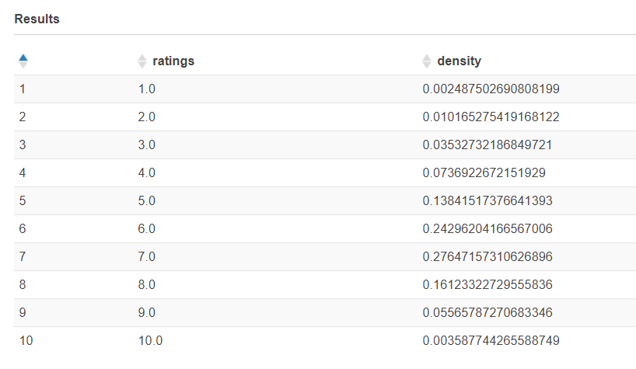](https://user-images.githubusercontent.com/46951312/74116098-9d45a500-4b77-11ea-8895-59ffdcc48075.png)

**Dear group, looks fine to me. Probably instead of saying “group by round(title_ratings.averagerating,0) order by round(title_ratings.averagerating,0) asc”, you could have made it shorter by saying “group by ratings order by ratings” . But this query is good.**

## Query G

1. Consolidated Distribution over numVotes: We would like to plot the density of last five years’ (2015-2019) all **movies** against ranges of numVotes. See numVotes and if it is in like 100,000 s, then each range should be 100,000s (like 0 - 100,000; 100,001 – 200,000; 200,001-300,000; etc.). First calculate total count of movies over last five years. Report the density of number of movies (made over last five years) for each range of numVotes and the corresponding range. Example report should look like:

|  |  |
| --- | --- |
| Range_of_numVotes | Density_Total_no_of_movies_in_last_5_yrs |
| 100000 | 0.05 |
| 200000 | 0.10 |
| 300000 | 0.15 |
| 400000 | 0.40 |
| 500000 | 0.20 |
| 600000 | 0.05 |
| 700000 | 0.05 |

**Comment:** The sum of densities is 1.0. Ignore movies made more than 5 years ago. This report may be extended to include the year as another attribute.

with cte1 as (select case when numvotes >=1 and numvotes <=100000 then 100000 when numvotes >100000 and numvotes<=200000 then 200000 when numvotes >200000 and numvotes<=300000 then 300000 when numvotes >300000 and numvotes<=400000 then 400000 when numvotes >400000 and numvotes<=500000 then 500000 when numvotes >500000 and numvotes<=600000 then 600000 when numvotes >600000 and numvotes<=700000 then 700000 when numvotes >700000 and numvotes<=800000 then 800000 when numvotes >800000 and numvotes<=900000 then 900000 when numvotes >900000 and numvotes<=1000000 then 1000000 when numvotes >1000000 and numvotes<=1100000 then 1100000 when numvotes >1100000 and numvotes<=1200000 then 1200000 when numvotes >1200000 and numvotes<=1300000 then 1300000 when numvotes >1300000 and numvotes<=1400000 then 1400000 when numvotes >1400000 and numvotes<=1500000 then 1500000 when numvotes >1500000 and numvotes<=1600000 then 1600000 when numvotes >1600000 and numvotes<=1700000 then 1700000 when numvotes >1700000 and numvotes<=1800000 then 1800000 when numvotes >1800000 and numvotes<=1900000 then 1900000 when numvotes >1900000 and numvotes<=2000000 then 2000000 when numvotes >2000000 and numvotes<=2100000 then 2100000 when numvotes >2100000 and numvotes<=2200000 then 2200000 else NULL end as num, t2.primarytitle, count(t2.primarytitle) over () as cnt from title_ratings t1 inner join title_basics_new t2 on t1.tconst = t2.tconst where t2.startyear >=2015 and t2.startyear <= 2019 and t2.titletype = 'movie') , grouped_num_1 as (select distinct t1.num as range, count(t1.primarytitle) over (partition by t1.num) as num_count, cast(t1.cnt as double) as tot from cte1 t1 )

select t.range, (t.num_count/t.tot) as density from grouped_num_1 t order by t.range

**Dear group, probably it works. Notice, you are doing “count(x) over (partition by t1.num)” kind of thing instead of “count(x) group by”. This query may be fine.**

## Query H

1. Consolidated Distribution over run-time: We would like to plot the density of last five years’ (2015-2019) all **movies** against runtimeMinutes. First calculate total count of movies over last five years. Report the density of number of movies (made over last five years) for each runtime (minutes) and the corresponding runtime. Example report should look like:

|  |  |
| --- | --- |
| runtimeMinutes | Density_Total_no_of_movies_in_last_5_yrs |
| 30 | 0.05 |
| 60 | 0.10 |
| 95 | 0.20 |
| 130 | 0.40 |
| 140 | 0.20 |
| 160 | 0.05 |

**Comment:** The sum of densities is 1.0. This report may be extended to include the year as another attribute.

create table if not exists runtimeminutes_in_each_year as select runtimeminutes, count(runtimeminutes) as count_of_movies from title_basics_new where titletype = 'movie' and startyear >=2015 and startyear <= 2019 group by runtimeminutes order by runtimeminutes asc;

select runtimeminutes, cast(a.count_of_movies as double)/b.total_sum_of_movies as density from runtimeminutes_in_each_year a CROSS JOIN ( select sum(count_of_movies) as total_sum_of_movies from runtimeminutes_in_each_year ) b

**Dear group, looks absolutely fine to me.**

## Query I

1. Consolidated Distribution over startYear: We would like to plot the density of number of all **movies** made in each year versus the startYear (for last 20 years say 2000-2019 and ignore others). First calculate total count of movies over each startYear (ignoring bdefore 2000 or 2020). Report the density of number of movies for each startYear and the corresponding startYear. Example report should look like:

|  |  |
| --- | --- |
| startYear | Density_Total_no_of_movies_in_last_5_yrs |
| 2000 | 0.05 |
| 2002 | 0.10 |
| 2007 | 0.20 |
| 2010 | 0.20 |
| 2016 | 0.20 |
| 2019 | 0.25 |

**Comment:** The sum of densities is 1.0.

create table if not exists movies_in_each_year as select startyear, count(startyear) as count_of_movies from title_basics_new where titletype = 'movie' and startyear >=2000 and startyear <= 2019 group by startyear order by startyear asc;

select startyear, cast(a.count_of_movies as double)/b.total_sum_of_movies as density from movies_in_each_year a CROSS JOIN ( select sum(count_of_movies) as total_sum_of_movies from movies_in_each_year ) b

**Dear group, looks absolutely fine to me.**

## Query J

1. Top 10 versatile movies: List those movies with 10 largest sets of genres starting from the top largest and going down by size of genres array with average rating above 5. Display the rank, movie id and its title and the genres. Example report should look like:

|  |  |  |  |
| --- | --- | --- | --- |
| Rank | Movie_title_id | Movie_title | Genres |
| 1 | CK00102 | Avatar | Fiction,Adventure,Romance, Family |
| 2 | CK00107 | Beyond The Sea | ScinceFiction, Adventure, Romance |
| 3 | CK00111 | SlumDog Millionaire | Romance, Adventure, Mystery |
| 4 | CK00101 | Titanic | Romance, Adventure, Exuberance |
| 5…9 | CK00103 ……… CK00104 | The Prestige…….. | …… |
| 10 | CK00106 | Spirited Away | Adventure, Mystery |

**Comment:** If there is conflict with more than 10, take any ten.

select row_number() over (order by cardinality(genre) desc) Rank, Movie_title_id, Movie_title, genre from (select a.tconst as Movie_title_id, a.primarytitle as Movie_title, a.genre from title_basics_new a inner join title_ratings b on a.tconst = b.tconst where b.averagerating > 5.0 and a.titletype = 'movie')

**Dear group, probably it works. Notice, you are doing “over(order by …) ” kind of thing instead of “group by …. Order by …”. This query may be fine.**

## Query K

1. Top 10 co-directed movies: List those movies with 10 largest sets of co-directors starting from the top largest and going down by size of co-director array with average rating above 5. Display the rank, movie id and its popular title and the directors. Example report should look like:

|  |  |  |  |
| --- | --- | --- | --- |
| Rank | Movie_title_id | Movie_title | Directors |
| 1 | CK00102 | Avatar | X, Y, Z, M |
| 2 | CK00107 | Beyond The Sea | A, B, C, D |
| 3 | CK00111 | SlumDog Millionaire | P, Q, R |
| 4 | CK00102 | Titanic | L, M, N |
| 5…9 | CK00102 ……… CK00102 | The Prestige…….. | …… |
| 10 | CK00102 | Spirited Away | C, T |

**Comment:** If there is conflict with more than 10, take any ten.

select row_number() over (order by cardinality(directors) desc) Rank, Movie_title_id, Movie_title, directors from (select a.tconst as Movie_title_id, b.primarytitle as Movie_title, a.directors from title_crew_new a inner join title_basics_new b on a.tconst = b.tconst inner join title_ratings c on a.tconst = c.tconst where c.averagerating > 5.0 and b.titletype = 'movie')

**Dear group, probably it works. Notice, you are doing “over(order by …) ” kind of thing instead of “group by …. Order by …”. This query may be fine.**