XAI: Model-Agnostic Methods
Exercise 5 - Partial Dependence Plots (PDP)

Pablo Huguet Chordi and Nacho Castilla Llorca

Index
1. Exercise 1 - One-dimensional Partial Dependence Plot 3
1.1 Methodology 3
1.2 Results 3
1.3 Question: Analysis of Feature Influence 3
2. Exercise 2 - Bidimensional Partial Dependence Plot 4
2.1 Methodology 4
2.2 Results 5
2.3 Question: Interpretation 5
3. Exercise 3 - PDP for House Price Prediction 5
3.1 Methodology 5
3.2 Results 6
3.3 Question: Analysis of Feature Influence 6
4. Conclusions 7

1. Exercise 1 - One-dimensional Partial Dependence Plot

1.1 Methodology
A Random Forest regressor was trained on the bike sharing daily dataset (day.csv) to predict the total number of bike rentals (cnt). The model uses features including days since 2011, temperature, humidity, wind speed, season, year, month, holiday and working day indicators, weather situation, and apparent temperature.
The Partial Dependence Plot (PDP) shows the marginal effect of each feature on the predicted outcome, averaging out the effects of all other features. For each feature, the model prediction is computed across a grid of values while keeping all other features at their observed values.
Model performance: R² = 0.8914 on training data, confirming the Random Forest captures the main patterns in the data.

1.2 Results
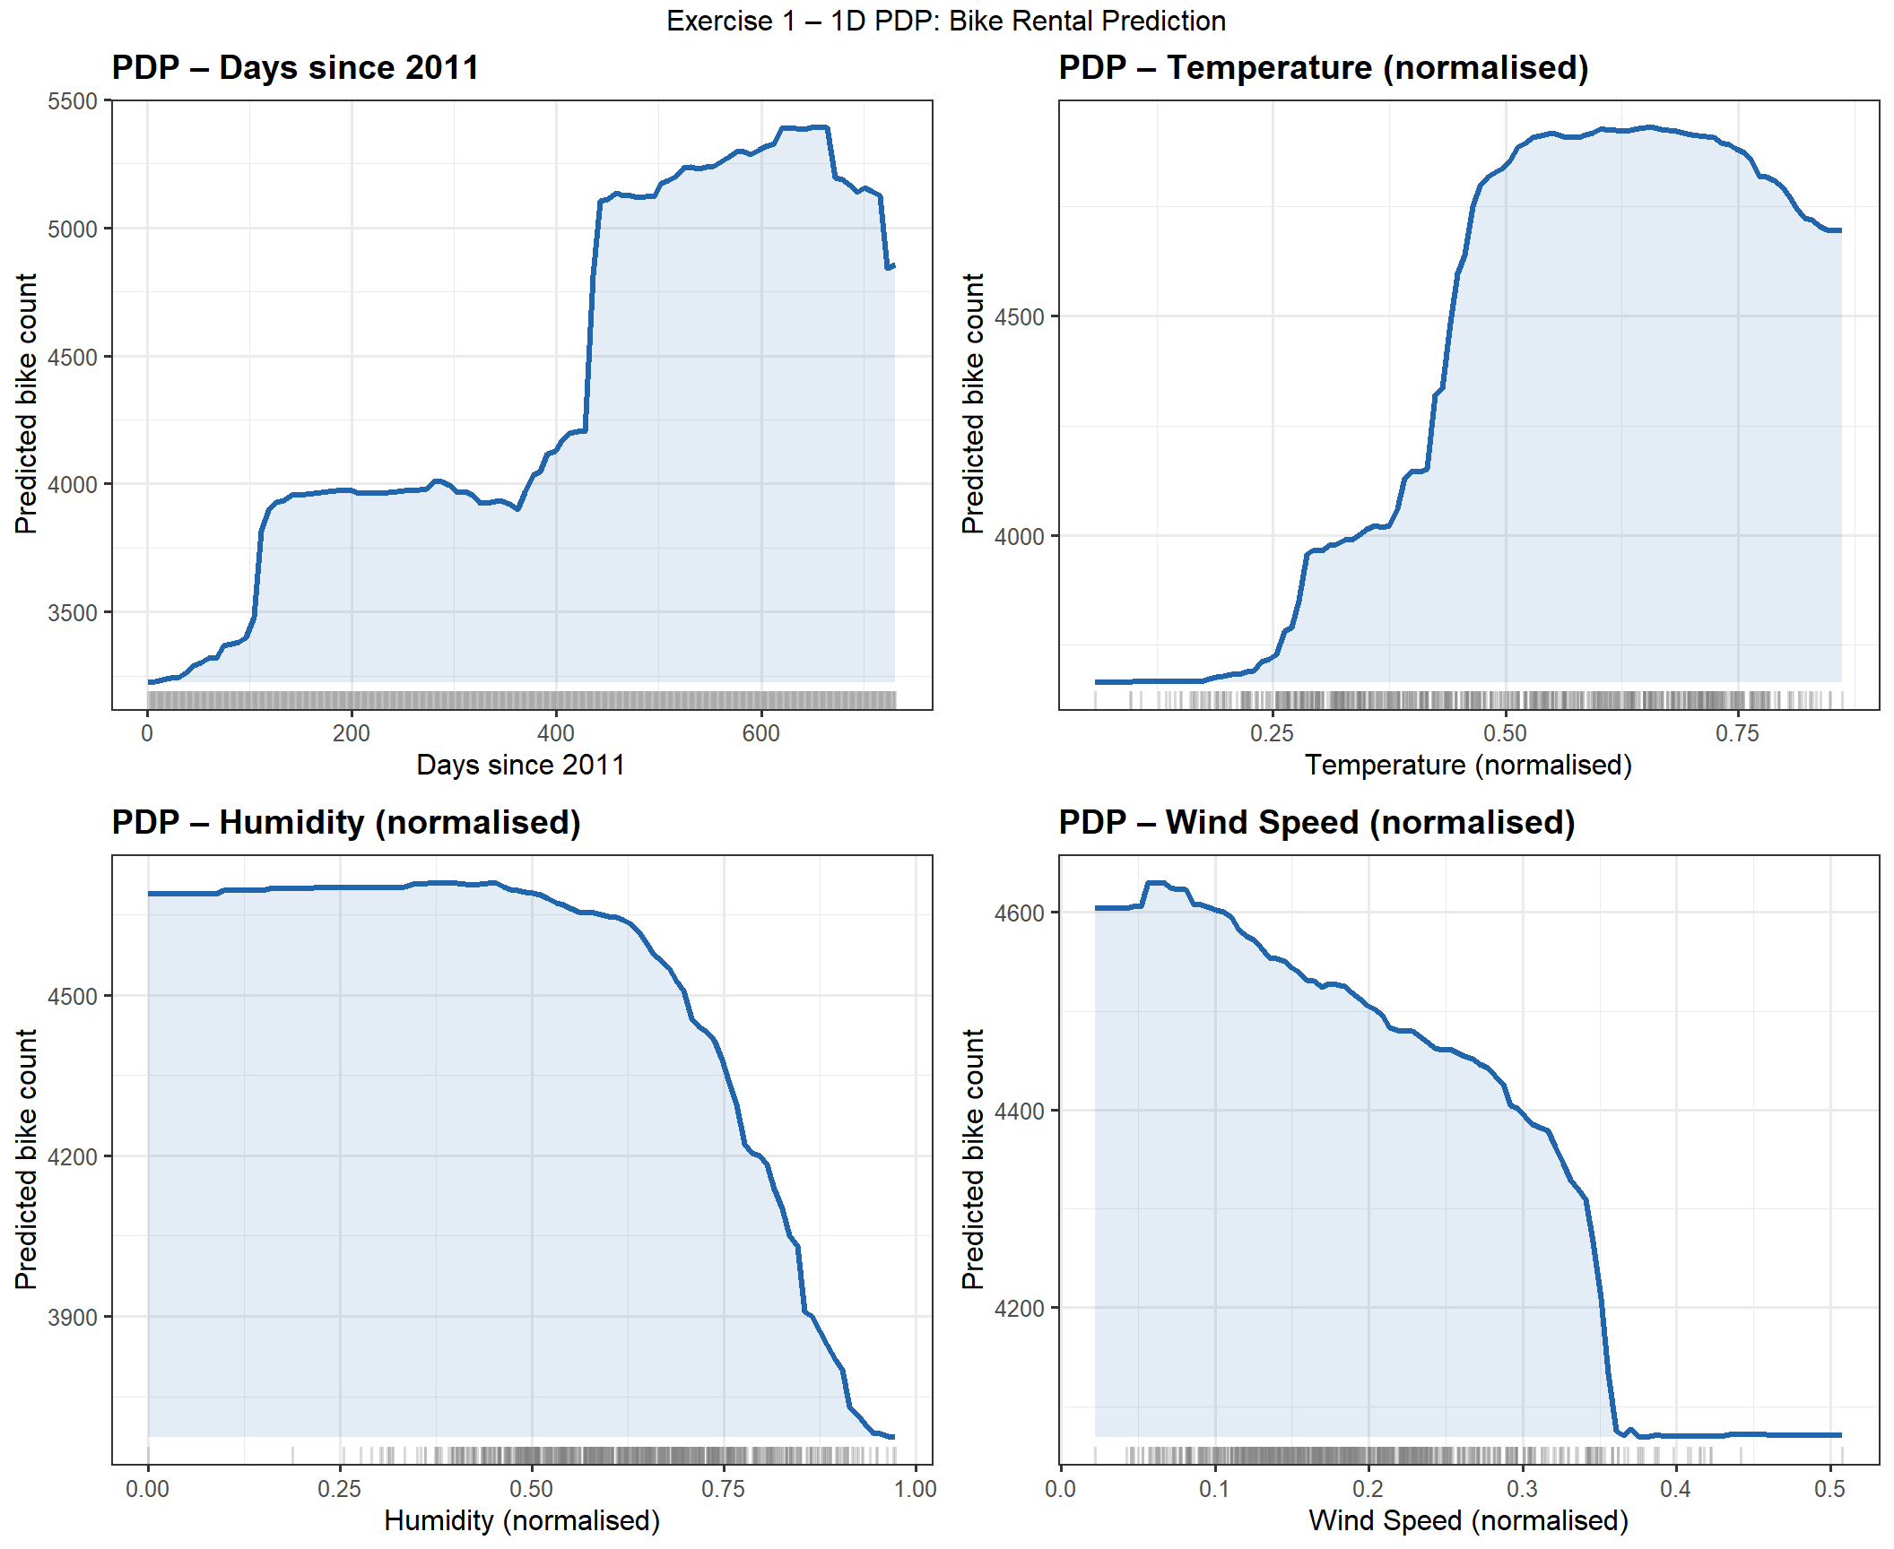
Figure 1. 1D Partial Dependence Plots for bike rental prediction.

1.3 Question: Analysis of Feature Influence
Days since 2011 (instant):
The PDP shows a non-linear upward trend over time. Rentals grow gradually during the first year (~days 0-365), then jump sharply around day 400 and reach a plateau between days 400-600, before dropping slightly at the very end. This reflects the seasonal growth pattern of the bike sharing system: a first year of moderate usage followed by a strong consolidation in 2012, with a slight drop at the end of the observation period possibly due to seasonal factors.
Temperature:
Temperature shows a strong positive effect on bike rentals, but with a markedly non-linear shape. The curve stays flat and low at cold temperatures (below 0.2), then rises steeply between 0.2 and 0.5, reaching a broad plateau around 0.5-0.8 (approximately 17-27°C). At the highest temperatures the curve slightly declines. This inverted-U pattern is consistent with seasonal behaviour: cold weather strongly suppresses demand, moderate warmth maximises it, and extreme heat slightly discourages cycling.
Humidity:
Humidity shows a clearly negative and non-linear relationship with predicted rentals. The curve remains flat and high for low-to-moderate humidity values (0.0-0.6), suggesting that mild humidity does not significantly affect cycling behaviour. However, above 0.6 the predicted count drops sharply and continuously until reaching its minimum at very high humidity (above 0.9). This steep decline indicates a threshold effect: once conditions become noticeably humid, demand falls rapidly.
Wind Speed:
Wind speed shows a negative effect on bike rentals, but the shape is notably non-linear. Predicted counts remain relatively stable at low wind speeds (0.0-0.1), then decline gradually up to around 0.3. Beyond that threshold, the curve drops sharply, suggesting that strong winds have a disproportionate deterrent effect. This is consistent with the physical discomfort and safety concerns associated with high wind, which particularly discourages casual riders.

2. Exercise 2 - Bidimensional Partial Dependence Plot

2.1 Methodology
A 2D PDP was generated combining humidity and temperature as joint predictors of bike rental counts. Due to the computational cost of evaluating all feature combinations, a random sample of 300 observations from the training set was used. The prediction surface was computed over a 50x50 grid covering the full range of both features, with all other features held at their sample means.
The density distributions of both features are shown alongside the main plot to contextualise where the data is concentrated.

2.2 Results
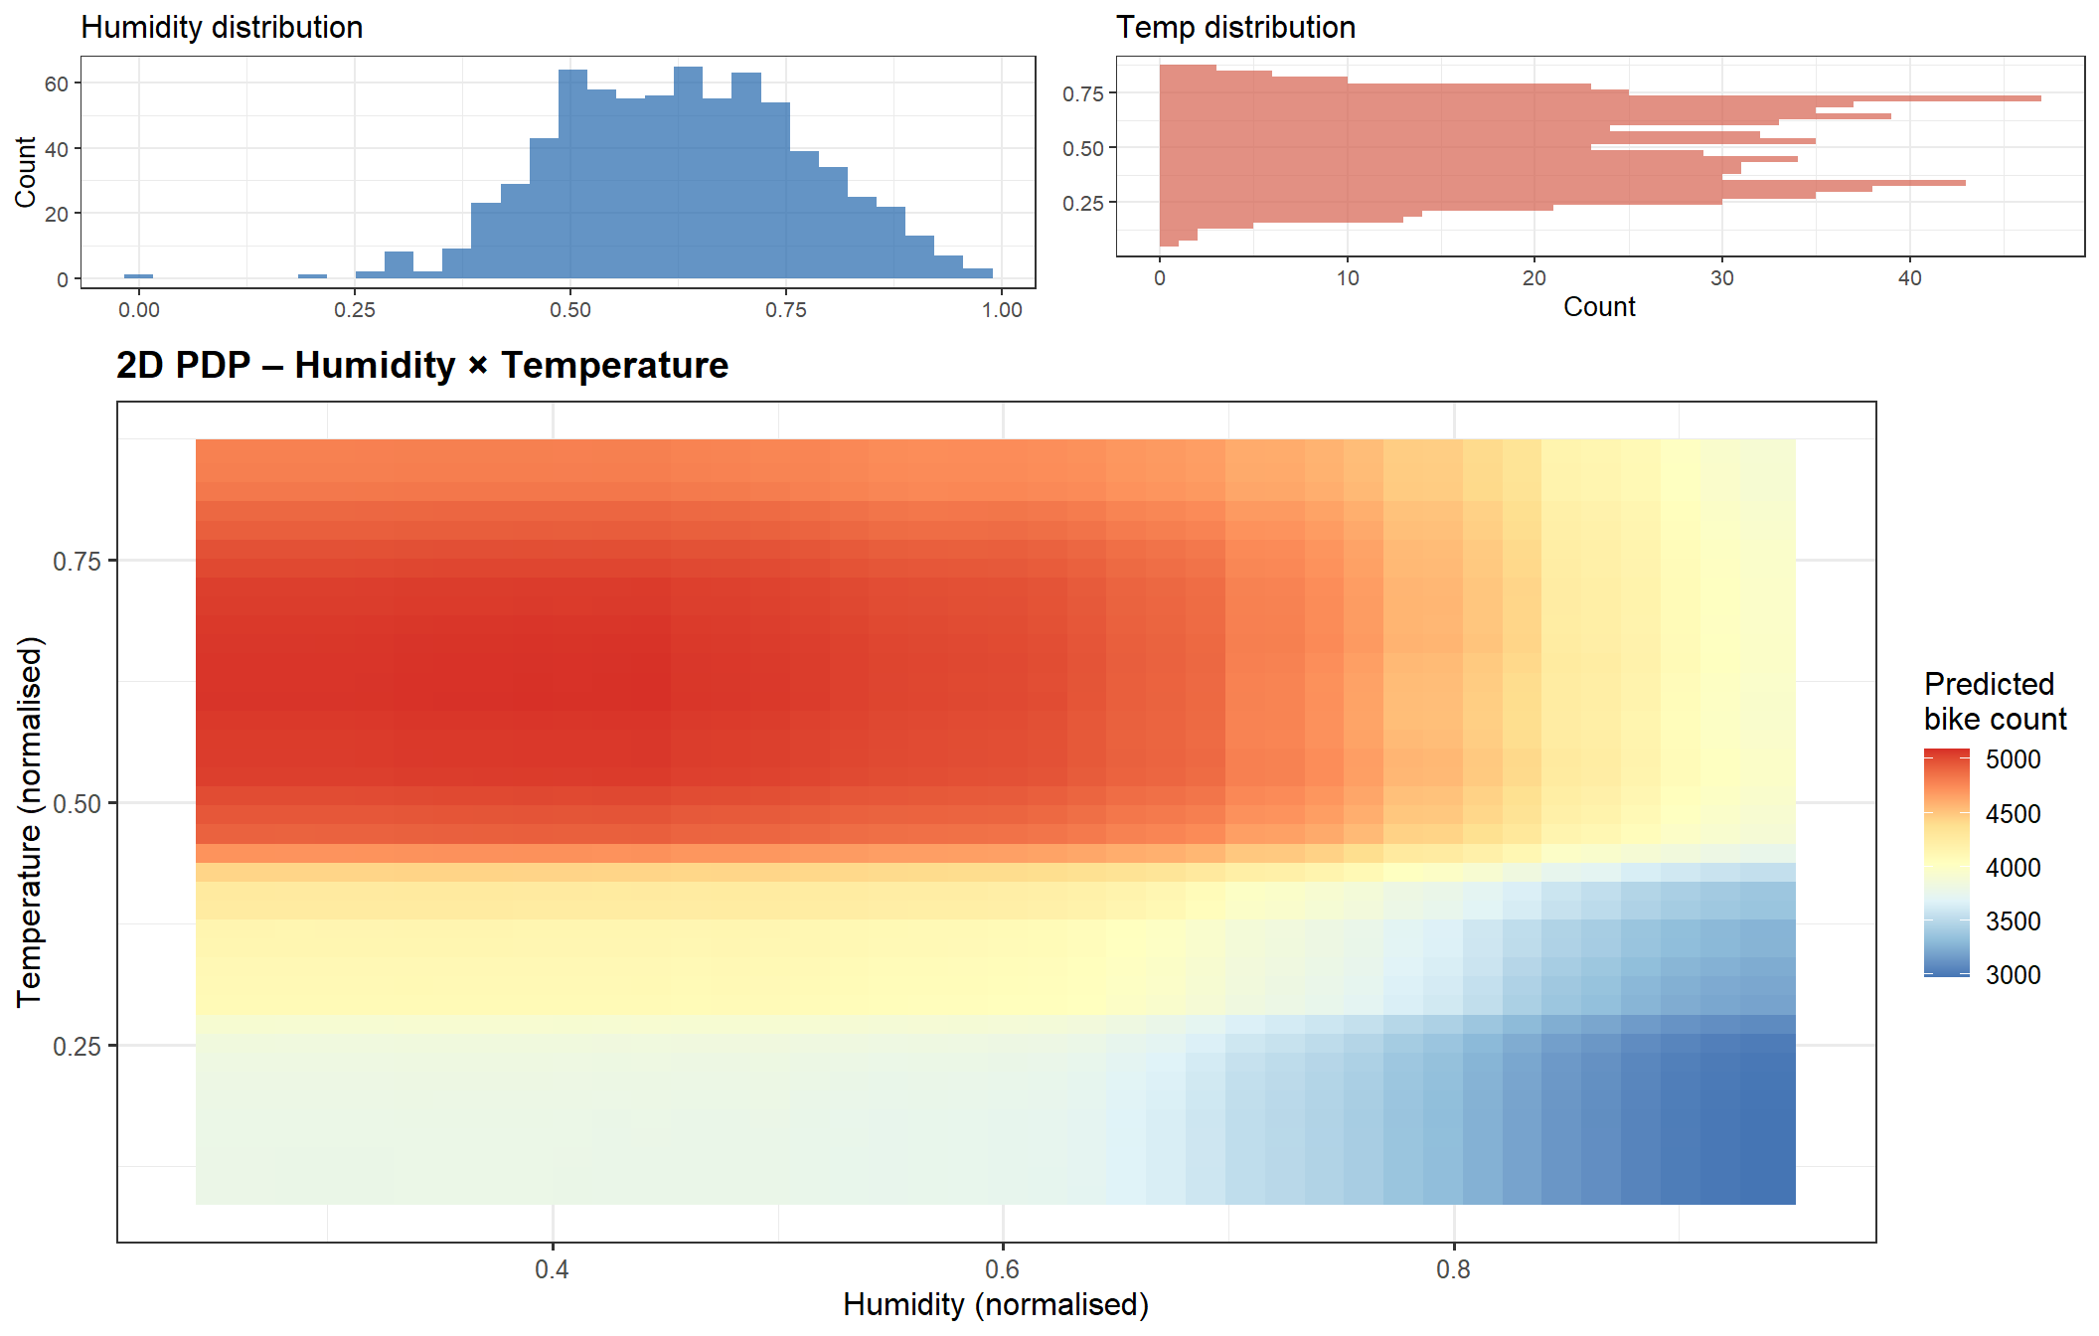
Figure 2. 2D Partial Dependence Plot: Humidity x Temperature for bike rental prediction.

2.3 Question: Interpretation
The 2D PDP confirms a strong interaction between temperature and humidity. The highest predicted rentals (red region) clearly correspond to high temperature (above 0.45) combined with low-to-moderate humidity (below 0.7). As temperature rises, the positive effect dominates regardless of humidity level, making it the primary driver of demand.
The bottom region (low temperature) consistently shows the lowest predicted counts regardless of humidity — confirming that cold weather is the strongest suppressor of bike rentals. In contrast, at high temperatures even elevated humidity does not reduce predictions as sharply, suggesting that warmth compensates partially for humid conditions. The top-right corner (high temperature, high humidity) shows a moderate reduction compared to the top-left, but remains higher than the cold regions.
The density plots confirm that the data is concentrated in humidity values between 0.4 and 0.8, and in temperatures between 0.25 and 0.75. The model's predictions in the extreme corners (very low temperature + very low humidity, or very high temperature + very high humidity) are therefore extrapolations with less data support and should be interpreted cautiously.

3. Exercise 3 - PDP for House Price Prediction

3.1 Methodology
A Random Forest regressor was fitted on the King County house price dataset (kc_house_data.csv) using six features: bedrooms, bathrooms, sqft_living, sqft_lot, floors, and yr_built. Given the size of the dataset (21,613 observations), a random sample of 3,000 records was used for both training and PDP computation.
Model performance: R² = 0.5699 on the sample. This moderate value reflects the difficulty of predicting house prices using only six structural features, excluding key factors such as location, neighbourhood quality, and renovation status.

3.2 Results
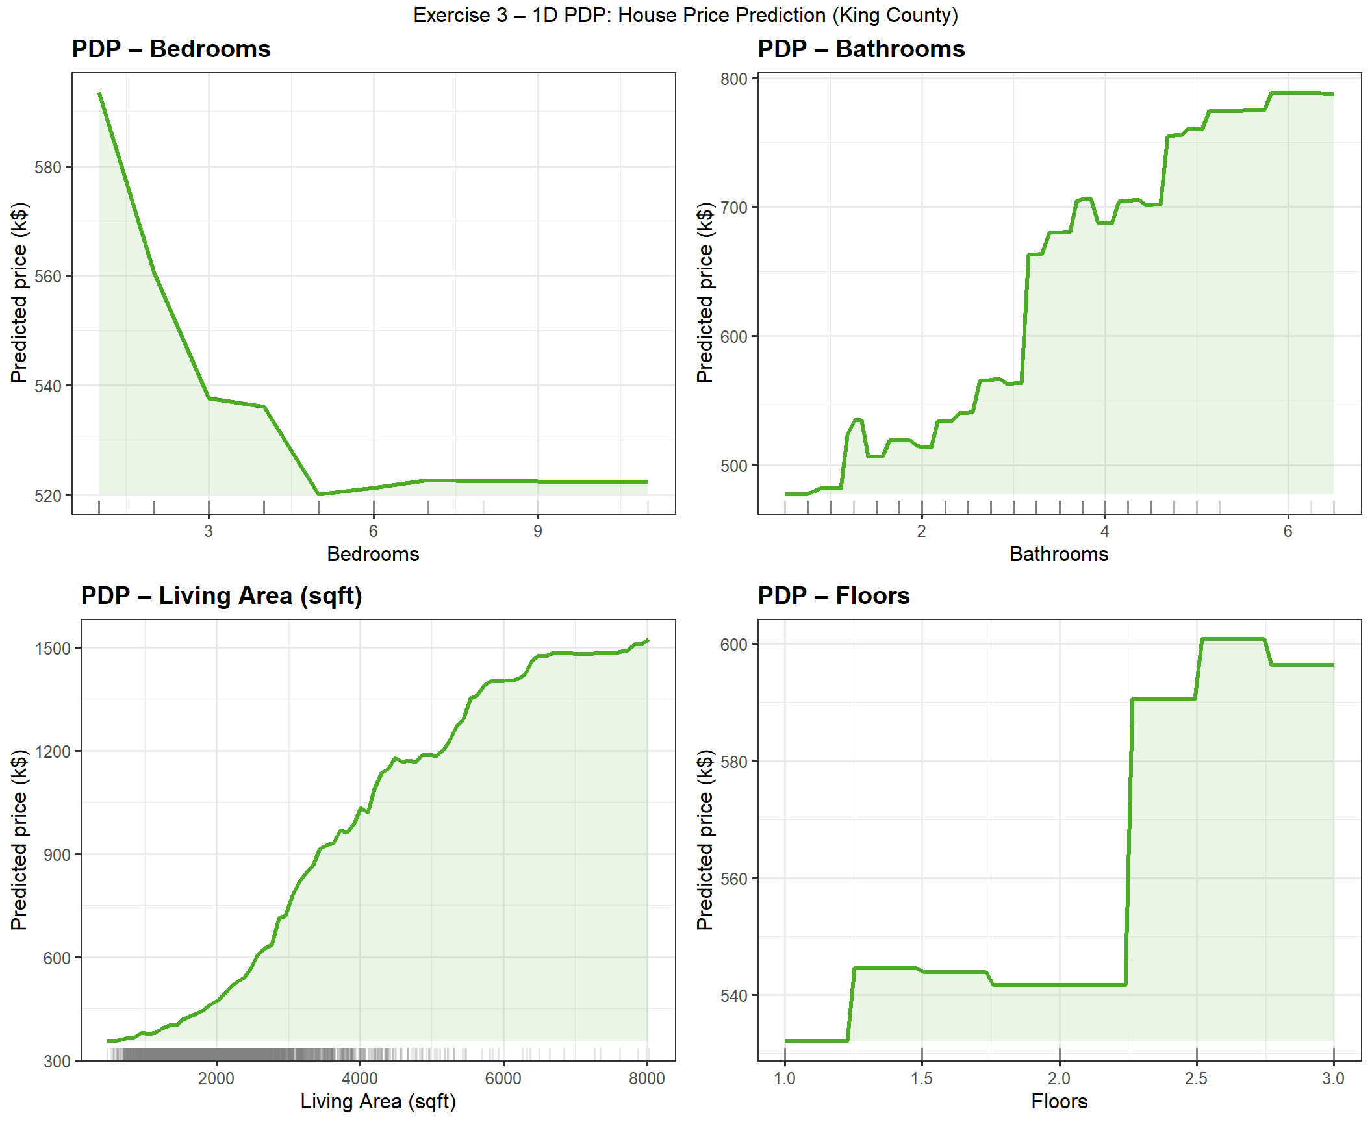
Figure 3. 1D Partial Dependence Plots for house price prediction.

3.3 Question: Analysis of Feature Influence
Bedrooms:
The PDP for bedrooms shows a clear and consistently negative relationship. Predicted price starts at its maximum (~$595k) for houses with 1-2 bedrooms and decreases steadily as the number of bedrooms increases, stabilising at around $520k for 5+ bedrooms. This is counterintuitive but reflects the fact that, when controlling for other features like living area, adding bedrooms means smaller individual rooms. Compact high-quality properties with few bedrooms tend to command higher prices than larger but less refined ones.
Bathrooms:
Bathrooms show a strong and mostly monotonic positive effect on predicted price. The curve rises from around $490k at 1 bathroom to nearly $800k at 6+ bathrooms, with the steepest increases occurring between 3 and 5 bathrooms. More bathrooms are strongly associated with higher-quality, more spacious homes, explaining this clear positive trend. There are minor fluctuations at intermediate values (around 2-2.5 bathrooms) which likely reflect data variability at those counts.
Living Area (sqft_living):
Living area has the strongest and most consistent positive effect on predicted price. The relationship is monotonically increasing and accelerating: prices rise from around $320k for small homes (~800 sqft) to over $1,500k for the largest (~8,000 sqft). The curve steepens noticeably above 4,000 sqft, suggesting a luxury premium for very large properties beyond the purely proportional size effect. This is the most informative feature in the model.
Floors:
Floors show a stepped, discrete positive effect. The PDP is nearly flat at around $530-545k for 1 to 2 floors, then jumps sharply to approximately $590k at 2.5 floors, and reaches its maximum around $600k at 2.5-3 floors before slightly declining at 3 floors. This staircase pattern reflects the discrete nature of the variable and suggests that mid-rise homes (2.5 floors) are valued as a distinct premium category, possibly associated with specific architectural styles in King County.

4. Conclusions
Partial Dependence Plots provide an intuitive and model-agnostic way to understand how each feature influences predictions of a trained machine learning model. Across all three exercises, the PDPs consistently reveal:
- Non-linear relationships that would be missed by simpler linear models (e.g. the temperature effect on bike rentals, or bedrooms vs house price).
- Interaction effects between features visible in the 2D PDP (humidity and temperature jointly determine bike demand).
- The practical value of the rug plots and density margins, which contextualise predictions within the observed data distribution and highlight regions where model extrapolation is uncertain.
The Random Forest models achieved R² = 0.89 for bike rentals and R² = 0.57 for house prices. The lower value for houses reflects the limited feature set used (only six structural variables), which excludes key predictors such as location and neighbourhood. Despite this, the PDPs successfully capture meaningful and interpretable patterns consistent with domain knowledge.

