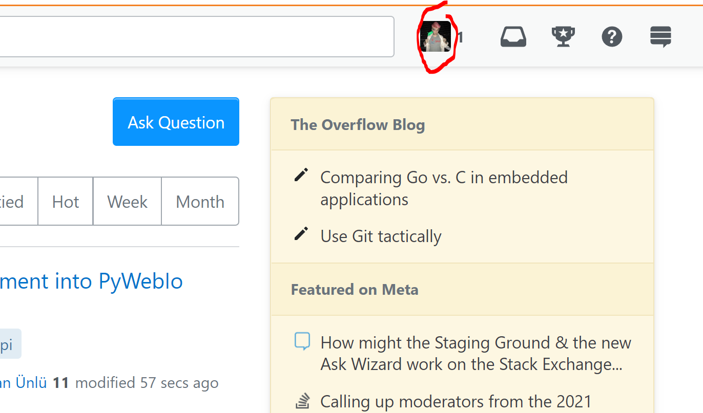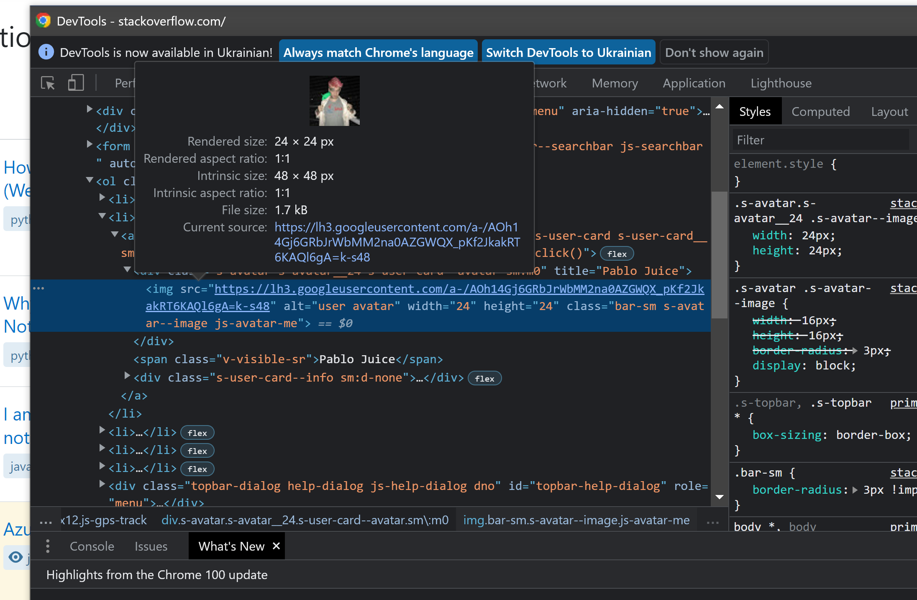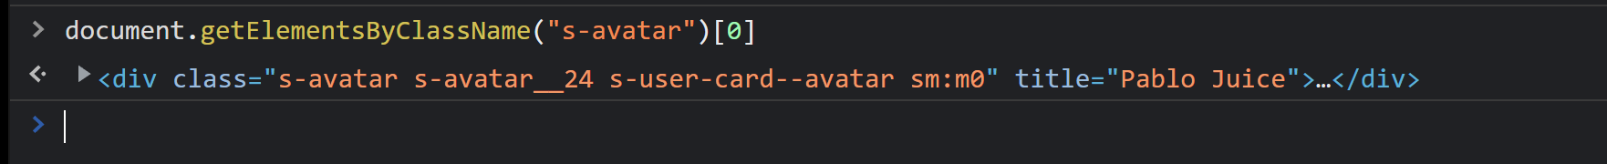

body > header > div > ol.s-topbar--content > li:nth-child(2) > a > div.s-avatar.s-avatar__24.s-user-card--avatar.sm\:m0

/html/body/header/div/ol[2]/li[2]/a/div[1]



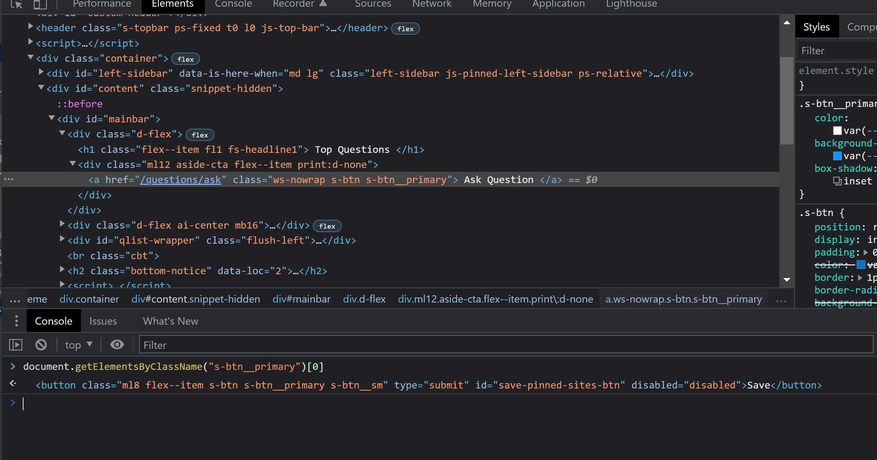

#mainbar > div:nth-child(1) > div > a

//*[@id="mainbar"]/div[1]/div/a

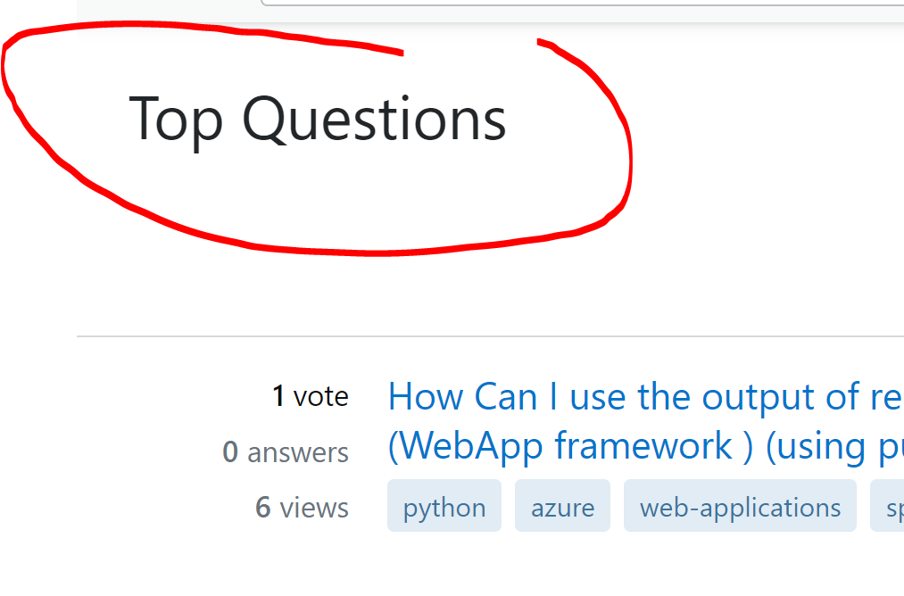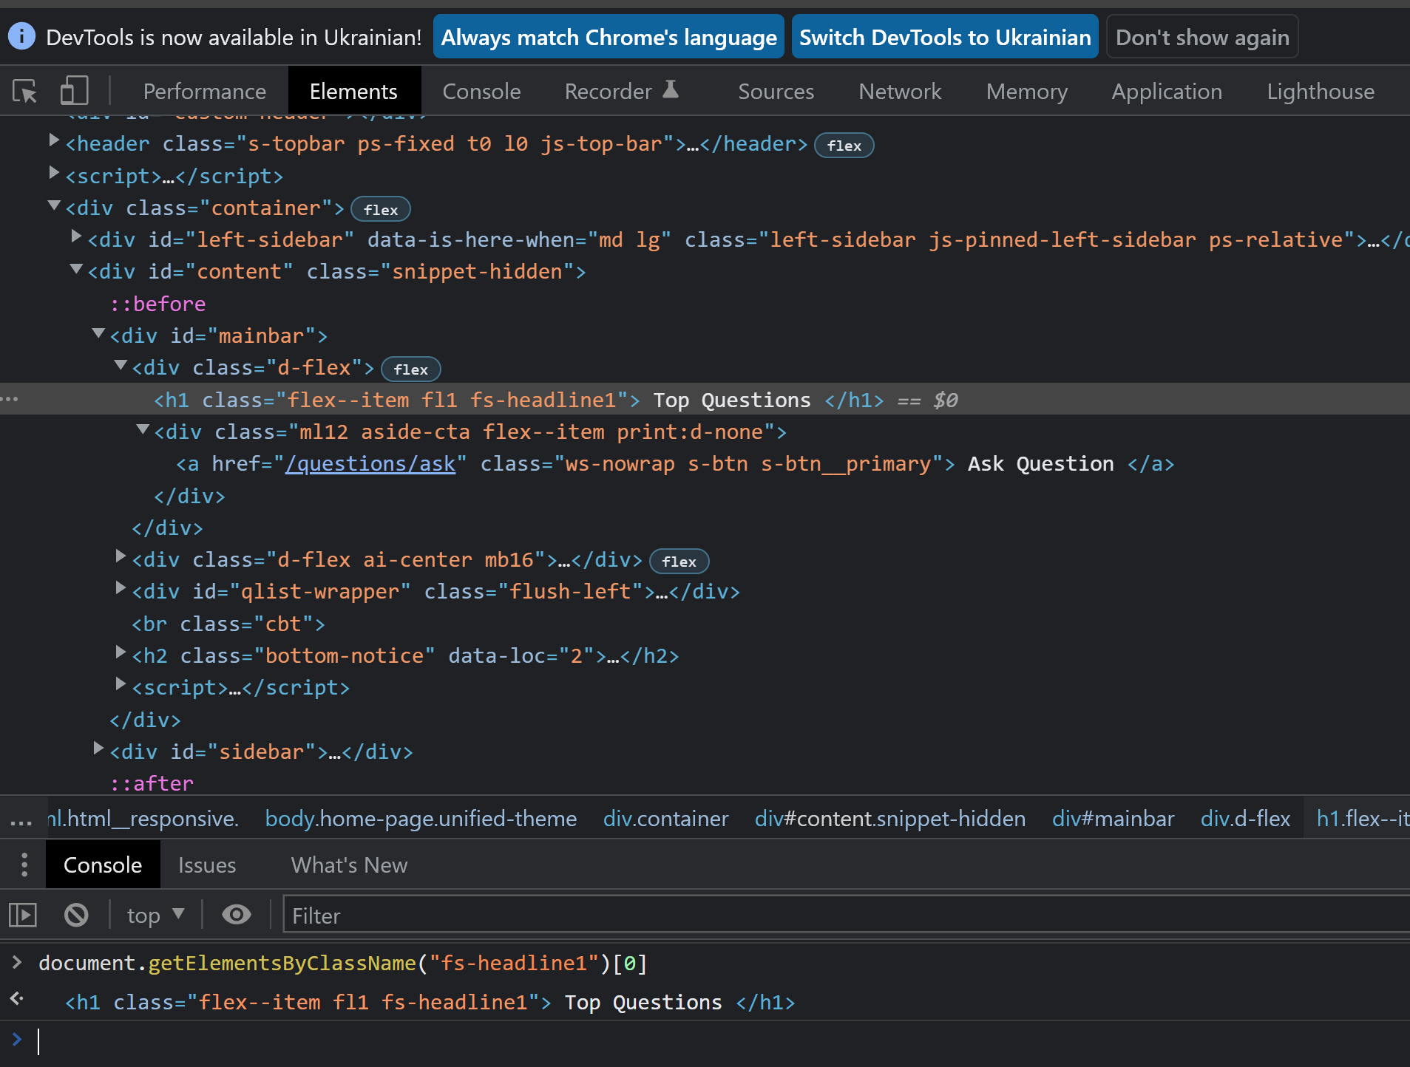

#mainbar > div:nth-child(1) > h1

//*[@id="mainbar"]/div[1]/h1