# Team LID - Work Log of Workshop 5 – Travel Experts Web App (ASP.NET)

## Daniel (3/31):

#### Scaffolding

Scaffold TravelExperts DB into Visual Studio, two non-fatal warning appear when doing it. As a result, Class Employee is not generated.



The reason for this is that Employees is an orphan table in database, but since this project is more about customers, packages, and doesn’t involve employee, I will just leave it like this for now.

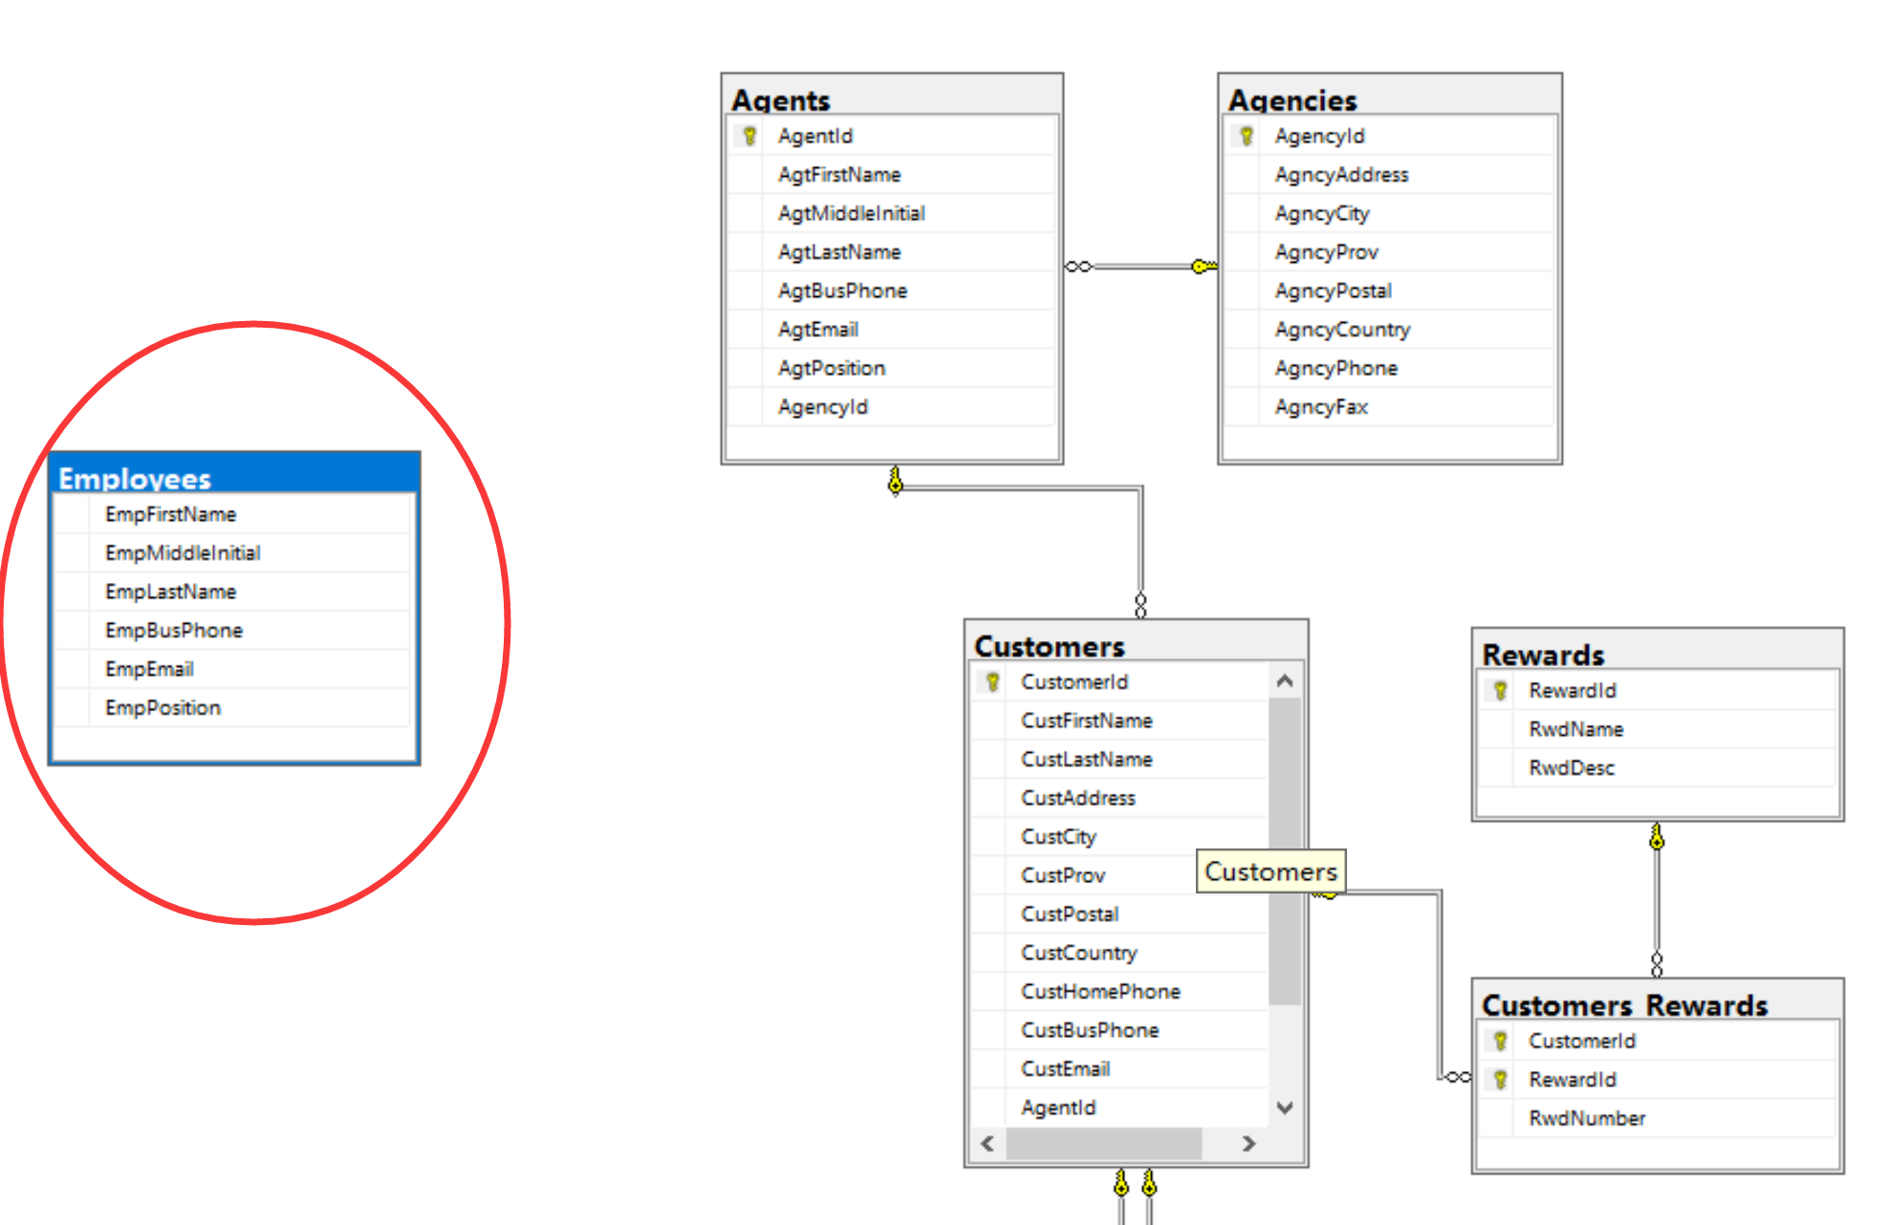

All other entity types were generated successfully.

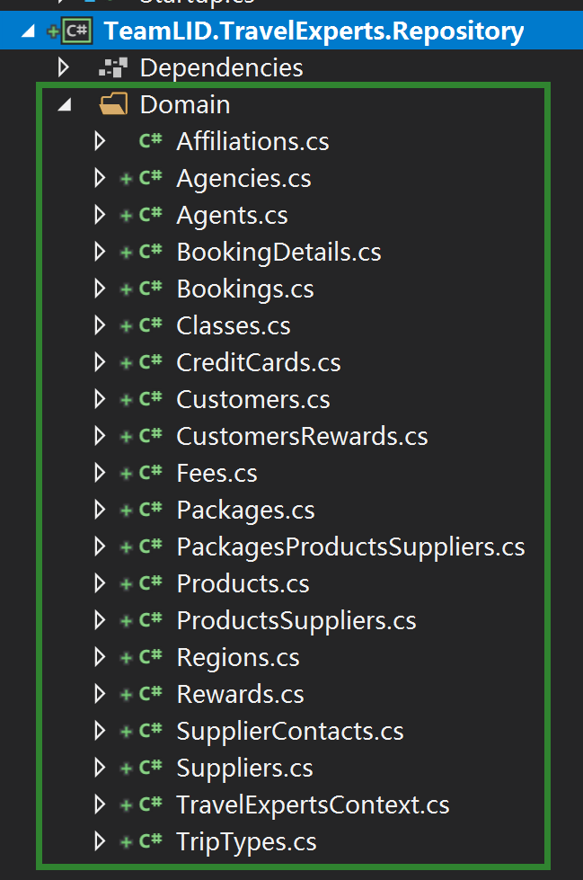

#### Creating Pages (MVC)

Add 3 controllers and views for them: CustomersController, PackagesController, AgentsController

After adding PackagesController and related Views, when try to run, an exception occurred. Need some trouble shooting: may need to configure service for context before using.

