Module 5 – Loops

Question 1: What is the last number that will be printed to screen?

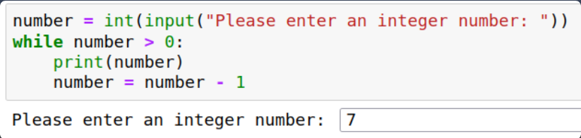
Answer :1

Question 2: What will be printed to screen?

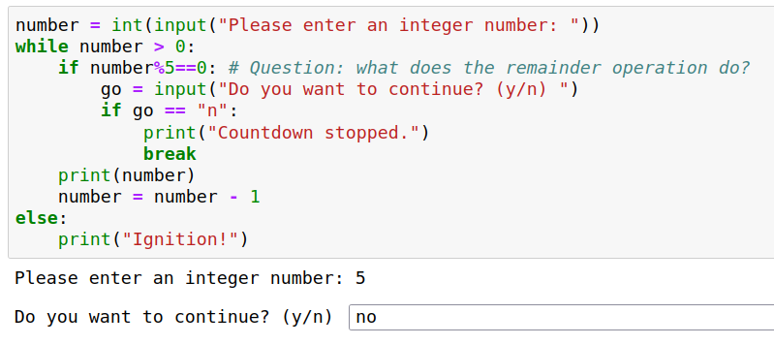
Answer: 5, 4, 3, 2, 1, ignition

Question 3: What is "pear" in Caesar Cipher?

Answer: shdu

Question 4: In which line is the mistake?
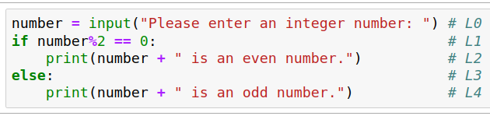
Answer: L0, L1

Question 5: What happens now?
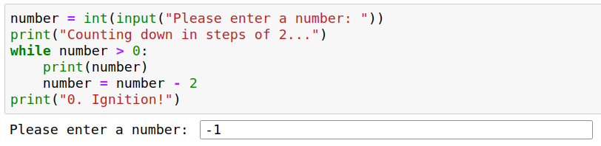
Answer: “0” is printed

