Regular Expressions
A note on special characters

When working with regular expressions (regex), remember that they are not designed specifically for Python. This means that some of the special characters might overlap, as we’ve seen in lecture. It might be helpful to think of the process as follows: you type in certain keys, which Python interprets according to its rules for string formatting, and these Python strings are then fed to the re module to work with regex. See this diagram:
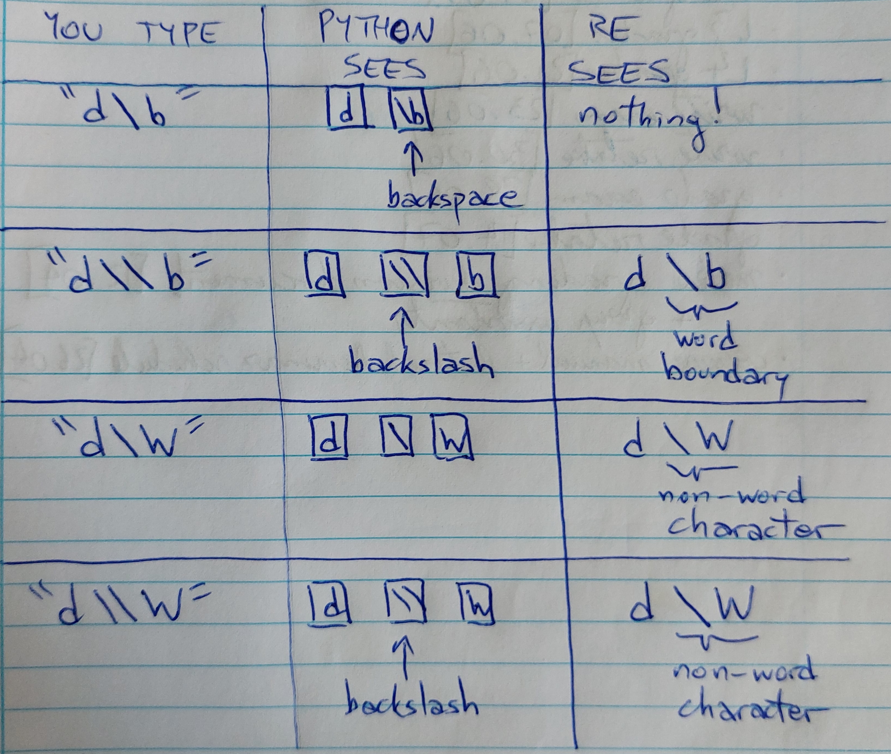

On the left-hand is what you type into your keyboard. Each symbol is a single key that you press. In the center is the sequence of characters that Python interprets from what you’ve typed. I’ve used rectangles to represent single Python characters. In the first example, \b is interpreted by Python as a backspace, so that the preceding character is actually removed, and the re module sees nothing at all as the pattern.

The other crucial point is that Python will interpret both “\” and “\\” as a single backslash. For this reason, the final two rows in the table have exactly the same effect.

