

- Alumno: Pablo Santiago, Paez Sheridan

- Profesor: Isabel Riomoros

- Titulo: Creación de una Base de Datos
Diagrama Entidad-Relación
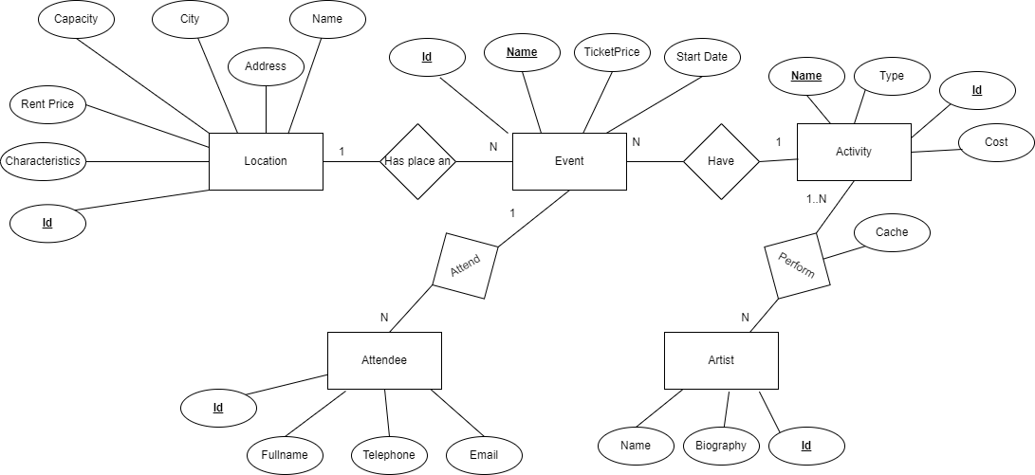
Modelo Relacional
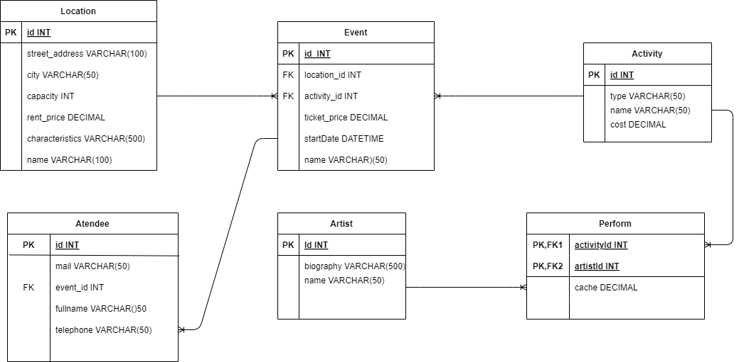
Script completo

CREATE DATABASE IF NOT EXISTS pablopaez ;
USE pablopaez;

CREATE TABLE IF NOT EXISTS Artist (
id INT PRIMARY KEY auto_increment,
biography VARCHAR(500),
full_name VARCHAR(50)
);

CREATE TABLE IF NOT EXISTS Location (
id INT PRIMARY KEY auto_increment,
street_address VARCHAR(50) NOT NULL,
city VARCHAR(50) NOT NULL,
capacity INT NOT NULL,
rent_price DECIMAL,
characteristics VARCHAR(100),
name VARCHAR(50) NOT NULL UNIQUE
);

CREATE TABLE IF NOT EXISTS Activity (
id INT PRIMARY KEY auto_increment,
type VARCHAR(100) NOT NULL,
name VARCHAR(100) NOT NULL UNIQUE,
cost DECIMAL DEFAULT 0
);

CREATE TABLE IF NOT EXISTS Event (
id INT PRIMARY KEY auto_increment,
location_id int NOT NULL,
activity_id int NOT NULL,
ticket_price DECIMAL,
start_date DATETIME,
name VARCHAR(100) NOT NULL UNIQUE,
FOREIGN KEY (location_id) REFERENCES Location(id),
FOREIGN KEY (activity_id) REFERENCES Activity(id)
);

CREATE TABLE IF NOT EXISTS Attendee (
id INT PRIMARY KEY auto_increment,
event_id INT NOT NULL,
mail VARCHAR(50) NOT NULL,
full_name VARCHAR(100) NOT NULL,
telephone VARCHAR(50),
FOREIGN KEY (event_id) REFERENCES Event(id),
UNIQUE(event_id, full_name)
);

CREATE TABLE IF NOT EXISTS Perform (
activity_id INT NOT NULL,
artist_id INT NOT NULL,
cache DECIMAL DEFAULT 0,

PRIMARY KEY(activity_id,artist_id)
);

-- Triggers

CREATE TRIGGER increment_activity_cost
AFTER INSERT ON Perform
FOR EACH ROW
UPDATE Activity
SET cost = cost + NEW.cache
WHERE id = NEW.activity_id;

CREATE TRIGGER decrement_activity_price
AFTER DELETE ON Perform
FOR EACH ROW
UPDATE Activity
SET cost = cost - old.cache
WHERE id = old.activity_id;

-- Vista

-- vista para mostrar todos los datos relacionados a un evento
CREATE VIEW event_data AS
SELECT e.name Event_Name, e.start_date Event_Start_Date, e.ticket_price Event_Ticket_Price, a.name Activity_Name, a.type Activity_Type, l.name Location_Name, l.street_address Location_Address, l.capacity Location_Capacity
FROM pablopaez.event e
inner join pablopaez.activity a on a.id = e.id
inner join pablopaez.location l on l.id = e.location_id ;

-- Queries

-- trae las ubicaciones ordenadas por el costo mas barato en relacion a la capacidad y el costo de alquiler
select l.name, l.rent_price / l.capacity as location_cost_per_seat
from location l
order by location_cost_per_seat DESC;

-- trae la informacion de los eventos futuros usando la vista de eventos
select * from event_data
where Event_Start_Date > NOW();

-- trae los artistas con el numero de actuaciones de cada uno
select a.full_name, COUNT(p.artist_id) as performings_numbers
from artist a
inner join perform p on p.artist_id = a.id
group by a.id
order by performings_numbers DESC;

-- trae las ubicaciones ordenadas por el numero de eventos
select l.name, COUNT(*) AS event_count from pablopaez.event e
inner join pablopaez.location l on l.id = e.location_id
group by l.id
order by event_count DESC;

-- trae las fechas con mas eventos
select e.start_date,COUNT(*) as event_count from pablopaez.event e
group by e.start_date
order by event_count;

-- trae los tipos de actividades ordenados por el numero de eventos asociados
select a.type, COUNT(*) as event_count from pablopaez.activity a
inner join pablopaez.event e on e.activity_id = a.id
group by a.type
order by event_count DESC;

-- trae los tipos de actividades ordenados por la suma del numero de asistentes en todos los eventos
select act.type, count(att.id) as attendes_per_activity_type
from pablopaez.activity act
inner join pablopaez.event e on e.activity_id = act.id
inner join pablopaez.attendee att on att.event_id = e.id
group by act.type
order by attendes_per_activity_type DESC;

-- traer los artistas que cobren mas barato en promedio
select a.full_name, SUM(p.cache)/ COUNT(p.activity_id) as average_cache
from pablopaez.artist a
inner join perform p on p.activity_id = a.id
group by a.id
order by average_cache DESC;

-- trae los eventos y sus rentabilidades (ganancias como la suma de las entradas vendidas menos el costo de la actividad)
select e.name, COUNT(att.id) * e.ticket_price - (act.cost + l.rent_price) as event_earning
from pablopaez.event e
inner join activity act on act.id = e.activity_id
inner join attendee att on att.event_id = e.id
inner join location l on l.id = e.location_id
group by e.id
order by event_earning DESC;

-- trae todo los futuros eventos con ubicacion disponible (que el numero de attendes sea menor a la capacity de la location)
select e.name, l.capacity - SUM(a.id) as capacity_available
from pablopaez.event e
inner join pablopaez.location l on l.id = e.location_id
inner join pablopaez.attendee a on a.event_id = e.id
where e.start_date > NOW()
group by e.id
having capacity_available > 0
order by capacity_available DESC;

