Kinect C# Quiz Handbook

An easy to follow user Guide

Table of Contents

Introduction to the program

This application is an interactive

Controls and navigation

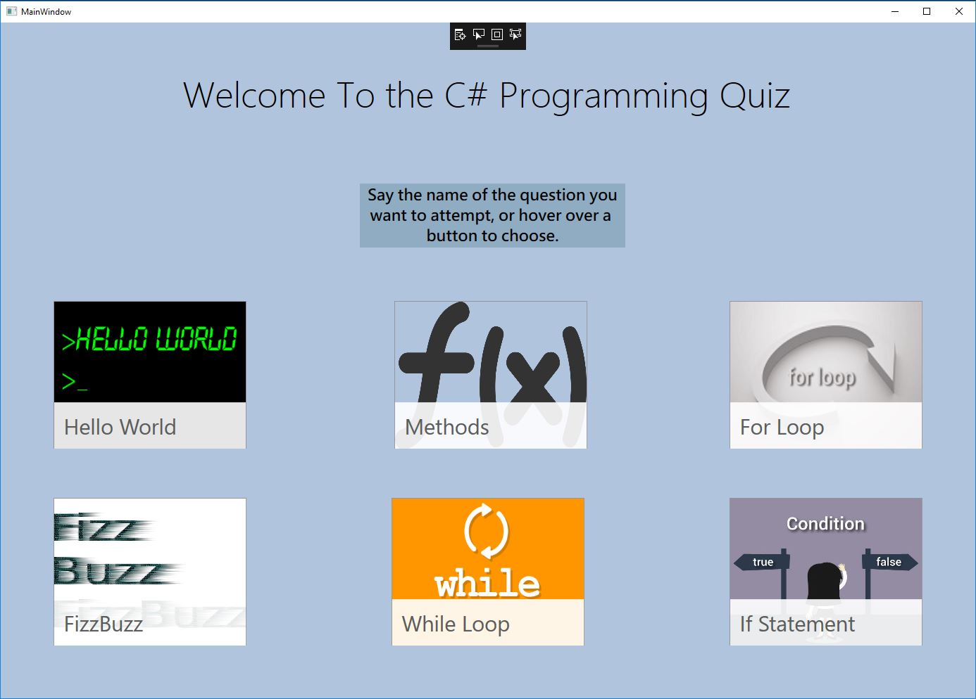

Answering Questions

