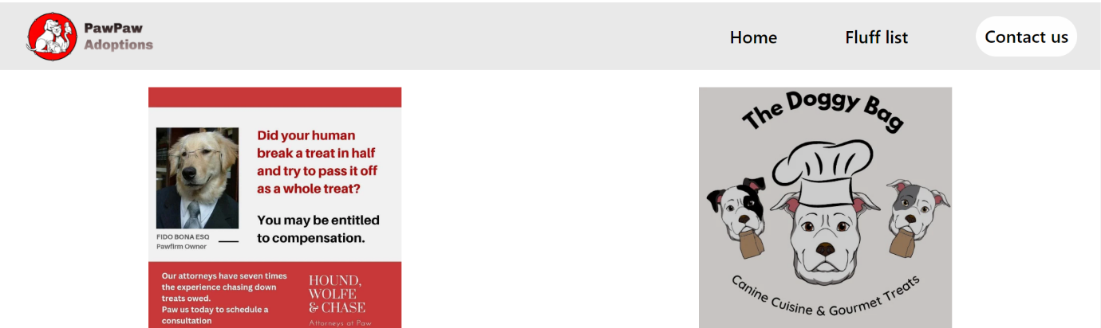**1.Header and Images**

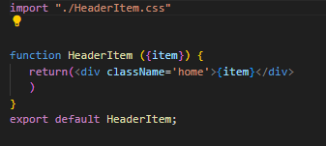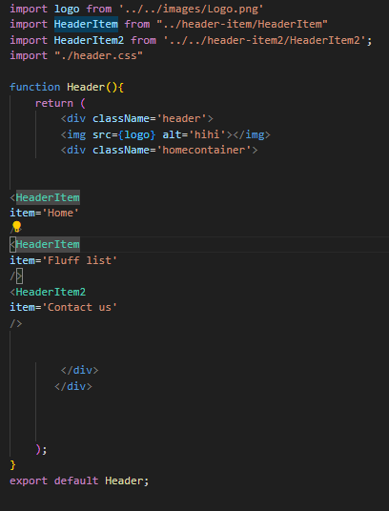

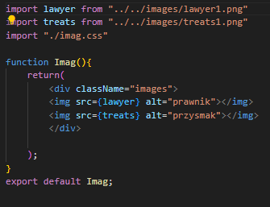

First to make a header we imported a logo and created a header item which contains the menu option then we imported images to be shown on the page

**2.Middle Part**

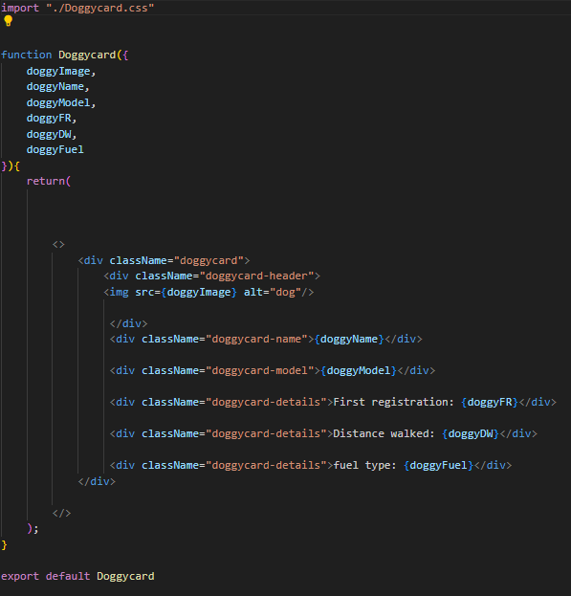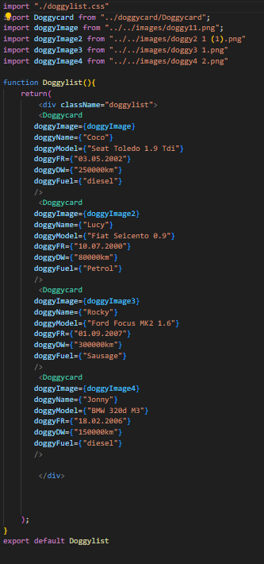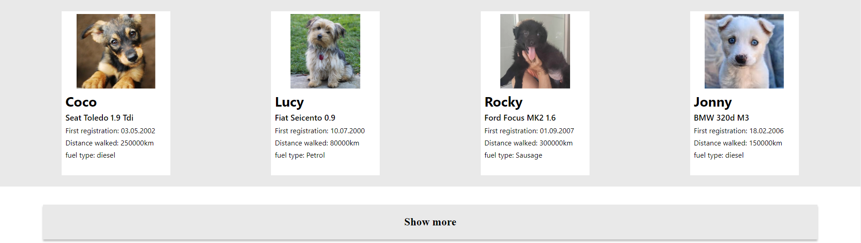

After the header we moved on to the doggylist. To Create the doggy list we made a doggy card component which is a template that we can freely edit and add to the doggy list.

**3.Banner**

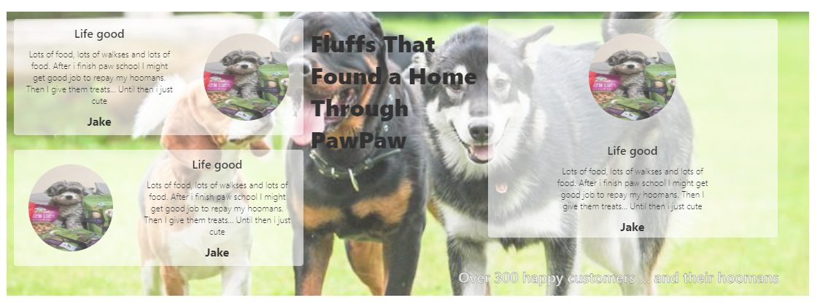

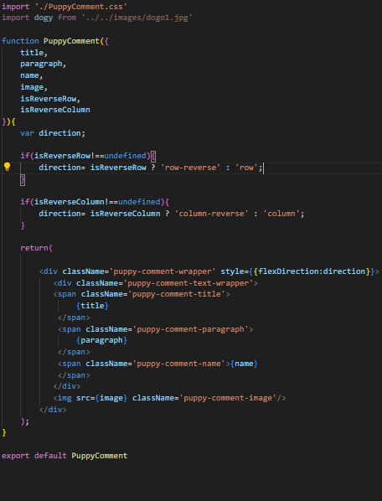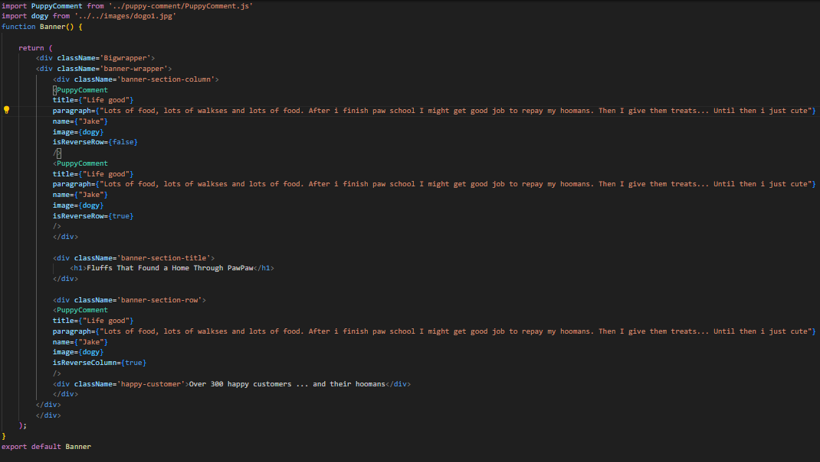

Creating the banner was pretty complicated. First we had to make a inner part of the banner: the Puppy Comment which is a template to the doggy description. Also Puppy comment has a logical function which is responsible for the ability for the Comment to reverse in row and column.

**4.Form**

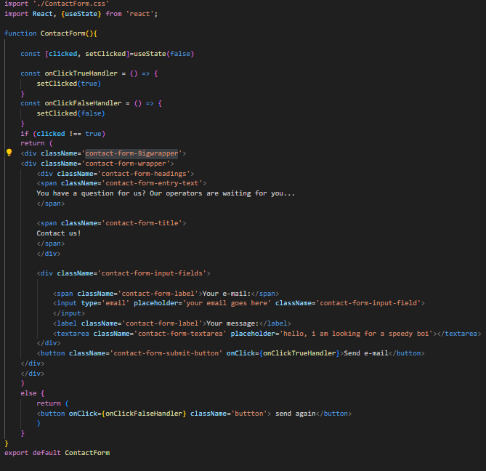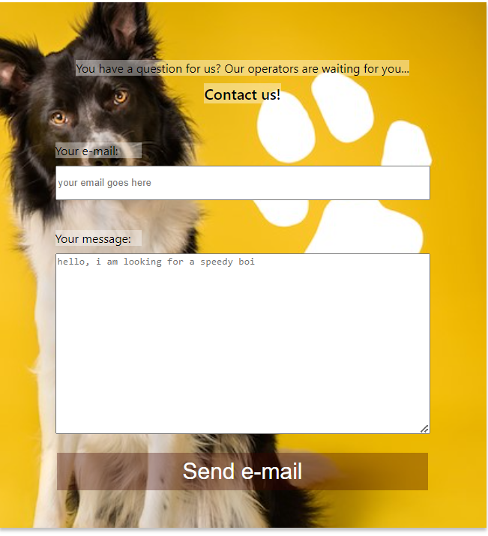

To make a working contact form we used a input tag for a message box and email with a button under it . The button has a function which activates onclick leading to a event. The event hides the form and shows the other button which reshows the form

**5.CSS**

To make the appearance of the website we’ve used CSS functions such as Flexbox which can make the website’s content move around and be available in many devices and resolutions. The example of the flexbox in the CSS code is down below

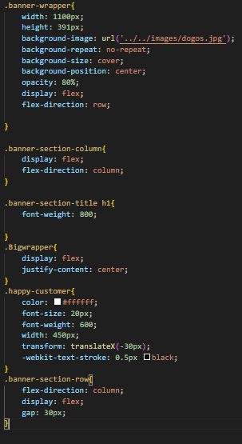

**6.Summary**

In summary we learnt how to use flexbox, java script, css, html, developing a site with react , uploading files into repositories with git, using git hub and figma. In our opinion the hardest thing to make on the site was the banner because it has many elements and logical functions. Despite the challenges we enjoyed the experience of developing the website