EXTENDED DEMOGRAPHY
AMXEDITOR – PLUGIN

EXTENDED DEMOGRAPHY 1
1. Introduction. 1
2. AD_Reference Table. 4
3. New Messages on AD_Message Table. 6
4. Fields Added on C_Country Table. 7
5. Capture Sequence on Table C_Country. 8
6. New Table C_Community 9
7. New Tables C_Municipality and C_Parish 11
8. Fields Added on C_Region Table. 14
9. Fields Added on C_Location. 16
10.Country-Community-Region-Municipality-Parish Window. 17

Author : Luis Amesty Linares
Madrid, Spain August 2018
luisamesty@gmail.com

1. Introduction.

This Plugin is related to Demographic concern on Idempiere ERP. It is well known that on some countries there is a political division with concepts more than country, region and city.

For example in Spain we talk about Communities, they are related to Group of Provinces that keeps a Local Government. They also have a political division for Provinces called Municipalities (Municipality-Municipio).

Another example is Venezuela, they have a political division for Provinces (Estados) called Municipalities (Municipality-Municipio) and a Municipality is also divided on Parishes (Parish-Parroquia). Particularity Main Mail office in Venezuela has published a new rule indicating the way postal address is to be written:

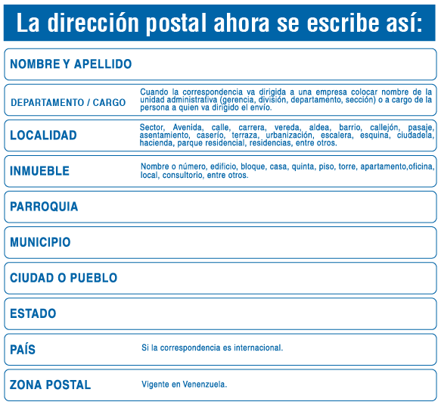

Postal Codes is another concern to be covered in future on this plugin, because a default value can be obtained from Region, Provinces, Municipality and Parish.

In order to accomplish what have been explained, some tables have to be modified, and some others have to be added to implement the new Window and plugin.

Tables
Modify | Add
C_Country (2) | C_Municipality
AD_Message (1) | C_Parish
C_Location (2) | C_Zipcode
C_Region (2) | C_Community
AD_Reference (1)

(1) Add New Records
(2) Add New Fields

I have been working with Idempiere since version 1.0c, before I made some test on Adempiere 3.70. Right now I am migrating my old Visual FoxPro application with one of my customer using Idempiere 2.0.

A list of Lectures and References related with this Material. Some information, procedures, code and data taken from:

Wiki Page: Developing plug-ins without affecting the trunk
http://wiki.idempiere.org/en/Developing_plug-ins_without_affecting_the_trunk
Jan Thielemann Videos in special:
Developing iDempiere 2.0 - Custom Editors (IEditorFactory and IDisplayTypeFactory)
https://www.youtube.com/watch?v=jVhKnFzsMZo
DCS-ERP Repository from Orlando Curieles.
https://bitbucket.org/dcs_bitbucket/
Initial Venezuelan Demography.
Redhuan Daniel Oon (red1) Repository.
https://bitbucket.org/red1/
Ghintech Location.
https://bitbucket.org/ghintech/com.ghintech.location
Carlos Ruiz (CarlosRuiz_globalqss)
https://bitbucket.org/CarlosRuiz_globalqss/

2. AD_Reference Table.

AD_Reference Table, it is an Application Dictionary’s Table that contains all Small List arrays associated with fields, where it is necessary to select from Short Length selection List. It is used instead of a Table. Normally Tables are used when Selection contains Large List Counts of records.

When defining Tables on Application Dictionary, AD_Reference table is used for selection of Field Type on Table’s Columns. For example, we can see records among others:

Name | Description
…. | ….
Image | Binary Image Data
Integer | 10 Digit numeric
List | Reference List
Location (Address) | Location/Address
LocationExtended | Location Extended /Address with Parish and Municipality

Location Reference Type is related with Address Fields, normally associated with C_Location table records thru C_Location_ID field. This reference selects the type of editor associated with the Table’s Field on AD Model. For example:

Integer: is associated with a plain integer number editor.
Date: is associated with a Date Format (MM/DD/YYYY) editor.
Location: is associated with Address Location Field (see Figure 2.1)
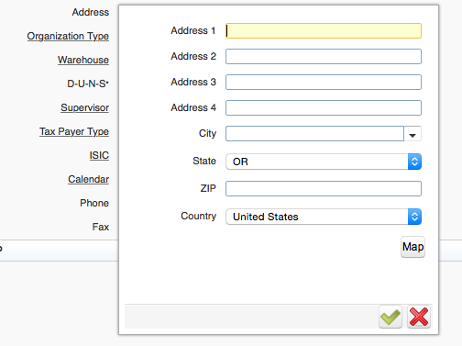

Figure 2.1
LocationExtended Is the name of the new reference to be added to Application Dictionary in order to run Plugin. It must to be defined exactly with this name, because plugin code will find on AD_Reference table as it.

When Plugin be completed and running, it can be associated The C_Location_ID field on C_BPartnerLocation Table to a LocationExtended reference, the address form will be presented as figure 2.2:

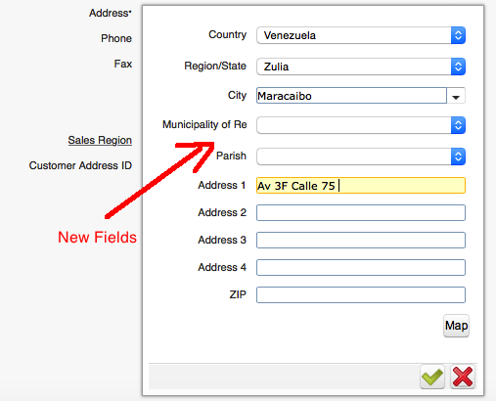
Figure 2.2

3. New Messages on AD_Message Table.

New Messages translations are required to be presented on Plugin Forms. Add new messages Community, Municipality, Parish and Zipcode, and their respective translation to your Localization Language. It must be done using AD window Message: (See examples)

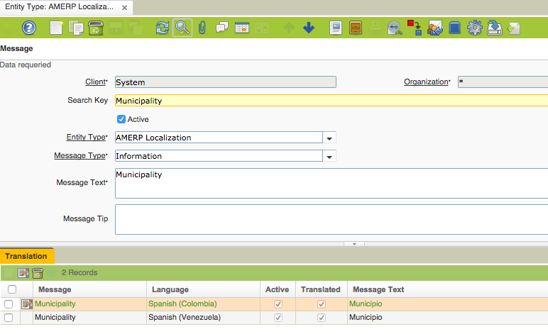
Figure 3.1

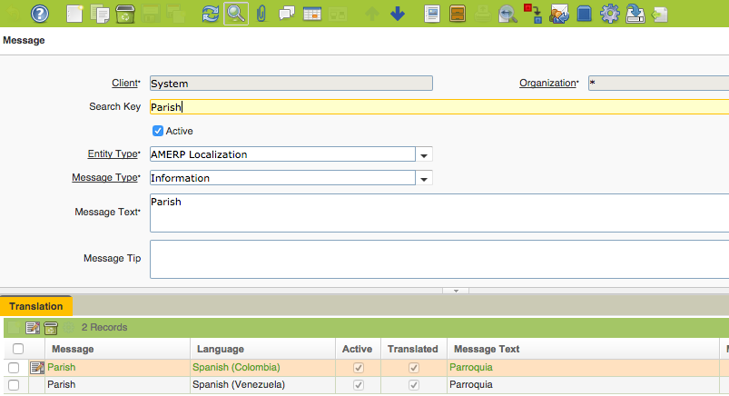
Figure 3.2

4. Fields Added on C_Country Table.

C_Country table contains Records for Countries. Some fields have been added to this table, and they have to be done using Application Dictionary. The fields added are:

System Element | DB Column Name | Description
CountryCode3 (*) | CountryCode3 | Country Code 3 Digits Standard
HasCommunity | HasCommunity | Country is divided in Communities Y-N
HasMunicipality | HasMunicipality | Country Regions are divided in Municipalities Y-N
HasParish | HasParish | Country Regions are divided in Municipalities and Parish Y-N

In some Countries the appropriate translation for Region differs, for example:

Colombia: Departamento.
Venezuela: Estado.
USA: Estado.
España: Provincia.

Take note for this, when create Field Elements and their translation:

(*) For CountryCode3 inclusion, see Script ‘amxeditor.sql’, included on Sources.

5. Capture Sequence on Table C_Country.

Capture Sequence indicates the order on which Address Fields are presented to the user when creating or modifying address fields (Location or LocationExtended).

Tokens are surrounded by @ character.

For example:

@CO@ @R@ @C@ @A1@ @A2@ @A3@ @A4@ @P@
Available Tokens:
CO: Country
R: Region
C: City
A1, A2, A3, A4: Four Address Lines.
P: Postal Code

Added Tokens to Plugin:
MU: Municipality
PA: Parish

Idempiere Administrator could change this Value in order to modify the Form’s Field Sequence on Window’s Address Fields.

Recommended sequence:
@CO@ @A1@ @A2@ @A3@ @A4@ @P@ @R@ @C@ @MU@ @PA@

6. New Table C_Community

C_Community Table contains the Community Political Territorial Division of The Country. As it will be used for Key reference on C_Region table, at least one record for each Country must be created. A SQL file is provided (See amxeditor.sql).

Create Table using PostgreSQL pgAdmin3 app, with this Script:

/* CREATE TABLE c_community (COUNTRY’S COMMUNITIES ) */
CREATE TABLE "adempiere"."c_community" (
"c_community_id" NUMERIC(10,0) NOT NULL,
"ad_client_id" NUMERIC(10,0) NOT NULL,
"ad_org_id" NUMERIC(10,0) NOT NULL,
"isactive" CHAR(1) DEFAULT 'Y'::bpchar NOT NULL,
"created" TIMESTAMP WITHOUT TIME ZONE DEFAULT now() NOT NULL,
"createdby" NUMERIC(10,0) NOT NULL,
"updated" TIMESTAMP WITHOUT TIME ZONE DEFAULT now() NOT NULL,
"updatedby" NUMERIC(10,0) NOT NULL,
"name" VARCHAR(60) NOT NULL,
"description" VARCHAR(255),
"c_country_id" NUMERIC(10,0) NOT NULL,
"isdefault" CHAR(1) DEFAULT 'N'::bpchar,
CONSTRAINT "c_community_pkey" PRIMARY KEY("c_community_id"),
CONSTRAINT "c_community_isactive_check" CHECK (isactive = ANY (ARRAY['Y'::bpchar, 'N'::bpchar])),
CONSTRAINT "c_community_isdefault_check" CHECK (isdefault = ANY (ARRAY['Y'::bpchar, 'N'::bpchar])),
CONSTRAINT "c_communityclient" FOREIGN KEY ("ad_client_id")
REFERENCES "adempiere"."ad_client"("ad_client_id")
ON DELETE NO ACTION
ON UPDATE NO ACTION
DEFERRABLE
INITIALLY DEFERRED,
CONSTRAINT "c_communityorg" FOREIGN KEY ("ad_org_id")
REFERENCES "adempiere"."ad_org"("ad_org_id")
ON DELETE NO ACTION
ON UPDATE NO ACTION
DEFERRABLE
INITIALLY DEFERRED,
CONSTRAINT "ccountry_cregion" FOREIGN KEY ("c_country_id")
REFERENCES "adempiere"."c_country"("c_country_id")
ON DELETE NO ACTION
ON UPDATE NO ACTION
DEFERRABLE
INITIALLY DEFERRED
) WITHOUT OIDS;

See Application Dictionary Window for Table C_Community:

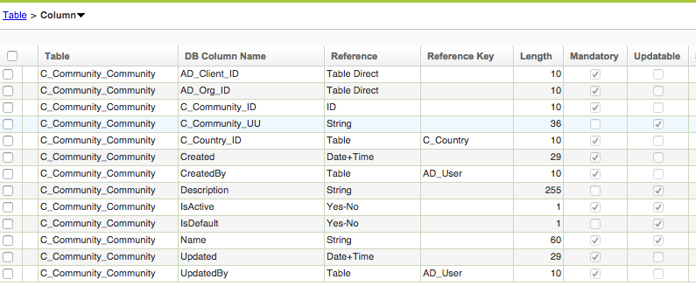

See Script ‘amxeditor.sql’, included on Sources.

7. New Tables C_Municipality and C_Parish

Some countries divide Region on Municipality entities.
This is the Script for create the table.

--- C_ Municipality TABLE (c_municipality)
CREATE TABLE "adempiere"."c_municipality" (
"c_municipality_id" NUMERIC(10,0) NOT NULL,
"ad_client_id" NUMERIC(10,0) NOT NULL,
"ad_org_id" NUMERIC(10,0) NOT NULL,
"isactive" CHAR(1) DEFAULT 'Y'::bpchar NOT NULL,
"created" TIMESTAMP WITHOUT TIME ZONE DEFAULT now() NOT NULL,
"createdby" NUMERIC(10,0) NOT NULL,
"updated" TIMESTAMP WITHOUT TIME ZONE DEFAULT now() NOT NULL,
"updatedby" NUMERIC(10,0) NOT NULL,
"name" VARCHAR(60) NOT NULL,
"capital" VARCHAR(60) NOT NULL,
"c_country_id" NUMERIC(10,0),
"c_region_id" NUMERIC(10,0),
"isdefault" CHAR(1) DEFAULT 'Y'::bpchar,
CONSTRAINT "c_municipality_pkey" PRIMARY KEY("c_municipality_id"),
CONSTRAINT "c_municipality_isactive_check" CHECK (isactive = ANY (ARRAY['Y'::bpchar, 'N'::bpchar])),
CONSTRAINT "c_municipalityclient" FOREIGN KEY ("ad_client_id")
REFERENCES "adempiere"."ad_client"("ad_client_id")
ON DELETE NO ACTION
ON UPDATE NO ACTION
DEFERRABLE
INITIALLY DEFERRED,
CONSTRAINT "c_municipalityorg" FOREIGN KEY ("ad_org_id")
REFERENCES "adempiere"."ad_org"("ad_org_id")
ON DELETE NO ACTION
ON UPDATE NO ACTION
DEFERRABLE
INITIALLY DEFERRED,
CONSTRAINT "ccountry_cmunicipality" FOREIGN KEY ("c_country_id")
REFERENCES "adempiere"."c_country"("c_country_id")
ON DELETE NO ACTION
ON UPDATE NO ACTION
DEFERRABLE
INITIALLY DEFERRED,
CONSTRAINT "cregion_cmunicipality" FOREIGN KEY ("c_region_id")
REFERENCES "adempiere"."c_region"("c_region_id")
ON DELETE NO ACTION
ON UPDATE NO ACTION
DEFERRABLE
INITIALLY DEFERRED
) WITHOUT OIDS;

Note:
PRIMARY KEY for C_Municipality Table is c_municipality_id.

Some countries also, divide Municipality on Parish entities.

This is the Script for create the table.
CREATE TABLE "adempiere"."c_parish" (
"c_parish_id" NUMERIC(10,0) NOT NULL,
"ad_client_id" NUMERIC(10,0) NOT NULL,
"ad_org_id" NUMERIC(10,0) NOT NULL,
"isactive" CHAR(1) DEFAULT 'Y'::bpchar NOT NULL,
"created" TIMESTAMP WITHOUT TIME ZONE DEFAULT now() NOT NULL,
"createdby" NUMERIC(10,0) NOT NULL,
"updated" TIMESTAMP WITHOUT TIME ZONE DEFAULT now() NOT NULL,
"updatedby" NUMERIC(10,0) NOT NULL,
"name" VARCHAR(60) NOT NULL,
"c_country_id" NUMERIC(10,0) NOT NULL,
"c_region_id" NUMERIC(10,0) NOT NULL,
"c_municipality_id" NUMERIC(10,0) NOT NULL,
"isdefault" CHAR(1) DEFAULT 'N'::bpchar,
CONSTRAINT "c_parish_pkey" PRIMARY KEY("c_parish_id"),
CONSTRAINT "c_parish_isactive_check" CHECK (isactive = ANY (ARRAY['Y'::bpchar, 'N'::bpchar])),
CONSTRAINT "c_parishclient" FOREIGN KEY ("ad_client_id")
REFERENCES "adempiere"."ad_client"("ad_client_id")
ON DELETE NO ACTION
ON UPDATE NO ACTION
DEFERRABLE
INITIALLY DEFERRED,
CONSTRAINT "c_parishorg" FOREIGN KEY ("ad_org_id")
REFERENCES "adempiere"."ad_org"("ad_org_id")
ON DELETE NO ACTION
ON UPDATE NO ACTION
DEFERRABLE
INITIALLY DEFERRED,
CONSTRAINT "ccountry_cparish" FOREIGN KEY ("c_country_id")
REFERENCES "adempiere"."c_country"("c_country_id")
ON DELETE NO ACTION
ON UPDATE NO ACTION
DEFERRABLE
INITIALLY DEFERRED,
CONSTRAINT "cmunicipality_cparish" FOREIGN KEY ("c_municipality_id")
REFERENCES "adempiere"."c_municipality"("c_municipality_id")
ON DELETE NO ACTION
ON UPDATE NO ACTION
DEFERRABLE
INITIALLY DEFERRED,
CONSTRAINT "cregion_cparish" FOREIGN KEY ("c_region_id")
REFERENCES "adempiere"."c_region"("c_region_id")
ON DELETE NO ACTION
ON UPDATE NO ACTION
DEFERRABLE
INITIALLY DEFERRED
) WITHOUT OIDS;

Note:
PRIMARY KEY for C_Parish Table is c_parish_id.
Finally take care of Adequate Name and Description on AD using Upper and Lower Cases on AD Tables.

C_Municipality Table looks like this on AD:
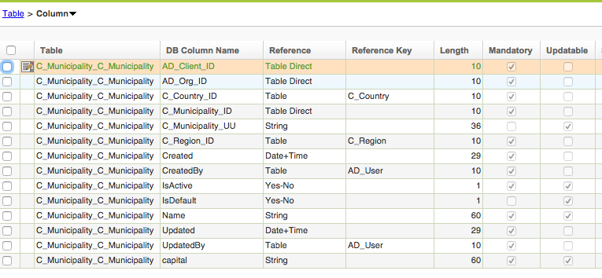

C_Parish Table looks like this on AD:
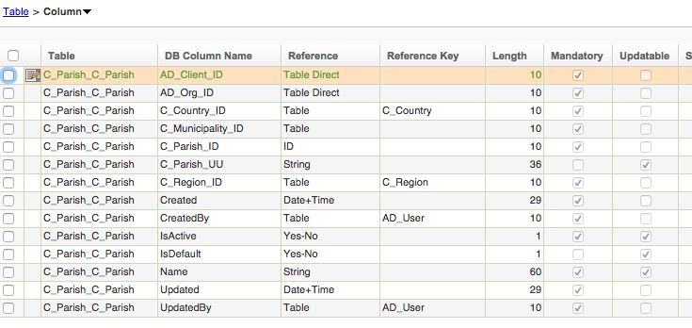

8. Fields Added on C_Region Table.

The table C_Region is the second level on demographic structure. On this new proposal C_Community is the New second level, nevertheless in order to be compatible with Standard Address structure on Idempiere, Community an Region are both Second Level, but on C_Region table a Community ID has to be indicated if Idempiere Administrator desire to use it.

See Figure 8.1 For the New Demographic Structure of Plugin:
C_Country

C_Community
C_Region

C_City
C_Municipality

C_Parish
C_Zipcode (*)

Figure 8.1
(*) Future Development

A new Field (C_Community_ID) is added to C_Region Table. This Field Accept Null values, because some country may not use this feature. See Figure 8.2.

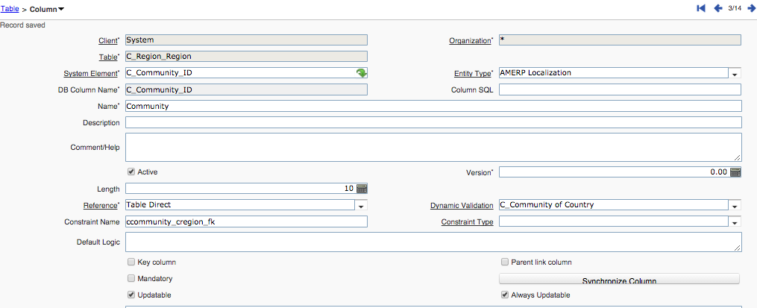
Figure 8.2

A new Validation Rule is created in order to accept only Communities from selected Country. See figure 8.3.

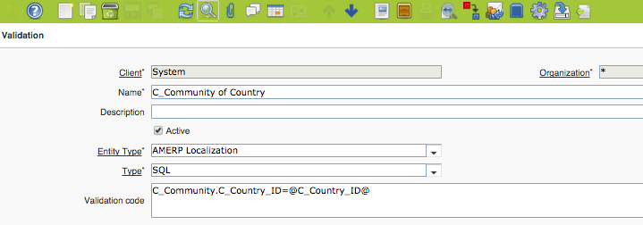
Figure 8.3

9. Fields Added on C_Location.

C_Location Table contains the all addresses included on Business Partners, Employees, Wharehouses, Organization Info, and any other table containing Location or LocationExtended Reference Fields.

New fields added are C_Municipalty_ID and C_Parish_ID, both have been mentioned before. See Figures 9.1 and 9.2 for AD window on Table C_Location.

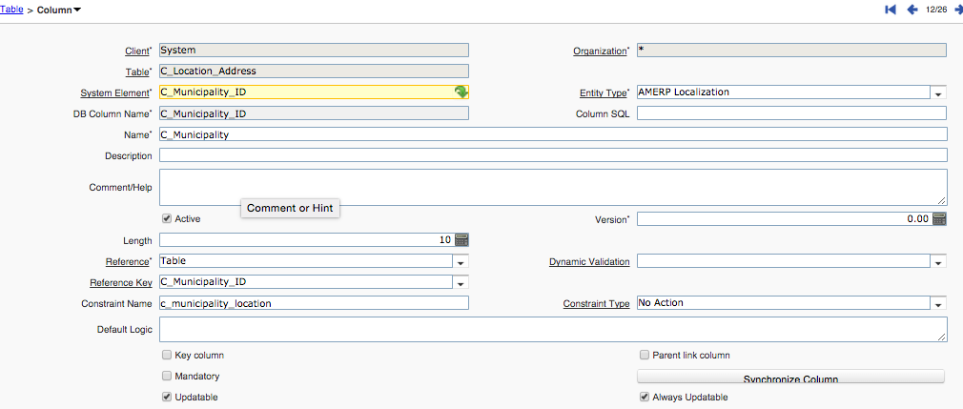
Figure 9.1.

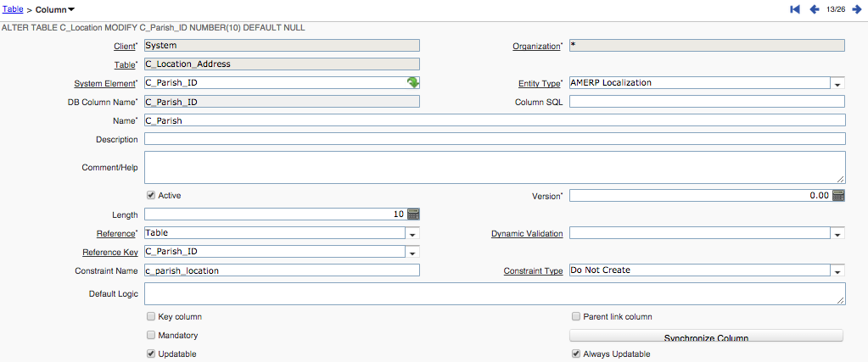
Figure 9.2

Both Fields may contain Null values in order to be compatible with Idempiere Address Standard.
Field C_City_ID may contain Null Value, because some Country can be configured with ‘Allow Cities out of List’ feaure. A City String Field is Provided for Storing values when this happens.

10.Country-Community-Region-Municipality-Parish Window.

Finally a New Window is created to perform extended address and Demographic Structure for the Countries. It has tried to develop the window so that it can be used as Standard Country-Region-City one. But also the Idempiere Administrator can perform the construction of new Communities, Municipalities and Parishes.

It is shown below the main Window, and will explain some fields that has to be set for Country in order to perform adequate update of actual Demography Structure.

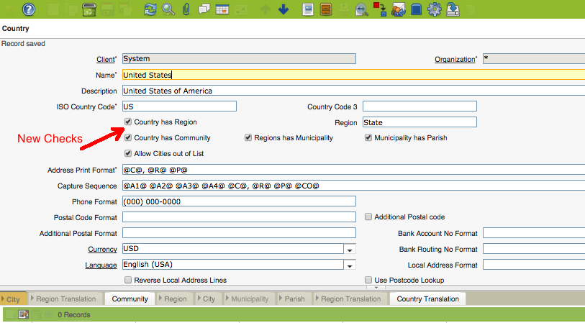
Figure 10.1

New Fields Added:
Country has Region
Country has Community
Regions has Municipality
Municipality has Parish

Idempiere Administrator may perform Community input through database, but just in case it is necessary to include the new Country’s Communities using the Window, the ‘Country has Community’ check has to be set in order to have Community Tab available and then include Communities.

After completing income communities, regions have to be associated with their respective communities. In order to do this job, Idempiere Administrator has to deselect ‘Country has Community’ check in order to have Standard Region Tab available. Having this Region Tab Visible, Regions can be updated in order to set Community associated with them. See Figure 10.2 and 10.3.

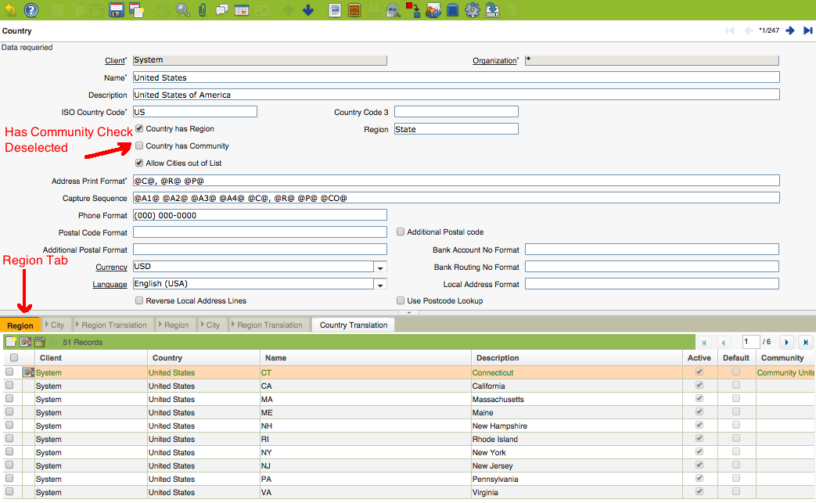
Figure 10.2

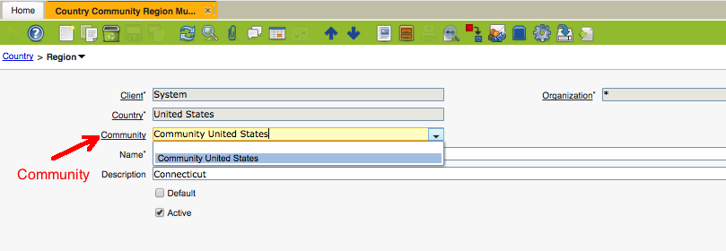
Figure 10.3

Complete Community association for all Regions and then set again ‘Country has Community’ Check. Community Tab will be visible again and Idempiere Administrator can perform Extended Demography Structure.
Community -> Region -> ( Municipality – City) → Parish

