AIR POLLUTION AND HOW COVID WAS GOOD FOR OUR LUNGS

Since Covid-19 was first announced by the WHO in January 2020 all of us have been subjected to numerous health security measures in our respective countries (ones more strict than others). Once the human-spread was confirmed and we realized it was not just a mild “fever” isolated in the region of Wuhan, many countries raised the state of alarm and confined their population: no one was allowed to leave their homes, except for basic needs. The streets were empty, and you could only see a car every once in a while.

Since most of the air pollution in anthropogenic: how did this situation affect the air quality worldwide? What countries modified their atmosphere the most? Has the air quality improved after Covid? To answer this question I will use air quality data extracted daily from more than 600 cities across 94 countries, from 2015 to 2021.

WORLDWIDE AIR POLLUTION

Air pollution is one of the main health risks to develop countless diseases or health complications and can highly decrease our life span [ref]. There is a lot of buzz around this issue, but many people deny the presence of air contamination (as well as Covid-19, climate change or the efectiveness of vaccines, but that is a story for another time).
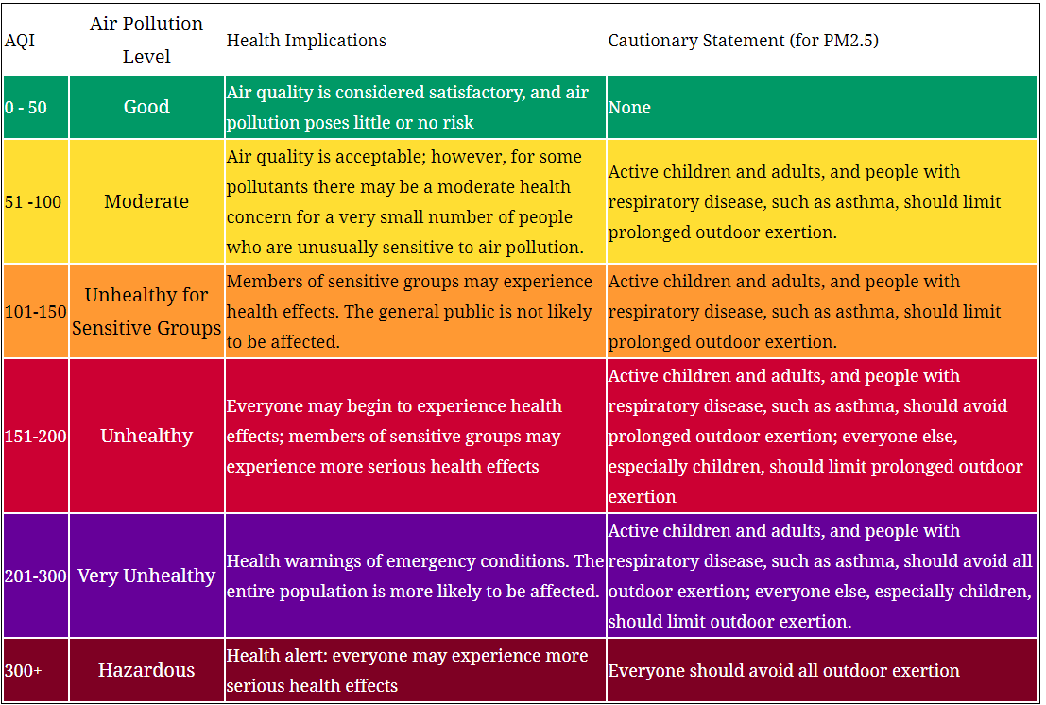
Before delving into numbers, I find it necessary to make a small introduction on how air quality is usually reported. Measuring systems acquire the amount of the pollutant in ug/m³ or ppb, but these values are hard to interpret by the population. More so when the amounts considered dangerous change from one pollutant to the next and the way they are calculated also change (due to their volatility in the atmosphere). Too many factors for someone that only wants to know if he/she can go running safely. The solution was to make a color-coded measuring scale that takes all of that into account: the AQI index. I will be using the US-EPA 2016 standard [ref], which varies from 0 to 500, 0 being optimal and 500 hazardous (see Table XX). This index can be calculated for every pollutant, but usually the overall AQI is reported, which corresponds to the maximum value of all the individual AQIs.

WHAT ARE THE RELATIVE AMOUNTS OF THE MAIN POLLUTANTS?

Let’s start by looking at the worldwide pollutant amounts. As can be seen in Figure XXX the larger percentage of all pollutants each year is PM_{2,5} (that’s why in the AQI table a cautionary statement is provided specifically for this pollutant) and the proportions have stayed more or less constant. Although for particular countries and/or cities these relative amounts may change (specially those close to large water masses), a worldwide view can give us a general sense. Therefore, the overall AQI shown from here on will be based on the PM_{2,5} levels, except specified.

HOW HAS THE AIR POLLUTION EVOLVED SINCE 2015?

As we can see in Figure XX, the overall average AQI has remained above the optimal values for the last 6 years across the globe and have been steadily increasing since 2015. However, we can clearly see there is a drop in 2020, that corresponds to a decrease of 10% ± 1% with respect to 2019, to a 95% confidence. This is a very large decrease whose cause is likely linked to the Covid restrictions through 2020. If we look at the decrease of each pollutant in 2020 relative to 2019 we see that those that PM25, SO2 and NO2 were the ones that decreased the most.

If we look at the monthly data of 2019 and 2020, we see that the month with the largest decrease in 2020 was February, which corresponds to a decrease of -14.2% ± 0.8%. The AQI index stayed below 2019 levels by more than 5% until November, where there is an increase of 3,7% ± 0,8% with respect to the previous year. This is probably due to the relaxation of the security measures.

DECREASE BY COUNTRY

During 2020 every country took different measures during different time periods, so what we saw before is just the convolution of all of them. It is expected that those with the strongest measures (and probably also the largest air pollutions) will be the ones to display a larger decrease. In figures XX and XX we can see that the countries that decreased their air pollution the most across the whole year of 2020 were …, …, …, …, and those that displayed the steepest monthly decrease were …, …, ..,.

In the following figure we can see an animation on how the AQI index varied monthly from 2015 to 2021, where the size of each point represents the country’s area.

Particularly, in Spain the confinement period lasted 3 months, from March 15th to June 21st. If we take a look at the data, we see that...

HOW IS 2021 LOOKING IN TERMS OF POLLUTION?

“Make a graph with “fill between” with a comparison of 2021-2020 and 2021-2019”.

We can all agree Covid-19 has been a great shock to our lives and it would have been better if it never happened. But it did. And, although small, every cloud has a silver lining. It is almost ironic: a world-wide spread virus whose main target is our lungs, improved the air we breathe.

