
Course Name
Job Title
Restauran and menu organization
Author Name
Pablo López Yebra
Adrián Escudero del Valle
Nikolaos Koumpanakis

Summary
- This project focuses on resolving and completing tasks regarding menu and food product management restaurant systems.
- The system is focused on deliveries and stock evaluation of stores that provide to the restaurant with the food and basic equipment material. We use different type of diagrams to explain different things like the actors and their functionalities with a Use Case diagram, how the restaurant work with an activity diagram, the structure of the restaurant with a Class diagram and finally, with a Sequence diagram we represent specific cases that happens on the restaurant like( the process to make a dish)
- The final system obtained can be applied to elaborate a real restaurant system and can be ampliated and applied in a future with services like online delivers or take away.

Acknowledgements
Maximum 1 page.
Thanks to all the people who were directly involved in the work carried out, or who contributed to its success.
Thanks to all the people who in some way supported the completion of the work, or who contributed to its success.
Any acknowledgements to other people, including friends or family.
Finally, mention and acknowledge any funding received (e.g. company grant, support from a national or international program).

Index

Acknowledgements II
Index III
Figure index V
Figure 1 – Use Case Diagram of the Restaurant Management System ................................ [5] V
Figure 2 – Class Diagram of the Restaurant Management System ..................................... [8] V
Figure 3 – Activity Diagram of the Restaurant Management System .................................. [9] V
Figure 4 – Sequence Diagram of the Restaurant Management System ............................... [10] V
1. Menu and food product management system 1
1.1. Framework 2
1.2. Objective 3
1.3. Organization of the Report 4
2. Presentation with some detail of the problem (replace with appropriate title) 5
Detailed Description of Main Use Cases 5
3.Presentation with some detail of the proposed solution (replace with appropriate title) 8
4. Presentation with some details of the prototype developed (replace with appropriate title) 11
4.1. Activity Diagram Description 11
5. References and Bibliography 13

Figure index

Figure 1 – Use Case Diagram of the Restaurant Management System ................................ [5]

Figure 2 – Class Diagram of the Restaurant Management System ..................................... [8]

Figure 3 – Activity Diagram of the Restaurant Management System .................................. [9]

Figure 4 – Sequence Diagram of the Restaurant Management System ............................... [10]

Menu and food product management system
The aim of this project is to model a restaurant management system focused on menu and product availability, identifying the main users of the system, their interactions and relationships between the rest of the system components.
The system includes 9 big actors Boss, Storage Organizer, Waiter, Provider, Chef, Client, Menu, Order and Dish. Each one with different responsibilities: The boss manages the restaurant providers and menu changes, the Storage Organizer checks the availability of ingredients and place an order to de Provider, the waiter handles and verifies the Orders, the Chef prepares Dishes and the client places Orders.
To represent the proposed system different types of diagrams are used to give us different perspectives of the same system.
The Use Case Diagram identifies the main actors and their interactions in the system. The Class Diagram represents the system´s main structural elements and the relations between them. The Activity Diagram describes the sequence of activities on the restaurant in a particular process, in this case ordering a dish, and finally the Sequence Diagram that represents the interactions of participants and system elements over time.
The project aims to establish a clear and organized representation of the restaurant´s main operations. The resulting conceptual model of the system can serve as a reference for a future restaurant management system. Although this project only focusses on a theoretical part rather than a complete implementation of the system, the model in the future could be applied to a real restaurant system with more functionalities.
This report is organized in different sections:
- The first one introduces the project describing the context.
- The second one presents the problem that the restaurant must organize the system.
- The third section describes the proposed solution and how the system should organize that solution.
- The fourth one presents a conceptual model through the different diagrams explaining each part.
- The fifth one presents the conclusions that we have got about the systems and future developments.
- Finally, the last section contains references and bibliography.

Framework
The restaurant environment implies some activities that should coordinate to have an efficient service. These activities include menu management, the client orders, preparing the dishes and verifying if they have the necessary ingredients.
One of the most important things is the control of the ingredients. If there are some products missing there can be dishes that cannot be prepared, because of that it´s necessary to have a procedure to identify those ingredients and solve the problem.
Another very important aspect is the menu gestion. The information on the menu must be clear and actualized. The coordination of the menu information and disponible of the ingredients contribute to upgrading the organization of the restaurant and reduce the possible errors.
In this context the model of the system let us represent in a structured way the information and processes related to these activities. On this way we can define how should organize a system before developing a possible informatic app.
The diagrams created can be used to represent the different aspects of the proposed system, the interactions between the users and the processes of restaurant management. These representations help to provide a clearer understanding of the system.

Objective
We can divide the specification of requirements into two main categories:
- Functional requirements:
  - The system should allow the Boss to register and manage the providers and update the menu.
  - The system must provide to the Storage organizer the tools to check the ingredient `s stock and create and order to the providers.
  - It also must allow clients to place an order, with the waiter management, modify and verify it.
  - The system must pass the accepted orders to the chef so he can start preparing them.
- Non – functional requirements:
  - The system must guarantee a high response speed, so it does not delay the real service in the restaurant.
  - It must ensure reliability and the precision of the control of the inventory.
  - It must facilitate the integration of different business areas to ensure the correct access of information.

Organization of the Report

This report is organized into six main chapters,
Chapter 1 introduces the restaurant management project, it outlines the context, the objectives we are trying to accomplish and the structure of the report.
Chapter 2 presents the problems we identified that compose the restaurant’s needs in everyday operations, them being stock management and correct communication between different roles inside the workplace in order handling and menu management.
Chapter 3 describes the proposed solution of our underlying system, and it encompasses the way that it’s designed to solve them.
Chapter 4 presents the system models and the diagrams we have developed for this project, showcasing interactions between restaurant staff, the customers, the suppliers and the system.
Chapter 5 summarizes our conclusions about the project and expands on possible improvements and developments.
Chapter 6 contains the references and bibliography used in preparing the report.

Presentation with some detail of the problem (replace with appropriate title)
- 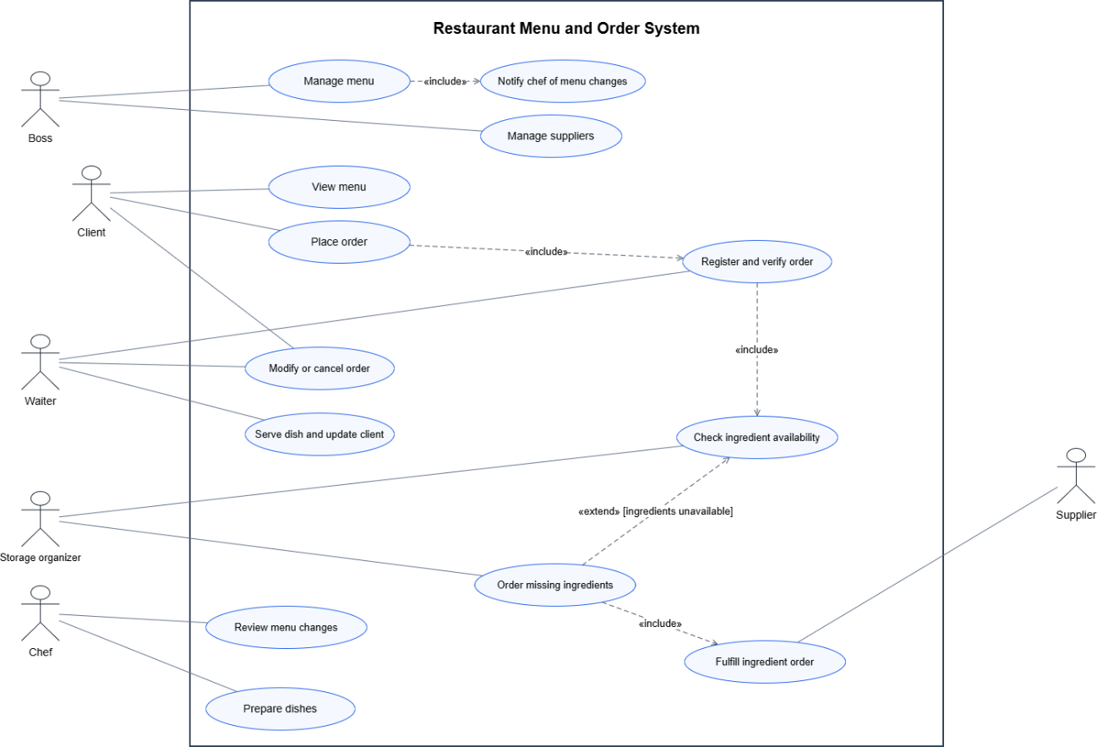

Detailed Description of Main Use Cases
Here is the detailed description of the main use cases of the restaurant system. They follow the Use Case Diagram.
Use Case: Place Order
- Actor: Client, Waiter
- Goal: Save a new food order in the system.
- Preconditions: The Client has seen the Menu and has chosen the dishes.
- Main Flow:
- The Client asks to make an order.
- The Waiter writes the order in the system (dishes and quantities).
- The system uses the <<include>> relationship and starts the "Verify order" use case.
- The system checks the order and sends it to the Kitchen (Chef).
- Postconditions: The order is saved as "pending" and the Chef knows he must start to cook.
Use Case: Verify order
- Actor: Waiter
- Goal: Be sure that the order is correct and the restaurant can make it.
- Preconditions: An order has been placed.
- Main Flow:
- The Waiter reads the order.
- The system uses the <<include>> relationship and starts "Checks availabilities of ingredients".
- If the ingredients are available, the order is confirmed.
- Alternative Flow: If some ingredients are missing, the system asks the Waiter to use the <<extend>> relationship "Modify Order".
Use Case: Checks availabilities of ingredients
- Actor: Storage organizer
- Goal: See if there is enough stock to cook the dishes of an order.
- Preconditions: An order is being verified.
- Main Flow:
- The system compares the ingredients needed with the inventory database.
- The Storage organizer confirms that the ingredients are available.
- Alternative Flow: If the stock is low, the Storage organizer can start the process to make an order to the Provider.
- Postconditions: The system gives a true/false answer about the availability of the ingredients.
Use Case: Modify Order
- Actor: Client, Waiter
- Goal: Change an existing order because an ingredient is missing or because the Client changes his mind.
- Preconditions: The order was placed, but the Chef has not prepared it yet.
- Main Flow:
- The Waiter opens the pending order in the system.
- The Waiter adds, removes or changes dishes, as the Client asks.
- The system updates the state of the order.
- The system uses the <<include>> relationship with "Order" (it processes the final state of the request).
- Postconditions: The new order is saved and the Chef receives the new instructions.
Use Case: Find provider
- Actor: Boss
- Goal: Look for a good provider of food products in the system or in an external database.
- Preconditions: The restaurant needs new ingredients that the current providers do not have.
- Main Flow:
- The Boss asks the system for providers by type of product.
- The system shows a list of providers that match.
- Alternative Flow: If the Boss is not happy with the current provider, he can use the <<extend>> relationship "Change provider" to replace him.

3.Presentation with some detail of the proposed solution (replace with appropriate title)
- The proposed solution is a restaurant management system for menu , order processing, ingredient stockkeeping and supplier replenishment. It supports the restaurant staff from the moment a client selects dishes until the order is prepared and served

- The boss oversees the menu’s options and its dishes. Each dish has an underlying recipe that requires different ingredients that the stock organizer (storage organizer) needs to take account of before every order is verified by him. The system evaluates dish availability based on this principle , so the staff don’t have to maintain a separate availability flag
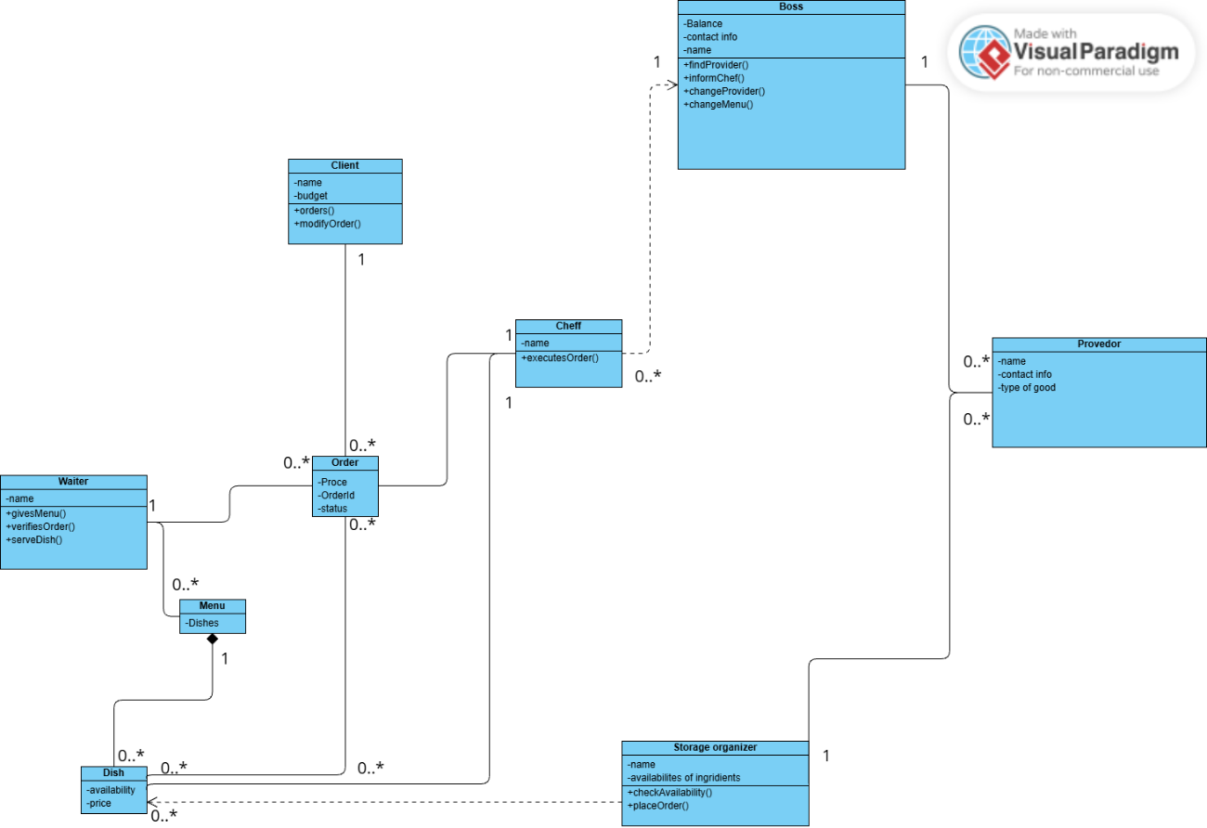
- The waiter records the client’s order and quantities of the required ingredients are processed by the storage organizer and he compares it with the available stock and updates it if the order is good to go onto the next phase. Once the chef prepares the dish the waiter picks up the complete order and serves the customer
- If there are any ingredients missing throughout this process, the organizer creates a supply order based on the missing ingredients in his stock. Once the order arrives the stock updates. If the supplier cannot complete or can’t provide the order the boss has the authority to change the provider and he informs the storage organizer of those changes for future orders.
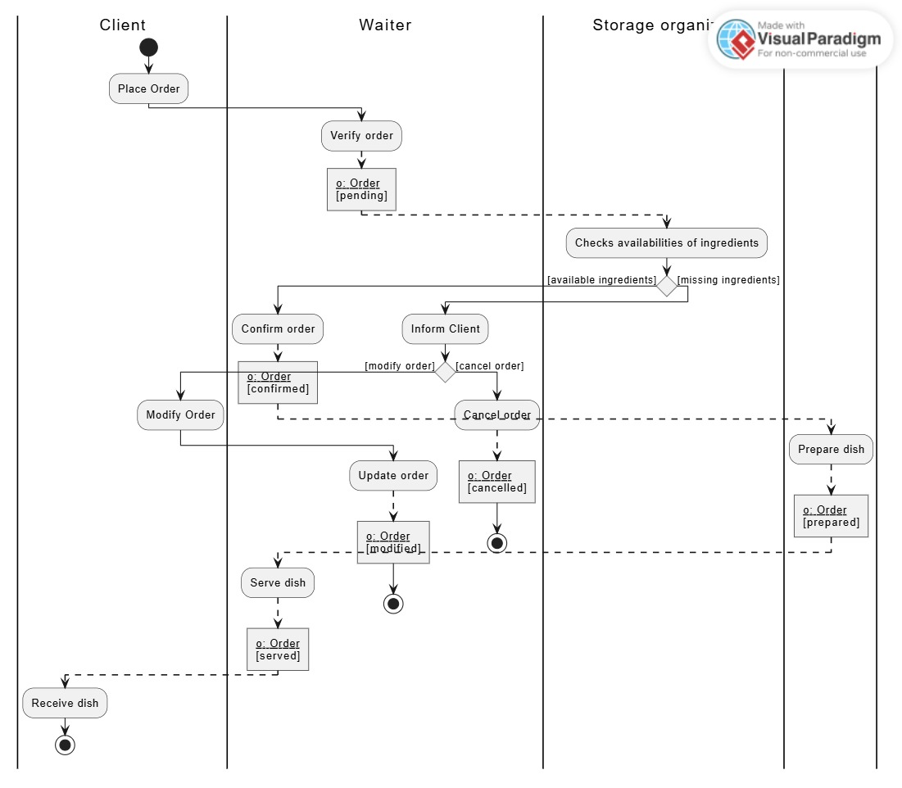
- The model represents each order separate from each other, meaning multiple dishes in the menu can be summed up in terms of ingredients, we do this in order to avoid misunderstandings between the communication line of client-waiter-storage organizer, and it makes recordkeeping easier for the next order. This version covers the menu, the orders and availability and communication with the supplier.
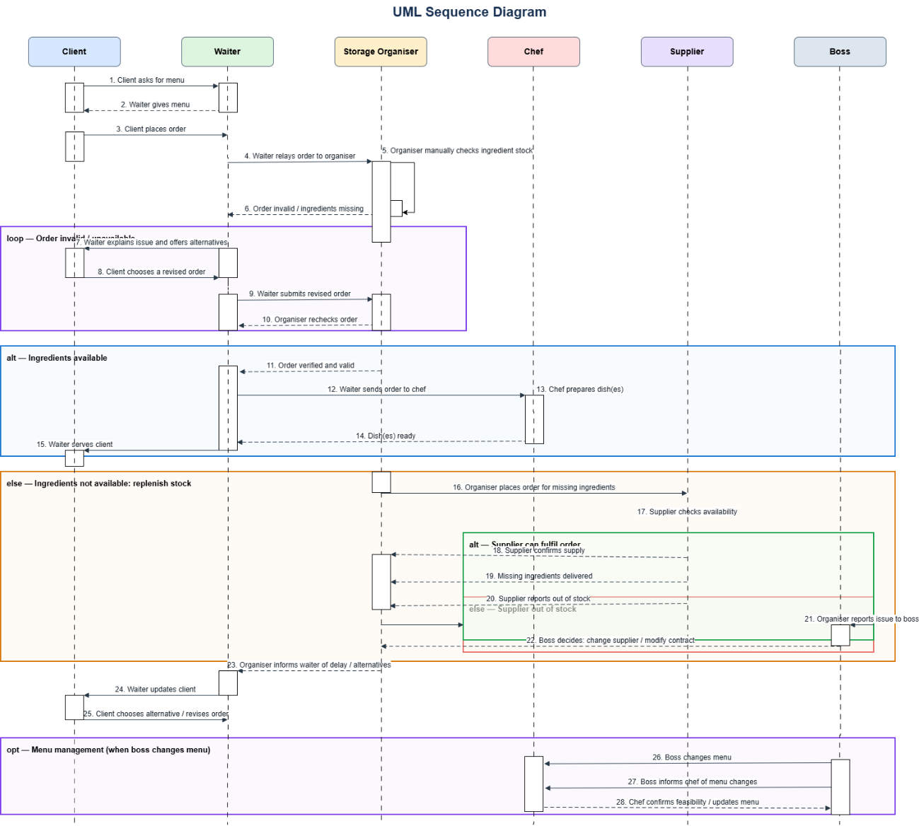

Presentation with some details of the prototype developed (replace with appropriate title)

Activity Diagram Description
The Activity Diagram shows how the restaurant system works step by step. It shows the actions, the decisions and the objects in each part of the restaurant.
- Organizational Units (Swim lanes): The diagram has four vertical swim lanes. Each one is an actor that does some action: Client, Waiter, Storage organizer and Chef.
- Action States and Control Flow:
  - 1. Place Order (Client): The process starts at the initial node, when the Client makes a food order.
  - 2. Verify order (Waiter): The Waiter receives the order and verifies the details. This creates or updates the object o: Order [pending].
  - 3. Checks availabilities of ingredients (Storage organizer): The Storage organizer checks if the ingredients are in the inventory.
- Decisions and Branching:
  - [available ingredients]: If all ingredients are in stock, the flow goes to the Chef, who does the Prepare dish action (the object changes to o: Order [prepared]). Then the Waiter does the Serve dish action (o: Order [served]) and the flow reaches the final state.
  - [missing ingredients]: If an ingredient is not in stock, the flow goes back to the Client, who must decide:
    - [modify order]: The Client does the Modify Order action (o: Order [modified]) and the Waiter verifies the modified order before the flow ends.
    - [cancel order]: The process ends at once in the final node.
- Object Streams: Following UML rules, the changes of the object o: Order between states ([pending], [prepared], [served], [modified]) are shown as rectangular object nodes joined by dashed arrows.
Conclusions and perspectives for future work (or another more appropriate title)
Payments, reservations, payment of the employees and accounting are outside the scope of this project

References and Bibliography
Sousa de Pinto Guimaraes, Ana,2026, Use Case Diagram, docent material of Systems Analysis and Modelling.
Sousa de Pinto Guimaraes, Ana,2026, Activity Diagram, docent material of Systems Analysis and Modelling.
Sousa de Pinto Guimaraes, Ana,2026, Sequence Diagram, docent material of Systems Analysis and Modelling.
Sousa de Pinto Guimaraes, Ana,2026, Class Diagram, docent material of Systems Analysis and Modelling.
Generative AI to solve doubts.

