|  |
| --- |
|  |
| DOCUMENTACIÓN |
| CUENTARMONÍA |
|  |
| **Pablo Calvo Izquierdo** |
| **6/20/2024** |

1. Pages
   1. Page Tree

Portada  
Listas  
Busqueda  
Resto Listas  
Reproduccion  
Comentario  
Audiolibros subidos  
Inicio Sesion  
Menu  
Perfil  
Registro

* 1. Portada
     1. User Interface

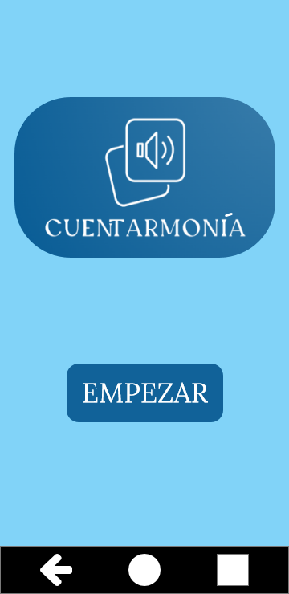

* 1. Listas
     1. User Interface

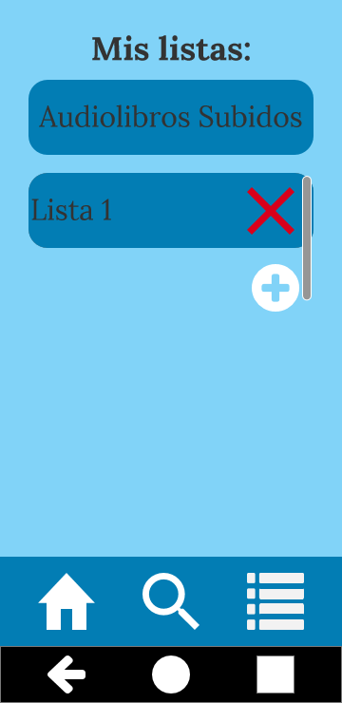

* + 1. Unnamed
       1. State1
       2. User Interface

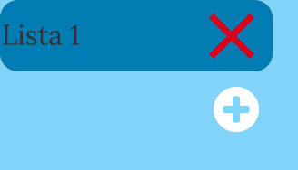

* + 1. Nueva-lista
       1. State1
       2. User Interface

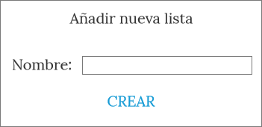

* + 1. Unnamed
       1. User Interface



* 1. Busqueda
     1. User Interface

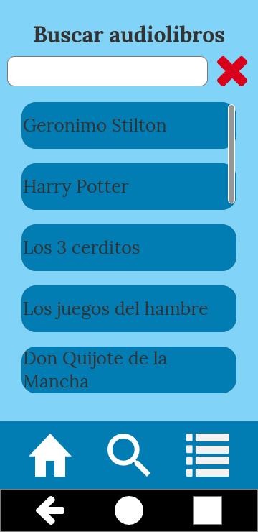

* + 1. Unnamed
       1. State1
       2. User Interface

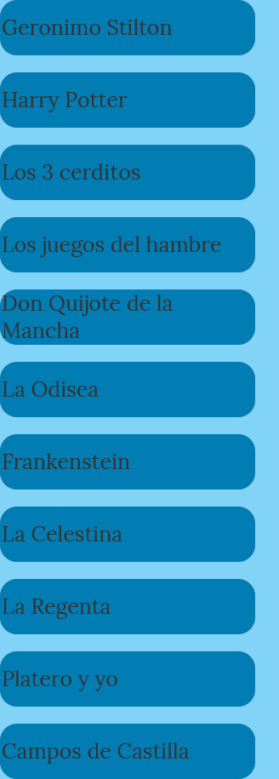

* + 1. audiolibros-repeater
       1. User Interface



* 1. Resto Listas
     1. User Interface

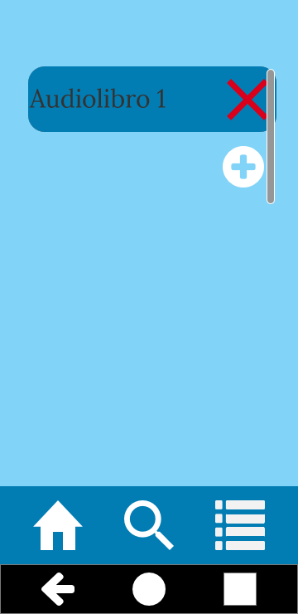

* + 1. Unnamed
       1. State1
       2. User Interface

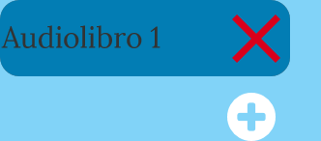

* + 1. Nueva-lista
       1. State1
       2. User Interface

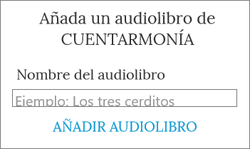

* + 1. Unnamed
       1. User Interface



* 1. Reproduccion
     1. User Interface

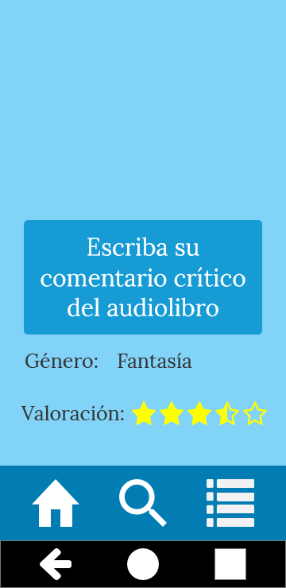

* + 1. audioPlayer
       1. State1
  1. Comentario
     1. User Interface

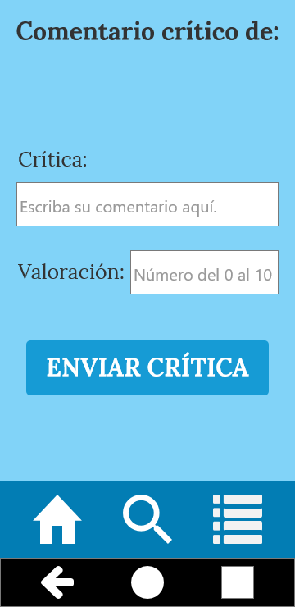

* + 1. Pop_Up
       1. State1
       2. User Interface

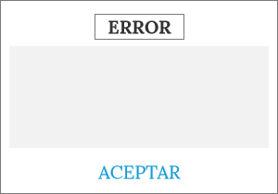

* + 1. Pop_UpCorrecto
       1. State1
       2. User Interface

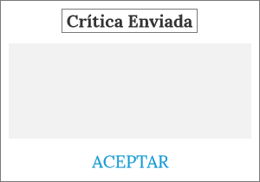

* 1. Audiolibros subidos
     1. User Interface

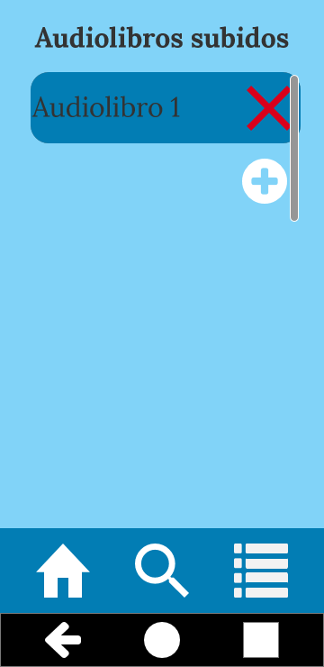

* + 1. Unnamed
       1. State1
       2. User Interface



* + 1. Nueva-lista
       1. State1
       2. User Interface

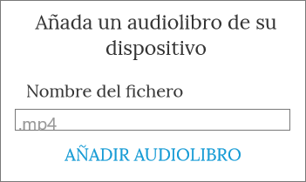

* + 1. Unnamed
       1. User Interface



* 1. Inicio Sesion
     1. User Interface

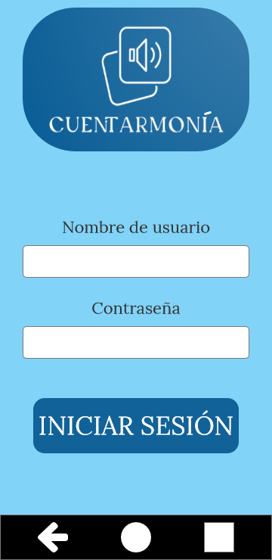

* + 1. Pop_Up
       1. State1
       2. User Interface

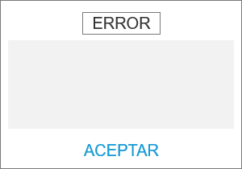

* 1. Menu
     1. User Interface

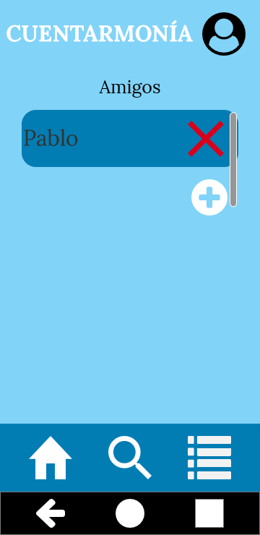

* + 1. Unnamed
       1. State1
       2. User Interface



* + 1. Nueva-lista
       1. State1
       2. User Interface

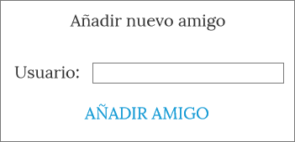

* + 1. Unnamed
       1. User Interface



* 1. Perfil
     1. User Interface

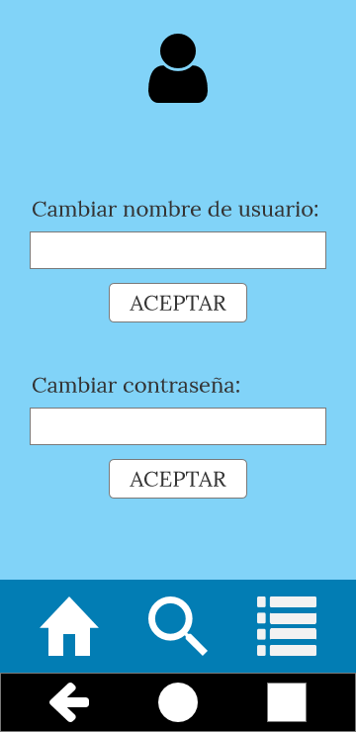

* 1. Registro
     1. User Interface

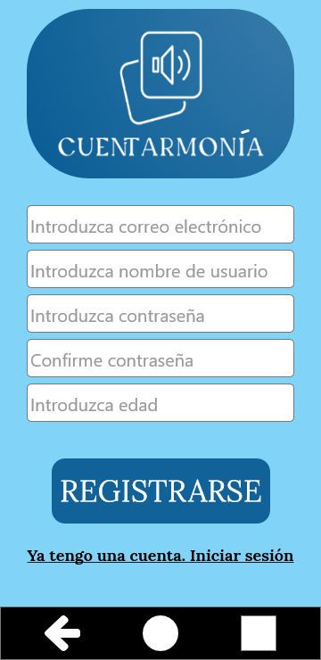

* + 1. Pop_Up
       1. State1
       2. User Interface

