Fantasy Basketball Roster Analytics
Software Requirements Document
Group 6
CISC 3171: Introduction to Software Engineering
Professor Alec Malstrom
Brooklyn College (CUNY), Fall 2026
Version 0.1 (Draft)
Team Members
Paul Cobourne
Joshua Goosby
Eugene Ye
Isaac Alao

1. Introduction

1.1 Purpose
This document describes what the Predictive NBA Trade & Roster Evaluator must do and how well it must do it. It is the reference the team will build and test against during the MVP and final release phases.

1.2 Scope
The app helps fantasy basketball managers make better roster decisions by projecting future fantasy points instead of only showing past stats. Users enter their roster or a proposed trade, and the app shows whether the move helps or hurts their team over a chosen time window, explains why, suggests waiver pickups, and recommends a daily lineup.

1.3 Intended Audience
This document is written for the Group 6 development team, Professor Malstrom, and anyone reviewing the project. The product itself targets fantasy basketball managers, from casual players to competitive, high-stakes league members.

1.4 Glossary
Fantasy and technical terms used in this document, for readers who don’t play fantasy basketball.
Term | Meaning
Fantasy points (FP) | Points a player earns for a fantasy team based on real stats (points, rebounds, assists, etc.) and the league’s scoring weights.
Points league | A league where every stat converts into fantasy points and teams compete on total points.
Category (9-cat) league | A league where teams compete in nine separate stat categories (points, rebounds, assists, steals, blocks, 3-pointers, FG%, FT%, turnovers) instead of one point total.
Scoring settings | The weights a league assigns to each stat, e.g. 1 point per point scored, 1.2 per rebound, –1 per turnover.
Roster slot | A lineup position a player can fill: PG, SG, SF, PF, C, G (guard), F (forward), UTIL (any position), and bench (BN).
Starting lineup | The players in active slots on a given day. Only starters earn fantasy points; bench players do not.
Waiver wire | The pool of unrostered players a manager can add, usually by dropping someone.
Add / drop | Picking up a player from the waiver wire and releasing a rostered player to make room.
Streaming | Repeatedly adding and dropping players to pick up extra games on days your roster has few players playing.
Per-game vs. total | Per-game is a player’s average FP per game played. Total is per-game × games played, which is what actually wins weekly matchups.
Back-to-back | A team playing games on two consecutive days. Players often see fewer minutes or rest on the second night.
Usage | How much of a team’s offense runs through a player while he is on the court. Usage usually rises when a teammate is injured.
Injury status (OUT / Q / DTD) | OUT: will not play. Q (questionable): may or may not play. DTD (day-to-day): minor injury, status decided game by game.
Rest of season (ROS) | The period from today until the end of the fantasy regular season.
Projection window | The future period the app projects over: next 1 week, next 2 weeks, or rest of season.
Baseline | The simple projection the model must beat: season average FP per game times games in the window.
Backtest | Running the model on past-season data as if it were live, then comparing its projections to what actually happened.
MAE | Mean absolute error: the average size of the gap between projected and actual fantasy points. Lower is better.
MoSCoW | Prioritization method: Must have, Should have, Could have, Won’t have (this release).

2. Overall Description

2.1 Product Perspective
Standard platform tools like Yahoo and ESPN evaluate trades using historical averages and ignore upcoming schedules, injuries, and role changes. Advanced fantasy sites fill that gap but require spreadsheets and manual work. This app sits between them: forward-looking analysis delivered through a simple, “weather forecast” style interface. It is a standalone web app and does not replace the user’s league platform.

2.2 User Classes
User class | Description | What they need most
Casual manager | Plays in one league with friends, checks the app a few times a week. | A clear helps/hurts answer with no math.
Competitive manager | Plays in several leagues or money leagues, checks daily. | Projection ranges, full breakdowns, lineup optimization, category support.

2.3 Assumptions and Dependencies
- At least one NBA data source (see Section 7) remains available for player stats, schedules, and injury status.
- Users enter their roster manually in the MVP; league platform import is not included.
- Users know their own league’s scoring settings, or accept the default points settings.

2.4 Constraints
- The team has one semester to reach the final release, so scope is prioritized using MoSCoW (Section 4).
- Data sources must be used within their terms of service and rate limits.
- The app runs on the web and must work on both desktop and mobile browsers.

3. User Stories
ID | User story
US-1 | As a manager, I want to enter a proposed trade so I can see if it raises or lowers my projected fantasy points.
US-2 | As a manager, I want to understand why a trade is rated good or bad so I can trust the recommendation.
US-3 | As a manager, I want to choose how far ahead the app looks (1 week, 2 weeks, rest of season) so the answer matches my goals.
US-4 | As a manager, I want to save my roster so I don’t have to re-enter it every visit.
US-5 | As a manager, I want add/drop suggestions so I can find waiver pickups that help my team this week.
US-6 | As a manager, I want a recommended daily lineup so I don’t leave points on the bench.
US-7 | As a manager in a custom league, I want to set my scoring weights so projections match my league.
US-8 | As a manager, I want to know when the data was last updated so I know if late injury news is included.

4. Functional Requirements
Each requirement is prioritized using MoSCoW: Must (required for the MVP), Should (important, planned for the final release), Could (nice to have if time allows), and Won’t (explicitly out of scope this semester).
ID | Requirement | Priority | Story
FR-1 | The system shall let users build a roster by searching for NBA players by name. | Must | US-1, US-4
FR-2 | The system shall apply default points-league scoring weights and let users edit them. | Must | US-7
FR-3 | The system shall support 9-category leagues. | Should | US-7
FR-4 | The system shall let users configure roster slots (PG, SG, SF, PF, C, G, F, UTIL, bench). | Should | US-6
FR-5 | The system shall generate projected fantasy points per game for every active NBA player. | Must | US-1
FR-6 | Projections shall account for the upcoming schedule: number of games, back-to-backs, and opponent defensive strength. | Must | US-1, US-3
FR-7 | Projections shall account for injury status and teammate absences that change a player’s role. | Should | US-1
FR-8 | The system shall offer 1-week and 2-week projection windows. | Must | US-3
FR-9 | The system shall offer a rest-of-season projection window. | Could | US-3
FR-10 | The trade evaluator shall accept up to 4 players on each side of a trade. | Must | US-1
FR-11 | The trade evaluator shall show the net change in projected fantasy points and a verdict: Helps, Hurts, or Roughly Even. | Must | US-1
FR-12 | The trade evaluator shall show a likely range and confidence level (Low / Medium / High) for the result. | Should | US-2
FR-13 | Every verdict shall show the top 3 factors behind it (see Section 5.2). | Must | US-2
FR-14 | The system shall rank add/drop suggestions by projected gain over the next 7 days. | Should | US-5
FR-15 | Waiver suggestions shall be filterable by position. | Could | US-5
FR-16 | The system shall show a daily lineup view with each player’s opponent, status, and projected FP. | Should | US-6
FR-17 | The system shall recommend an optimal daily lineup that respects slot eligibility. | Should | US-6
FR-18 | The system shall refresh stats, schedules, and injury data at least once per day. | Must | US-8
FR-19 | Every projection screen shall show a “data last updated” timestamp. | Must | US-8
FR-20 | The system shall let users create an account and save rosters between sessions. | Should | US-4
FR-21 | Import rosters directly from ESPN or Yahoo leagues. | Won’t | —
FR-22 | Push or email notifications for injury news. | Won’t | —

5. Prediction Accuracy and Explainability
The app’s value depends on two things: projections that are actually better than simple averages, and verdicts users can understand and trust. This section makes both measurable.

5.1 Prediction Accuracy
The model is judged against a baseline: each player’s season-average FP per game multiplied by their games in the window. If the model can’t beat that, it isn’t adding value over the tools that already exist.
ID | Requirement | Priority
PA-1 | In a backtest on at least 4 weeks of past-season data, the model’s weekly MAE per player shall be at least 10% lower than the baseline’s. | Must
PA-2 | Trades with a projected net change within ±5 FP shall be labeled “Roughly Even” instead of Helps or Hurts, to avoid false confidence. | Must
PA-3 | For backtested trades with a projected difference over 10 FP, the Helps/Hurts verdict shall match the actual outcome at least 65% of the time. | Should
PA-4 | During the season, accuracy shall be re-measured weekly against real results and logged. | Should
PA-5 | If the model does worse than the baseline for 2 weeks in a row, the system shall fall back to the baseline and flag this to the team. | Could
Note: the 10% and 65% targets are starting points. The team will confirm or adjust them after the first backtest.

5.2 Explainability
ID | Requirement | Priority
EX-1 | Every verdict shall list its top 3 factors, ranked by impact, each as a plain-English sentence marked + (helps) or – (hurts). | Must
EX-2 | Factors shall come from a fixed set of reason codes (table below) so explanations are consistent and testable. | Must
EX-3 | Each verdict shall show its assumptions: scoring settings, projection window, and data timestamp. | Must
EX-4 | A “See full breakdown” view shall show each player’s projected FP game by game across the window. | Should

Reason code | Example explanation shown to user
Games in window | Player C has 8 games in the window vs. 6 for Player A.
Back-to-backs | Player B plays 3 back-to-backs, which usually means fewer minutes.
Opponent defense | Player B faces 3 top-5 defenses in the next 2 weeks.
Injury status | Player D is listed as questionable for Tuesday.
Teammate absence | Player D’s usage rises while a teammate is out injured.
Role / minutes trend | Player J’s minutes are up over the last 5 games.
Recent form | Player A is scoring well below his season average over the last 2 weeks.

6. Non-Functional Requirements

6.1 Performance, Usability, and Reliability
ID | Requirement
NFR-1 | A trade evaluation (up to 4-for-4) shall return results within 3 seconds for 95% of requests.
NFR-2 | A first-time user shall be able to complete a trade evaluation within 2 minutes without instructions.
NFR-3 | The app shall work on screens from 375 px (phone) up to desktop width.
NFR-4 | If a data refresh fails, the app shall keep showing the last good data with its timestamp and a warning, not a blank screen.
NFR-5 | Passwords shall be hashed, all traffic shall use HTTPS, and the app shall never ask for or store users’ league platform passwords.

6.2 Accessibility
Trade verdicts are naturally shown as “green good, red bad,” which fails for color-blind users (about 1 in 12 men). These requirements make sure no one misses the answer.
ID | Requirement
A-1 | Good/bad results shall never be shown by color alone. Every verdict uses an icon (▲ / ▼ / ≈) and a text label (Helps / Hurts / Roughly Even).
A-2 | Text and key UI elements shall meet WCAG 2.1 AA contrast (at least 4.5:1 for normal text).
A-3 | All features shall be usable with a keyboard alone, with a visible focus indicator.
A-4 | Charts and range bars shall have text alternatives for screen readers (for example, “likely range +6 to +29 points”).
A-5 | The layout shall stay usable when browser text is enlarged to 200%.

7. Data Requirements and Sources

7.1 Candidate Data Sources
The whole app depends on NBA data, so the choice of source is a real project risk. The team will confirm current pricing, rate limits, and terms before committing.
Source | Type | Pros | Cons / Risks
nba_api | Free, open-source Python package that wraps NBA.com stats endpoints | Very detailed stats, box scores, and schedules; no cost | Unofficial; endpoints can change without notice; NBA.com may throttle or block requests, especially from cloud servers
balldontlie | REST API with free and paid tiers (API key) | Simple to use; well documented; works from any backend | Free tier is rate-limited and some data (e.g. injuries) may require a paid tier
SportsDataIO | Commercial sports data provider | Includes injuries, depth charts, and schedules; reliable | Paid for production use; free/trial access may be limited or delayed

Working plan: use a free source (nba_api or balldontlie) for the MVP, cache everything in our own database, and never call the external API directly on a user request. This keeps us within rate limits and lets the app keep working if the source goes down.

7.2 Data Stored
- NBA players, teams, and positions
- Game schedule and results, plus per-game box scores for the current and previous season
- Injury status per player, with the time it was last updated
- Generated projections, stored with the model version and timestamp
- User accounts, saved rosters, and league scoring settings

7.3 Refresh Schedule
- Box scores and results: nightly, after the last game ends
- Injury status: several times per day on game days (exact frequency depends on the source’s limits)
- Projections: regenerated after every data refresh

7.4 Data Usage Rules
- Stay within each source’s rate limits and terms of service.
- Do not redistribute raw data from the source; show only derived projections and stats inside the app.
- Credit the data source in the app footer if its terms require it.

8. Edge Cases
Real NBA news doesn’t wait for our refresh schedule. This table defines how the app should behave when things change or data is missing.
Scenario | Expected behavior | Related
Player ruled out after projections were generated | At the next refresh, mark the player OUT, set his projection to 0 for missed games, and recalculate any saved evaluations. | FR-7, FR-18
Player listed as questionable | Keep the projection but show a “Q” flag and lower the confidence level. | FR-12
Player traded in real life | Update his team, schedule, and role at the next refresh; set confidence to Low for his first 5 games with the new team. | FR-6
Suspension | Treat as OUT for the suspended games. | FR-7
Rookie or player with very few games | Use a blended estimate (e.g. minutes-based) and set confidence to Low. | FR-5, FR-12
No games in window (e.g. All-Star break) | Show “No games in this window” instead of a verdict. | FR-11
Offseason | Put the app in read-only mode: rosters can be viewed, projections are disabled with a message. | FR-5
Game postponed | Update the schedule and recalculate games in window. | FR-6
Uneven trade (e.g. 2-for-1) | Account for the open roster spot: assume the user fills it with the best available waiver player, and say so in the assumptions. | FR-10, EX-3
Same player on both sides / player already on roster | Block with a clear validation message. | FR-10
Misspelled player name | Show closest-match suggestions. | FR-1
Data refresh fails | Show last good data with timestamp and a warning banner. | NFR-4

9. User Interface Wireframes
These low-fidelity wireframes show layout and priorities, not final visual design. Three principles guide every screen:
- Answer first. The verdict or recommendation is the biggest thing on the screen.
- Reason next to the answer. The “why” is always visible without extra clicks (EX-1).
- Icon + label, never color alone. ▲ Helps / ▼ Hurts / ≈ Roughly Even (A-1).
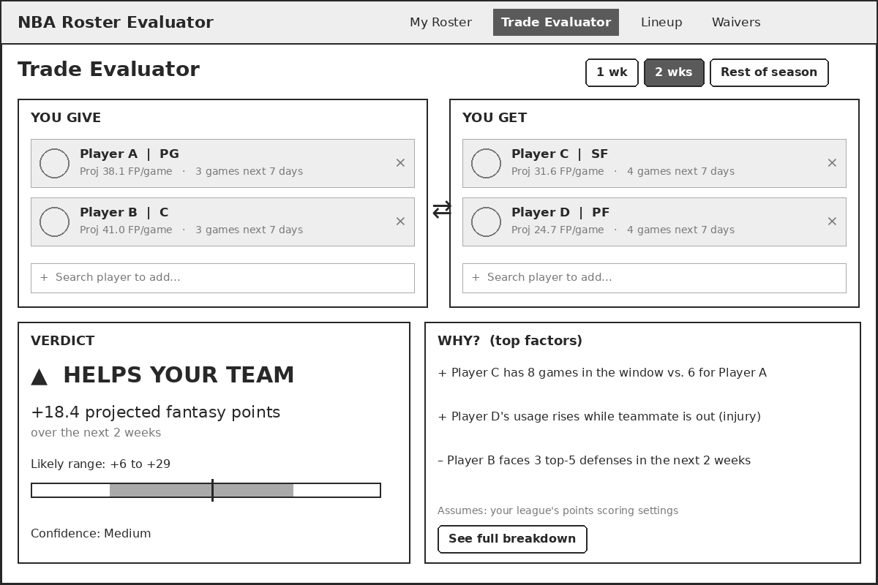
Figure 1: Trade Evaluator — the user adds players to each side, picks a window, and sees the verdict, range, confidence, and top factors (FR-10 to FR-13).
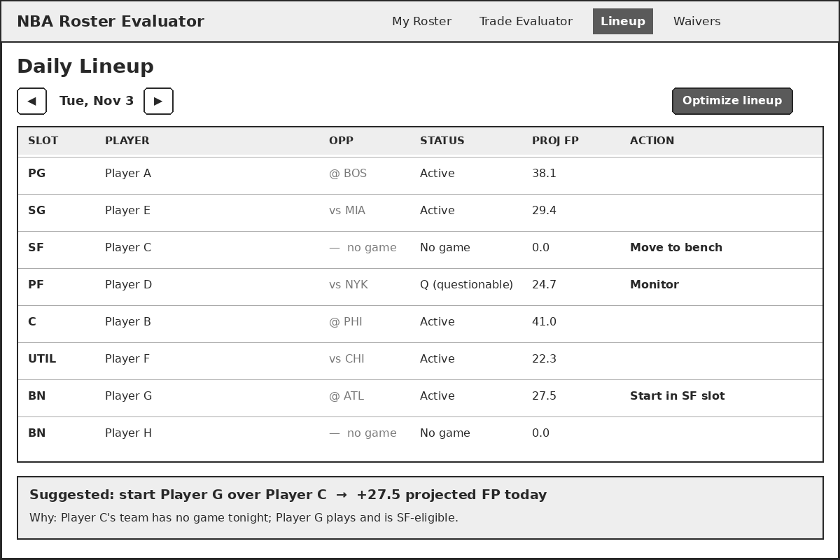
Figure 2: Daily Lineup — shows each slot’s opponent, status, and projection, with a one-click optimize and a plain-English suggestion (FR-16, FR-17).
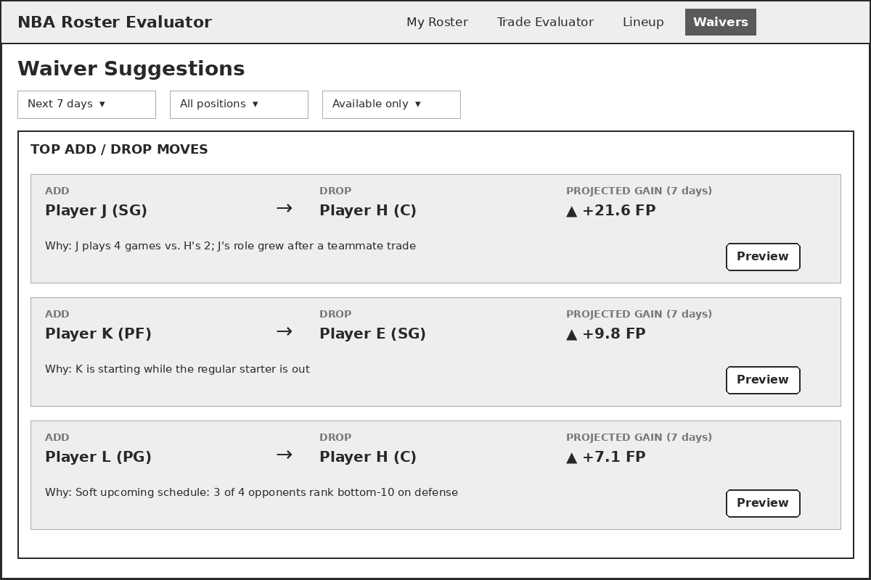
Figure 3: Waiver Suggestions — ranked add/drop pairs with projected gain and a one-line reason (FR-14, FR-15).

10. Release Plan and Scope
Release | Includes
MVP | All Must requirements: roster entry, points scoring, schedule-aware projections, 1- and 2-week windows, trade evaluator with verdict and top 3 factors, daily data refresh with timestamps, baseline backtest (PA-1, PA-2), core accessibility.
Final release | Should requirements: injury/teammate adjustments, confidence ranges, 9-cat leagues, roster slots, waiver suggestions, lineup optimizer, accounts, weekly accuracy tracking.
If time allows | Could requirements: rest-of-season window, position filters, automatic baseline fallback.

10.1 Out of Scope
- Importing leagues from ESPN, Yahoo, or other platforms
- Push or email notifications
- Betting odds, gambling features, or daily fantasy (DFS) salary optimization
- Native iOS or Android apps (the web app is mobile-friendly instead)

11. Acceptance Criteria
ID | Requirement(s) | How it will be verified
AC-1 | FR-10, FR-11 | Enter a 2-for-2 trade; the app shows a net FP change and one of Helps / Hurts / Roughly Even.
AC-2 | FR-13, EX-1, EX-2 | Every verdict shows exactly 3 factors, each tied to a defined reason code.
AC-3 | PA-1 | Backtest report shows model MAE at least 10% lower than baseline over 4+ weeks.
AC-4 | PA-2 | A trade with a projected change of +3 FP is labeled Roughly Even.
AC-5 | FR-18, FR-19 | After the nightly job runs, every projection screen shows a timestamp from the last 24 hours.
AC-6 | NFR-1 | Load test: 95% of trade evaluations return in under 3 seconds.
AC-7 | NFR-2 | 3 of 4 first-time test users complete a trade evaluation in under 2 minutes without help.
AC-8 | A-1, A-2 | Verdict screen checked in grayscale and with a contrast checker; all results readable and all text passes 4.5:1.
AC-9 | Edge cases | Simulate a player being ruled out; after refresh, his projection drops to 0 and saved evaluations update.
AC-10 | NFR-4 | Force a failed data refresh; the app shows last good data with a warning instead of an error.

