DC temperature sweep (-50ºC, 125ºC): testbench and post layout results:
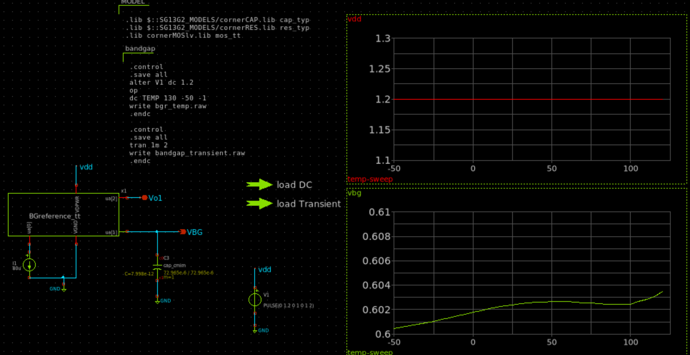

Transient power on: testbench and post layout results:
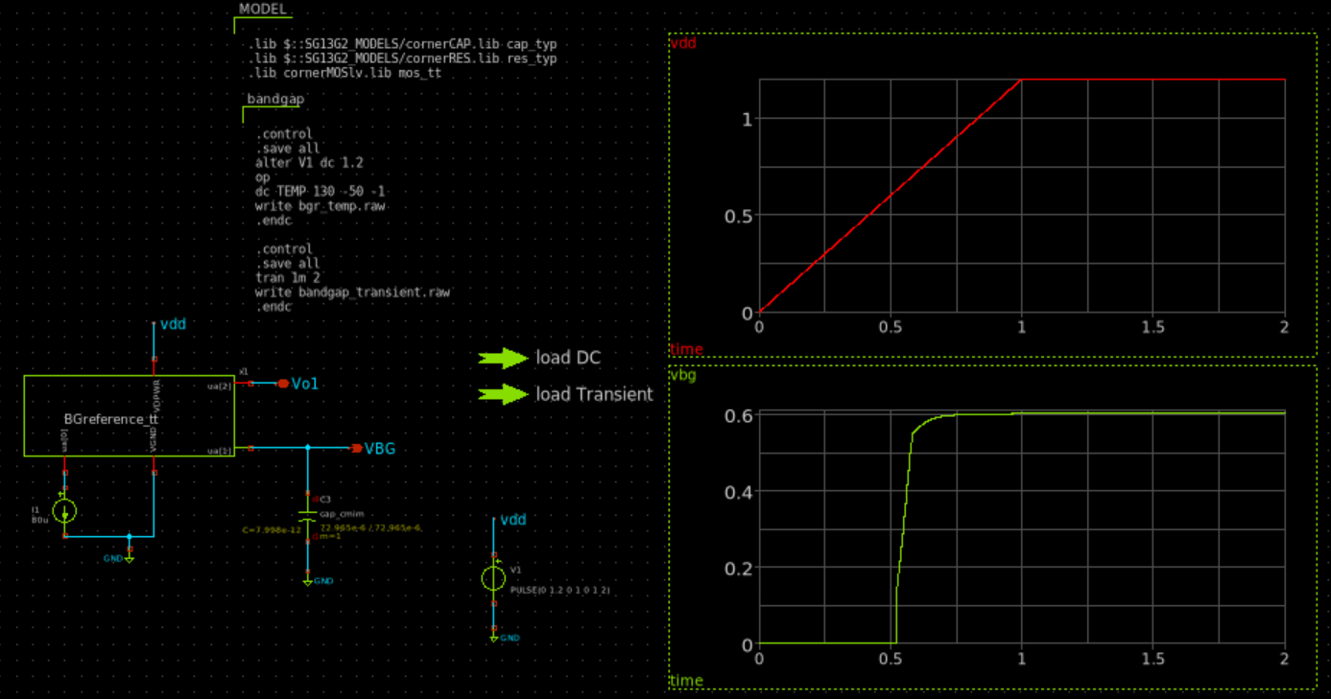

Monte Carlo testbench and post layout results:
