Práctica de laboratorio

ISOP101_VMWare

NOMBRE ALUMNO: PABLO DE LUCIO

# Fecha de entrega de práctica: 30/09/2021

516-PDLucio-ISOP102_VMWare

-Literal.docx

# Tabla de contenido

Contenido

Fecha de entrega de práctica: 30/09/2021 1

Tabla de contenido 1

Objetivo de la práctica 1

Inventario de material necesario 1

Ejecución, investigación y desarrollo 2

Instalación Windows Desktop 2

Instalación de Ubuntu Desktop 16

Consideraciones finales y metacognición 24

Guía de laboratorio 24

# Objetivo de la práctica

Install two virtual machines, an Ubuntu Desktop and a Windows Desktop using the VirtualBox application

# Inventario de material necesario

The class computers only, and regarding the specifications of the machine, which I have seen convenient since nothing was specified

# Ejecución, investigación y desarrollo

# Instalación Windows Desktop



We will select the "New" section

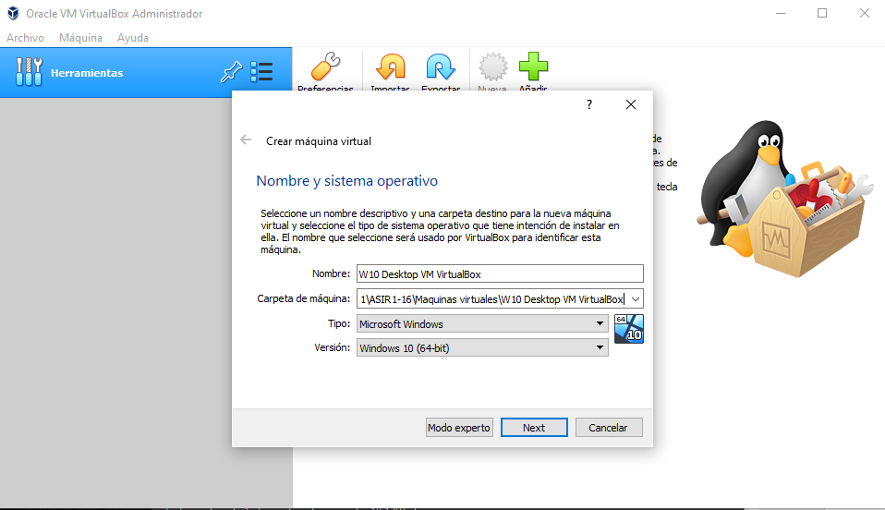

In this section we will configure the name and the folder where the virtual machine will be stored

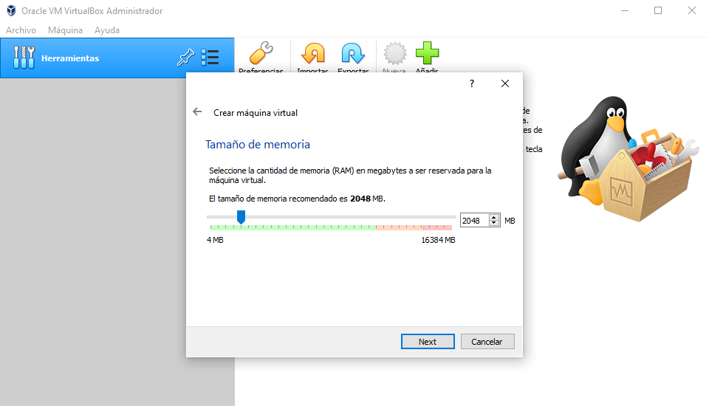

Here we select the RAM memory we want, I select approximately 2 GB

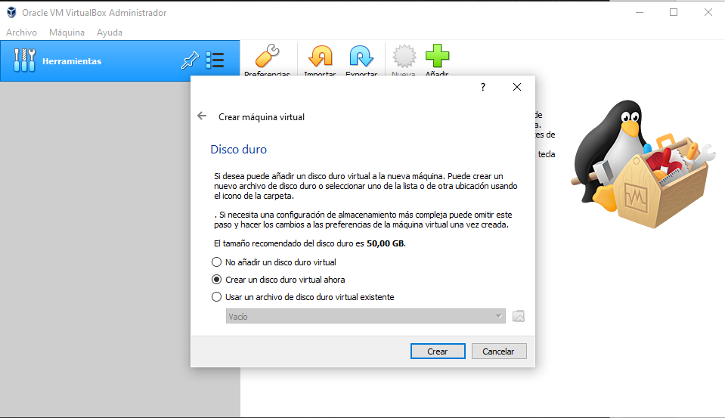

Here we will select whether to create the hard drive or select an existing one, in this case we Will create it

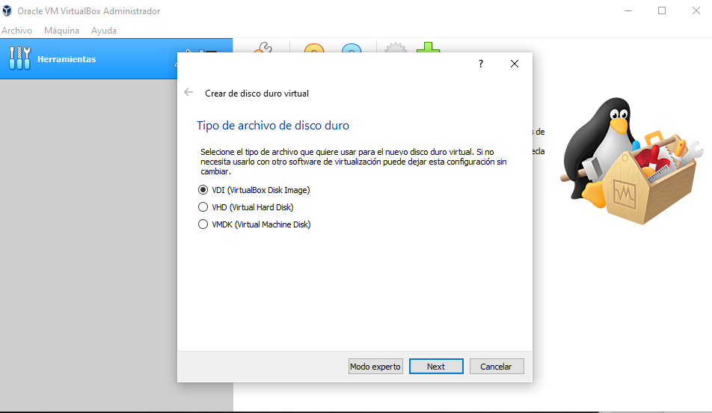

Here we select the type of hard drive we want, I will select the VDI

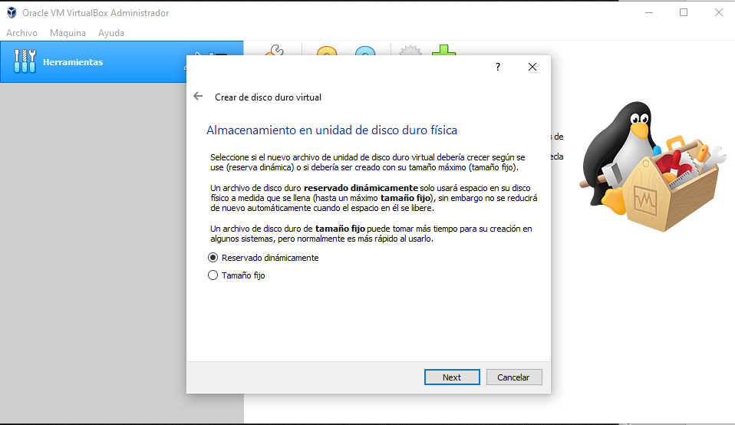

In this section we will decide if we want our hard disk to expand dynamically if the equipment needs it or leave it with a fixed size, in this case I will select the fixed size since I am only going to demonstrate how the machine is installed

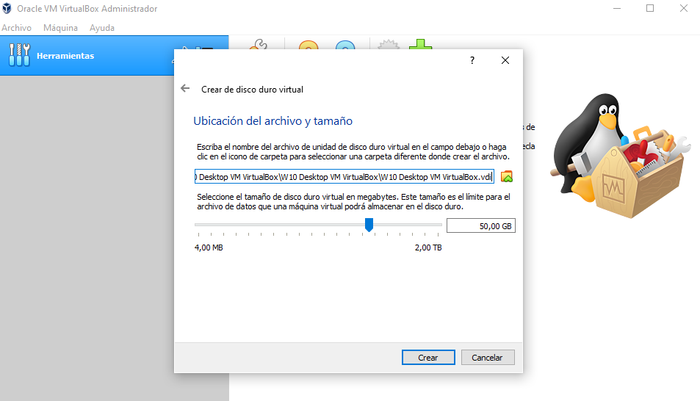

Here we will define the capacity of our hard drive and the place where our hard drive will be stored

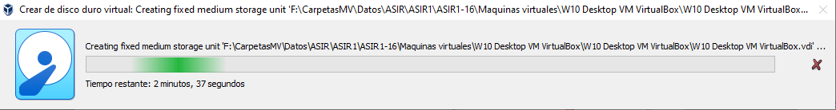

This is the process by which the hard drive begins to be created

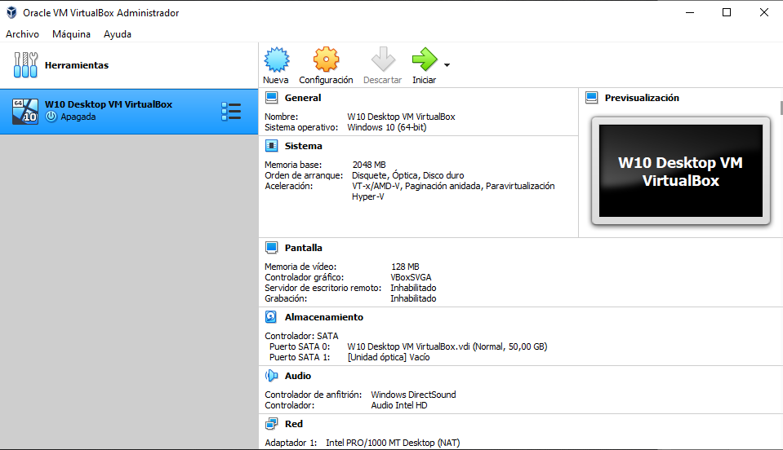

This is the summary of our virtual machine, as we agree we will start the machine

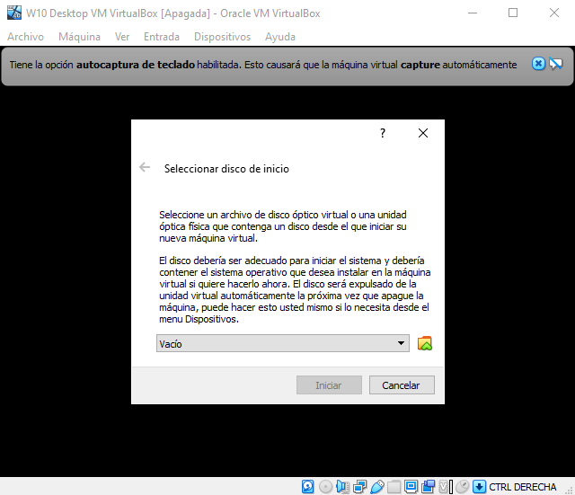

When starting the machine, it will ask us for an ISO, we will have to go to the path of our ISO and we will select it

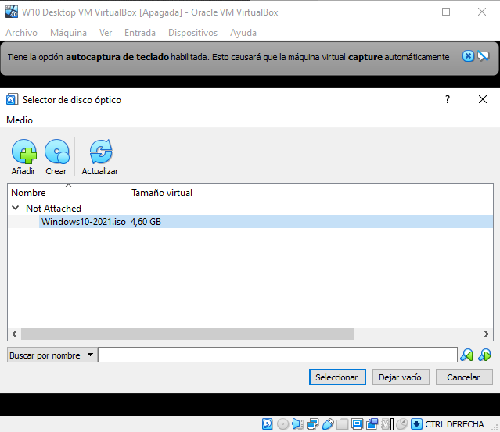

Once the disk is selected, we will select and start the machine

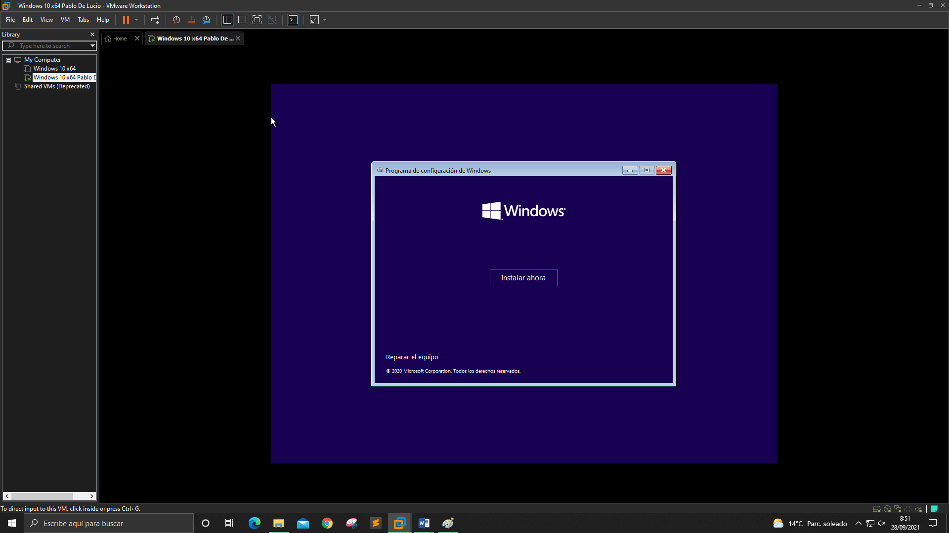

We click "Install Now"

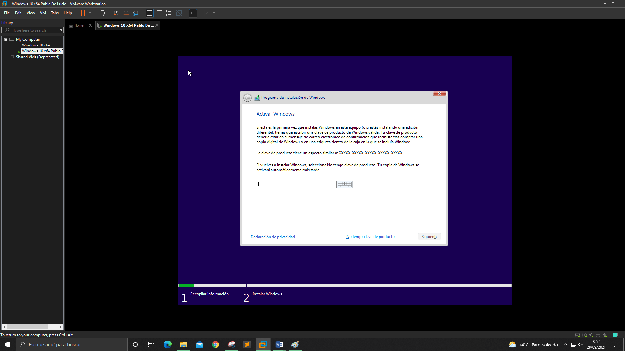

Here we would have to put a valid license key for our Windows, but since we do not have any since this is a test we will give "I do not have a product key"

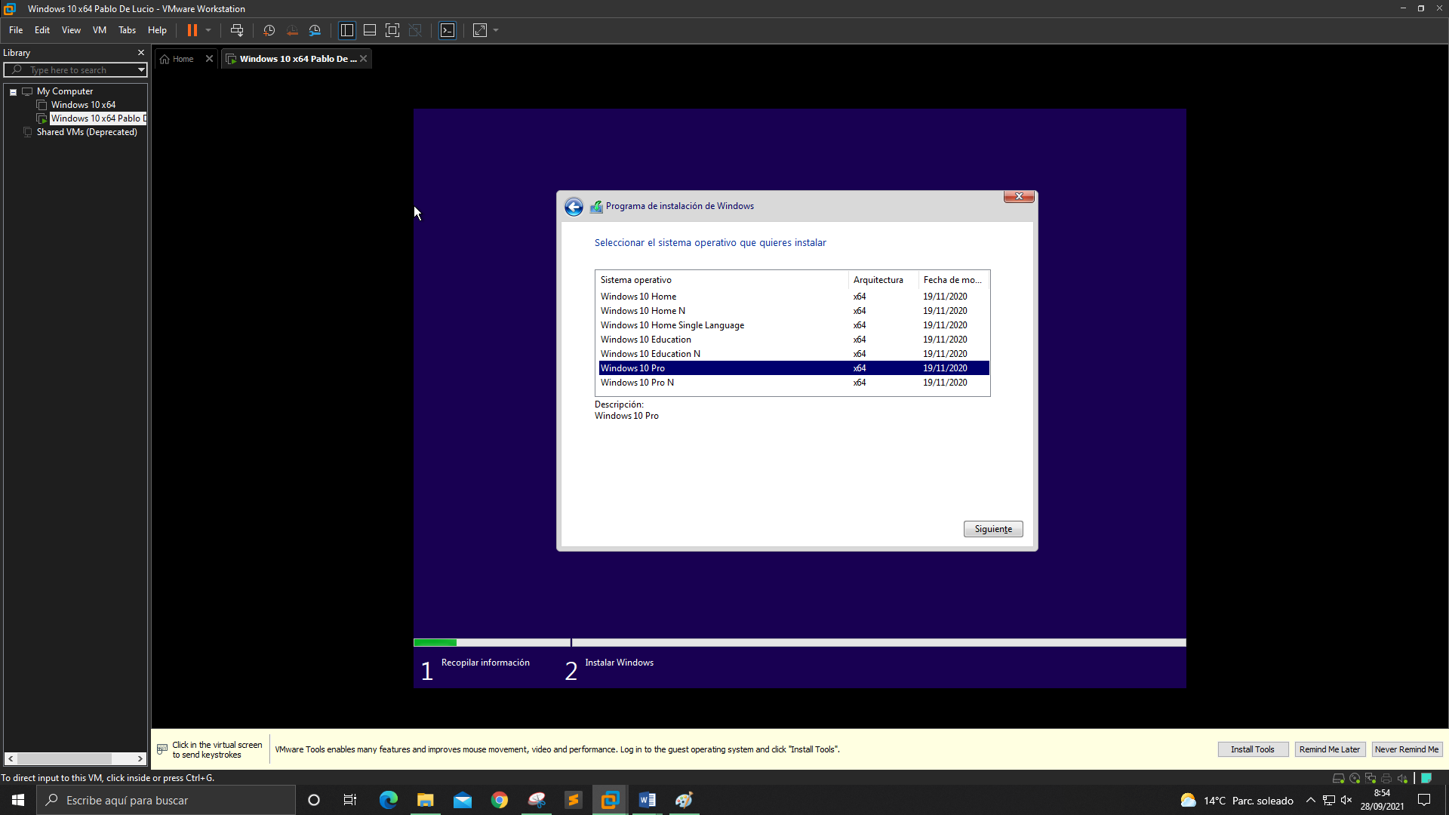

Here we will select the type of Windows that we want to be installed, then we select "Windows 10 Pro" and we click "next"

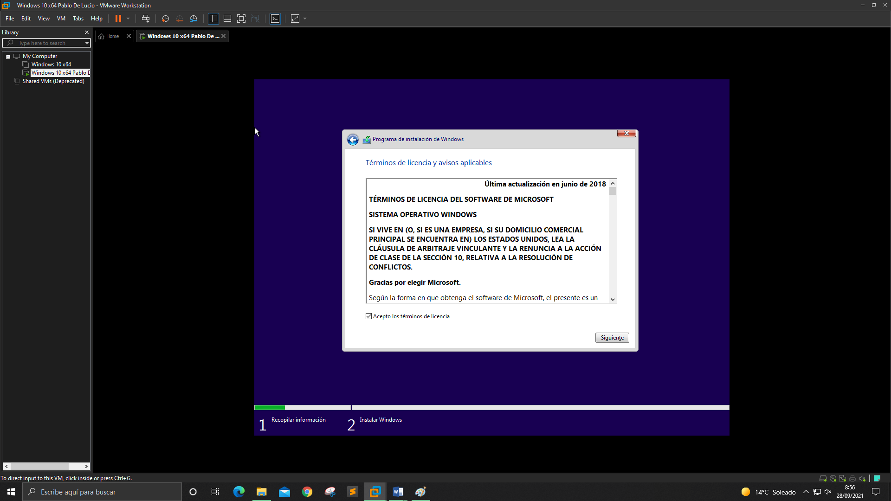

We accept the license terms and click on "Next"

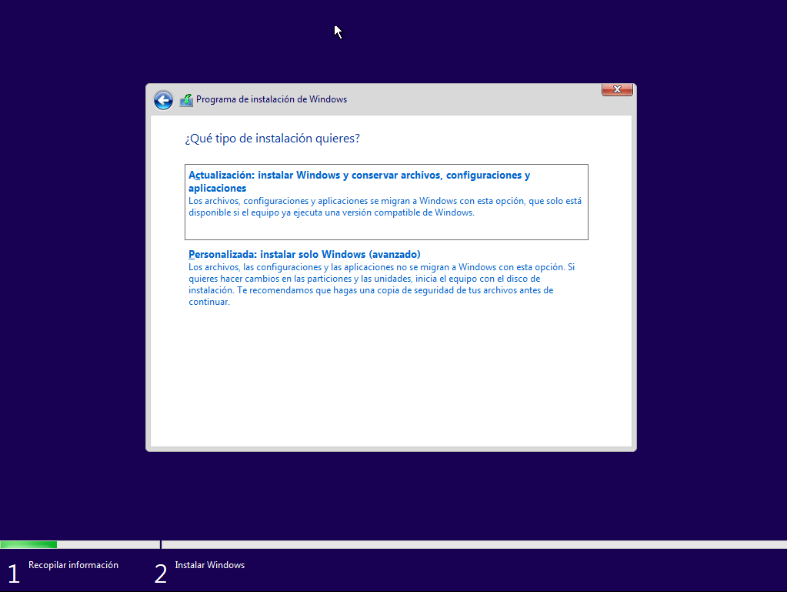

We click on "Custom" since we want to select where we want it to be installed and which one we want to install

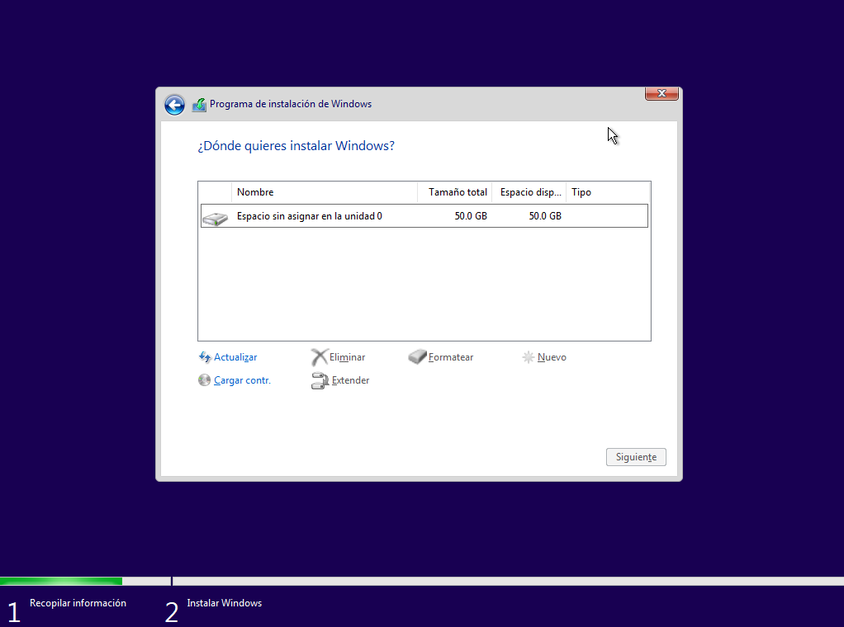

We select the disk that we have created of 50GB so that our Windows is installed

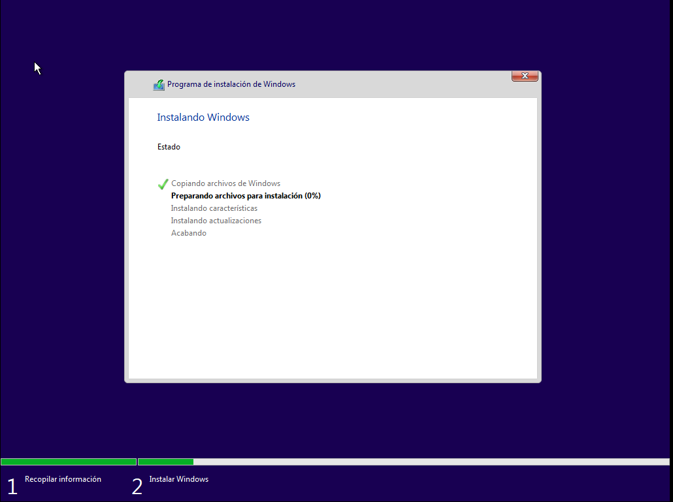

Once all this is defined, our Windows will begin to be installed.

When it finishes installing it will restart and the Windows wizard will start

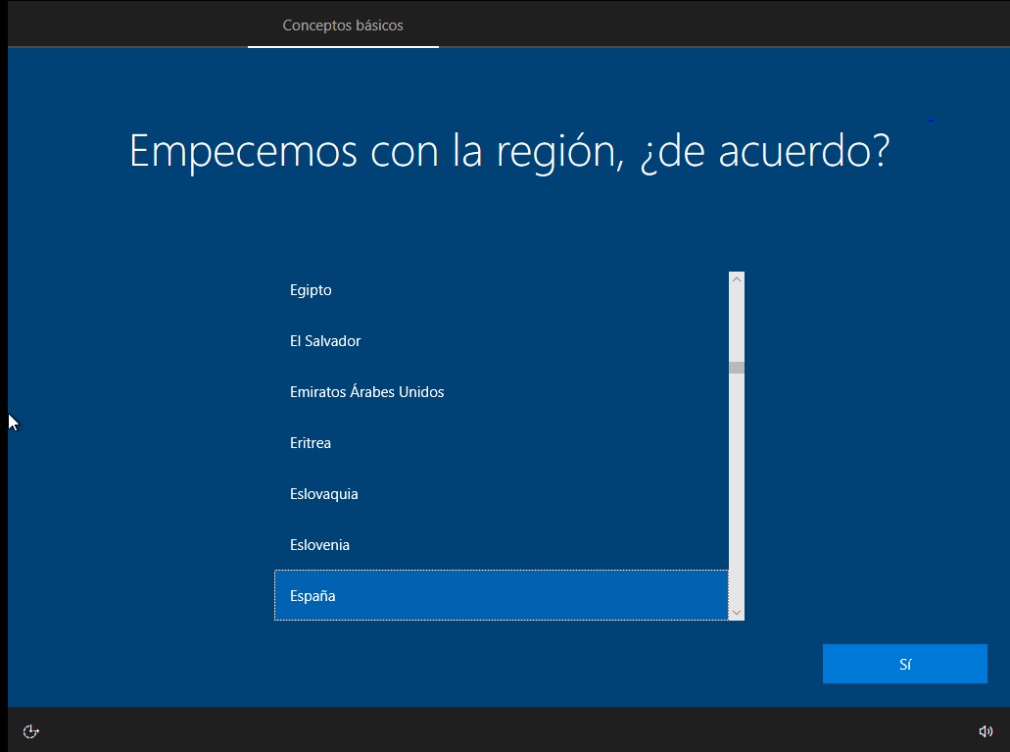

We select the desired region

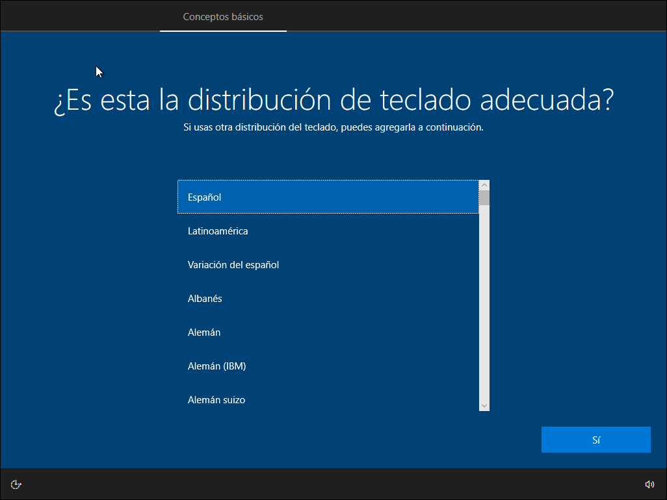

We select the desired layout of our keyboard

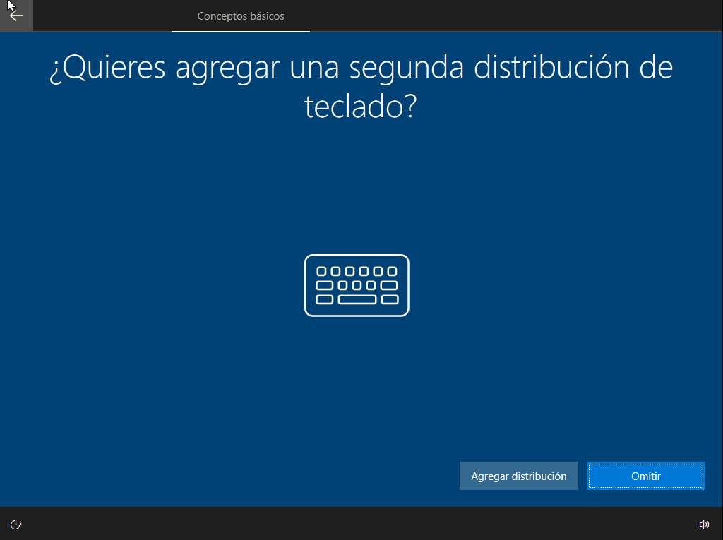

We click on Skip as we don't want another keyboard layout

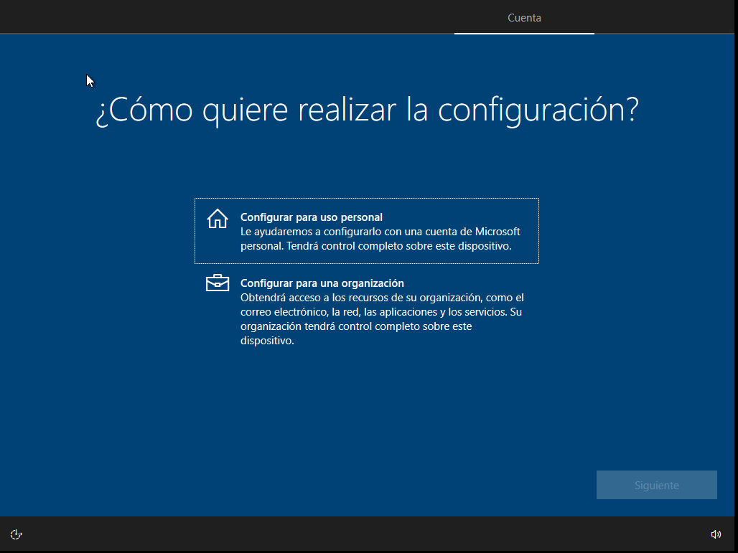

We will select the one for Personal Use

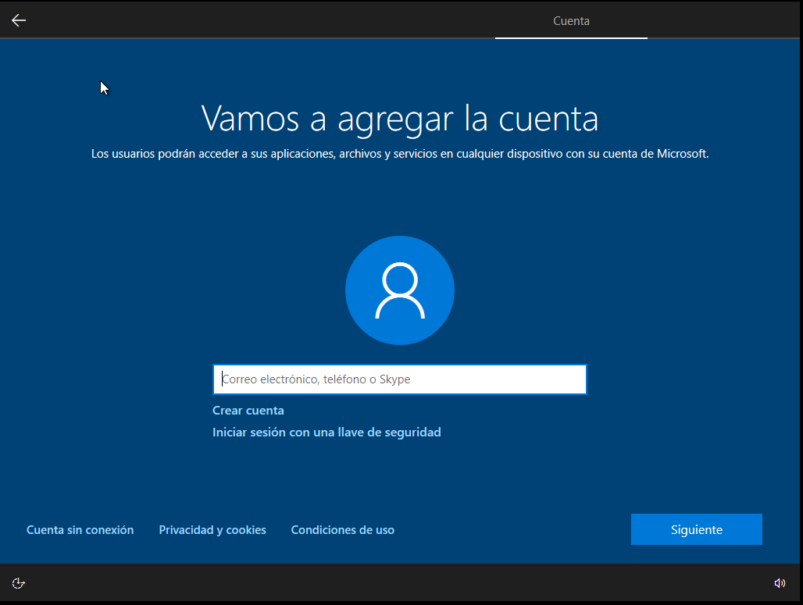

Here we will select the offline account section since we will not associate any email

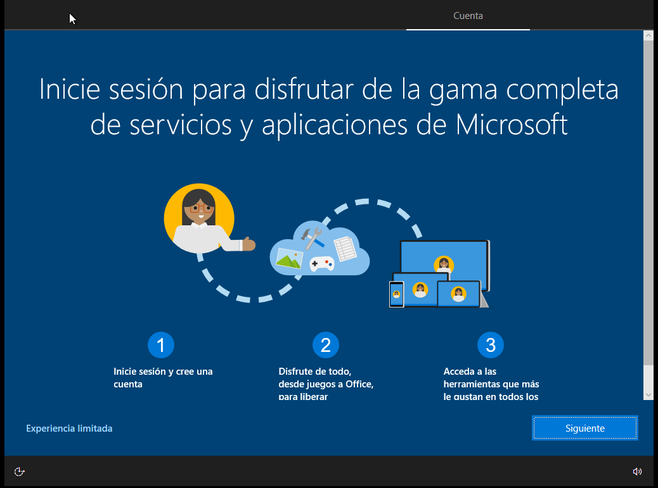

We select the Limited Experience section

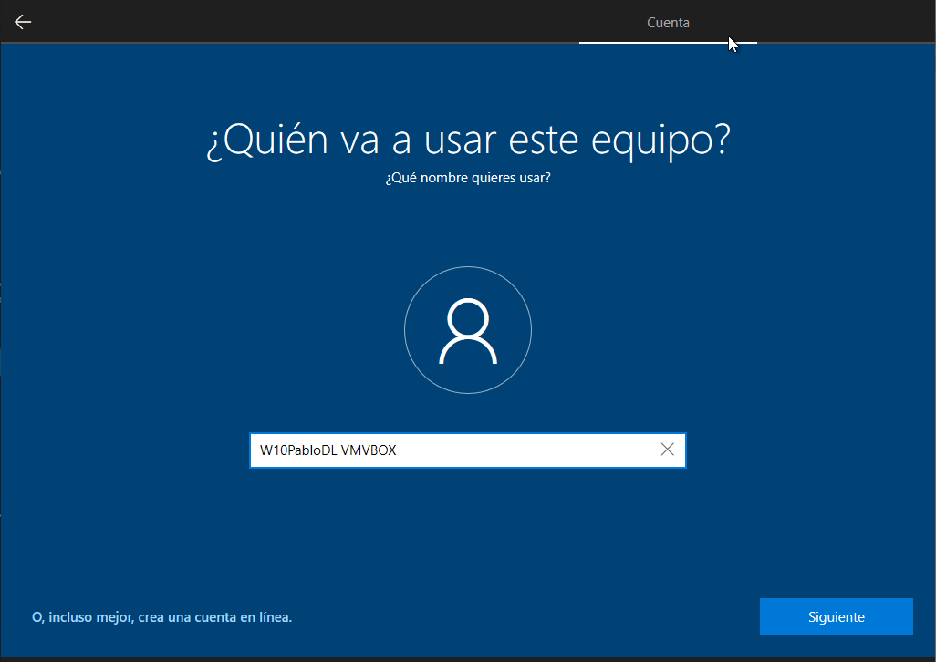

Here we will put our username

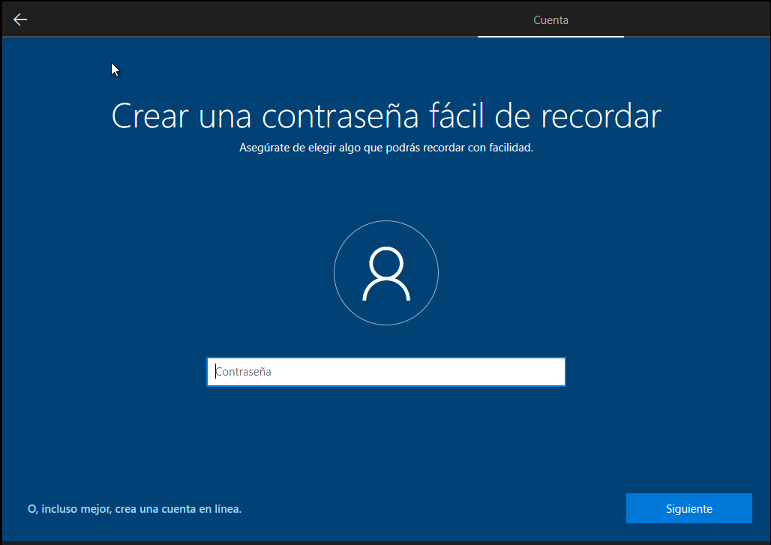

Here the password that we see opportune, as this is a test I will put Contra123

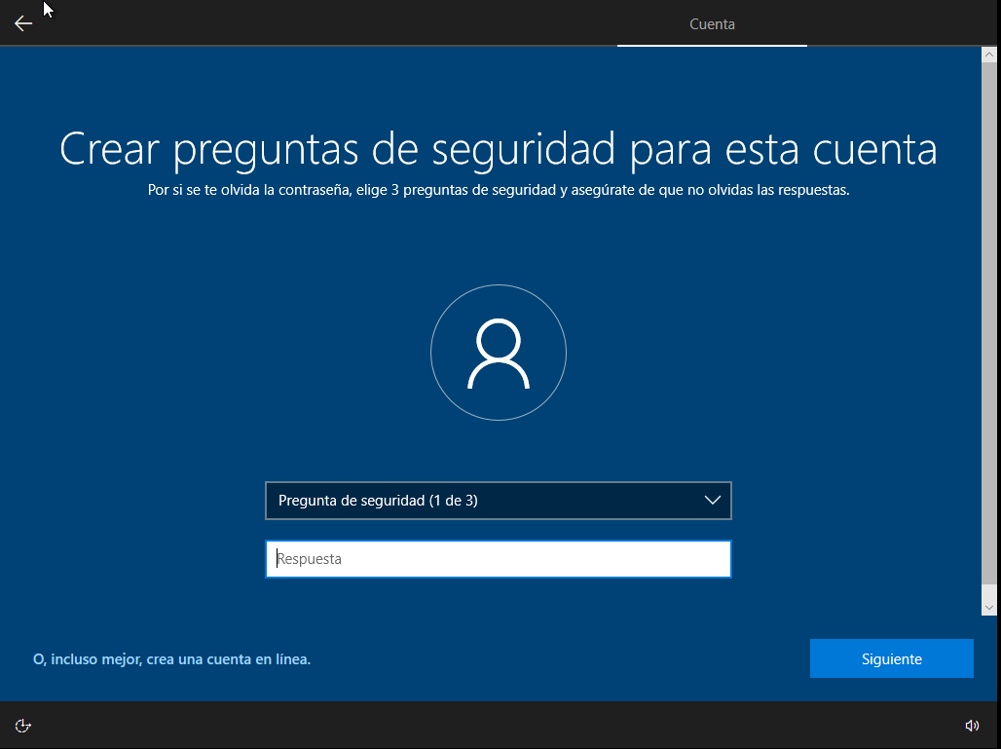

Here we will have to choose some security questions and answers for each one, this serves if you ever forget the access password, that you are asked the security questions and you can access your desktop

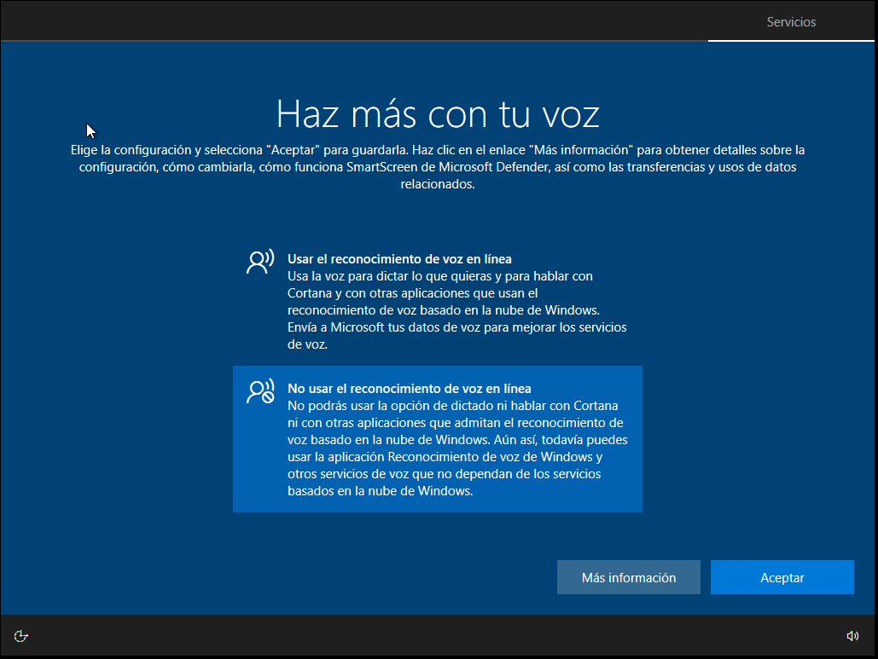

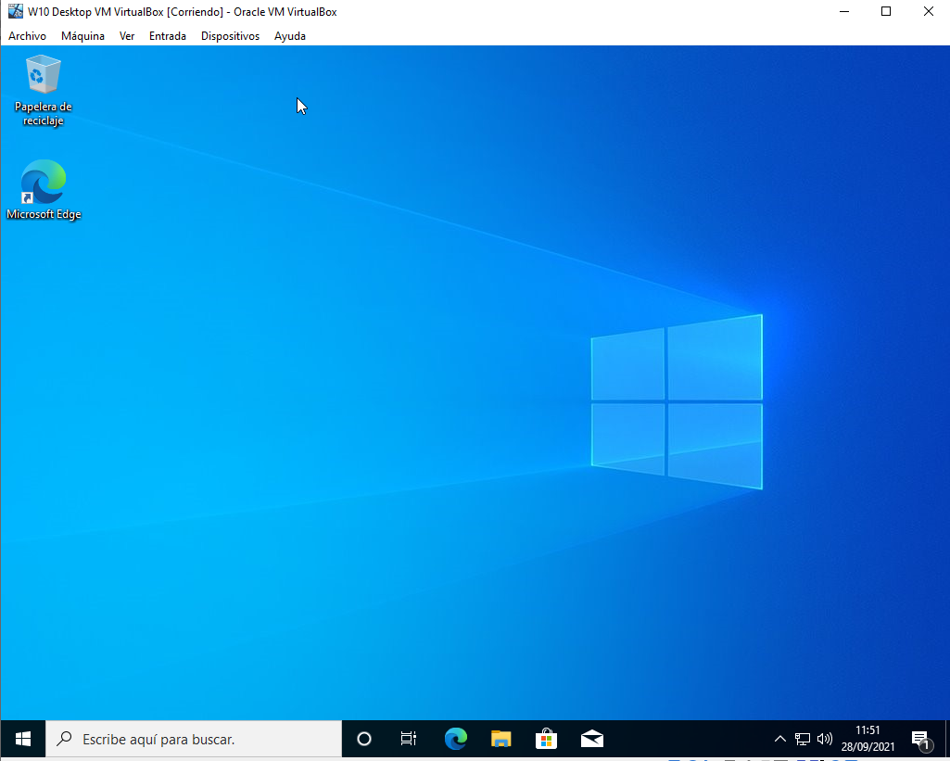

And this would be the end result

# Instalación de Ubuntu Desktop

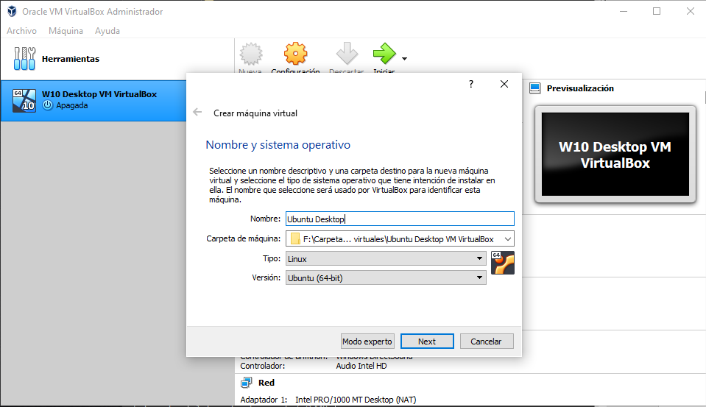

In this section we will define the installation path of the virtual machine

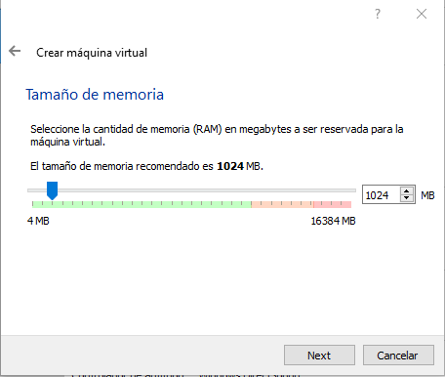

In that section we will define the RAM of the machine

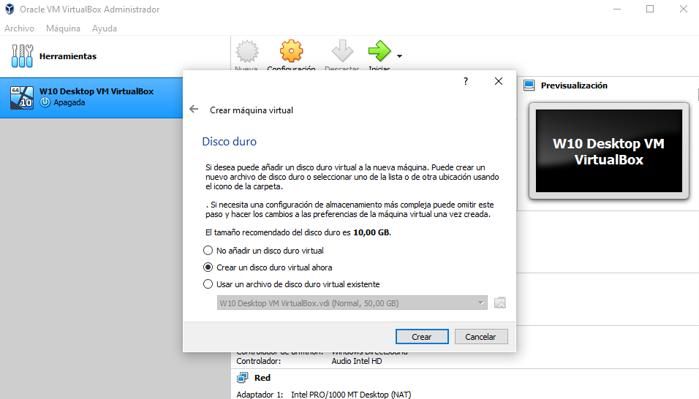

In this section we will create the hard disk of the virtual machine

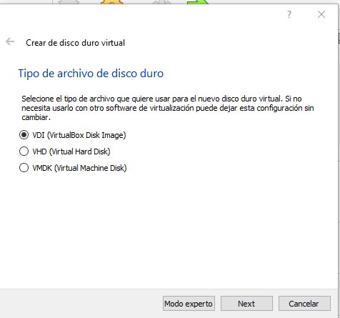

Here we will select the type of hard drive we want, I will select the VDI

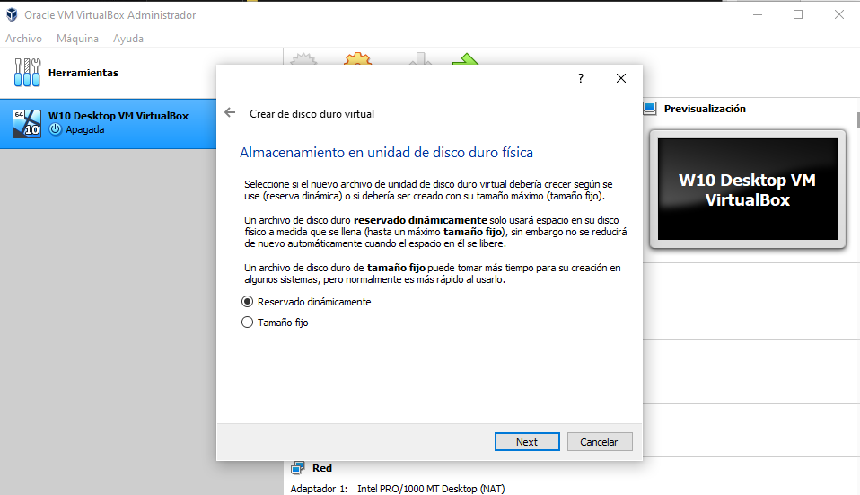

This serves to define if the hard disk will increase its size based on the needs of the system or stays at fixed size, I will select the fixed size

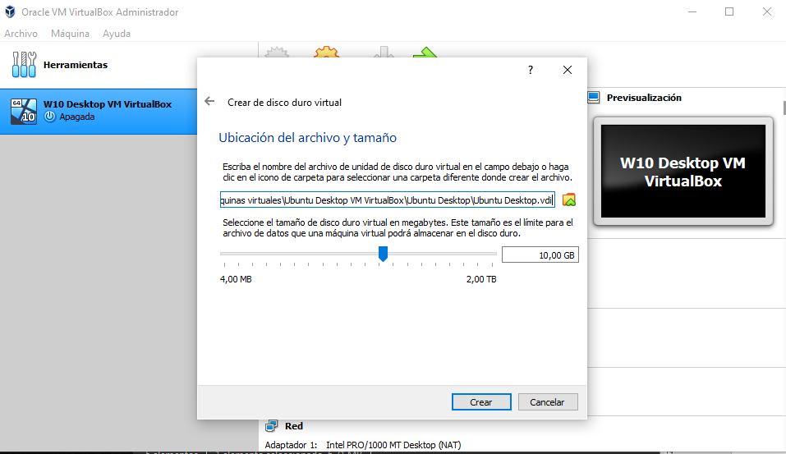

Here we will define the size of the disk and where the virtual hard disk will be located

Once we give it to finish, the machine will restart

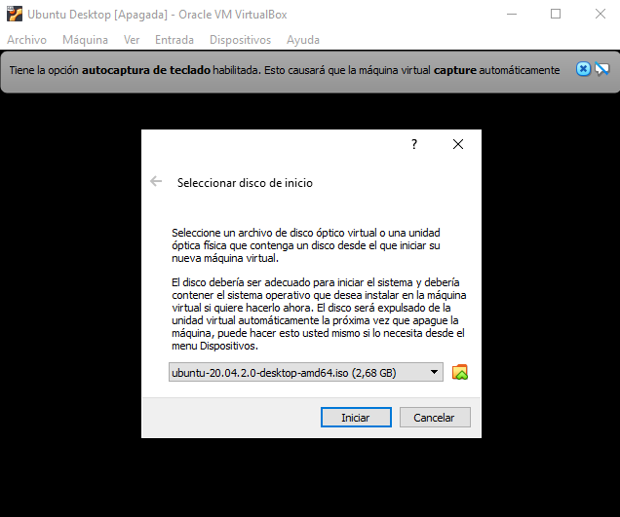

Here we select the ISO we want

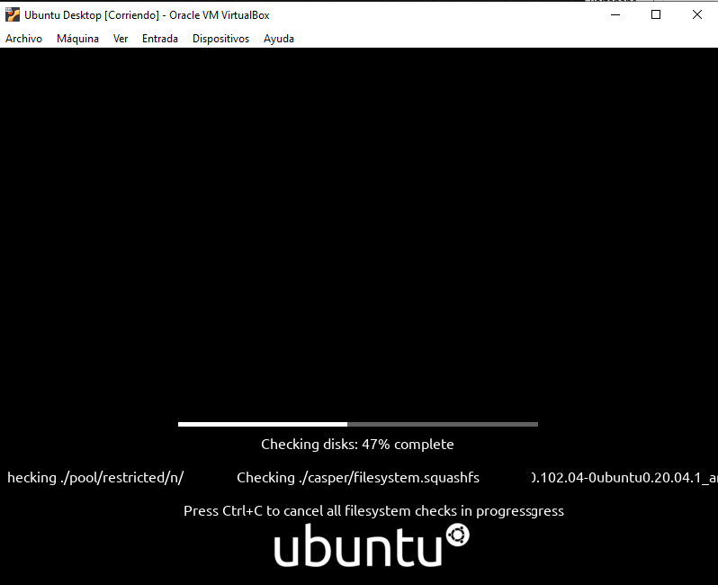

Here he makes a brief check that everything is correct

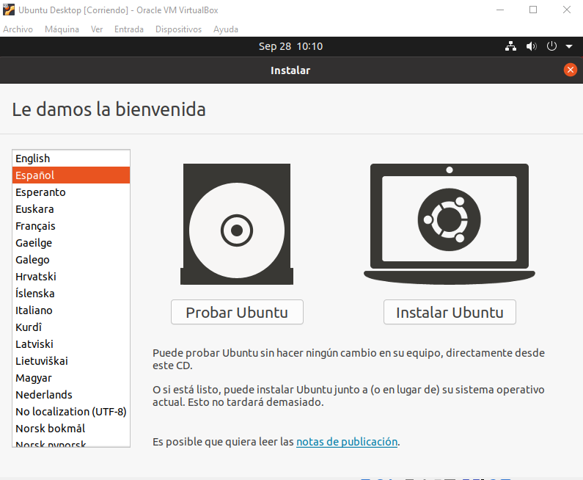

Here we will select the language in which we want it to be installed

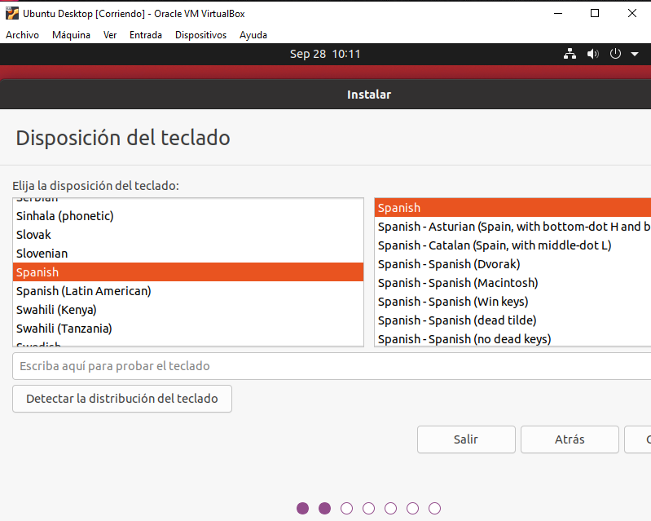

Here we select the language of Ubuntu

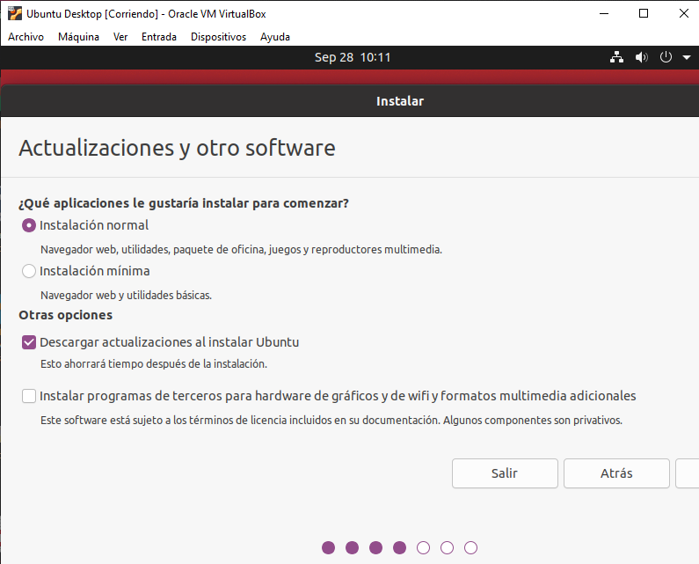

Here we select the normal Installation and give it to continue

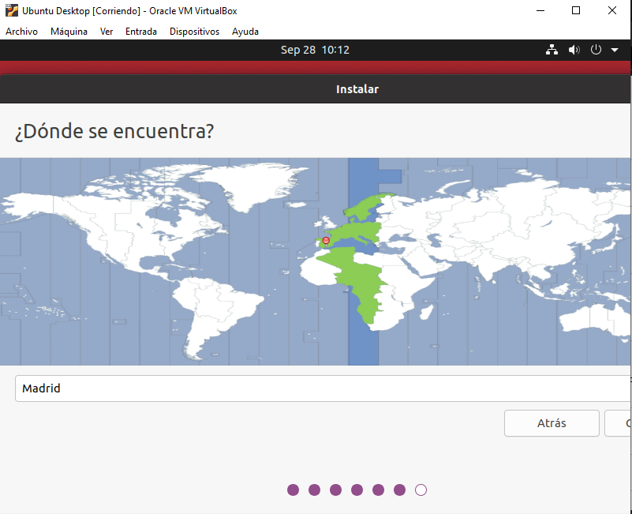

Here we select our region

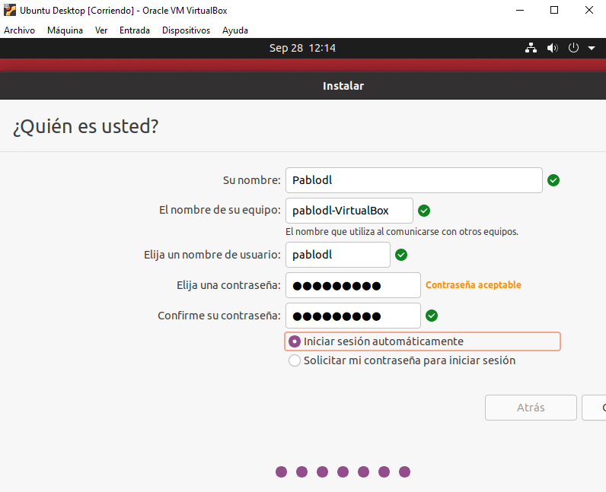

Here we put our username and the machine name and set our password, in my case I will put Contra123

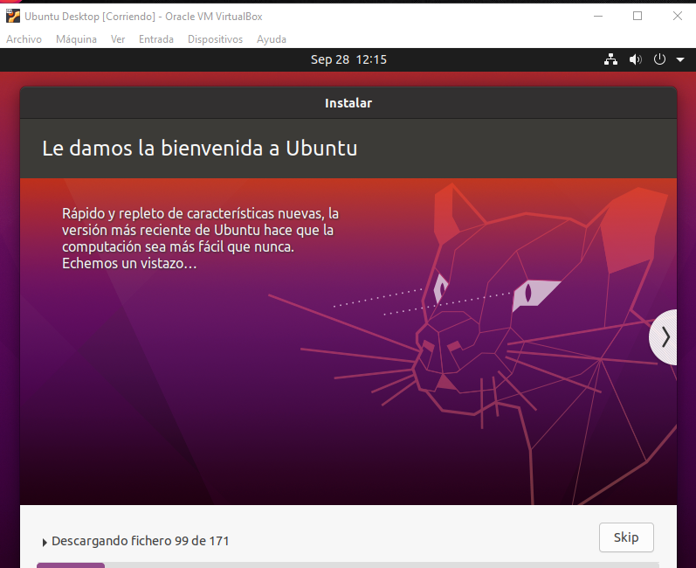

Ubuntu is being downloaded here

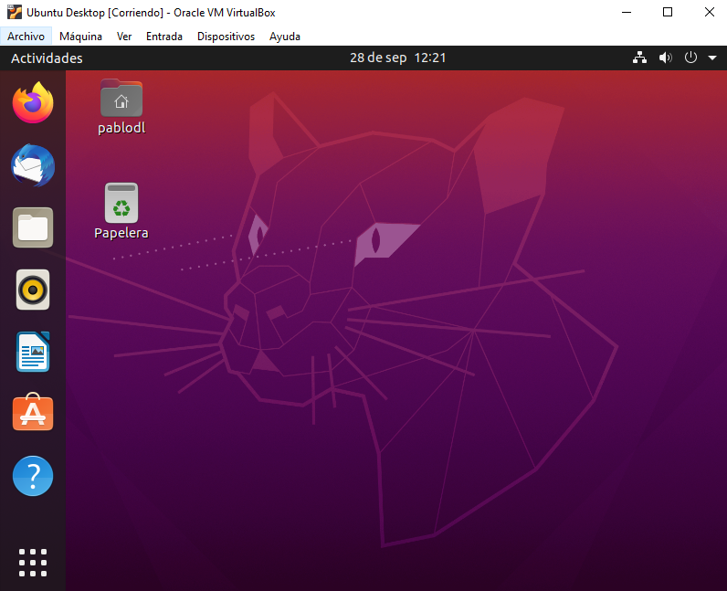

And this is the installation already finished

# Consideraciones finales y metacognición

The practice has seemed interesting to me since it has helped me to remember the installation methods of the different operating systems, I can not think of disadvantages since it is a methodical practice and I do not have to think much, I can not think of another way to improve this Practice because I believe that this is learned by doing many practices, an example with which I would compare it is riding a bicycle since at first it will cost you and you will fall but as you ride more times you will do it better and faster

# Guía de laboratorio

***No entiendo a que se refiere esto***