NAME | RYAN S. PABIRAN
PROJECT TITLE | RP: FileMatrix Document Management System
SUBJECT:  CODE:  TIME: | IT15/L Integrative Programming and Technologies  8460  3:30PM-5:30PM
TOPIC (Type of Business Process) | #17 Document Management Systems (DMS
Products/Services | Secure Digital Document Hub
Deployed Link / Website link | http://filematrix.tryasp.net/
2nd Deliverables-1st Hands-on Exam (Deployed Protype/Design)
Log in-Page | 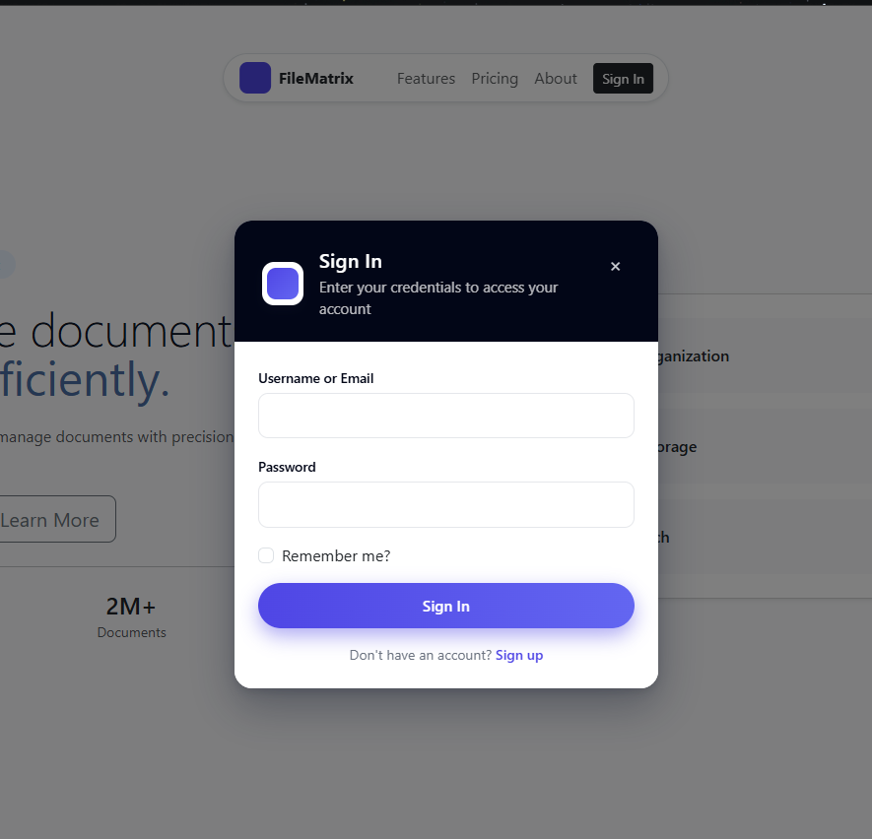  The login page functionally serves as a secure authentication gateway, allowing existing users to submit their username/email and password credentials through a modal form, validate them against the system, create an authenticated session on success (with optional "Remember me" persistence), redirect the user to their appropriate dashboard based on role, and display clear error feedback on failure.
Dashboard (Admin) | 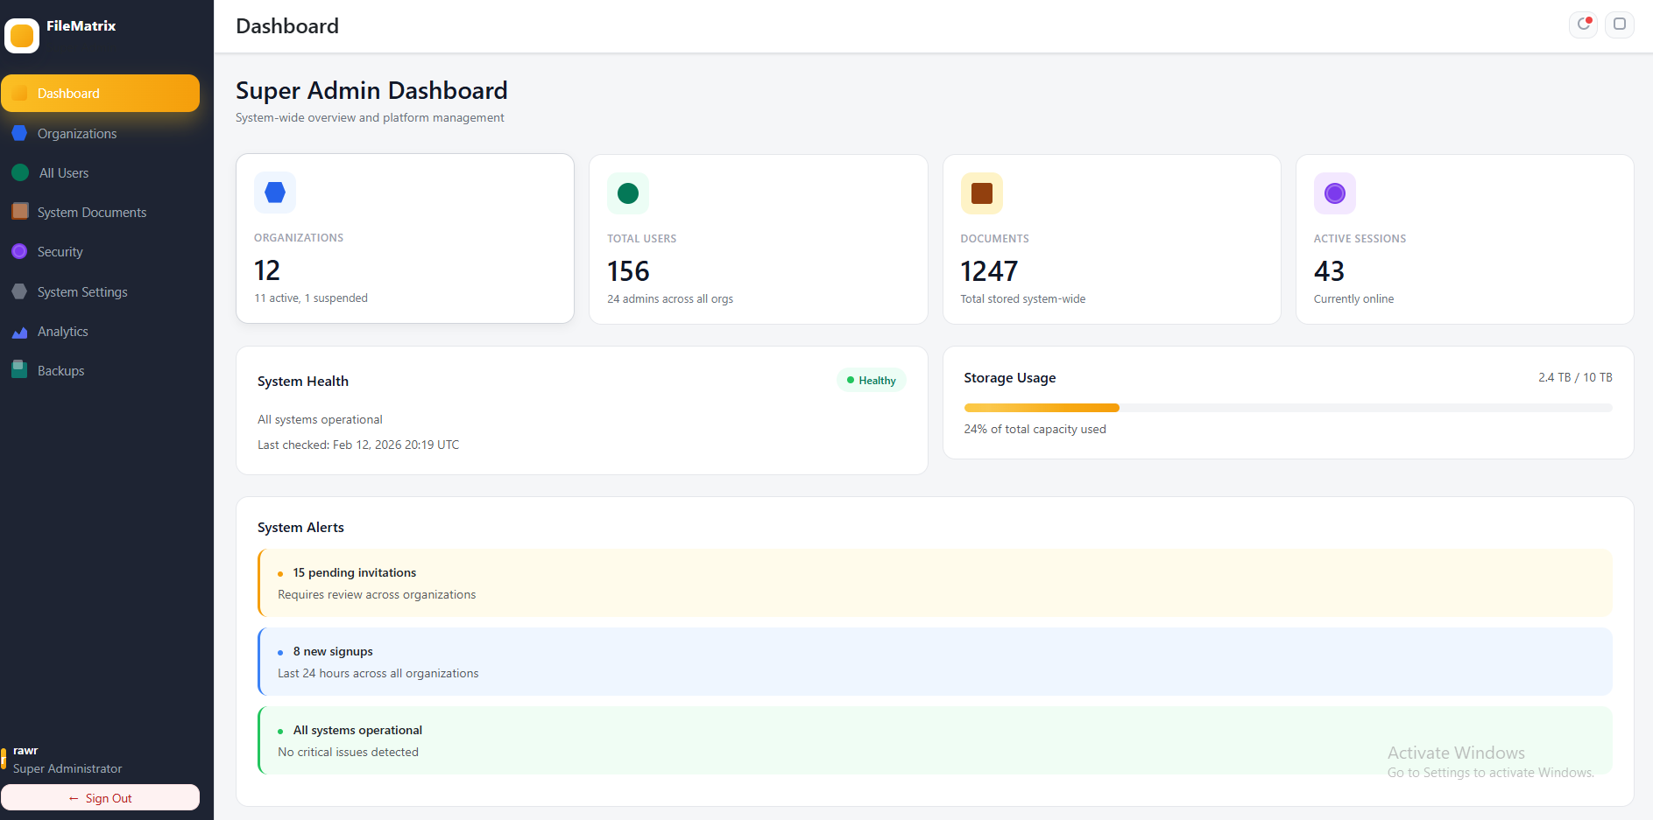  The super admin dashboard functionally serves as the central command center for platform-wide management, delivering system-level oversight through stat cards displaying total organizations (with active/suspended breakdown), aggregate user count across all organizations, total system-wide document storage, and real-time online user metrics; it monitors overall system health via status indicators (Healthy/Warning/Error) with last-check timestamps, visualizes storage capacity using progress bars with animated shimmer effects, presents categorized system alerts (warnings for critical issues, info for updates/new signups, and success confirmations), shows a unified cross-organization activity timeline of key events (organization creation, bulk operations, backups, security incidents) with user attribution and exact timestamps, highlights top organizations by performance metrics with status badges and direct access links, and offers quick-action controls for creating new organizations, managing all organizations, accessing the global user directory, viewing system logs, configuring platform security policies, handling backups and restoration, and adjusting global settings—all secured behind Super Admin role authentication and distinguished by a unique orange/gold visual theme.
Dashboard (Client/End-User) | 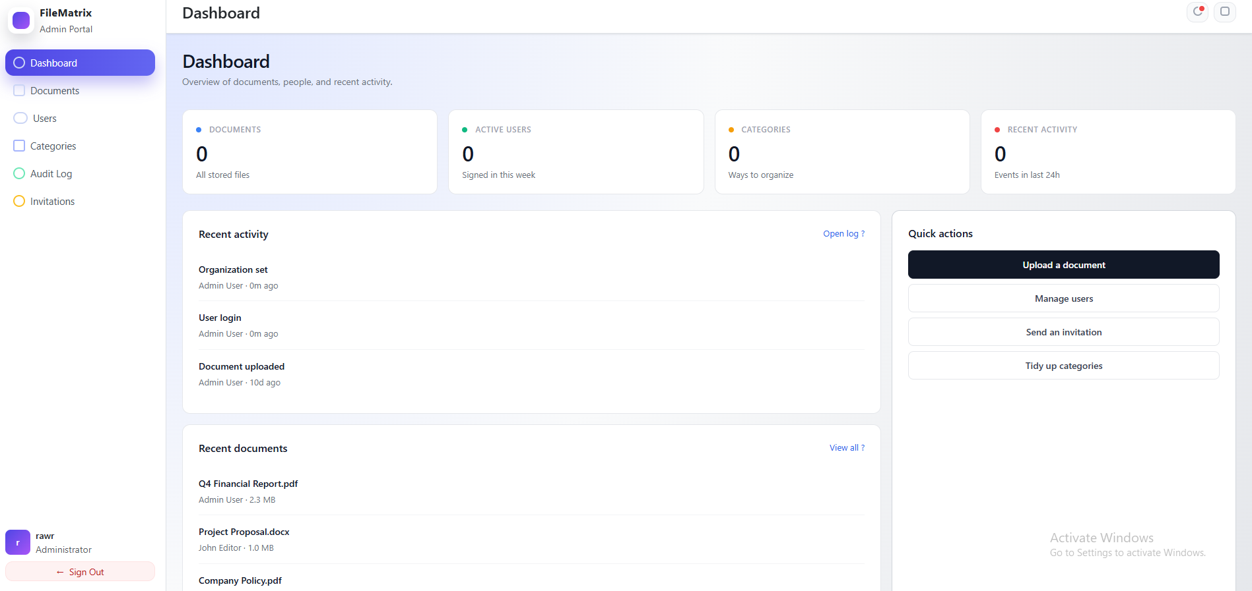  The admin dashboard functionally serves as a centralized overview for organization administrators, delivering at-a-glance insights through visually distinct stat cards showing total documents, active users, categories, and recent activity counts, while featuring a chronological recent activity feed with user and timestamp details, a list of recently uploaded or modified documents including file size, owner, and upload date, and prominent quick-action buttons for frequent tasks such as uploading documents, managing users, sending invitations, and organizing categories.
Add / Create Page | 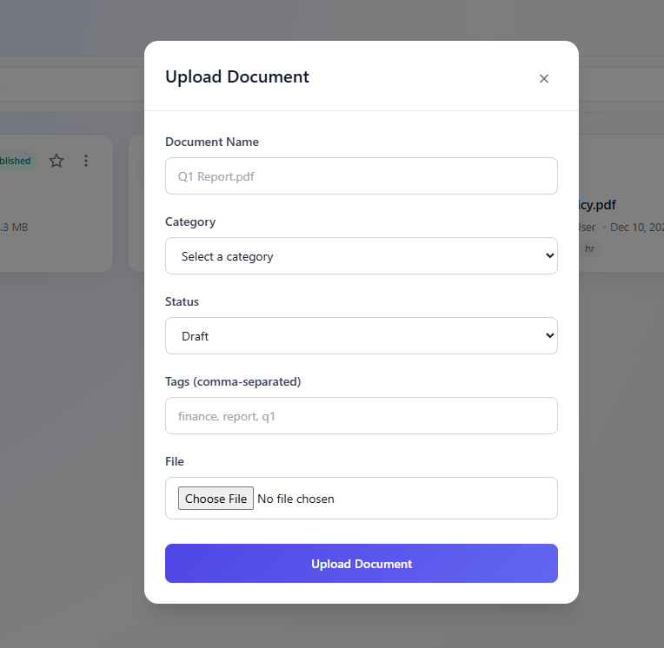  The Upload Document feature functionally serves as the primary document creation interface, enabling administrators to add new files to the system through a streamlined modal form that collects essential metadata—document name (with placeholder guidance), category (via dropdown: Financial, Projects, Legal, Marketing), status (Draft or Published), comma-separated tags for organization and searchability—and supports file upload with type restrictions; it opens cleanly from the “Upload Document” toolbar button, enforces validation on required fields (name, category, status, file), prevents background scrolling while open, submits all data to the backend for secure processing and storage, and upon success instantly adds the document to the library grid where it becomes visible, searchable, and filterable by category, status, and tags.
Update/Edit Page | 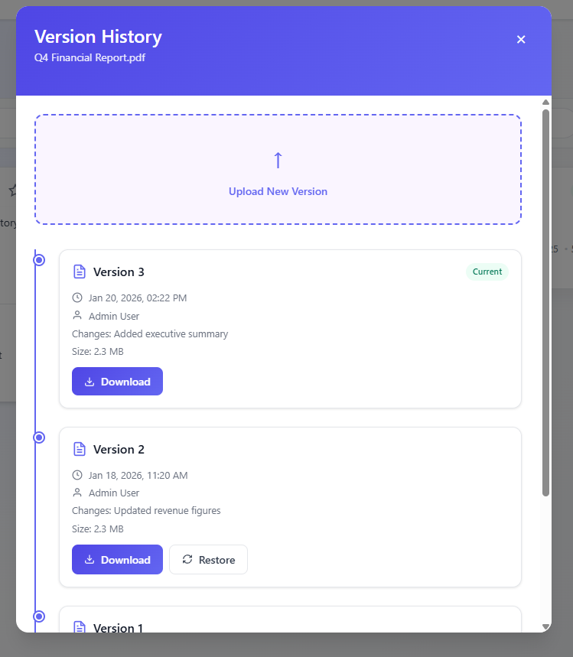  The Version History feature functionally acts as a complete document version control system, enabling users to upload new versions of existing documents, view a chronological timeline of all versions displaying metadata (upload date, uploading user, change description, and file size), download or restore any previous version, clearly identify the currently active version with a “Current” badge, and automatically preserve every update while marking the latest upload as active, providing full change tracking and safe rollback capabilities.
Display Records | 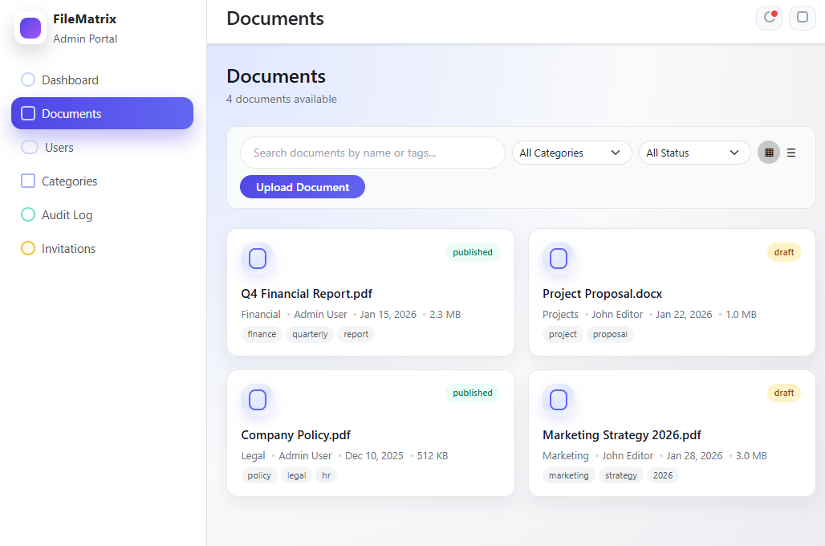  The Documents Management page functions as a central, responsive document library that displays all organization files in an adaptive card grid (1–4 columns), with each card showing key metadata (name, file type, category, owner, upload date, size, status badge, and tags), while offering real-time full-text search, category and status filters, grid/list view toggling, and a prominent button to upload new documents.
Date Submitted: | FEB 13, 2026
Teacher’s Feedback | _________________________________________________________________  _________________________________________________________________  _________________________________________________________________  _________________________________________________________________  _________________________________________________________________  _________________________________________________________________  ________________________________ __________________________  Student’s Signature (after feedbacking) Teacher’s Signature

