**Assignment-1**

**List of Query:**

**1. show databases;**

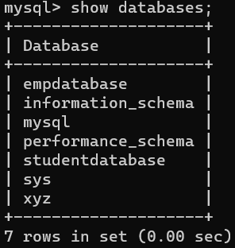

**2. select * from emp;**

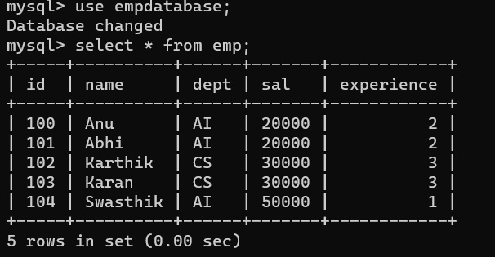

**3.select * from std;**

