**Date: 15/04/2024**

**Task**

**1. Create a table Customer with columns cid and cname. cid should be a**

**primary key in the table and cname should be NOT NULL.**

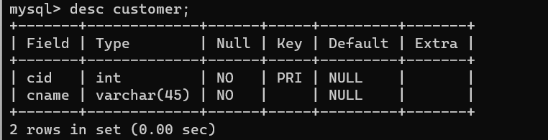

**2. Insert three customer data into the table.**

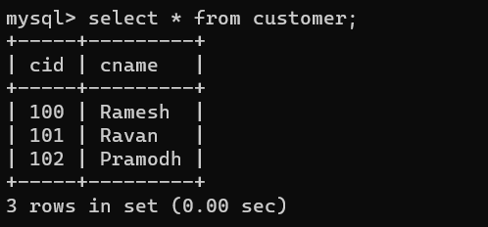

**3. Add columns age, city and phnum. Age &gt; 20, city default value should**

**be ‘Bangalore’ and phnum should be unique.**

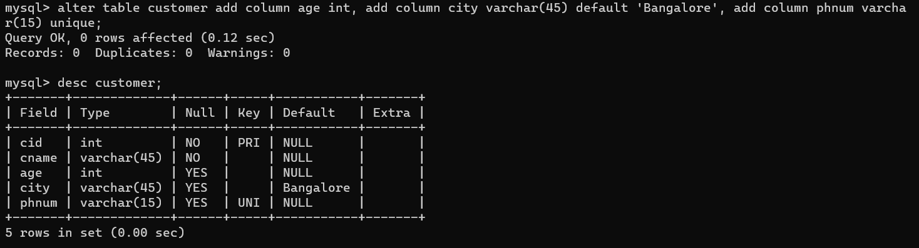

**4. Turn on the transaction on.**

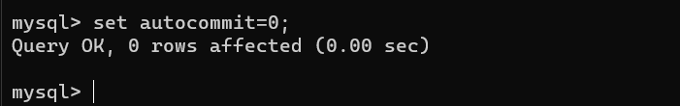

**5. Insert another two customer data into the table without city value.**



**6. Display data from the table.**

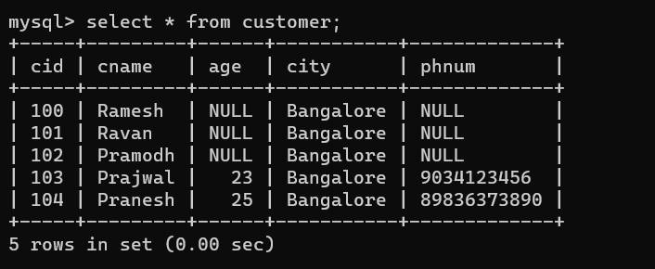

**7. Create a savepoint ‘ins’.**



**8. Update the first age of all the customers.**

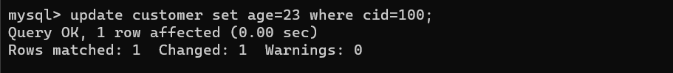

**9. Display data from the table.**

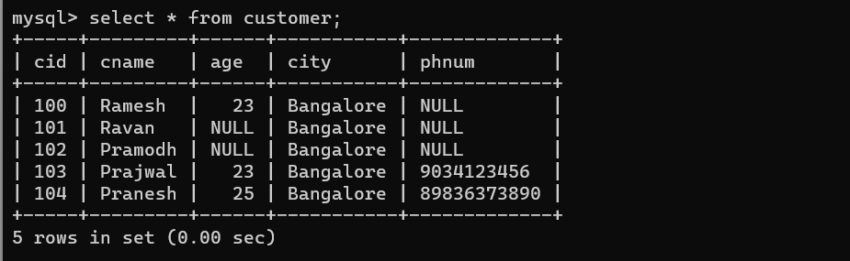

**10. Create savepoint ‘up1’;**



**11. Update all the customer’s city of the first three customers.**

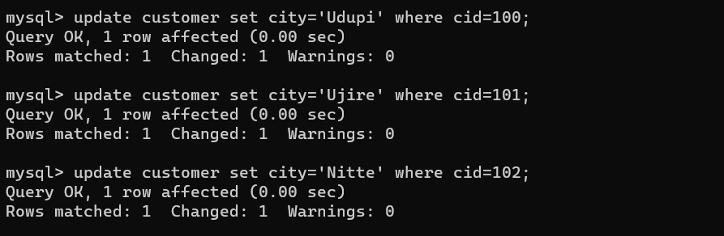

**12. Display data from the table.**

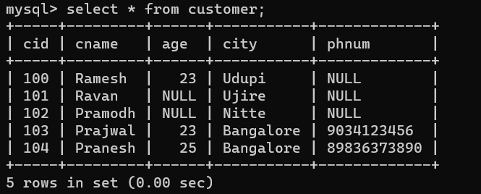

**13. Create savepoint ‘up2’.**



**14. Roll back to up1.**

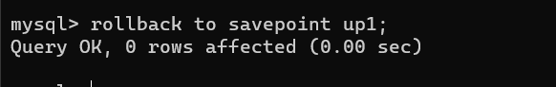

**15. Display data from the table.**

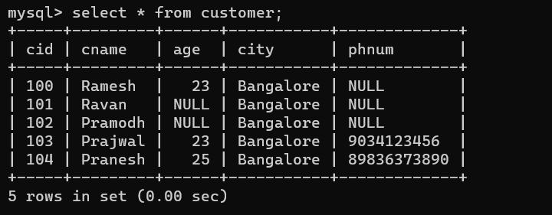

**16. Commit.**



**17. Display data from the table.**

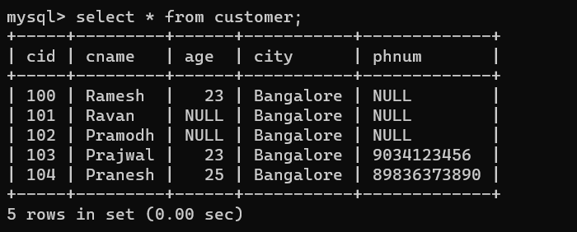

**18. Turn off the transactions.**

