Example of How to interoperate the Graphs and Information Presented

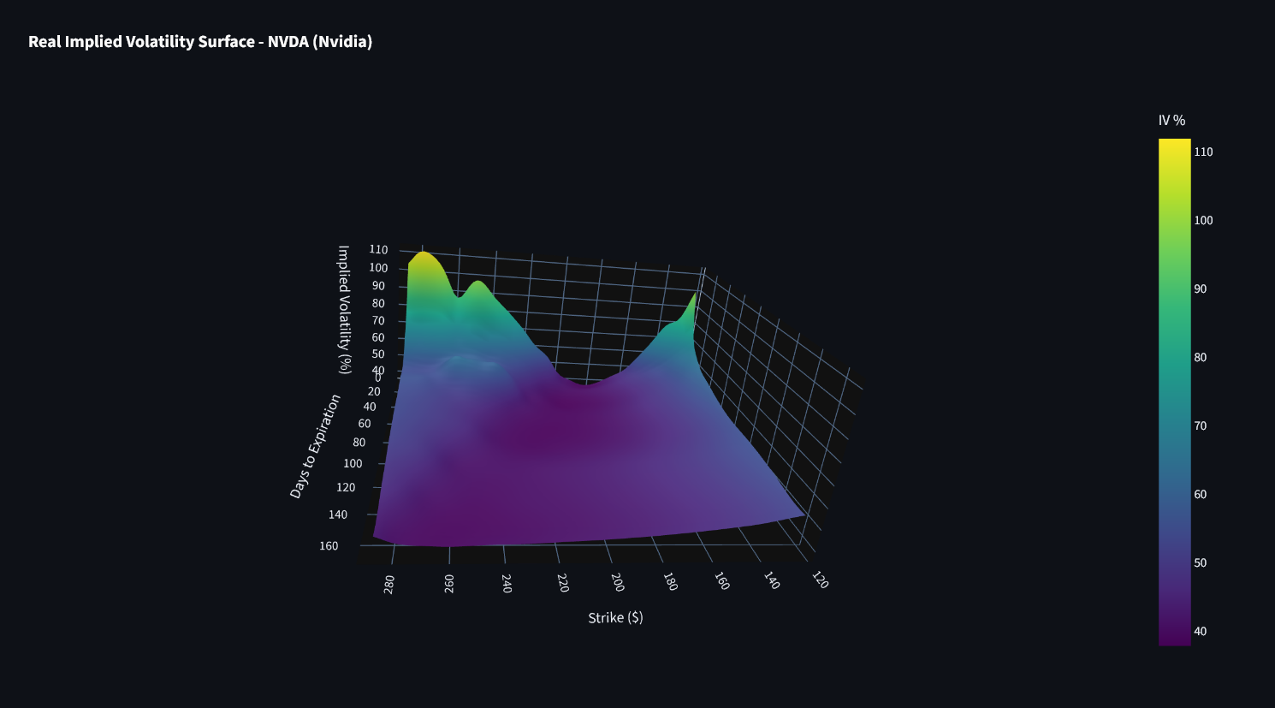
- Traders fear big down moves more than big up moves. This increases the chances of people selling out of fear driving the price down
- Short term volatility is much higher than long-term.
- The market sees uncertainty in the near future (earnings, macro, etc.).

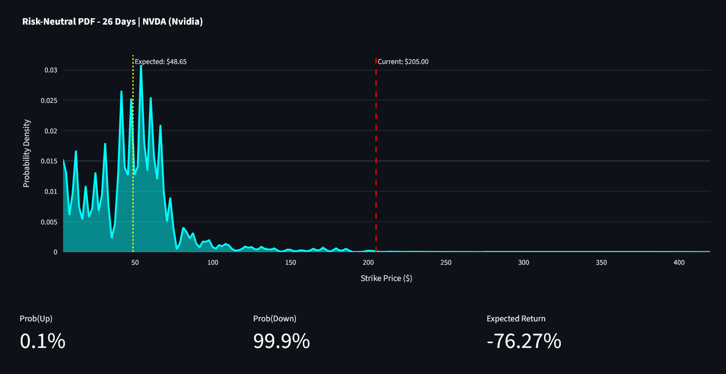
Options prices right now are implying that NVDA has an extremely high chance of dropping far below the current price, even to levels that are unrealistic in real life.
This is why the expected value shown is so negative.
This is because:
- Put options are very expensive
- IV skew is extremely steep
- There is large demand for downside protection

I feel it is important to mention this is not a realistic prediction of where price will move in the market. It does NOT mean the real-world fair price is $48. It is meanly saying that the distribution looks very bearish. Which may create opportunities for put-selling or call-buying.

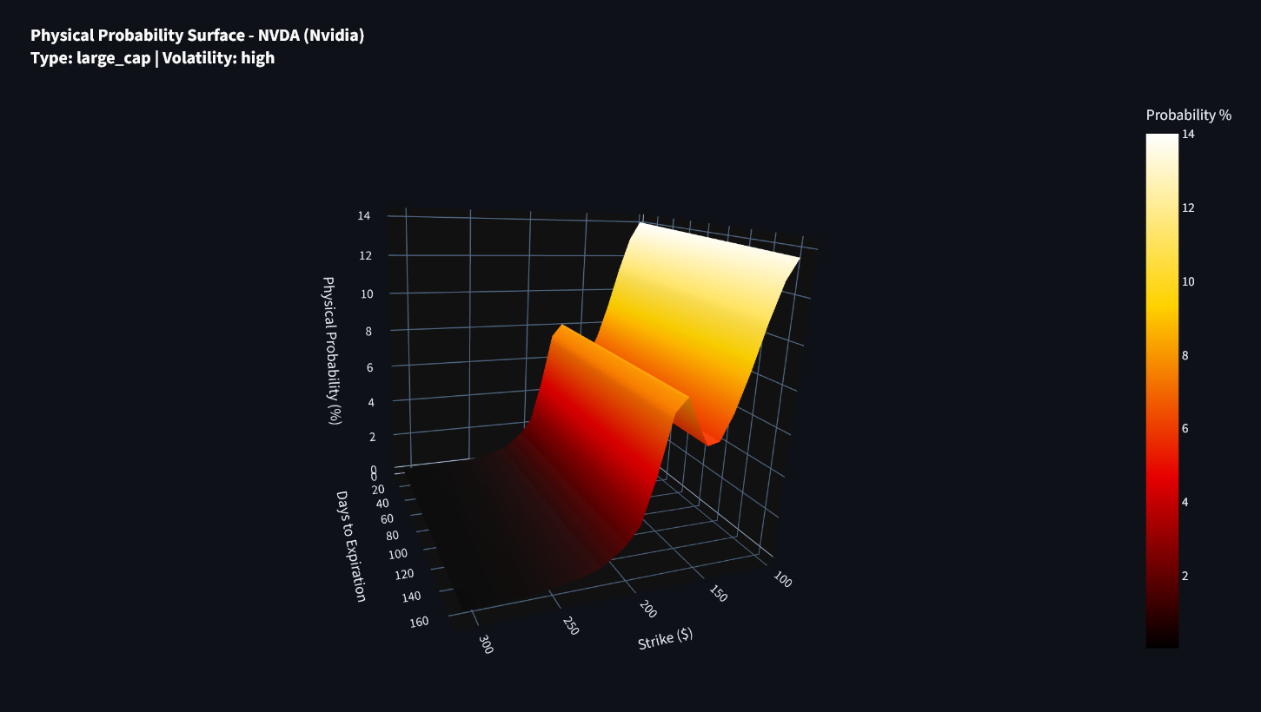
- Estimates the probability of the price of Nvidia in the future
- Probability drops sharply for strikes above ~200 and below ~140 showing that this is an unlikely extreme move.
- There is a small hump near ~160–180 meaning market thinks this region is a realistic future price zone.
How would we use this information:
- If IV is low but REAL probability is high: option is underpriced and you should BUY
From Example:
- Around ~160–180 strike, probability is high
- IV there is not extremely high

- If IV is high but the REAL probability is low: option is overpriced and you should SELL
- If both probability AND IV are low: expect nothing significant

Summery:
- IV surface = what the market THINKS will happen.
- Probability surface = what is LIKELY to happen in real life.
- Where they disagree = opportunity.

