


Submitted By
Abik maharjan
Dipesh Shrestha
Loozala Bajracharya
Saugat Maharjan
Urjala Pariyar

TABLE OF CONTENTS

LIST OF TABLES II
LIST OF FIGURES III
CHAPTER 1: INTRODUCTION 1
1.1 Introduction 1
1.2. Problem Statement 1
3. Objectives 2
4. Methodology 2
a. Requirement Identification 2
i. Study of Existing System / Literature Review 3
ii. Requirement Analysis 4
b. Feasibility Study 6
i. Technical Feasibility 7
ii. Operational Feasibility 7
iii. Economic Feasibility 7
iv. Schedule Feasibility 8
c. High level Design of system 9
i. Methodology of proposed system 9
ii. Flow chart 9
iii. Architectural Design of the system 11
iv. Working Mechanism of proposed system 12
v. Description of Algorithms 13
5. Expected outcomes 18
6. References 19

LIST OF TABLES

Table 4.1: Estimated Project Schedule 8
Table 4.2: Frequency Category 14
Table 4.3: Recency Category 14
Table 4.4: Parameters used for Vincenty’s Algorithm 15

LIST OF FIGURES

Fig 4.1: Use Case Diagram of Blood Donor Recipient Matching System 6
Fig 4.2: Gantt Chart of Project Schedule 9
Fig 4.3: Flowchart of Blood Donor and Recipient Activity 11
Fig: 4.4 Architectural Design of Blood Donor-Recipient Matching System 12

—

KJKJK

f
f
f
f
f
j

CHAPTER 1: INTRODUCTION

1.1 Introduction
Blood is a lifesaving and essential element in various clinical situations including surgery, accidents, difficult childbirth, or other medical conditions. However obtaining compatible blood donors remains challenging, especially in developing nations such as Nepal. The project Smart Blood Donor-Recipient Matching System, named BloodLink is a web-based program that uses modern technologies to provide functionalities necessary to aid and improve the blood donation procedure. The system matches recipient with eligible donors based on blood group compatibility, distance, and donor health information. It uses Vincenty’s algorithm to calculate the geographical proximity between donors and recipients and optionally uses Naive Bayes machine learning model to predict whether donor will be willing to donate or not, based on factors such as total donations and recency of the last donation. The system also offers a user-friendly interface for donors and recipients to register, request or donate blood, chat with one another, integrated through Socket programming, and receive push notifications. It gives admin access to manage users, requests, match logs, donation logs and collect new training data to improve machine learning model over time.
Hence, BloodLink integrates the location-based intelligence, predictive analysis, and real-time communication to make blood donation faster, smarter, and reliable. It not only helps to increase operational efficiency but also towards long-term infrastructure building which is sustainable and data-driven for blood management in Nepal, and other developing countries.

1.2. Problem Statement
The existing blood donation and transfusion system in Nepal are largely manual, time-consuming, and inefficient due to outdated record keeping and lack of intelligent donor-recipient matching mechanisms. In emergency situations, patients or their families often rely on manual methods such as contacting hospitals, blood banks, or posting on social media to find donors. This could take a day or more and even lead to failure to find compatible donors in time. During blood shortage, onsite replacement donations are done by friends and family of the patient. After the blood is collected, they are tested to confirm safe transfusion to patients. Patients in need of blood and its products, are responsible for arranging blood for medical procedures on their own in almost all hospitals. This leads to chaotic, stressful and emotionally draining blood-search process especially during emergencies. Patients’ families need to figure out where the blood banks are located and which one has the blood type they need in stock [1]. Even within hospital settings in Nepal, coordination delays and insufficient communication are significant challenges. For example, a study observing bedside blood transfusions in two tertiary hospitals found that over 53% of transfusions were delayed by more than two hours from dispatch to actual transfusion [2].
Moreover, there is no centralized platform that can intelligently connects donors and recipients based on factors like blood type compatibility, location proximity, donor health condition, and willingness to donate. This gap highlights the urgent need for a smart, real-time, and automated solution that can improve the speed, efficiency, and coordination of the blood donation process.

3. Objectives
The primary objective of this project is to develop a smart web-based system that enhances the efficiency, accuracy, and responsiveness of blood donor-recipient matching in Nepal. The system seeks to address the limitations of traditional practices and contribute to the digital transformation of healthcare services. The specific objectives are as follows:
- To develop a centralized digital platform that connects blood donors and recipients in real time through a user-friendly and accessible web interface.
- To integrate geolocation and machine learning technologies for intelligent donor-recipient matching based on proximity, eligibility, and predicted willingness to donate.
- To replace traditional manual practices with an automated, secure, and traceable system that improves coordination, logging, and overall transparency in the blood donation process.

4. Methodology

a. Requirement Identification
For the development of the Smart Blood Donor-Recipient Matching System, requirement identification was carried out through the study of existing systems, literature review, observation of traditional methods used in Nepal, and identification of gaps that modern technology can address. This step formed the foundation for system design and requirement Identification.

i. Study of Existing System / Literature Review
To effectively design a Smart Blood Donor-Recipient Matching System, existing blood donation platforms were analyzed, particularly those relevant to the Nepali context.
One notable initiative is the Nepali Blood Donor (NBD) App, a mobile-based platform aimed at addressing the regular demand for blood . The application aspires to function as a digital blood bank by integrating various health services.
NBD has served as a valuable foundation for digitizing blood-related services in Nepal. Currently, available services of NBD are: Find Donors near to your location, Request Post and Share Blood Request, Find Ambulance near to your location, Event Management(Add and Share Events), News and Blogs, Profile and History Management, Generating donor card and Registering as member of NBD [3]. However, several critical limitations have been identified in the NBD system:
- No proximity-based intelligent matching: While users can browse donors or blood banks near them, the app lacks geolocation-powered filtering.
- No predictive donor analysis: The system does not predict donor willingness rather show all donors in their area.
- No donor filtering: The blood donors are not filtered based on their health status but just based on blood group.
In addition to the Nepali Blood Donor (NBD) app, another significant initiative in Nepal is Hamro LifeBank. HLB works closely with blood banks to maintain their information and also recruit, engage and retain donors as per the demand. Folks in search of blood can get access to blood availability info [4]. Its primary focus is on connecting patients in need of blood with hospitals and blood banks, rather than directly with individual donors.
- No direct donor-recipient matching as need to connect through blood banks and hospitals.
- No geolocation-based prioritization of nearby individual donors.
- No predictive analysis to assess donor willingness.
- Manual coordination still needed between hospitals, banks, and volunteers.
In contrast, the Nepal Red Cross Society (NRCS) has been running a manual blood transfusion service since 1966. With a network across 108 locations in 73 districts, NRCS has supplied over 4 million units of blood and components. Their focus is on timely supply of blood and blood products through voluntary non-remunerable blood donation to meet the transfusion requirements of the people of Nepal [5], but the system lacks a digital, intelligent matching approach.
The proposed Smart Blood Donor-Recipient Matching System seeks to bridge this gap by creating a geolocation-based, predictive, real-time matching system that connects individual donors and recipients directly, quickly, and efficiently tailored specifically to Nepal's needs.

ii. Requirement Analysis
Based on the study of existing systems, literature, and the current challenges in Nepal's blood donation infrastructure, the following requirements have been identified for the proposed Smart Blood Donor-Recipient Matching System.
Functional Requirements
These are core features that the system must perform to fulfill its intended purpose:
- User Registration and Authentication
Donors and recipients must be able to register and securely log in.
- Profile Management
Users should be able to update personal information and health history.
- Blood Request Creation
Recipients must be able to submit a blood request specifying blood group, urgency, hospital location, and other relevant details.
- Automated Donor Matching
The system should automatically match requests with eligible donors based on:
Blood group compatibility, Donor eligibility (health, donation gap, etc.), Geographic proximity, Donor willingness based on past behavior.
- Eligibility and Willingness Prediction
Donor eligibility should be predicted based on historical data such as age, weight, medical conditions whereas willingness is predicted using past behavior and willingness score.
- Chat Functionality Between Donor and Recipient
Once a donor accepts a request, a chat interface should be enabled between the donor and the requesting recipient for coordination.
- Real-Time Request Alerts
The system will enable notification of urgent blood requests to matched donors, accepted request, real-time chat.
- Admin Dashboard
Admins should have access to overall system statistics, manage users, and monitor ongoing requests.
- Donation Review
After a successful donation, recipients should be able to leave a review for the donor. Donors should be able to view these reviews in their profile.
- Donation History Tracking
User should be able to view a detailed history of their past donations including review feedback.

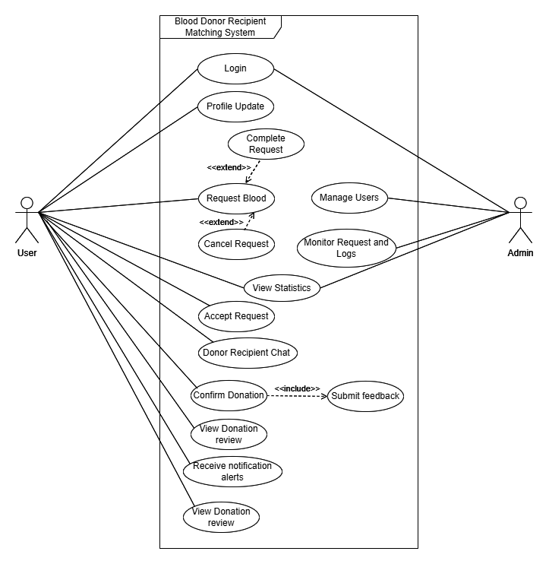

Fig 4.1: Use Case Diagram of Blood Donor Recipient Matching System

Non Functional Requirements
In addition to functional features, the system must exhibit key non-functional qualities to ensure its effectiveness in real-world scenarios. These characteristics define how well the system performs under expected conditions and how it responds to growth and usage challenges. The non-functional requirements for the proposed system are as follows:
- Usability
The system should have a simple and intuitive interface that works well on both mobile and desktop platforms, as most users (donors/recipients) may access it via smartphone.
- Performance
Blood request submissions and donor matching should respond within a few seconds to avoid delay, especially for urgent cases.
- Security and Privacy
Sensitive user data must be securely stored and accessible only to authorized users. Token-based authentication like JWT should be used to protect session security.
- Maintainability
The system should be built with modular code structure, making it easy to fix bugs or introduce new features like improved donor ranking or chat updates.

b. Feasibility Study
The feasibility of the Smart Blood Donor-Recipient Matching System has been evaluated across four different areas:

i. Technical Feasibility
The proposed system is technically feasible using widely available open-source technologies. The frontend is built with React.js to provide a responsive and user-friendly interface, while the backend uses Node.js with Express for handling business logic, authentication, and database operations. MongoDB manages user profiles, health records, blood requests, donation history, and matching logs. The system incorporates a Naive Bayes model developed in Python for predicting donor willingness, which is integrated with the backend to enable intelligent matching.
Geolocation features are implemented using OpenStreetMap to prioritize nearby donors and improve emergency response times. Security is ensured through JWT-based authentication and role-based access control, protecting user data and privacy. All tools and frameworks used are free or open-source for academic purposes, making the solution cost-effective. The development team possesses the necessary technical skills in web application development and machine learning techniques (notably the Naive Bayes algorithm used in this system) to successfully develop this system.

ii. Operational Feasibility
The system is operationally feasible as it directly addresses existing challenges in Nepal’s blood donation process. By facilitating real-time, direct connections between donors and recipients, it minimizes delays and eliminates the need for third-party intermediaries such as hospitals or blood banks.
It is designed with a user-friendly web interface, the system ensures easy access for donors, recipients, and administrators, including those with limited technical knowledge. It is particularly effective in emergency situations by automating donor searches using intelligent matching and timely notifications, thereby reducing the time typically lost in manual communication.

iii. Economic Feasibility
The proposed system is economically feasible as an academic prototype, leveraging open-source and free tools that minimize development costs. During the initial phase, maintenance expenses remain low, with potential scaling costs assessed later based on real-world deployment, especially if deployed for public or institutional use.
Beyond cost considerations, the system offers significant social return on investment by facilitating timely blood donations, improving donor engagement, and alleviating pressure on hospitals during emergencies. Future collaborations with government agencies, hospitals, and NGOs could support broader deployment, ensuring sustainability and cost-effectiveness at a national level.

iv. Schedule Feasibility
The project schedule is feasible and has been carefully structured to ensure timely completion of all phases within the available academic timeframe. The project is planned over a period of approximately two to three months between June to August.

Table 4.1: Estimated Project Schedule
Phase | Start Date | Duration (days) | End Date
Project Planning | 15-May-25 | 3 | 17-May-25
Requirement Gathering | 18-May-25 | 4 | 21-May-25
ML Data Collection | 22-May-25 | 3 | 24-May-25
System Design (UI & DB) | 25-May-25 | 4 | 28-May-25
Frontend & Backend Development | 29-May-25 | 45 | 12-Jul-25
ML Model Development & Integration | 15-Jun-25 | 4 | 18-Jun-25
Geolocation & Matching Logic | 19-Jun-25 | 3 | 21-Jun-25
Testing & Bug Fixing | 13-Jul-25 | 12 | 24-Jul-25
Documentation and Report Preparation | 25-Jul-25 | 6 | 30-Jul-25

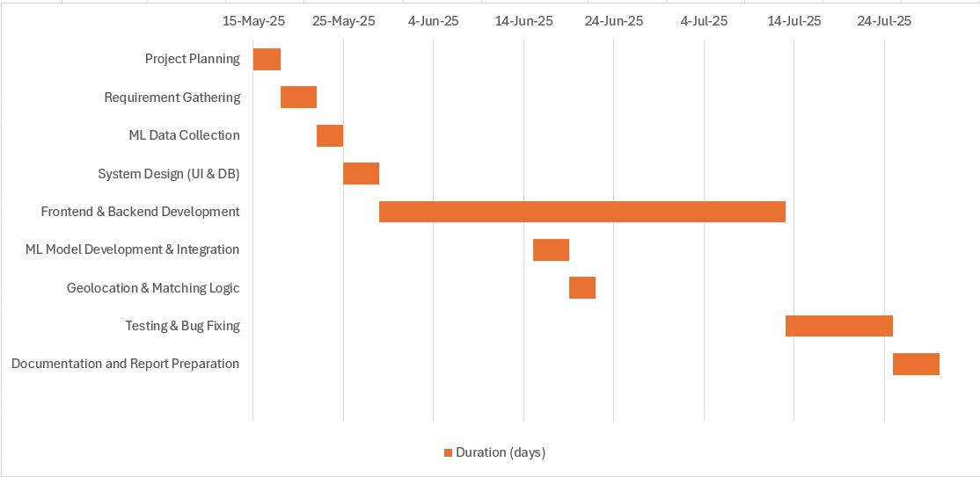

Fig 4.2: Gantt Chart of Project Schedule

c. High level Design of system

i. Methodology of proposed system
The system was developed using a modified Waterfall model due to its simplicity and suitability for academic projects with a defined scope and timeline. Unlike Agile, which requires frequent client feedback and flexible requirements, our project had clear goals from the start. Minor overlaps between phases (e.g., testing during development, ML integration during API development) made it more efficient than the traditional Waterfall approach.

The major steps followed were:
Requirement Identification: Gathering system needs by studying existing platforms and identifying gaps like lack of smart real time matching.
System Design: Designing UI, database schema, and overall architecture for frontend, backend, and ML integration.
Development: Building frontend (React.js), backend (Node.js/Express), APIs, and integrating geolocation and a custom-built Naive Bayes model.
Testing: Performing functional and integration testing to ensure reliability.
Documentation & Reporting: Preparing system documentation and compiling the final project report.
This structured approach ensured clarity, timely progress, and alignment with the project's technical and academic goals.

ii. Flow chart
The Smart Blood Donor-Recipient Matching System starts when a recipient submits a blood request by providing details like blood type and urgency. The system then validates the request and filters eligible donors based on eligibility criteria. It uses a machine learning model to predict willingness. After identifying suitable donors, it calculates distances using the Vincenty algorithm to find those nearby. Matched donors are notified, and if any accept the request, the system connects them with the recipient. The donor and recipient may star a conversation through real time chatting. Once the donation is confirmed recipient submits the review to the donor, then the donation history are updated. The process is completed with Complete or End request followed by the system updating the request and matching logs.

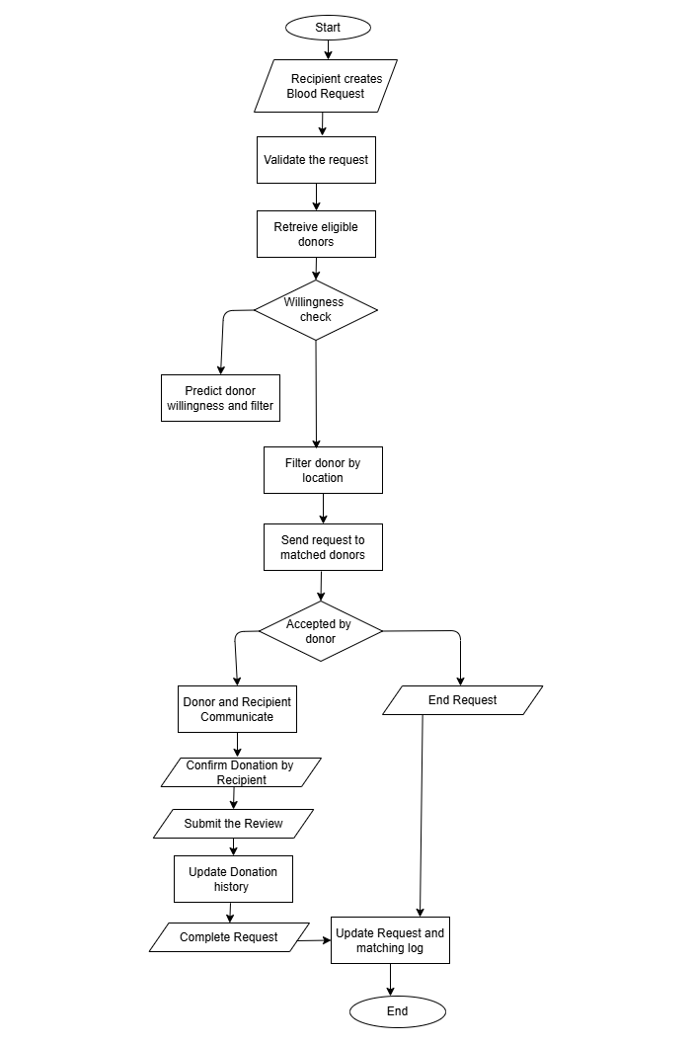

Fig 4.3: Flowchart of Blood Donor and Recipient Activity

iii. Architectural Design of the system
The system follows a client-server architecture based on the MERN stack (MongoDB, Express.js, React.js, Node.js). The frontend client (React) handles user interaction and communicates with the backend server (Express/Node.js) through RESTful APIs. The server manages business logic, authentication, database operations, and machine learning predictions.
The machine learning was implemented using Python's Naive Bayes classifier, was trained offline. The calculated probabilities (prior, likelihood) were exported as a JSON file and imported into the server, where predictions are made dynamically based on requests. The system also uses an external API (Nominatim/OpenStreetMap) from the client side for geolocation features. MongoDB serves as the primary database for storing user, health, request, matching logs, message and donation data. This architecture ensures modularity, scalability, and easy future enhancements.

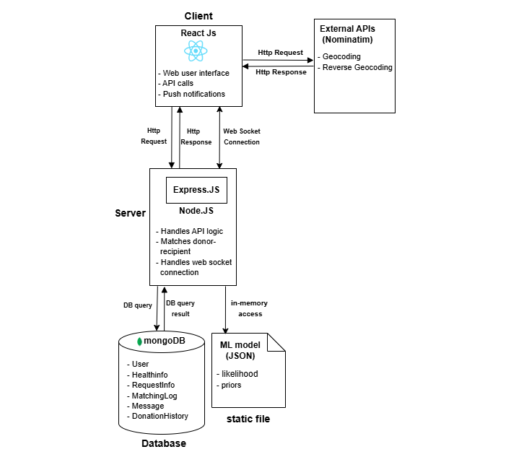

Fig: 4.4 Architectural Design of Blood Donor-Recipient Matching System

iv. Working Mechanism of proposed system
The Smart Blood Donor-Recipient Matching System is a web-based platform that enables efficient and intelligent blood donation matching. The system works through the following key steps:
- User Registration and Profile Setup
Donors and recipients register through the platform, providing basic personal information. Donors also enter health data, donation history, and location details.
- Blood Request Posting
When a recipient needs blood, they fill out a request form specifying blood type, urgency, and location. This request is saved in the system.
- Donor Filtering and Matching
The system filters available donors based on:
  - Blood group compatibility
  - Geographic proximity using Vincenty Algorithm.
  - Eligibility and willingness, predicted using a Naive Bayes model trained on historical donor data
- Request sent to Donors
Request is sent to all matched eligible donors who responds to the requests.
- Request Status Tracking
Once a donor accept the request the recipient is notified, and both can coordinate the donation and may start a conversation. Admins can also monitor and update request statuses as Pending, Completed, or Cancelled.
- Donation Record and Feedback
Once the donation is completed, the recipient selects "Complete Donation" and submits a short review of the donor. This feedback is saved as part of the donor’s donation history.
- Request Completion
After recording the donation and review, the recipient marks the request as Completed, officially closing it. If the donation doesn’t occur, the status can be set to Cancelled.
- Data Logging and History
The system records request history, donations made, and user activity for future reference and analytics.

This mechanism ensures real-time, intelligent, and location-aware donor-recipient matching, reducing delay and manual coordination in emergency situations.

v. Description of Algorithms
The proposed system uses two main algorithms: Categorical Naive Bayes for predicting donor willingness and Vincenty’s formula for calculating geolocation-based distance between donors and recipients.
1. Categorical Naive Bayes Classification for Donor Willingness Prediction
The Smart Blood Donor-Recipient Matching System uses a Categorical Naive Bayes classifier to predict whether a donor is likely to respond positively to a blood request. This helps prioritize available, eligible, and willing donors during matching.
The model is trained using the Blood Transfusion Service Center Dataset obtained from the UCI Machine Learning Repository. The original dataset comprises the following features:
- Recency: Number of months since the last donation
- Frequency: Total number of donations
- Monetary: Total volume of blood donated (in c.c.)
- Time: Number of months since the first donation
In this model, Monetary and Time are dropped because due to redundancy and low impact on willingness prediction.
- Monetary is directly derived from Frequency (volume per donation (250) × frequency), offering no additional predictive value.
- Time was found to be highly correlated with Frequency and contributed little additional predictive power to the model.
Since Categorical Naive Bayes requires discrete categorical inputs, the continuous numerical features were transformed using fixed binning.

Range (Donations) | Category
0-2 | Rare
3-8 | Occasional
9-18 | Regular
19-25 | Active
>25 | Veteran
Table 4.2: Frequency Category
Table 4.3: Recency Category
Range (Months) | Category
2-4 | Very Recent
5-7 | Recent
8-12 | Moderate
>12 | LongAgo

Mathematical Formula:
Naive Bayes uses the following formula to calculate the posterior probability:
P(C | X) = $\frac{P\left(C\right).\prod_{i=1}^{n}{P(x_{i} | C)}}{P(X)}$
Where:
- P(C∣X): Posterior probability of class C (willing or not willing) given input features X
- P(C): Prior probability of class
- P(x_{i}∣C): Likelihood of feature xi given class C
- P(X): Marginal probability of input (same across classes, can be ignored for comparison). However in our case we didn’t exclude since we need to compare with threshold probability.
While marginal probability P(X) is often omitted in standard classification (as it's the same across classes), it is explicitly computed in this system This is necessary because the model's final output a willingness score is compared against a predefined decision threshold derived from a 1–5 scale representing levels of donor willingness. The model calculates posterior for both classes (willing = 1, not willing = 0), normalizes them using marginal probability P(X), and selects the class based on the threshold. When a donor-blood request match is initiated, the system:
- Accepts donor inputs (recency and frequency).
- Applies the Naive Bayes calculation.
- Returns a predicted probability.
- Compares this probability to the threshold.
- Integrates the result with other modules such as eligibility filtering, blood type compatibility, and geolocation ranking to finalize matching decisions.
This modular integration ensures that the donor's behavioral willingness is used not in isolation, but in coordination with medical and geographic constraints, thus improving the the matching process.

2. Vincenty Algorithm for Donor-Recipient Distance Calculation
To ensure that blood requests are matched with geographically nearby donors, the system uses the Vincenty formula to compute the geodesic distance between the recipient and potential donors based on their latitude and longitude coordinates.
The formulae were developed by Thaddeus Vincenty for calculating geodesic distances between a pair of latitude/longitude points on an ellipsoidal model of the Earth.
Unlike the Haversine method for calculating distance on a sphere, these formulae are an iterative method and assume the Earth is an ellipsoid [6], providing highly accurate distance calculations especially over long distances.

Table 4.4: Parameters used for Vincenty’s Algorithm
Symbols | Meaning
a | Semi-major axis of the Earth ellipsoid (in meters)
b | Semi-minor axis of the Earth ellipsoid (in meters)
f | Flattening of the ellipsoid
ϕ1​, ϕ2​ | Latitude of point 1 and point 2 (in radians)
λ1​, λ2 | Longitude of point 1 and point 2 (in radians)
U1​, U2​ | Reduced latitudes of point 1 and point 2 (adjusted for flattening)
L | Difference in longitude: λ2−λ1
λ | Difference in longitude of the points on the auxiliary sphere
σ | Angular distance between the two points on the ellipsoid
α | Azimuth angle at the equator
σ_{m} | angular distance on the sphere from the equator to the midpoint of the line.
A, B | Coefficients derived from u²
Δσ | Correction term applied to the angular separation
d | Geodesic distance between two points (in meters)

After identifying a potential match between a donor and a blood request, system needs to determine how far apart the two individuals are in real-world distance. This is where the Vincenty distance formula is applied. The parameters used in this algorithm, in Table 4.2, are mapped to actual project data as follows:
- ϕ₁, ϕ₂ (Latitude of point 1 and point 2):
These represent the geographical latitudes (in radians) of the two individuals. ϕ₁ corresponds to the recipient’s latitude, which is extracted from the blood request, and ϕ₂ refers to the donor’s latitude, which is retrieved from the donor’s profile.
- λ₁, λ₂ (Longitude of point 1 and point 2):
Similar to the latitudes, λ₁ and λ₂ are the longitudes of the recipient and donor respectively, also in radians. These are used to compute the longitudinal separation (east-west) between the two points.
- a (Semi-major axis):
A constant (≈ 6378137 m) representing the Earth’s radius at the equator. This value doesn’t change and is used to model the Earth’s shape for accurate distance calculation.
- f (Flattening of the ellipsoid):
A constant (≈ 1/298.257223563) that accounts for the Earth's slight flattening at the poles. This ensures our system does not treat Earth as a perfect sphere.
- b (Semi-minor axis):
This is the polar radius of the Earth. It is also a constant and is derived using the semi-major axis and the flattening factor. It helps define the shape of the ellipsoid used in the Vincenty formula.
- U₁, U₂ (Reduced latitudes):
These are intermediate values derived by adjusting ϕ₁ and ϕ₂ using the flattening factor f. They provide a reduce representation of latitude on an auxiliary sphere.
- L (Difference in longitude):
This is the raw difference between λ₂ and λ₁, i.e., the difference in longitude between the donor and recipient.
- λ (Longitude difference on the auxiliary sphere):
Iteratively adjusted version of L used for precise path computation.

- σ (Angular distance on the ellipsoid):
Represents the angle formed at the Earth's center between the two points (donor and recipient) on the ellipsoid surface.
- α (Azimuth angle at the equator):
The direction of travel (angle) if one were to move from the recipient toward the donor along the shortest path.
- σ_{m} (Angular distance to midpoint):
Helps refine the calculation by determining the halfway point on the path between the donor and recipient.
- A, B (Ellipsoid coefficients):
Calculated from intermediate values, these coefficients help fine-tune the final angular distance and correct the geodesic path.
- Δσ (Correction term):
A mathematically derived adjustment that compensates for distortions due to Earth’s shape. It ensures that the angular distance σ becomes highly accurate.
- d (Geodesic distance):
This is the final output of the Vincenty formula, the real-world distance in meters between the donor and recipient. This is converted to kilometers and is used to filter out donors who are too far away from the recipient.
Algorithm Flow in the system:
- Retrieve coordinates of the potential donors from the database.
- Convert latitude and longitude from degrees to radians.
- Calculate reduced latitudes U₁​ and U₂, which adjust for Earth’s flattening:
U_{i} = arctan((1-f) * tan ϕ))
- Initialize λ=L the difference in longitude.
- Iterate to solve for λ until it converges using trigonometric relations involving U1, U2 and λ
- Compute σ, the angular distance and α, the azimuth.
- Calculate auxiliary variables u², A, B, Δσ to correct for the ellipsoidal shape.
- Finally, compute the distance in meters which is later converted in kilometers.
d=b⋅A⋅(σ−Δσ)
This distance d is then used by the system to find donors within a search distance defined by the recipient, ensuring efficient matching.

5. Expected outcomes
The Smart Blood Donor-Recipient Matching System is designed to modernize and streamline the blood donation process in Nepal. By integrating intelligent matching algorithms, real-time geolocation, and predictive analytics, the system aims to significantly improve the speed, accuracy, and reliability of connecting donors with those in urgent need. The system is expected to provide a user-friendly and responsive web interface that enables recipients, donors to seamlessly connect and administrators to manage, track and oversees the operations. The system is built on a secure and scalable architecture employing role-based access control with JWT authentication, ensuring reliable access management and data protection.
Significant improvements in efficiency and accuracy are expected through the use of a categorical Naive Bayes model that intelligently predicts donor willingness based on historical donation patterns. This model filters out unwilling donors while minimizing false negatives, reducing the chance that potential donors are mistakenly excluded. Although current data limitations restrict the training set, the model is expected to achieve approximately 75% accuracy, prioritizing higher recall to identify all suitable donors even at the cost of some false positives, thereby minimizing missed donation opportunities.
For geographical proximity, the system uses Vincenty’s formula to calculate geodesic distances on an ellipsoidal Earth model with exceptional precision typically accurate within 0.5 millimeters. This ensures that only donors who are geographically close enough to respond quickly are considered, minimizing critical delays in emergencies.
Additionally, the modular design supports seamless future integration with hospitals, blood banks, and the national health infrastructure, enhancing the system’s adaptability and long-term viability. As a prototype, this system lays a strong foundation for national expansion, aiming to become a key component of Nepal’s public health infrastructure. Overall, it is expected to make the blood donation process smarter, faster, and more life-saving, setting the stage for long-term, technology-driven improvements in healthcare delivery.

6. References

[1] | Hamro LifeBank, "Report on Blood Managment System of Nepal & Future Possibilities," Kupandole,Lalitpur, 2019.
[2] | A. Sapkota, S. Poudel, A. Sedhain and N. Khatiwada, "Blood Transfusion Practice among Healthcare Personnel in Nepal: An Observational Study," 2018.
[3] | Nepali Blood Donor, "Nepali Blood Donor," [Online]. Available: https://nepaliblooddonors.com/. [Accessed May 2025].
[4] | Hamro LifeBank, "Hamro LifeBank," [Online]. Available: https://www.hamrolifebank.com/. [Accessed May 2025].
[5] | Nepal Red Cross Society, "Blood Transfusion Service," [Online]. Available: https://nrcs.org/blood-transfusion-service/. [Accessed May 2025].
[6] | NeoVa Solutions, "Haversine vs Vincenty – Which Is the Best?," [Online]. Available: : https://www.neovasolutions.com/2019/10/04/haversine-vs-vincenty-which-is-the-best/. [Accessed May 2025].
[7] | J. Han, M. Kamber, J. and Pei, in Data Mining: Concepts and Techniques, 3, Ed., Morgan Kaufmann (an imprint of Elsevier), 2012, pp. 351-353.
[8] | T. Vincenty, "Direct and Inverse Solutions of Geodesics on the Ellipsoid with Application of Nested Equations," Survey Review, vol. XXIII, no. 176, 1975.
[9] | M. Kennedy, "Distance on an ellipsoid: Vincenty’s formulae," Esri Community, [Online]. Available: https://community.esri.com/t5/coordinate-reference-systems-blog/distance-on-an-ellipsoid-vincenty-s-formulae/ba-p/902053. [Accessed May 2025].
[10] | I.-C. Yeh, "Blood Transfusion Service Center Data Set," 2019. [Online]. Available: https://archive.ics.uci.edu/dataset/176/blood+transfusion+service+center. [Accessed May 2025].

