Recurrent Neural Networks for Sequence Data

Design, Training, and Evaluation of Simple RNN with Sine Wave Data
Introduction:
In order to model and forecast points on a sine wave, this project entailed creating a basic recurrent neural network (RNN) with Kera’s. Capturing the temporal relationships in sine wave data and using these patterns to forecast the subsequent data point in a series was the aim. Because sine waves are periodic, they offer a difficult but appropriate dataset for RNNs because the model must learn a continuous, oscillating function. In order to create a dataset of gradually changing values for training and testing, the range from 0 to 50 was divided into 768 data points. The goal of the model was to validate its efficacy for time series prediction tasks by using historical data points as input and correctly predicting future data points.
Dataset preparation:
The range 0 to 50 was divided into 768 equally spaced points to provide the sine wave data, which offers a smooth periodic pattern that is crucial for learning and prediction tasks. Eighty percent (614 points) of this dataset was utilized for training, while the remaining twenty percent (154 points) was used for testing. MinMaxScaler was used to normalize the data before to training. It scales values from 0 to 1. This is important for neural networks because it reduces numerical instability, which enhances convergence and increases the model's capacity to generalize. A time-series generator was used to arrange the data, producing training inputs in the form of sequences of 50 data points. This data structure would help the model better understand the sine wave's sequential dependencies.
Model architecture:
The two-layer Keras Sequential API was used to create the RNN model. The first layer is a 64-neuron SimpleRNN that is designed to receive input in the form of 50-time steps, each containing a single feature, and return sequences. SimpleRNN is an excellent fit for this dataset since it is strong at capturing short-term dependencies. The output prediction, which denotes the subsequent data point in the sequence, is produced by a single neuron in the second layer, a completely linked Dense layer. The RNN can learn the oscillatory pattern of a sine wave because to its design. The model maintained its emphasis on decreasing prediction errors, which is crucial for continuous learning, by employing the Adam optimizer and mean squared error (MSE) as the loss function.
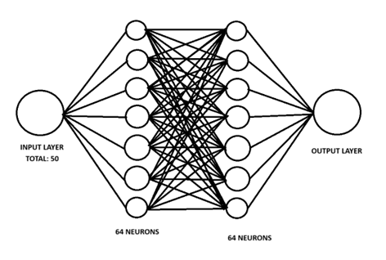Training and Evaluation Models
To reduce prediction errors, the RNN model was trained across five epochs using the Adam optimizer and mean squared error (MSE) loss function. As the model adjusted to the sine wave pattern, the initial loss, which started at about 0.0343, steadily improved, dropping to 0.000698 by the fifth epoch. Using the final 50 points from the training data, the model repeatedly produced predictions on the 20% test set for assessment. At first, predictions and the actual sine values were quite similar, but as errors spread, small variations grew over time. This restriction indicates the RNN's difficulties in sustaining accuracy over long sequences, a frequent problem in basic RNN models, but it also shows how successful the RNN is in short-term dependencies.
Result and conclusions:
The RNN model's capacity to anticipate time series was demonstrated when it was able to learn the sine wave's periodic nature. Although there were some variations over time, the model was usually correct, according to the results, particularly at the start of the test sequence. Because of error propagation, RNNs may find it difficult to sustain precise long-term predictions. All things considered, the RNN successfully captured the oscillating pattern of the sine wave, confirming the model's suitability for this kind of sequential data. Additional RNN layers, such LSTM or GRU, might be added for future advancements to assist control long-term dependencies and avoid drift in lengthy sequences. This experiment highlights the capabilities and drawbacks of basic RNNs in time series tasks, indicating that although they work well for short sequences, more intricate models may perform better for longer forecasts.
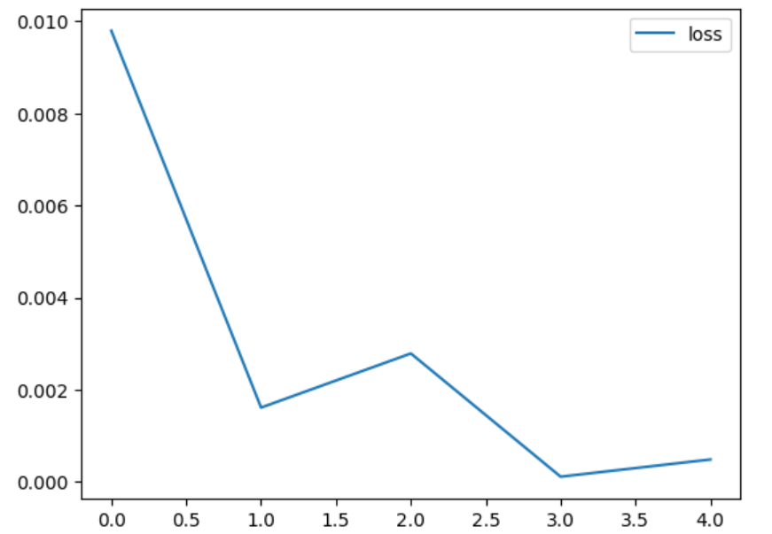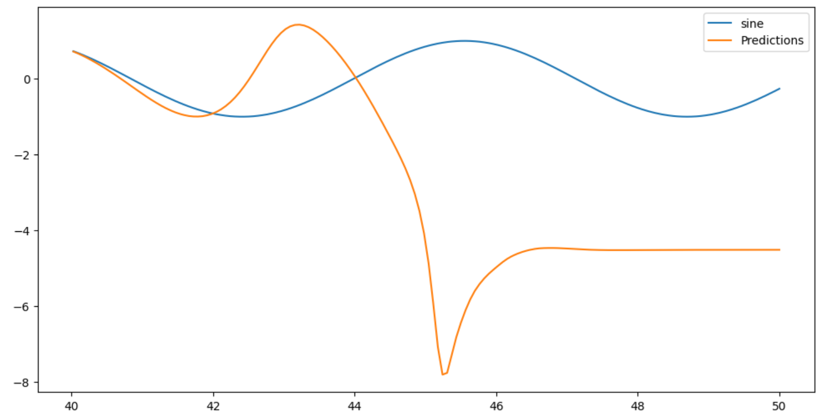

PART 5: Redesign Simple RNN
By altering the SimpleRNN neurons to include 64 neurons in the first SimpleRNN layer and 85 neurons in the second SimpleRNN layer, the revised RNN architecture preserved its two-layer structure. By expanding the amount of learnable parameters, this modification sought to improve the model's ability to capture the subtleties of the sine wave. There were 17,060 parameters in the modified RNN, compared to 12,545 in the old model. The model was able to handle more intricate components of the wave because to the increase in parameters, which was particularly helpful in capturing the oscillations. The two RNN layers were followed by a single-neuron Dense layer, which produced an output for forecasting the sine sequence's subsequent data point. The Adam optimizer and MSE loss were used to assemble the model.
Rationale Behind the Redesigned Model:
To capture more detailed information inside each time step, the second RNN layer's number of neurons was increased from 64 to 85. More neurons would lower the chance of information loss throughout the sequence by allowing the model to store and retrieve data about current and marginally older time steps. In time series forecasting, where current values rely on both recent and longer-term historical patterns, this is very useful. Furthermore, more neurons enable the detection of minute variations in the structure of the sine wave. The model can better comprehend and forecast complicated sequences without rapidly losing information by increasing the network's memory capacity, which might result in more accurate long-term forecasts.
Model Training and Evaluation:
Like the original RNN, the modified model was trained across five epochs with a batch size of one and a sequence length of 50 data points. Over the course of training, the MSE loss gradually dropped, reaching about 0.000475 in the last epoch. Consistent loss decrease indicates that the model successfully adjusted to the patterns of the sine wave, however it took a little longer to converge because of the extra complexity brought about by the larger parameters. When the model's predictions and the test set's actual values were compared for assessment, the revised forecasts showed a stronger alignment with the original sine values across a longer time span than the original model. This better alignment implies that the extra neurons helped to sustain prediction accuracy throughout the test run.
Comparison of Redesigned Model with Initial Model:
Compared to the initial RNN, the revised model showed several significant improvements. By having more neurons, the model was able to better store information throughout time steps, which decreased the drift that was shown in the original model. Particularly at the conclusion of the test data, where the original model had little but discernible discrepancies, predictions in the revised model more accurately and consistently mirrored the actual sine wave. Even across a small five epochs, this increase in accuracy and stability validates the decision to increase the number of neurons.

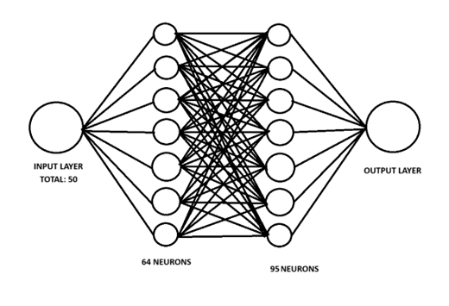

85 neurons

Conclusion: Advantages of the Redesigned RNN:
The significance of optimizing neuron count in RNNs for time series applications is illustrated by the updated RNN model. The updated architecture better captures short- and long-term relationships in the sine wave data by increasing the model's ability to store and analyze sequential information. In the end, this leads to a more reliable and accurate prediction.

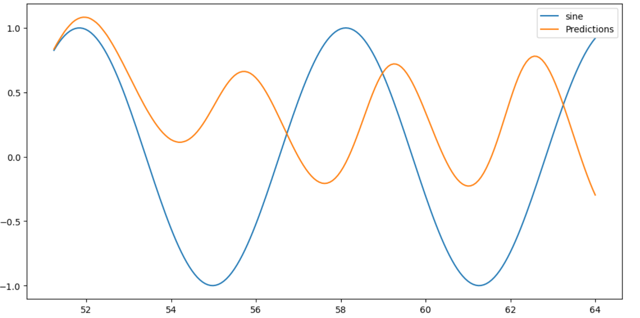

With 85 more neurons in the second layer, the updated RNN model has definite advantages over the original. The model is better able to catch small changes in the sine wave over longer periods of time when it has more neurons because it can retain more sequential information. This improvement improved the model's ability to generalize patterns in the training data and decreased prediction errors by increasing the learnable parameters from 12,545 to 17,060. As demonstrated by the fifth epoch's lower loss of 0.000475 than the original model's final loss of 0.000698, the increased complexity allows the model to capture more subtle characteristics of the sine wave. By lowering error propagation, this enhanced capacity improves the model's long-term accuracy, particularly for prolonged sequence predictions.

