Master’s Thesis

A simulation study on the modulation of information transfer in feedforward networks

Sailamul, Pachaya ( )

Department of Bio and Brain Engineering

KAIST

2015

A simulation study on the modulation of information transfer in feedforward networks

A simulation study on the modulation of information transfer in feedforward networks

Advisor : Professor Paik, Se-Bum by

Sailamul, Pachaya

Department of Bio and Brain Engineering

KAIST

A thesis submitted to the faculty of KAIST in partial fulfillment of the requirements for the degree of Master of Science in Engineering in the Department of Bio and Brain Engineering . The study was conducted in accor- dance with Code of Research Ethics1.

2015. 07. 15. Approved by

Professor Paik, Se-Bum

[Advisor]

1 Declaration of Ethical Conduct in Research: I, as a graduate student of KAIST, hereby declare that I have not committed any acts that may damage the credibility of my research. These include, but are not limited to: falsification, thesis written by someone else, distortion of research findings or plagiarism. I affirm that my thesis contains honest conclusions based on my own careful research under the guidance of my thesis advisor.

Sailamul, Pachaya

.

2015\:: 07� 15�

( )

( )

( )

MBIS

20134765

Sailamul, Pachaya. A simulation study on the modulation of information transfer in feedforward networks.

{:I �'?-. Department of Bio and Brain Engineering . 2015. 20p. Advisor Prof. Paik, Se-Bum. Text in English.

**ABSTRACT**

There are vast amount of correlated neural activities, such as oscillation and synchronization, observed in the brain. These activities are one of the important keys for communication in the brain. However, the questions on how to modulate the synchronization level and how these synchronized activities affect spike transfer from one layer to another layer in different convergent connection conditions are not clearly understood. In this work, we employ computer simulation of realistic neural network to address the questions.

The neural network consists of two layers of conductance based single cell model, source layer and target layer. The interlayer connections follow statistical wiring diagram, for which, strength and connectivity of the connection depend on the distance between the target cell and the source cells which define as Gaussian-Gaussian (GG) rule. For comparison, we built two other convergent connection rules while keeping connection probability constant. One is the constant strength of connection called Uniform-Uniform (UU) rule and another is the random strength of connection that follows negative exponential distribution, Uniform-Exponential (UE) rule. Then, the responses on target layer were measured from various convergent conditions. To study how the synchronization of input contribute to the neuron network’s response, we compared the oscillating input and the static input given to the system.

We showed that output firing rate increases when oscillating input were given to the network despite the average input firing rate were equal to those in static input. Also, we found that when the strong oscillation were given the same level of output response can be made with less connection strength compare to the static case. Next, we discovered that the network with oscillation input can induced more output response. Similarly, the input and output synchronization get stronger when the oscillation input were given. In addition, the different in oscillation and static input were large in UU convergent connection rule compare to the two other rules.

In summary, we found that neural network with Uniform-Uniform convergent connection rules could selec- tively allow spike information from specific synchronization level to be transferred to another layer with least cost of connection compared to the other two rules. This work suggests the combined role of input synchronization level and interlayer connection rules as the key to understand brain connection.

i

**Contents**

|  |  |  |  |  |  |  |  |  |  |  |  |  |  |  |  |  |  |  |  |  |  |  |  |  |  |  |  |  |  |  |  |  |  |  |  |  |  |  |  |  |  |
| --- | --- | --- | --- | --- | --- | --- | --- | --- | --- | --- | --- | --- | --- | --- | --- | --- | --- | --- | --- | --- | --- | --- | --- | --- | --- | --- | --- | --- | --- | --- | --- | --- | --- | --- | --- | --- | --- | --- | --- | --- | --- |
| **Abstract . . .** | **.** | **.** | **.** | **.** | **.** | **.** | **.** | **.** | **.** | **.** | **.** | **.** | **.** | **.** | **.** | **.** | **.** | **.** | **.** | **.** | **.** | **.** | **.** | **.** | **.** | **.** | **.** | **.** | **.** | **.** | **.** | **.** | **.** | **.** | **.** | **.** | **.** | **.** | **.** | **.** | i |
| **Contents . .** | **.** | **.** | **.** | **.** | **.** | **.** | **.** | **.** | **.** | **.** | **.** | **.** | **.** | **.** | **.** | **.** | **.** | **.** | **.** | **.** | **.** | **.** | **.** | **.** | **.** | **.** | **.** | **.** | **.** | **.** | **.** | **.** | **.** | **.** | **.** | **.** | **.** | **.** | **.** | **.** | ii |
| **List of Tables** | **.** | **.** | **.** | **.** | **.** | **.** | **.** | **.** | **.** | **.** | **.** | **.** | **.** | **.** | **.** | **.** | **.** | **.** | **.** | **.** | **.** | **.** | **.** | **.** | **.** | **.** | **.** | **.** | **.** | **.** | **.** | **.** | **.** | **.** | **.** | **.** | **.** | **.** | **.** | **.** | iv |
| **List of Figures** |  | **.** | **.** | **.** | **.** | **.** | **.** | **.** | **.** | **.** | **.** | **.** | **.** | **.** | **.** | **.** | **.** | **.** | **.** | **.** | **.** | **.** | **.** | **.** | **.** | **.** | **.** | **.** | **.** | **.** | **.** | **.** | **.** | **.** | **.** | **.** | **.** | **.** | **.** | **.** | v |

**Chapter 1. Introduction 1**

**1.1 Old Intro . . . . . . . . . . . . . . . . . . . . . . . . . . . . . . . . . . . . .** 1

**1.2 New Intro according to professor on 15.05.29 . . . . . . . . . . . . . . . . .** 1

**1.3 Computational Neuroscience . . . . . . . . . . . . . . . . . . . . . . . . . .** 2

**1.4 Realistic Neural Network simulation . . . . . . . . . . . . . . . . . . . . . .** 2

**1.5 The NEURON simulator . . . . . . . . . . . . . . . . . . . . . . . . . . . .** 2

**1.6 The Correlated Neural Activities; the oscillation and synchronization . . .** 2

**1.7 The Feedforward Network . . . . . . . . . . . . . . . . . . . . . . . . . . .** 2

**Chapter 2. Methodology 3**

**2.1 Generalised model for neural network simulation . . . . . . . . . . . . . .** 3

**2.1.1 Single Cell Model . . . . . . . . . . . . . . . . . . . . . . . . . . . .** 3

**2.1.2 Neural Population Modeling . . . . . . . . . . . . . . . . . . . . . .** 5

**2.1.3 Lateral Connection modelling . . . . . . . . . . . . . . . . . . . . .** 5

**2.1.4 Interlayers connection . . . . . . . . . . . . . . . . . . . . . . . . .** 5

**2.1.5 Parameter Search : Tuning model properties for the desired system**

**to the existing experimental data . . . . . . . . . . . . . . . . . . . .** 5

**2.2 A simulation study on the modulation of information transfer in feedfor-**

|  |  |  |  |  |  |  |  |  |  |  |  |  |  |  |  |  |  |  |  |
| --- | --- | --- | --- | --- | --- | --- | --- | --- | --- | --- | --- | --- | --- | --- | --- | --- | --- | --- | --- |
| **ward** | **networks . . . . . . . . . . . . . . . . .** | **.** | **.** | **.** | **.** | **.** | **.** | **.** | **.** | **.** | **.** | **.** | **.** | **.** | **.** | **.** | **.** | **.** | 5 |
| **2.2.1** | **Introduction and Overall Modelling .** | **.** | **.** | **.** | **.** | **.** | **.** | **.** | **.** | **.** | **.** | **.** | **.** | **.** | **.** | **.** | **.** | **.** | 5 |
| **2.2.2** | **Oscillating Input and static Input . .** | **.** | **.** | **.** | **.** | **.** | **.** | **.** | **.** | **.** | **.** | **.** | **.** | **.** | **.** | **.** | **.** | **.** | 6 |
| **2.2.3** | **The feedforward interlayer connection** |  | **.** | **.** | **.** | **.** | **.** | **.** | **.** | **.** | **.** | **.** | **.** | **.** | **.** | **.** | **.** | **.** | 6 |
| **2.2.4** | **The convergent connection condition** | **.** | **.** | **.** | **.** | **.** | **.** | **.** | **.** | **.** | **.** | **.** | **.** | **.** | **.** | **.** | **.** | **.** | 8 |
| **2.2.5** | **The equivalent condition . . . . . . .** | **.** | **.** | **.** | **.** | **.** | **.** | **.** | **.** | **.** | **.** | **.** | **.** | **.** | **.** | **.** | **.** | **.** | 8 |

**Chapter 3. Results 10**

**3.1 The activity map of target layer shows unique response for each combina-**

**tion of convergent rules and input pattern . . . . . . . . . . . . . . . . . . .** 10

**3.2 The feedforward network with strong oscillation input has highest output**

**firing rate . . . . . . . . . . . . . . . . . . . . . . . . . . . . . . . . . . . . .** 10

**3.3 The Uniform-Uniform model has highest response gain from static input**

**to oscillating input . . . . . . . . . . . . . . . . . . . . . . . . . . . . . . . .** 12

**3.4 The Uniform-Uniform model has highest number of induced spike gain on**

**target layer from one spike in source layer . . . . . . . . . . . . . . . . . .** 13

**3.5 The output spikes in target layer of the Uniform-Uniform model depend**

**on phase-lock to oscillation the most . . . . . . . . . . . . . . . . . . . . . .** 15

**3.6 The Uniform-Uniform model has highest sensitivity to synchronized input because of its optimal distribution of weighting factor . . . . . . . . . . . .** 16

**Chapter 4. Conclusion 19**

**References 20**

**Summary (in Korean) 21**

– iii –

**List of Tables**

**List of Figures**

2.1 Network Sample . . . . . . . . . . . . . . . . . . . . . . . . . . . . . . . . . . . . . . . . . . . 5

2.2 The simple feedforward network with oscillating input and convergent connections. L1:Layer1, L2:Layer2 . . . . . . . . . . . . . . . . . . . . . . . . . . . . . . . . . . . . . . . . . . . . . . . 6

2.3 Input Pattern to the feedforward network. *fc* = 20 Hz, *fosc* = 40 Hz,*Af* =10 Hz for weak oscilla-

tion, and *Af* = 20 Hz for strong oscillation. . . . . . . . . . . . . . . . . . . . . . . . . . . . . . 7

2.4 Types of Convergent Connection Rules; GG - Connection Probability and Connection Strength follows Gaussian distribution, UU - Connection Probability and Connection Strength follows uni- form distribution, UE-Uniform Connection Probability and Random Connection Strength that fol-

lows negative exponential distribution . . . . . . . . . . . . . . . . . . . . . . . . . . . . . . . . 8

2.5 Density map of each type of convergent connection rules. The range of connection is equal to 3 *σ*

of Gaussian distribution in GG rule. . . . . . . . . . . . . . . . . . . . . . . . . . . . . . . . . . 9

2.6 Variation in Convergent Conditions . . . . . . . . . . . . . . . . . . . . . . . . . . . . . . . . . . 9

2.7 The total summation of connection strength were controlled to be same in all convergent rules. . . 9

3.1 The activity matrix shows response of a feedforward network under different condition. Row : Convergent Rules; Gaussian-Gaussian(GG), Uniform-Uniform(UU), and Uniform-Exponential(UE)

, Column : Input pattern; static, weak oscillation, and strong oscillation input. . . . . . . . . . . . 11

3.2 The Activity Map that made from contour plot of activity matrix. Red dots shows the location of same convergent condition in each case but they have different response due to input pattern and convergent rules . . . . . . . . . . . . . . . . . . . . . . . . . . . . . . . . . . . . . . . . . . . . 11

3.3 The observed response of network when range of connection fixed and varies weight . . . . . . . 12

3.4 The observed response of network when strength of connection (or weight) fixed and varies range

of connection . . . . . . . . . . . . . . . . . . . . . . . . . . . . . . . . . . . . . . . . . . . . . 12

3.5 The response function (mean firing rate vs. total feedforward strength) of UU, GG, and UE from

left to right. The firing rate increases when connection strengthens. . . . . . . . . . . . . . . . . . 13

3.6 Comparison of slope or gain. A. Firing rate increases for oscillating input. B. The UU model has highest different in firing rate between strong oscillation and static input. . . . . . . . . . . . . . . 13

3.7 Comparing output firing rate of static input and oscillating input. WO-S, and SO-S are comparison between static input to weak oscillation and strong oscillation respectively. . . . . . . . . . . . . . 14

3.8 The Uniform-Uniform model had the biggest gain from static to oscillation. . . . . . . . . . . . . 14

3.9 Example plot for timing of the Induced target spike from a spike in source layer. The shade area,

area under the first peak to the baseline level, imply the number of total induced spikes. . . . . . . 15

3.10 The number of induced spike gain from static to oscillation input. UU has highest gain in both

level of oscillation. (T-test, *p <* 0*.*05) . . . . . . . . . . . . . . . . . . . . . . . . . . . . . . . . 15

3.11 Spiking timing in one period of oscillation input pattern. Left, the example of the tuning plot .

Right, the normalised spiking timing by that of static input and the width measurement, Full width

at half maximum (FWHM). . . . . . . . . . . . . . . . . . . . . . . . . . . . . . . . . . . . . . . 16

3.12 The UU convergent rule has the smallest width indicating the highest tuning to oscillation input compare to the GG and UE rules . . . . . . . . . . . . . . . . . . . . . . . . . . . . . . . . . . . 16

3.13 The distribution of weighting factors of convergent connections to a target cell . . . . . . . . . . . 17

3.14 The distribution of weighting factors of all convergent connections to target layer. Small figure: Top the cumulative distribution function of weight distribution in all types. Bottom: The plot of

2D Gaussian filter shows increasing in ring area at boundary where the Gaussian value is low compare to the inner area that has high Gaussian value but it got limited space. . . . . . . . . . . 17

3.15 The schematic figure to employ idea of temporal summation [7] to explain why the UU model has highest sensitivity to level of synchronization in input . . . . . . . . . . . . . . . . . . . . . . . . 18

**Chapter 1. Introduction**

**1.1 Old Intro**

Correlated neural activities such as synchronizations and oscillations are observed in various areas in the brain. A number of studies suggest that this neural synchronization might be a key to understand various brain functions and brain diseases, but the detailed mechanism of how the synchronized neural activity can be system- atically controlled is not completely understood yet. In this study, we use the simulated model neural network to understand how the synchronization of spike activities in local neural population can be modulated by the activity of a specific ion channel. Then, we examine the role of synchronization in transmission of information between the neuronal layers. In addition, we examine how different types of interlayer connection affects the level and speed of information transfer across neuronal layers.

The objectives of the work

o Reproduce the neural network of Parkinson’s Disease animal model

o Study bursting behavior in thalamic layer with and without T-type calcium channel

o Simulate the thalamocortical network of Parkinson’s Disease animal model using statistical wiring diagram

The justification for these objectives: Why is the work important?

Existing experiments in animals’ brain require much human effort and time in preparing different types of genetic manipulated animals

Outcomes of most experiments target on only a limited number of species

Results of those experiments are not sufficient to explain neural mechanisms in general

Many simulations use the parameters of experiments from the literatures without considering properties of individual animal species Suggests the need to bridge the gap between simulations and experiment effort on animals

Background: Who else has done what? How? What have we done previously?’ Guidance to the reader: What should the reader watch for in the paper? What are the interesting high points? What strategy did we use? Summary/conclusion: What should the reader expect as conclusion? Research Question o RQ1 : How much can computational simulation resemble experimental results of animal study? o RQ2 : Can simulation predict functional connection between thalamus and motor cortex in the real animal? o RQ3 : Is the neural population with higher synchronization level better than the un-synchronized neural population in information transfer to another layer? o RQ4 : Would the neural population with high synchronization level require small level of convergence input to another layer given the same net level of presynaptic inputs compare to the neural population with unsynchronized activities.

**1.2 New Intro according to professor on 15.05.29**

¡Re-arrange the wording & sentences again ¿ Mention that you get inspired by the manuscript(?) findings(?) of Dr.Kim that they found the animal with T-type calcium channel get blocked lost the correlation between VL and M1 and resulted in reduce in motor output compare to the normal function case . This lead to the question of, what is the role of synchronization in information transfer. In addition, the relationship between the neural

synchronization and interlayer connection are not clearly understood. Note : Clearly mentioned that we do not use any of their data in the analysis. Just use it for reference.

Then talk about basic comp neuro analysis information and technique - Response Function - Any others

Spike Statistics

**1.3 Computational Neuroscience**

**1.4 Realistic Neural Network simulation**

**1.5 The NEURON simulator**

**1.6 The Correlated Neural Activities; the oscillation and synchronization**

**1.7 The Feedforward Network**

**Chapter 2. Methodology**

In this paper, the generalised model for neural network simulation is introduced first. The model is template for simulation study that does not limit to this paper only, but also any other neural network model. Using this generalised model, a model for study on the modulation of information transfer in feedforward network is discussed in the later part of this methodology.

**2.1 Generalised model for neural network simulation**

**2.1.1 Single Cell Model**

The single cell in this work has been model based on the Hodgkin-Huxley model, the conductance-based single cell model with addition of T-Type calcium channel and input synaptic connections [1, 2, 3]. The differential equations for the model can be shown as the following.

*dv*

*C dt* = *− gL* (*v − VL* ) *− GN a* (*v − VN a* ) *− GK* (*v − VK* ) *− X GC aT* (*v − VC aT* )

*− gσE* (*t*)(*v − VE* ) *− gσI* (*t*)(*v − VI* ) *− ginput* (*t*)(*v − VE* )

where, *σ* : type of neuron, excitatory(E) or inhibitory(I),

*gL* : leakage conductance,

*gσE* or *gσI* : synaptic conductance providing excitatory or inhibitory input

*C* : membrane capacitance, *GN a* : Na channel conductance, *GK* : K channel conductance,

*GC aT* : T-type Calcium channel conductance,

*X* : T-type Calcium controlling factor;

X=1 for normal functioning case (WT) X=0 for not functioning case (KO)

The equations for sodium, potassium, and T-type calcium voltage-gated channel conductances( *GN a* , *GK*

and *GC aT* respectively ) are shown as the following

*GN a* = *g*¯*N a m*3 *h, GK* = *g*¯*k n*4 *, GC aT* = *g*¯*C aT r*3 *s*

Where m,h,n,r and s are the channel activation variable. For sodium and potassium channel,

*dx*

*dt* =*αx* (*v*)(1 *− x*) *− βx* (*V* )*x, x* = *m, h, n*

For T-type calcium channel, the mechanism has three state kinetic process

*dr*

*dt* =*αr* (*v*)(1 *− r*) *− βr* (*V* )*r*

*ds*

*dt* =*αs* (*v*)(1 *− s − d*) *− βs* (*V* )*s*

*dd*

*dt* =*βd* (*v*)(1 *− s − d*) *− αd* (*V* )*d*

Where the *αx* and *βx* are rate constants for each type of channel. The form for these rate constants are taken from the existing empirical measurements [1, 4, 2].

For sodium channel,

*αm* (*v*) = 0*.*1 *−* (*v* + 40)

exp

*−*(*v* + 40)

10 *−* 1

*βm* (*v*) = 4 exp

*−*(*v* + 65)

18

*αh* (*v*) = 0*.*07 *−* (*v* + 65)

exp

*−*(*v* + 65)

20 *−* 1

*βh* (*v*) = 1*/*

exp

*−*(*v* + 35) + 1

10

For potassium channel,

*αn* (*v*) = 0*.*1(*−*(*v* + 55))

exp

*−*(*v* + 55)

10 *−* 1

*βn* (*v*) = 0*.*125 exp

*−*(*v* + 65)

80

For T-type calcium channel,

*−*(*v* + 28*.*2)

*αr* (*v*) = 1*.*0

1*.*7 + exp

13*.*5

*βr* (*v*) = exp

*−*(*v* + 63*.*0)

7*.*8

(*v* + 160*.*3)

exp

*−*(*v* + 28*.*8)

13*.*1

+ 1*.*7

*αs* (*v*) = exp ( *−*

17*.*8

*v* + 83*.*5

*−*(*v* + 160*.*3)

*βs* (*v*) =

0*.*25 + exp

6*.*3

*−* 0*.*5 *∗*

exp

17*.*8

*v* + 37*.*4

*v* + 83*.*5

*αd* (*v*) = (1*.*0 + exp

30*.*0

*v* + 83*.*5

240*.*0 *∗* (0*.*5 +

0*.*25 + exp

6*.*3

*βd* (*v*) =

0*.*25 + exp

6*.*3

*−* 0*.*5

*∗ αd*

Each cell can receive both types of synaptic input, excitatory and inhibitory input. Upon the arrival of spike, or spike event, the membrane potential at the postsynaptic cell response to the input. They are called

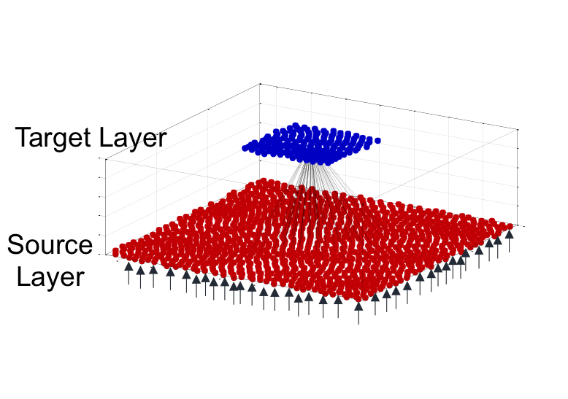

Figure 2.1: Network Sample

excitatory postsynaptic potential(EPSP) and inhibitory postsynaptic potential (IPSP) for excitatory and inhibitory input respectively. The conductance that responsible for EPSP and IPSP were modelled as the following function, *G* = *w ∗* (exp( *−t* ) *−* exp( *−t* ) where, w is weighting factor, *τ*1 is the rise time constant, and *τ*2 is the decay

*τ*2 *τ*1

time [4]. The value of *τ*1 and *τ*2 are 1 and 3 millisecond(ms) respectively for EPSP, 1 and 7 ms respectively for

IPSP.

**2.1.2 Neural Population Modeling**

–¿ Repulsive interaction // Reference - PIPP model

**2.1.3 Lateral Connection modelling**

Figure 2.1.3 The model neural network with sample connection

**Synaptic Transmission**

**Statistical Wiring Diagram**

Connection Probability and Strength of connection depend on distance between cell [5, 6]

**2.1.4 Interlayers connection**

**2.1.5 Parameter Search : Tuning model properties for the desired system to the existing experimental data**

**2.2 A simulation study on the modulation of information transfer in feed- forward networks**

**2.2.1 Introduction and Overall Modelling**

After the generalised model for neural network simulation has been introduced in first part, we utilised such model to study properties of feedforward network. The question that was asked in this work is how difference in

feed forward connection rules generate different information transfer rate when different degree of input synchro- nization is given. To investigate this question, a simple feedforward network with two layers has been made under various convergent connection rules and different levels of synchronization in input as can be shown in Figure 2.2. The hypothesis for this study is feedforward convergent connection rules; Uniform-Uniform, Gaussian-Gaussian, and Uniform-Exponential rules may determine the synchronization dependent response of the network.

Input to the system

A feedforward network

Convergent connection

Static Input L2

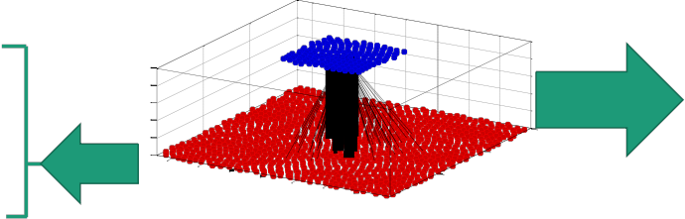

Convergent Connection

parameters

Oscillating Input



Input



L1

Convergent

Connection

Target

Source

Connection

Probability

& Connection Strength

Figure 2.2: The simple feedforward network with oscillating input and convergent connections. L1:Layer1, L2:Layer2

**2.2.2 Oscillating Input and static Input**

In this feedforward network, cells in layer 1 are defined as source cells and cells in layer2 are target cells. Source cells in layer 1 give input to the target cells in layer 2. In this network, there are two kind of input pattern that source cells send to target cells; static input and oscillating input as described in Figure 2.3. The static input has constant frequency at 20 Hz. The oscillating input were defined by sine wave with offset equal to the average firing rate in static input, 20 Hz. There are two kind of oscillating input; weak oscillation and strong oscillation. In the weak oscillation case, the input oscillate with amplitude equal to 10 Hz, or half of the mean firing rate. In the strong oscillation case oscillating input has amplitude 20 Hz, or equal to the mean firing rate. Both input have 40Hz oscillation frequency which is in gamma band. The exact spike pattern for each cell were generated by Poisson spike generator from the expected firing rate.

**2.2.3 The feedforward interlayer connection**

The feedforward interlayer connections in this work were made by three convergent connection rules; Gaussian- Gaussian(GG), Uniform-Uniform(UU), and Uniform-Exponential(UE). As mentioned in the first part of method- ology, there are two things to considered when making interlayers connection; probability of connection and con- nection strength. The three convergent rules in this work are different in the way they make connection probability and connection strength as showed in Figure 2.4. First, the Gaussian-Gaussian convergent rule has Connection Probability and Connection Strength follows Gaussian distribution and depend on distance between cells. The GG convergent rule is a conventional method to model lateral connection and interlayer connection in model neuron network [5, 3, **?**]. Next, the Uniform-Uniform rules has Connection Probability and Connection Strength follows uniform distribution over limited range. Lastly, the Uniform-Exponential rule has connection probability follows uniform distribution but the connection strength are randomly pick from negative exponential distribution.

1

𝑓 𝑡 = 𝑓 sin(

) + 𝑓𝑐 Static input

Oscillating input

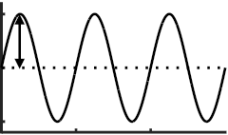

𝑓𝑂𝑆𝐶

Assumed firing rate of source

𝑓𝑐

𝑓𝑐

𝑓

Instantaneous firing rate

of source

𝑓𝑐

𝑡 𝑡

𝑓𝑐

𝑡 𝑡

Figure 2.3: Input Pattern to the feedforward network. *fc* = 20 Hz, *fosc* = 40 Hz,*Af* =10 Hz for weak oscillation, and *Af* = 20 Hz for strong oscillation.

The steps of making these interlayers connection for any range of connection R and connection strength W for each cell in target layer are as the following steps.

1. Find the cells that are located within range of connection ( R = 3 sigma), called these cells ”potentialLayer1”

2. Set the connection probability and Connection Strength in GG model

(a) Get the Probability of connection of all potential cells, from Gaussian Distribution The summation of all of these values are defined as ”volume of connection probability” or ”pGauss”

(b) Make connection in GG model from the probability of connection

(c) From these connection, find their respective connection strength from gaussian distribution. The sum- mation of weight for connected cells are called ”wGauss”

3. Set the connection probability for connection in UU and UE

(a) From the volume of connection probability or pGauss as defined in 2(a), calculate probability of con- nection for uniform distribution

(b) Probability of connection for uniform distribution = pGauss / total number of cells within range

(c) Make cells connection for UU and UE

4. Set the connection strength in UU model

(a) The average connection strength for UU model is wGauss / total number of connected cells in UU and

UE. Define it as W’

(b) Set the connection strength to W’ in all connected cells

5. Set the connection strength in UE model

(a) Get the average connection strength = W’

(b) Pick weight for each connection by draw it from the negative exponential distribution that has mean equal to W’

Probability of synaptic connection

Synaptic strength

UU (Uniform-Uniform) 𝑝 𝑝

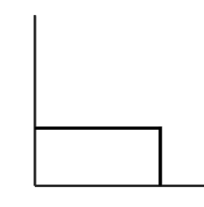

R

*Probability*

*Probability*

GG (Gaussian-Gaussian)

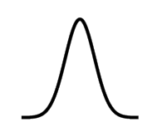

R r

*Distance*

𝑝 𝑤

Cw

*Probability*

*Strength*

Cw’ 𝑤

*Strength*

R = 3𝜎

UE (Uniform-Exponential)

R r

*Distance*

𝑝 𝑝

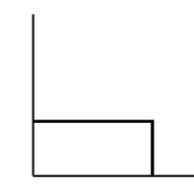

R r

*Distance*

R

*Probability*

*Probability*

R r



*Distance*

𝑤

*Strength*

Figure 2.4: Types of Convergent Connection Rules; GG - Connection Probability and Connection Strength follows Gaussian distribution, UU - Connection Probability and Connection Strength follows uniform distribution, UE- Uniform Connection Probability and Random Connection Strength that follows negative exponential distribution

(c) Because the W values are from random generator, so the summation of W is not always equal to GG and UU,therefore a normalisation is need in order to make summation of weight for each target cell equalized in all convergent rules.

Using these modelling method for interlayer connection, the density of convergent connection to a source cell at coordinate (0,0) can be shown in Figure 2.5. The density map has been made by sum up connection strength of source cells that were connected to the target cell at the center of a plot in their relative distance between cell. This map shows the spatial distribution of source cells that were connected to the target cell and, if they connected, the spatial distribution of the connection strength between them. According to the density map, the characteristics of each convergent rules are revealed. First, the UU convergent rule has constant probability of connection and strength of connection.

**2.2.4 The convergent connection condition**

**2.2.5 The equivalent condition**

Figure 2.5: Density map of each type of convergent connection rules. The range of connection is equal to 3 *σ* of

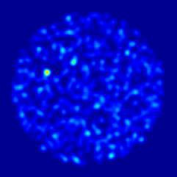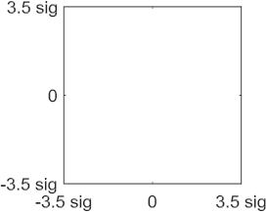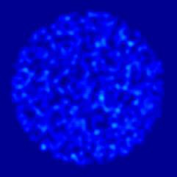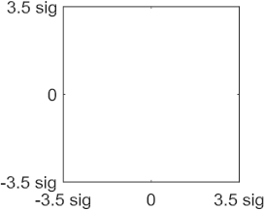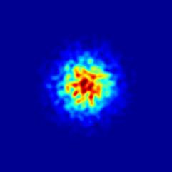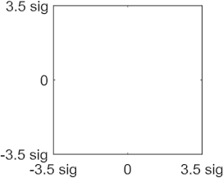

Gaussian distribution in GG rule.

Convergent Connection

Target

**W -> strength**

Source

**Range -> # of source cells**

Convergent conditions

(R and W)

Activity Matrix

Ex. Average Output Firing rate at Layer 2

Fr(Hz)

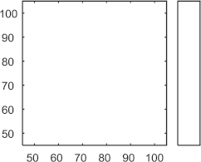

27

# of source cell

22

Range [um]

17

13

10

7

W [a.u.]

3 Types of Input

- Static(S)

- Weak Oscillation (WO)

- Strong Oscillation (SO)



3 Types of Convergent

- Uniform-Uniform

- Gaussian - Gaussian

- Uniform - Exponential

Figure 2.6: Variation in Convergent Conditions

GG,UU,UE

Σ𝑤

=1 𝑖

27



22

# of source cell

Range [um]

17

13

10

7

W [a.u.]

Figure 2.7: The total summation of connection strength were controlled to be same in all convergent rules.

**Chapter 3. Results**

In the previous chapter, a simple feedforward network with two layers has been made. The responses of various convergent connections in such network to static and oscillating input are discussed in this section. The goal for this research study is to investigate how information transfer as infer from output firing rate can be modulate by level of synchronization in the input and which convergent connection rule has the highest output response to this input synchronization.

First, we describe the unique activity map under various kind of input and various kind of convergent con- nection rules. We then show the increase in output firing rate when feedforward connection strength increase and when the synchronization level in input increase. We demonstrate that in Uniform-Uniform convergent rule(UU) has highest response gain from static input to oscillating input when compare to other convergent rules. Finally, we reveal that the UU rule has highest number of induced spike gain and it is highly dependent on phase of input oscillation. The explanation on why the UU rule is most sensitive to synchronized input based on idea of temporal summation was also introduced.

**3.1 The activity map of target layer shows unique response for each com- bination of convergent rules and input pattern**

For each combination of input pattern and convergent rules, an activity matrix has been made by assigned each element as average firing rate of target layer at given convergent conditions ( *ri* , *wi* ). Three convergent rules and three input levels multiply to nine cases of activity matrix as shown in figure 3.1 The contour plot from this matrix build up the activity map for each condition(Figure 3.2). In the activity map the lighter color mean the higher firing rate. In all the cases, when convergent conditions increase the response increase. However, the rate of increasing are different in each case as that can be easily observed when the compare the same position of the map in all cases (red dot position; *ri* = 80, *wi* = 80 ).

To explore the role of each convergent condition parameter, the output firing rate were plot when one pa-

rameter is fixed. If range of connection is fixed, the output firing rate vs. weighting factor parameter were plot (Figure 3.3). Likewise, if weight condition is fixed, the output firing rate vs. range parameter were plot (Fig- ure 3.4). When observe the change in the output firing rate, we found that the strong oscillating input has highest response compare to the other input pattern in all cases.

**3.2 The feedforward network with strong oscillation input has highest output firing rate**

According to the observation in the previous part, it showed that the oscillating input gave higher response compare to the static input. Next, the general analysis is made for all the convergent conditions by look at relation- ship between output firing rate and total feedforward strength ( or total weight summation as introduced earlier). From this plot (Figure 3.5 ), it can clearly be seen that as total feedforward connection strengthen the output firing rate also increase. In addition, the firing rate in all convergent rules increases for oscillating input compare to the static input case. The slope of this plot can be considered as gain or average firing rate per unit feedforward

Static Input



Weak Oscillation

Strong Oscillation



w

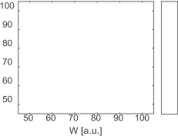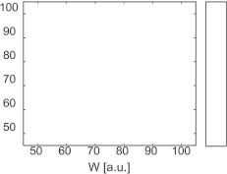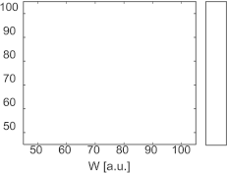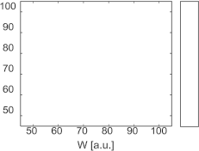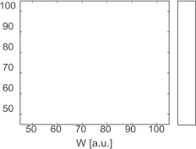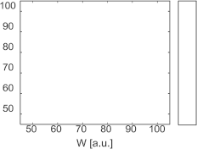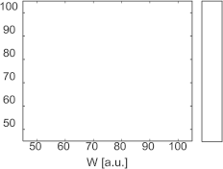

**GG**

A’

*Strength*



3𝜎 r

***Distance***

𝑤 **UU**

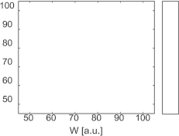

*Strength*

A’

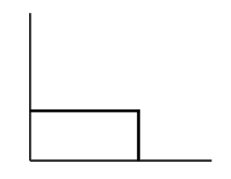

R=3𝜎 r

***Distance***

**UE**

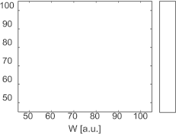

𝑝



*Probability*

𝑝 𝑤 = 𝑒 (−𝑤)

***Strength*** 𝑤

Figure 3.1: The activity matrix shows response of a feedforward network under different condition. Row : Con- vergent Rules; Gaussian-Gaussian(GG), Uniform-Uniform(UU), and Uniform-Exponential(UE) , Column : Input

pattern; static, weak oscillation, and strong oscillation input.

Static Input



Weak Oscillation

Strong Oscillation

w

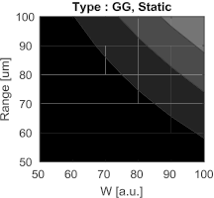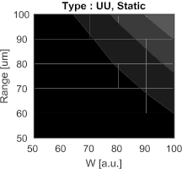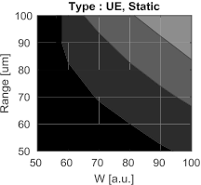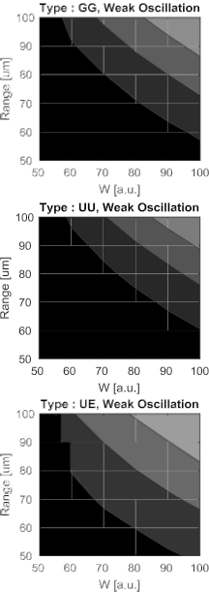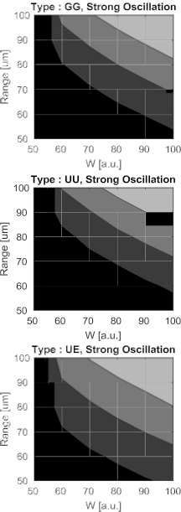

**GG**

* * *

*Strength*

3𝜎 r

***Distance***

𝑤 **UU**



*Strength*

* * *



A’

R=3𝜎 r

***Distance***

**UE**



𝑝

* * *

*Probability*

𝑝 𝑤 = 𝑒 (−𝑤)

***Strength*** 𝑤

Figure 3.2: The Activity Map that made from contour plot of activity matrix. Red dots shows the location of same convergent condition in each case but they have different response due to input pattern and convergent rules

W [a.u.]

Range [um]

(Hz)

SO SO

WO

(Hz)

(Hz)

WO SO S

S WO

S

Figure 3.3: The observed response of network when range of connection fixed and varies weight

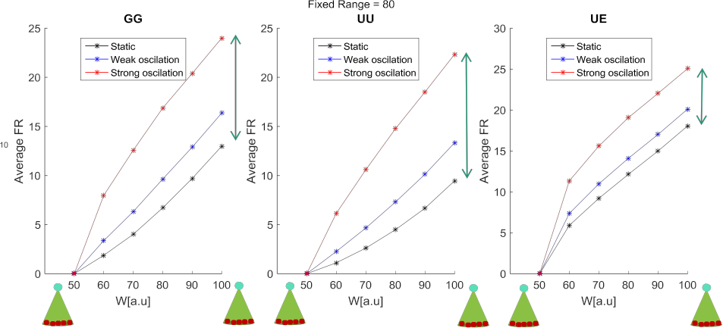

SO



Range [um]

FR(Hz)

(Hz)

(Hz)

(Hz)

WO

W [a.u.] S

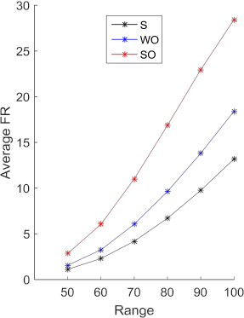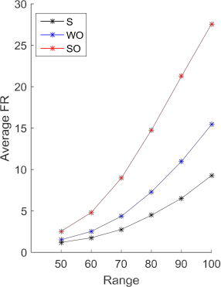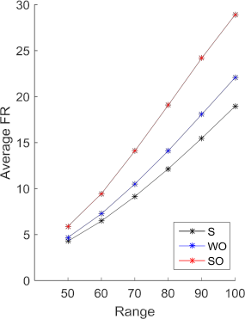

Range [um] Range [um] Range [um]

Figure 3.4: The observed response of network when strength of connection (or weight) fixed and varies range of connection

strength. Higher gain value means the feedforward network can transfer more spikes to output layer with the same connection strength to the lower gain value. The slope or gain from this response function were plot in Figure 3.6. From this plot, it can clearly be seen in all convergent rules that the strong oscillation input has highest gain, then weak oscillation and static input respectively. If we examine it further by look at the different in slope of strong oscillation input and that of static input of all convergent rules, we found that the Uniform-Uniform model has highest different in the gain value as in Figure 3.6 B.

**3.3 The Uniform-Uniform model has highest response gain from static input to oscillating input**

In the previous section, the Uniform-Uniform model has highest oscillation-static different in gain (average output firing rate over total feedforward connection strength ). Plus, it is known from the previous result that the feedforward network with oscillating input has higher response in target layer than the static input case. Next, in order to explore how much response in oscillating input increase from static input, the firing rate of each condition was scattered onto static input axis and oscillating input axis (Figure 3.7). A linear fitting has been

UU GG UE

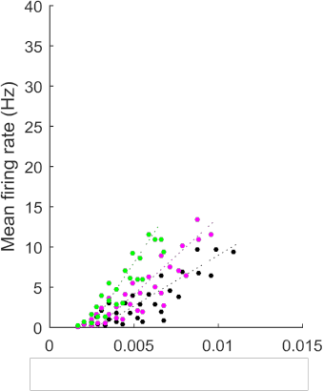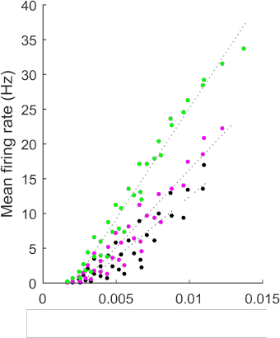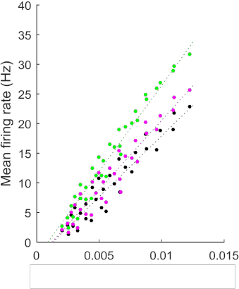

**−** Strong oscillation

**−** Weak oscillation

**−** Static input

Total Feedforward Strength [a.u.] Total Feedforward Strength [a.u.] Total Feedforward Strength [a.u.]

Figure 3.5: The response function (mean firing rate vs. total feedforward strength) of UU, GG, and UE from left

to right. The firing rate increases when connection strengthens.

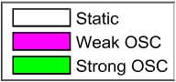

A B

4

2

2

Gain [a.u.]

SO-S ∆Gain [a.u.]

(All significantly different; t-test, p< 0.05)

(All significantly different; t-test, p< 0.05)

Figure 3.6: Comparison of slope or gain. A. Firing rate increases for oscillating input. B. The UU model has highest different in firing rate between strong oscillation and static input.

made for data from each of the convergent rules; Gaussian-Gaussian(GG),Uniform-Uniform(UU), and Uniform- Exponential(UE). Then, the slope for each convergent rules population are determine and compared. The slope of this fitted line are defined as gain (output firing rate when given oscillating input over those when static input were given) and are plotted in Figure 3.8. Since there are two kind of oscillation input, two comparisons can be made; weak oscillation vs static(WO-S), and strong oscillation vs static(SO-S). We found that in both comparison WO-S and SO-S, the Uniform-Uniform has highest gain from static to oscillation compare to the other convergent rules. The gain can infer to the sensitivity of each feedforward network to the synchronization level of input.

**3.4 The Uniform-Uniform model has highest number of induced spike gain on target layer from one spike in source layer**

From previous result, the UU model has highest response gain from static input to oscillating input. The further analysis was introduced to quantify the number of output spike that one input spike can made. This analysis starting with counting number of postsynaptic spikes in target layer that following each of the presynaptic spike in source layer when there exist connection between the layer. Then, normalised this count with total number of

**−** UU

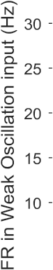

**−** GG

**−** UE

**−** UU

**−** GG

**−** UE



Figure 3.7: Comparing output firing rate of static input and oscillating input. WO-S, and SO-S are comparison

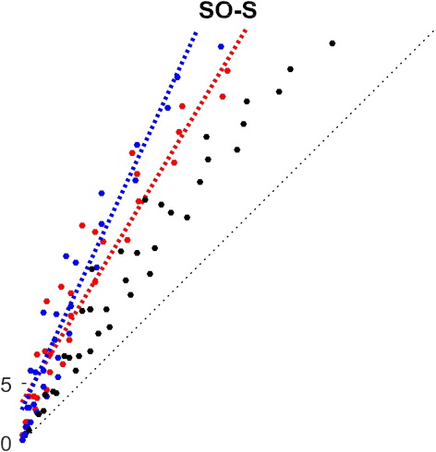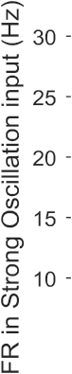

between static input to weak oscillation and strong oscillation respectively.

Gain [a.u.]

Gain = 𝑖𝑛 𝑎𝑐

(All significantly different; t-test, p< 0.05)

Figure 3.8: The Uniform-Uniform model had the biggest gain from static to oscillation.

spikes to get the induced spikes plot. The area under the first peak of the curve cut by baseline activity is the yield induced spike. Scattered these induced spike of static and oscillating input then we can investigated relationship between levels of synchronization in the input.The gain function then calculated from the ratio between induced spike from oscillation and induced spike from static (Figure 3.9. ). The average gain of each convergent rules are shown in Figure 3.10 with two types of oscillation-static comparison. The result shows that the number of induced spikes in the Uniform -Uniform model is highest compare to the other two cases ( GG came in second, and UE had least gain). Plus, overall gains of induced spikes in SO-S case is higher than WO-S case which is expectable since the synchronization level in WO less than SO input. The highest gain in induced spike shows that the Uniform-Uniform convergent rules can produce more spike per one input spike. This result shows analysis in the cell level compare to the previous analysis that were looked upon properties in network level.



Figure 3.9: Example plot for timing of the Induced target spike from a spike in source layer. The shade area, area

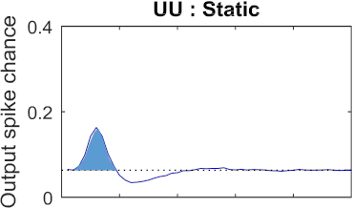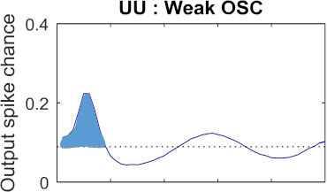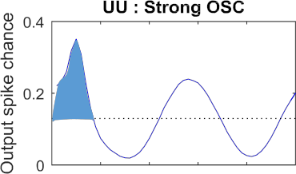

under the first peak to the baseline level, imply the number of total induced spikes.

SO-S WO-S

Number of Induce Spike Gain

Figure 3.10: The number of induced spike gain from static to oscillation input. UU has highest gain in both level of oscillation. (T-test, *p <* 0*.*05)

**3.5 The output spikes in target layer of the Uniform-Uniform model de- pend on phase-lock to oscillation the most**

All previous results showed that the strong oscillation has highest response compare to weak oscillation and static input. Also, the Uniform-Uniform convergent rules has the highest sensitivity to the change in static input to the oscillating input. Next question is how the output spikes related to the phase of the input pattern and how convergent rules behave differently on this phase-tuning. The output response - input phase relation has been made by count output spike timing in one period of input oscillation and sum up all the periods available in simulation. The result can be shown in Figure 3.11. It appeared that the responses are phase lock to crest of oscillating input. Since, we are interested in the gain or different of those value in oscillating input over static input, the plot for each convergent rules are normalised by its spike number in static input. From this curve, the full width half maximum (FWHM) were measure and the average values are plotted in bar graph (Figure 3.12). The small width mean the response are sharply tune to the phase of oscillated input pattern. For Strong oscillation - static input comparison, the UE had stand out biggest width, the UU and GG has small width. Comparing between the UU and GG model, they are significantly different with smaller width in UU. The WO-S comparison showed similar result but overall higher width in all cases. Therefore, this evidence suggest that the Uniform-Uniform model were tuned to phase of input oscillation the most.

FWHM

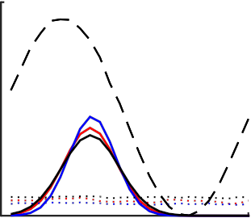

Number of Spike

per time bin

Normalized Number of Spike

Progress time in

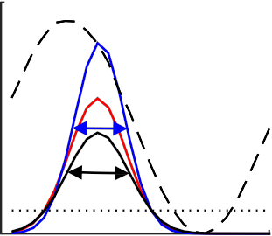

one period(ms)

Progress time in

one period(ms)

Figure 3.11: Spiking timing in one period of oscillation input pattern. Left, the example of the tuning plot . Right, the normalised spiking timing by that of static input and the width measurement, Full width at half maximum

(FWHM).

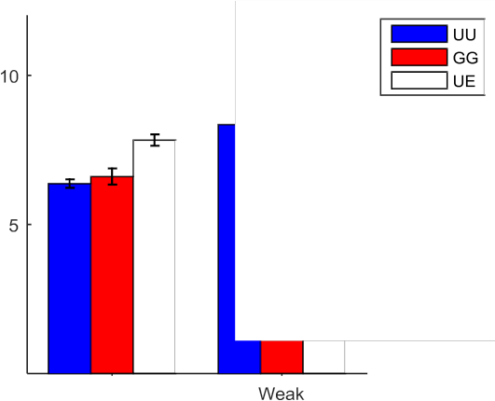

p=0.108

Average Normalized Width

p=0.0248

Figure 3.12: The UU convergent rule has the smallest width indicating the highest tuning to oscillation input compare to the GG and UE rules

**3.6 The Uniform-Uniform model has highest sensitivity to synchronized input because of its optimal distribution of weighting factor**

The Uniform - Uniform convergent rules has the highest sensitivity to the level of synchronization in the input pattern as can be seen from the response gain from static to oscillating input, number of induced spike gain, and phase-lock to the oscillation. The next question is to explain what happen in the Uniform-Uniform convergent rules that make it sensitive to change in synchronization level in input.

We has confirmed that the distribution of connection probability and connection strength are as we design in the methodology chapter(Figure 3.13). Adding on to that, the distribution of weighting factor of all cells in the target layer showed different distribution to that of single target cell due to stochastic in the system, as shown in Figure 3.14). According to this distribution, the UE model has exponential distribution as expected. The UU model has normal-like distribution due to stochastic environment. The Gaussian-Gaussian model has almost flat distribution. The Gaussian distribution has high weighting factor in center population and has lower weight

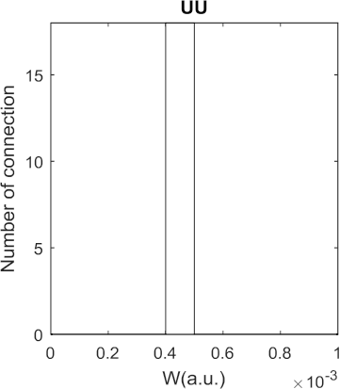

Figure 3.13: The distribution of weighting factors of convergent connections to a target cell

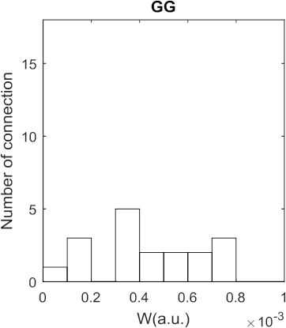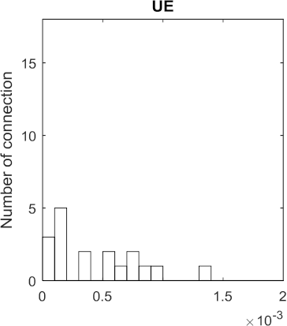

value in boundary. However, due to the increase in area covering by the filter at the boundary where connection probability and weighting factor are low, the compensation for low connectivity effect occurred and bring up the total number of low weight. As a result, the GG model has flat distribution (Figure 3.14). When comparing cumulative sum of these distribution, the UU model clearly had narrow range of strength compare to conventional model like GG model.

3𝜎

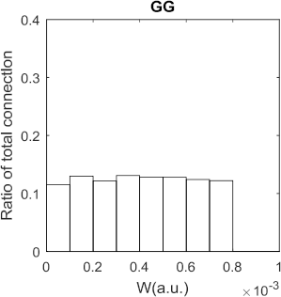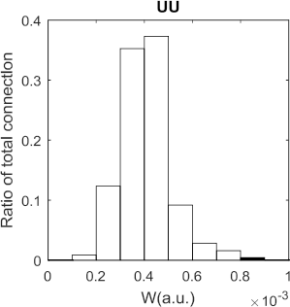

2D Gaussian

-3𝜎

-3𝜎

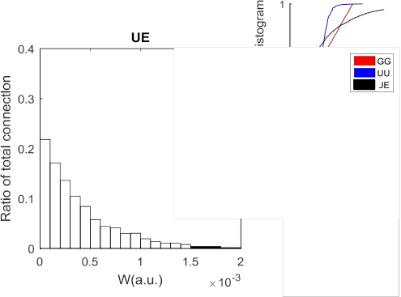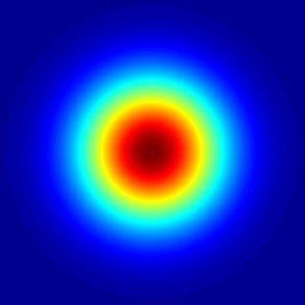

3𝜎

Figure 3.14: The distribution of weighting factors of all convergent connections to target layer. Small figure: Top the cumulative distribution function of weight distribution in all types. Bottom: The plot of 2D Gaussian filter shows increasing in ring area at boundary where the Gaussian value is low compare to the inner area that has high Gaussian value but it got limited space.

The distribution in weighting factor or strength of a feedforward connection is key explanation on its sensitiv- ity to synchronization level in the input. We divided the group of weighting factor into three groups according to their range; low, middle, and high, then use it to explain feedforward connection characteristics and its response. In the case of high connection strength, spike from source cell can make spike in target layer. In case of low connection strength, it is hard to make spike cell from only single spike from source layer. However, at the middle range of connection strength, it is the range that the probability of making spike is not certain but depend on the pattern of input spikes and it can explained by idea of temporal summation in cell conductance (Figure 3.15). When there is no oscillation in the input, the spikes arrive the postsynaptic cell individually (not overlap or not too close to each other). At this middle range of connection strength, the conductance of these single spikes cannot reach threshold of action potential, therefore it cannot produce spike in target cell. If oscillating input were given

W’

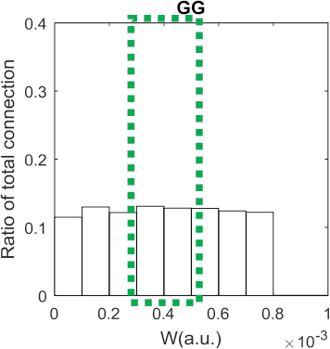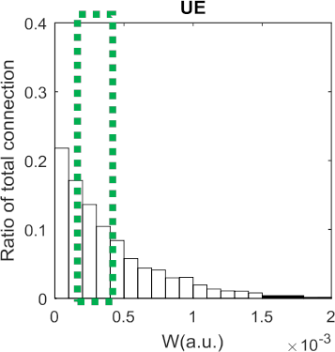

Many single spikes

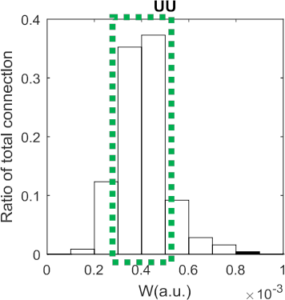

-> middle range w can not drive

target cell

High overlapping spike

-> middle range w can drive target cell

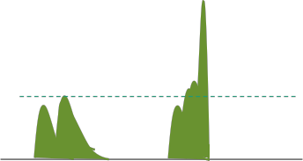

gW’ gW’

Single Spikes

Overlap/ Multiple Spikes

Figure 3.15: The schematic figure to employ idea of temporal summation [7] to explain why the UU model has highest sensitivity to level of synchronization in input

at this same middle range of connection strength, however, there are many spikes with short inter-spike-interval and many overlap spikes (because they are synchronized) which then their conductance sum up as in temporal summation idea and drive spike in target cell. The connection strength in the UU model clustered around middle range that is why the change in static and the strong oscilation in UU model is highest.

**Chapter 4. Conclusion**

First, we describe the unique activity map under various kind of input and various kind of convergent connection rules. We then show the increase in output firing rate when feedforward connection strength increase and when the synchronization level in input increase. We demonstrate that in Uniform-Uniform convergent rule(UU) has highest response gain from static input to oscillating input when compare to other convergent rules. Finally, we reveal that the UU rule has highest number of induced spike gain and it is highly dependent on phase of input oscillation. The explanation on why the UU rule is most sensitive to synchronized input based on idea of temporal summation was also introduced.

What does it mean? Successfully regenerate experimental results with computational simulation The simu- lation shows functional connection between thalamus and motor cortex in the real animal What hypotheses were proved or disproved? We can make computational simulation which resemble the experimental data The T-Type calcium channel generate bursting behavior of single cell The neural population are highly synchronized during bursting behavior The high synchronization level in neural population can transfer information from one layer to another layer What did I learn? I can make computational model that can regenerate experimental data and I can use it to predict new properties of neural system Why does it make a differences? The simulation predicts functional connection between VL and M1 neuronal layers The simulation suggest that reverse testing of KO cells to resemble WT can also drive motor command in M1. The finding suggests that the bursting is the important factor for high synchronization level of neural population and it is the key for neural network to transfer data from VL to M1

Add a new, higher level of analysis Indicate explicitly the significance of the work This work shows the potential of using computational simulation to regenerate experimental data in silico and employ it to manipulate properties of neuron network that are hard to do in the experiments and use it to predict new hypothesis

**References**

[1] Hodgkin, A. L. & Huxley, A. F. A quantitative description of membrane current and its application to con- duction and excitation in nerve. *The Journal of physiology* **117**, 500–544 (1952).

[2] Wang, X.-J., Rinzel, J. & Rogawski, M. A. A model of the t-type calcium current and the low-threshold spike in thalamic neurons. *Journal of neurophysiology* **66**, 839–850 (1991).

[3] Paik, S.-B., Kumar, T. & Glaser, D. A. Spontaneous local gamma oscillation selectively enhances neural network responsiveness. *PLoS computational biology* **5**, e1000342 (2009).

[4] Carnevale, N. T. & Hines, M. L. *The NEURON book* (Cambridge University Press, 2006).

[5] Ringach, D. L. Haphazard wiring of simple receptive fields and orientation columns in visual cortex. *Journal of neurophysiology* **92**, 468–476 (2004).

[6] McLaughlin, D., Shapley, R., Shelley, M. & Wielaard, D. A neuronal network model of macaque primary visual cortex (v1): Orientation selectivity and dynamics in the input layer 4c*α*. *Proceedings of the National Academy of Sciences* **97**, 8087–8092 (2000).

[7] Magee, J. C. Dendritic ih normalizes temporal summation in hippocampal ca1 neurons. *Nature neuroscience*

**2**, 508–514 (1999).

**Summary**

A simulation study on the modulation of information transfer in feedforward networks

10 \:: , 2

2 . 0

1eV .

2 , �

, , .

I 0 .

|  |  |  |  |  |  |  |  |  |  |  |
| --- | --- | --- | --- | --- | --- | --- | --- | --- | --- | --- |
| E |  |  |  |  |  | I |  |  | 0 | . |
|  | 2 |  |  | u |  |  | . |  |  |  |

0 :

: 1972\:: 3� 25�

: 0,__0 ...

: Tr 0 ...

: Tr 0 ...

E-mail : [yongh](mailto:yonghyunkim@test.kaist.ac.kr)[yunkim@test.kaist.ac.kr](mailto:yunkim@test.kaist.ac.kr)

1988. 3. – 1990. 2. (2\:: )

1990. 3. – 1997. 2. (B.S.)

1997. 3. – 1999. 2. (M.S.)

1997. 3. – 1999. 2. �

2001. 7. – 2002. 1.

2002. 8. – 2002. 12.

1. J. Choi, **Yong-Hyun Kim**, K.J. Chang, and D. Tomanek, *Occurrence of itinerant ferromagnetism in C/BN*

*superlattice nanotubes*, 5th Asian Workshop on First-Principles Electronic Structure Calculations, Seoul

(Korea), October., 2002.

1. **Yong-Hyun Kim**, J. Choi, K.J. Chang, and D. Tomanek, *Magnetic instability in partly opened C*60 *isomers*, in preparation.