What really happens and what factors influence the fall of a meteorite

the background is a map with different events reported over these years, classified by the mass as shown in the image with the difference of colors and sizes

is classified in the mass collected from the impact and the dangerousness of these events,

that factors influence the fall of a meteorite and the most important thing to know

the fall of meteorites is a natural phenomenon that like any natural phenomenon can not be avoided, but can reduce adverse damage. in the case of meteorites these celestial objects meet common factors that may be related to the impact on the earth. The which are:

1-soil composition: when an area has mineral-rich soils this function as a magnet and when meteorites having metal composition can influence the impact zone

2-gravitational force: the gravitational force influences a lot because there are areas on earth with more force than another one an example of this are the poles where a gravitational force of 9.8 m/s², while in areas such as the equator the force is 9.7 m/s²

3-Reported incidents: when a meteorite falls somewhere on Earth it is classified as a possible impact zone due to the specific characteristics needed for this natural phenomenon, this is evident in the proximity of the points shown on the map

**GRAFICAS DEL POSTER**

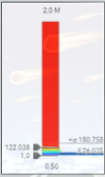

Classification of recorded events and color difference related to mass collected at impact

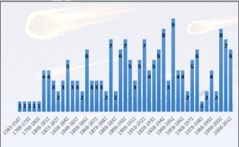

Record of incidents grouped by years to show the number of reports related in our database



Continents classified by number of incidents reported over time and in relation to the total of the sample.

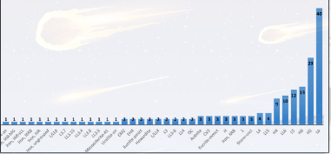

Chondrite meteorites are classified into three main groups: H (high iron content), L (low iron content) and LL (very low iron content). Within these groups, the number (in this case, 6) indicates the degree of thermal metamorphism on a scale of 3 to 7, where:

3: Little thermal disturbance, maintaining many primary characteristics.

4-6: Progressive increase of thermal metamorphism.

7: Complete recrystallization and loss of primordial structures.

In our graph it is reported that large numbers of the meteorites collected are classified in the L6.

What is thermal metamorphism: Thermal metamorphism is a geological process in which rocks undergo changes in their mineralogical composition and structure due to exposure to high temperatures. This process does not involve the fusion of rocks, but occurs in solid state, affecting the texture and mineralogy of pre-existing rocks

sometimes meteorites have no metal content and their classification is based on the predominant component

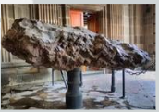

The Allende meteorite is one of the most studied and famous meteorites. It fell to Earth in the early hours of February 8, 1969. The impact site was near the town of Pueblito de Allende, in the state of Chihuahua, Mexico. This event dispersed a large number of fragments over a large area, creating an extensive meteorite scattering field.

Additional info **(no hablar ni decir a menos que yisus pida)**

"Type of meteorite: Allende is a carbonaceous chondrite of the CV3 group, known for its high carbon content and presence of refractory inclusions.

Composition: Contains a mixture of primitive minerals, refractory inclusions and conclaves. It is particularly notable for the presence of amino acids and other complex organic molecules.

Scientific Significance: Allende has provided valuable information about the early days of the solar system, including the formation of minerals in high temperature environments and the presence of organic precursors that could have contributed to the formation of life on Earth."

**CONCLUSIÓN O PÁRRAFO DE CIERRE**

Meteorites provide valuable information about the formation and evolution of the solar system. Their study allows us to understand the primordial processes that gave rise to the planets and life on Earth. Meteorites contain minerals and organic compounds that provide clues about the chemistry and conditions of outer space. In addition, historical impact analysis helps assess risks of future collisions and develop mitigation strategies. In short, meteorites are fundamental to planetary science, geology and the protection of our planet.