

**MULTIMEDIA UNIVERSITY OF KENYA**

FACULTY OF COMPUTING AND INFORMATION TECHNOLOGY

**MULTILINGUAL FAKE NEWS DETECTION SYSTEM**

BY

**ODHIAMBO PATRICK OLUOCH**

**CIT-223-040/2017**

Submitted in partial fulfillment of the requirements of Bachelor of Science in Computer Science.

# DECLARATION

I hereby declare that this project proposal is my own work and has, to the best of my knowledge, not been submitted to any other institution of higher.

Student: ______________________________Registration Number:_______________________

Signature:__________________________Date:_______________________________________

This project proposal has been submitted as a partial fulfillment of requirements for the Bachelor of Computer Science of Multimedia University of Kenya with my approval as the University Supervisor.

Supervisor: _____________________________________

Signature:________________________________ Date: ________________________________

# DEDICATION

I dedicate my project work to my family and many friends. A special feeling of gratitude to my loving guardians, Dominic and Gaudencia Okeyo whose words of encouragement and push for tenacity ring in my ears. My siblings Joyce, Brigit, Mark, Arthur, David, Lizzy, Dan and George have never left my side and are very special. I also dedicate this work to my many friends and church family who have supported me throughout the process. I will always appreciate all they have done, especially Maurice Bosire for helping me develop my technology skills and for the many hours of proofreading. I dedicate this work and give special thanks to my project supervisor Mr. Peter Henry Henry Ndithi for being there for me throughout the entire project study. You have been my best cheerleader.

# ACKNOWLEDGEMENT

I sincerely appreciate my Lecturer Supervisor MR.HENRY NDITHI who sacrificed his time to guide and mentor me to be a critical thinker and solve concrete problems in the society, as a computer science student. He provided a conducive environment for open discussions and this not only improved my communication skills but also made me view problems from various perspectives.

This proposal would not have been successful without the cooperation and support of my aunt Gaudencia Okeyo, friends and other family members who encouraged me never to give up, who funded me in performing my research, and who have promised to always offer support until the end of project execution.

# ABSTRACT

There has been a tremendous rise in the spread of fake news, i.e., false information created with the intention of deception. This poses a serious threat to both political, economic and social life, since it fosters political polarization and the distrust of people with respect to their leaders. The overload amount of news that is disseminated through social media makes manual verification tiresome and less accurate since humans are subject to bias, which has promoted the design and implementation of automatic systems for fake news detection. Fake news disseminators use myriads of approaches to promote the success of their creations, with one of them being to excite the stands of the recipients and cause public harm. This has led to sentiment analysis, the part of text analytics concerned with determining the polarity and strength of sentiments expressed in a text, to be used in fake news detection approaches. The previous studies have explained the different uses of sentiment analysis in the detection of fake news. There is need to consider other multimedia elements like images, and different natural languages since multilingualism has not been properly met.

# LIST OF ABBREVIATIONS

API – Application Programming Interface

CPU – Central Processing Unit

CI/CD – Continuous Integration/ Continuous Deployment

GPU – Tensor Processing Unit

SSD – Solid State Drive

HDD –Hard Disk Drive

TABLE OF CONTENT

DECLARATION ii

DEDICATION iii

ACKNOWLEDGEMENT iv

ABSTRACT v

LIST OF ABBREVIATIONS vi

LIST OF TABLES ix

LIST OF FIGURES x

CHAPTER ONE 1

1 INTRODUCTION 1

1.1 Background study 1

1.2 Problem statement 2

1.3 Proposed solution 2

1.4 Aim of the study 2

1.5 Research objectives 2

1.6 Significance of the study 2

1.7 Scope 3

1.8 Assumptions and limitations 3

CHAPTER TWO 4

2 LITERATURE REVIEW 4

2.1 Related systems 4

Google fact check tool 4

PolitiFact Website 5

Snopes Website 5

2.2 Limitations of the existing systems 5

2.3 How the proposed system solves the challenges 5

CHAPTER THREE 6

3 METHODOLOGY 6

3.1 Introduction 6

3.2 Agile Development Methodology 9

Reasons for Choosing agile development methodology 9

Challenges of agile development methodology 10

3.3 DATA COLLECTION METHODS 10

Questionnaires 10

Interviews 11

Observation 12

Secondary sources 12

3.4 Project resources 13

Hardware resources. 13

Software resources 14

CHAPTER FOUR 15

4 SYSTEM ANALYSIS 15

4.1 System Architectural Diagram 15

4.2 System Flowchart Diagram 16

4.3 System requirements 16

Functional requirements 17

Non-functional Requirements 17

CHAPTER FIVE 19

5 SYSTEM DESIGN 19

5.1 Architectural Design 19

5.2 System Flowchart 20

5.3 Database design 21

5.4 User interface design 22

Website mockup 22

Website design 23

CHAPTER SIX 25

6 IMPLEMENTATION AND TESTING 25

CHAPTER 7 26

7 CONCLUSION 26

References 27

8 APPENDIX 28

8.1 Project Schedule 28

8.2 Project budget 29

# LIST OF TABLES

Table 1 Database Schema Design 21

Table 2Project budget plan 29

# LIST OF FIGURES

Figure 1Decision Tree 7

Figure 2Random Forest 8

Figure 3Existing System Architecture 15

Figure 4 Existing System Flowchart 16

Figure 5 Architerual Diagram 19

Figure 6 System Flowchart 20

Figure 7Database Design 21

Figure 8 Website mockup 22

Figure 9 Web User Interface Design 23

Figure 10 Project schedule 28

# CHAPTER ONE

# INTRODUCTION

## Background study

Fake news existed years before the advent of the internet and the dissemination occurred through the print media such as the magazines, journal and other hard copy productions. The advent of the internet attracted the masses as the universe embraces the concept of digital economy, speed and costs being a consideration.

These Online platforms have always been a cutting-edge sword for news updates in the ever-evolving internet society. On the other hand, online media provides for easy access, little to no cost, and the spread of information at an impressive rate (Shu, Sliva, Wang, Tang, & Liu, 2017). The fake news creators to spread false information can take the superb advantage of faster dissemination. False news has the tendency of spreading faster as compared to genuine information because people tend to base their logic on what they are exposed to but not necessarily, what is true.

Studies have been conducted by scholars with an aim of mitigating the spread of fake news on social media platforms taking into concern the impacts fake information can pose to the society. Fake news can cause harm to individuals and to large cooperation including the government. An example is the impact of fake news on the United States 2016 presidential election on Twitter. The misinformation campaigns altered public opinion and endangered the integrity of the presidential election (Alexandre Bovet & Hernán A. Makse 2019). An example of effects on corporations is when a journalist posted an article on CNN’s iReport.com in 2008 that Steve Jobs, CEO of Apple Inc., had a heart attack. Everyone responded to this by sharing the article widely. The caused a fluctuation to the stock of Job’s company, Apple Inc. due to a single false news report that had been mistaken for authentic news reporting (Rubin, 2017).

The creation and spread of fake news on online platforms is not only limited to humans but also to programmed social bots, trolls and cyborg users. This has been boosted by the fact that there are less strict solid laws and restrictions against information sharing over the internet. Trolls are real humans who “aim to disrupt online communities” in hopes of provoking social media users into an emotional response (Shu et al., 2017). They do this to confuse the public on the polarity of truth in news items while Cyborg users are a combination of “automated activities with human input” (Shu et al., 2017) owning pseudo accounts and having false identities.

## Problem statement

The spread of fake news has been rampant as compared to the spread of true news particularly political news (Vosoughi, S. Roy, D. Aral, S., 2018). Despite the previous studies conducted by the social media giants and researchers to counter the spread, the issue of multilingualism and the analysis of other multimedia elements other than textual content has not been properly handled. Apart from the use of digital techniques, organizations have partnered with independent fact checkers that greatly rely in human research, which may be subject to bias and inability to handle large amount of work loads, this include Snopes and PolitiFact.

## Proposed solution

My proposal for the solution to the problem under study is a system that intelligently detect the truthfulness in news items in different natural languages and that is less reliant on human intervention. This is based on Natural Language Processing and data mining techniques based on metrics such as author credibility, author-article publication history, information from independent fact checkers like Snopes, Textual content analysis.

## Aim of the study

Develop a multilingual system reliant on optimal sentiment analysis techniques to detect untruthfulness in news items.

## Research objectives

1. Extract data sets on Kaggle about the historical news items and their truth indices.
2. Detect statistical features and relationships in the dataset.
3. Train and a test the model to detect truth value in news items.

## Significance of the study

The study will aid in the reduction of the rate of spread of false news on social media networks and news outlets hence reduce the negative impacts caused by propagation of faulty and unjustified information by programmed bots and/or human beings.

## Scope

The study will be constrained to the use of free datasets available on online via Kaggle and through web crawling.

The study will be constrained to the textual data and not images and other graphical formats.

The study is constrained to the use of open source libraries and technologies.

## Assumptions and limitations

The project will be subject to an assumption that news items will be presented as textual content. Therefore, textual data will be used throughout the project from training to testing due to the.

The assumptions poses a limitation to the system in that news is always presented as a composition of multimedia like images, videos and audio.

# CHAPTER TWO

# LITERATURE REVIEW

A look at scholarly articles published indicates clearly that the issue of fake news over the internet is a great topic of concern amongst researchers, and recently has been a great concern in the spread of false news on COVID-19 vaccines. The concern should not only be relegated to the IT department or public relations only, but should be a concern to everyone. Despite the issue of fake news on social platforms gaining more attention in the recent past, still there is no adequate publications to address such. Researchers have proposed various machine learning techniques to identify truthfulness in news items through Natural Language Processing Techniques. Kai Shu et al proposes the use of machine learning ensemble methods to detect faultiness in news items. Fake news is a complex topic that does not only require a single technique but an optimization of several techniques presented in machine learning as ensemble methods (Kai Shu et al, 2019). Xinyi Zhou and Reza Zafarani in an article published in July 2020 proposes the use of knowledge-based, propagation-based, style-based and source-based techniques to detect fake news. The paper classifies knowledge-based as manual fact checking done by human experts and automatic fact checking done through machine learning approaches. Style- based as the analysis being subject to the textual structure and source-based is the deep analysis of the news source credibility by identifying the authors and publication history.

The previous works indicate that fake news imposes integrity as a security implication to data and this creates a challenge in the current business world where data is an asset. Wrong data implies wrong forecasting plus poor results.

## Related systems

### Google fact check tool

This is a fact checker by google that retrieves information about a particular statement, from sources on the web and displays to the user depending on the query keyed in by the user. The site is steered by the keyword search and does not give the level of truthfulness on information feed in but gives the various instances where similar statements appear on the web.

### PolitiFact Website

This is a website platform run by editors and reporters from Tampa Bay Newspaper. It is majorly detect veracity on political news, with geographical span being America and it is environs. The researchers and reporters perform intensive research on news and assign indices based on the level of truth on the information.

The indices (PolitiFact O meter) include True, mostly true, half true, mostly false and pants on fire.

PolitiFact is more accurate, however, the fact that it is much reliant on human researchers makes it least considered in the analysis of bulk news posts from social platforms and news outlets before being posted to the public.

### Snopes Website

Similar to PolitiFact, the fact checking process is much dependent on human researchers, there is less automation, and the geographical constrain is America and its environments.

## Limitations of the existing systems

1. Google fact check tool though is automated and is less dependent on human, is based on checking for facts on the metrics of how frequent is it on other sites across the web.
2. Snopes, PolitiFact, and others like factcheck.org systems implement the idea of fact-checking journalism to identify facts on news.
3. Both Snopes and PolitiFact are geographically limited to American region hence does not fully accommodate other regions and languages.
4. Human beings are subject to bias and gets overwhelmed with much loads of data.

## How the proposed system solves the challenges

1. The proposed system will support different languages other than English language.
2. The proposed system will rely much on optimal machine learning algorithms as opposed to human researchers.

# CHAPTER THREE

# METHODOLOGY

## Introduction

The system will make use of the different Natural Language Processing Techniques to come up with truth-values to news items and reduce the level of bias posed by human fact checkers by media institutions.

The solution to the problem will also rely on the use of web crawlers in data mining across web pages, language translators and News Outlets Application Programming Interfaces to extract data items for analysis.

The detection of truth in news items will involve various metrics which are not limited to; subject credibility analysis which trains a model on truth values of different news subjects, creator-article publication history(Number of articles an author has in history), articles credibility with textual content analysis, creator credibility analysis.

The implementation will be based on but not limited to data mining and machine learning classification techniques.

The proposed techniques are:

**Classification techniques**

Classification technique will be used to assign a truth-value to news items after performing various sentiment analysis.

Classification algorithms applied on training data will be used to detect patterns in data and assign a label based on whether an item is true or false as per the defined truth meter.

1. **Naïve Bayes**

This technique calculates the possibility of whether a data point belongs within a particular category or does not. We will be using these techniques to categorize words and phrases as belonging to a preset tag or not.

For example with naïve Bayes, we can check whether a news item is false, partially false, true or partially true.

This employs the concept of probability in its implementation for instance; we may test for the probability of a news being true when the author’s credibility is guaranteed. Bayes has a general equation of:



This implies the probability of A, if B is true, is equal to the probability of B , if A is true, times the probability of A being true, divided by the probability of B being true.

1. **Decision Tree**

We will use decision trees to categories sentences into phrases phrases into words and make intelligent decisions on the tree. This will help us to create categories within categories, allowing for organic classification under limited human supervision.

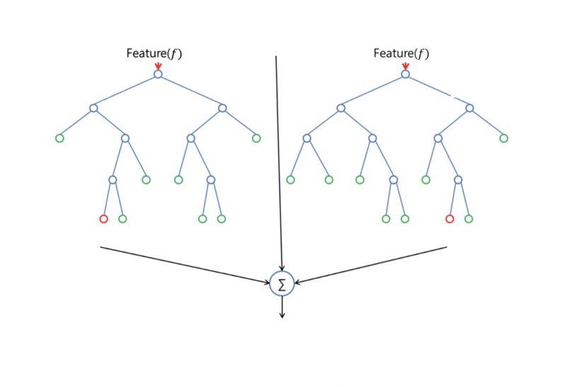

Figure 1Decision Tree

1. **Random Forest**

The constructed decision trees will be ensemble to obtain a final tree to obtain a more accurate and stable prediction because additional randomness is achieved while growing the tree.



Figure 2Random Forest

**iv. Support Vector Machines**

This technique will be used in training and classifying news items within degree of polarity. This helps in identifying and categorizing various news items as true or false.

Through this we will be able to analyses various sentiment lexicons and assign appropriate labels to them.

**Justification**

It is justifiable to choose the above techniques since they offer the best sentiment analysis machine learning approaches, in terms of accuracy and performance. Support Vector machines can both be used in supervised learning to classify data items into categories and unsupervised learning too.

## Agile Development Methodology

These methodologies are rooted in adaptive planning, early delivery and continuous improvement, all with an eye toward being able to respond to change quickly and easily.

However, as more and more development teams adopt an agile philosophy, testers have struggle to keep pace. That is because the widespread adoption of Agile has led teams to issue releases and much undocumented software on a more frequent basis. This frequency forces testers to shift when they conduct testing, how they work with developers and even what tests they conduct, all while maintaining quality standards.

In order to achieve better of an agile development methodology, the methodology will be incorporated in a CI/CD pipeline to ensure that testing and development do not overlap.

### Reasons for Choosing agile development methodology

1. Improved quality: by adapting this methodology, organizations can deliver; organization can deliver solutions in time and with the higher degree of client and customer satisfaction.
2. Focus on business value through increased focus on delivering strategic value by involving business stakeholders in the development process.
3. Focus on users: agile development methodology uses user’s stories with business focus acceptance criteria to define product features.
4. Stakeholder engagement: this provide more opportunity for the team to truly understand the business vision, deliver working software early and frequently increase stakeholders trust.
5. Transparency: this can include prioritizing features, iteration planning and review section or frequent software builds containing new features

### Challenges of agile development methodology

1. People’s behavioral change: changing the way people work is difficult- the habit and culture of large development organization are typically in grain. People naturally restrict change and therefor when confronted with an agile transformation.
2. Lack of skilled product owners from the business side: most product owners do not understand user stories and hesitate to give up the BRD for something different because they view it as a contract between them and IT.
3. Lack of dedicated cross-functional team: In most cases, there has always been inefficient cross-functional team.

## DATA COLLECTION METHODS

### Questionnaires

This was done through eliciting the feelings, beliefs, experiences, perceptions or attitudes of some members of the public. This was conducted through online forms via Google forms and Microsoft forms. Direct issues to questionnaires to individuals supplemented these online forms. As a data collection instrument a questionnaire can be *structured, unstructured* or *semi structured.*

A structured Questionnaire is one that has closed ended questions. It is restricted and calls for a “yes” or “no” answer.

**Unstructured questionnaire** is one that has open-ended questions. It is unrestricted and calls free response from the respondent. Semi structured questionnaire has both open and closed ended questions.

Advantages

1. It has a low costs-even when the universe is large and widely spread geographically, google forms are free of change easy to design and distribute via social media.
2. Online questionnaires are relatively free from bias of the interviewer.
3. Uniformity of the questions i.e. standardized questions.
4. Respondents have adequate time to give all the answers in the convenience of their time.

Disadvantages

1. It has a low rate of return.
2. Respondent’s motivation is difficult to assess since there is less physical interaction with individuals.
3. May present biased samples
4. It can only be used when respondents are educated and cooperative. The control of the questionnaire may be lost once it is sent.

### Interviews

It involves presentation of oral-verbal stimuli in terms of oral responses. This method can be used through personal/ telephone interviews. Personal interviews involve an interviewer asking the respondent questions in a face-to-face contact. It is a conversation in which the roles of the interviewer and the respondent change continually. They may be structured interviews where a guiding questionnaire (interview schedule) is used or unstructured interview where there is no questionnaire to be followed. Structured interviews are rigidly standardized and formal while unstructured interviews are flexible and informal .

Advantages

1. Helps a researcher to get more information and in greater depth.
2. It can also be applied to record verbal answers to various questions.
3. Sample can be controlled.
4. Can be used with young children and illiterates
5. Allows the interviewer to clarify questions
6. The language of the interviewer can be adapted to the nature of the respondent
7. The interviewer can collect supplementary information.

Disadvantages

1. It is expensive to achieve.
2. Gaining access to interviewers may be very difficult especially if they are high profile people 3. It is time consuming.

### Observation

It is commonly used in studies related to behavioral science. It has to be systematically planned and controlled and subjected to checks and controls on validity and reliability and constructed to serve a formulated research purpose for it to serve as a scientific tool for data collection. Direct observation is a measuring instrument to measure such traits as self-control, cooperativeness, truthfulness and honesty. One observes without asking questions to correspondence.

Advantages

1. The researcher is enabled to record the natural behavior.
2. It is done in a natural behavior thus, much bias is reduced.
3. Observation is relatively cheap.
4. It allows collection of a wide range of information
5. It is ideal in studying non-verbal communication.

Disadvantages

1. Observation lacks control of variables in its natural set up.
2. There is difficulty in quantification because it is mostly descriptive.
3. It lacks privacy and has limited study.

Observation studies use a smaller sample than survey studies.

### Secondary sources

Data obtained via secondary sources include web sources, journals, textbooks, and eBooks and research papers.

**Advantages**

1. It is economical. It saves efforts and expenses.
2. It is time saving.
3. It helps to make primary data collection more specific since with the help of secondary data, we are able to make out what are the gaps and deficiencies and what additional information needs to be collected.
4. It helps to improve the understanding of the problem.
5. It provides a basis for comparison for the data that is collected by the researcher.

**Disadvantages**

1. Secondary data is something that seldom fits in the framework of the marketing research factors.
2. Accuracy of secondary data is not known and can rarely be justified.
3. Data may be outdated.

## Project resources

For the project to achieve its stated objectives from the analysis to deployment phase there are a few tools that will be required. These tools range from software to hardware.

### Hardware resources.

Personal computer/Laptop

This is the hardware that the source code of the project will run on and which the testing will be performed.

Since the machine learning algorithms may be so much compute intensive, a laptop with the following specifications is preferred:

* At least 4G RAM computer.
* Internal storage of relatively 500GB HDD or SDD to host the other software needed to implement the system.
* Graphics Processing Unit or a Tensor Processing Unit of global memory access of up to 48GB, around 200cycles and shared memory of about 164kb.

High speed and secure server, with higher latency for securely deploying the API.

### Software resources

An integrated development environment PyCharm Community Edition that is freely available for developer community.

Google colabs – this is freemium platform by google which has the necessary hardware to accommodate highly compute intensive deep learning algorithm.

Scikit-learn – this is an open source Python machine-learning framework.

Scrapy – this is a python web crawler. We will be using this in implementing our web crawlers to perform data mining on web pages. It is an open source library.

# CHAPTER FOUR

# SYSTEM ANALYSIS

The current system is subject to limitations such as the lack of multilingualism support.

The following is the analysis of the current system:

## System Architectural Diagram

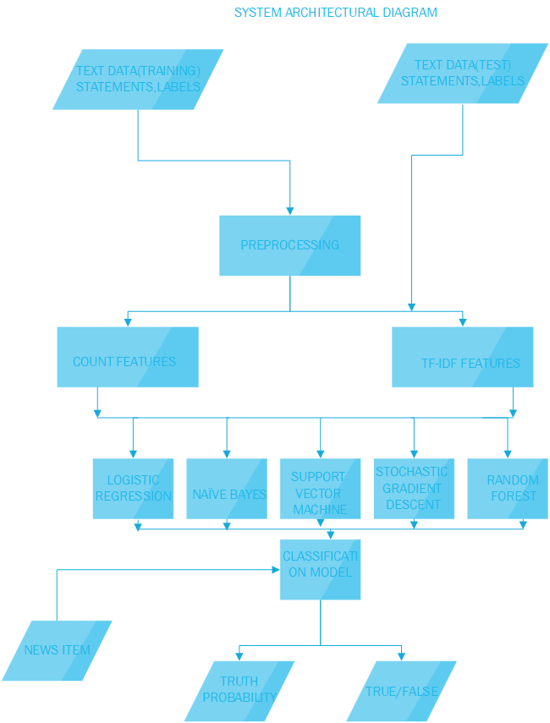

Figure 3Existing System Architecture

## System Flowchart Diagram

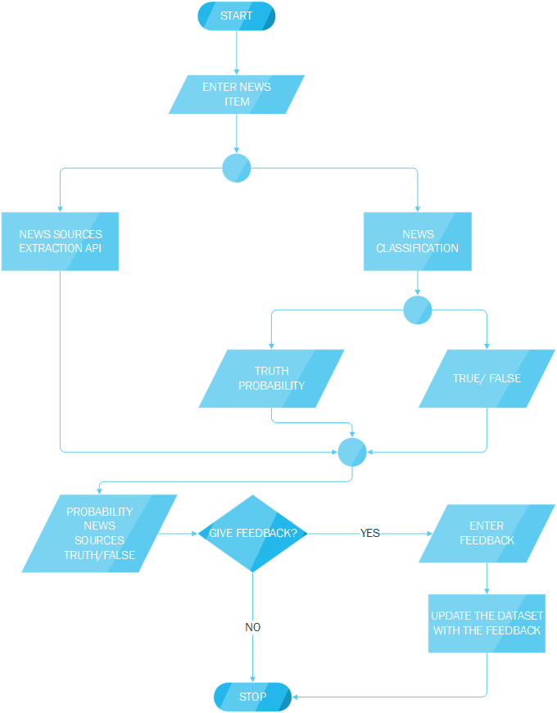

Figure 4 Existing System Flowchart

## System requirements

A requirement is a ‘statement regarding an intended product that specifies what it should do or how it should perform’. (Rogers, 2011.). The two types of requirements for the proposed system are:

### Functional requirements

These are the functions of a system and its components. It describes a set of input, the behavior and output. The functional requirements for this project are:

**For Guests:**

Q1: The system should allow users to copy paste the news items

Q2: The system should allow users to view the truth probability of the item

Q3: The system should allow users to view other sources of the news item

Q4: The system should allow users to give feedback on their satisfaction on the prediction.

Q5: The system should allow the users to subscribe to newsletter for truth-values of trending news.

Q6: View the list of trending news items plus their truth values

**For administrators:**

Q1: View the analysis of the feedbacks given by the news checkers

### Non-functional Requirements

A non-functional requirement specifies the properties of the information system itself. Some of the non-functional requirements for this project are:

**Security**: All the email addresses of subscribers and the responses given as feedbacks will be treated with high confidentiality and will not be used for purposes other than improving the performance of the system.

All the input forms have been properly sanitized using Django form filters to avoid cross-site scripting and exposure of the system to vulnerabilities.

The system will be hosted on secure HTTP to ensure confidentiality to user inputs.

**Availability**: the system will serve users throughout the day and will be hosted on high latency servers to accommodate high traffic with high performance maintained.

**Reliability:** the performance of the system is consistent according to its specifications

**Speed:** The system should respond to users’ requests within 2-3 seconds

**Usability:** The system gives direct input on how real users use the system.

**Portability:** The system is cross platform supporting different operating system and hardware specifications since it will be web based.

**Efficiency:** The system provides appropriate output based on the list of inputs.

# CHAPTER FIVE

# SYSTEM DESIGN

## Architectural Design



Figure 5 Architerual Diagram

## System Flowchart

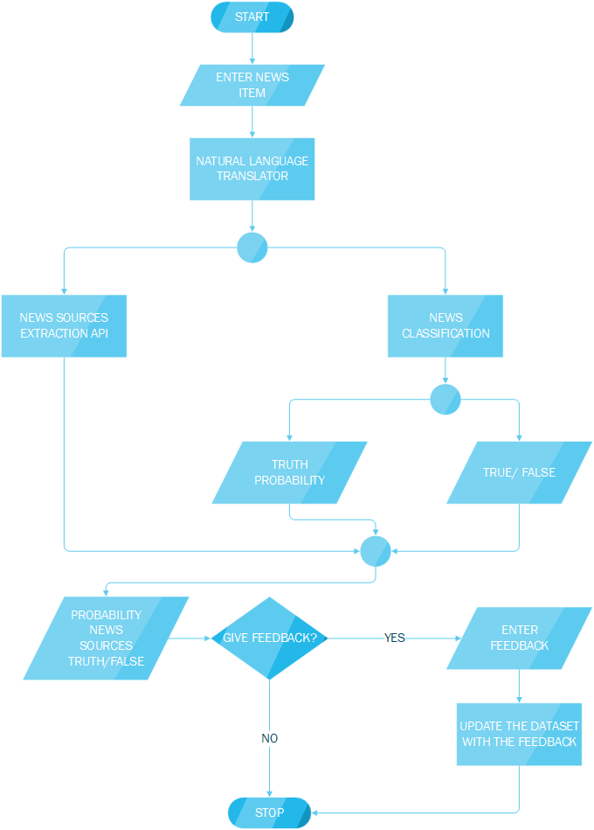

Figure 6 System Flowchart

## Database design

The system database schema will comprise of subscription table to hold the list of subscribers email addresses. The table will be made up of two columns:

subscription_id – that’s the primary key of the table

email– the verified email of the subscriber

|  |  |  |
| --- | --- | --- |
| Field | Datatype | Description |
| Subscription_id | int | Primary Key |
| email | Varchar(34) | Subscribers email addresses |

Table 1 Database Schema Design

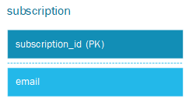

Figure 7Database Design

## User interface design

### Website mockup

This is the basic structure of the website on which the application will run on.

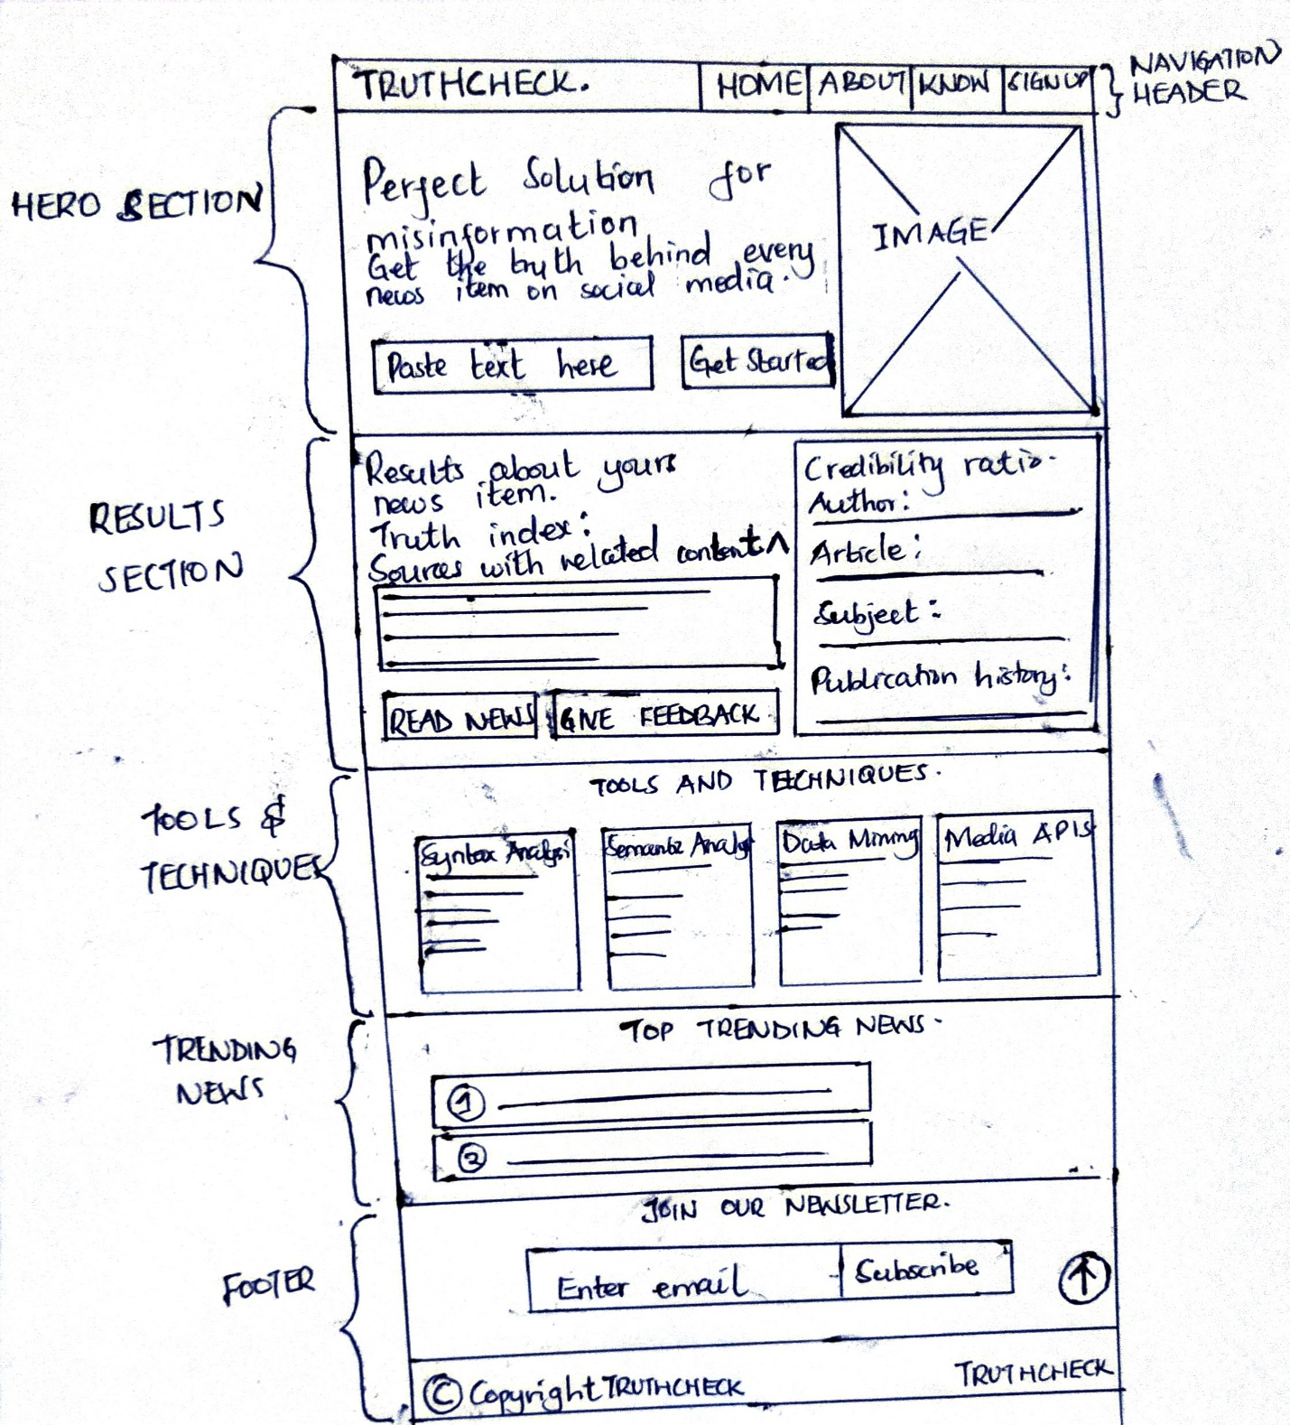

Figure 8 Website mockup

### Website design

This illustrates the basic structure and components of the proposed website for the Truthcheck web application done using Adobe XD software.

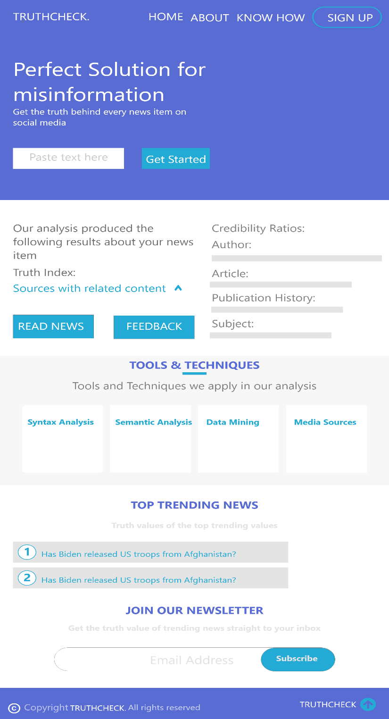

Figure 9 Web User Interface Design

# CHAPTER SIX

# Implementation and testing

Series of testings’ and evaluation will be use on the developed system in order to avoid system errors and make sure every functional requirement gathered from the requirement stage is been implemented in the system.

## Development environment

### The analysis and design environment

The analysis and design environment is aligned to the planning and analysis phases of the SDLC. The following software were used to come up with the various designs and analysis of the system.

Adobe XD: this is a proprietary software licensed by Adobe Corporation. This was used in the design of the user interfaces of the web application.

Microsoft Visio: this was used in the design of the sequence diagrams, flowcharts and the architectural diagrams.

### Software and Hardware Environments

This is a collection of hardware and software resources used in developing the system before deployment.

#### Software Environment

sklearn – this is the machine learning library based on Python programming language.

Pycharm community edition- this is the text editor used in coding the project. It was a better choice since it offers a better syntax highlighting for Python programming.

Sqlite- this is the database management system used during the development phase; postgresql will be used during deployment.

Pyenv –this was used to decouple and easily manage the various Python and pip packages specific to the project without installing the previous versions.

Django Web Framework- this is the backend language used to create communications between the backend and the frontend.

#### Hardware environment

The system was developed on a personal computer, which provided a local server for the system. The local server was running on the following specifications:

* At least 4G RAM computer.
* Internal storage of relatively 500GB HDD or SDD to host the other software needed to implement the system.
* Graphics Processing Unit or a Tensor Processing Unit of global memory access of up to 48GB, around 200cycles and shared memory of about 164kb.

## System components

The system is comprised of both the hardware, software and the liveware.

### Hardware

This is the physical components of the computer on which the system will run for deployment. The API will be hosted in a secure and high-speed server that can accommodate higher traffics with higher latency.

### Software component

This is includes the frontend and the backend of the system.

#### Frontend component

The frontend is the part of web-based part of the system that offers the channel of communication between the user and the system.

#### The backend component

This is will carry and handle all the requests issued by the users. The backend will perform analysis of the news items, get the sources with the related news items and manage the email subscriptions of the users.

This part houses the database and the analytics and prediction functionalities of the system.

### Liveware

These are the users of the system. These may include media houses integrating the system into their media platforms as APIs or individual users.

## Test data

After the completion of the developed system, an evaluation was carried out with users and experts. The aim of this evaluation was determine the accuracy of the system, how users navigate on different webpages on the website and also identify the possible problems faced by each user. The system was also evaluated to test whether the results given were as accurate and explainable as possible.

### Usability testing

This was done to investigate on how easy is it for end users to perform tasks on the web application.

For this evaluation, the goal of using usability testing is to test with users to identify the problems they faced when interacting with the website. The web application was hosted on a personal computer as the testing environment and IP address shared amongst testing end users. A random selection method was chosen to select participant who will evaluate the website. This type of selection was chosen because many individuals make use of the internet for personal purpose and has definitely used an online booking site to make a reservation or an enquiry about a place. Ten participants were given a list of task to perform on the website and were observed during the evaluation.

* The equipment’s used during this evaluation are:
* A laptop to show the website interface and locally host the website.
* Cannon 1200D use to record videos and audio.
* A Timer to record the duration taken to complete a task.
* Google analytics and crashlytics to track errors during operation.

Task given to users are:

• Copy and Paste a news item

• Subscribe to the news letters

• Give feedback

Each participant will carry out this tasks listed about without any help or guide by the researcher.

## Test results

# CHAPTER 7

# CONCLUSION

# References

Vosoughi, S.; Roy, D.; Aral, S. (2018) The spread of true and false news online. Science , 359,

1146–1151.

Kesavaraj, G ; Sukumaran, S (2013) A study in classification techniques in data mining. *Data Science*

Soon, W; Ng, Hwee; Lim, D. (2017) A Machine Learning Approach to Coreference Resolution of Noun Phrases.*Computational Linguistics*

Beysolow , T.I. (2018). Applied Natural Language Processing With Python Apress

Secker ,Davies, Freitas, Timmis, Mendao. (2019) An Experimental Comparison of Classification Algorithms for Hierarchical Prediction of Protein Function. <http://www.cs.kent.ac.uk/projects/biasprofs>

# APPENDIX

## Project Schedule

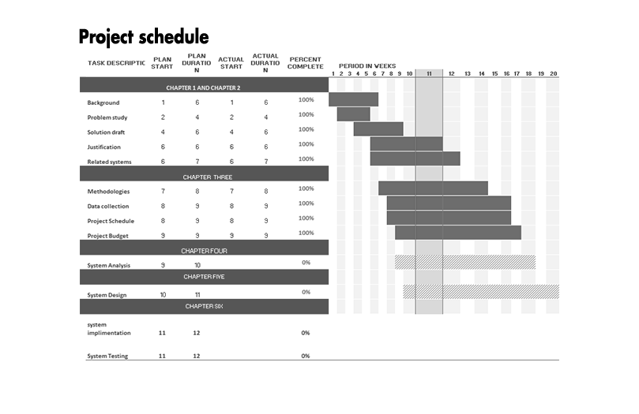

Figure 10 Project schedule

## Project budget

Below is the projected budget of the project.

|  |  |  |
| --- | --- | --- |
| Name | Description | Amount required |
| High specifications personal computer. | System development and testing will be done from this computer. | Ksh. 150,000 |
| Research expenses | This include subscriptions to online libraries and learning websites. | Ksh. 100,000 |
| Professional services | This includes the legal pieces of advice from professional and grants to access various news media resources. | Ksh. 150,000 |
| Contingency reserves | This will allow for flexibility and reduce the risk of budget overruns | Ksh. 200,000 |
| Travelling expenses | This is the capital set aside to accommodate for travelling while doing field research | Ksh. 100,000 |
| Hosting services fund allocation | The API will be hosted in a secure and high-speed server that can accommodate higher traffics with higher latency. | Ksh. 200,000 (starting cost) |
| **TOTAL** |  | Ksh. 900,000 |

Table 2Project budget plan