**Ethereum Dracaena Mining**

Recommend OS: Ubuntu 16.04.5 64-bit TLS

Link Download: <http://old-releases.ubuntu.com/releases/16.04.5/>

Please find and download: ubuntu-16.04.5-desktop-amd64.iso

Recommend: Minimum 8GB RAM

Swap Memory (Ubuntu): need to be set from 16G → 32G

Install Vivado-Lab. Please use following link to download and install Vivado_Lab: <https://www.xilinx.com/support/download/index.html/content/xilinx/en/downloadNav/vivado-design-tools/2019-2.html>

Put your license.txt in the run folder:

Right click and select “Open In Terminal”:

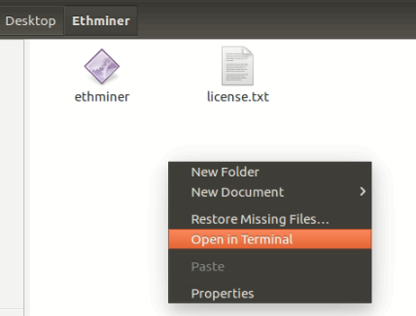

**Program Bitstream**

Open program.sh, change path to your Vivado path

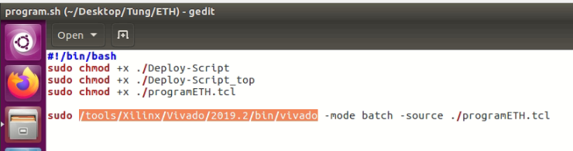

Then run below commands in terminal:

$sudo chmod +x ./program.sh

$sudo ./program.sh

This file will help you to program bitstream for all FPGAs available.

**Load Driver, Run Miner**

In Deploy-Script, change our example wallet to your wallet and your target pool. Please do not change other thing.

Then run below Command line:

$sudo ./Deploy-Script_top

Then enter your amount of FPGAs, wait for your machine to load driver (only a few sec)

Then press “y” to run miner, or “n” to reboot or “e” to exit

If your miner is not running as expected, reboot your PC and run Deploy-Script_top again.

**Summary of running steps:**

Program.sh -> reboot -> Deploy-Script_top-> input your amount of FPGAs.

**Caution:** *If your machine is stopped or suddenly off during DAG file generating phase, please delete all generating-in-progress DAG files before rerun ethminer.*