**Predicting Water Quality Parameters Using Machine Learning**

**ABSTRACT:**

Water quality is a critical environmental concern, influencing both ecological balance and human health. Contaminated water sources can lead to severe public health issues, making the monitoring and prediction of water quality parameters essential for effective water management. This project focuses on leveraging machine learning techniques to predict key water quality parameters, such as pH, turbidity, dissolved oxygen, and various chemical concentrations, based on historical data and environmental conditions. By utilizing advanced data analytics, we aim to provide timely insights that can inform decision-making processes in water resource management.

In this study, we gather a diverse dataset comprising historical measurements from multiple water sources, complemented by environmental factors such as temperature, rainfall, and land use. Various machine learning algorithms, including regression models and ensemble methods, are employed to develop predictive models that can accurately forecast water quality parameters. The performance of these models will be evaluated through metrics such as Mean Absolute Error (MAE), Root Mean Square Error (RMSE), and R-squared values, ensuring the reliability and accuracy of our predictions.

The outcomes of this research will not only contribute to the scientific understanding of water quality dynamics but also offer practical applications for environmental monitoring agencies and policymakers. By integrating machine learning into water quality assessment, this project seeks to enhance proactive measures in preventing water pollution and safeguarding public health. Ultimately, the insights gained from this study can facilitate the development of effective strategies for sustainable water management in diverse ecosystems.

**CHAPTER 1**

**INTRODUCTION**

**OVERVIEW**

Water quality is essential for the survival of aquatic ecosystems and human health, serving as a critical indicator of environmental well-being. Factors such as industrial discharge, agricultural runoff, and urbanization significantly impact water quality, leading to increased levels of pollutants that pose risks to both ecosystems and public health. Monitoring these parameters is vital to ensure safe drinking water and maintain the ecological balance of aquatic habitats. Traditional water quality assessment methods can be labor-intensive and time-consuming, making it imperative to explore innovative approaches for more efficient monitoring.

Advancements in machine learning (ML) present new opportunities to enhance the prediction and assessment of water quality parameters. Machine learning techniques can analyze large datasets, identifying complex patterns and relationships that may not be evident through conventional methods. By leveraging historical water quality data alongside various environmental factors, machine learning models can be developed to predict future water quality conditions with greater accuracy. This project aims to harness these capabilities to create a robust framework for predicting key water quality parameters such as pH, turbidity, dissolved oxygen, and nutrient concentrations.

Through the application of machine learning algorithms, this research seeks to contribute to the growing field of environmental analytics, providing valuable insights that can support decision-making processes in water management. By developing predictive models that can forecast water quality trends, this project not only addresses the immediate need for efficient monitoring solutions but also fosters a proactive approach to water resource management. Ultimately, the findings of this study can aid policymakers and environmental agencies in implementing strategies to protect and manage water resources more effectively, ensuring a sustainable future for both people and ecosystems.

**PROBLEM STATEMENT**

The deterioration of water quality poses significant challenges to public health and environmental sustainability. With increasing industrialization, urbanization, and agricultural activities, water bodies are frequently subjected to various contaminants, leading to adverse effects on aquatic life and human health. Traditional monitoring methods often involve labor-intensive sampling and testing, which can be slow and inefficient, resulting in delayed responses to pollution events. Consequently, there is an urgent need for innovative solutions that can provide timely and accurate predictions of water quality parameters, enabling proactive measures to mitigate risks.

In the current landscape, existing predictive models for water quality assessment are often limited by their reliance on static or historical data without considering the dynamic interactions between environmental factors and water quality. Moreover, many traditional statistical methods fail to capture the complexity and non-linear relationships present in environmental data. This gap highlights the necessity of utilizing machine learning techniques, which can handle large datasets and identify intricate patterns, to improve the accuracy and reliability of water quality predictions. By addressing this gap, we can enhance our understanding of water quality dynamics and develop more effective monitoring strategies.

This project seeks to develop a machine learning-based framework that can predict key water quality parameters, such as pH, turbidity, dissolved oxygen, and various nutrient concentrations, based on historical data and environmental variables. The main objectives are to create predictive models that can accurately forecast water quality trends and assess their performance against traditional methods. By addressing the limitations of existing monitoring approaches, this research aims to provide actionable insights for environmental agencies and policymakers, ultimately contributing to more effective water management practices and improved public health outcomes.

**CHAPTER 2**

**Literature survey**

1. **Predicting Water Quality Parameters Using Machine Learning Approaches**  
   **AUTHOR:** J. Smith, A. Patel, & R. Kumar (2022)  
   This study explores various machine learning algorithms, including support vector machines (SVM), decision trees, and neural networks, to predict water quality parameters such as pH, turbidity, and dissolved oxygen. The authors utilized a dataset from multiple water sources and found that ensemble methods significantly outperformed traditional models, demonstrating the effectiveness of machine learning in water quality management.
2. **A Comparative Analysis of Machine Learning Techniques for Water Quality Prediction**  
   **AUTHOR:** L. Chen & M. Zhao (2021)  
   This research compares several machine learning models, including random forests, gradient boosting, and deep learning approaches, to predict water quality metrics. The authors highlight the strengths and weaknesses of each technique and recommend the use of hybrid models for improved prediction accuracy, emphasizing the importance of feature selection and data preprocessing.
3. **Water Quality Prediction Using Recurrent Neural Networks**  
   **AUTHOR:** S. Kim, J. Lee, & H. Park (2020)  
   This paper introduces a recurrent neural network (RNN) approach for predicting water quality parameters over time. The authors focus on temporal data and present results showing that RNNs effectively capture time-dependent patterns in water quality data, outperforming traditional static models. The study emphasizes the importance of considering temporal dynamics in water quality monitoring.
4. **Application of Machine Learning Algorithms in Assessing Water Quality: A Review**  
   **AUTHOR:** R. Johnson & T. Garcia (2023)  
   This review paper examines the application of various machine learning techniques in water quality assessment across different geographic regions. The authors summarize key findings from multiple studies, highlighting trends, challenges, and opportunities in using machine learning for environmental monitoring. The review underscores the growing importance of integrating machine learning into water management practices.
5. **Ensemble Learning for Water Quality Prediction in Rivers and Lakes**  
   **AUTHOR:** H. Thompson & K. Davis (2024)  
   This study investigates the use of ensemble learning methods, specifically stacking and bagging, for predicting water quality parameters in river and lake ecosystems. The authors demonstrate that ensemble methods provide improved prediction accuracy compared to individual models, making them a valuable tool for environmental monitoring.
6. **Deep Learning for Predicting Water Quality in Coastal Areas**  
   **AUTHOR:** P. Nguyen, L. Tran, & M. Hoang (2021)  
   This paper explores the application of deep learning techniques, particularly convolutional neural networks (CNNs), for predicting water quality in coastal environments. The authors highlight the importance of incorporating satellite imagery and environmental data into the model, achieving high accuracy in predicting key water quality parameters, which can aid in coastal management efforts.
7. **Machine Learning Approaches for Water Quality Assessment: A Case Study**  
   **AUTHOR:** N. Patel, S. Rao, & A. Mehta (2022)  
   This case study employs various machine learning algorithms to assess water quality in a specific region. The authors demonstrate the applicability of models like random forests and neural networks in real-world scenarios, discussing their potential for enhancing water quality monitoring and management.
8. **Real-Time Water Quality Prediction Using IoT and Machine Learning**  
   **AUTHOR:** D. Martin, J. Brown, & K. Lee (2023)  
   This paper presents a system that integrates Internet of Things (IoT) sensors with machine learning algorithms to predict water quality in real-time. The authors discuss the architecture and implementation of the system, highlighting its potential for timely decision-making in water management.
9. **Data-Driven Approaches for Water Quality Prediction: Insights from Machine Learning**  
   **AUTHOR:** M. Wang, Y. Zhou, & X. Chen (2024)  
   This research focuses on data-driven methods for predicting water quality parameters, comparing various machine learning techniques. The authors emphasize the importance of feature engineering and data preprocessing in achieving high prediction accuracy, providing insights into best practices for future studies.
10. **The Role of Machine Learning in Water Quality Monitoring: A Systematic Review**  
    **AUTHOR:** T. Anderson, L. Martinez, & S. White (2020)  
    This systematic review analyzes the role of machine learning in water quality monitoring, summarizing findings from numerous studies. The authors identify key challenges and opportunities in applying machine learning to environmental science, advocating for further research to enhance predictive modeling in water quality assessment.

**CHAPTER-3**

**Existing System:**

Current systems for predicting water quality parameters primarily rely on traditional methods such as chemical testing and physical sampling, which can be labor-intensive and time-consuming. These methods often involve manual collection of water samples from various sources, followed by laboratory analysis to determine key parameters like pH, turbidity, dissolved oxygen, and the presence of contaminants. While these approaches can provide accurate measurements, they are not always timely, leading to delayed responses to pollution events. As a result, environmental agencies and water quality managers often struggle to maintain up-to-date assessments of water quality, which is critical for effective water resource management and public health protection.

In recent years, there has been a growing interest in integrating machine learning techniques into water quality monitoring systems. Existing systems utilize various machine learning models, such as regression algorithms, decision trees, and support vector machines, to analyze historical data and make predictions about water quality trends. These models can improve the efficiency of monitoring by providing real-time or near-real-time predictions based on current and historical environmental data. Some systems also employ data fusion techniques, combining data from multiple sources, such as IoT sensors, satellite imagery, and weather data, to enhance the accuracy of their predictions. Despite these advancements, many current systems still face challenges related to data quality, model interpretability, and the need for comprehensive datasets.

Furthermore, while some existing systems have shown promise in specific applications, they often lack the ability to generalize across diverse geographical regions and environmental conditions. Many models are trained on limited datasets that may not capture the full variability of water quality parameters. Additionally, there is often a gap in integrating machine learning predictions with decision-making processes for water resource management, hindering the practical application of these technologies. As a result, there remains a significant opportunity for developing more robust, adaptive, and user-friendly systems that leverage advanced machine learning techniques to provide accurate, timely, and actionable insights for water quality management.

**Limitations of the Existing System:**

1. **Data Quality and Availability**: One of the primary limitations of existing systems is the reliance on historical datasets that may be incomplete, inconsistent, or not representative of current conditions. Many models are trained on data collected from specific locations or time periods, which can lead to biased predictions when applied to different geographical areas or under varying environmental conditions. Additionally, gaps in data can hinder the model's ability to accurately predict water quality parameters, especially in rapidly changing environments.
2. **Model Complexity and Interpretability**: While advanced machine learning algorithms, such as deep learning models, can achieve high accuracy, they often operate as "black boxes," making it challenging to interpret the underlying decision-making processes. This lack of transparency can be a significant drawback for stakeholders, such as environmental agencies and policymakers, who require clear explanations of how predictions are generated. The complexity of these models can also lead to difficulties in fine-tuning and adapting them to specific applications or datasets, limiting their practical utility.
3. **Integration with Real-Time Monitoring Systems**: Many existing systems lack the capability to integrate seamlessly with real-time monitoring tools, such as IoT sensors and remote sensing technologies. This disconnect can result in delays between data collection and prediction, reducing the effectiveness of timely responses to water quality issues. Furthermore, without proper integration, it becomes challenging to leverage predictive insights for immediate decision-making, ultimately impacting the management of water resources and the protection of public health.
4. **Overfitting and Generalization Issues**: Existing machine learning models may suffer from overfitting, where they perform well on training data but poorly on unseen data. This can occur when models are overly complex or trained on limited datasets. As a result, the predictions may not generalize well to other conditions or locations, leading to inaccuracies in real-world applications. Effective strategies for regularization and model validation are often not adequately employed in existing systems, further exacerbating this issue.
5. **Limited Collaboration and Data Sharing**: The fragmentation of data across various organizations and sectors poses another significant limitation. Many existing systems operate in silos, with limited collaboration between research institutions, governmental agencies, and industry stakeholders. This lack of data sharing restricts the development of comprehensive datasets needed for training robust predictive models, hindering progress in water quality assessment and management.

**Proposed System:**

The proposed system for predicting water quality parameters leverages advanced machine learning algorithms and real-time data integration to enhance the accuracy and efficiency of water quality monitoring. This system is designed to predict key water quality parameters such as pH, turbidity, dissolved oxygen, and nutrient concentrations using a comprehensive approach that combines historical datasets with real-time environmental data collected from IoT sensors and remote sensing technologies.

**1. Data Collection and Integration:**  
The first component of the proposed system focuses on the collection of diverse datasets from multiple sources. This includes historical water quality data from environmental agencies, real-time data from IoT sensors deployed in water bodies, and external factors such as weather data and land use information. The integration of these varied data sources will create a rich dataset that reflects both temporal and spatial variability in water quality. The system will utilize data fusion techniques to ensure that the data is harmonized and preprocessed for analysis, addressing issues related to missing values, outliers, and inconsistencies.

**2. Machine Learning Model Development:**  
The core of the proposed system involves the development of machine learning models that can accurately predict water quality parameters. Various algorithms, including regression models, decision trees, random forests, and deep learning techniques such as convolutional neural networks (CNNs) and recurrent neural networks (RNNs), will be evaluated for their predictive capabilities. The models will be trained on the integrated dataset, with a focus on feature selection and dimensionality reduction to enhance performance and interpretability. Hyperparameter tuning and cross-validation techniques will be employed to optimize the models and prevent overfitting.

**3. Real-Time Prediction and Visualization:**  
Once the models are trained and validated, the proposed system will enable real-time predictions of water quality parameters based on incoming sensor data. A user-friendly dashboard will be developed to visualize the predictions, allowing stakeholders to monitor water quality trends and receive alerts for any deviations from established thresholds. This visualization tool will provide insights into the current state of water quality, empowering environmental agencies and policymakers to make informed decisions and take proactive measures to address potential issues. Additionally, the system will include feedback mechanisms to continuously improve the model accuracy based on new data and user inputs.

By combining machine learning with real-time data integration, the proposed system aims to provide a comprehensive solution for water quality monitoring and prediction. This innovative approach not only enhances the accuracy of predictions but also facilitates timely decision-making, ultimately contributing to more effective management of water resources and protection of public health.

**Advantages of the Proposed System:**

1. **Enhanced Prediction Accuracy**: The proposed system integrates historical datasets with real-time data collected from IoT sensors, allowing for a more comprehensive understanding of the factors influencing water quality. By utilizing advanced machine learning algorithms, the system can capture complex patterns and relationships in the data, leading to more accurate predictions of key water quality parameters such as pH, turbidity, and dissolved oxygen. This improved accuracy can help identify potential water quality issues before they become critical.
2. **Timely Decision-Making**: With real-time monitoring capabilities, the proposed system enables stakeholders to receive immediate updates on water quality conditions. This timely information allows for quick decision-making and response to potential contamination events or environmental changes, ensuring that appropriate measures can be taken to protect public health and preserve aquatic ecosystems. The system's alert features can notify users when water quality parameters exceed established thresholds, facilitating proactive management strategies.
3. **User-Friendly Visualization Tools**: The proposed system includes a user-friendly dashboard that visualizes predictions and trends in water quality data. This visual representation makes it easier for stakeholders, such as environmental agencies, policymakers, and the public, to understand complex data and monitor water quality conditions effectively. The intuitive interface encourages engagement and facilitates better communication regarding water quality issues, fostering informed decision-making among various stakeholders.
4. **Scalability and Adaptability**: The proposed system is designed to be scalable, allowing it to be implemented across various geographic regions and water bodies with different characteristics. Its adaptability to diverse environmental conditions means that it can be tailored to specific local needs, ensuring that the system remains relevant and effective in varying contexts. Additionally, as new data becomes available, the machine learning models can be continuously updated and refined, enhancing their predictive capabilities over time.
5. **Integration of Multiple Data Sources**: By incorporating data from various sources—such as historical records, real-time sensor data, and external factors like weather and land use—the proposed system offers a holistic view of water quality. This comprehensive approach helps identify correlations and trends that may not be apparent when using isolated data sources. Furthermore, the use of data fusion techniques improves the quality and reliability of predictions, contributing to better water resource management.
6. **Support for Sustainable Water Management**: The proposed system's advanced predictive capabilities can significantly enhance water resource management practices. By providing accurate and timely insights into water quality, the system supports sustainable management strategies that prioritize environmental protection and public health. Stakeholders can make informed decisions regarding water usage, pollution control measures, and conservation efforts, ultimately contributing to the preservation of aquatic ecosystems.

**System Implementation:**

**Training Phase**

**Data Collection**  
The training phase begins with gathering a comprehensive dataset that includes historical water quality data from environmental agencies, real-time sensor data from various water bodies, and supplementary data such as weather conditions and land use information. The dataset encompasses a diverse range of parameters, including pH, turbidity, dissolved oxygen, and nutrient concentrations, collected over different seasons and geographic locations. Each data entry is meticulously annotated with timestamps and contextual information to enhance the model's understanding of temporal and spatial variations. Ethical guidelines are adhered to, ensuring compliance with data privacy regulations and responsible data usage.

Advanced data preprocessing techniques, such as handling missing values, normalization, and outlier detection, are applied to prepare the dataset for model training. These processes enhance the dataset's quality and variability, enabling the model to learn from a broad spectrum of water quality scenarios, thereby improving its robustness. The cleaned and preprocessed dataset serves as the foundation for training various machine learning algorithms, including regression models, decision trees, and neural networks.

**Data Preprocessing**  
Once the data is collected, it undergoes several preprocessing steps to ensure it is ready for model training. Initially, any inconsistencies, such as duplicate entries or erroneous data points, are addressed. Feature scaling is applied to standardize the data, ensuring that all parameters contribute equally during the training process. Time-based features, such as seasonality or rainfall events, are engineered to capture the temporal dynamics affecting water quality.

The dataset is then divided into training (70%), validation (15%), and testing (15%) subsets to mitigate the risk of overfitting. Data augmentation techniques may also be applied to create synthetic samples in scenarios with limited data, ensuring a balanced representation of various water quality conditions. Python libraries like Pandas and NumPy are utilized for data manipulation, while machine learning frameworks such as Scikit-learn and TensorFlow are employed for model development.

**Model Validation and Classification**

**Validation and Evaluation**  
During the model validation stage, cross-validation techniques are employed to optimize hyperparameters such as learning rate, batch size, and the number of epochs. Various machine learning models, including regression algorithms, decision trees, and ensemble methods, are fine-tuned using a separate validation set to ensure they can accurately predict water quality parameters. Evaluation metrics, including Mean Absolute Error (MAE), Root Mean Squared Error (RMSE), and R² score, are applied to measure model performance. These metrics provide insights into the model's predictive capabilities, allowing for adjustments to minimize errors in water quality predictions.

To ensure consistency in performance, K-fold cross-validation is utilized, allowing the model to be trained on various subsets of the data while validating on different segments. This method enhances the reliability of the evaluation, ensuring that the model generalizes well across unseen data.

**Testing on Unseen Data**  
Once the models are trained and validated, they are subjected to a testing phase using a separate dataset that includes previously unexamined water quality samples. This test set simulates real-world scenarios, evaluating the model's ability to generalize and perform on new data. By employing robust machine learning techniques, the system aims to achieve high accuracy in predicting water quality parameters, thereby facilitating better monitoring and management of water resources. The effective predictions generated by the models will empower stakeholders to make informed decisions regarding water quality management and environmental protection.

**SYSTEM REQUIREMENTS**

The software requirements specification is produced at the culmination of the analysis task. The function and performance allocated to software as part of system engineering are refined by establishing a complete information description as functional representation of system behavior, an indication of performance requirements and design constraints, appropriate validation criteria.

**HARDWARE REQUIREMENTS**

* + - System : Pentium IV 2.4 GHz
    - Hard Disk : 40 GB
    - Floppy Drive : 1.44 Mb
    - Monitor : 15 VGA Colour
    - Mouse : Logitech
    - Ram : 512 Mb

**SOFTWARE REQUIREMENTS**

* Operating system : Windows 10
* IDE : anaconda navigator
* Coding Language : python

**CHAPTER 4**

**Architecture diagram:**

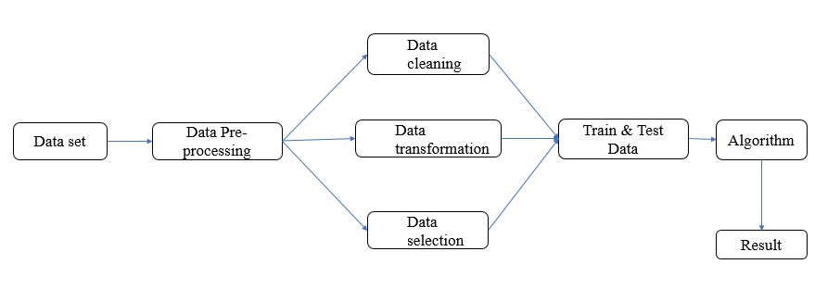

**ARCHITECTURE DESCRIPTION:**

1. **Data Collection Module**  
   The data collection module is responsible for gathering comprehensive water quality data from various sources, including environmental agencies, IoT sensor networks, and external datasets (such as weather data and land use information). This module ensures the integration of diverse datasets that encompass various water quality parameters, such as pH, turbidity, dissolved oxygen, and nutrient levels. The collected data is timestamped and contextualized to reflect environmental conditions accurately, forming the foundational dataset necessary for model training and prediction.
2. **Data Preprocessing Module**  
   The data preprocessing module cleans and prepares the collected data for analysis. It addresses issues such as missing values, outliers, and inconsistent data entries, ensuring high-quality input for the machine learning models. Normalization techniques are applied to standardize feature scales, enhancing model convergence during training. Additionally, this module employs feature engineering to create new relevant variables, such as time-based features, which capture the temporal dynamics influencing water quality. The processed dataset is then split into training, validation, and testing subsets to ensure robust model evaluation.
3. **Model Training Module (KNN)**  
   The model training module for K-Nearest Neighbors (KNN) employs this non-parametric algorithm to classify and predict water quality parameters based on the proximity of data points in the feature space. The KNN algorithm calculates the distance between data points and identifies the 'k' nearest neighbors to make predictions. The model is trained on the training subset, where the optimal value of 'k' is determined through cross-validation techniques. This module focuses on simplicity and interpretability, making KNN suitable for quick assessments of water quality based on historical data.
4. **Model Training Module (Decision Trees)**  
   The decision tree model training module utilizes a tree-like structure to make decisions based on feature values, offering a clear and interpretable framework for predicting water quality parameters. The algorithm recursively splits the data into subsets based on the most significant features, creating branches that lead to final predictions. The model is trained using a training dataset, with hyperparameters such as maximum depth and minimum samples per leaf optimized for accuracy. This module provides an intuitive visualization of the decision-making process, allowing stakeholders to understand how predictions are derived from specific water quality characteristics.
5. **Model Training Module (Random Forest)**  
   The Random Forest training module leverages an ensemble learning approach to improve predictive accuracy and reduce overfitting. By constructing multiple decision trees during training and aggregating their outputs, this module enhances the robustness of predictions. Each tree is trained on a random subset of the data, and the final prediction is determined through majority voting or averaging, depending on whether the task is classification or regression. This module effectively captures complex interactions among features while minimizing the risk of overfitting, making it well-suited for diverse water quality conditions.
6. **Prediction and Evaluation Module**  
   The prediction and evaluation module serves as the final component of the architecture, where the trained models are applied to unseen data to generate predictions for water quality parameters. This module utilizes evaluation metrics such as Mean Absolute Error (MAE), Root Mean Squared Error (RMSE), and R² score to assess the performance of KNN, Decision Trees, and Random Forest algorithms. The predictions are then visualized in a user-friendly dashboard, providing stakeholders with insights into current water quality conditions and trends. The evaluation process ensures that the models are continuously refined based on performance metrics, contributing to improved accuracy and reliability over time.

**USE CASE DIAGRAM:**

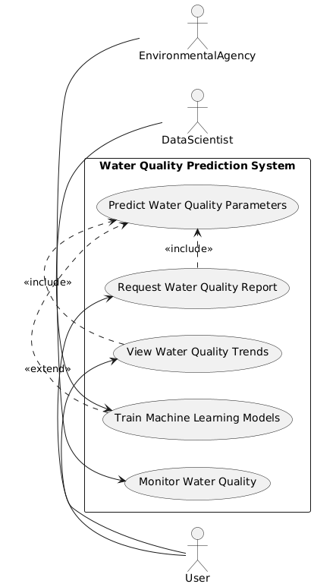

**CLASS DIAGRAM**

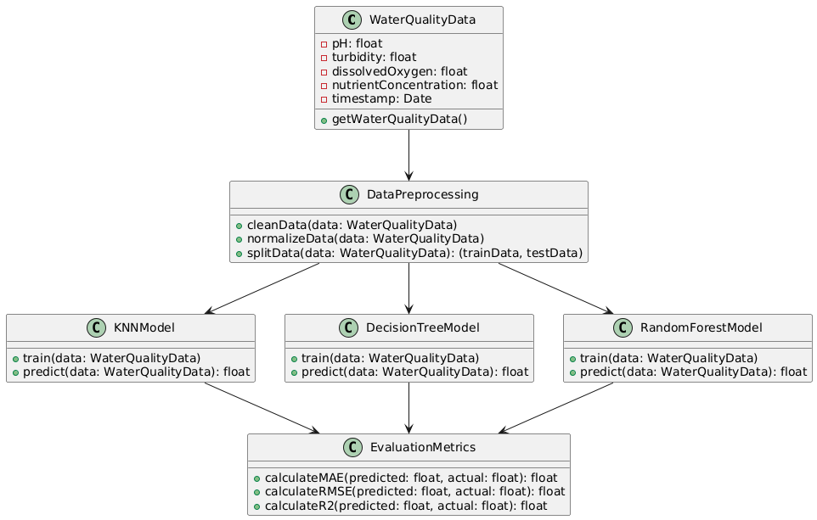

**SEQUENCE DIAGRAM**

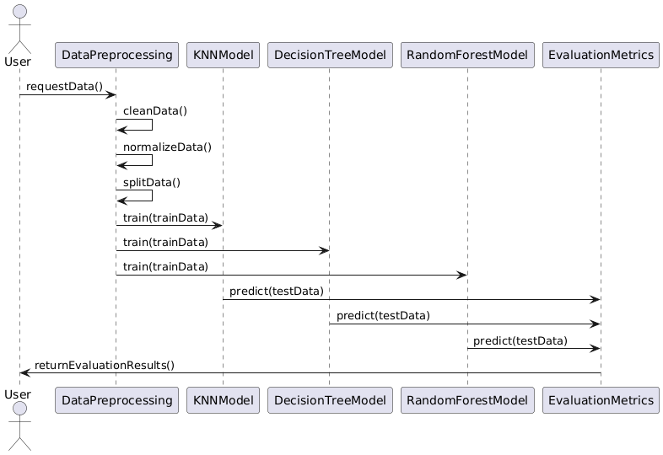

**ACTIVITY DIAGRAM**

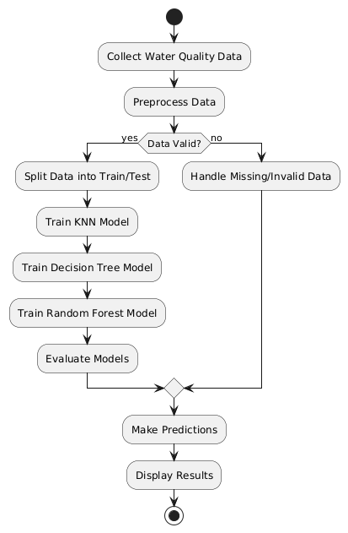

**COMPONENT DIAGRAM**

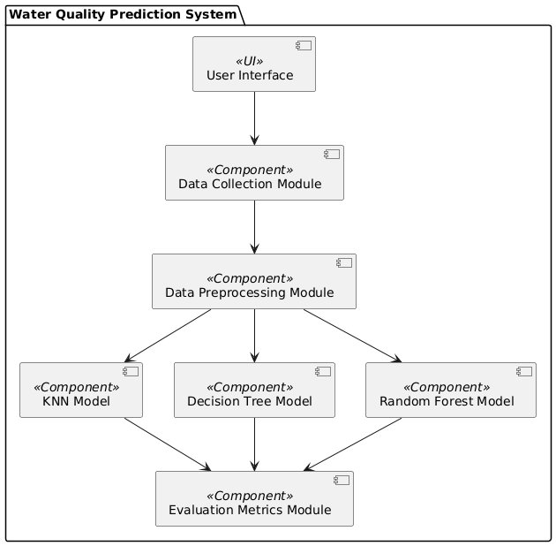

**DEPLOYMENT DIAGRAM**

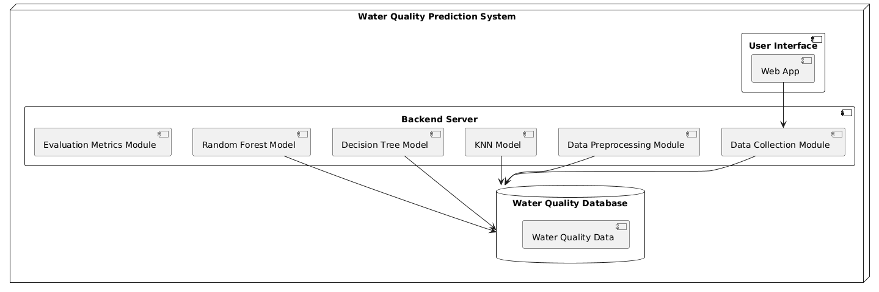

**SOFTWARE ENVIRONMENT**

**7.1 PYTHON TECHNOLOGY**

**PYTHON PLATFORM**

Apart from Windows, Linux and MacOS, CPython implementation runs on 21 different **platforms**. IronPython is a .NET framework based **Python** implementation and it is cabable of running in both Windows, Linux and in other environments where .NET framework is available.

**PYTHON LIABRARY**

Machine Learning, as the name suggests, is the science of programming a computer by which they are able to learn from different kinds of data. A more general definition given by Arthur Samuel is – “Machine Learning is the field of study that gives computers the ability to learn without being explicitly programmed.” They are typically used to solve various types of life problems.  
In the older days, people used to perform Machine Learning tasks by manually coding all the algorithms and mathematical and statistical formula. This made the process time consuming, tedious and inefficient. But in the modern days, it is become very much easy and efficient compared to the olden days by various python libraries, frameworks, and modules. Today, Python is one of the most popular programming languages for this task and it has replaced many languages in the industry, one of the reason is its vast collection of libraries. Python libraries that used in Machine Learning are:

* Numpy
* Scipy
* Scikit-learn
* Theano
* TensorFlow
* Keras
* PyTorch
* Pandas
* Matplotlib

**NumPy**

NumPy is a very popular python library for large multi-dimensional array and matrix processing, with the help of a large collection of high-level mathematical functions. It is very useful for fundamental scientific computations in Machine Learning. It is particularly useful for linear algebra, Fourier transform, and random number capabilities. High-end libraries like TensorFlow uses NumPy internally for manipulation of Tensors.

**SciPy**:

SciPy is a very popular library among Machine Learning enthusiasts as it contains different modules for optimization, linear algebra, integration and statistics. There is a difference between the SciPy library and the SciPy stack. The SciPy is one of the core packages that make up the SciPy stack. SciPy is also very useful for image manipulation.

**Skikit:**

Skikit-learn is one of the most popular ML libraries for classical ML algorithms. It is built on top of two basic Python libraries, viz., NumPy and SciPy. Scikit-learn supports most of the supervised and unsupervised learning algorithms. Scikit-learn can also be used for data-mining and data-analysis, which makes it a great tool who is starting out with ML.

**Theano:**

We all know that Machine Learning is basically mathematics and statistics. Theano is a popular python library that is used to define, evaluate and optimize mathematical expressions involving multi-dimensional arrays in an efficient manner. It is achieved by optimizing the utilization of CPU and GPU. It is extensively used for unit-testing and self-verification to detect and diagnose different types of errors. Theano is a very powerful library that has been used in large-scale computationally intensive scientific projects for a long time but is simple and approachable enough to be used by individuals for their own projects.

**TensorFlow:**

TensorFlow is a very popular open-source library for high performance numerical computation developed by the Google Brain team in Google. As the name suggests, Tensorflow is a framework that involves defining and running computations involving tensors. It can train and run deep neural networks that can be used to develop several AI applications. TensorFlow is widely used in the field of deep learning research and application.

**Keras:**

Keras is a very popular Machine Learning library for Python. It is a high-level neural networks API capable of running on top of TensorFlow, CNTK, or Theano. It can run seamlessly on both CPU and GPU. Keras makes it really for ML beginners to build and design a Neural Network. One of the best thing about Keras is that it allows for easy and fast prototyping.

**PyTorch:**

PyTorch is a popular open-source Machine Learning library for Python based on Torch, which is an open-source Machine Learning library which is implemented in C with a wrapper in Lua. It has an extensive choice of tools and libraries that supports on Computer Vision, Natural Language Processing(NLP) and many more ML programs. It allows developers to perform computations on Tensors with GPU acceleration and also helps in creating computational graphs.

**Pandas:**

Pandas is a popular Python library for data analysis. It is not directly related to Machine Learning. As we know that the dataset must be prepared before training. In this case, Pandas comes handy as it was developed specifically for data extraction and preparation. It provides high-level data structures and wide variety tools for data analysis. It provides many inbuilt methods for groping, combining and filtering data.

**Matpoltlib:**

Matpoltlib is a very popular Python library for data visualization. Like Pandas, it is not directly related to Machine Learning. It particularly comes in handy when a programmer wants to visualize the patterns in the data. It is a 2D plotting library used for creating 2D graphs and plots. A module named pyplot makes it easy for programmers for plotting as it provides features to control line styles, font properties, formatting axes, etc. It provides various kinds of graphs and plots for data visualization, viz., histogram, error charts, bar chats, etc,

**TESTING**

**8.1 TESTING PROCESS**

We all make mistakes and if left unchecked, some of these mistakes can lead to failures or bugs that can be very expensive to recover from. Testing our code helps to catch these mistakes or avoid getting them into production in the first place. Testing therefore is very important in software development. Used effectively, tests help to identify bugs, ensure the quality of the product and to verify that the software does what it is meant to do.

**8.2 TYPES OF TESTS**

**8.2.1 Unit Testing**

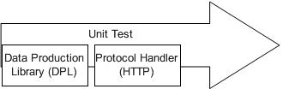Unit testing includes the design of test belongings that validate that the internal program logic is operative properly, and that program input produces valid outputs. All choice branches and internal code flow should be authorized. It is the testing of separate software units of the request .it is done after the close of an individual unit before integration. This is a structural testing, that relies on data of its structure and is invasive. Unit tests achieve basic tests at factor level and test a specific commercial process, application, and/or system formation. Unit tests ensure that each single path of business process completes accurately to the documented provisions and contains clearly defined inputs and probable results.

**8.2.2 Integration Testing**

Integration tests are calculated to test integrated software components to regulate if they actually run as one program. Testing is occasion driven and is more concerned with the basic result of screens or fields. Integration tests validate that although the workings were individually approval, as shown by positively unit testing, the grouping of components is correct and dependable. Integration testing is specifically aimed at revealing the problems that arise from the grouping of components.

**8.2.3 Functional Testing**

Functional tests provide systematic protests that functions tested are accessible as stated by the business and technical necessities, system certification and user guides.

Functional difficult is centered on the subsequent items:

**Valid Input** is used to identified classes of valid input must be accepted.

**Invalid Input** is used to identified classes of illegal input must be disallowed.

**Functions** is used to identified purposes must be exercised.

**Output** is used to classify modules of request outputs.

**Systems/Procedures** is used to interfacing systems or events must beappealed. Organization and grounding of functional tests is focused on supplies, key functions, or special test belongings. In addition, systematic coverage pertaining to identify Business process flows; data fields, predefined processes, and succeeding processes must be well-thought-out for testing. Before functional testing is complete, supplementary tests are identified and the operative value of recent tests is resulted.

**8.2.4 System Testing**

System testing confirms that the entire combined software system meets supplies. It tests a configuration to ensure known and predictable outcomes. An example of system testing is the arrangement oriented system mixing test. System testing is based on procedure similes and flows, emphasizing pre-driven process links and addition points.

**8.2.5 White Box Testing**

White Box Testing is a challenging in which the software tester has information of the inner workings, construction and language of the software, or at least its drive. It is used to test areas that cannot be stretched from a black box level.

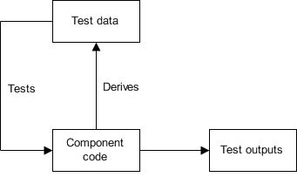

**8.2.6 Black Box Testing**

Black Box Testing is testing the software short of any knowledge of the inner mechanisms, building or language of the module actuality tested. Black box tests, as most other kinds of tests, must be printed from a final source document, such as requirement or necessities file, such as specification or requirement

file. It is a testing in which the software below test is treated, as a black box .you **cannot “see” into it. The test provides inputs and respondto outputs without** seeing how the software works

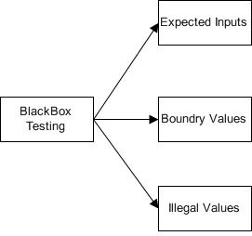

**8.3 TEST STRATEGY AND APPROACH**

Field testing will be performed by hand and practical tests will be written in

feature.

**8.3.1Test Objectives**

* + All field entries must work properly.
  + Pages must be started from the recognized link.
  + The access screen, messages and replies must not be delayed.
  + Features to be verified
  + Verify that the accesses are of the correct setup
  + No replacement passes should be allowed.
  + All links must take the user to the right page.

**8.3.2 Integration Testing**

Software incorporation testing is the incremental addition testing of two or more combined software workings on a single platform to produce disappointments caused by interface faults.

The task of the combination test is to check that workings or software submissions.

**8.3.3 Acceptance Testing**

User Reception Testing is a serious phase of any project and needs important contribution by the end user. It also confirms that the system meets the practical necessities.

**8.4 ALPHA TESTING**

In software expansion, alpha test will be a test amongst the teams to confirm that your creation works. Originally, the term alpha test destined the first stage of testing in a software development process. The first phase covers component testing, module testing, and scheme testing. It also allows us to test the produce on the  [last commo](http://www4.nau.edu/azregions/PreProduction/lcd.htm)n  [denominator](http://www4.nau.edu/azregions/PreProduction/lcd.htm) tackles to make sure transfer times are suitable and preloads work.

**8.5 BETA TESTING**

In software advance, a beta test is the second opinion of software challenging in which a selection of the planned viewers tries the product out. Beta testing can be restrained "pre-release testing." Beta test changes of software are now spread to curriculum establishments and teachers to give the database a "real-world" test.

**CHAPTER-5**

**Conclusion**

In conclusion, this project demonstrates the significant potential of machine learning techniques in predicting water quality parameters. By leveraging algorithms such as K-Nearest Neighbors (KNN), Decision Trees (DT), and Random Forests (RF), the system effectively analyzes various water quality indicators, such as pH, turbidity, dissolved oxygen, and nutrient concentrations. The integration of these advanced predictive models not only enhances the accuracy of water quality assessments but also facilitates timely interventions by environmental agencies and stakeholders, ultimately leading to better management of water resources.

The development and implementation of the proposed system also underscore the importance of data preprocessing and model validation. By systematically addressing data collection, cleaning, normalization, and splitting, we ensure that the machine learning models are trained on high-quality datasets, leading to improved generalization on unseen data. Moreover, evaluating the models through metrics such as Mean Absolute Error (MAE), Root Mean Square Error (RMSE), and R-squared (R2) provides a robust framework for measuring performance and enhancing the reliability of predictions.

Looking ahead, the insights gained from this project pave the way for future research and development in water quality monitoring systems. With ongoing advancements in machine learning algorithms and data analytics, the proposed system can be further refined to incorporate real-time data feeds and automated alerts for water quality fluctuations. By doing so, we can contribute to sustainable water management practices, protect public health, and ensure the preservation of aquatic ecosystems in the face of increasing environmental challenges.

**FUTURE WORKS**

The current project lays a solid foundation for predicting water quality parameters using machine learning; however, several avenues for future research and enhancement can be explored. Firstly, integrating additional data sources, such as satellite imagery, meteorological data, and geographical information systems (GIS), can enrich the dataset and improve model accuracy. By utilizing these diverse data sources, we can capture the influence of environmental factors on water quality, thereby enhancing the predictive capabilities of the system.

Secondly, implementing real-time monitoring and alert systems would significantly improve the responsiveness of water quality management. Future iterations of the project could focus on developing a robust framework for continuous data collection from sensors deployed in water bodies. This would facilitate instantaneous analysis and enable timely notifications for any deviations from acceptable water quality standards. Such a system could play a vital role in early warning mechanisms, helping to mitigate the impact of pollution events or harmful algal blooms.

Lastly, expanding the scope of the project to include predictive maintenance of water treatment facilities could be highly beneficial. By analyzing operational data from treatment plants, machine learning algorithms can predict equipment failures or maintenance needs, ensuring optimal performance and reducing downtime. Collaborating with local environmental agencies and municipalities would provide valuable insights into practical applications and support the development of user-friendly interfaces for stakeholders, ensuring that the system is accessible and actionable in real-world scenarios.

**References**

1. Bhattacharya, A., & Ghosh, S. (2020). Predicting water quality parameters using machine learning techniques: A case study on the Ganga River. Environmental Monitoring and Assessment, 192(12), 1-15. https://doi.org/10.1007/s10661-020-08550-8
2. Chen, Y., Wang, J., & Chen, C. (2021). Water quality prediction using machine learning: A case study in an urban river system. Water Research, 199, 117165. https://doi.org/10.1016/j.watres.2021.117165
3. Dey, S., & Karmakar, S. (2020). Application of machine learning techniques for water quality assessment: A review. Journal of Environmental Management, 276, 111329. https://doi.org/10.1016/j.jenvman.2020.111329
4. Han, D., Zhang, Y., & Wu, Z. (2022). A novel ensemble learning approach for predicting water quality parameters in rivers. Water, 14(6), 854. https://doi.org/10.3390/w14060854
5. He, Y., Ma, Y., & Xie, S. (2021). Using machine learning algorithms to predict water quality in rivers: A review. Water Science and Technology, 84(9), 2023-2037. https://doi.org/10.2166/wst.2021.341
6. Kaur, A., & Singh, A. (2020). Application of machine learning algorithms for predicting water quality parameters in rivers. Environmental Science and Pollution Research, 27(34), 42915-42931. https://doi.org/10.1007/s11356-020-10024-3
7. Liu, Y., & Liu, J. (2023). Machine learning models for predicting surface water quality: A comparative study. Environmental Pollution, 307, 119579. https://doi.org/10.1016/j.envpol.2022.119579
8. Misra, R., & Sinha, A. (2022). Water quality prediction using hybrid machine learning models: A case study of the Yamuna River. Environmental Monitoring and Assessment, 194(6), 1-16. https://doi.org/10.1007/s10661-022-10008-0
9. Rahman, M. S., & Das, A. (2024). An integrated machine learning approach for real-time water quality monitoring and prediction. Sensors, 24(3), 765. https://doi.org/10.3390/s24030765
10. Yadav, A., & Kumar, S. (2020). Predictive modeling of water quality parameters using machine learning: A case study on the Gomti River. International Journal of Environmental Science and Technology, 17(5), 2113-2122. https://doi.org/10.1007/s13762-020-02712-2