Stock status, exploitation rate conversion, and simulation analysis of future stock status under varying productivity and exploitation rate scenarios for Fraser River Spring and Summer 5₂ (1.3) Chinook Salmon (Oncorhynchus tshawytscha)
Colin Bailey¹, Isabella Borea², Cameron Freshwater³, Dan Greenberg³, Catarina Wor³, Angus Straight⁴, and Charles Parken¹
¹Fisheries and Oceans Canada, 985 McGill Place
Kamloops, British Columbia, V2C 6X6
²Fisheries and Oceans Canada, 3-100 Annacis Parkway
Delta, British Columbia, V3M 6A2
³Pacific Biological Station
Fisheries and Oceans Canada, 3190 Hammond Bay Road
Nanaimo, British Columbia, V9T 6N7
⁴Fisheries and Oceans Canada, 401 Burrard Street
Vancouver, British Columbia, V6C 3S4

Foreword
This series documents the scientific basis for the evaluation of aquatic resources and ecosystems in Canada. As such, it addresses the issues of the day in the time frames required and the documents it contains are not intended as definitive statements on the subjects addressed but rather as progress reports on ongoing investigations.
Published by:
Fisheries and Oceans Canada
Canadian Science Advisory Secretariat
200 Kent Street
Ottawa ON K1A 0E6
http://www.dfo-mpo.gc.ca/csas-sccs/
DFO.CSAS-SCAS.MPO@dfo-mpo.gc.ca

© His Majesty the King in Right of Canada, as represented by the Minister of the
Department of Fisheries and Oceans, 2026
DOI: xxx.xxx.xxx
This report is published under the Open Government Licence - Canada
ISSN 1919-5044
ISBN 978-0-660-xxxxx-x Cat. No. Fs70-5/2026-nnnE-PDF
Correct citation for this publication:
Bailey, C.J., Borea, I., Freshwater, C., Greenberg, D., Wor, C., Parken C. 2026. Stock status, exploitation rate conversion, and simulation analysis of future stock status under varying productivity and exploitation rate scenarios for Fraser River Spring and Summer 1.3 (52) Chinook Salmon (Oncorhynchus tshawytscha). DFO Can. Sci. Advis. Sec. Res. Doc. 2026/nnn. iv + xx p. doi: xxx.xxx.xxx
Aussi disponible en français :
[Auteurs, I]. 2026. [Titre – doit correspondre exactement à la page couverture]. Secr. can. des avis sci. du MPO. Doc. de rech. 2026/nnn. iv + xx p. doi : xxx.xxx.xxx
TABLE OF CONTENTS
ABSTRACT 1
INTRODUCTION 2
Objectives 3
Methods 5
Stock Structure 5
Data: Spring 1.3 Chinook 9
Data: Summer 1.3 Chinook 11
Assessment 13
Ricker Stock-Recruit Parameters 13
Reference Points 18
WSP Status Assessment 19
Simulations 20
FMI-to-CYER Translation Analysis 22
Results 23
Assessment 23
Ricker Stock-Recruit Parameters 23
Reference Points 28
FMI-to-CYER Translation Analysis 28
Stock Status and Trends: Spring 5₂ (1.3) 29
Simulations: Spring 5₂ (1.3) 33
Hatchery Enhancement: Spring 5₂ (1.3) 36
Stock Status and Trends: Summer 5₂ (1.3) 39
Simulations: Summer 1.3 43
Hatchery Enhancement : Summer 5₂ (1.3) 46
History of Management 50
Ecosystem and Climate Change Considerations 66
Exceptional Circumstances 67
Discussion 67
Escapement Data 67
Exploitation Rate 68
Simulations 69
Future Research 71
Summary 72
REFERENCES CITED 74
APPENDIX A: WILD SALMON POLICY RAPID STATUS assesments 77
A.1. SPRING 1.3 79
A.1.1 CK-04 Lower Fraser 82
A.1.2 CK-08 Middle Fraser River- Fraser Canyon 84
A.1.4 CK-12 Upper Fraser 89
A.1.5 CK-18 North Thompson 93
A.2. SUMMER 1.3 96
A.2.1 CK-05 Lower Fraser-Upper Pitt 97
A.2.2 CK-06 Lower Fraser 99
A.2.3. CK-09 Middle Fraser River – Portage 101
A.2.4. CK-11 Middle Fraser 103
A.2.5. CK-14 South Thompson 106
A.2.6. CK-19 North Thompson 109
APPENDIX B: Age and Fecundity data 112
APPENDIX C: Ricker Parameter Estimates 126
Appendix D: Chilko Survival Results 127
Appendix E: Additional Simulation Results 128
E1. Spring 1.3 128
E1.1. Perfect Implementation Error 128
E1.2. Pessimistic Implementation Error 130
E2. Summer 1.3 132
E2.1. Perfect Implementation Error 132
E2.2. Pessimistic Implementation Error 134
APPENDIX F: Hatchery release data 136
F.1 SPRING 1.3 136
F.2. SUMMER 1.3 141
APPENDIX G: glossary 146
APPENDIX H: Fecundity-Based Expansion Validation 150
Methods 150
Results 151
Fecundity 152
Ricker ln(α) Estimates 153
Discussion 155

ABSTRACT
The Fisheries Management sector of Fisheries and Oceans Canada (DFO) requested that reference points consistent with the DFO Precautionary Approach (DFO 2009) be developed for Fraser Spring and Summer 5₂ (1.3) Chinook salmon (Oncorhynchus tshawytscha) stock management units (SMUs). Both Fraser Spring and Summer 5₂ (1.3) Chinook SMU timeseries of exploitation rate (ER) are short and uncertain, and escapement records are dominated by relative index, rather than absolute spawner abundances. In addition, until now ERs for these SMUs have been measured using the Fisheries Mortality Index, a run reconstruction- and genetics-based method that has different assumptions than the coded wire tag (CWT)-based Calendar Year Exploitation Rate (CYER) used to assess stock status against Pacific Salmon Treaty management objectives. Thus, there are insufficient spawner and recruitment data are to fit traditional stock-recruit models. Instead, to develop reference points and provide advice to management through simulation exercises, Ricker stock recruit parameters (which underpin reference point calculation and population dynamics in simulations) were estimated using a blend of new and previously-used methods by leveraging productivity data from a similar data-rich stock, scaling productivity estimates relative to fecundity, and using the Parken Habitat model to estimate capacity. The relationship between the FMI and CYER was estimated using a measurement error model to contextualize the quality of information provided by the FMI relative to CYER. The results suggest that the maximum sustainable exploitation rates for Fraser Spring and Summer 5₂ (1.3) Chinook SMUs are 0.44 and 0.41, respectively. In the simulation analysis, the likelihood of exceeding the lower biological benchmark for all CUs in either SMU was extremely low (0 – 4%), which was driven by small CUs. Finally, the parameter estimates suggest that the slope of the relationship between FMI and CYER is biased low and that the magnitude of this bias increases with greater observation error in either metric. Although data limitations for both SMUs reduced the scope of this document, there are novel elements that will serve to inform fisheries management.

INTRODUCTION
The Fisheries Management sector of Fisheries and Oceans Canada (DFO) has requested that reference points consistent with the DFO Precautionary Approach(DFO 2006) be developed for Fraser Spring and Summer 5₂ (1.3) Chinook salmon (Oncorhynchus tshawytscha) stock management units (SMUs). This request includes a review of possible fishing and stock productivity scenarios for Fraser Spring and Summer 5₂ (1.3) Chinook salmon that could contribute to stock rebuilding, and that the stock status be assessed relative to the reference points as part of a Canadian Science Advice Secretariat (CSAS) Fisheries Science Advisory Report (FSAR) process. However, at this time, most Pacific salmon FSARs have been completed for relatively data-rich stocks with lengthy timeseries of high-quality escapement and exploitation rate (ER) estimates (e.g., Fraser Pink Salmon, Interior Fraser Coho, Early Stuart Sockeye). In those cases, fisheries stock-recruit models (e.g., Ricker) could be fit to stock-recruit data to estimate abundance-based benchmarks and parameterize simulation analyses. In contrast, Fraser Spring and Summer 5₂ (1.3) Chinook salmon timeseries of ER are short and uncertain, and escapement records are dominated by relative index rather than absolute spawner abundances. Thus, the spawner and recruit data are not appropriate for fitting traditional stock-recruit models.
The exploitation rate analysis (ERA) for Pacific Salmon Commission (PSC) exploitation rate indicator stocks (ERIS) relies on coded wire tag (CWT) data (Chinook Technical Committee 2025a) to estimate stock-specific brood year total-, age-, and fishery-specific ERs, as well as maturation rates and smolt-to-age 3 survival rates (for Chinook with stream-type life history), and annual distribution of mortalities among fisheries (Chinook Technical Committee 2025a) The calendar year exploitation rate (CYER) is then computed as the ratio of the total mortality in fisheries (or subsets) to the total mortality in fisheries plus escapement for a given calendar year. The ER and absolute abundance stock-recruit timeseries are short because of insufficient CWT and age-specific spawner abundance data for the Fraser Spring and Summer 5₂ (1.3) Chinook SMUs. Both SMUs have recently developed CWT ERIS programs that have too few years with sufficient data (CWT recoveries in fisheries or age-specific spawner estimates) to estimate stock-recruit parameters. Indeed, brood year 2020 was the first year that more than 100,000 CWT smolts were released for the Chilko ERIS (i.e., the release abundance estimated to be necessary to meet CWT recovery targets). As a result, 2025 was the first year with sufficient CWT recoveries from all age classes, fisheries and spawning grounds for the ERA to be completed. There are not yet enough CWT recoveries to estimate CYER for the Lower Chilcotin ERIS (Fraser Spring 5₂ (1.3) ERIS).
In the absence of CYER estimates for the Fraser Spring and Summer 5₂ (1.3) Chinook salmon SMUs, indices of harvest rate were established during a review of the Fraser River Chinook Salmon Management approach (Dobson et al. 2020)The alternative index (originally termed the Exploitation Rate Index (Dobson et al. 2020) and now referred to as the Fisheries Mortality Index (FMI; (DFO 2025b)) uses a combination of genetic sampling of Canadian marine fisheries and a run reconstruction model for freshwater fisheries to generate estimates of SMU-specific catch in Canadian fisheries, which are then scaled by total escapement within an SMU. The FMI is only estimated for Fraser River Chinook salmon SMUs and has been used in recent years to determine whether relative harvest impacts across various fisheries on Fraser River Spring 4₂ (1.2), Spring 5₂ (1.3), and Summer 5₂ (1.3) SMUs have remained below the 2014-2018 average.
While a detailed comparison of CYER and FMI methods is outside the scope of this manuscript (see Dobson et al. 2020), the key differences between these measures of mortality include the fisheries whose impacts are estimated, how fisheries-related incidental mortality is incorporated, the ecological scale of the data, and the degree of review received. CYER includes impacts from American and a larger number of Canadian marine fisheries, while FMI only estimates impacts from marine fisheries that are Canadian and are anticipated to overlap with Fraser River stocks. Fisheries-related incidental mortality rates vary among fisheries for CYER, while for FMI it is only applied to marine recreational fisheries (DFO 2025b)). CYER provides estimates of harvest impacts for an indicator stock that is assumed to be representative of a larger population aggregate, while FMI estimates harvest impacts at the SMU level. Thus, the estimates of both catch and escapement used to derive each index differ, not just catch alone. The sampling programs used to generate CYER estimates have received substantial review by the PSC’s Chinook Technical Committee, the Pacific Salmon (PSC 2005, 2008, 2015) and are believed to be approximately unbiased estimates of harvest rate for the tagged ERISs (though the assumption that ERISs are representative of untagged stocks remains). Conversely, the FMI is a much shorter time series and the underlying methodology (e.g. data inputs, model assumptions) continues to be refined. A quantitative comparison of both indices provides an important first step towards understanding the impact of these uncertainties on management frameworks.
Here, an approach was developed for providing Pacific salmon stock assessment advice when spawner abundance and recruitment time series are short or otherwise data-limited. Specifically, in addition to the standard information that is supplied in Pacific salmon FSARs: 1) new methods were developed and used to estimate Ricker stock-recruit parameters; 2) the relationship between the FMI and Canadian portion of the CYER was estimated; and 3) future conservation unit (CU)-level Chinook abundance for the Fraser Spring and Summer 5₂ (1.3) Chinook SMUs was simulated across a range of potential ER and productivity scenarios while incorporating or communicating uncertainty from 1) and 2).

Objectives
The following section describes where to find the information in this document addressing each TOR (Table 1).
Table 1. TORs and relevant section (section page numbers provided in Table of Contents).
TOR # | TOR | Sections addressing TORs
1. | Stock status and trends, accounting for assumptions regarding stock structure and distribution. Include the historical and recent trajectory of both stock and fishing indicators. | Table 2, Stock Structure Assumption, Stock Status and Trends.
1.a. | Stock structure and distribution: Describe the component populations (including hatchery releases), Conservation Units (CUs), Designatable Units (DUs), and Stock Management Units (SMUs) as applicable and demographic features. For the Chilko River (CWT ERIS for Fraser Summer 5₂), the proportion of hatchery-origin spawners will be estimated for 2019–2024 using data from the escapement monitoring program. For other systems, develop a tool to estimate the proportion of hatchery-origin spawners given a range of juvenile release numbers and natural origin spawners. Stock status and trends: include the historical and recent trajectory of stock abundance (spawners and catch) with respect to the stock’s reference points. | Stock Structure Assumption, Table 2, Figures 18-19, Figures 19-21, Figures 13 and 21, Appendix B.
1.a.i. | Stock status considering CU-status based LRPs, where CU status is based on assessment methods applied under the Wild Salmon Policy (WSP) (Holt et al. 2009). Where applicable, recommend candidate fisheries reference points (FRPs) for the SMU, and evaluate aggregate spawner abundances for the SMU relative to the FRPs. Available escapement data are relative index abundance data and therefore spawner abundances will not be assessed against abundance-based reference points. Instead, spawner abundances will be assessed against WSP rapid status trend-based metrics. For the same reason, the FRP will be an exploitation rate (ER)-based target, rather than an abundance-based target. | WSP Status Assessment, Stock Status and Trends: Spring 5₂ (1.3), Stock Status and Trends: Summer 5₂ (1.3), Reference Points, Table 5.
1.b. | Hatchery/enhancement data and metrics: where applicable, include the history of enhancement that has occurred within the SMU and the objective of the enhancement, referring to completed Enhancement Plans when available. Where data is available, provide estimates of other enhancement-related metrics. | History of Hatchery and Supplementation, Supplementary Materials A; Appendix A.
2. | Ecosystem and climate change considerations affecting the stock. Describe how environmental and climate considerations were or were not considered in the assessment. | Simulations in Stock Assessment Approach, History of Freshwater Habitat Impacts, Ecosystem and Climate Change Considerations, Table 9.
3. | Evaluate or provide estimates of: Candidate reference points for the stock, and FRPs for the SMU as requested. | Reference Points.
3.a. | The only candidate reference point that will be reported is the RR (i.e., U_{msy}) as it is an ER-based reference point. | Reference Points.
3.b. | If the stock has an enhanced (hatchery) component, clearly define whether these reference points apply to the mixed stock or to a natural/wild stock. If possible, reference points should be estimated for the natural/wild component of the stock. | Reference Points.
4. | Evaluate or provide estimates of the impact of candidate harvest and/or other management options on the stock. Provide advice on the potential impact of the scenarios on the SMU and CU(s) through quantitative or qualitative scenario evaluations. A simulation analysis of changes in the relative abundance of each CU within each SMU will be conducted that estimates the probability of WSP Amber or better CU status. Outcomes will be assessed across a range of harvest (varying ERs from 0 to the RR) and productivity scenarios. | Simulations in Stock Assessment Approach, Simulations: Spring 5₂ (1.3), Simulations: Summer 5₂ (1.3)  , Appendix E.
5. | If the SMU is below the LRP: | Stock Status and Trends: Spring 5₂ (1.3), Stock Status and Trends: Summer 5₂ (1.3).
5.a. | Review CU components contributing to SMU status below the CU-status based LRP. | Stock Status and Trends: Spring 5₂ (1.3), Stock Status and Trends: Summer 5₂ (1.3), Simulations in Discussion.
5.b. | Review factors driving (or limiting) production across the species life history and evaluate the potential future impact of climate on those factors and/or succinctly describe gaps in knowledge. | History of Freshwater Habitat Impacts, Ecosystem and Climate Change Considerations.
5.c. | If applicable, associate limiting factors with anthropogenic threats and provide general recommendations for prioritizing potential mitigation actions and/or succinctly describe gaps in knowledge. | History of Freshwater Habitat Impacts, Ecosystem and Climate Change Considerations, Future Research.
5.d. | If rebuilding targets have been established, evaluate the effect of management actions on probabilities of reaching rebuilding targets if possible. | Rebuilding targets have not been established. See Simulations in Stock Assessment Approach, Simulations: Spring 5₂ (1.3), Simulations: Summer 5₂ (1.3), Supplementary Materials B for potential effects of management scenarios on conservation status.
6. | Describe any exceptional circumstances or assessment triggers for the stock. | Exceptional Circumstances.

Methods

Stock Structure
The major stocks prescribed under the Fisheries Act consists of two SMUs – Fraser Spring 5₂ (1.3) Chinook Salmon and Fraser Summer 5₂ (1.3) Chinook Salmon. These SMUs are further subdivided into Conservation Units (CUs) based on geographic location and neutral genetic markers. The Fraser Spring 5₂ (1.3) SMU contains five CUs and the Fraser Summer 5₂ (1.3) contains six CUs (Table 2). The extent of spawning in the Fraser Spring 5₂ (1.3) and Fraser Summer 5₂ (1.3) SMUs covers a large geographical area which encompasses the Lower, Middle, and Upper Fraser River watershed, as well as tributaries of the North and South Thompson Rivers (Figures 1 and 2; Doutaz et al. 2021; Weir et al. 2022; Dionne et al. 2023)). Chinook Salmon in both SMUs exhibit a stream-type life history, spending at least one year rearing as juveniles in freshwater prior to migrating to the ocean, and return to freshwater as adults several weeks before spawning. Nearly all the Spring 5₂ (1.3) Chinook populations migrate upstream through the Lower Fraser River before July, whereas the Summer 5₂ (1.3) Chinook populations migrate after, with most populations overlapping in migration times (Parken et al. 2008). An exception is the Middle Fraser River-Portage FA 1.3 CU, which is part of the Summer 5₂ (1.3) Chinook salmon SMU, with peak migration through the Lower Fraser River around September 28th (Potapova et al. 2026).The limited age data available for these SMUs suggests the dominant age class of adults returning to freshwater to spawn is age-4 to age-5 (Appendix E), with lower proportions of age-3 and age-6.
Table 2. List of Conservation Units (CUs) within the Fraser Spring 5₂ (1.3) and Fraser Summer 5₂ (1.3) Stock Management Units with corresponding Designatable Units (DUs), COSEWIC status, and WSP Rapid Statuses.
Stock Management Unit | Conservation Unit ID | Conservation Unit name | Designatable Unit ID | Designatable Unit | COSEWIC Status (2018, 2020) | WSP Rapid Status (2024)
Fraser Spring 5₂ | CK-04 | Lower Fraser SP 1.3 | DU3 | Lower Fraser, Stream, Spring (Birkenhead) | Endangered | Red, medium confidence
Fraser Spring 5₂ | CK-08 | Middle Fraser- Fraser Canyon SP 1.3 | DU7 | Middle Fraser River, Stream, Spring (Nahatlatch) | Endangered | Red,  high confidence
Fraser Spring 5₂ | CK-10 | Middle Fraser SP 1.3 | DU9 | Middle Fraser River, Stream, Spring | Threatened | Red, medium confidence
Fraser Spring 5₂ | CK-12 | Upper Fraser SP 1.3 | DU11 | Upper Fraser River, Stream, Spring | Endangered | Amber, low confidence
Fraser Spring 52 | CK-18 | North Thompson SP 1.3 | DU16 | North Thompson, Stream, Spring | Endangered | Amber, low confidence
Fraser Summer 5₂ | CK-05 | Lower Fraser- Upper Pitt SP 1.3 | DU4 | Lower Fraser River Stream Summer (Upper Pitt) | Endangered | Red, medium confidence
Fraser Summer 5₂ | CK-06 | Lower Fraser River SU 1.3 | DU5 | Lower Fraser River Stream Summer | Threatened | Data Deficient
Fraser Summer 5₂ | CK-09 | Middle Fraser River – Portage FA 1.3 | DU8 | Middle Fraser River Stream Fall (Portage) | Endangered | Red,  high confidence
Fraser Summer 5₂ | CK-11 | Middle Fraser SU 1.3 | DU10 | Middle Fraser River Stream Summer | Threatened | Amber, low confidence
Fraser Summer 5₂ | CK-14 | South Thompson SU 1.3 | DU13 | South Thompson Stream Summer | Endangered | Amber, low confidence
Fraser Summer 5₂ | CK- 19 | North Thompson SU 1.3 | DU17 | North Thompson Stream Summer | Endangered | Amber, low confidence
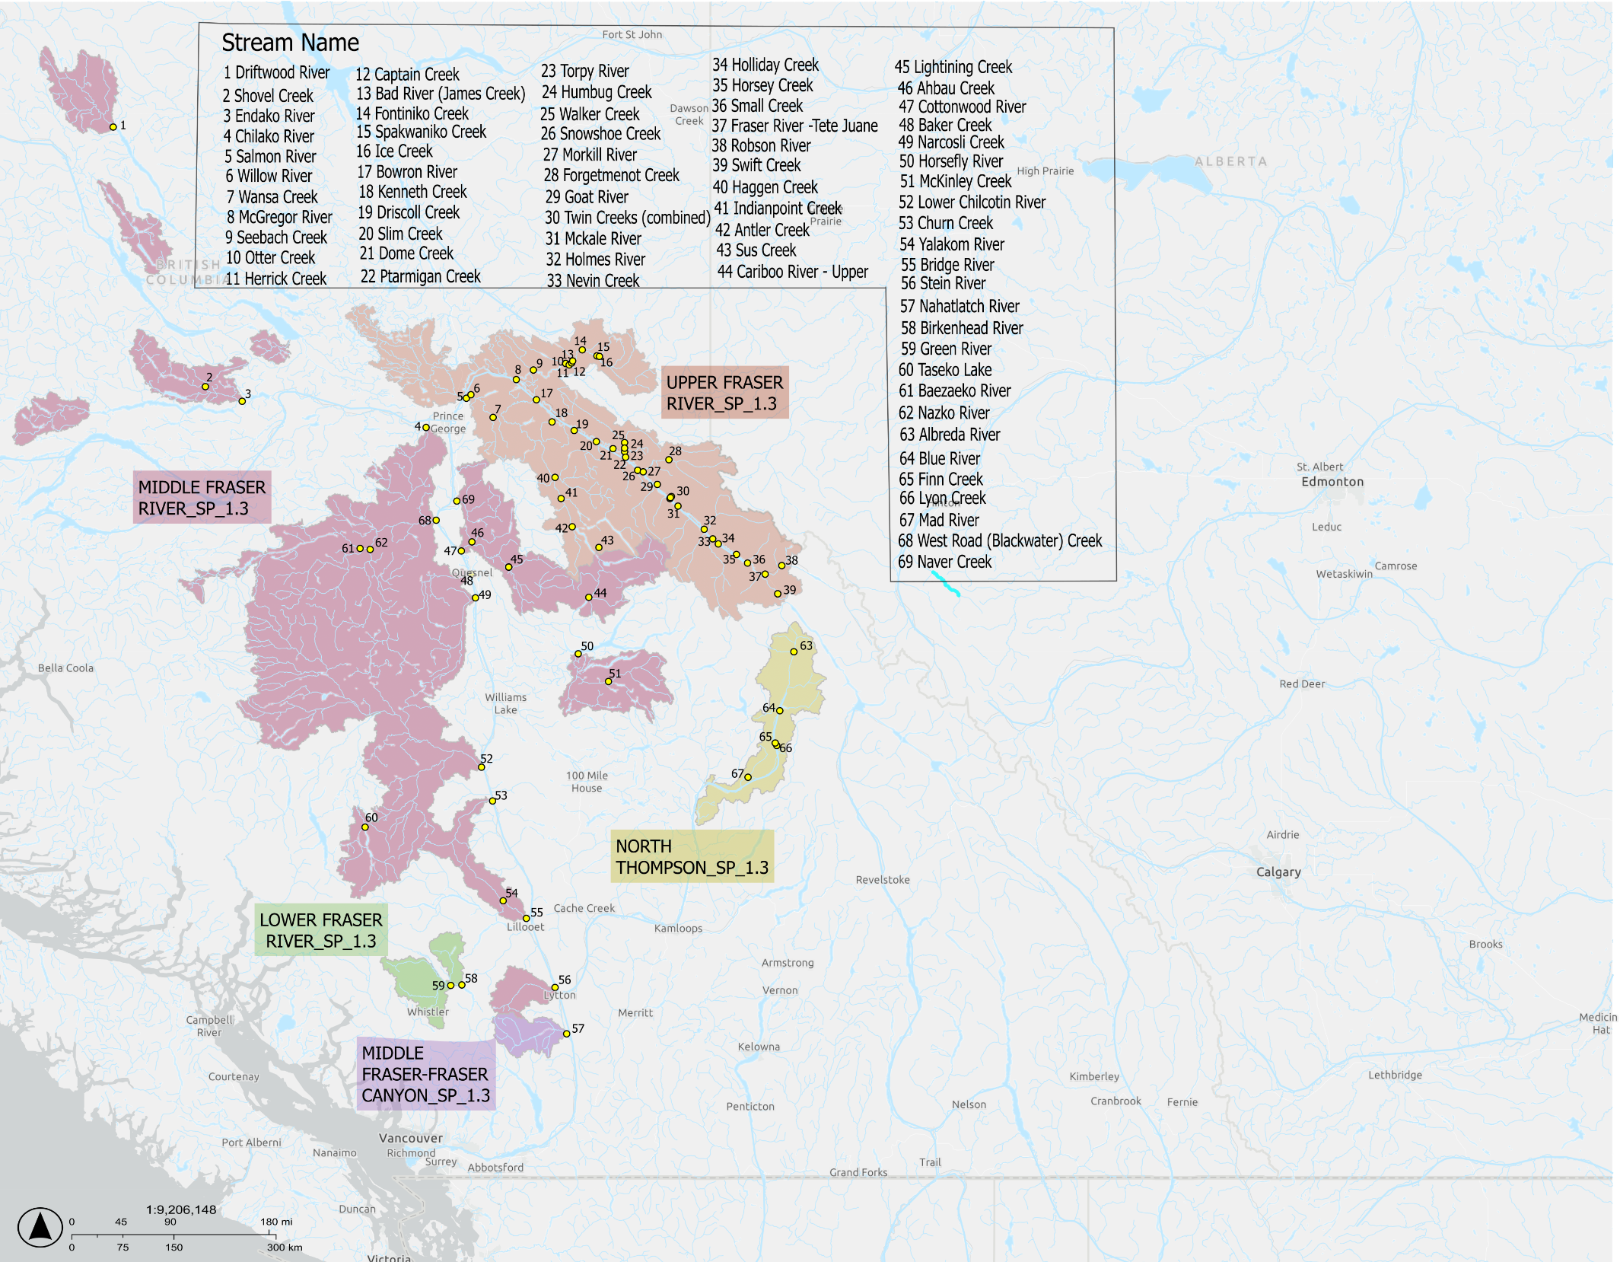
Figure 1. Fraser Spring 5₂ (1.3) Chinook Salmon Conservation Units and survey sites. Numbered sites are surveyed annually to generate escapement estimates. Adapted from Fisheries and Oceans Canada (2026). Salmon Space. Government of Canada. https://egisp.dfo-mpo.gc.ca/apps/SalmonSpace-EspaceSaumon/
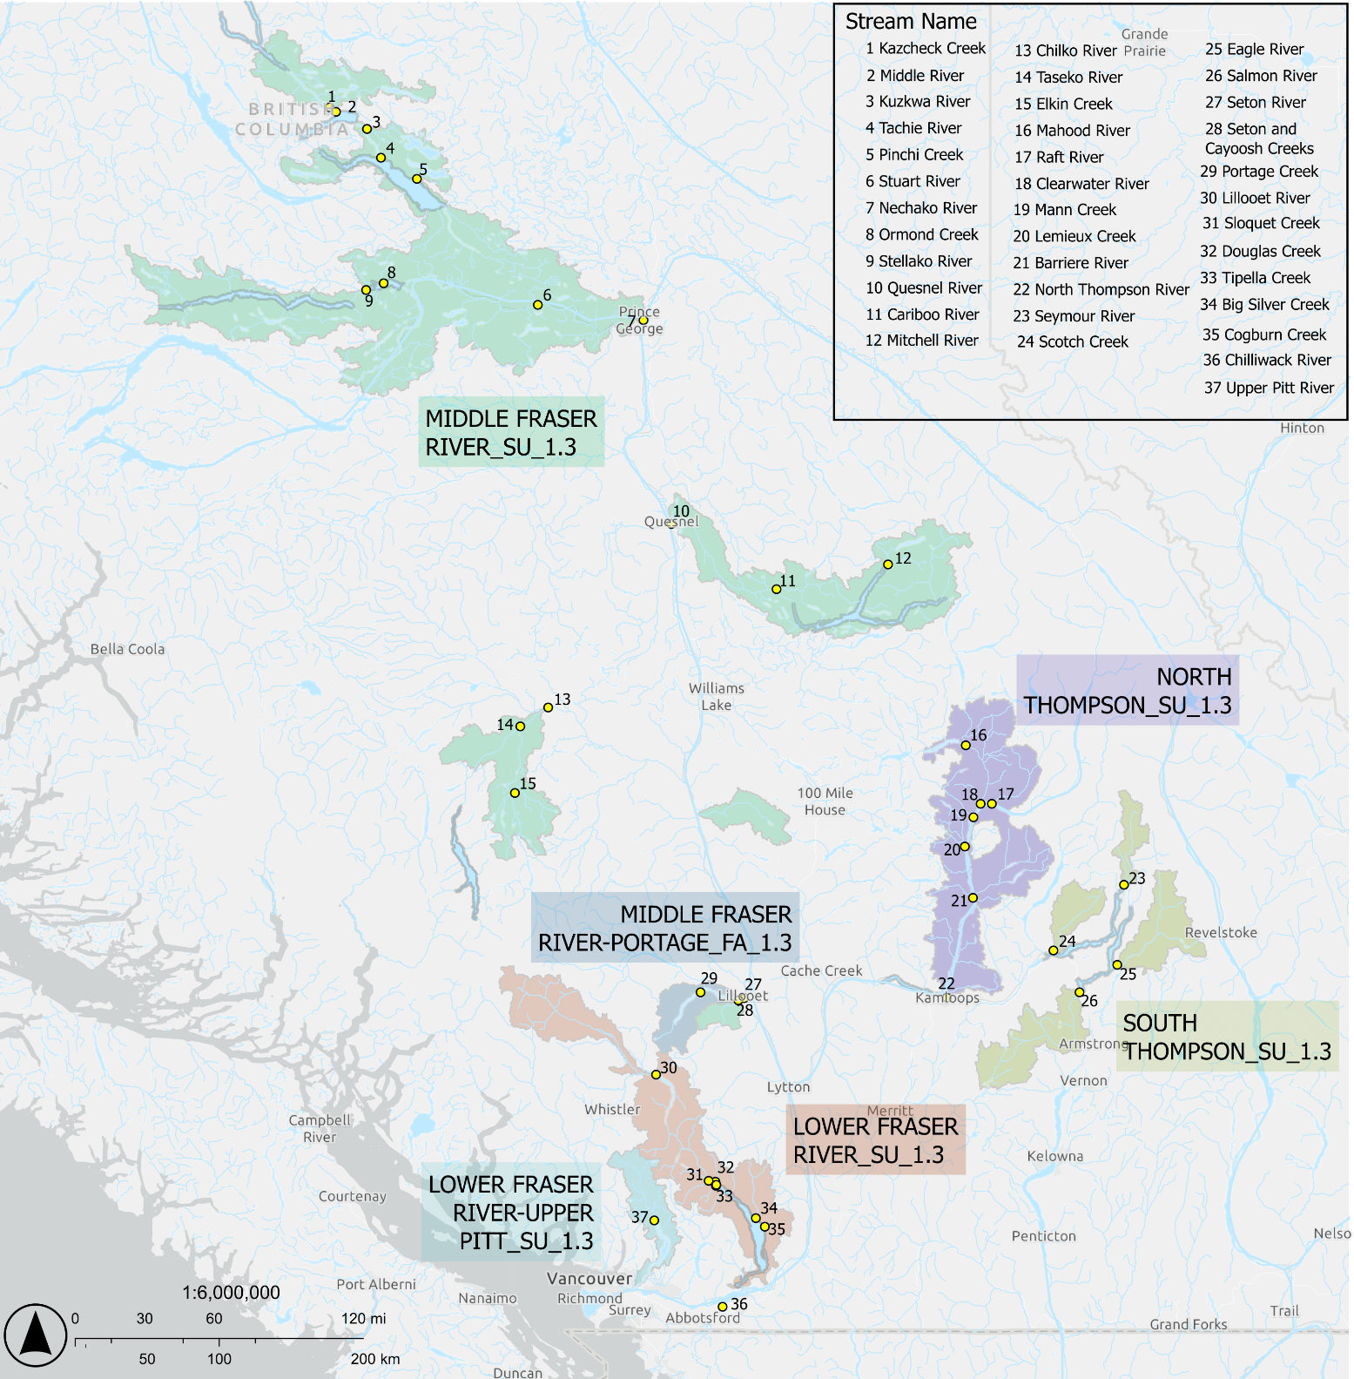
Figure 2. Fraser Summer 5₂ (1.3) Chinook Salmon Conservation Units and survey sites. Numbered sites are surveyed annually to generate escapement estimates. Adapted from Fisheries and Oceans Canada (2026). Salmon Space. Government of Canada. https://egisp.dfo-mpo.gc.ca/apps/SalmonSpace-EspaceSaumon/

Data: Spring 5₂ (1.3) Chinook

Enumeration Methods
The number of adult Chinook Salmon that return to the spawning grounds has been estimated using a variety of survey methods from 1975-2024 across CUs within this SMU. Most systems within the 5 Fraser Spring 5₂ (1.3) CUs are enumerated using standardized visual methods (stream-walk, float or aerial surveys) and a peak count expansion factor of 1.54 is applied to generate the final escapement estimate (Parken et al. 2003)To improve estimate accuracy and precision, SONAR and resistivity counters were installed to estimate escapement in the Bridge River from 2014-2022 and in the Lower Chilcotin River (CK-10 ;Middle Fraser SP 1.3 CU) since 2008, respectively. The Lower Chilcotin River population is a developing ERIS for the Fraser Spring 5₂ (1.3) SMU with a CWT program that was implemented in 2019 to monitor survival, exploitation rate, marine and freshwater distribution, and age structure (Chinook Technical Committee 2025a)

Data Quality Filtering
To align with the Wild Salmon Policy, spawner escapement timeseries included in this assessment only include sites where the number of natural origin spawners could be estimated or are expected to make up greater than 97% of the population. Key steps in processing escapement data for the purposes of the Rapid Status Assessment are described in detail in (Brown et al. 2020) Briefly, data quality is assessed based on the number and completeness of surveys, coverage of the spawning period, visibility and reliability of records, and level of enhancement). Only sites that pass the survey and enhancement data quality standards are included in the derivation of CU-level generational averages and estimation of biological benchmarks (Pestal et al. 2023)
Survey data quality is assigned according to the New Salmon Escapement Database System (NuSEDS) estimate classification system (Brown et al. 2020), where survey methods are categorized from the highest level of precision (Type-1) to the lowest level of precision (Type-6). Estimate types 1-2 are designated as high quality and are estimates of absolute spawner abundance, whereas estimate types 3-4 are designated as moderate quality and are indices of abundance, and estimate types 5-6 are considered low quality indices of abundance (Brown et al. 2020). In the Rapid Status Assessment Chinook data processing framework (Bailey et al. 2026), types 1-2 are considered suitable for comparison against abundance- and trend-based benchmarks, whereas types 3-4 are only suitable for comparison against trend-based benchmarks (Pestal et. al 2023). Sites with low quality estimates are excluded from further analyses and do not contribute to the CU-level spawner estimates for status assignment (Figure 3, (Brown et al. 2020; Pestal et al. 2023).
When there are sufficient data to calculate the proportionate natural influence (PNI) for hatchery-enhanced populations, using the classification system developed (Withler et al. 2018) is recommended, where sites with PNI <0.5 are excluded from further analyses. Due to lack of sufficient pHOS data for majority of sites within these CUs, the (Withler et al. 2018) framework could not be directly applied. Instead, the approach from the 2016 CSAS review on the assessment of Southern BC Chinook CUs was applied (DFO 2016). Briefly, Salmonid Enhancement Program (SEP) records for a site must have a minimum of three generations of enhancement data after brood year 2000 available (DFO 2016a) Sites with greater than 25% mean hatchery-origin contribution or with greater than 25% of years enhanced are ranked as high and excluded from further analyses (DFO 2016a; Brown et al. 2020)
There are a total of 60 survey sites across the 5 Fraser Spring 5₂ (1.3) CUs, 44 of which were included as persistent sites. A persistent site is defined as a site with consistent records (50% of observations from the CU start year, with no more than one generation of consecutive years missing) of high or moderate data quality as described above (Figure 3, Brown et al. 2020). Four sites were excluded from the assessment due to enhancement (See hatchery supplementation section for CU-specific release data by life-stage and Supplementary Materials A, Appendix A for site-specific release data by life-stage), and the remaining were considered data deficient (See Appendix B Tables B.1.1 and B.2.1 for the complete list of persistent sites and Figures B.1.2 – B.1.11 for data quality filtering summaries by CU). The data used in this assessment were described in detail by (Weir et al. 2022; Dionne et al. 2023b). The last integrated status assessment for the CUs in this SMU occurred for return year 2012 (DFO 2016b). Some of the data were also recently used in the Fraser Chinook Recovery Potential Assessments (Doutaz et al. 2021; Weir et al. 2022; Dionne et al. 2023)
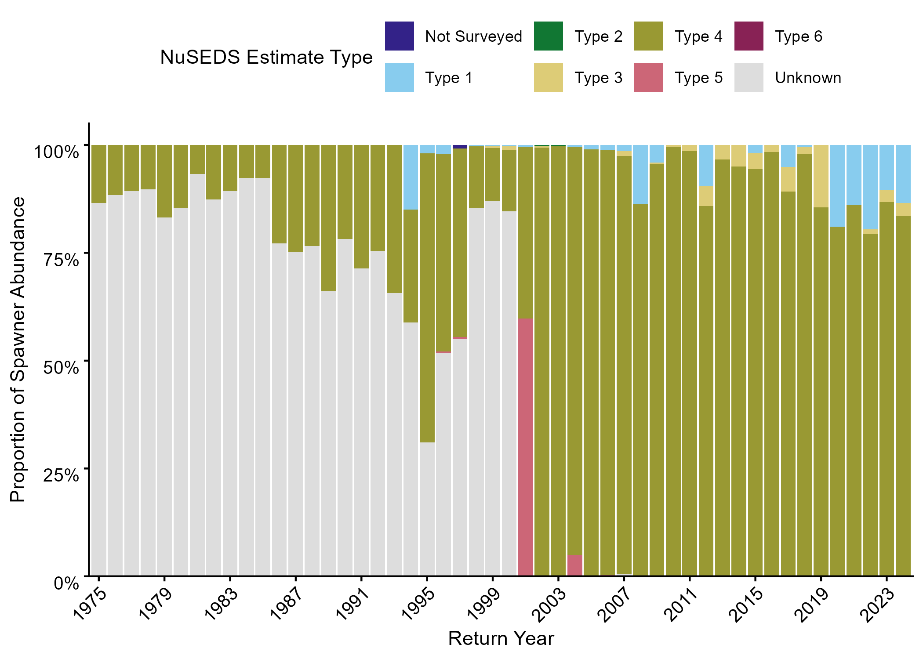
Figure 3. Fraser Spring 5₂ (1.3) proportions of escapement estimates by NuSEDS classification type from 1975-2024. Under the WSP Rapid Status Approach criteria from Brown et al. (2020), Types 1-2 are considered high quality, Types 3-4 are considered moderate quality, Types 5-6 are considered low quality.

Exploitation Rate
Under the 2019 PST Agreement, the Lower Chilcotin population is considered both a developing escapement and CWT ERIS with the recent introduction of the CWT program. Historically, Dome Creek (Upper Fraser; CK-12) was used as the CWT ERIS, but the tagging program at the Dome Creek hatchery was discontinued in 2005. Once enough CWT recoveries occur annually, the Lower Chilcotin population’s CYER will be estimated annually and the population will be subject CYER limits for Individual Stock Based Management (ISBM) fisheries (PSC 2023; Chinook Technical Committee 2024) The Lower Chilcotin CWT program is in an earlier phase of development compared to the Chilko Summer 5₂ (1.3) ERIS population (see Summer 5₂ (1.3) Data Section; Chinook Technical Committee 2025). For this reason, ER is currently evaluated by the Fishing Mortality (FMI) index approach.
To determine SMU-level catch (Figure 5A) and recruitment (Figure 5C), FMI values from 2019-2024 (provided in (DFO 2025) were converted to the proportion of fish that reached the spawning grounds (p_{spawn}) as in Equation 1 below :
- $p_{spawn}=1- FMI$
From there, the number of recruits was determined using the SMU-level natural origin spawner estimates (NO_{spawn}) generated from the WSP Rapid Status Assessment Approach (Appendix B) and p_{spawn} as shown in Equation 2:
- $recruits=\frac{{NO}_{spawn}}{p_{spawn}}$
Finally, catch was calculated by multiplying the number of recruits by the FMI as shown in Equation 3:
- $catch=FMI*recruits$

Data: Summer 5₂ (1.3) Chinook

Enumeration Methods
The number of adult Chinook Salmon that return to the spawning grounds has been estimated using a variety of survey methods from 1975-2024 across the 6 CUs. Most systems within the 6 CUs are surveyed using visual methods (streamwalk, float or aerial) and a peak count expansion factor of 1.54 is applied to generate the final escapement estimate (Parken et al. 2003) In 2010, a Mark-Recapture program was implemented to estimate escapement in Chilko River (Middle Fraser CU). The Salmon River in the South Thompson CU is surveyed using a fixed-site counting fence and escapement has been estimated using this method since 1999. The Chilko River population is the established ERIS for the Fraser Summer 5₂ (1.3) SMU. Historical visual-based escapement estimates prior to 2010 for the Chilko River have been calibrated to the contemporary high-precision mark recapture estimates. In the calibrated timeseries, all visual-based survey estimates were replaced with predicted spawner abundances from a simple linear model fit to 14 years (2010 – 2024) of paired visual-based and mark-recapture-based estimates.

Data Quality Filtering
The same data processing steps described above for the Fraser Spring 5₂ (1.3) SMU were applied to the Fraser Summer 5₂ (1.3) SMU. There are 39 sites across the 6 Fraser Summer 5₂ (1.3) CUs, 21 of which are included as persistent sites, 3 are excluded due to enhancement (See hatchery supplementation section and Supplementary Materials A, Appendix A for CU-specific release data by life-stage), and the remaining are considered data deficient (See Appendix B Table B.2 for the complete list of persistent sites and Figures B.2.2 – B.2.12 for data quality filtering summaries by CU). The average spawner data quality is considered moderate throughout the time series for all CUs, with occasional high-quality data where SONAR or resistivity counters have been implemented (Figure 4). For Lower Fraser SU 5₂ (1.3) CU, most sites were considered data deficient, resulting in a limited time series with acceptable data (Appendix B, Figure B.2.4). Similarly, Lower Fraser – Upper Pitt SU 1.3 had a limited time series with sufficient data quality (Appendix B, Figure B.2.2).
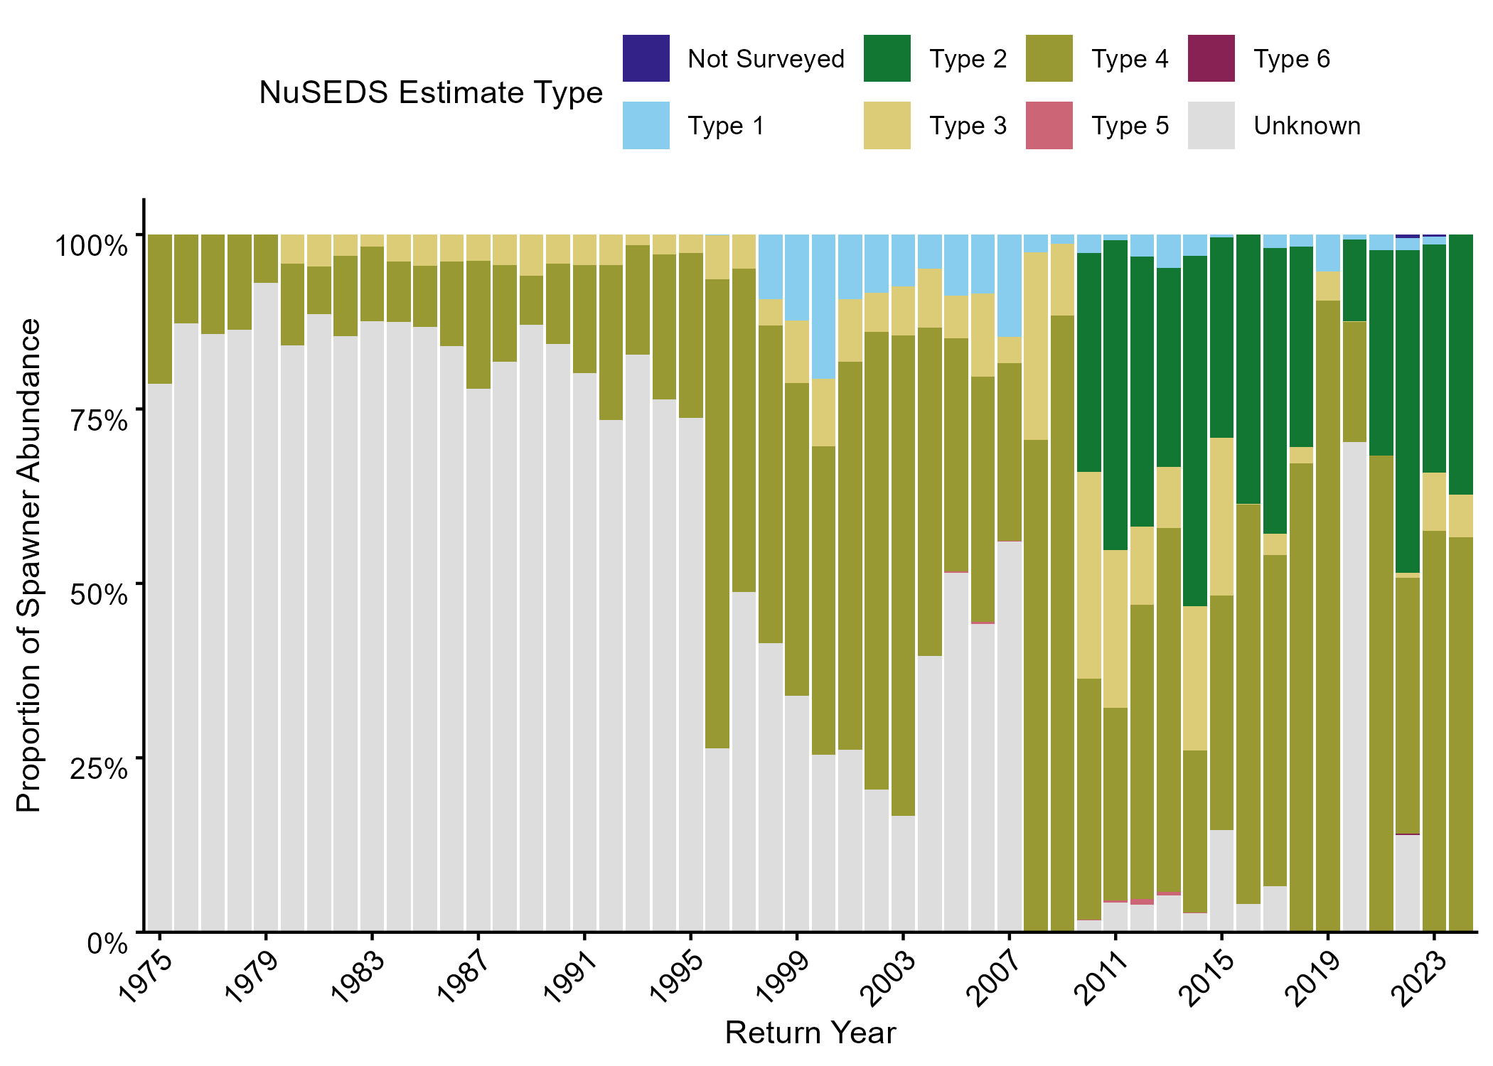
Figure 4. Fraser Summer 5₂ (1.3) proportions of escapement estimates by NuSEDS classification type from 1975-2024. Under the WSP Rapid Status Approach criteria from (Brown et al. 2020), Types 1-2 are considered high quality, Types 3-4 are considered moderate quality, Types 5-6 are considered low quality.

Exploitation Rate
Under the 2019 PST Agreement, the Chilko population is considered both a developing escapement indicator and CWT ERIS with the introduction of the CWT program. As such, the population will be subject to Calendar Year Exploitation Rate (CYER) limits for Individual Stock Based Management (ISBM) fisheries in Canada and the U.S. Due to lack of historical estimates, a CYER limit has not been set for this ERIS. There are enough CWT recovery data from the 2020 brood year onwards to calculate the CYER, however, the data has not yet been published as part of the official CTC annual Exploitation Rate Analysis (ERA) to meet PST obligations ((PSC 2023; Chinook Technical Committee 2023)
To determine SMU-level catch (Figure 13A) and recruitment (Figure 13C), FMI values from 2019-2024 (provided in (DFO 2025)) and preliminary CYER values from 2019-2024 provided by the Chinook Technical Committee (ZENODO LINK), were converted to the proportion of fish that reached the spawning grounds (p_{spawn}) as shown in Equation 1 for the Spring 5₂ (1.3) SMU. Similarly, subsequent calculations of catch and recruitment were derived as shown in Equations 2 and 3 for the Spring 5₂ (1.3) SMU.

Smolt-to-age_3 Survival
Smolt survival (SS) is the proportion of out-migrating smolts that survive to recruit to the fishery (age-3 for stream-type populations). SS is calculated using CWT recoveries and a backwards cohort analysis to estimate the pre-fishery cohort abundance, which is then divided by the total number of CWT-marked smolts released for the cohort (Chinook Technical Committee 2025a) SS is determined as part of the annual ERA developed by the CTC for ERISs. For the Chilko ERIS, 2020 is the first brood year with sufficient CWT recovery data to estimate SS. However, this initial run of the Chilko ERA included tag codes from fry and smolt releases, thus, the survival rates reported in this document are underestimates of hatchery smolt-to-age_3 survival rates.

Assessment
There are 3 main analytical components to this stock assessment:
- Stock Status Assessments
- Simulations
- FMI ~ CYER Translation Analysis
All 3 provide complimentary information contextualizing past and current spawner abundances/statuses and simulating potential future abundance-based statuses. However, due to data limitations (quality and quantity), the analyses for 1) and 2) are not directly comparable despite overlapping characteristics and benchmarks (Figure 5). Whereas current and historical status is assessed using trends in observed spawner abundances (i.e., using index spawner abundance from a subset of spawning streams for each CU) and expert knowledge, the simulations attempt to predict future CU and SMU status from simulated spawner abundances based on Ricker stock-recruit parameters estimated using proxies (i.e., not estimated from prior observations of spawner returns in either SMU). Furthermore, the simulations assume an “omniscient” scenario where all returning spawners can be observed with high precision. Thus, projected statuses in simulations were assessed entirely against abundance-based benchmarks, while status assessments were largely determined by trend-based metrics (although abundance-based benchmarks were estimated as part of the Rapid Status Approach). In contrast, the 3) FMI ~ CYER analysis illustrates the potential degree of error using the FMI as an indicator of fishing mortality, and how that may translate to different simulated conservation outcomes.

Ricker Stock-Recruit Parameters
Ricker stock-recruit parameters (α, β) underpin a large portion of the analyses in this paper. They form the basis for estimating abundance-based benchmarks reported (but not used) in the WSP Rapid Status assessment (Appendix B, Table B1), and more importantly, are used to set the CU-level population dynamics and estimate the lower biological benchmarks used in the Simulations (Figure 5). Due to data limitations, Ricker α (productivity) and β (inverse of spawners at maximum recruitment, S_{max}) could not be estimated using the standard method of fitting a Ricker stock-recruit function to stock-recruit timeseries. Data requirements for fitting stock-recruit curves (as defined by the Chinook Technical Committee; CTC 1999) that are missing or deficient for these SMUs include:
- Exploitation Rate: ER timeseries for both SMUs are too short (6 years) and/or discontinuous; i.e., there are no estimates of age-structured ER for the Fr. Sp. 5₂ (1.3) CK SMU since 2005, and estimates of age-structured ER for the Fr. Su. 5₂ (1.3) CK SMU do not start until 2019. 18 years of age-structured ER estimates are needed to generate the minimum 15 complete cohorts of stock-recruit data required to fit Ricker stock-recruit curves (CTC 1999).
- Escapement Data: Most spawning populations are monitored using visual survey methods that produce type 3 or lower quality counts (Brown et al. 2020) which are inconsistently biased low and lack age-structure (Bailey et al. 2000), and are thus inappropriate for stock-recruit analysis (CTC 1999). Age-structured escapements are only available for Chilko (Fr. Su. 5₂ (1.3) CK ERIS) and Lower Chilcotin River populations (Fr. Sp. 5₂ (1.3) CK ERIS). While stock-recruit relationships will eventually be fit to these ERISs, only 16 years of escapement-at-age are available for Chilko, and 6 years for Lower Chilcotin. 18 years of data are required for 15 complete cohorts of stock-recruit data for each population, the minimum for fitting stock-recruit relationships (CTC 1999).
- Hatchery Data: The proportion of hatchery-origin spawners (pHOS) is only known for the Chilko River population (6 years of data), and while hatchery fish are released in other streams in both SMUs, pHOS is not known due to a lack of marking and recovery. These data are required for fitting stock-recruit curves as the proportion of hatchery-origin spawners needs to be removed from the estimate of recruits because they were not produced by natural spawning, but included in the estimate of spawners because they contribute to the next generation of recruits.
As a result of data limitations, alternative methods were used to estimate Ricker α and β. Ricker α was estimated at the SMU-level based on the Ricker α estimate from a proxy population adjusted for proportional differences in fecundity (Figure 5). Ricker β was estimated at the CU-level using the Parken Habitat Model (Parken et al. 2006) to predict S_{rep} (spawners at replacement) based on accessible watershed area, which was then converted to β using the SMU-level α estimates (Figure 5).
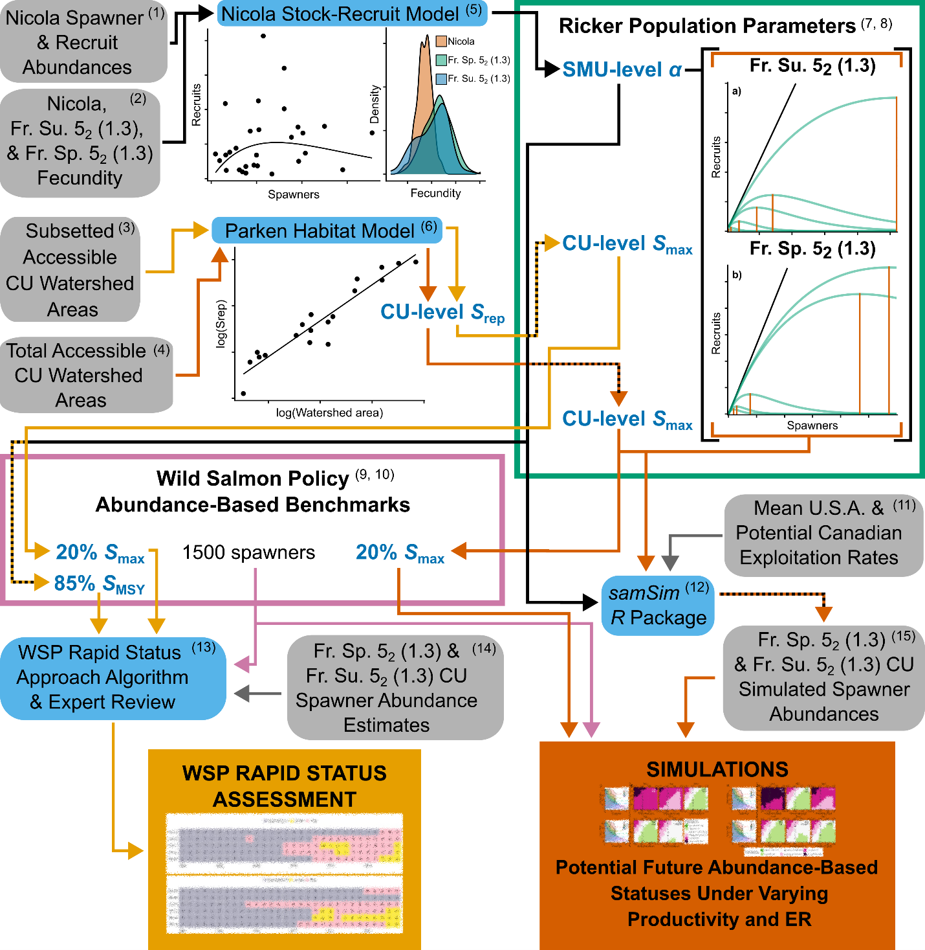
Figure 5. Diagram mapping the separate but related analytical processes for the WSP Rapid Status Assessment and Simulations. Critical differences include CU-level watershed area (subset vs total and CU-level salmon abundance inputs (observed vs simulated). Grey bubbles represent data inputs, blue bubbles represent models/algorithms, and blue text represents estimated parameters. Paths with arrows are colour-coded black for processes that lead to the estimation of Ricker α or use Ricker α as an input, yellow for processes/parameters that are based on subset accessible watershed area, orange for processes/parameters based on total accessible watershed area, and checkered lines where Ricker α is used to calculate a parameter. (1-4) Data available in Bailey et al. (INSERT ZENODO ARCHIVE LINK). (5) Equations 4-5 in Methods. (6) Equations 7-8 in Methods. (7, 8) Equations 4-5, and 7-8 in Methods. (9, 10) Equations 9-11 in Methods. (11) U.S.A. exploitation rates available in Appendix D (Table D.1). (12) Described in Simulations and Appendix B of (Holt 2023)). (13) WSP Rapid Status Approach described in WSP Status Assessment and (Pestal et al. 2023) (14) Described in Data in Methods. (15) Output from samSim available in (INSERT ZENODO ARCHIVE LINK).
Estimating Ricker α
The first step was to estimate Ricker α (the maximum number of recruits per spawner; Skoglund et al. 2022) for another Fraser Chinook stock, the Nicola River (Fr. Sp. 4₂ (1.2)) ERIS (Figure 3). The Nicola River stock was selected because it has a robust stock-recruit time series (DFO 2026 in press) and it is the Fraser River population that shares the most life-history traits (and likely is most similar in productivity) with the Fraser Spring and Summer 5₂ (1.3) Chinook SMUs. Specifically, the Spring 4₂ (1.2), Spring 5₂ (1.3) and Summer 5₂ (1.3) SMUs are all stream-type Chinook that rear in freshwater for one year before migrating to sea, have moderate overlap in their spawning migration timing (Doutaz et al. 2021; Weir et al. 2022) and share similar early and late marine distributions. Importantly, there is evidence of juveniles from all 3 SMUs rearing in a variety of habitats throughout the Fraser Watershed including their natal streams, mainstem habitats (e.g., Thompson River mainstem for Nicola River Chinook or Mainstem Fraser for the other SMUs), and in the Lower Fraser (see History of Freshwater Habitat Impacts below for details), therefore they overlap in rearing habitat and conditions. Additionally, there is considerable circumstantial evidence in the literature (e.g., Duffy & Beauchamp 2011, Healey 1982, Moss et al. 2005) to suggest that early marine migratory conditions are the strongest determinant of marine survival (a component of productivity (Ricker α) in stock-recruit functions) for Pacific salmon, and all Fraser Chinook must migrate through the Salish sea before moving offshore (Figures 1-2). Thus, the Nicola River ERIS is the best available productivity proxy for Fraser Spring and Summer 5₂ (1.3) Chinook.
The following linearized Ricker stock-recruit function (Bailey et al. 2026) used to estimate Ricker α for Nicola River Chinook:
(4) $\ln\left(\frac{R}{S}\right)\sim normal(ln\left(α\right)-βS+ γj, σ_{r})$
where R = recruits, S = natural origin spawner abundance, β = density dependence coefficient, ln(α) = productivity coefficient, γ = smolt-to-age-3 recruit survival coefficient, j = logit-transformed, standardized (z-scored) smolt-to-age-3 recruit survival, and σ_{r} = standard deviation of variation in recruitment. Smolt-to-age-3 survival is not a standard covariate in Ricker stock-recruit curves, and describes the portion of the variation in Ricker α that is explained by marine productivity. By z-scoring smolt-to-age-3 survival, the interpretation of Ricker α is unaffected, but the standard error of Ricker α is reduced. The model used an AR-1 temporal autocorrelation structure, and residuals were moderately correlated (phi = 0.6). Weakly informative priors (Table 3) were used to fit the model. Parameter means, medians, and credible intervals were calculated from posterior distributions.
Table 3. Priors used in the Ricker stock recruit model fit to spawner and recruit data from the Nicola River Chinook population.
Parameter | Distribution | Mean | Standard Deviation
ln(α) | normal | 1 | 1
1/β | normal | 10000 | 4000
ᵧ | normal | 0 | 1
σ_{r} | half-cauchy | 0 | 2
Next, the Nicola River Chinook α parameter was adjusted using proportional differences in fecundity between the Nicola River Chinook ERIS, Chilko River Chinook ERIS, and Fraser Spring 5₂ (1.3) Chinook genetically identified and sampled at Big Bar during the landslide response (Figure 3; see data in ZENODO ARCHIVE). A fecundity-based approach was used because all else being equal (i.e., survival across all life stages) among the Nicola stock and the Fraser 5₂ (1.3) Chinook SMUs, fecundity should be proportional to productivity (Feddern et al. 2024; Koslow 1991). To validate this assumption, two Fraser Watershed ocean-type Chinook ERIS populations (Harrison River (Fraser Fall 4₁ (0.3) Chinook) and Lower Shuswap River (Fraser Summer 4₁ (0.3) Chinook)) were used to reciprocally test if proportional differences in fecundity could be used to approximate Ricker α parameters estimated from Ricker stock-recruit analyses in the opposing population (see Appendix E for analysis). Because the results of validation did not conclusively support nor invalidate this approach, it was justified based on two key observations: 1) there is significant life-history overlap among the Spring 4₂ (1.2), Spring 5₂ (1.3), and Summer 5₂ (1.3) SMUs at the life stages with the greatest mortality; and 2) natal stream freshwater habitat quality for the Spring 4₂ (1.2) SMU should be lower on average than for the Spring 5₂ (1.3) and Summer 5₂ (1.3) SMUs.
Life-history overlap among the Spring 4₂ (1.2), Spring 5₂ (1.3), and Summer 5₂ (1.3) from the egg through smolt stages is central to the assumption that productivity scales with fecundity among these SMUs. The productivity parameter in the Ricker stock-recruit curve represents the cumulative survival over the density independent stages, therefore, the life stages with the greatest mortality (in the absence of fishing) have the greatest impact on the estimate of productivity (Ricker α). In Pacific salmon, the density independent mortality is generally assumed to occur in the juvenile freshwater and early marine life stages (Bradford 1995; Beamish and Mahnken 2001) during which all 3 SMUs overlap significantly in their habitat use (Fraser Watershed (freshwater) and Salish Sea (early marine). With respect to the impact of freshwater habitat quality, it is likely that the Nicola River Chinook ERIS and the Spring 4₂ (1.2) SMU are representative of the most degraded natal stream freshwater habitats (DFO 2026 in press) among the Spring and Summer 5₂ (1.3) Chinook SMUs. Because juveniles from all 3 SMUs rear in their natal as well as downstream freshwater habitats, we expect that egg-to-smolt mortality rates should be comparable or potentially lower on average among the Spring and Summer 5₂ (1.3) SMUs when compared to the Nicola River Chinook ERIS. Thus, using the Nicola River Chinook ERIS as a proxy for productivity adjusted for differences in fecundity may provide a conservative estimate of productivity for the Fraser Spring and Summer 5₂ (1.3) Chinook SMUs.
Fecundity data collected by the Salmon Enhancement Program within DFO (see supplementary materials A, Appendix A) were used to estimate the mean fecundity of each stock (Equation 5). Ricker α was estimated at the SMU-level because fecundity has not been sampled broadly enough across all of the CUs within the Fraser 5₂ (1.3) Chinook SMUs to estimate CU-specific α. Data were sourced from individual- and group-level estimates of fecundity collected during enhancement activities for the Nicola River ERIS (Fraser Spring 4₂ (1.2) Chinook), Chilko River Chinook ERIS (Fraser Summer 5₂ (1.3) Chinook) and Lower Chilcotin River Chinook ERIS (Fraser Spring 5₂ (1.3) Chinook) as well as fecundity sampling from genetically identified Fraser Spring 5₂ (1.3) Chinook captured at Big Bar during the 2019 and 2020 landslide response. To transform group-level mean fecundities for the 5₂ (1.3) stocks into individual-level fecundities for use in Equation 5, the standard deviation (SD) of only the individual-level fecundities was estimated in R for the Fraser 5₂ (1.3) Chinook stocks. This SD was then used with the group-level means to generate individual-level fecundities drawn from a normal distribution in R. All Nicola River ERIS fecundities were individual-level, so no adjustment was required. Individual-level fecundities (broken out by SMU) were then used to scale Ricker α according to the proportional difference in fecundity between Fraser Spring or Summer 5₂ (1.3) and the Nicola population (Equation 6):
(5) $f \sim normal({mu}_{f}, {sd}_{f} )$

(6) $α_{1.3}= α_{nic} × (f_{1.3} /{ f}_{nic})$
Where α_{1.3} is the productivity of either the Fraser Spring or Summer 5₂ (1.3) Chinook SMU, α_{nic} is the productivity of Nicola River Chinook, f_{1.3} is the estimated fecundity of either the Fraser Spring or Summer 5₂ (1.3) Chinook SMU, and f_{nic} is the estimated fecundity of Nicola River Chinook. Note that the Nicola, Fraser Spring 5₂ (1.3), and Fraser Summer 5₂ (1.3) measures of f were estimated as parameters in Stan, allowing uncertainty in the estimates of mean fecundity to be propagated through the estimates of α_{1.3} (Bailey et al. 2026)

Estimating Ricker β
For Ricker β, CU-level values were estimated using the Parken Habitat Model (Parken et al. 2006) SMU-level estimates of ln(α) and CU-level estimates of accessible watershed area ((Bailey et al. 2025, 2026); Figure 3). Because Ricker β is used directly in the simulations as well as for estimating lower biological benchmarks (20% S_{max}) in both the simulations and the WSP Rapid Status Assessment, two different sets of CU-level Ricker βs were estimated. For the WSP Rapid Status Assessment, accessible watershed area was restricted to the spawning populations/streams included in the WSP Rapid Status Assessment because the benchmarks are required to scale with the included populations/streams (Figure 5; Bailey et al. 2026); Appendix B, Tables B.1.2 and A.2.2). However, for the simulations (for which we are assuming an “omniscient” scenario and can observe all returning spawners with high precision) we used the total accessible watershed area for all known populations within each CU.
The Parken Habitat Model predicts S_{rep} (spawners at replacement) as a function of available watershed area based on previously published values of Ricker parameters (α and β) for wild Chinook populations in North America, where S_{rep} is calculated using the following equation:
(7) $S_{rep}= \frac{ln⁡(α)}{β}$
And the watershed model is a simple linear regression described by the following function:
(8) $S_{rep} \sim normal(int+m×w_{area}, σ_{h}$)
Where w_{area} is watershed area, m is the slope of the relationship, int is the intercept, and σ_{h} is normally distributed error. For this study, we re-fit the Parken Habitat Model using only stream-type Chinook populations (see (Bailey et al. 2026) and Appendix C for details), and then predicted S_{rep} for each Fraser 5₂ (1.3) Chinook CU using cumulative watershed area. The predicted S_{rep} values can then be converted to estimates of Ricker β by rearranging equation (4) to divide ln(α) by S_{rep}. Ln(α) for both Fraser 1.3 Chinook SMUs were estimated from the Nicola ERIS α using the fecundity-based expansion described in equations (5,6). The Parken Habitat Model (Parken et al. 2006) was fit to the data using a Bayesian approach in Stan and R (see code in (Bailey et al. 2026) The calculation of Ricker β used the full posteriors of the estimates of Ricker ln(α) and S_{rep} to propagate uncertainty in the parameter estimates.

Reference Points
Four sets of reference point estimates were evaluated in this document: 1) SMU-level removal reference points (U_{MSY}); 2) CU-level lower biological benchmarks (20% S_{max}); 3) CU-level upper biological benchmarks (85% S_{MSY}) for the WSP Rapid Status Assessment only; and 4) SMU-level lower fisheries reference points (FRP-Ls). U_{MSY} was calculated from SMU-level estimates of Ricker α using the following equation:
(9) $U_{MSY}=1-W(e^{(1-\ln\left(α_{1.3}\right))}$)
Where W represents the Lambert W Function (Scheuerell 2016) and α_{1.3} is the productivity of either the Fraser Spring or Summer 5₂ (1.3) Chinook SMU.
20% S_{max} was calculated from CU-level estimates of Ricker β using the following equation:
(10) $20\% S_{max}=\left(\frac{1}{β}\right)×0.20$
And 85% S_{MSY}) was calculated from SMU-level estimates of Ricker α and the WSP Rapid Status Assessment CU-level estimates of Ricker β using the following equation:
(11) $85\% S_{MSY}=0.85×\frac{(1-W\left(α_{1.3}×e^{\left(1-α_{1.3}\right)}\right))}{β}$
Where W represents the Lambert W Function (Scheuerell 2016), and α_{1.3} is the productivity of either the Fraser Spring or Summer 5₂ (1.3) Chinook SMU.
Finally, the SMU-level FRP-Ls estimates were attempted based on the outcomes of the Simulations (methods described below). To estimate a valid FRP-L for an SMU, a simulation must have a combination of ER and stock productivity that is associated with a high probability of all CUs exceeding their lower biological benchmarks, thus achieving amber or better status using the Rapid Status Approach.

WSP Status Assessment
Assessment of CU status was conducted using the WSP Rapid Status (Pestal et al. 2023; DFO 2024; Grant et al. 2026 in press) These methods are used to assign Red, Amber, and Green statuses to CUs for each year of data reflecting a range from high to low extinction risk. Depending on the metrics used to assign status along the decision tree path, confidence levels are also assigned ranging from Low or Moderate (when trend metrics are applied) to High (when absolute or relative abundance metrics are applied). Data deficient categories are used when data do not meet minimum standards to assess status (see Appendix A in Grant et al. 2026 in press). These methods are built on a foundation of IUCN methods used to assess the status of global wildlife species, and adapted for Pacific Salmon CUs over 15 years of research and implementation (Supplementary Materials A: (Grant et al. 2026 in press). These methods are based on fundamental principles of conservation ecology and are designed to be widely applicable, relatively easy to implement, comparable, objective, reproducible and transparent (Grant et al. 2026 in press) The WSP rapid status approach relies on an iterative process with CU experts’ input used to finalize status determinations and associated narratives (see Supplementary Materials A).
The majority of spawner abundance data for Fraser Spring and Summer 5₂ (1.3) consist of relative indices of abundance. These indices are assumed to be proportional to total spawner abundance , although the absolute magnitude of total abundance is generally uncertain. Data that meet WSP rapid status minimum data standards ((Grant et al. 2026 in press) were assessed with trend metrics, and for a couple of small CUs, with the absolute abundance metric. CUs assessed with the absolute abundance metric followed Branch 1 of the decision tree (Appendix B, Figure B1), where expert consensus determined that spawner abundances were below the lower threshold of 1500 spawners. CUs assessed with trend metrics followed Branch 3 of the decision tree (Appendix B, Figure B1). In this pathway, there are two trend metrics that are applied in sequence, the percent change metric and the long-term trend metric (Pestal et al. 2023) The percent change metric measures change in the geometric mean of spawner abundance over the most recent 3 generations with thresholds set at -25% and -15% for the lower and upper benchmarks, respectively (DFO 2024). The long-term trend metric measures the difference in spawner abundance between the geometric mean of the current generation and the long-term geometric mean of the whole timeseries (a minimum of 15 years is required, with no data gaps in the most recent generation) with thresholds set to 50% and 75% for the lower and upper benchmarks, respectively (DFO 2024) Trend metric thresholds are used for relative-index data that are estimated by standardized visual survey methods, to which a fixed expansion factor is applied. This fixed expansion factor is based off limited data and does not incorporate uncertainty (Farwell et al. 1999; Parken et al. 2003) however, observation error is unlikely to bias trend-based estimates given the magnitude of the trend thresholds in the Rapid Status Assessment framework.
SMU status (above or below the Limit Reference Point) was determined using the CU status-based approach approved in 2022/2023 (Holt et al. 2009; Grant 2013; Pestal et al. 2023; DFO 2024)). If all CUs within an SMU are Amber or better status, the SMU exceeds its LRP. If any single CU within an SMU is Red status, the SMU is below its LRP.

Simulations
Previously used closed-loop simulation methods (Freshwater et al. 2019; DFO 2026 in press) were adapted to evaluate the performance of fixed Canadian exploitation rate (ER) scenarios for each SMU. Specifically, simulations were used to assess the probability that each CU (within an SMU) would exceed their respective lower biological benchmarks (20% S_{max} or 1500 spawners, whichever value is higher; Table C.1), that each CU would exceed 20% S_{max} (regardless of whether 20% S_{max} < 1500 spawners), and that each SMU will exceed its CU status-based LRP. The simulations were parameterized with: 1) Ricker stock-recruit parameters; 2) a variance-covariance matrix representing correlated recruitment deviations among CUs estimated using the natural origin spawner escapement time series for each CU; 3) estimates of the mean and variance in spawner proportions-at-age based on available ERIS data (see Appendix B, Bailey et al. 2026) for details); and 4) ER implementation error (Holt and Peterman 2006)

Ricker Stock-Recruit Parameters
Boundaries were set on the range of productivities and ERs to be explored in simulation based on the estimated Ricker stock-recruit parameters. A range of scenarios were evaluated allowing ln(α) to vary at even fixed intervals across 10 levels from 0.35 – 2.10 and from 0.25 – 2.00 (the 95% credible intervals of productivity) for Fraser Spring and Summer 5₂ (1.3) Chinook SMUs, respectively. Canadian ER ranged from 0% – 45% (i.e., zero to approximately U_{MSY}) for both SMUs, in increments of 5% (10 total ER scenarios). This broad range of plausible productivity values was used to account for climate change driving uncertainty in future environmental conditions in addition to uncertainty in the actual productivity of these stocks, and therefore uncertainty in future productivity. Total U.S. fishery ERs were fixed at 4% for both SMUs, the approximate sum of the mean U.S. Aggregate Abundance-Based Management (AABM) and Individual Stock-Based Management (ISBM) fishery ERs from 2019 to 2023 measured from the Chilko Fraser Summer 5₂ (1.3) ERIS (see Appendix D, Table D.1). The same U.S. ERs were assumed for both SMUs based on information from the Chilko Summer 5₂ (1.3) ERIS because there are no data available for U.S ER on Fraser Spring 5₂ (1.3) Chinook and available data suggest their exposure to marine fisheries is similar.
Simulations in the package “samSim” require Ricker stock recruit parameters for each CU. Here, the 10 levels of SMU-specific productivity (Ricker ln(α), representing alternative productivity scenarios) were combined with paired posterior draws of CU-specific β and SMU-specific σ_{r} (see (Bailey et al. 2026) for code). Values of ln(α) were not randomly paired with posterior draws of β and σ_{r} because extreme combinations of ln(α) and β (i.e., high and low or vice versa) resulted in unrealistic population trajectories. To solve this problem, paired posterior draws of β and σ_{r} were binned based on the values of β into 10% quantiles. Randomly assigned pairs of β and σ_{r} within a quantile were paired with the matching level of ln(α). For example, random draws from the 91-100% quantile bin of β and σ_{r} were combined with the 10th (i.e., highest productivity scenario) level of ln(α).

CU Variance-Covariance Matrix
Simulations required a variance-covariance matrix for each SMU representing correlated interannual recruitment deviations σ_{r}. We parameterized the matrices using observed correlations among natural origin spawner escapement time series from each CU within a given SMU (same timeseries as used in the WSP Rapid Status Assessments).We trimmed the CU timeseries to the same start year as the shortest CU timeseries within an SMU and estimated pairwise Pearson correlation coefficients (Bailey et al. 2026).

Age Composition
The mean and variation in the proportion of spawners-at-age for each SMU were estimated from the age data available from their respective ERISs. From the Lower Chilcotin River ERIS (Fraser Spring 5₂ (1.3)) there were 5 years of spawner escapement-at-age data (ZENODO ARCHIVE), and for the Chilko River ERIS (Fraser Summer 5₂ (1.3)) there were 6 years of spawner escapement-at-age data. Although there are more years of escapement-at-age data for the Chilko River, those data are from before there were sufficient CWT recoveries to verify and correct age composition. In contrast, there are no years with sufficient CWT recoveries to verify and correct age composition for the Lower Chilcotin, thus the age composition data used to estimate the mean and variance in the escapement-at-age information for the Fraser Spring 5₂ (1.3) simulation are uncorrected. Timeseries of escapement-at-age were used to estimate a mean and variance in annual age compositions according to a multivariate logistic normal distribution (Sehnute et al. 1995) that was then propagated into simulations.

Exploitation Rate Implementation Error
The final parameterization step was implemented over 3 versions of the simulation (6 total, 3 per SMU) analysis to explore how ER implementation error may affect conservation outcomes. Uncertainty in the implementation of a given target exploitation rate was integrated directly into simulations under 3 different levels of implementation error: 1) optimistic implementation error (CV = 0.1); 2) pessimistic implementation error (CV = 0.3); and 3) perfect (no) implementation error (CV = 0.0).

Performance Metrics
Each version of the simulation (6 total, 3 versions of ER implementation error for each SMU) was run for a total of 35 years (+ 60 years of 'burn-in' to the simulation). In the burn-in stage of the simulation, each CU started at S_{rep} and was allowed to reach its equilibrium under zero ER for a burn-in period of 60 years to ensure a complete mixing of generations according to the simulated age structure. At year 61, the simulation then applied the target ER for a given scenario for an additional 35 years, where the “result” of an iteration of the simulation was the geometric mean of spawner abundance over the last 5 years (1 generation) of the simulation. Each variation of the simulation was run using 500 iterations of each unique combination of ER (10 levels) and productivity (10 levels) producing 50,000 1-generation geometric mean spawner abundances. These spawner abundances were then used to calculate the proportion of iterations that met or exceeded a given conservation goal for a given productivity and ER scenario. For the probability of a CU meeting or exceeding its WSP lower biological benchmark, the 1-generation geometric mean spawner abundance was compared against 20% S_{max} or 1500 spawners, whichever value was greater, which is consistent with the Rapid Status Approach (Pestal et al. 2023) For the probability of a CU meeting or exceeding 20% S_{max}, the 1-generation geometric mean spawner abundance was compared against that value. Finally, to assess the probability of an SMU exceeding its CU status-based limit reference point (LRP), we calculated the proportion of iterations where all CUs exceeded their lower biological benchmark.

FMI-to-CYER Translation Analysis
While both CYER and FMI provide imperfect estimates of ER, the former is a multidecadal time series and has received extensive validation given its role in Pacific Salmon Treaty processes (Pacific Salmon Commission 2023) Conversely, year-specific estimates of FMI are only considered reliable since 2019 and the methods used to estimate FMI continue to be revised, suggesting it may have greater uncertainty (DFO 2025b) Furthermore, contemporary CYER time series do not exist for the Spring 5₂ (1.3) SMU, while the Summer 5₂ (1.3) SMU CYER time series is relatively short, limiting its utility. Thus, fisheries management objectives for both SMUs are commonly evaluated using FMI. We quantified the relationship between FMI and CYER to better understand how managing fisheries using FMI may influence implementation error (i.e., deviations between target and realized exploitation rates).
We used hierarchical generalized linear models (GLMs) with a logit link to model the relationship between Canadian CYER c and FMI f for Fraser River ERIS populations where both indices were estimated. Observations include return years 2019 to 2024. We excluded American fisheries from CYER estimates because they are not included in the FMI. We note that because FMI is estimated at the SMU level and CYER is calculated at the ERIS level, SMUs with multiple ERIS (i.e., Fraser Fall and Fraser Summer 0.3) have observations of FMI that are associated with two different CYER observations (one per ERIS).
We modeled the unobserved latent relationship between the indices while accounting for observation error using a Bayesian state-space framework. We fit three models that shared a common process model, but assumed different levels of catch observation error (none, moderate (coefficient of variation CV = 0.1), and high (CV = 0.3)). We selected the high CV value based on previous estimates of observation error for CWT-derived exploitation rates for a PSC ERIS (PSC 2008) and the low value as an arbitrary intermediate estimate.
The process model, c followed a Beta distribution with parameters $α$ and $β$ that are a function of the mean $μ$ and precision parameter $ϕ$:
(12)
$$c ∼ Beta\left(α,β\right)$$
$$α = μϕ$$
$$β=\left(1-μ\right)ϕ$$
We modeled the linear predictor for $μ$ as
(13)
$$logit\left(μ\right)=γ+γ_{f}f+γ_{k}$$
Where $γ$ represents the intercept, $γ_{f}$ the estimated per unit effect of f on c, and $γ_{k}$ a hierarchical intercept representing normally distributed variation, $σ_{k}$, in mean c among ERISs k.
Observations of Canadian CYER $c^{'}$ and FMI $f^{'}$ in year i were assumed to be a function of the true latent states with normally distributed observation errors $σ$:
(14)
$$logit\left(c_{i}^{'}\right)=Normal\left( logit\left(c_{i}\right),σ_{c_{i}}\right)$$
$$f_{i}^{'}=Normal\left(f_{i},σ_{f_{i}}\right)$$
Since $σ$ is challenging to estimate independently of precision $ϕ$ without considerable data and assumptions, we instead calculated $σ$ across a range of plausible coefficients of variation CV (0.1 and 0.3, as well as a non-state space model representing a CV of 0).
(15)
$$σ_{c_{i}}=\frac{CV}{c_{i}^{'}\left(1-c_{i}^{'}\right)}$$
$$σ_{f_{i}}=\frac{CV}{f_{i}^{'}\left(1-f_{i}^{'}\right)}$$
Although it is plausible that CYER has a lower CV than FMI, we did not have sufficient data to inform index specific estimates and assumed fixed CV values were shared among indices.
We fit the GLM in a Bayesian framework in Stan. We used moderately informative priors for the fixed effects $γ$ and $γ_{f}$ to reflect our a priori belief that the two indices are expected to be positively correlated with one another (e.g., a slope of one implies perfect congruence between the two normalized quantities) and constrain the model from exploring unrealistic parameter values which can lead to convergence issues with Beta GLMs. Hierarchical intercepts were modeled using a non-centered parameterization. We ran the model with four chains and 4000 iterations. We confirmed convergence by evaluating chain plots and $R_hat$ values. The effective sample size for all estimated parameters was greater than 500. All priors are listed in Table 4.
Table 4. CYER-FMI GLM priors.
Parameter | Prior Distribution
$$γ$$ | Normal(--2.75, 1.5)
$$γ_{f}$$ | Normal(5.5, 2)
$$σ_{k}$$ | Exponential(1)
$$ϕ$$ | Exponential(1)
CV | NA (fixed at 0, 0.1, or 0.3)
We used posterior predictions from the fitted model to visualize uncertainty in the relationship between FMI and Canadian CYER (Figure 11). We also produced kernel density plots aligned with the ‘ice-cream’ plots describing the results of the simulations that illustrate how the bias in the relationship between the FMI and Canadian CYER may translate to a given outcome in the simulation analyses (Figures 15-17,- 24-26).

Results

Assessment

Ricker Stock-Recruit Parameters

Ricker α
The Nicola River Chinook ERIS Ricker stock-recruit curve was fit to 29 years of data across a broad range of spawner and recruit abundances (Figure 6). The estimate of Ricker ln(α) was uncertain with a median of 0.67 (95% CI 0.07 – 1.79). Model diagnostics (Gelman-Rubin’s test) indicated convergence (Rhat <1.01).
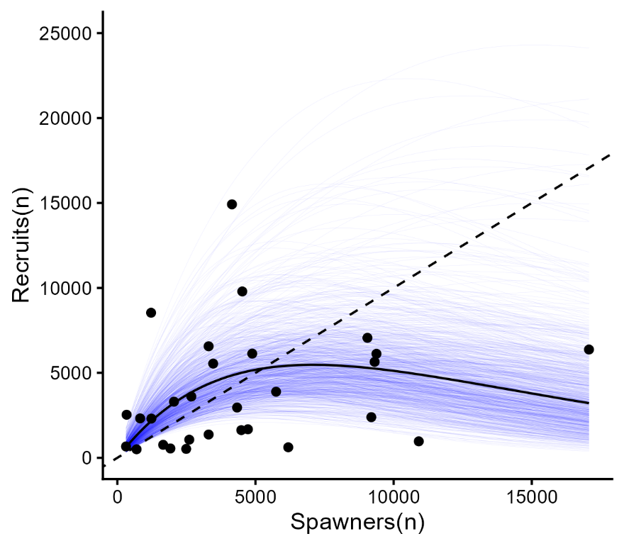
Figure 6. Ricker stock-recruit function fit to the Nicola River Fraser Spring 4₂ (1.2) Chinook ERIS dataset. Points represent individual spawner-recruit pairs linked by brood year. The solid black line shows the mean relationship between recruits and spawners. The thin blue trace lines show 1000 posterior draws sampled within the 95% CI of the Ricker ln(α) posterior, and the dashed black line shows the 1:1 line.
Normal distributions of fecundity (Figure 7) were estimated from the Nicola River ERIS (Fraser Spring 4₂ (1.2) Chinook), Fraser Spring 5₂ (1.3) Chinook, and Fraser Summer 5₂ (1.3) Chinook fecundity data. Fraser Spring 5₂ (1.3) Chinook were the most fecund with a mean of ~4500 eggs per female (95% CI 4400 – 4700), followed by Fraser Summer 5₂ (1.3) Chinook with a mean of ~ 4100 eggs per female (95% CI 3900 – 4300), and then the Nicola River ERIS (Fraser Spring 4₂ (1.2) Chinook) with a mean of ~3400 eggs per female (95% CI 3300 – 3500).
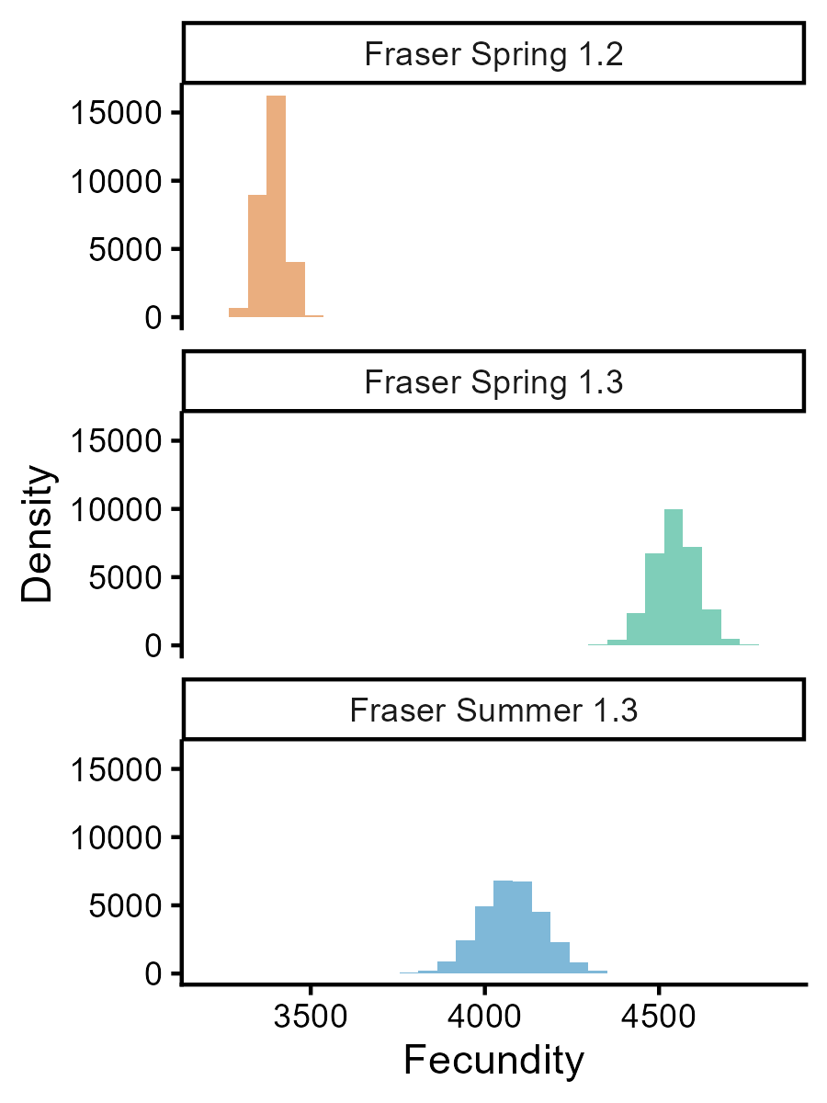
Figure 7. Estimated fecundity distributions for the Nicola River ERIS (Fraser Spring 4₂ (1.2) Chinook), Fraser Spring 5₂ (1.3) Chinook, and Fraser Summer 5₂ (1.3) Chinook.
Using the proportional differences in fecundity between the Nicola River ERIS (Fraser Spring 4₂ (1.2) Chinook) and the other 2 SMUs, Nicola River Ricker ln(α) was adjusted to create productivity estimates for both the Fraser Spring 5₂ (1.3) Chinook, and Fraser Summer 5₂ (1.3) Chinook. Productivity estimates for both SMUs were uncertain, with a median Ricker ln(α) of 0.98 (95% CI 0.37 – 2.08) for Fraser Spring 5₂ (1.3) Chinook and 0.87 (95% CI 0.26 – 1.98) for Fraser Summer 5₂ (1.3) Chinook (Figure 8).
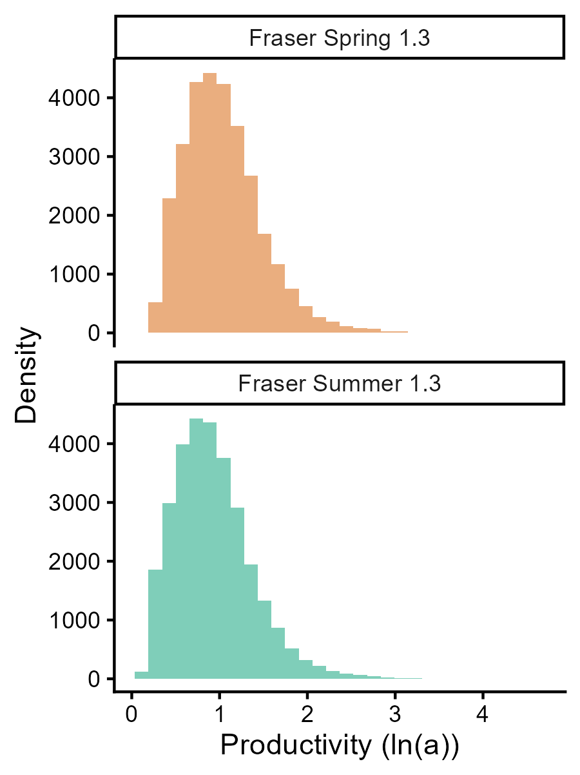
Figure 8. Estimated Ricker ln(α) distributions for the Fraser Spring 5₂ (1.3) Chinook and Fraser Summer 5₂ (1.3) Chinook.

Ricker β
Two sets of CU-level Ricker β parameters were estimated; one set for the WSP Rapid Status Assessment (Figure 6; Table C1) based on the watershed areas of the spawning populations included in the assessment, and a second set for the Simulations (Figure 7; Table C1) which includes the watershed areas for all known spawning populations.
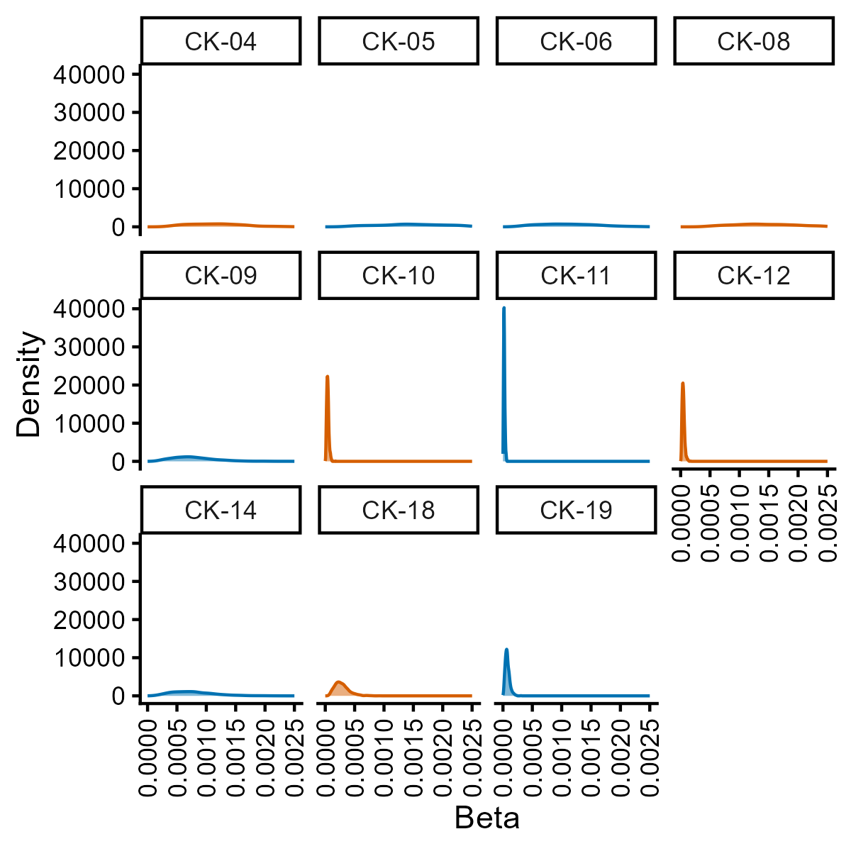
Figure 9. Estimated CU-level Ricker β distributions used to calculate the lower biological benchmarks reported in the WSP Rapid Status Assessment for the Fraser Spring 5₂ (1.3) Chinook and Fraser Summer 5₂ (1.3) Chinook.
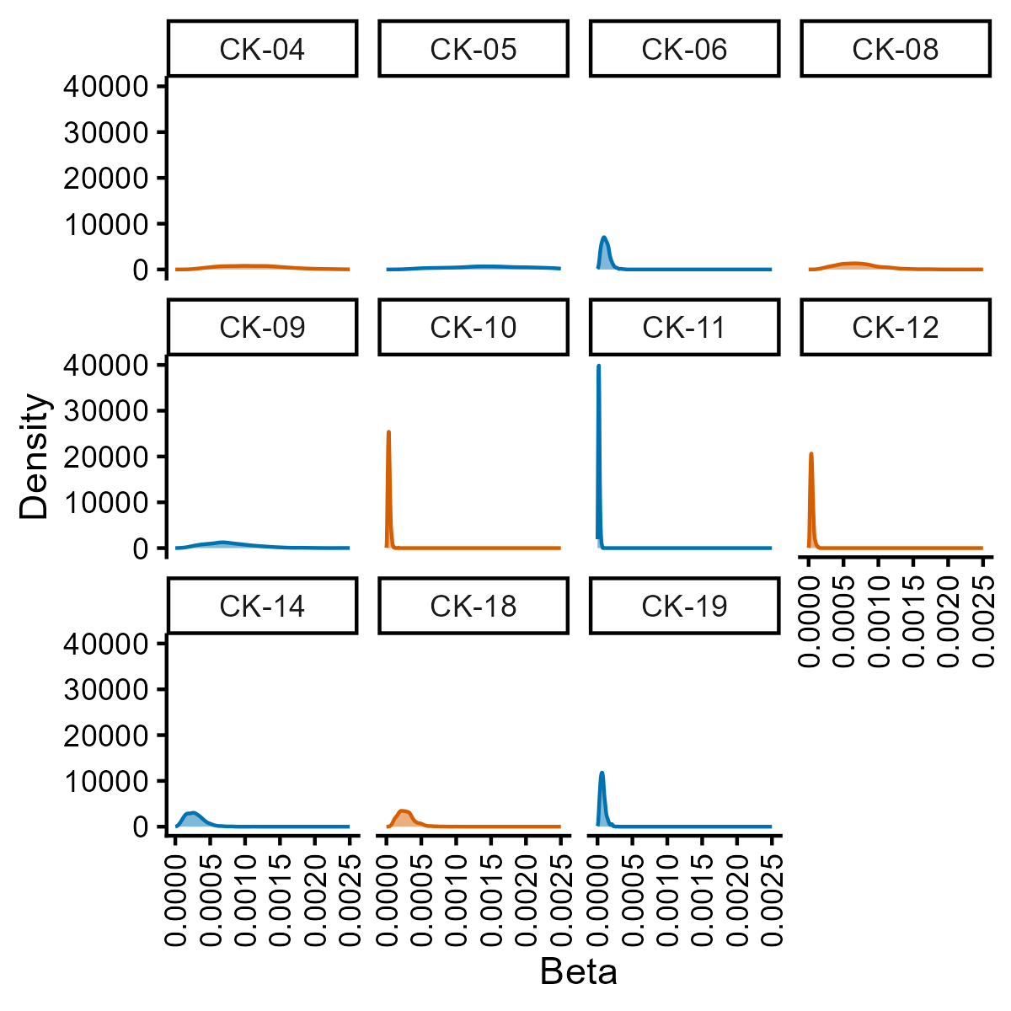
Figure 10.Estimated CU-level Ricker β distributions used to calculate the lower biological benchmarks for the simulations of Fraser Spring 5₂ (1.3) Chinook and Fraser Summer 5₂ (1.3) Chinook.

Reference Points
SMU-level Removal References (Table 5) and CU-level lower and upper biological benchmarks (20% S_{max}; 85% S_{MSY}) for the WSP Rapid Status Assessment (Table B1) and CU-level lower biological benchmarks (20% S_{max}) for the simulations (Appendix C, Tables C.1-C.2) were estimated. Note that neither set of lower nor upper biological benchmarks are appropriate for comparison against observed relative index abundance spawner abundances (the bulk of the spawner escapement estimates for both SMUs), thus these benchmarks are presented in the Appendices and the Simulations section rather than in this section. While Lower fishery reference point estimates (FRP-Ls) were attempted based on the simulation results, there were no simulation scenarios that produced more than a 0-4% probability of either SMU exceeding its CU status-based LRP.
Table 5. Fraser River Spring 5₂ (1.3) and Fraser River Summer 5₂ (1.3) Chinook Stock Management Unit (SMU) proposed reference points. Uncertainty in these values is large, thus the 95% CIs are presented first, followed by the median in brackets. The Lower fishery reference point (FRP-L) for each SMU is equivalent to its CU-status based LRP.
SMU scale Reference Point | Description | Fr. Sp. 5₂ (1.3) CK | Fr. Su. 5₂ (1.3) CK
Lower fishery reference point (FRP-L) | Greatest Exploitation Rate (ER) that allows all CUs to meet or exceed WSP Amber status | NA | NA
Removal Reference (U_{MSY}) | Discrete fishing mortality (U) that will produce Maximum Sustainable Yield (MSY) under equilibrium conditions | 0.17 – 0.74 (0.42) | 0.12 – 0.72 (0.38)

FMI-to-CYER Translation Analysis
Although FMI was positively correlated with Canadian CYER, the relationship was relatively uncertain. As assumed observation error increased, the strength of the relationship (i.e., the magnitude of $γ_{f}$) declined (Figure 11). In other words, when observation error is assumed to be high, relatively large changes in FMI are associated with relatively smaller changes in Canadian CYER. Note that predictions outside the range of observations are particularly uncertain. We found moderate evidence of differences among ERISs in the mean relationship between FMI and Canadian CYER (median $σ_{k}$ ranged from 0.23 to 0.27 among models).
If CYER is assumed to more closely approximate the true exploitation rate, the estimated relationship suggests that realized exploitation rates may be biased with respect to FMI targets, particularly if observation error is high. Specifically, targets based on FMI may consistently result in realized exploitation rates that are higher (lower) than expected at FMI values below (above) approximately 0.15 for the moderate CV model (Figure 11). However, when observation error increased to 0.3, FMI underpredicted Canadian CYER throughout the range of observed data (i.e., is consistently biased low). This highlights that FMI may be weakly correlated with exploitation rates for these stocks.
We present distributions of predicted Canadian CYERs at different levels of FMI relative to simulation results, across a range of realized exploitation rates, to visually demonstrate the range of uncertainty that may exist when setting management benchmarks based on FMI. We note, however, that this assumes that CYER, a measurement that itself is likely to be observed with error, is a precise measurement of realized exploitation rates.
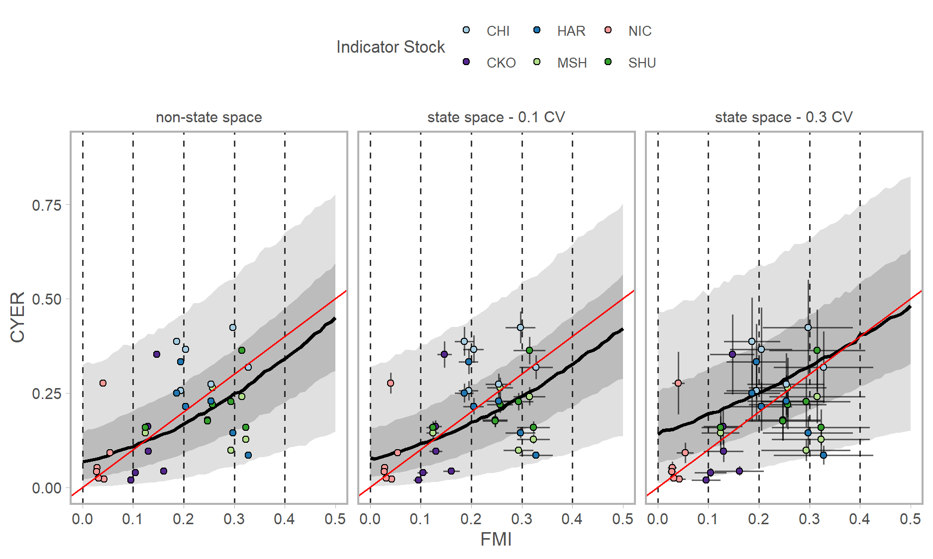
Figure 11. Posterior predictions, in proportional space, of GLMs estimating the relationship between FMI and CYER. Panels represent different models with assumed CVs on observations of 0 (non-state space model), 0.1 and 0.3. Black lines represent the median, dark ribbons represent the 50th percentile interval, and light ribbons the 90th percentile interval. Red lines represent a slope of one in real space. Points represent individual ERIS and year observations. Whiskers represent the assumed CVs described above. Vertical dashed black lines align with the horizontal coloured lines in the kernel density plots in column a) of the simulation results figures shown below (Figures 7-9, 16-18). ERISs are: Chilliwack (CHI; Fall 4₁ (0.3) SMU), Harrison (HAR; Fall 4₁ (0.3) SMU), Nicola (NIC; Spring 4₂ (1.2) SMU), Chilko (CKO; Summer 5₂ (1.3) SMU), Middle Shuswap (MSH; Summer 4₁ (0.3) SMU), and Shuswap (SHU, Summer 4₁ (0.3) SMU).

Stock Status and Trends: Spring 5₂ (1.3)

Current Status
Two of five CUs in the Fraser Spring 5₂ (1.3) Chinook salmon Stock Management Unit (SMU) are assessed as WSP Red Status (Figure 4), therefore the Fraser Spring 5₂ (1.3) SMU is below its CU-status based Limit Reference Point (LRP). These include CK-04 (Lower-Fraser) and CK-08 (Middle Fraser-Canyon).
For one CU in this SMU (CK-08: Middle Fraser-Fraser Canyon), status was assessed as Red (Figure 12) based on the absolute abundance lower threshold. Though these data are indices of abundance, expert consensus was spawner abundances are less than 1500 spawners, and this has been the case for all available years in the time series (Figure 13B).
For all other CUs in the SMU, absolute and relative abundance metrics were deemed inapplicable based on data quality standards and expert consensus, and only trend metrics were used. These CUs were assessed as WSP Amber (Figure 12).
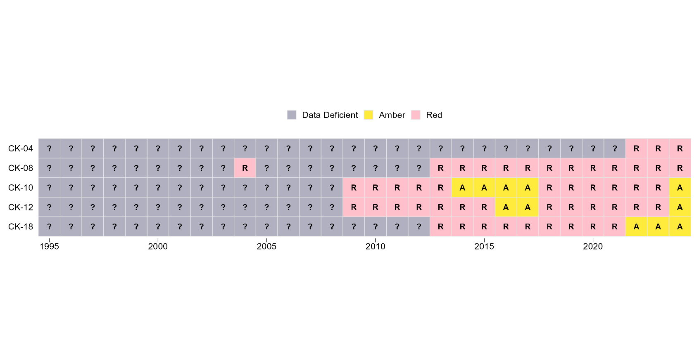
Figure 12. Fraser Spring 5₂ (1.3) (CK-04 Lower Fraser ; CK-08 Middle Fraser-Fraser Canyon ; CK-10 Middle Fraser ; CK-12 Upper Fraser ; CK-18 North Thompson) Wild Salmon Policy Rapid Status time series for years with applicable data. Each row summarizes the statuses available for each Conservation Unit.

Escapement
Escapement estimates of Fraser Spring 5₂ (1.3) Chinook have varied substantially over the last decade (Figure 13B). The 2024 escapement estimate was 13,900 spawners – 57% of the 1975-2024 average of 24,300 spawners (Chinook Technical Committee 2025b) Escapement estimates were expected to remain below average for 2024 due to the 5-year-old adults returning from the brood year that was severely impacted by the 2019 Big Bar landslide. Both of the small population CUs (Lower Fraser and Middle Fraser-Fraser Canyon) spawn in tributaries that meet the Fraser River mainstem downstream of Big Bar, and therefore were unaffected by the landslide.
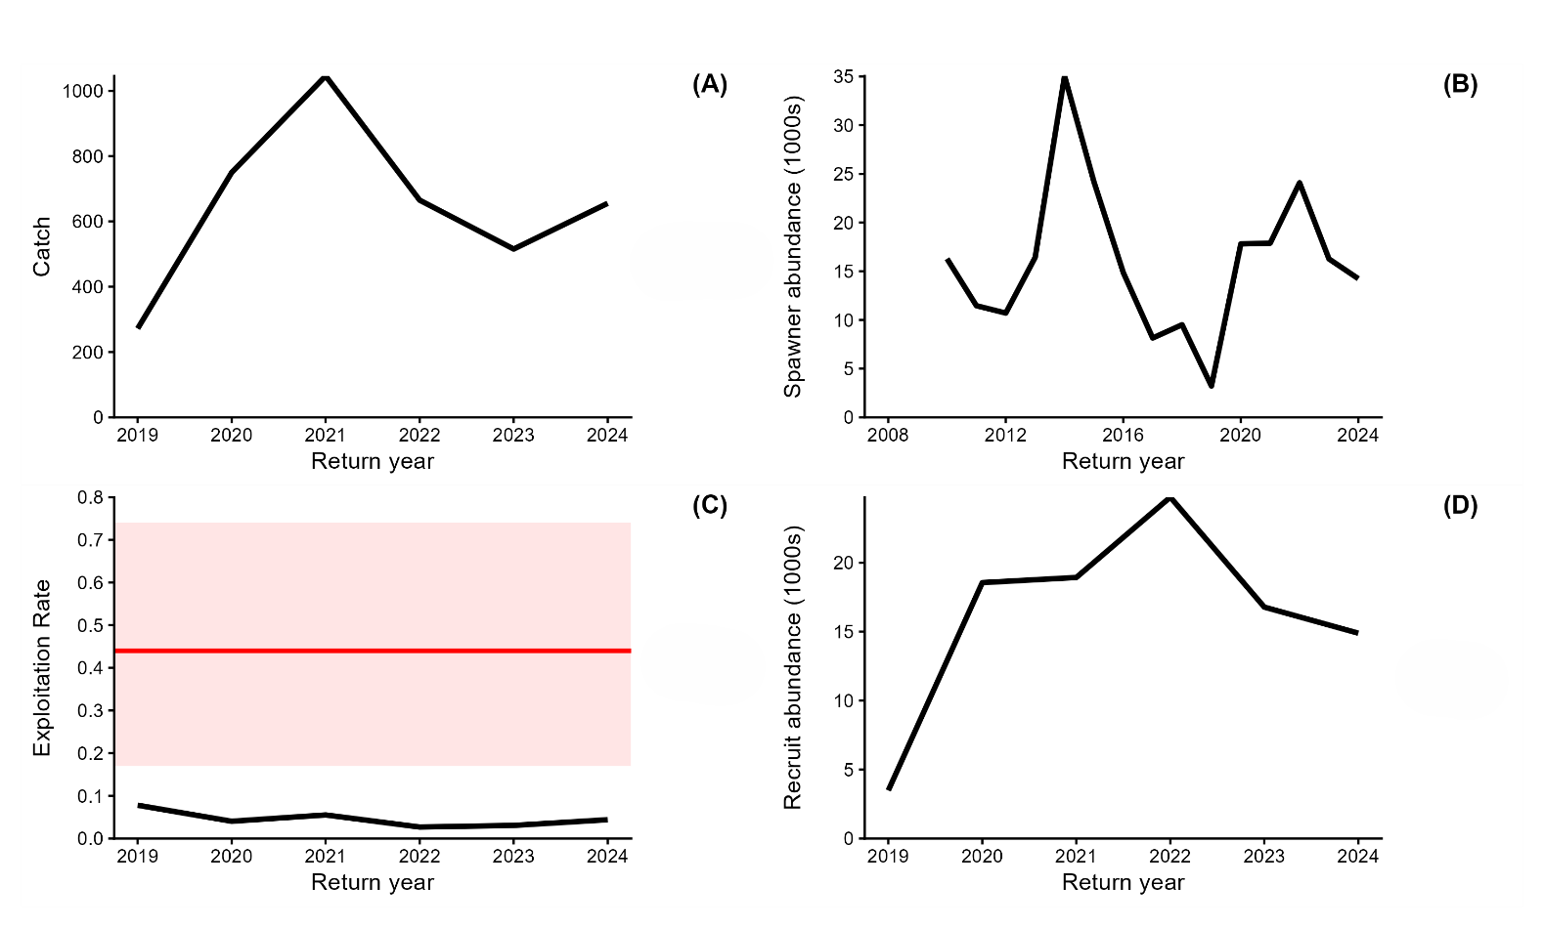
Figure 13. Fraser Spring 5₂ (1.3) Chinook (A) aggregate catch derived from the Fishing Mortality Index (FMI), (B) aggregate spawner abundance, (C) Exploitation rate (FMI) in relation to fishing mortality that results in maximum sustainable yield (U_{msy}- represented by the solid red horizontal line, with the 95% Credible Interval represented by the red shaded band), (D) recruit abundance. Note the different x-axis limits for plot (B) as catch, exploitation rate and recruit abundance data are derived from CWT recovery data that are only available from 2019-2024.
A range of 134-1,520 spawners returned to systems in the Lower Fraser CU (CK-04) between 2008-2024, and 2021 was the lowest return year on record. The highest spawner estimates were observed between 2008-2012 (Figure 14A). The Middle Fraser – Fraser Canyon CU (CK-08) is the smallest population within the SMU, escaping between 2 and 169 spawners between 1997 – 2024 (Figure 14B). Escapement estimates in the Middle Fraser River CU (CK-10) have ranged from 1,041 – 18,042 spawners from 1995 – 2024. Spawner abundances have begun to stabilize at lower levels since the declines that took place between 2015 and 2020 (Figure 14C). Escapement estimates in the Upper Fraser CU (CK-12) have ranged from 1,968 – 37,541 spawners from 1995 – 2024. The sharpest decline occurred between 2005 – 2010. The recent 15-year trend is positive (Figure 14D). Escapement estimates in the North Thompson CU (CK-18) have ranged from 61 – 1,746 spawners from 1999 – 2024. The recent 15-year trend has increased from a period of steady decline between 2000 – 2018 (Figure 14E).
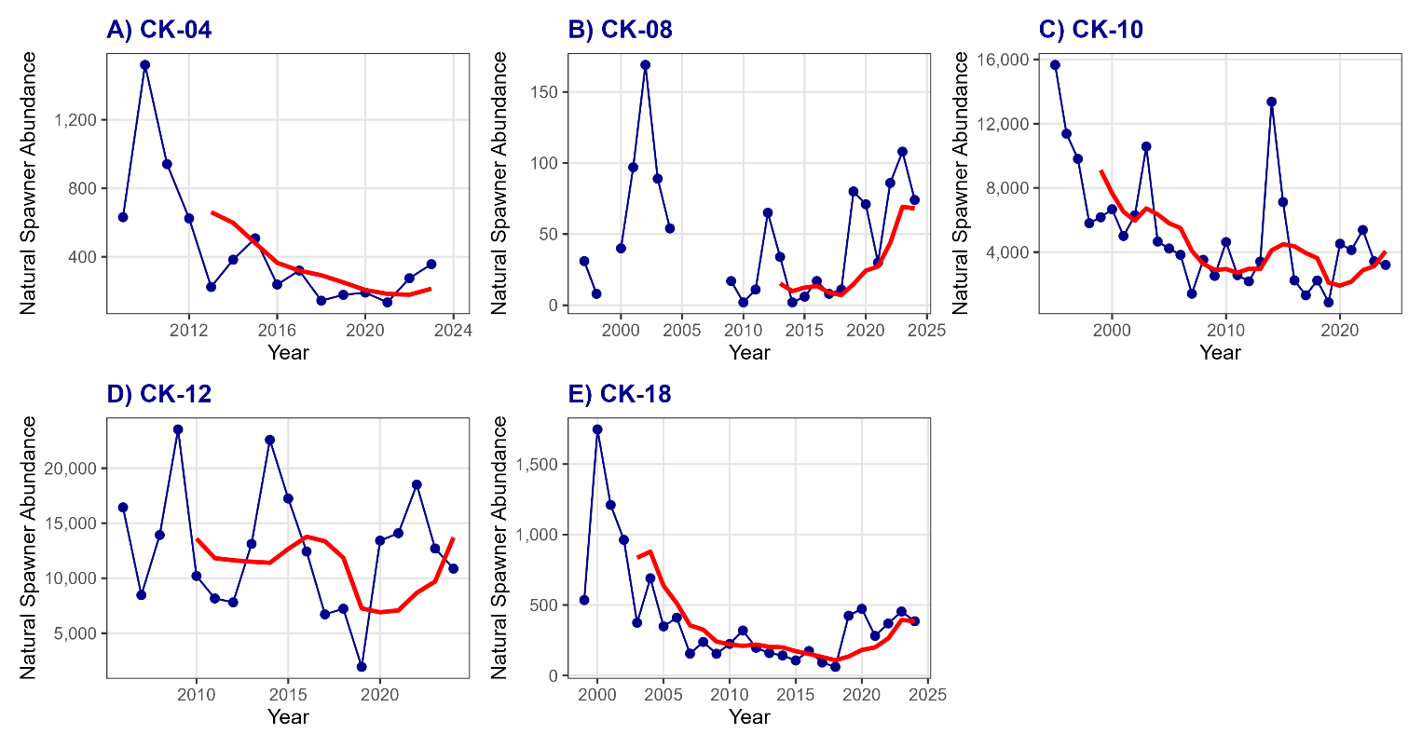
Figure 14. WSP Rapid Status Approach time series of natural spawner abundance (blue line) and generational average abundance (red solid line) for all Spring 5₂ (1.3) CUs: A) CK-04, Lower Fraser; B) CK-08, Middle Fraser – Fraser Canyon; C) CK-10, Middle Fraser; D) CK-12, Upper Fraser; and E) CK-18, North Thompson.

Exploitation Rate
Between 2019 and 2024 the FMI, a proxy for Canadian exploitation rate, has been low and modestly variable ranging between 3 and 8% (Figure 13C). However, given the uncertainty in the FMI metric and the relatively weak correlation between FMI and CYER (Figure 11 ), this timeseries of ER (and thus catch (Figure 13A) and recruit abundance (Figure 13D) should be interpreted cautiously. The FMI estimates were used to reconstruct SMU-specific catches and recruit abundance time series (Figure 13A and 13D).

Simulations: Spring 5₂ (1.3)
The probability plots of the Spring 5₂ (1.3) CU and SMU simulation results were not sensitive to varying levels of implementation error (i.e., the CV placed on Canadian and U.S. ER in the simulation; Figures 15-17, Supplementary Materials B; Figures _-_), thus the figures presented in the main body of this document are from the optimistic scenario (CV = 0.1).
One purpose of simulating future Chinook abundance was to develop an aggregate SMU-level ER target (e.g., Lower Fisheries Reference Point (FRP-L) associated with a high probability of all CUs exceeding their lower biological benchmarks, and thus achieving amber or better status using the Rapid Status Approach). Although we simulated a wide range of Canadian ERs (0 – 0.45) and productivity/smolt survival rates (ln(α) 0.35 – 2.1), there were no combinations of ER and ln(α) that escaped enough spawners for the geometric mean of the last generation to exceed 20% S_{max} (Table 6) and/or 1500 spawners (thresholds used in the Rapid Status Approach to determine CU status, although the 20% S_{max} values used in the simulations are different than those reported for the Rapid Status Assessment (see Methods for details)) for all CUs in the SMU (Figure 15). This result is driven by the small size of the Lower Fraser and Fraser Canyon Spring 5₂ (1.3) CUs, which were unlikely to exceed the 1500 spawner threshold, but had a moderately high to high likelihood of exceeding 20% S_{max} alone when the 1500 spawner threshold was not incorporated into simulations (Figure 16). Thus, there is less than a 5% probability of exceeding the SMU LRP, even with high productivity and a Canadian ER of zero (Figure 17), and an FRP-L could not be identified for this SMU.
Table 6. Median and 95% credible intervals (CIs) of CU-level lower biological benchmarks (20% S_{max}) for the Fraser Spring 5₂ (1.3) Chinook SMU.
CU Name | Benchmark | 50% CI | 2.5% CI | 97.5% CI
Lower Fraser (CK-04) | 20% S_{max} * | 180 | 90 | 520
Middle Fraser – Fraser Canyon (CK-08) | 20% S_{max} * | 290 | 140 | 800
Middle Fraser CU (CK-10) | 20% S_{max} | 5700 | 2600 | 15600
Upper Fraser (CK-12) | 20% S_{max} | 4700 | 2000 | 12300
North Thompson CU (CK-18) | 20% S_{max} * | 760 | 350 | 2000
* Although 20% S_{max} values were calculated for these CUs , they were not used in simulated probabilities of future abundance in Figures 15 and 17. Instead, the absolute abundance spawner threshold of 1500 was used because 20% S_{max} values < 1500 for these CUs.

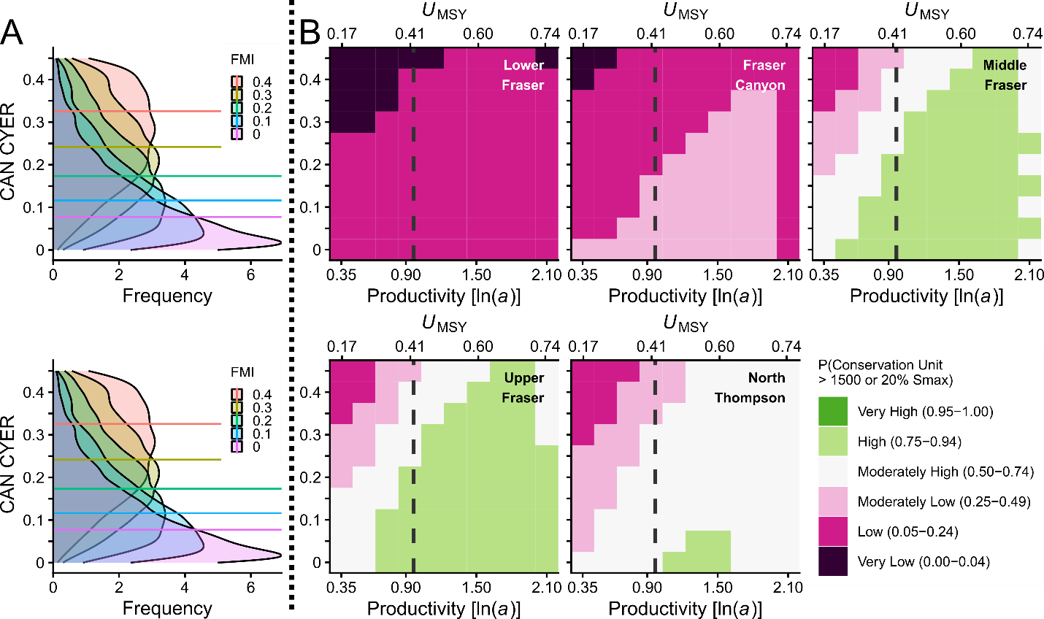
Figure 15. Simulated probability that CUs in the FR SP 5₂ (1.3) CN SMU meet or exceed their Wild Salmon Policy lower biological benchmarks in the optimistic implementation error scenario. Horizontal lines in the A side plots represent median values of CYER for a given value of FMI, with associated posterior distributions describing the range of possible CYER outcomes for a given target FMI. The A-side plots are derived from a measurement error model of CYER ~ FMI assuming both indices include an observation error with CV = 0.1. B-side ice-cream plot results are based on CYER with implementation error (CV = 0.1) across a range of productivity values covering the 95% CI of estimated ln(alpha). The secondary x-axis shows U_{MSY} values relative to productivity. Squares are colour-coded according to the probability that the geometric mean of the last generation (5 years) of spawner abundance for a given CU meets or exceeds 20% Smax or 1500 spawners, whichever value is greater. The vertical dashed grey lines in the B-side plots represents the median estimated productivity. Given the expectation that climate change will negatively impact the productivity of this SMU, scenarios to the left of the dashed grey lines are more likely.
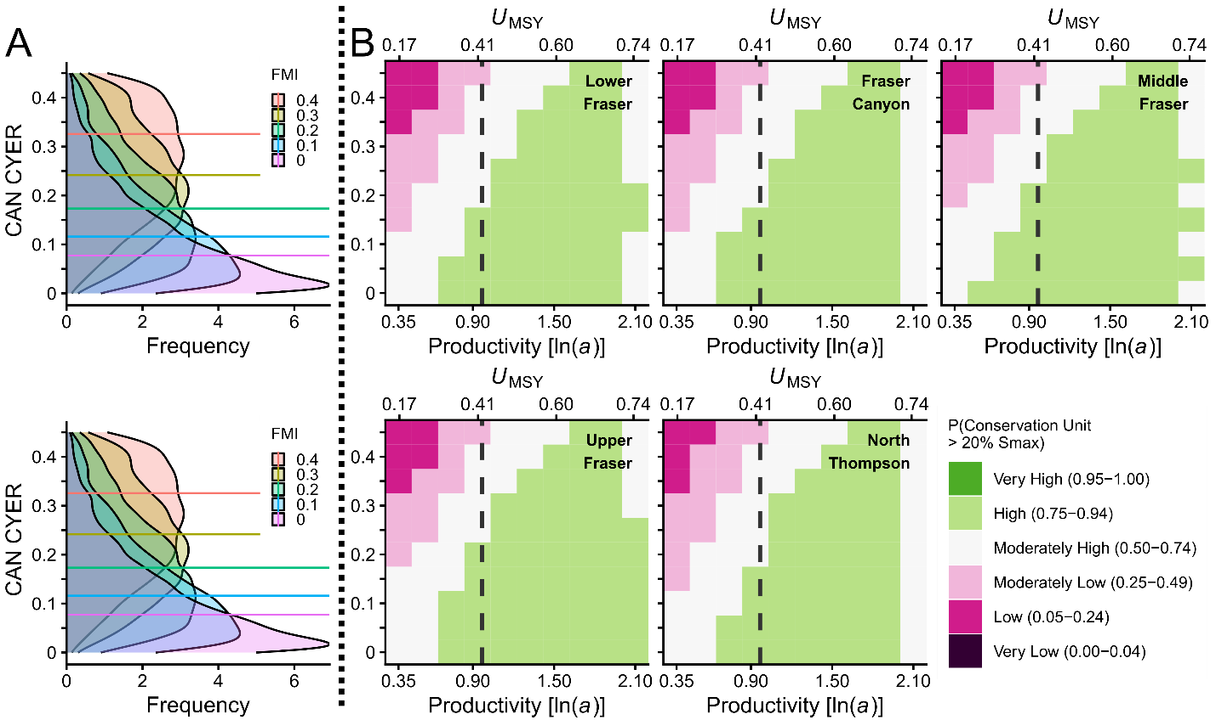
Figure 16. Simulated probability that CUs in the FR SP 5₂ (1.3)CN meet or exceed 20% S_{max} in the optimistic implementation error scenario. Horizontal lines in the A side plots represent median values of CYER for a given value of FMI, with associated posterior distributions describing the range of possible CYER outcomes for a given target FMI. The A-side plots are derived from a measurement error model of CYER ~ FMI assuming both indices include an observation error with CV = 0.1. B-side ice-cream plot results are based on CYER with implementation error (CV = 0.1) across a range of productivity values covering the 95% CI of estimated ln(alpha). The secondary x-axis shows U_{MSY} values relative to productivity. Squares are colour-coded according to the probability that the geometric mean of the last generation (5 years) of spawner abundance for a given CU meets or exceeds 20% S_{max}. The vertical dashed grey lines in the B-side plots represents the median estimated productivity. Given the expectation that climate change will negatively impact the productivity of this SMU, scenarios to the left of the dashed grey lines are more likely.
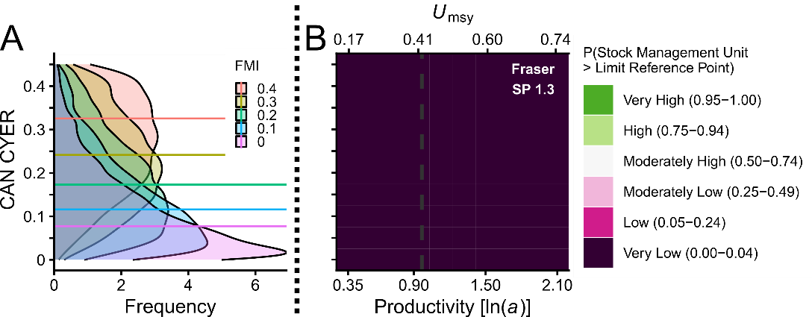
Figure 17. Simulated probability the FR SP 5₂ (1.3) CN meets or exceeds the CU status-based LRP in the optimistic implementation error scenario. Horizontal lines in the A-side plots represent median values of CYER for a given value of FMI, with associated posterior distributions describing the range of possible CYER outcomes for a given target FMI. The-A side plots are derived from a measurement error model of CYER ~ FMI assuming both indices include an observation error with CV = 0.1. B side ice-cream plot results are based on CYER with implementation error (CV = 0.1) across a range of productivity values covering the 95% CI of estimated ln(alpha). The secondary x-axis shows U_{MSY} values relative to productivity. Squares are colour-coded according to the probability that the geometric mean of the last generation (5 years) of spawner abundance for all CUs meets or exceeds CU-specific 20% S_{max} or 1500 spawners, whichever value is greater. The vertical dashed grey line in the B-side plot represents the median estimated productivity. Given the expectation that climate change will negatively impact the productivity of this SMU, scenarios to the left of the dashed grey lines are more likely.

Hatchery Enhancement: Spring 5₂ (1.3)
Hatchery enhancement of Fraser Spring 5₂ (1.3) Chinook was more prolific during the mid 1980’s to early 1990’s (Figure 18). In the Lower Fraser CU, over 100,000 sub-yearling smolts were released into the Birkenhead River in brood years 2002 and 2003. In the Middle Fraser-Fraser Canyon CU, only fed-fry have been released into the Nahatlatch River. Enhancement continues for the Middle and Upper Fraser CUs across five hatchery facilities (located on Spius Creek, Chehalis River, N`Quatqua River, Nechako River, and Quesnel River), under assessment, rebuilding, and conservation objectives. Enhancement in CK-10 and CK-12 increased to a peak of ~300,000 fry in 2022 and ~100,000 yearling smolts in 2023 primarily in response to the Big Bar Landslide in 2019. Smolt production remains steady while fry production is decreasing towards the mean of the previous decade. Because enhancement has only been recently undertaken on CUs CK-10 and CK-12, it is too soon to directly estimate the proportion of hatchery-origin spawners (pHOS) for any spawning population in this SMU (i.e. the first year of age 5 marked returns will be 2026). Given this, we calculated hypothetical pHOS values for the range of observed release sizes and spawning abundances for populations in this SMU to help contextualize the hatchery release information provided in Figure 10. Minimum and maximum pHOS scenarios were generated by multiplying the minimum and maximum observed return rates from the Chilko River Chinook ERIS by the range of observed releases. Chilko River Chinook was used as a proxy for return rates for populations in this SMU because it is the only population in either the Fraser Spring 5₂ (1.3) Chinook or the Fraser Summer 5₂ (1.3) Chinook SMU for which direct return rate estimates exist. For 1+ smolts, the minimum return rate was 0.21% and the maximum return rate was 1.22% (for brood years 2014 to 2019). For fed fry, the minimum return rate was 0.03% and the maximum return rate was 0.29% (for brood years 2014 to 2018). Figure 19 shows the resulting potential pHOS range for both the minimum and maximum hatchery-origin return rate scenarios, for both 1+ smolt and fed fry releases. Colours in the ice cream plots align with pHOS designations from Withler et al. (2018).
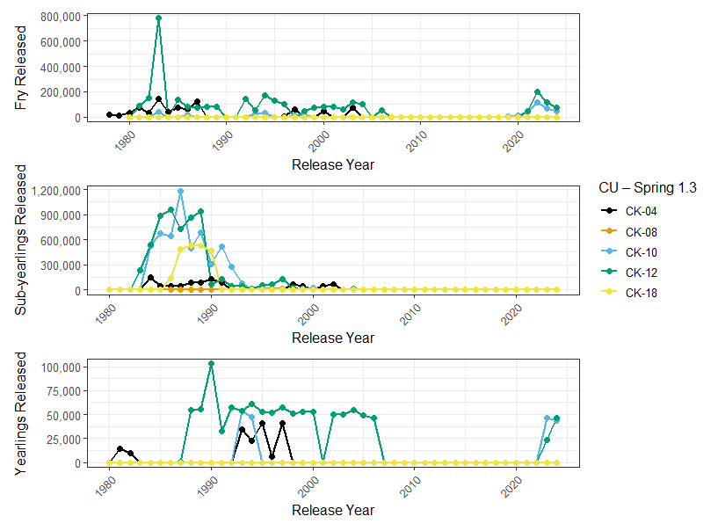Figure 18. Hatchery releases by life stage (Fry, Sub-yearling Smolts, Yearling Smolts) and Conservation Unit (CK-04, CK-08, CK-10, CK-12, CK-18) for the Fraser Spring 5₂ (1.3) SMU.
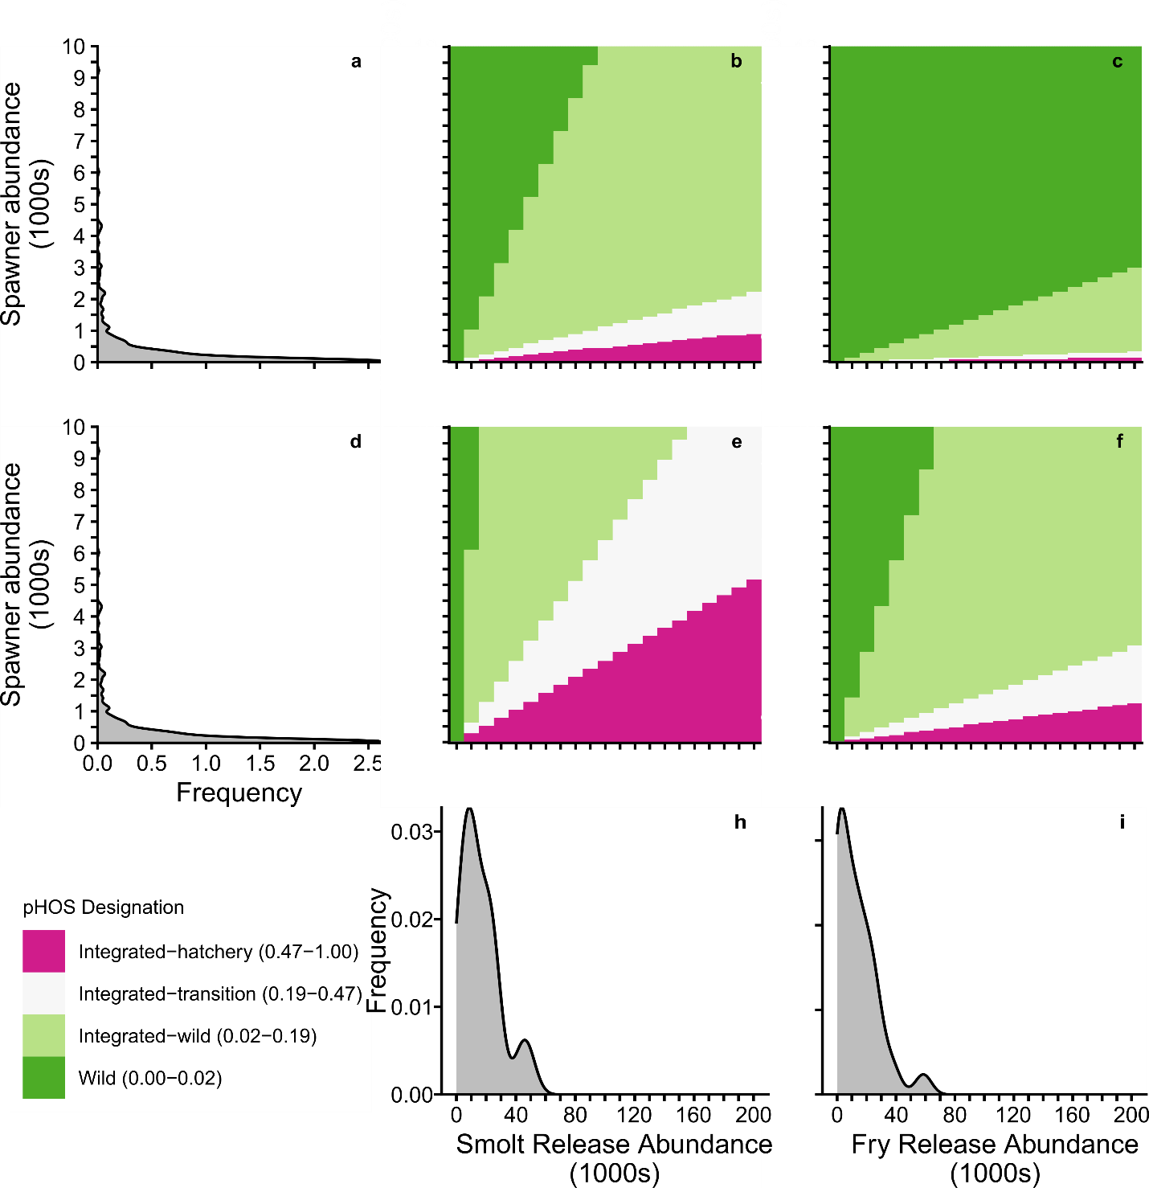Figure 19. Range in potential proportion of hatchery-origin spawners (pHOS) in relation to pHOS designations from Withler et al. (2018) based on the abundance and lifestage of juveniles released and the total spawning population abundance. Plots a) and d) show the relative frequency distribution of spawner abundances in the 2014 – 2024 return year period for Fraser Spring 5₂ (1.3) Chinook populations. Plots b) and e) show the minimum and maximum resulting pHOS for a population, respectively, based on the minimum and maximum observed return rates for CWT 1+ smolts from the Chilko River ERIS. Plots c) and f) show the minimum and maximum resulting pHOS for a population, respectively, based on the minimum and maximum observed return rates for CWT fry produced for the Chilko River ERIS. Plots h) and i) show the relative frequency of different-sized Spring 5₂ (1.3) smolt and fry releases for the 2014 – 2024 release years, respectively.

Stock Status and Trends: Summer 5₂ (1.3)

Current Status
Two of six CUs in the Fraser Summer 5₂ (1.3) Chinook salmon SMU are assessed as WSP Red Status (Figure 20), therefore the Fraser Summer 5₂ (1.3) SMU is below its CU-status based Limit LRP. These include CK-05 (Lower Fraser-Upper Pitt) and CK-06 (Lower Fraser).
For one CU in this SMU (CK-09: Middle Fraser River -Portage), status was assessed as Red based on the absolute abundance lower threshold (Figure 20). Though these data are indices of abundance, expert consensus was spawner abundances are less than 1500 spawners, and this has been the case for all available years in the time series (Figure 22A).
For all other CUs in this SMU, absolute and relative abundance metrics were deemed inapplicable by minimum data quality standards and expert consensus, and only trend metrics were used. These CUs were assessed as WSP Amber (Figure 20). The Lower Fraser CU (CK-06) is designated as data deficient (Figure 20) because the Chilliwack River is excluded due to high enhancement, and there is not a long enough time series available for the only other system surveyed (Big Silver Creek) to calculate trend metrics (See Appendix B.2.2).
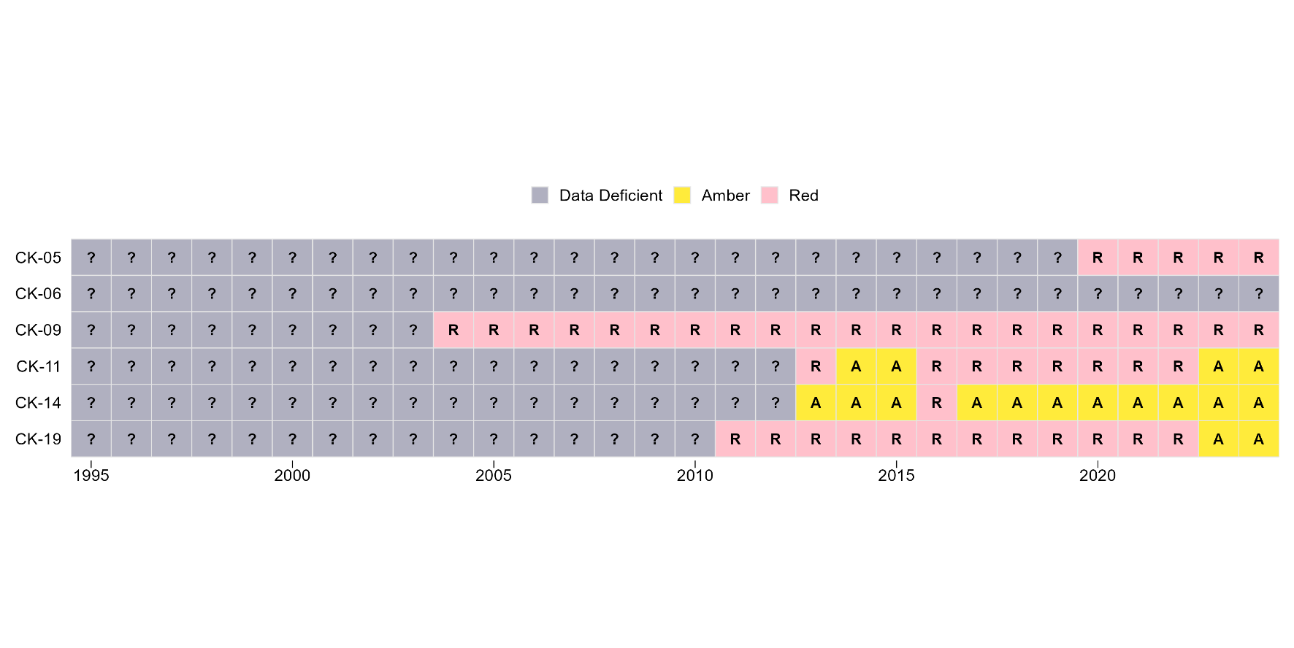
Figure 20. Fraser Summer 5₂ (1.3) (CK-05 Lower Fraser-Upper Pitt ; CK-06 Lower Fraser River ; CK-09 Middle Fraser River-Portage ; CK-11 Middle Fraser River ; CK-14 South Thompson ; CK-19 North Thompson) Wild Salmon Policy Rapid Status time series for years with applicable data. Each row summarizes the statuses available for each Conservation Unit.

Escapement
Escapement estimates of Fraser Summer 5₂ (1.3) Chinook have varied substantially over the last decade (Figure 21B). The 2024 escapement estimate was 11,800 spawners – just 60% of the 1975-2024 average escapement of 19,800 spawners (CTC 2024, Figure 21B ). 2018 and 2019 were the lowest estimates observed since 1995 (Figure 21B). Escapement estimates remain below average for 2024 due to the 5-year-old adults returning from the brood year that was severely impacted by the 2019 Big Bar landslide. Both of the small population CUs (Lower Fraser – Upper Pitt and Lower Fraser River) spawn in tributaries that meet the Fraser River mainstem downstream of Big Bar.
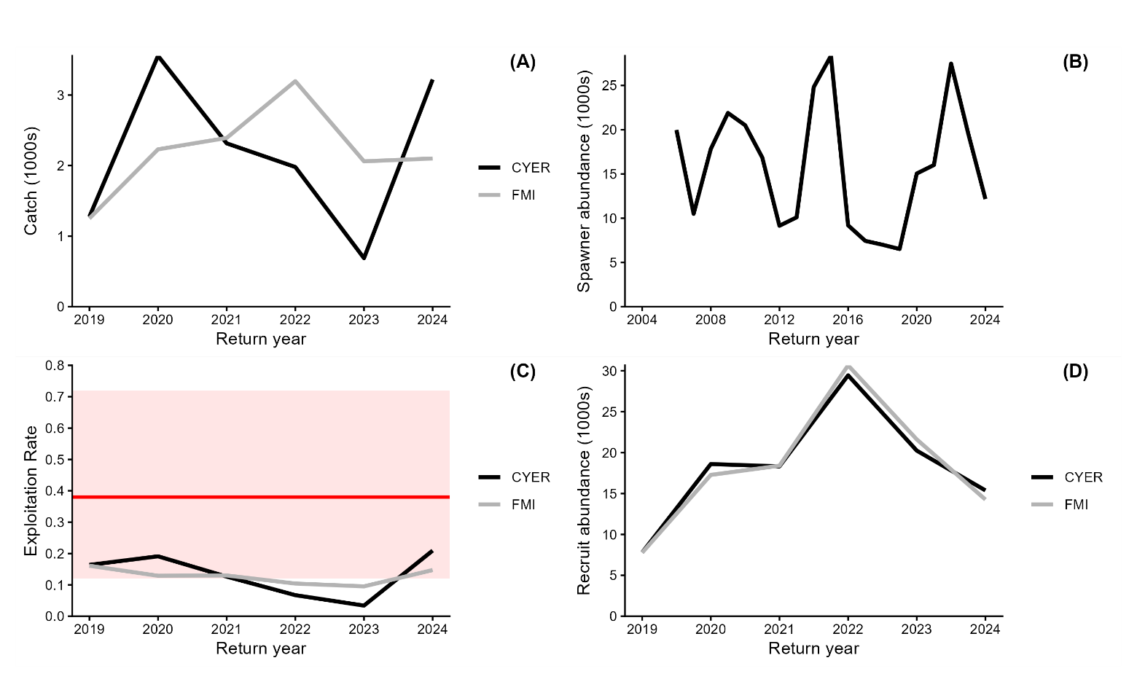
Figure 21. Fraser Summer 5₂ (1.3) Chinook (A) aggregate catch derived from Canadian Calander Year Exploitation Rate (CYER- represented by the black solid line) and Fishing Mortality Index (FMI – represented by the grey solid line), (B) aggregate spawner abundance, (C) Canadian exploitation rate (CYER – represented by the black solid line and FMI- represented by the grey solid line ) in relation to fishing mortality that results in maximum sustainable yield (U_{msy}- represented by the solid red horizontal line, with 2.5% and 97.5% Confidence Intervals represented by the red shaded band), (D) recruit abundance derived from CYER (represented by the black solid line) and FMI (represented by the grey solid line). Note the different x-axis limits for (B) as catch, exploitation rate and recruit abundance data are derived from CWT recovery data that are only available from 2019-2024.
Escapements to the Lower Fraser – Upper Pitt CU (CK-05) have ranged from 11 – 276 spawners from 2002 – 2024. This population is naturally small, however, there has been a decline in the long-term trend since 2021 (Figure 22A). Escapements to the Lower Fraser River CU (CK-06) have ranged from 12 – 105 spawners from 2015 – 2024. There is limited spawner data available for this CU (Figure 14B). Escapements to the Middle Fraser River-Portage CU (CK-09) have ranged from 12 – 445 spawners from 1995 – 2024. This population is also naturally small, however, the recent short-term trend has increased since 2022 (Figure 22C). Escapements to the Middle Fraser CU (CK-11) have ranged from 4,400 – 34,000 spawners from 1995 – 2024. The sharpest period of decline occurred between 2015 – 2020 and the long-term trend has since increased (Figure 22D). Escapements to the South Thompson CU (CK-14) have ranged from 280 – 2,700 spawners from 1995 – 2024. The long-term trend has improved since 2020, with 2021 being the highest year on record (Figure 22E). Escapements to the North Thompson CU (CK-19) have ranged from 670 – 9,900 spawners from 1995 – 2024. After a period of steady decline between 2010 – 2020, the recent generation trend has improved (Figure 22F).
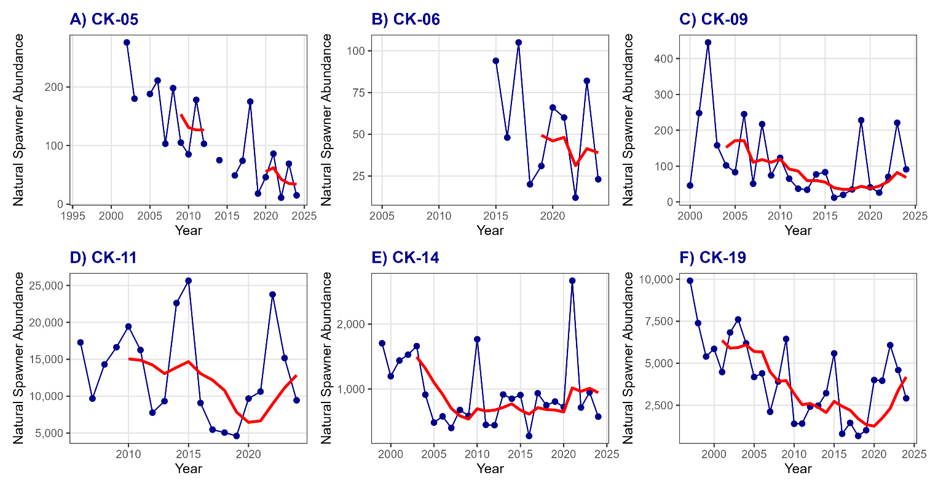
Figure 22. WSP Rapid Status Approach time series of natural spawner abundances (blue line) and generational average abundance (red solid line) for all Summer 5₂ (1.3) CUs A) CK-05 ; Lower Fraser-Upper Pitt B) CK-06; Lower Fraser River C) CK-09; Middle Fraser River - Portage, D) CK-11; Middle Fraser River ,E) CK-14 ; South Thompson, F) CK-19 ; North Thompson.

Smolt-to-age 3 Survival
For years where sufficient CWT recovery data are available to estimate SS for the Chilko CWT ERIS, the smolt-to-age 3 survival index is variable. Survival was below 1.0% prior to 2017, peaked in 2019 at 2.4%, and then declined to 1.4% in 2020 (Figure 23; note that the age 5 component of the 2020 brood year is not included and biasing the survival estimate low). However, the initial run of the Chilko exploitation rate analysis (ERA) included CWTs from both smolt and fry releases, thus survival estimates are biased low relative to smolt-to-age 3 survival for the dominant freshwater life history type.
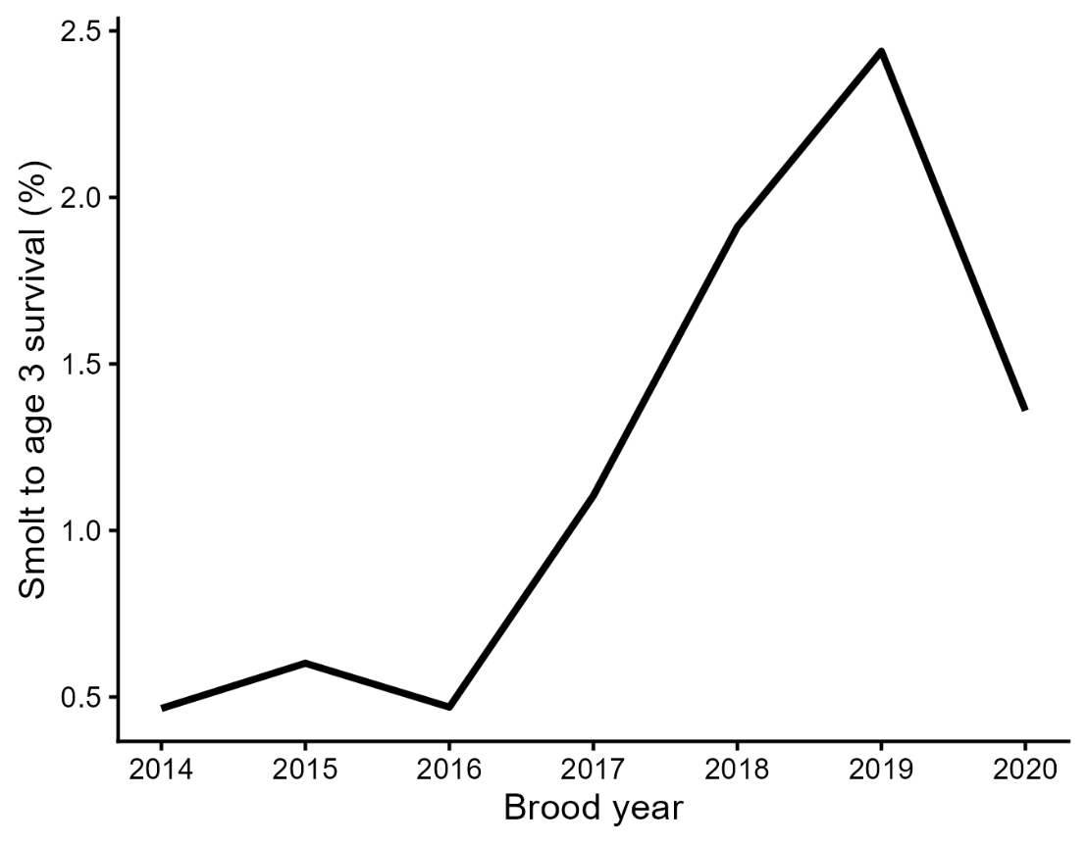
Figure 23. Smolt-to-age 3 survival values based on the Exploitation Rate Analysis for the Chilko CWT ERIS. Note that this run of the ERA included CWTs from juveniles released as fry, thus survival rates are likely underestimated.

Exploitation Rate
Measured exploitation rate using the FMI (2019 – 2024) has been moderate and modestly variable ranging between 10 and 16% (Figure 22C). In contrast, the CYER from the Chilko River ERIS has ranged from 3 – 21 % (Figure 22C, with U.S. fishing contributing on average 4% total mortality. Canadian-only CYER has ranged from 2 – 19%. The results of the measurement error model (Figure 3) align with the variability in the observations of the CYER and FMI (Figures 13A & C).

Simulations: Summer 5₂ (1.3)
As with the Spring 5₂ (1.3) simulation results, Summer 5₂ (1.3) CU and SMU simulation results were not sensitive to varying levels of implementation error (i.e., the CV placed on Canadian and U.S. ER in the simulation; Figures 24-26, Supplementary Materials B, Figures _), thus the figures presented in the main body of this document are from the optimistic scenario (implementation error CV = 0.1).
One purpose of simulating future Chinook abundance was to develop an aggregate SMU-level ER target (e.g., Lower Fisheries Reference Point (FRP-L) associated with a high probability of all CUs exceeding their lower biological benchmarks, and thus achieving amber or better status using the Rapid Status Approach. Based on the results of CU simulation analysis exploring a wide range of Canadian ERs (0 – 0.45) and productivity (ln(α) 0.25 – 2.0), there were no combinations of ER and ln(α) that escaped enough spawners for the geometric mean of the last generation to exceed 20% S_{max} (Table 7) and/or 1500 spawners (thresholds used in the Rapid Status Approach to determine CU status, although the 20% Smax values used in the simulations are different than those reported for the Rapid Status Assessment (see Methods for details)) for all CUs in the SMU (Figure 24). This result is driven in part by the small size of the Upper Pitt, Lower Fraser, and Portage Summer 5₂ (1.3) CUs, which were unlikely to exceed the 1500 spawner threshold, and in part by the depressed state of the larger South Thompson and North Thompson Summer 5₂ (1.3) CUs. In the absence of the 1500 spawner minimum threshold used in the Rapid Status Approach, the likelihood of exceeding 20% Smax alone was moderately high to high (Figure 25). Thus, there is less than a 5% probability of exceeding the SMU LRP, even with high productivity and an ER of zero (Figure 26), and no analytical solution to producing an FRP-L for this SMU.
Table 7. Median and 95% credible intervals (CIs) of CU-level lower biological benchmarks (20% S_{max}) for the Fraser Summer 5₂ (1.3) Chinook SMU.
CU Name | Benchmark | 50% CI | 2.5% CI | 97.5% CI
Lower Fraser – Upper Pitt (CK-05) | 20% S_{max} * | 120 | 50 | 440
Lower Fraser River (CK-06) | 20% S_{max} | 1900 | 800 | 6100
Middle Fraser River – Portage (CK-09) | 20% S_{max}* | 270 | 120 | 800
Middle Fraser River (CK-11) | 20% S_{max} | 10000 | 4100 | 36100
South Thompson (CK-14) | 20% S_{max} * | 770 | 340 | 2500
North Thompson (CK-19) | 20% S_{max} | 2900 | 1200 | 9500
* Although 20% S_{max} values were calculated for these CUs, they were not used in simulated probabilities of future abundance in Figures 16 and 18. Instead, the absolute abundance spawner threshold of 1500 was used because 20% S_{max} values < 1500 for these CUs.
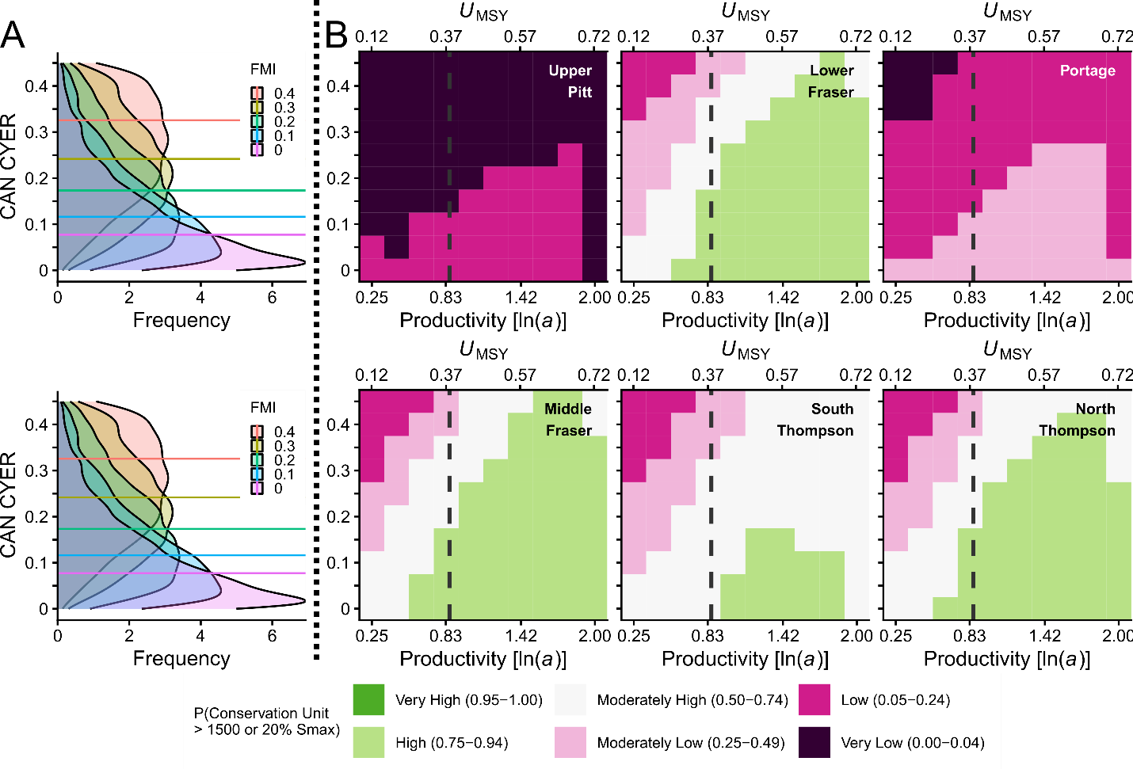
Figure 24. Simulated probability that CUs in the FR SU 1.3 CN meet or exceed their Wild Salmon Policy lower biological benchmarks in the optimistic implementation error scenario. Horizontal lines in the A side plots represent median values of CYER for a given value of FMI, with associated posterior distributions describing the range of possible CYER outcomes for a given target FMI. The A-side plots are derived from a measurement error model of CYER ~ FMI assuming both indices include an observation error with CV = 0.1. B-side ice-cream plot results are based on CYER with implementation error (CV = 0.1) across a range of productivity values covering the 95% CI of estimated ln(alpha). The secondary x-axis shows U_{MSY} values relative to productivity. Squares are colour-coded according to the probability that the geometric mean of the last generation (5 years) of spawner abundance for a given CU meets or exceeds 20% S_{max} or 1500 spawners, whichever value is greater. The vertical dashed grey lines in the B-side plots represents the median estimated productivity. Given the expectation that climate change will negatively impact the productivity of this SMU, scenarios to the left of the dashed grey lines are more likely.
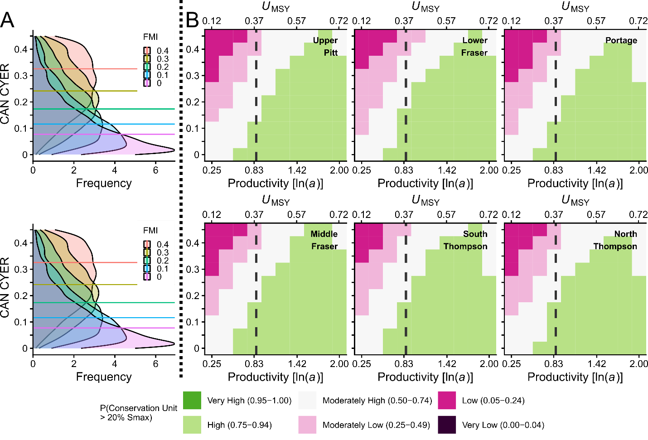
Figure 25. Simulated probability that CUs in the FR SU 1.3 CN meet or exceed 20% S_{max} in the optimistic implementation error scenario. Horizontal lines in the A side plots represent median values of CYER for a given value of FMI, with associated posterior distributions describing the range of possible CYER outcomes for a given target FMI. The A-side plots are derived from a measurement error model of CYER ~ FMI assuming both indices include an observation error with CV = 0.1. B-side ice-cream plot results are based on CYER with implementation error (CV = 0.1) across a range of productivity values covering the 95% CI of estimated ln(alpha). The secondary x-axis shows U_{MSY} values relative to productivity. Squares are colour-coded according to the probability that the geometric mean of the last generation (5 years) of spawner abundance for a given CU meets or exceeds 20% S_{max}. The vertical dashed grey lines in the B-side plots represents the median estimated productivity. Given the expectation that climate change will negatively impact the productivity of this SMU, scenarios to the left of the dashed grey lines are more likely.
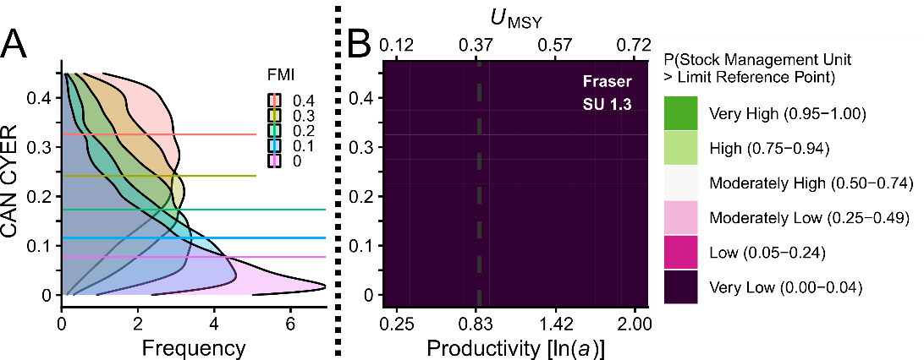
Figure 26. Simulated probability the FR SU 1.3 CN meets or exceeds the CU status-based LRP in the optimistic implementation error scenario. Horizontal lines in the A-side plots represent median values of CYER for a given value of FMI, with associated posterior distributions describing the range of possible CYER outcomes for a given target FMI. The-A side plots are derived from a measurement error model of CYER ~ FMI assuming both indices include an observation error with CV = 0.1. B side ice-cream plot results are based on CYER with implementation error (CV = 0.1) across a range of productivity values covering the 95% CI of estimated ln(alpha). The secondary x-axis shows U_{MSY} values relative to productivity. Squares are colour-coded according to the probability that the geometric mean of the last generation (5 years) of spawner abundance for all CUs meets or exceeds CU-specific 20% S_{max} or 1500 spawners, whichever value is greater. The vertical dashed grey line in the B-side plot represents the median estimated productivity. Given the expectation that climate change will negatively impact the productivity of this SMU, scenarios to the left of the dashed grey lines are more likely.

Hatchery Enhancement: Summer 5₂ (1.3)
Hatchery enhancement of Fraser Summer 5₂ (1.3) Chinook was more prolific during the mid 1980’s to early 1990’s (Figure 27). The Lower Fraser Upper-Pitt CU (CK-05) had annual sub-yearling smolt releases up to ~ 150,000 historically, but has not been enhanced since the 1990’s. Chilliwack River in the Lower Fraser CU (CK-06) has been consistently enhanced since the late 1980s, with annual releases of ~500,000 sub-yearling smolts. Portage (CK-09) began enhancement in 2021, with ~160, 000 yearling smolts released between 2021 – 2024. In the Middle Fraser River CU (CK-11), five major systems were enhanced historically, with Quesnel River having the most recent release in 2001 of ~ 250,000 yearling smolts. Enhancement continues in the Nechako River with annual releases of ~200,000 fed fry between 2015-2024. Significant enhancement of Eagle River and Salmon River in the South Thompson CU (CK-14) occurred historically (peaking at 650,000 fry in 1991, 500,000 subyearling smolts in 1991, and 125,000 yearling smolts in 1990), with Salmon River having more recent yearling smolt releases from 1994-2010. Fry continue to be released annually in Salmon River, averaging ~65,000 annual releases between 2010-2023. At the peak, over 1 million sub-yearling smolts were released annually in the late 80s and early 90s in the North Thompson CU (CK-19), but there have been no releases in the major systems from 1994 onward.
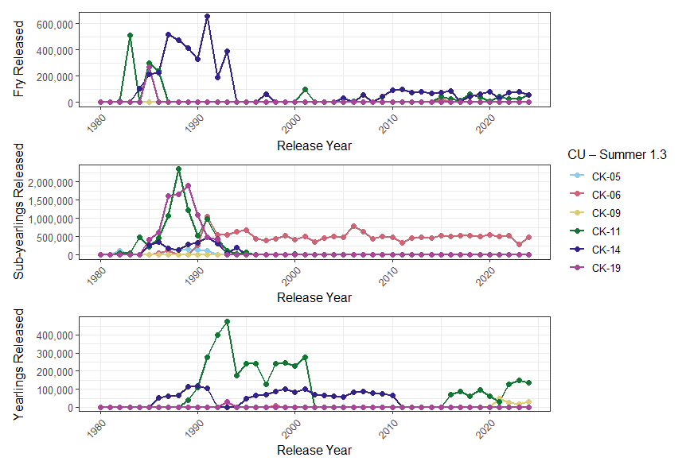
Figure 27. Hatchery releases by life stage (Fry, Sub-yearling Smolts, Yearling Smolts) and Conservation Unit (CK-05, CK-06, CK-09, CK-11, CK-14, CK-19) for the Fraser Summer 5₂ (1.3) SMU.
Currently, estimates of the proportion of hatchery-origin spawners (pHOS) can only be directly estimated using CWT recoveries for the Chilko River Chinook ERIS for return years 2019 to 2024. The lowest pHOS observed for Chilko River was in 2020 with 94 CWT recoveries (3%), increasing to a maximum value of 760 CWT recoveries (15%) in 2024 (Figure 28; note that hatchery spawners for a given return year correspond to brood year 1+ smolt releases from 1-3 years prior). For example, CWTs recovered in the 2019 return year would be associated with smolts released in 2017-2019). To provide additional context for the implications of current hatchery release numbers (Figure 27) on pHOS for other populations in this SMU, pHOS values were calculated for the range of observed release sizes and spawning abundances for these populations. Minimum and maximum pHOS scenarios were generated by multiplying the minimum and maximum observed return rates from the Chilko River Chinook ERIS by the range of observed releases. Chilko River Chinook was used as a proxy for return rates for populations in this SMU because it is the only population in either the Fraser Spring 5₂ (1.3) Chinook or the Fraser Summer 5₂ (1.3) Chinook SMU for which direct return rate estimates exist. For 1+ smolts, the minimum return rate was 0.21% and the maximum return rate was 1.22% (for brood years 2014 to 2019). For fed fry, the minimum return rate was 0.03% and the maximum return rate was 0.29% (for brood years 2014 to 2018). Figure 29 shows the resulting potential pHOS range for both the minimum and maximum hatchery-origin return rate scenarios, for both 1+ smolt and fed fry releases. Colours in the ice cream plots align with pHOS designations from Withler et al. (2018).
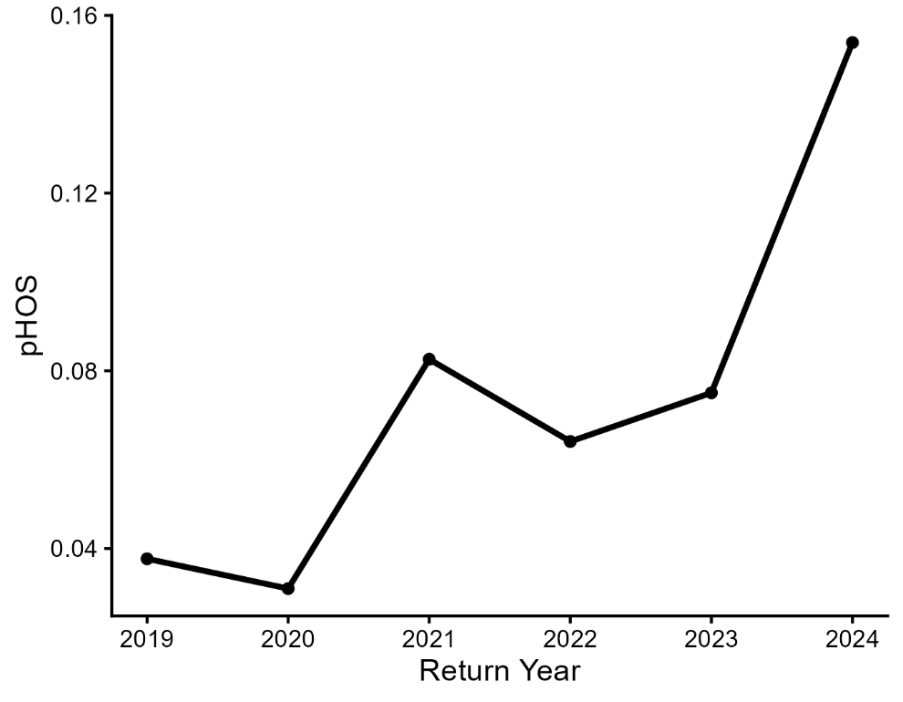
Figure 28. Proportion of hatchery origin spawners (pHOS) by return year for the Chilko ERIS. Chilko pHOS was estimated by dividing mark-recapture-based estimates of CWT spawners by total spawners. Return year CWT recoveries correspond to smolt-releases from 1-3 years prior.
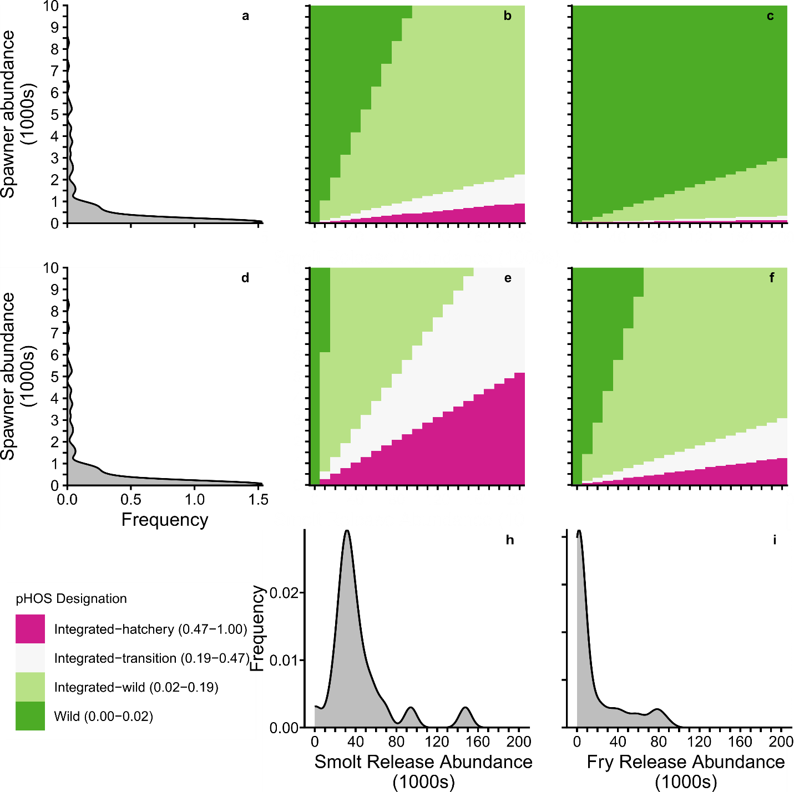
Figure 29. Range in potential proportion of hatchery-origin spawners (pHOS) in relation to pHOS designations from Withler et al. (2018) based on the abundance and lifestage of juveniles released and the total spawning population abundance. Plots a) and d) show the relative frequency distribution of spawner abundances in the 2014 – 2024 return year period for Fraser Summer 5₂ (1.3) Chinook populations. Plots b) and e) show the minimum and maximum resulting pHOS for a population, respectively, based on the minimum and maximum observed return rates for CWT 1+ smolts from the Chilko River ERIS. Plots c) and f) show the minimum and maximum resulting pHOS for a population, respectively, based on the minimum and maximum observed return rates for CWT fry produced for the Chilko River ERIS. Plots h) and i) show the relative frequency of different-sized Summer 5₂ (1.3) smolt and fry releases for the 2014 – 2024 release years, respectively.

History of Management

History of Management Objectives and Outcomes
The Pacific Salmon Treaty framework for Chinook Salmon consists of two fisheries management regimes: Aggregate Abundance-Based Management (AABM) and Individual Stock-Based Management (ISBM) ((Pacific Salmon Commission 2023) AABM mixed stock fisheries are managed to an annual total allowable catch (TAC) under a variable harvest rate strategy. ISBM fisheries are managed domestically under a fixed exploitation rate strategy for multiple indicator stocks, where the limit is defined by the CYER (Pacific Salmon Commission 2023)
Domestic management measures in response to low abundance have restricted directed commercial and recreational fisheries for stream-type Fraser Chinook Salmon for years, and First Nations Food, Social and Ceremonial (FSC) fisheries have also been significantly limited (DFO 2025b). Since 2000-2008, management measures implemented to reduce impacts of Canadian AABM fisheries on west coast Vancouver Island natural-origin Chinook also reduced impacts on co-migrating stream-type Fraser Chinook stocks, including the Spring 5₂ (1.3) and Summer 5₂ (1.3) SMUs. Similarly, a broad suite of management measures including time-area closures, catch limits, mark-selective retention, and various gear restrictions were implemented across commercial and recreational fisheries to further reduce impacts on stream-type Fraser Chinook in 2012 (Dobson et al. 2020) Additional restrictions, primarily more extensive time-area closures, were implemented in 2019 (Dobson et al. 2020; DFO 2025b). Since 2012, the Albion gill-net test fishery was delayed to late-April to reduce impacts on stream-type Fraser Chinook (Dobson et al. 2020; Weir et al. 2022)
There is currently no quantitative escapement goal for either (Chinook Technical Committee 2025a); however, the objective of the 2023 Salmon Integrated Fisheries Management Plan (IFMP) was to manage Canadian fisheries in a highly precautionary manner to allow as many fish to pass through the spawning grounds as possible (DFO 2025b) This approach was implemented in 2019 and reduced FMI from 23.7% (2014-2018 mean) to 4.4% (2019-2024 mean)(DFO 2025a)

Bycatch in non-salmon fisheries
Enhanced monitoring of the Pacific region groundfish trawl fishery was initiated in 2022 to provide accurate estimates of Pacific Salmon bycatch by species and assess stock composition using genetics (Lagasse et al. 2025) CWT recoveries and/or DNA samples were collected from a random sample of Chinook Salmon bycatch from each fishery region to determine the CU of origin. Fraser Spring 5₂ (1.3) and Summer 5₂ (1.3) Chinook Salmon represented a very low proportion (less than 3%) of Chinook bycatch sampled in 2023. (Lagasse et al. 2025)

History of Freshwater Habitat Impacts
Fraser Spring 5₂ (1.3) and Summer 5₂ (1.3) Chinook spend a significant portion of their life cycle in freshwater as a result of their stream-type life history strategy (Weir et al. 2022; Dionne et al. 2023) Juveniles rear in their natal streams as well as in off-channel mainstream habitats and non-natal tributaries of the Thompson and Fraser Rivers, dispersing and rearing downstream of their natal stream as far as the lower Fraser River (Murray and Rosenau 1989; Bradford and Taylor 1997, 2023). Many systems in these SMUs are highly susceptible to extreme weather events such as wildfires, landslides, high water temperatures, and extreme high or low flows, although flexibility in the timing of spawning ground arrival and dispersal of juveniles throughout the Fraser watershed helps buffer impacts on upstream migration and rearing. Substantial adult en route mortality occurred during the 2019 Big Bar Landslide on the Fraser River mainstem and resulted in record low spawner returns for Fraser Spring 5₂ (1.3) Chinook, and some Summer 5₂ (1.3) Chinook populations were also restricted (Chinook Technical Committee 2025b) The Big Bar slide impacted Spring 5₂ (1.3) migration in 2020, however there was no significant mortality or delay in migration detected at Big Bar in 2021 and 2022 (CTC 2025, DFO 2025). Similarly for Summer 5₂ (1.3) Chinook, there was no mortality or delays detected with respect to Big Bar passage in 2020 for stocks returning through the Fraser Canyon, and no mortality or delays in migration detected at Big Bar observed in 2021 or 2022 (Chinook Technical Committee 2025b; DFO 2025a) In July of 2024, another major landslide occurred on the Chilcotin River, blocking fish passage for multiple weeks during the migration period of populations that spawn above the slide. Although SONAR data showed that migration resumed in early September, mortality due to the initial blockage and downstream debris flow has not been quantified, and impacts on the productivity of the affected CUs will not be evident until the entire cohort has returned (Chinook Technical Committee 2025a)
Construction of the Terzaghi Dam on the Bridge River (Middle Fraser River SP 1.3 CU) in 1960 cut-off important spawning and rearing habitat that was historically used by the Bridge River Chinook population, and resulted in the dewatering of ~4km of habitat downstream of the dam (Bradford et al. 2011; Weir et al. 2022)). The Bridge River population accounts for ~3% of the Spring 5₂ (1.3) SMU. Construction of the Kenny Dam in the early 1950s significantly impacted local ecosystems in the Nechako River basin, where large areas of land were flooded or drained causing displacement of salmon and other fish species. Impacts of the Kenny Dam at the CU scale on Middle Fraser Spring 5₂ (1.3) Chinook are expected to be low due to the large geographic range of the CU ((Doutaz et al. 2021) The Lower Fraser River and estuary have been heavily modified for floodplain control and agricultural development, which has drastically altered conditions in off-channel habitat that is used by Chinook juveniles for rearing.

Ecosystem and Climate Change Considerations
Fraser Spring 5₂ (1.3) and Summer 5₂ (1.3) Chinook encounter a wide range of ecosystems and climate conditions during their life-cycle (Doutaz et al. 2021; Weir et al. 2022; Dionne et al. 2023). Table 8 summarizes major ecosystem and climate considerations by life-stage for both SMUs. An in-depth summary of the major climate threats to specific CUs and recommended management actions to address these threats are outlined in the associated Recovery Potential Assessments ((Doutaz et al. 2021; Weir et al. 2022; Dionne et al. 2023)
Table 8. Fraser River Spring and Summer 5₂ (1.3) Chinook required habitat and the effect of the top 3 threats by life stage. Information adapted from ((Doutaz et al. 2021)
Life stage | Top threats | Mechanisms of threats
Egg/alevin | - Modifications to catchment surfaces  - Climate change increasing freshwater environmental variation | - Increased likelihood of dewatering or egg/alevin-scouring flood events
Fry/parr | - Modifications to catchment surfaces  - Climate change increasing freshwater environmental variation | - Alters the freshet, affecting the timing and duration of access to off-channel rearing habitat  - Increases variation in stream temperature, increasing the number of metabolically stressful days
Smolt | - Modifications to catchment surfaces  - Climate change increasing freshwater and marine environmental variation | - Alters the freshet, changing the timing of smolt migration and ocean entry  - Increase or decrease early marine survival through competition and predation
Immature adult | - Climate change increasing marine environmental variation | - Increase or decrease growth rates and survival through competition and predation
Spawning adult | - Modifications to catchment surfaces  - Climate change increasing freshwater environmental variation | - Alters surface and groundwater availability, determining whether fish can access preferred spawning areas  - Watersheds have been heavily impacted by wildfires and are susceptible to landslides that can restrict fish passage to spawning habitat.

Exceptional Circumstances
We recommend that a re-assessment of the Fraser Spring 5₂ (1.3) and Fraser Summer 5₂ (1.3) SMUs be triggered if any of the following occur:
- New information becomes available that results in changes to the historical time-series of spawner abundance and/or catch data used in this research document.
- New information becomes available that results in changes to our understanding of stock structure (e.g. CU designations) and/or major drivers of stock dynamics.
- New information becomes available regarding the recent landslide events’ impact on spawner abundance and the susceptibility of CUs to future landslides.
- There is a long enough time series of exploitation rate data to classify Chilko as an established CWT ERIS rather than a developing CWT ERIS. The results of the first Exploitation Rate Analysis will be presented by the Chinook Technical Committee later this year (2026).

Discussion
Many Pacific salmon SMUs have insufficient data to estimate stock recruit parameters and, as a result, traditional fisheries reference points. Yet under the Fish Stock Provisions within the Canadian Fisheries Act, all major stocks must be assessed against science-based reference points. Here, a mix of new and previously-used methods was used to asses the status of data-limited Fraser Spring and Summer 5₂ (1.3) Chinook SMUs. We estimated the reference point U_{MSY} (maximum sustainable ER) for both SMUs. We simulated future spawner abundances under a variety of productivity and ER scenarios, but were unable to provide an FRP-L due to the persistent low abundance of several CUs within each SMU even when Canadian exploitation rates were zero and productivity was high. Additionally, we developed a model to examine the relationship between the Canadian CYER (a robust ER index used in PST management) and FMI (the only ER index currently available for the Fraser Spring 5₂ (1.3) SMU). While the results can inform fisheries decisions and management, they require additional context and discussion given uncertainty in the data and analyses used to generate them.

Escapement Data
The type and quality of the escapement data impacted both reference point estimates and the simulation methods. Most systems within the Spring 5₂ (1.3) and Summer 5₂ (1.3) SMUs are based on visual survey methods, with a standardized expansion factor applied to estimate spawner escapement. This expansion factor is not adjusted for stream-specific factors that affect observer efficiency such as turbidity, stream size and morphology, and fish density (Bevan 1961; Jones et al. 1998; Parken et al. 2003) and estimates tend to be biased low (Chinook Technical Committee 2024). For example, in the Upper Fraser SP 1.3 and North Thompson SP 1.3 CUs, many systems are glacial fed, making them visually difficult to assess due to frequent low water clarity, likely increasing negative bias in spawner counts. It is currently unknown what proportion of Upper Fraser and North Thompson Chinook attempt to spawn in the mainstems of these rivers versus the tributaries, and what impact that may have on spawner-to-smolt productivity. Currently, we hypothesize that when environmental conditions in the tributaries are unfavorable due to low flows and high temperatures, Chinook may switch to spawning in the North Thompson or Upper Fraser mainstems where they are not visible in the turbid water. Because conditions in spawning streams vary from year-to-year, not only would a system-specific expansion factor need to be adjusted for low water clarity, but it would also potentially need to vary with annual environmental conditions as fish move between higher and lower clarity spawning habitat. Thus, the most data for both SMUs were classified as relative index abundance data, which are not suitable for estimating abundance-based reference points, nor Ricker stock-recruit parameters.
The limitations associated with relative index abundance data are widely recognized. Spawning for both SMUs occurs across most of the Fraser River Watershed, frequently in locations that are remote. While SONAR and mark-recapture programs may provide a solution for converting some visual-based surveys to high-precision spawner surveys, it is currently financially and logistically impractical to apply to high-precision counting methods on all of the streams that are visually surveyed.

Exploitation Rate
We found that the relationship between the FMI and Canadian CYER was positive, but relatively weak. We found evidence of proportional bias. Specifically, when observation error was low or moderate, FMI underestimated (overestimated) CYER at low (high) values of FMI. Conversely, when observation error was high, FMI consistently underestimated Canadian CYER. Although there appear to be qualitative differences in the mean relationship between indices among SMUs, there are too few observations for each ERIS to estimate these effects with high precision. Stock-specific relationships are likely driven by multiple factors including, for example, the relative sampling efficiency of CWT- and GSI-based programs (for CYER and FMI respectively), population size, and the extent to which ERISs represent the populations sampled to inform FMI.
We expected FMI and Canadian CYER to deviate from one another due to differences in the underlying data and models used to generate each index. Briefly, CYER is based on CWT recoveries in fisheries and spawning grounds (summarized in (Chinook Technical Committee 2025a). CYER incorporates data on total catch or escapement via sampling rates. As smolt survival rates have declined and fisheries have been reduced, there have been concerns that the precision of CYER estimates has declined, though minimal sampling requirements have also been designed to mitigate these effects (PSC 2008). Perhaps most importantly CYER is estimated for a relatively small number of ERIS populations that are expected to represent ERs for untagged populations with similar life history traits from the same geographic region. For example, marine ERs for the Chilko ERIS population are assumed to be shared by all CUs within the Fraser Summer 5₂ (1.3) SMU. We found that within the Fraser Summer 4₁ 0.3 and Fall 4₁ 0.3 SMUs there were relatively large differences in Canadian CYER between ERIS, highlighting challenges associated with inferring SMU-level harvest rates from ERIS.
Conversely, FMI partitions estimates of total catch in Canadian fisheries using either genetic samples (marine fisheries) or a run reconstruction model (freshwater fisheries), then scales removals relative to estimates of escapement to estimate harvest at the scale of SMUs (Dobson et al. 2020) Thus, FMI does not rely on tagged populations and integrates over among-population variability when estimating harvest impacts. Yet FMI includes other important uncertainties including a less statistically-sound sampling structure (e.g., infilling of unsampled strata), the exclusion of a relatively small number of fisheries where catch of Fraser River SMUs may be minimal, genetic assignment error, and assumptions within the run reconstruction model (e.g., stationary migration timing, equivalent fishery vulnerability among populations). Additionally, hatcheries have transplanted some Fraser SMUs outside of the Fraser and the escapements for these locations are not included in the FMI. Overall enhancement to the Spring 5₂ (1.3) and Summer 5₂ (1.3) SMUs is low with the potential exception of the Chilliwack River in the Lower Fraser CU (CK-06). Future efforts to mass mark hatchery releases may improve monitoring of hatchery contributions to fisheries and on the spawning grounds for both SMUs. These uncertainties are reviewed in detail in Dobson et al. 2020, though we note that the FMI has been refined since that publication.
It was outside the scope of this working paper to quantify the relative precision of either the FMI or CYER. We assumed the same level of observation error in both metrics when estimating the relationship between them (though we did not assume that observation error was itself correlated). For the same reason, we tested different quantities of error in both metrics. Our findings suggest that FMI-based estimates of ER should be interpreted cautiously particularly when: a) there is strong evidence that CYER estimates are precise, unbiased, and representative of the SMU as a whole, b) FMI values are higher than approximately 0.1, or c) there is strong evidence that the CV of observation error on FMI exceeds 0.1. Given the limitations of each index, we strongly recommend continuing current levels of CWT smolt production for the Chilko ERIS population and increasing CWT smolt production for the developing Lower Chilcotin ERIS so that ER in both SMUs can be estimated using multiple indices. Further work will include the estimation of impacts of mark-selective fisheries (MSFs) on exploitation rate estimates. To date, the differences in exploitation rates between natural and hatchery components of the Spring and Summer 5₂ SMUs are thought to be small due to the small extent of MSFs implemented in Canadian fisheries.

Ricker α
Estimating Ricker α from proxy populations and proportional differences in fecundity comes with considerable uncertainty. Here, Ricker α estimates were based on the assumption that fecundity scales with productivity across Chinook salmon populations because fecundity physically limits the total number of offspring a female chinook can potentially produce. This aligns with the general assumption that declines in size at maturity in Chinook populations will result in declines in productivity due to reductions in fecundity (Ohlberger et al. 2018, 2020; Oke et al. 2020; Malick et al. 2023). However, the translation of fecundity to recruitment at low spawning densities (i.e., Ricker α) depends on density-independent mortality (Koslow 1991) and the trade-off between fecundity and egg size limited by female internal body volume (Fleming & Reynolds 2004). Density-independent mortality (i.e., mortality independent of spawner abundance) may be driven by extreme environment events (Einum et al. 2008) such as egg scour caused by flooding (Ohlberger et al. 2018). Populations that use river systems and marine areas more prone to extreme environmental events will on average have lower Ricker α parameters because recruitment per female is depressed at low abundances relative to systems less prone to extreme events. In the case of fecundity versus egg size, females trade off juvenile size/quality with the number of juveniles they can produce, where larger eggs may produce juveniles that are more likely to survive, but smaller eggs that produce smaller juveniles allow a greater number of offspring to be produced at the potential cost of lower survival rates. Indeed, fecundity does not always scale with total reproductive investment as fecundity varies relative to total gonad mass or volume per unit length among salmon populations (Beacham & Murray 1993). For example, Beacham and Murray (1993) found that coastal salmon populations were more likely to produce fewer, larger eggs relative to their length than salmon populations with long freshwater migrations. Thus, choosing an appropriate proxy population with similar expected density-independent mortality and freshwater migration distance is critical for estimating reasonable fecundity-based estimates of Ricker α for data-limited stocks.
Density-independent mortality and freshwater migration distances for Fraser Spring 4₂ (1.2) Chinook are more representative of the Fraser Spring and Summer 5₂ (1.3) Chinook than Fraser Summer 4₁ (0.3) Chinook density-independent mortality rates and freshwater migration distances are of Fraser Fall 4₁ (0.3) Chinook. The Nicola River stock (Fraser Spring 4₂ (1.2) Chinook) significantly overlap in juvenile rearing habitat with the Fraser Spring and Summer 5₂ (1.3) Chinook, and migrate an intermediate distance in freshwater relative to the Fraser 5₂ (1.3) Chinook SMUs (Bailey et al. 2026 in press). In contrast, Lower Shuswap River Chinook (Fraser Summer 4₁ (0.3) Chinook) migrate significantly further than Harrison River Chinook (Fraser Fall 4₁ (0.3) Chinook), and arrive in the Fraser estuary much later, rearing in flooded off-channel habitats on their way to saltwater (Dionne et al. 2023; Doutaz et al. 2021). Because of the greater freshwater migratory distance for Lower Shuswap River Chinook, they are expected to have higher fecundity relative to female length (Beamish & Murray 1993), explaining why Lower Shuswap River Chinook have higher fecundity than Harrison River Chinook despite lower productivity when estimated using Ricker stock-recruit functions (Appendix E). Thus, the inconclusive results of the fecundity-based expansion validation (Appendix E) are consistent with previous research.
For the reasons listed in the Methods section (i.e., similarities in life-history, habitat degradation, and overlapping juvenile rearing and early marine habitats) and the previous paragraph, the fecundity-based expansion used to estimate Ricker α applied in this paper was likely appropriate for the Fraser Spring and Summer 5₂ (1.3) Chinook SMUs. In addition, the range in Ricker α values used in this paper heavily overlapped with the most ecologically similar SMU (Fraser Spring 4₂ (1.2) Chinook), thus it is likely that the “true” median productivity of the Fraser Spring and Summer 5₂ (1.3) were within the 95% CIs estimated for each stock. However, it is not recommended to apply this method to other data-limited stocks in future stock assessments until more research can confirm or invalidate the broader utility of this approach. Until then, there are alternative approaches, such as using the estimated range in productivity directly from a proxy population (in this case, directly from the Nicola River ERIS), or by combining the posterior distributions of productivity for all chinook populations within the same larger watershed (e.g., all the Fraser ERIS populations for the SMUs assessed in this paper).

Simulations
The main takeaways of the simulation analysis were that a) simulation outcomes were not sensitive to unbiased implementation error; b) we were unable to develop an FRP-L (lower fisheries reference point) due to multiple small CUs in each SMU; and C) that extremely high-productivity scenarios can create unstable simulation outcomes. The lack of sensitivity to implementation error may be attributed to the broadness of the outcome categories (e.g., the moderately low and moderately high categories cover 25% probability ranges) and that outcomes were the average of all iterations for a given ER-producivity scenario (i.e., while the variance in the outcomes among iterations may increase, the average remains relatively stable). We could not develop an FRP-L because several CUs within each SMU remained below the lower biological benchmark of 1500 spawners regardless of changes in Canadian exploitation rate or productivity. Finally, instability in conservation outcomes in high-productivity scenarios were likely driven by unstable population dynamics, where recruitment was potentially exceeding carrying capacity driving boom-bust cycles.
Our simulation results are sensitive to several assumptions that were necessary given data limitations. Ideally, simulations would have been parameterized using representative stock-recruit data for each SMU. Instead, simulations were parameterized with our best estimates of Ricker parameters using productivity estimates from the Nicola Fraser Spring 4₂ (1.2) ERIS population (scaled to account for differences in fecundity) and the Parken Habitat model (Parken et al. 2006) Furthermore, we could not prime the simulation with observed spawner abundance data since only relative index abundance estimates were available for many CUs. Instead, initial abundance values within the simulations were based on stochastic population dynamics projected from the assumed Ricker parameters. As a result, it is impossible to determine whether the simulated population trajectories were initialized at realistic levels reflecting current spawner abundance. This is a concern because ERs approaching U_{MSY} are usually appropriate for CUs at their equilibria, but CUs not in equilibrium (e.g., Lower Fraser SP 1.3 and Middle Fraser River Portage SU 1.3) may recover faster with lower-than-U_{MSY} ERs, particularly if productivity is depressed. Finally, we used simulated true spawner abundance relative to absolute abundance-based reference points (i.e., 20% S_{max}) because we were unable to develop an observation sub-model that realistically simulated relative index abundance data. Thus, the simulation analysis provides managers information on the probability of a conservation outcome given a consistent productivity and ER regime (with implementation error) over time when status (i.e., spawner abundance relative to biological reference points) can be perfectly observed. In reality, several of the CUs within the Fraser Spring and Summer 5₂ (1.3) Chinook SMUs are currently WSP Red status using trend-based metrics suitable for relative index abundance data. ER-productivity combinations with a high probability of success in simulations may not produce the same result when using realistic status assessment methods and data.
There were a variety of factors that potentially influence the interpretation of the simulation results. Simulated conservation outcomes (as shown in Figures 15-17, 24-26 and Supplementary Materials B; Figures _ – _ were not sensitive to different levels of unbiased implementation error. However, if the relationship between the two ER metrics is representative of implementation error (i.e., if true realized exploitation rates are not just variable relative to targets, but biased), then the ability to apply the exploitation rates represented by the probability plots will be limited (as represented by the associated kernel density plots) and conservation outcomes will become less certain. Another factor affecting the interpretation of the simulation results was the size of the component CUs. CUs that include a small number of populations with persistently low abundance (e.g., Lower Fraser River-Upper Pitt SU 1.3, Middle Fraser-Fraser Canyon SP 1.3, etc.) were more likely to have poor conservation outcomes than larger CUs. This result is expected because small CUs have lower biological benchmarks that are less than 1500 spawners, thus they must exceed a spawner abundance greater than their lower biological benchmark to achieve an Amber or better status under the WSP Rapid Status Approach. The 1,500 threshold is well established empirically in the literature, and for that reason is used by independent organizations for global and Canadian wildlife species status assessments: Union for the Conservation of Nature (IUCN) and Committee on the Status of Endangered Wildlife in Canada (COSEWIC). This metric and thresholds has also been approved for use in WSP status assessments over the past 15 years in a number of CSAS processes, and outperformed other decision trees when these metrics and thresholds are included to assess WSP salmon status (Pestal et al. 2023; DFO 2024; Grant et al. 2026 in press) Here, we note the impact of small CUs on simulation outcomes. Future processes to suggest applicable science advice on how to manage ‘recovery’, including appropriate ‘rebuilding targets’ for small populations, which might differ from large populations that have declined to below the lower absolute abundance thresholds, on DFO rebuilding plans is recommended.
Ultimately, the results of the simulation analysis should be interpreted cautiously, as there are many sources of uncertainty affecting the outcomes. Until better ER, stock-recruit, and spawner abundance data become available, attempts to predict future Chinook abundances for the Fraser Spring and Summer 5₂ (1.3) SMUs will be uncertain, limiting quantitative evaluation of alternative management procedures.

Future Research
We recommend three general topics of research to reduce data limitations for the Fraser Spring and Summer 5₂ (1.3) SMUs. First, low abundance despite reductions in exploitation rate for both SMUs suggests that population productivity has declined. A mechanistic understanding of the drivers of these declines could improve management interventions to promote rebuilding. Specifically, we recommend studies to quantify the impact of upstream migratory conditions on en route mortality and per capita productivity (e.g., spawning success, egg-to-fry and fry-to-smolt survival). Given that juvenile stream-type Chinook from middle and upper Fraser River populations also rear in the Lower Fraser River (Murray and Rosenau 1989; Bradford and Taylor 1997, 2023) research to quantify the proportional contribution of this life history would provide insight on the effect of recent and future anthropogenic impacts on productivity. Many Chinook salmon populations have shown persistently low marine survival and reduced size-at-age or age-at-maturity (Ohlberger et al. 2019; Xu et al. 2020; Oke et al. 2020; Welch et al. 2021; Freshwater et al. 2022). Identifying the relative magnitude of these effects on Fraser Spring 5₂ (1.3) and Summer 5₂ (1.3) declines, as well as identifying causal factors, could also help develop more robust management interventions.
Second, while it is likely unfeasible to develop absolute spawner abundance estimates for every CU in these SMUs, short-term studies could be used to better understand the magnitude of bias in relative index estimates. For example, SONAR-based estimates paired with visual estimates of creek-spawning Upper Fraser SP 1.3 Chinook could be collected over a period of several years to determine whether there is evidence for facultative mainstem spawning. Further, if significant mainstem spawning occurs and is correlated with environmental conditions in tributaries, the trade-off in spawner-to-fry productivity between mainstream and creek habitats should be assessed.
Third, given the uncertain relationship between CYER and FMI, and the impact of this relationship on contextualizing implementation error, efforts to better understand the major factors driving the divergence would be beneficial. More reliable estimates of observation error could be used to refine the quantitative model we developed. Similarly, our analysis could be extended by quantifying FMI-to-CYER relationships on similar ecological scales (e.g., calculating FMI for a given ERIS rather than an SMU), which would provide a more reliable comparison and test one hypothesized driver of divergence between the two indices.

Summary
The six TORs set for this CSAS process were met and our conclusions are summarized below (Table 9).
Table 9. Summary of how TORs were addressed.
TOR # | Summary
1. | We described the component populations’ (SMUs, CUs, DUs, ERIS populations, and hatchery releases) trends, statuses, and life-history characteristics. The pHOS of the Chilko ERIS was illustrated in Figure 28, and pHOS tools for both Spring and Summer 5₂ (1.3) were developed and illustrated with Figures 19 and 29.
1.a. & 1.a.i. | Stock statuses were determined using the established WSP Rapid Status Approach. We provided an estimate of U_{msy} for both SMUs, but were unable to provide FRP-Ls. FRP-Ls were unavailable because none of the simulated productivity/ER scenarios (including a scenario with zero Canadian ER and high productivity) were associated with greater than a 4% probability of either SMU exceeding its status-based LRP.
1.b. | The history of enhancement was described in terms of the abundance of hatchery fish released, as well as either measured pHOS (Chilko River, Figure 28) or potential pHOS given observed return rates by release stage and spawning population size (Figures 11 and 21).
2. | We summarized ecosystem- and climate change-based threats to Fraser 1.3 chinook in the History of Management and Ecosystem and Climate Change Considerations sections. Environmental and climate change considerations were included in our analysis by simulating scenarios across a broad range of productivity (Ricker ln(α)) values, accounting for uncertainty in future productivity driven by environmental uncertainty. Data limitations precluded fitting traditional Ricker stock recruit curves to ERIS data for both SMUs, further preventing analysis of varying environmental conditions on stock productivity.
3. | We estimated candidate reference points for both SMUs.
3.a. | U_{msy} was reported for both SMUs, but we were unable to develop FRP-Ls for either SMU (see TOR 1.a. summary in Table 9).
3.b. | U_{msy} for both SMUs was estimated using only natural-origin recruit and spawner data, thus these estimates only pertain to the natural-origin portion of each SMU.
4. | We developed and conducted simulations of future CU-level abundances for both SMUs using a broad range of ER and productivity scenarios. Future abundances were assessed against lower biological benchmarks (20% Smax or 1500 spawners, whichever is the larger value) to determine the probability of a CU achieving a WSP Amber or better status. SMUs were assessed as above or below their CU status-based LRPs for each ER/productivity scenario to determine the probability of an SMU exceeding its LRP.
5. | Both SMUs were determined to be below their LRPs due to multiple WSP Red status CUs within each SMU.
5.a. | We reviewed the WSP Rapid Status Approach methods and results, displaying the status for each CU within each SMU (Table 2, Stock Status and Trends: Spring 5₂ (1.3) & Summer 5₂ (1.3)).
5.b. & 5.c. | We summarized the top threats to both SMUs in Table 8. We also discussed how CUs with small watershed areas and/or few populations with sufficient data quality can lead to WSP Red status in the Simulations portion of the Discussion. We also highlighted gaps in knowledge that future research could address, reducing uncertainty in the drivers of productivity and spawner escapements.
5.d. | Rebuilding targets have not been established. For these SMUs, an abundance-based rebuilding target would not be appropriate since many CUs are assessed using relative index abundance escapement data.
6. | We described exceptional circumstances for both SMUs including data-, management, and environmental-based triggers for reassessment.

REFERENCES CITED
Bailey, C., Greenberg, D., Freshwater, C., and Borea, I. 2025. Pacific-salmon-assess/FIA-CN-FSRR-FSAR. Available from https://codemeta.github.io/terms/#codeRepository [accessed 3 February 2026].
Bailey, C., Greenberg, D., Freshwater, C., and Borea, I. 2026. Pacific-salmon-assess/FIA-CN-FSRR-FSAR. Available from https://github.com/Pacific-salmon-assess/FIA-CN-FSRR-FSAR [accessed 3 February 2026].
Beacham, T. D., & Murray, C. B. (1993). Fecundity and egg size variation in North American Pacific salmon (Oncorhynchus). Journal of Fish Biology, 42, 485–508.
Beamish, R.J., and Mahnken, C. 2001. A critical size and period hypothesis to explain natural regulation of salmon abundance and the linkage to climate and climate change. In Progress in Oceanography. Available from www.elsevier.com/locate/pocean.
Bevan, D. 1961. Variability in Aerial Counts of Spawning Salmon.
Bradford, M.J. 1995. Comparative review of Pacific salmon survival rates. Can. J. Fish. Aquat. Sci. 52: 1227-1338.
Bradford, M.J., Higgins, P.S., Korman, J., and Sneep, J. 2011. Test of an environmental flow release in a British Columbia river: Does more water mean more fish? Freshw. Biol. 56(10): 2119–2134. doi:10.1111/j.1365-2427.2011.02633.x.
Bradford, M.J., and Taylor, G.C. 1997. Individual variation in dispersal behaviour of newly emerged chinook salmon (Oncorhynchus tshawytscha) from the Upper Fraser River, British Columbia. Can. J. Fish. Aquat. Sci. 54: 1585-1592.
Bradford, M.J., and Taylor, G.C. 2023. Diversity in freshwater life history in spring and summer Chinook Salmon from the Fraser River, Canada. Trans. Am. Fish. Soc. 152(2): 129–144. John Wiley and Sons Inc. doi:10.1002/tafs.10396.
Brown, G.S., Thiess, M.E., Wor, C., Holt, C.A., Patten, B., Bailey, R.E., Parken, C.K., Baillie, S.J., Candy, J.R., Willis, D.M., Hertz, E., Connors, B., and Pestal, G.P. 2020. 2020 Summary of Abundance Data for Chinook Salmon (Oncorhynchus tshawytscha) in Southern British Columbia, Canada. Canadian Technical Report of Fisheries and Aquatic Sciences 3401.
Chaput, G., Cass, A.J., Grant, S., Huang, A., and Veinott, G. 2013. Considerations for defining reference points for semelparous species, with emphasis on anadromous salmonid species including iteroparous salmonids. GDFO Can. Sci. Advis. Sec. Res. Doc. 2012(146): v + 48.
Chinook Technical Comittee. 2023. 2023 Exploitation Rate Analysis. Pacific Salmon Commission Joint Technical Committee Report. Vancouver.
Chinook Technical Committee. 2024. Annual Report of Catch and Escapement for 2023. Available from https://www.psc.org/reports/tcchinook-24-01.
Chinook Technical Committee. 2025a. 2024 Exploitation Rate Analysis. Pacific Salmon Commission Joint Technical Committee Report. Vancouver. Available from https://www.psc.org/reports/tcchinook-25-01.
Chinook Technical Committee. 2025b. Annual Report of Catch and Escapement for 2024 CHINOOK TECHNICAL COMMITTEE. Available from https://www.psc.org/reports/tcchinook-25-02.
Chinook Technical Committee. 2025c. 2024 Exploitation Rate Analysis. Vancouver, BC. Available from https://www.psc.org/reports/tcchinook-25-01.
DFO. 2005. Canada’s policy for conservation of wild Pacific Salmon. In Fisheries and Oceans Canada. Fisheries and Oceans Canada.
DFO. 2006. A Harvest Strategy Compliant with the Precautionary Approach. DFO Can. Sci. Advis. Sec. Sci. Advis. Rep. 2006/023
DFO. 2015a. Wild Salmon Policy Biological Status Assessment for Conservation Units of Interior Fraser River Coho Salmon (Oncorhynchus Kisutch). DFO Can. Sci. Advis. Sec. Sci. Advis. Rep. 2015(022): 12.
DFO. 2015b. Development of reference points for Atlantic salmon (Salmo salar) that conform to the Precautionary Approach. DFO Can. Sci. Advis. Sec. Sci. Advis. Rep. 2015/058(December).
DFO. 2016a. Proceedings of the Pacific regional peer review on the Assessment of Southern British Columbia Chinook Salmon Conservation Units, Benchmarks and Status. Available from http://www.dfo-mpo.gc.ca/csas-sccs/csas-sccs@dfo-mpo.gc.ca.
DFO. 2016b. Integrated Biological Status of Southern British Columbia Chinook Salmon (Oncorhynchus Tshawytscha) Under the Wild Salmon Policy.
DFO. 2024. Rapid Status Approximations for Pacific Salmon Derived from Integrated Expert Assessments Under DFO’s Wild Salmon Policy. DFO Can. Sci. Advis. Sec. Sci. Resp. 2024/004.
DFO. 2025a. Fraser River Chinook Salmon: Fishery Mortality Index Summary 2014 to 2024.Technical Memo.
DFO. 2025b. Integrated Fisheries Management Plan for Salmon of Southern British Columbia: July 1,2025-June 30, 2026. 23-2544 647p.
DFO. 2026. In press. Fraser Chinook Spring 1.2 (4₂) Chinook Salmon (Oncorhynchus Tshawytscha) Stock Assessment in 2024. DFO . Can. Sci. Advis. Sec. Sci. Resp.2024/nnn
Dionne, K., Rachinski, T., Parken, C., Weir, L., Doutaz, D., Ritchie, L., Bailey, R., Jenewein, B., Miller-Saunders, K., Labelle, M., Manson, M., Welch, P., Trouton, N., Mozin, P., and Walsh, M. 2023. Recovery Potential Assessment for Southern British Columbian Chinook Populations, Fraser and Southern Mainland Chinook Designatable Units (1, 6, 13 and 15). DFO Can. Sci. Advis. Sec. Res. Doc. 2023/042. xvii + 291p.
Dobson, D., Holt, K., and Davis, B. 2020. A Technical Review of the Management Approach for Stream-Type Fraser River Chinook. DFO Can. Sci. Advis. Sec. Res. Doc. 2020/027. x + 280 p.
Doutaz, D., Weir, L., Arbeider, M., Braun, D., Jenewein, B., Rickards, K., Labelle, M., Curtis, S., Mozin, P., Whitney, C., Parken, C., and Bailey, R. 2021. Canadian Science Advisory Secretariat (CSAS) Recovery Potential Assessment for 11 Designatable Units of Fraser River Chinook Salmon, Oncorhynchus tshawytscha, Part 1: Elements 1 to 11. DFO Can. Sci. Advis. Sec. Res. Doc. 2021/063. xiii + 337 p.
Einum, S., Fleming, I. A., Côté, I. M., & Reynolds, J. D. 2003. Population stability in salmon species: effects of population size and female reproductive allocation. Journal of Animal Ecology, 72(5), 811–821. https://doi.org/10.1046/j.1365-2656.2003.00752.x
Farwell, M.K., Bailey, R.E., and Rosenberger, B. 1999. Enumeration of the 1995 Nicola river Chinook Salmon Escapement.
Freshwater, C., Anderson, S.C., Holt, K.R., Huang, A.-M., and Holt, C.A. 2019. Weakened portfolio effects constrain management effectiveness for population aggregates. 29(7): 1–14. doi:10.2307/26797117.
Freshwater, C., Parken, C.K., Tucker, S., Velez-Espino, A., and King, J. 2022. Nonstationary patterns in demographic traits covary with Chinook salmon marine distributions. Canadian Journal of Fisheries and Aquatic Sciences 79(11): 1860–1878. Canadian Science Publishing. doi:10.1139/cjfas-2021-0312.
Grant, S.C.H., Macdonald, B.L., Holt, C.A., Grant, S.C.H., Macdonald, B.L., Pestal, G., and Holt, C.A. 2026. in press. Speed Meets Standards: Powering the Wild Salmon Policy with Rapid Status Assessments for Pacific Salmon Conservation Units. Can. J. Fish. Aquat. Sci.
Grant, S.C.H., and Pestal.G. 2013. Integrated Biological Status Assessments Under the Wild Salmon Policy Using Standardized Metrics and Expert Judgement: Fraser River Sockeye Salmon (Oncorhynchus nerka) Case Studies. Can .Sci. Advis. Sec. Res. Doc. 2012/106. V + 132 p.
Holt, C., Cass, A., Holtby, B., and Riddell, B. 2009. Indicators of Status and Benchmarks for Conservation Units in Canada’s Wild Salmon Policy. DFO Can. Sci. Advis. Sec. Res. Doc. 2009/058. Viii + 74 p.
Holt, C.A, Holt, K., Warkentin, L., Wor, C., Connors, B., Grant, S., Huang, A.-M., and Marentette, J., 2023. Guidelines for Defining Limit Reference Points for Pacific Salmon Stock Management Units. DFO Can. Sci. Advis. Sec. Res. Doc. 2023/009. iv + 66 p.
Holt, C.A., and Peterman, R.M. 2006. Missing the target: Uncertainties in achieving management goals in fisheries on Fraser River, British Columbia, sockeye salmon (Oncorhynchus nerka). Canadian Journal of Fisheries and Aquatic Sciences 63(12): 2722–2733. doi:10.1139/F06-155.
Jones, E.L., Quinn, T.J., and Van Alen, B.W. 1998. Observer Accuracy and Precision in Aerial and Foot Survey Counts of Pink Salmon in a Southeast Alaska Stream. N. Am. J. Fish. Manag. 18(4): 832–846. Oxford University Press (OUP). doi:10.1577/1548-8675(1998)018<0832:oaapia>2.0.co;2.
Koslow, J. 1991. Fecundity and the Stock-Recruitment Relationship. Can. J. Fish. Aquat. Sci. 49:
Lagasse, C.R., Fraser, K.A., Braithwaite, E., and Komick, N. 2025. Salmon Bycatch Monitoring and Sampling Results for the Pacific Region 2023/24 Groundfish Trawl Fishery. Can. Sci. Manuscr. Rep. Fish. Aquat. Sci. 3298: vi + 41 p. https://doi.org/10.60825/d0e4-pp46
Malick, M.J., Losee, J.P., Marston, G., Agha, M., Berejikian, B.A., Beckman, B.R., and Cooper, M. 2023. Fecundity trends of Chinook salmon in the Pacific Northwest. Fish and Fisheries 24(3): 454–465. John Wiley and Sons Inc. doi:10.1111/faf.12738.
Matheson, D., Holzer, D., Engie, K., Morita, M., Jorgensen, J., and Seminet, E. 2007. Viability Criteria for Application to Interior Columbia Basin Salmonid ESUs Interior Columbia Basin Technical Recovery Team.
Murray, C.B., and Rosenau, M.L. 1989. Rearing of Juvenile Chinook Salmon in Nonnatal Tributaries of the Lower Fraser River, British Columbia. In Transactions of the American Fisheries Society.
Ohlberger, J., Brenkman, S.J., Crain, P., Pess, G.R., Duda, J.J., Buehrens, T.W., Quinn, T.P., and Hilborn, R. 2019. A Bayesian life-cycle model to estimate escapement at maximum sustained yield in salmon based on limited information. Canadian Journal of Fisheries and Aquatic Sciences 76(2): 299–307. Canadian Science Publishing. doi:10.1139/cjfas-2017-0382.
Ohlberger, J., Schindler, D.E., Brown, R.J., Harding, J.M.S., Adkison, M.D., Munro, A.R., Horstmann, L., and Spaeder, J. 2020. The reproductive value of large females: Consequences of shifts in demographic structure for population reproductive potential in Chinook Salmon. Canadian Journal of Fisheries and Aquatic Sciences 77(8): 1292–1301. Canadian Science Publishing. doi:10.1139/cjfas-2020-0012.
Ohlberger, J., Ward, E.J., Schindler, D.E., and Lewis, B. 2018. Demographic changes in Chinook salmon across the Northeast Pacific Ocean. Fish and Fisheries 19(3): 533–546. Blackwell Publishing Ltd. doi:10.1111/faf.12272.
Oke, K.B., Cunningham, C.J., Westley, P.A.H., Baskett, M.L., Carlson, S.M., Clark, J., Hendry, A.P., Karatayev, V.A., Kendall, N.W., Kibele, J., Kindsvater, H.K., Kobayashi, K.M., Lewis, B., Munch, S., Reynolds, J.D., Vick, G.K., and Palkovacs, E.P. 2020. Recent declines in salmon body size impact ecosystems and fisheries. Nat. Commun. 11(1). Nature Research. doi:10.1038/s41467-020-17726-z.
Pacific Salmon Commission. 2023. Treaty Between the Government of Canada and the Government of the United States of America Concerning Pacific Salmon, as amended through June 2023.
Pacific Salmon Commission. 1985. Pacific Salmon Commission Treaty. Available from http://www.psc.org/.
Parken, C.K., Bailey, R.E., and Irvine, J.R. 2003. Incorporating Uncertainty into Area-under-the-Curve and Peak Count Salmon Escapement Estimation. N. Am. J. Fish. Manag. 23(1): 78–90. Oxford University Press (OUP). doi:10.1577/1548-8675(2003)023<0078:iuiaut>2.0.co;2.
Parken, C.K., McNicol, R.E., and Irvine J.R. 2006. Habitat-based methods to estimate escapement goals for data limited Chinook salmon stocks in British Columbia, 2004. DFO. Can. Sci. Advis. Res. Doc. 2006/083.
Pestal, G., MacDonald, B.L., Grant, S.C.H., and Holt, C.A. 2023b. State of the Salmon: rapid status assessment approach for Pacific salmon under Canada’s Wild Salmon Policy. In Canadian Technical Report of Fisheries and Aquatic Sciences. Available from https://waves-vagues.dfo-mpo.gc.ca/library-bibliotheque/41207890.pdf.
Potapova, A., Moore, J.W., Parken, C.K., Sloat, M., Atlas, W., and Jones, L.A. 2026. Range-wide life history diversity and climate exposure in adult Chinook salmon. Ecosphere 17(3). John Wiley and Sons Inc. doi:10.1002/ecs2.70572.
PSC. 2005. Report of the Expert Panel on the Future of the Coded Wire Tag Program for Pacific Salmon. Pacific Salmon Comm. Tech. Rep. No. 18: 230 p.
PSC. 2008. An Action Plan in Response to Coded Wire Tag (CWT) Expert Panel Recommendations A Report of the Pacific Salmon Commission CWT Workgroup. Pacific Salmon Comm. Rep. No. 25:170 p.
PSC. 2015. Five-Year Synthesis Report of the PSC Coded Wire Tag (CWT) Improvement Program Pacific Salmon Commission Joint CWT Implementation Team. Pacific Salmon Comm. Tech. Rep. No. 33:48 p.
Scheuerell, M.D. 2016. An explicit solution for calculating optimum spawning stock size from Ricker’s stock recruitment model. PeerJ 4: e1623. doi:10.7717/peerj.1623.
Scott, D. C., Chalifour, L., MacDuffee, M., Baum, J. K., Beacham, T., Rondeau, E., & Hinch, S. G. (2024). Variation in estuary use patterns of juvenile Chinook salmon in the Fraser River, BC. Canadian Journal of Fisheries and Aquatic Sciences. https://doi.org/10.1139/cjfas-2024-0012
Sehnute, J.T., Richards, L. 4, Schnute, J. Te, and Richards, L.J. 1995. The influence of error on population estimates from catch-age models. In Can. J. Fish. Aquas. Sci. Nanaimo.
Weil, J., Luedke, W., Healy, T.M., Withler, R.E., Brown, N.A.W., Bokvist, J., and Porszt, E. 2025. The Magnitude and Extent of Chinook Straying from Hatcheries in Southern British Columbia. Available from http://www.dfo-mpo.gc.ca/csas-sccs/DFO.CSAS-SCAS.MPO@dfo-mpo.gc.ca.
Weir, Lauren., Doutaz, D., Arbeider, M., and Davis, B. 2022. Recovery potential assessment for 11 designatable units of Fraser River chinook salmon, Oncorhynchus tshawytscha, part 2 : elements 12 to 22. Canadian Science Advisory Secretariat (CSAS).
Welch, D.W., Porter, A.D., and Rechisky, E.L. 2021. A synthesis of the coast-wide decline in survival of West Coast Chinook Salmon (Oncorhynchus tshawytscha, Salmonidae). Fish and Fisheries 22(1): 194–211. Blackwell Publishing Ltd. doi:10.1111/faf.12514.
Withler, R.E., Bradford, M.J., Willis, D., and Holt, C.A. 2018. Genetically Based Targets for Enhanced Contributions to Canadian Pacific Chinook Salmon Populations. DFO Can. Sci. Advis. Sec. Sci. Advis. Rep. 2018/019(001): 88 p.
Xu, Y., Decker, S., A., Parken, C.K., Ritchie, L.M., Patterson, D.A., and Fu, C. 2020. Climate effects on size-at-age and growth rate of Chinook Salmon (Oncorhynchus tshawytscha) in the Fraser River, Canada. Fish. Oceanogr. 29(5): 381–395. Blackwell Publishing Ltd. doi:10.1111/fog.12484.

APPENDIX A: glossary
[AABM] Aggregate Abundance Based Management Fishery: Fisheries for Chinook Salmon are managed to a Treaty catch limit set annually pre-season. They are mixed stock fisheries that intercept and catch migratory Chinook salmon from many stocks (PST 2019, CTC 2024).
Benchmarks: also known as “benchmarks of biological status”, these are thresholds used to determine the status (e.g., red, amber, green) of a Conservation Unit (DFO 2018).
Brood year: the single or main contributing spawning year that produced a group of juveniles or adult recruits (https://www.pac.dfo-mpo.gc.ca/fm-gp/salmon-saumon/gloss-eng.htmlhttps://www.pac.dfo-mpo.gc.ca/fm-gp/salmon-saumon/gloss-eng.html).
Bycatch: non-target fish species captured in commercial or recreational fisheries (https://www.pac.dfo-mpo.gc.ca/fm-gp/salmon-saumon/gloss-eng.htmlhttps://www.pac.dfo-mpo.gc.ca/fm-gp/salmon-saumon/gloss-eng.html).
Catchment surface: the land area that rainfall is intercepted by. The qualities of the catchment surface affect how and when water moves through a watershed.
[CU] Conservation Unit: a group of wild Pacific salmon populations that would not recover naturally nor recolonize the habitat after extirpation within a human lifetime (DFO 2005).
[CWT] Coded Wire Tag: A small metal tag inserted into the nose of a juvenile salmon (usually hatchery stock) prior to release or migration to the ocean. The tag has encoded information that indicates the origin and year of release of the fish.(https://www.pac.dfo-mpo.gc.ca/fm-gp/salmon-saumon/gloss-eng.htmlhttps://www.pac.dfo-mpo.gc.ca/fm-gp/salmon-saumon/gloss-eng.html).
[CYER] Calendar Year Exploitation Rate: adult equivalent (AEQ) -adjusted total mortalities in ISBM fisheries of Canada or the U.S. summed across ages divided by the sum of AEQ-adjusted mortalities in all fisheries plus escapement for a single calendar year.
[COSEWIC]: The Committee on the Status of endangered Wildlife in Canada. An established advisory body created in 1977 to provide a single, scientifically-sound classification of wildlife species at risk of extinction. (https://www.cosewic.ca/index.php/en/about-us.html)
[DU] Designatable Unit: Species, Subspecies, variety or geographically or genetically distinct population that may be assessed by COSEWIC, where such units are both discrete and evolutionarily significant. (COSEWIC guidelines for recognizing designatable units)
[ER] Exploitation Rate: “expressed as a percentage, the proportion of the total return of adult salmon in a given year that die as a result of fishing activity” (https://www.pac.dfo-mpo.gc.ca/fm-gp/salmon-saumon/gloss-eng.html).
[ERA] Exploitation Rate Analysis: An annual report submitted to the Pacific Salmon Commission (PSC) by the Chinook Technical Committee (CTC) to fulfill Pacific Salmon Treaty obligations regarding managing Chinook salmon fisheries and stocks harvested within the Treaty area. (CTC 2025).
[ERIS] Exploitation Rate Indicator Stock: A stock chosen to represent a larger similar group of stocks for survival, exploitation rate and marine distribution patterns. The Chinook Technical Committee currently monitors 45 ERIS Pacific Salmon Treaty obligations (CTC 2025).
Escapement target: the number of fish fisheries management aspires to return to the spawning grounds.
[FRP-L] Lower Fisheries Reference Point: SMU aggregate abundance reference points (i.e., escapement targets that are relevant to the scale of management and are associated with specific probabilities of the stock exceeding its CU-based LRP.
[FMI] Fishing Mortality Index: An approach for estimating exploitation rates for Chinook stocks without sufficient Coded-Wire-Tag data. The approach combines Stock Management Unit-level estimates of in-river catch and escapement from the Fraser River Chinook Run Reconstruction model (developed by the Chinook Technical Committee) and Genetic Stock Identification estimates from marine fisheries to create exploitation rate indices (Dobson et al. 2020).
Fish Stock Provisions: an updated section of the Fisheries Act that came into force on April 4, 2022 and triggered the development of Fish Science Advice Reports (https://www.dfo-mpo.gc.ca/about-notre-sujet/engagement/2022/fish-stock-provisions-dispositions-stocks-poissons-eng.html).
Full assessment: also known as “full integrated status assessment”, these are the traditional stock status assessments under the Wild Salmon Policy using standardized data reviewed over a multi-day meeting of experts to determine the status of individual Conservation Units (DFO 2015a).
Integrated-wild population: “populations with an integrated hatchery program that is managed to achieve conservation and genetic goals while contributing to production. Benchmarks associated with this category ensure the majority (>50%) of fish spawning in the river meet the criteria for wild under the Wild Salmon Policy and 80% or more of the spawning population will be of natural origin.” (Withler et al. 2018)
[ISBM] Individual Stock Based Management Fishery: A fishery that constrains the annual impacts within the fisheries of a jurisdiction of a naturally spawning Chinook stock or stock group. They are managed with the intent of meeting objectives for individual stocks listed in Chapter 3, Attachment I, Annex IV of the 2019 PST Agreement.
[IUCN] International Union for Conservation of Nature: A membership Union of government and civil society organizations, created in 1948 as a global authority to advance sustainable development and measures towards safeguarding the natural environment. (https://iucn.org/about-iucn)
[LRP] Limit Reference Point: a scientifically-determined threshold below which Fisheries and Oceans Canada is legally obligated to develop a stock rebuilding plan for a given Stock Management Unit (Holt et al. 2023).
Natural fish: a fish produced through natural spawning, but whose parents may be of natural or hatchery origin.
[NuSEDS] New Salmon Escapement Database System: DFO’s Pacific Region central database that stores individual spawner survey data records and spawner abundance estimates.
Off-channel habitat: Typically small, shallow, often ephemeral (i.e., not always submerged) wetted channels and pools that are seasonally or continuously connected to the mainstem of a stream.
[PA] Precautionary approach: a policy published by Fisheries and Oceans Canada within the Sustainable Fisheries Framework that states the intention of the federal government to use caution when scientific knowledge is uncertain (e.g., harvest less in the face of uncertainty; https://www.dfo-mpo.gc.ca/reports-rapports/regs/sff-cpd/precautionary-precaution-back-fiche-eng.htmhttps://www.dfo-mpo.gc.ca/reports-rapports/regs/sff-cpd/precautionary-precaution-back-fiche-eng.htm).
[PBT] Parentage based tagging: The use of genetic makers to identify progeny back to hatchery of origin and brood year (Whatman sheet sampling instructions for Parent Age Based Tagging (PBT) at hatcheries | Pacific Region | Fisheries and Oceans Canada).
[pHOS] Proportion of Hatchery Origin Spawners: The proportion of Chinook on the spawning grounds that are of hatchery origin. (Weil et al. 2025)
[PNI] Proportionate natural influence: the proportion of natural origin spawners in a salmon population (Withler et al. 2018).
Pre-fishery abundance: The number of estimated adult fish that would have returned to the beginning of their spawning migration in the absence of fishing mortality.
[PSC] Pacific Salmon Commission: A governmental body formed by the Canada and United States in 1984 to implement the Pacific Salmon Treaty.
[PST] Pacific Salmon Treaty: An agreement between Canada and the United States to cooperate in the management, research, and enhancement of Pacific Salmon stocks of mutual concern (Pacific Salmon Commission 1985).
[QET] quasi-extinction threshold: The minimum number of spawners below which the population is likely to be critically and immediately imperiled (Matheson et al. 2007)
Reference points: thresholds that trigger changes in the harvest of stock management units. Limit reference points are scientifically determined, but removal references and upper stock references include both biological and management considerations in their development (Chaput et al. 2013).
Regime shift: a large, rapid change from one relatively stable general pattern to a new pattern.
[RR] Removal Reference: “maximum acceptable removal rate for the stock which would apply when the stock is in the healthy zone and includes all anthropogenic mortality” (DFO, 2015a).
[SAS] Smolt-to-Adult Survival: the proportion or percent of smolts that survive to recruit to the fishery. In most cases, smolt counts occur early in the downstream seaward migration, and include downstream freshwater mortality in addition to marine mortality.
[SEP] Salmonid Enhancement Program: A group within DFO that manages, and administers hatchery enhancement in British Columbia. ((Weil et al. 2025)
[S_{gen}] The number of spawners required for “recovery to S_{MSY} in one generation under equilibrium conditions” (Holt et al. 2009)
[S_{max}] The number of spawners required to produce maximum recruitment(Holt et al. 2009)
[S_{MSY}] Spawners at Maximum Sustainable Yield: the number of spawning adults that generates the greatest difference between the number of spawners and the number of adult recruits they produce (where spawners are fish that escaped the fishery, and recruits are the fish available to the fishery before fishing begins).
[SMU] Stock Management Unit: “a group of one or more conservation units (CU) that are managed together with the objective of achieving a joint status” (https://www.pac.dfo-mpo.gc.ca/pacific-smon-pacifique/science/research-recherche/smon-summ-somm-eng.html). Note that in older documents this is also written as “Management Unit”, or MU.
[U_{MSY}] Fishing mortality rate that will lead to the Maximum Sustainable Yield: the highest sustainable fishing mortality, which would lead spawner abundance to match Spawners at Maximum Sustainable Yield (S_{MSY}).
[USR] Upper Stock Reference: the stock level below which losses must be progressively reduced in order to avoid reaching the LRP. In other words, the point below which harvest control rules change as the population size declines until it reaches the LRP (https://www.dfo-mpo.gc.ca/reports-rapports/regs/sff-cpd/precaution-eng.htm).
Wild population: population of salmon that spent their entire life cycle in the wild and originate from parents that were also produced by natural spawning and continuously lived in the wild (DFO 2005).
[WSP] Wild Salmon Policy: a policy published by Fisheries and Oceans Canada that states the intention to “restore and maintain healthy and diverse salmon populations and their habitats for the benefit and enjoyment of the people of Canada in perpetuity” and provides guidelines for achieving this objective (DFO 2005).
WSP Integrated Status: The biological status (green/amber/red) of a conservation unit assessed by a group of experts over a multi-day meeting using standardized data (Pestal et al. 2023)
WSP Rapid Status: A method and process that approximates the Integrated Status Assessment using the same data inputs and a decision tree coded into a decision tree to estimate the biological status of a conservation unit (Pestal et al. 2023). The data and results are vetted through Area CU experts, and for official purposes the data and results also go through a broader process with local experts, including Indigenous Knowledge experts, to finalize both statuses and accompanying narratives and information packages for WSP Rapid status.

APPENDIX B: WILD SALMON POLICY RAPID STATUS assesments
The Wild Salmon Policy Rapid Status assessment assigns a ‘Red’ (poor), ‘Amber’ (intermediate), or ‘Green’ (good) status with ‘Low’, ‘Medium’, or ‘High’ confidence rating to WSP conservation units (CU) with applicable data. CU statuses are generated by applying Pacific salmon CU data to a computer-coded WSP rapid status decision tree that assigns status depending on answers to twelve Yes/No questions that approximate the decision-making process that experts used in WSP integrated status assessments (Figure B1). The combination of metrics applied, and their individual status values compared to metric thresholds, leads to a WSP rapid status. The decision tree results are then reviewed annually by CU experts, where additional qualitative data is considered in the final assignment of WSP status (Grant et al. 2026). For Spring and Summer 5₂ (1.3) SMUs, two expert review processes were completed in 2025 for the 2023 and 2024 escapement years (see Supplementary Materials A in [INSERT ZENODO LINK] for complete reports from these review processes).
Metric Dashboards (Figures B1.1- B2.6) are also produced for WSP rapid status assessment processes. However, it should be noted that the decision tree thresholds are not always one-to-one with metric benchmarks because the decision tree uses decision rules to approximate expert-driven decisions. Methods and background information are described in greater detail in (Pestal et al. 2023; DFO 2024; Grant et al. 2026 in press) Updated benchmark values developed in this research document (Table B1) are reflected in the status dashboards presented here (Figures B1.1-B.2.). These benchmark updates did not result in any changes in CU-status outcomes that were evaluated at the recent expert review processes [INSERT ZENODO LINK].
Figure B.1. WSP rapid status decision. To assess a CU, metric values are compared to thresholds presented at each decision point. Yes or No answers split each path of the decision tree, terminating at WSP rapid status assignments. The different splits are identified as nodes: 1 to 65. Branch 1 is taken if a CU’s abundance falls below the absolute abundance lower threshold of 1,500 (Node 3). Branch 2 is taken when a CU’s abundance falls between the absolute abundance lower threshold of 1,500 and the upper threshold of 10,000. Branch 3 is taken if a CU’s abundance exceeds the absolute abundance upper threshold of 10,000, or the total spawner abundance for the CU is unknown (Grant et al. 2026 in press)

Relative Abundance Benchmarks
Table B1. Median estimates (50% credible interval) of CU-level lower (20% S_{max}) and upper (85% S_{MSY}) relative abundance benchmarks for the Rapid Status Assessment, with lower (2.5%) and upper (97.5%) credible intervals. Note that these benchmark values do not affect CU status outcomes because all CUs are evaluated using either the 1500 absolute abundance threshold or trend-based thresholds due to the quality of escapement data available.
SMU Name | CU Name | CU ID | Benchmark | 50% CI | 2.5% CI | 97.5% CI
Fraser Spring 5₂ (1.3) | Lower Fraser | CK-04 | 20% S_{max}  85% S_{MSY} | 180  350 | 80  160 | 490  990
 | Middle Fraser – Fraser Canyon | CK-08 | 20% S_{max}  85% S_{MSY} | 140  260 | 60  120 | 360  720
 | Middle Fraser | CK-10 | 20% S_{max}  85% S_{MSY} | 4800  9500 | 2300  4600 | 12900  26100
 | Upper Fraser | CK-12 | 20% S_{max}  85% S_{MSY} | 4600  9200 | 2100  4100 | 12600  24900
 | North Thompson | CK-18 | 20% S_{max}  85% S_{MSY} | 780  1600 | 360  700 | 2100  4200
Fraser Summer 5₂ (1.3) | Lower Fraser – Upper Pitt | CK-05 | 20% S_{max}  85% S_{MSY} | 130  250 | 50  100 | 450  930
 | Lower Fraser River | CK-06 | 20% S_{max}  85% S_{MSY} | 180  360 | 80  160 | 590  1200
 | Middle Fraser River – Portage | CK-09 | 20% S_{max}  85% S_{MSY} | 260  520 | 110  210 | 840  1700
 | Middle Fraser River | CK-11 | 20% S_{max}  85% S_{MSY} | 10200  20200 | 4300  8300 | 37500  76500
 | South Thompson | CK-14 | 20% S_{max}  85% S_{MSY} | 280  560 | 120  230 | 850  1800
 | North Thompson | CK-19 | 20% S_{max}  85% S_{MSY} | 2800  5700 | 1200  2400 | 9000  18600

B.1.SPRING 5₂ (1.3)
Survey sites and years included in the CU-level escapement time series for the purposes of the Rapid Status Approach and model simulations are summarized in Table B.1.1 for Fraser Spring 5₂ (1.3) Chinook. Complete status dashboards for each CU are described in Figures B1.1- B.1.11). The decision tree node pathway associated with the status dashboard for each CU are also described in Tables B.1.2-B.1.7.
Table B.1.1 Conservation Units (CUs) included in this Stock Management Unit (SMU) and lists of the streams/populations within each CU used in the Rapid Status Assessment. Streams have their NuSEDS population identifications in brackets.
CU # | CU Name | Streams Included (Population ID) | Enhanced Streams Excluded (Population ID) | Timeseries
CK-04 | Lower Fraser SP 1.3 | Birkenhead River (46101) |  | 2008-2024
CK-08 | Middle Fraser- Fraser Canyon SP 1.3 | Nahatlatch River (47165) |  | 1996-2024
CK-10 | Middle Fraser SP 1.3 | Ahbau Creek (47287)  Baezaeko River (44752)  Cariboo River-Upper (46892)  Chilako River (46011)  Chilcotin River-Lower (46842)  Endako River(45510)  Horsefly River(46901)  Lightning Creek(47297)  Mckinley Creek(45051)  Nazko River(44762)  Shovel Creek(45520)  Swift River(2483)  West Road (Blackwater) River (45991)  Yalakom River (47234) | Chilcotin River-Upper (46841)  Bridge River (47229) | 1995-2024
CK-12 | Upper Fraser SP 1.3 | Antler Creek (47457)  Bad River (47397)  Bowron River (47427)  Captain Creek (47387)  Fontoniko Creek (47407)  Forgetmenot Creek (44691)  Fraser River-Above Tete Jaune (44549)  Goat River (47538)  Haggen Creek (47437)  Holliday Creek (1207)  Holmes River (46931)  Horsey Creek (46951)  Ice Creek (3075)  Indianpoint Creek (47447)  Mckale River (47548)  Morkill River (47528)  Nevin Creek (46941)  Salmon River (47317)  Seebach Creek (47357)  Slim Creek (47477)  Small Creek (45325)  Swift Creek (46961)  Torpy River (47497)  Twin Creeks (Combined) (44497)  Walker Creek (47507)  Wansa Creek (47337) | Dome Creek (47487)  Willow River (47327) | 1995-2024
CK-18 | North Thompson SP 1.3 | Blue River (46801)  Finn Creek (46790) |  | 1997-2024

B.1.1 CK-04 Lower Fraser
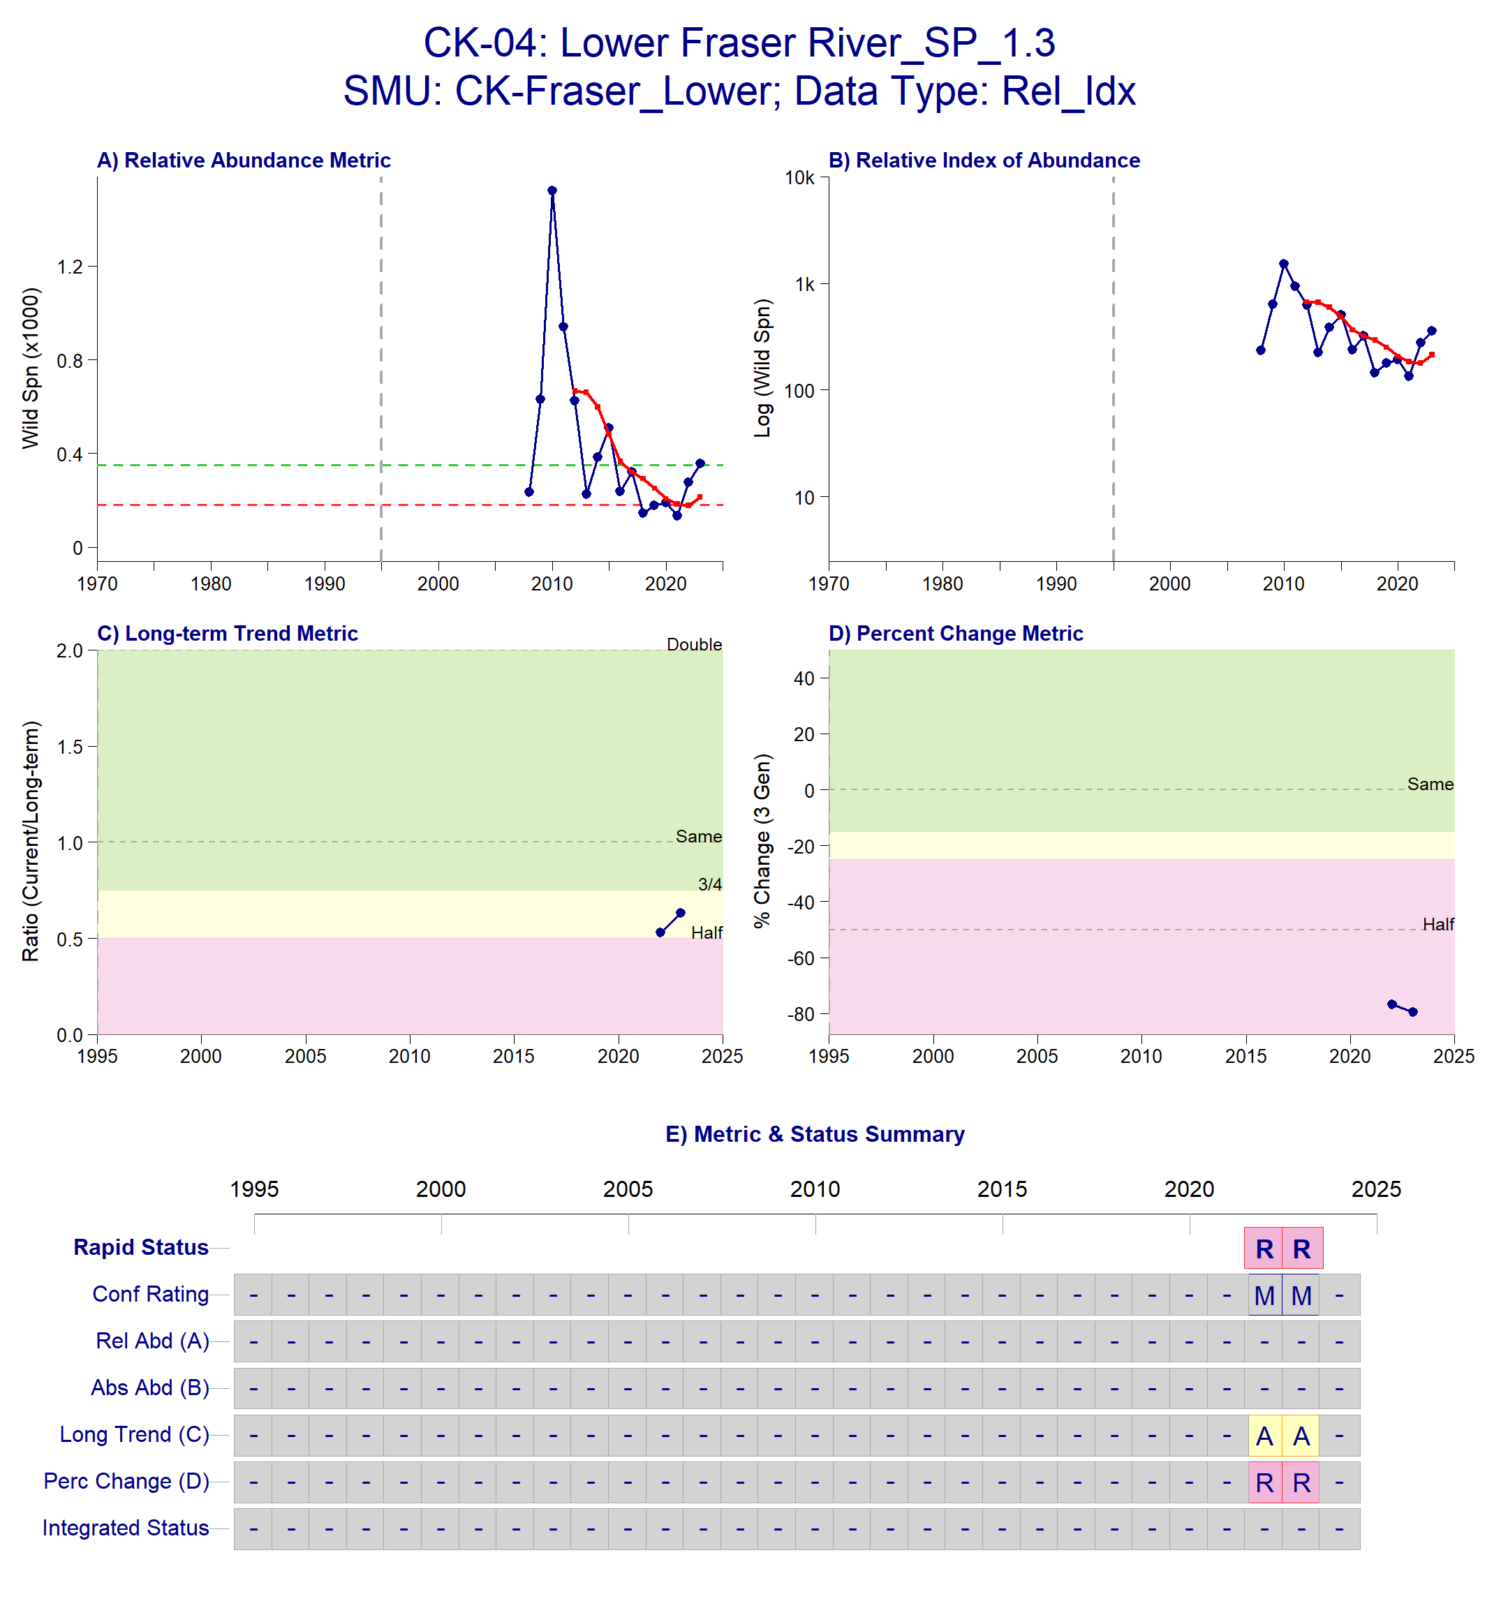
Figure B.1.1: Metrics and Status for Lower Fraser SP 1.3 (CK-04). Panels on top show the four standard WSP metrics, calculated based on the available time series of spawner abundances. Bottom panel summarizes the status for each individual metric and shows the resulting WSP rapid status for the CU with a confidence rating. If integrated WSP status assessments have been completed for this CU, they are shown on the last row (IntStatus). Note that metric benchmarks may differ from decision tree thresholds, since thresholds approximate the status determination process from past WSP integrated status assessments.
Table B.1.2. Decision tree path given data and metric values for the Lower Fraser SP 1.3 in 2024; this aligns with Figure A.1 above. For each node, the decision is made by comparing the CUs current metric value to the metric threshold and answering Yes or No, running through sequential nodes and decisions until the final WSP rapid status for that CU and year is reached.
Node | Metric | Metric Threshold | CUs Current Value | Decision
1 | Relative Index | <1,500 | 214 | NO, YES
2 | Relative index | < 10,000 | 214 | NO,YES
4 | Relative abundance | Available? |  | NO
8 | Long term trend | <79% of long term average | 214 | YES
17 | FINAL STATUS NODE |  |  | RED, MEDIUM

Data Quality Filtering
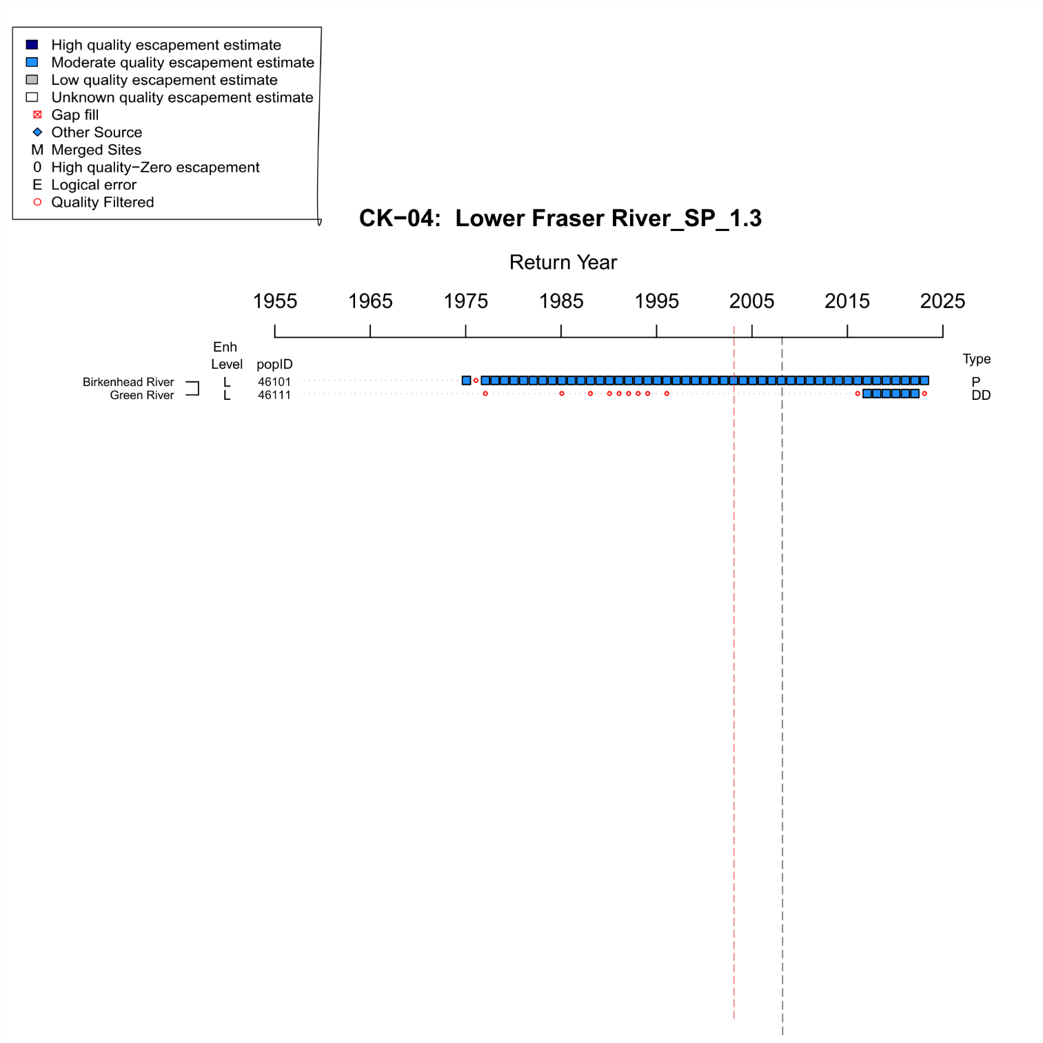
Figure B.1.2. WSP Rapid Status Assessment data quality filtering summary from 1975-2024 for Lower Fraser River Spring 1.3 (CK-04). The grey dashed line indicates the assigned start year for the rapid status assessment time series (2008). The red dashed line indicates the last significant brood year smolt release (2003). Enh level indicates the enhancement rank (H = High, M = Moderate, L = Low, U = Unknown), popID refers to the site population identification number in the NuSEDS database, Type refers to the site designation ( P = persistent, DD = data deficient, AGG = aggregated, DEL = deleted or extirpated. As stated in the legend, dark blue squares indicate years with high quality escapement estimates (NuSEDS Types 1-2), light blue squares indicate years with moderate quality escapement estimates (NuSEDS Types 3-4), , red squares indicate years were gap filling was conducted, red open circles indicate years that were quality filtered (NuSEDS Types 5-6 or unknown).
Expert Consensus
During the January 2025 expert review, the start year for the rapid status time series was changed from 1975 to 2008 due to consistent enhancement of Birkenhead River. Sub-yearling smolts were released annually from brood years 1983-1998 (Supplementary Materials A, Appendix A). Additionally, 122,500 sub-yearling smolts were released between brood years 2000-2003 (Supplementary Materials A, Appendix A).

B.1.2 CK-08 Middle Fraser River- Fraser Canyon
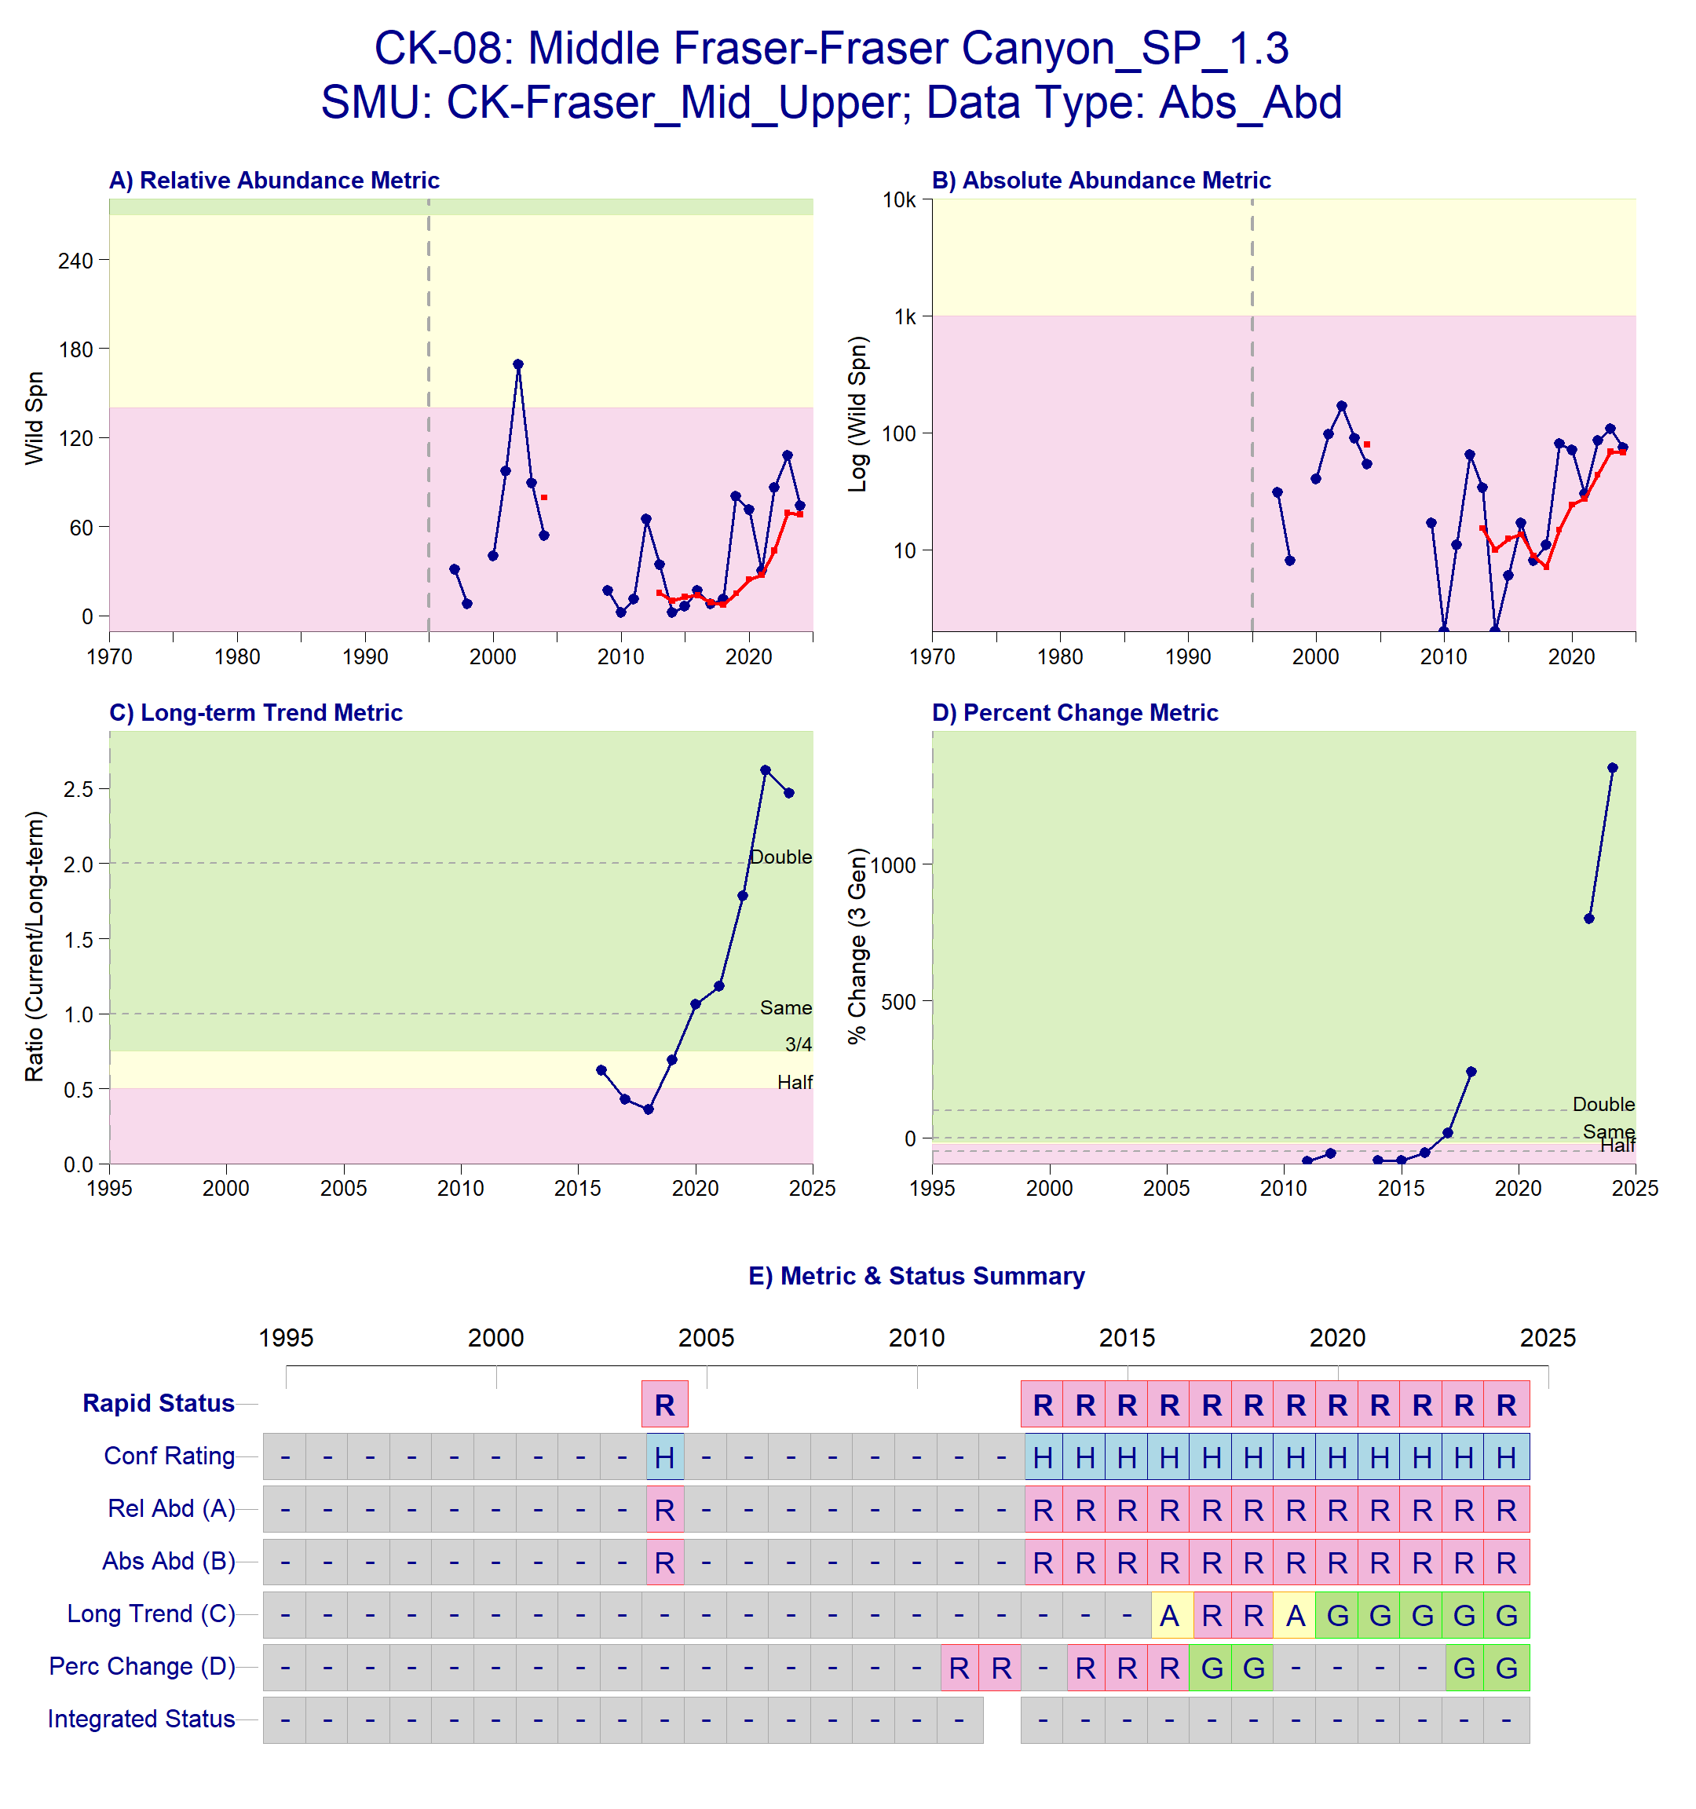
Figure B.1.3. Metrics and Status for Middle Fraser – Fraser Canyon SP 1.3 (CK-08). Panels on top show the four standard WSP metrics, calculated based on the available time series of spawner abundances. . Bottom panel summarizes the status for each individual metric and shows the resulting WSP rapid status for the CU with a confidence rating. If integrated WSP status assessments have been completed for this CU, they are shown on the last row (IntStatus). Note that metric benchmarks may differ from decision tree thresholds, since thresholds approximate the status determination process from past WSP integrated status assessments.
Table B.1.4. Decision tree path given data and metric values for Middle Fraser – Fraser Canyon SP 1.3 2024; this aligns with Figure B.1.3 above. For each node, the decision is made by comparing the CUs current metric value to the metric threshold and answering Yes or No, running through sequential nodes and decisions until the final WSP rapid status for that CU and year is reached.
Node | Metric | Metric Threshold | CUs Current Value | Decision
1 | Absolute Abundance | <1,500 | 68 | YES, YES
3 | FINAL STATUS NODE |  |  | RED, HIGH

Data Quality Filtering
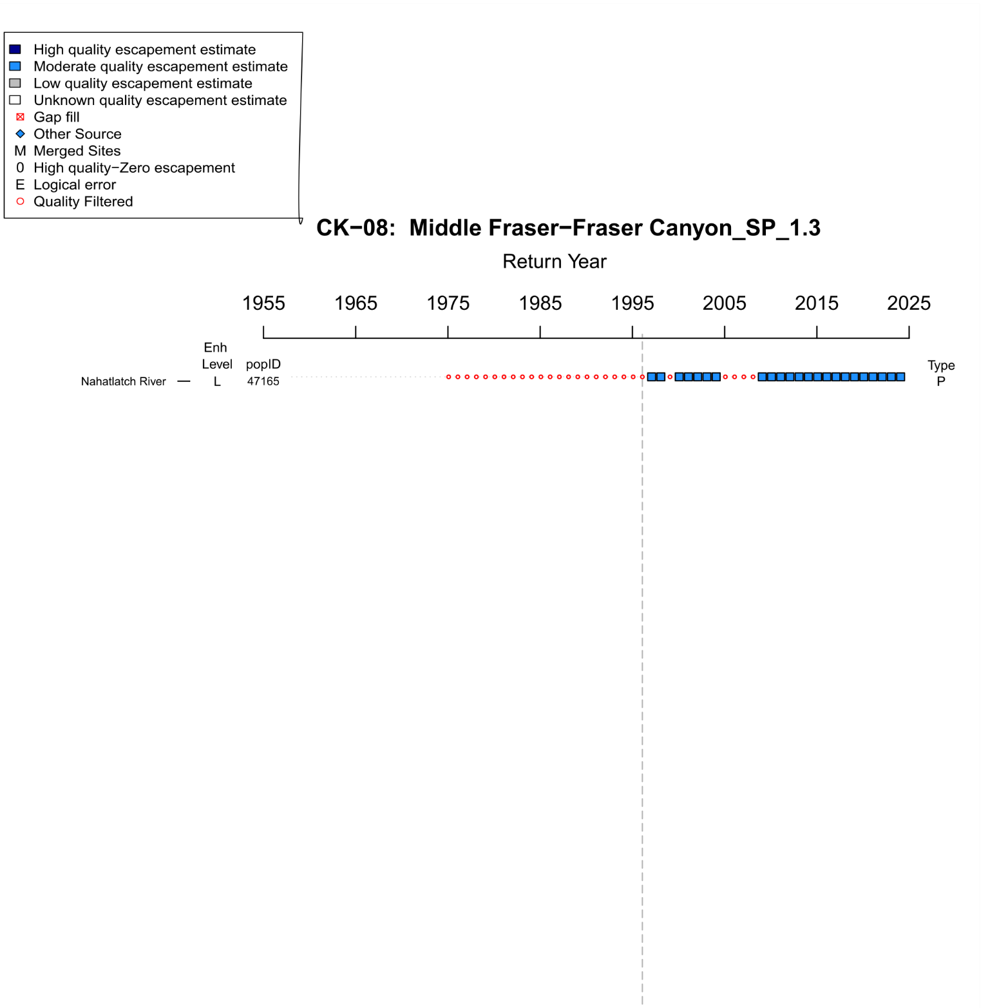
Figure B.1.5. WSP Rapid Status Assessment data quality filtering summary from 1975-2024 for Middle Fraser- Fraser Canyon Spring 1.3 (CK-08). The grey dashed line indicates the assigned start year for the rapid status assessment time series (1996). Enh level indicates the enhancement rank (H = High, M = Moderate, L = Low, U = Unknown), popID refers to the site population identification number in the NuSEDS database, Type refers to the site designation ( P = persistent, DD = data deficient, AGG = aggregated, DEL = deleted or extirpated. As stated in the legend, dark blue squares indicate years with high quality escapement estimates (NuSEDS Types 1-2), light blue squares indicate years with moderate quality escapement estimates (NuSEDS Types 3-4), , red squares indicate years were gap filling was conducted, red open circles indicate years that were quality filtered (NuSEDS Types 5-6 or unknown).
Expert Consensus
During the January 2025 expert review, there was strong agreement to use absolute abundance metrics for this CU and change to Red status with High confidence because estimates are well below 1,500 spawners for the entire time series and reviewers have strong confidence that the real abundances of returning spawners are less than 1,500 individuals. The Nahatlatch population is enumerated using a combination of float and aerial surveys which are likely to underestimate total abundance, however the uncertainty associated with these estimates is unlikely to exceed the benchmark threshold. Additionally, the size of the system and suitable spawning habitat is also unlikely to support a population larger than 1,500 spawners. For these reasons, the absolute abundance metric was used based on expert consensus again for 2024.

B.1.3 CK-10 Middle Fraser River
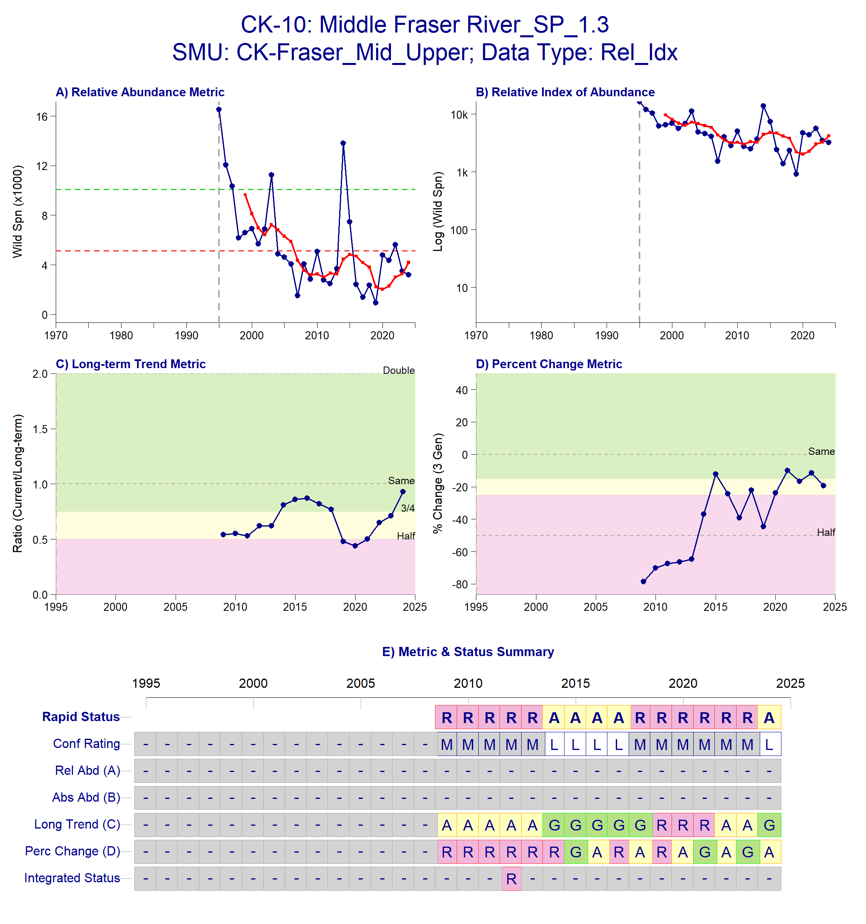
Figure B.1.6. Metrics and Status for Middle Fraser River SP 1.3 (CK-10). Panels on top show the four standard WSP metrics, calculated based on the available time series of spawner abundances. Bottom panel summarizes the status for each individual metric and shows the resulting WSP rapid status for the CU with a confidence rating. If integrated WSP status assessments have been completed for this CU, they are shown on the last row (IntStatus). Note that metric benchmarks may differ from decision tree thresholds, since thresholds approximate the status determination process from past WSP integrated status assessments.
Table B.1.5. Decision tree path given data and metric values for Middle Fraser River Spring 1.3 (CK-10 in 2024; this aligns with Figure B.1.6 above. For each node, the decision is made by comparing the CUs current metric value to the metric threshold and answering Yes or No, running through sequential nodes and decisions until the final WSP rapid status for that CU and year is reached.
Node | Metric | Metric Threshold | CUs Current Value | Decision
1 | Relative Index | <1,500 |  | NO, NO
2 | Relative Index | < 10,000 |  | NO, NO
4 | Relative Abundance | Available? | No | NO
8 | Long Term Trend | <79% of long term average | 4,202 | NO
16 | Percent Change | < 70% decline | 4,202 | NO
32 | Long Term Trend | < 233% of long term average | 4,202 | YES
65 | FINAL STATUS NODE |  |  | AMBER,LOW

Data Quality Filtering
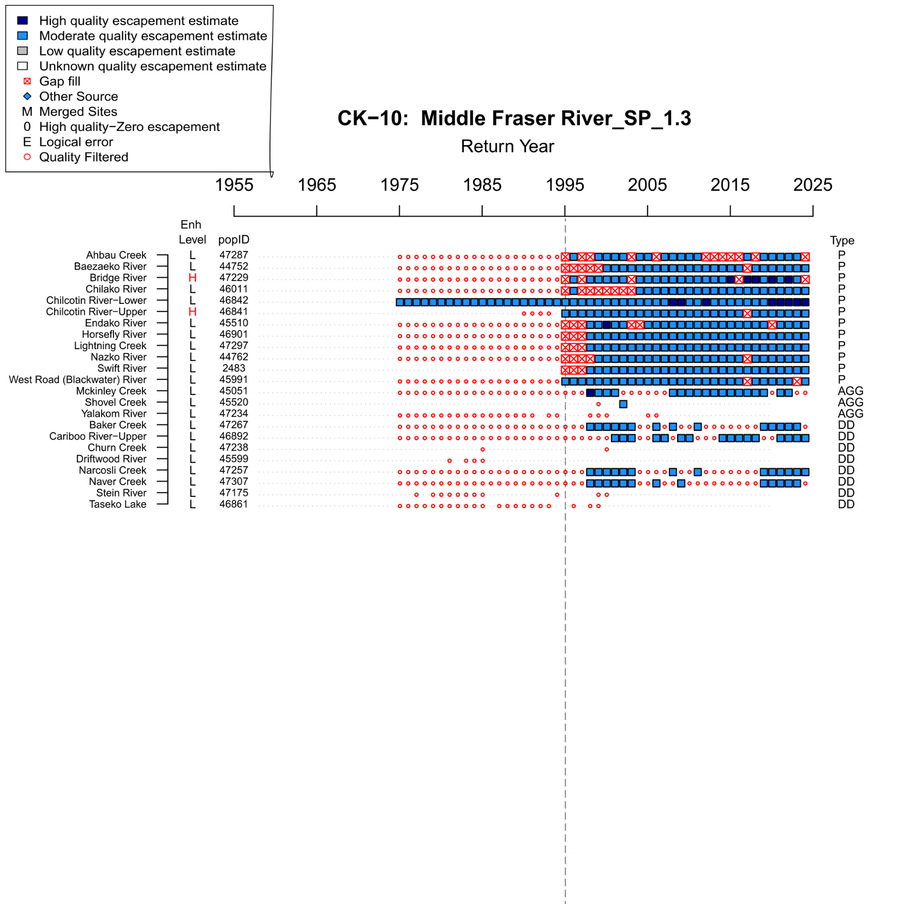
Figure B.1.7. WSP Rapid Status Assessment data quality filtering summary from 1975-2024 for Middle Fraser River Spring 1.3 (CK-10). The grey dashed line indicates the assigned start year for the rapid status assessment time series (1995). Enh level indicates the enhancement rank (H = High, M = Moderate, L = Low, U = Unknown), popID refers to the site population identification number in the NuSEDS database, Type refers to the site designation ( P = persistent, DD = data deficient, AGG = aggregated, DEL = deleted or extirpated. As stated in the legend, dark blue squares indicate years with high quality escapement estimates (NuSEDS Types 1-2), light blue squares indicate years with moderate quality escapement estimates (NuSEDS Types 3-4), , red squares indicate years were gap filling was conducted, open circles indicate years that were quality filtered (NuSEDS Types 5-6 or unknown).
Expert Consensus
The addition of 2024 data shifted the status of this CU from Red to Amber with Low confidence. The recent three generation trend has begun to stabilize after a period of decline between 2015-2020. However, impacts of the Chilcotin landslide in 2024 may alter this recent stability in future return years. No other additional comments were provided by expert reviewers.

B.1.4 CK-12 Upper Fraser
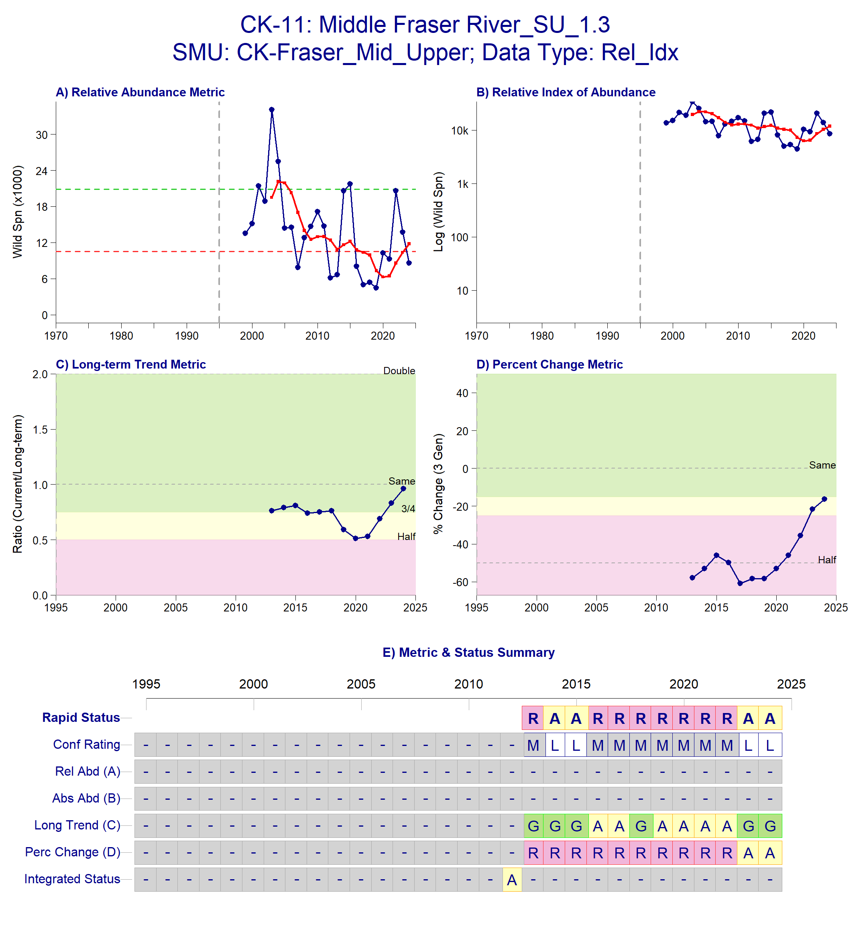
Figure B.1.8. Metrics and Status for Upper Fraser River SP 1.3 (CK-12). Panels on top show the four standard WSP metrics, calculated based on the available time series of spawner abundances. Bottom panel summarizes the status for each individual metric and shows the resulting WSP rapid status for the CU with a confidence rating. If integrated WSP status assessments have been completed for this CU, they are shown on the last row (IntStatus). Note that metric benchmarks may differ from decision tree thresholds, since thresholds approximate the status determination process from past WSP integrated status assessments.
Table B.1.6. Decision tree path given data and metric values for Upper Fraser River SP 1.3 (CK-12) in 2024; this aligns with Figure B.1.8 above. For each node, the decision is made by comparing the CUs current metric value to the metric threshold and answering Yes or No, running through sequential nodes and decisions until the final WSP rapid status for that CU and year is reached.
Node | Metric | Metric Threshold | CUs Current Value | Decision
1 | Relative Index | <1,500 |  | NO, NO
2 | Relative index | < 10,000 |  | NO, NO
4 | Relative abundance | Available? | No | NO
8 | Long term trend | <79% of long term average | 12,881 | NO
16 | Percent Change | < 70% decline | 12,881 | NO
32 | Long term trend | < 233% of long term average | 12,881 | YES
65 | FINAL STATUS NODE |  |  | AMBER,LOW

Data Quality Filtering
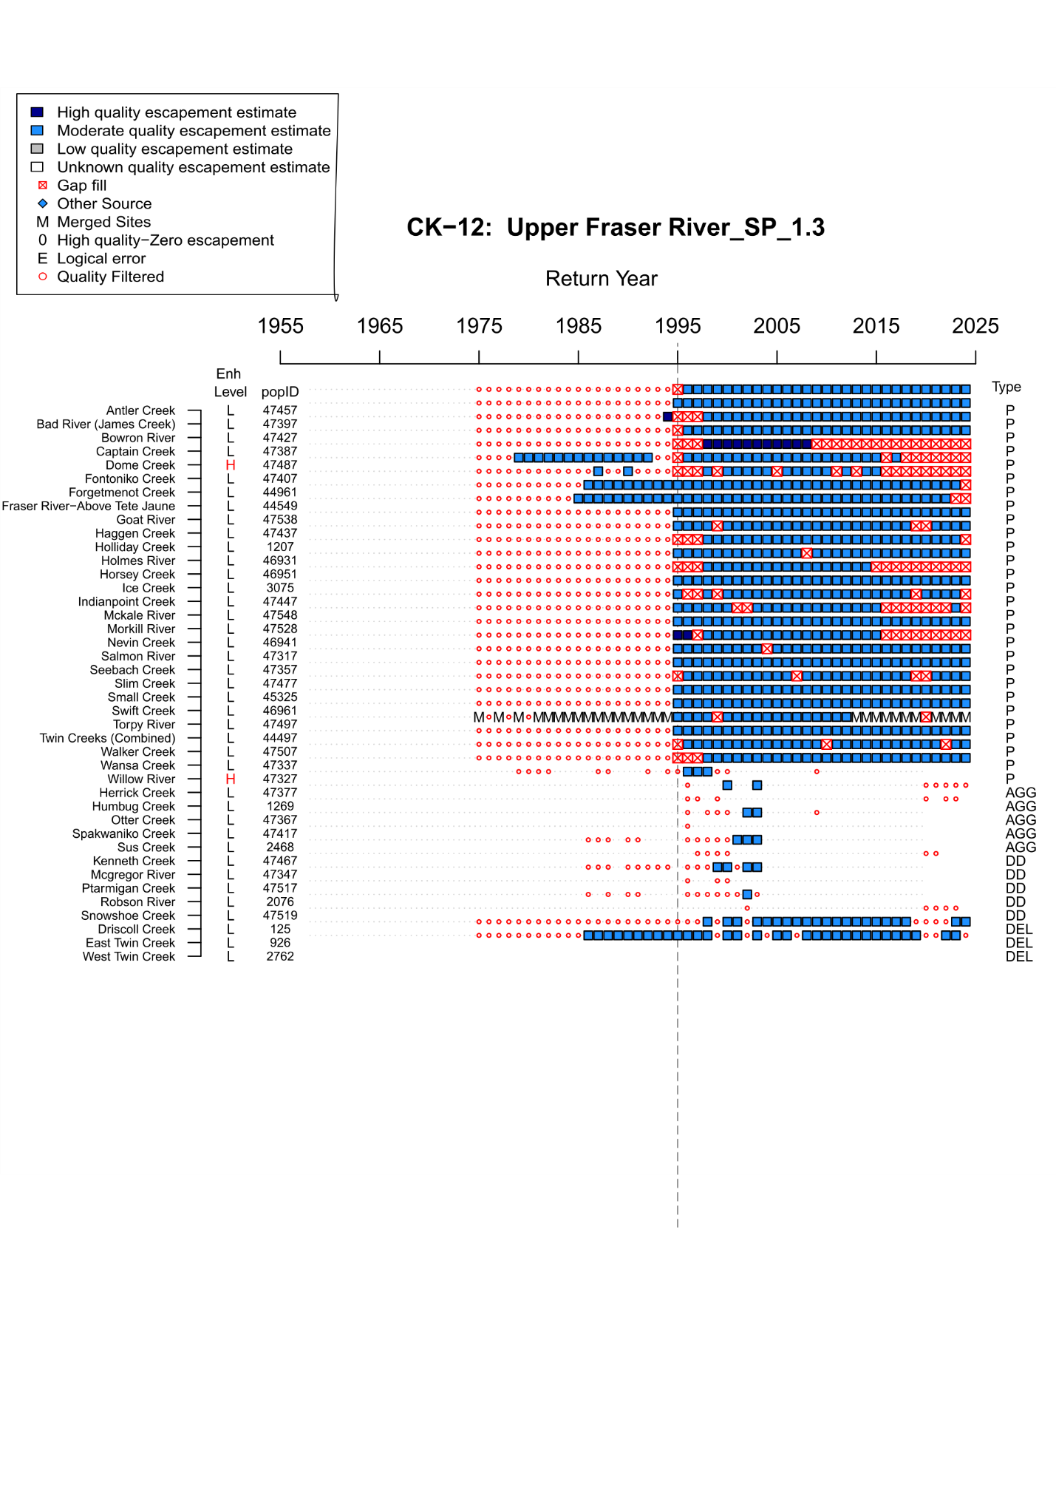
Figure B.1.9. WSP Rapid Status Assessment data quality filtering summary from 1975-2024 for Upper Fraser River Spring 1.3 (CK-12). The grey dashed line indicates the assigned start year for the rapid status assessment time series (1995). Enh level indicates the enhancement Rank (H = high, M = Moderate, L = Low, U = Unknown), popID refers to the site population identification number in the NuSEDS database, Type refers to the site designation ( P = persistent, DD = data deficient, AGG = aggregated, DEL = deleted or extirpated. As stated in the legend, dark blue squares indicate years with high quality escapement estimates (NuSEDS Types 1-2), light blue squares indicate years with moderate quality escapement estimates (NuSEDS Types 3-4), , red squares indicate years were gap filling was conducted, red open circles indicate years that were quality filtered (NuSEDS Types 5-6 or unknown), M indicates years where sites were merged.
Expert Consensus
During the January 2025 expert review, it was noted that this CU is difficult to assess on the spawning grounds due to high turbidity resulting in low water clarity for aerial and ground surveys, and counts may be inflated. There were some concerns about the absolute and relative abundance metrics not being used for this CU, even though the generational average is above the 1,500 spawner threshold in recent years. It was later concluded to leave the status as is for now because SONAR feasibility is being assessed to help improve data quality in the time series.
The addition of 2024 data shifted the status of this CU from Red to Amber with Low confidence. For the 2024 assessment, Dome Creek and Willow River were excluded due to enhancement. Dome Creek was not regularly surveyed by FIA Stock Assessment after 2008 and yearling smolts were consistently released from brood years 1986-2004 (Supplementary Materials A). Willow River was also excluded due to release of 69,263 yearling smolts between brood years 2021-2022 (Supplementary Materials A) There were some concerns regarding the enhancement categorization of tributaries under the same conservation hatchery timeline as Willow River (Slim, Torpy, Walker, Wansa and Swift Creeks). It was discussed that the life-stage of releases was the determining factor in ranking Willow as high enhancement (i.e., yearling smolts tend to survive approximately at rates 10 times higher than fry or sub-yearling smolts). No changes to the assignment of Amber status were recommended at this time, however, further verification of SEP data and sensitivity tests with these tributaries were recommended for future assessments.

B.1.5 CK-18 North Thompson
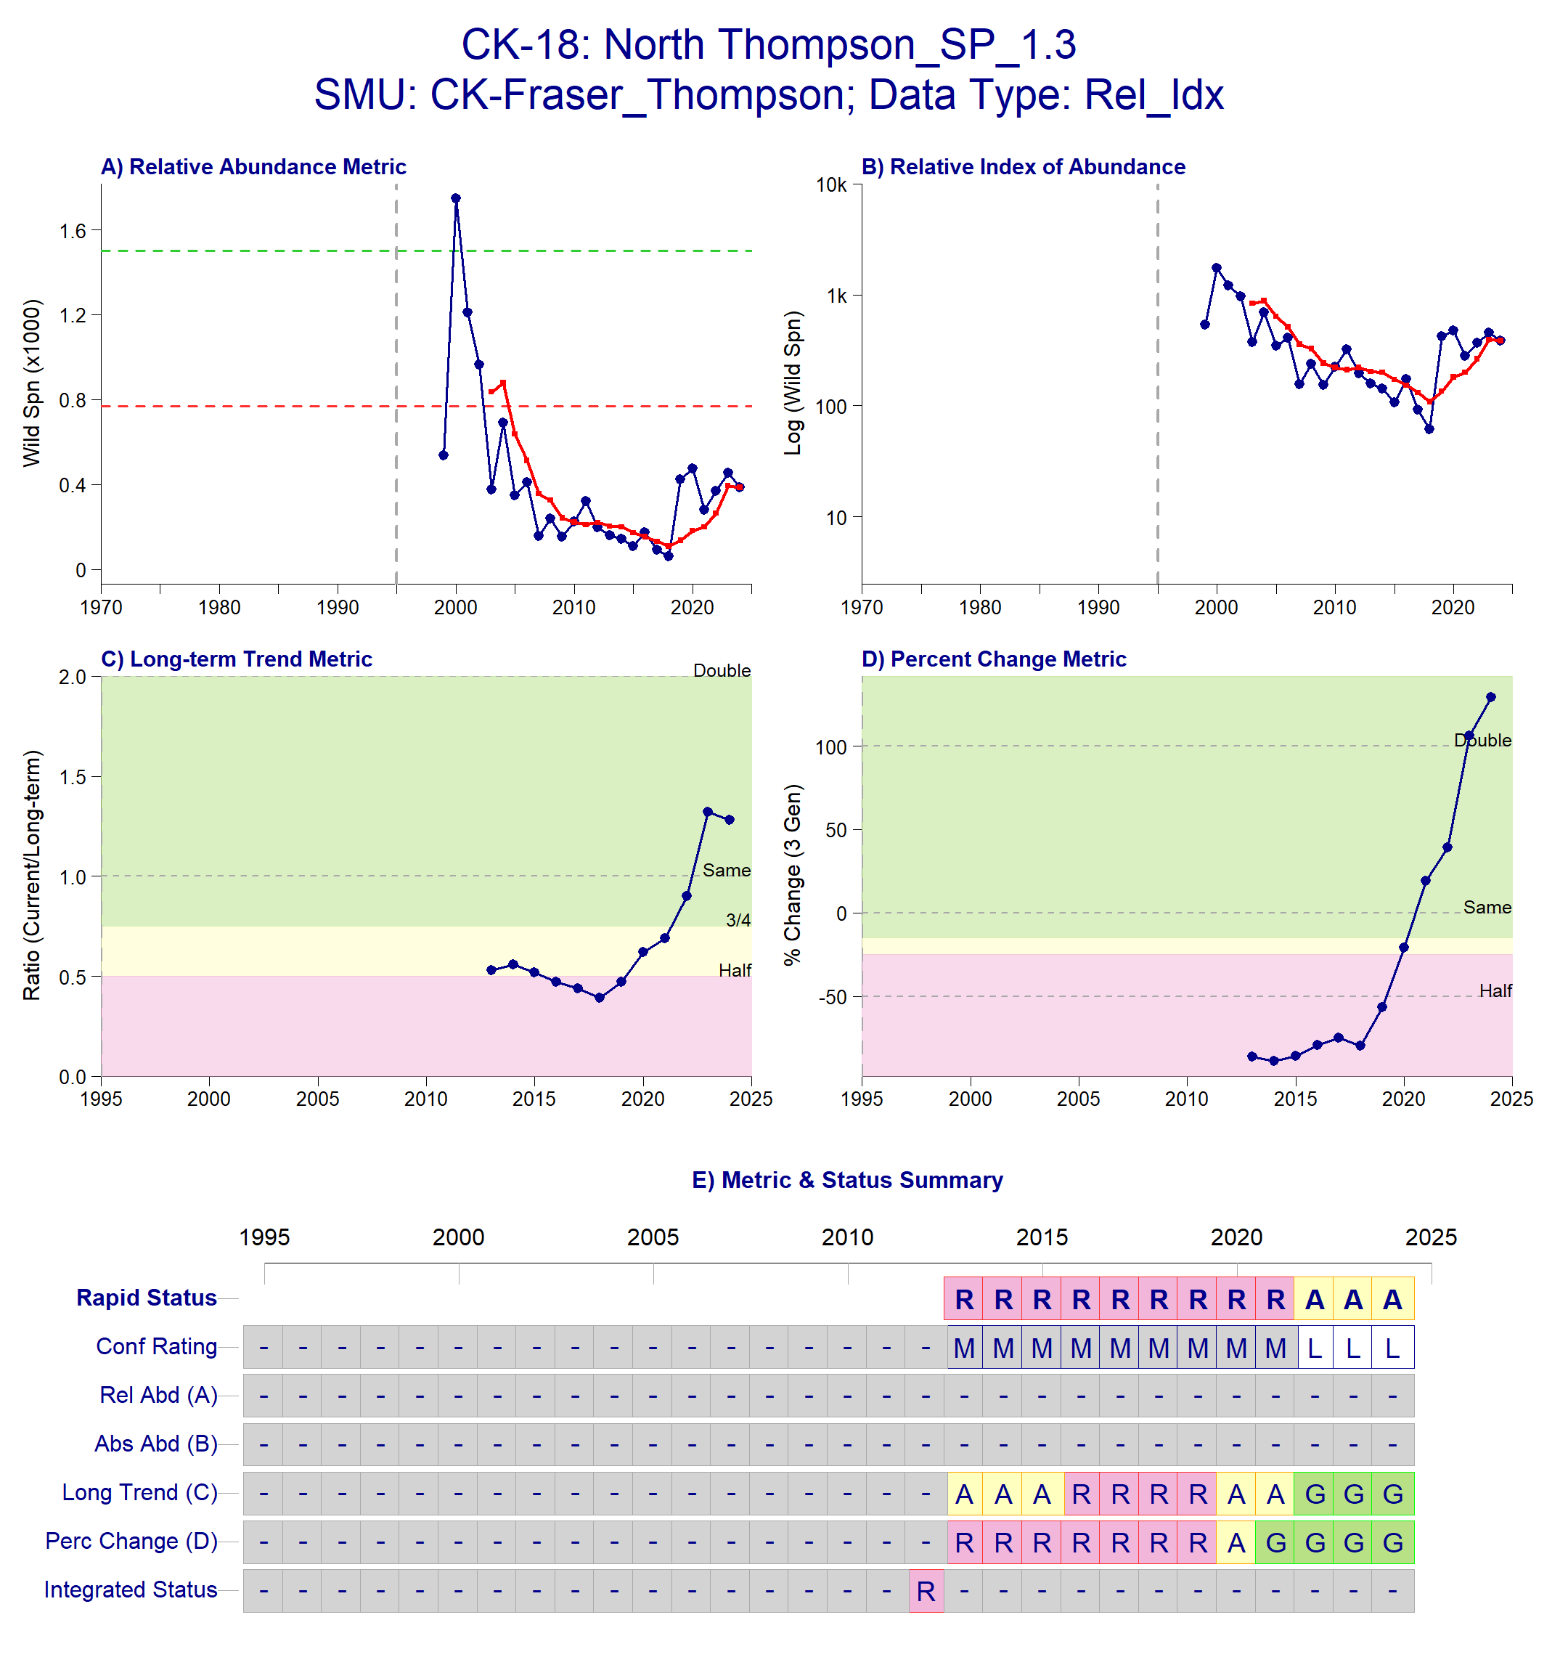
Figure B.1.10. Metrics and Status for North Thompson SP 1.3 (CK-18). Panels on top show the four standard WSP metrics, calculated based on the available time series of spawner abundances. Bottom panel summarizes the status for each individual metric and shows the resulting WSP rapid status for the CU with a confidence rating. If integrated WSP status assessments have been completed for this CU, they are shown on the last row (IntStatus). Note that metric benchmarks may differ from decision tree thresholds, since thresholds approximate the status determination process from past WSP integrated status assessments.
Table B.1.7: Decision tree path given data and metric values for North Thompson Spring 1.3 Chinook (CK-18) in 2024; this aligns with Figure B.1.10 above. For each node, the decision is made by comparing the CUs current metric value to the metric threshold and answering Yes or No, running through sequential nodes and decisions until the final WSP rapid status for that CU and year is reached.
Node | Metric | Metric Threshold | CUs Current Value | Decision
1 | Relative Index | <1,500 |  | NO, NO
2 | Relative index | < 10,000 |  | NO, NO
4 | Relative abundance | Available | No | NO
8 | Long term trend | <79% of long term average | 386 | NO
16 | Percent Change | < 70% decline | 386 | NO
32 | Long term trend | < 233% of long term average | 386 | YES
65 | FINAL STATUS NODE |  |  | AMBER,LOW
Data Quality Filtering
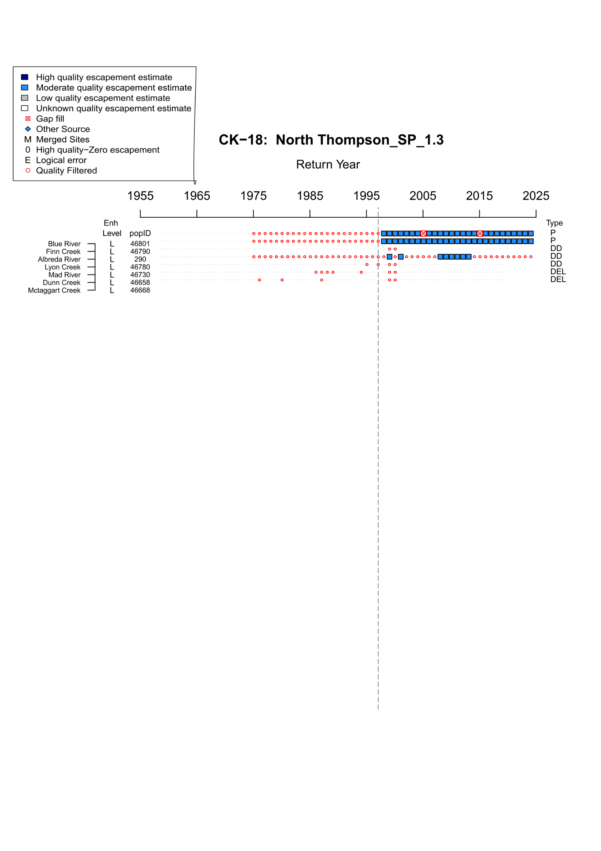
Figure B.1.11. WSP Rapid Status Assessment data quality filtering summary from 1975-2024 for North Thompson Spring 1.3 (CK-18). The grey dashed line indicates the assigned start year for the rapid status assessment time series (1997). Enh level indicates the enhancement Rank (H = high, M = Moderate, L = Low, U = Unknown), popID refers to the site population identification number in the NuSEDS database, Type refers to the site designation ( P = persistent, DD = data deficient, AGG = aggregated, DEL = deleted or extirpated. As stated in the legend, dark blue squares indicate years with high quality escapement estimates (NuSEDS Types 1-2), light blue squares indicate years with moderate quality escapement estimates (NuSEDS Types 3-4), , red squares indicate years were gap filling was conducted, red open circles indicate years that were quality filtered (NuSEDS Types 5-6 or unknown).
Expert Consensus
There was no change in status with the addition of 2024 data for this CU. Trend metrics have improved since 2020. During the January 2025 expert review meeting, no change in use of metrics was suggested, however, it was noted that there is variation in which system is driving the metric trends throughout the time series. Historically, Finn Creek has made up the larger proportion of abundance. Blue River uses an expanded peak count, that was originally enumerated by float surveys, but is now surveyed using a combination of float surveys and aerial surveys. There were also comments on the uncertainty associated with visual surveys in the North Thompson due to lack of water clarity which is anticipated to be alleviated by SONAR.

B.2 SUMMER 5₂ (1.3)
Survey sites and years included in the CU-level escapement time series for the purposes of the Rapid Status Approach are summarized in Table A1 for Fraser Summer 5₂ (1.3) Chinook. Complete status dashboards for each CU are described in Figures B.2.1 – B.2.). The decision tree node pathway associated with the status dashboard for each CU are also described in Tables B.2.3-B.2.7.
¹ Chehalis River is binned under a separate CU category (CK-9006), which is defined as a Fraser-Cross Supplementation CU, meaning the genetic heritage is tied to other Southern BC Chinook populations (Weil et al. 2025). This CU is not included in the Rapid Status Assessment process due to its high hatchery influence.
Table B.2.1. Conservation Units (CUs) included in this Stock Management Unit (SMU) and lists of the streams/populations within each CU used in the Rapid Status Assessment. Streams have their NuSEDS population identifications in brackets.
CU No# | CU Name | Streams (Population ID) | Enhanced Streams Excluded (Population ID) | Timeseries
CK-05 | Lower Fraser – Upper Pitt SU 1.3 | Upper Pitt River (47921) |  | 2002-2024
CK-06 | Lower Fraser River SU 1.3 | Big Silver Creek (46076) | Chilliwack River (46985)  Chehalis River (46042)¹ | 2005-2024
CK-09 | Middle Fraser River-Portage FA 1.3 | Portage Creek (47189) |  | 2000-2024
CK-11 | Middle Fraser SU 1.3 | Cariboo River (46891)  Chilko River (46851)  Elkin Creek (46871)  Kuzkwa River (45555)  Middle River (44564)  Nechako River (46001)  Pinchi Creek (45547)  Stellako River (46021)  Tachie River (45550)  Taseko River (2507) | Quesnel River (468810) | 1999-2024
CK-14 | South Thompson SU 1.3 | Eagle River (46366)  Scotch Creek (46296)  Seymour River (46336) | Salmon River (46407) | 1999-2024
CK-19 | North Thompson SU 1.3 | Barriere River (46608)  Clearwater River (46688)  Lemieux Creek (46648)  Mahood River (46708)  Raft River (46718) |  | 1996-2024

B.2.1 CK-05 Lower Fraser-Upper Pitt
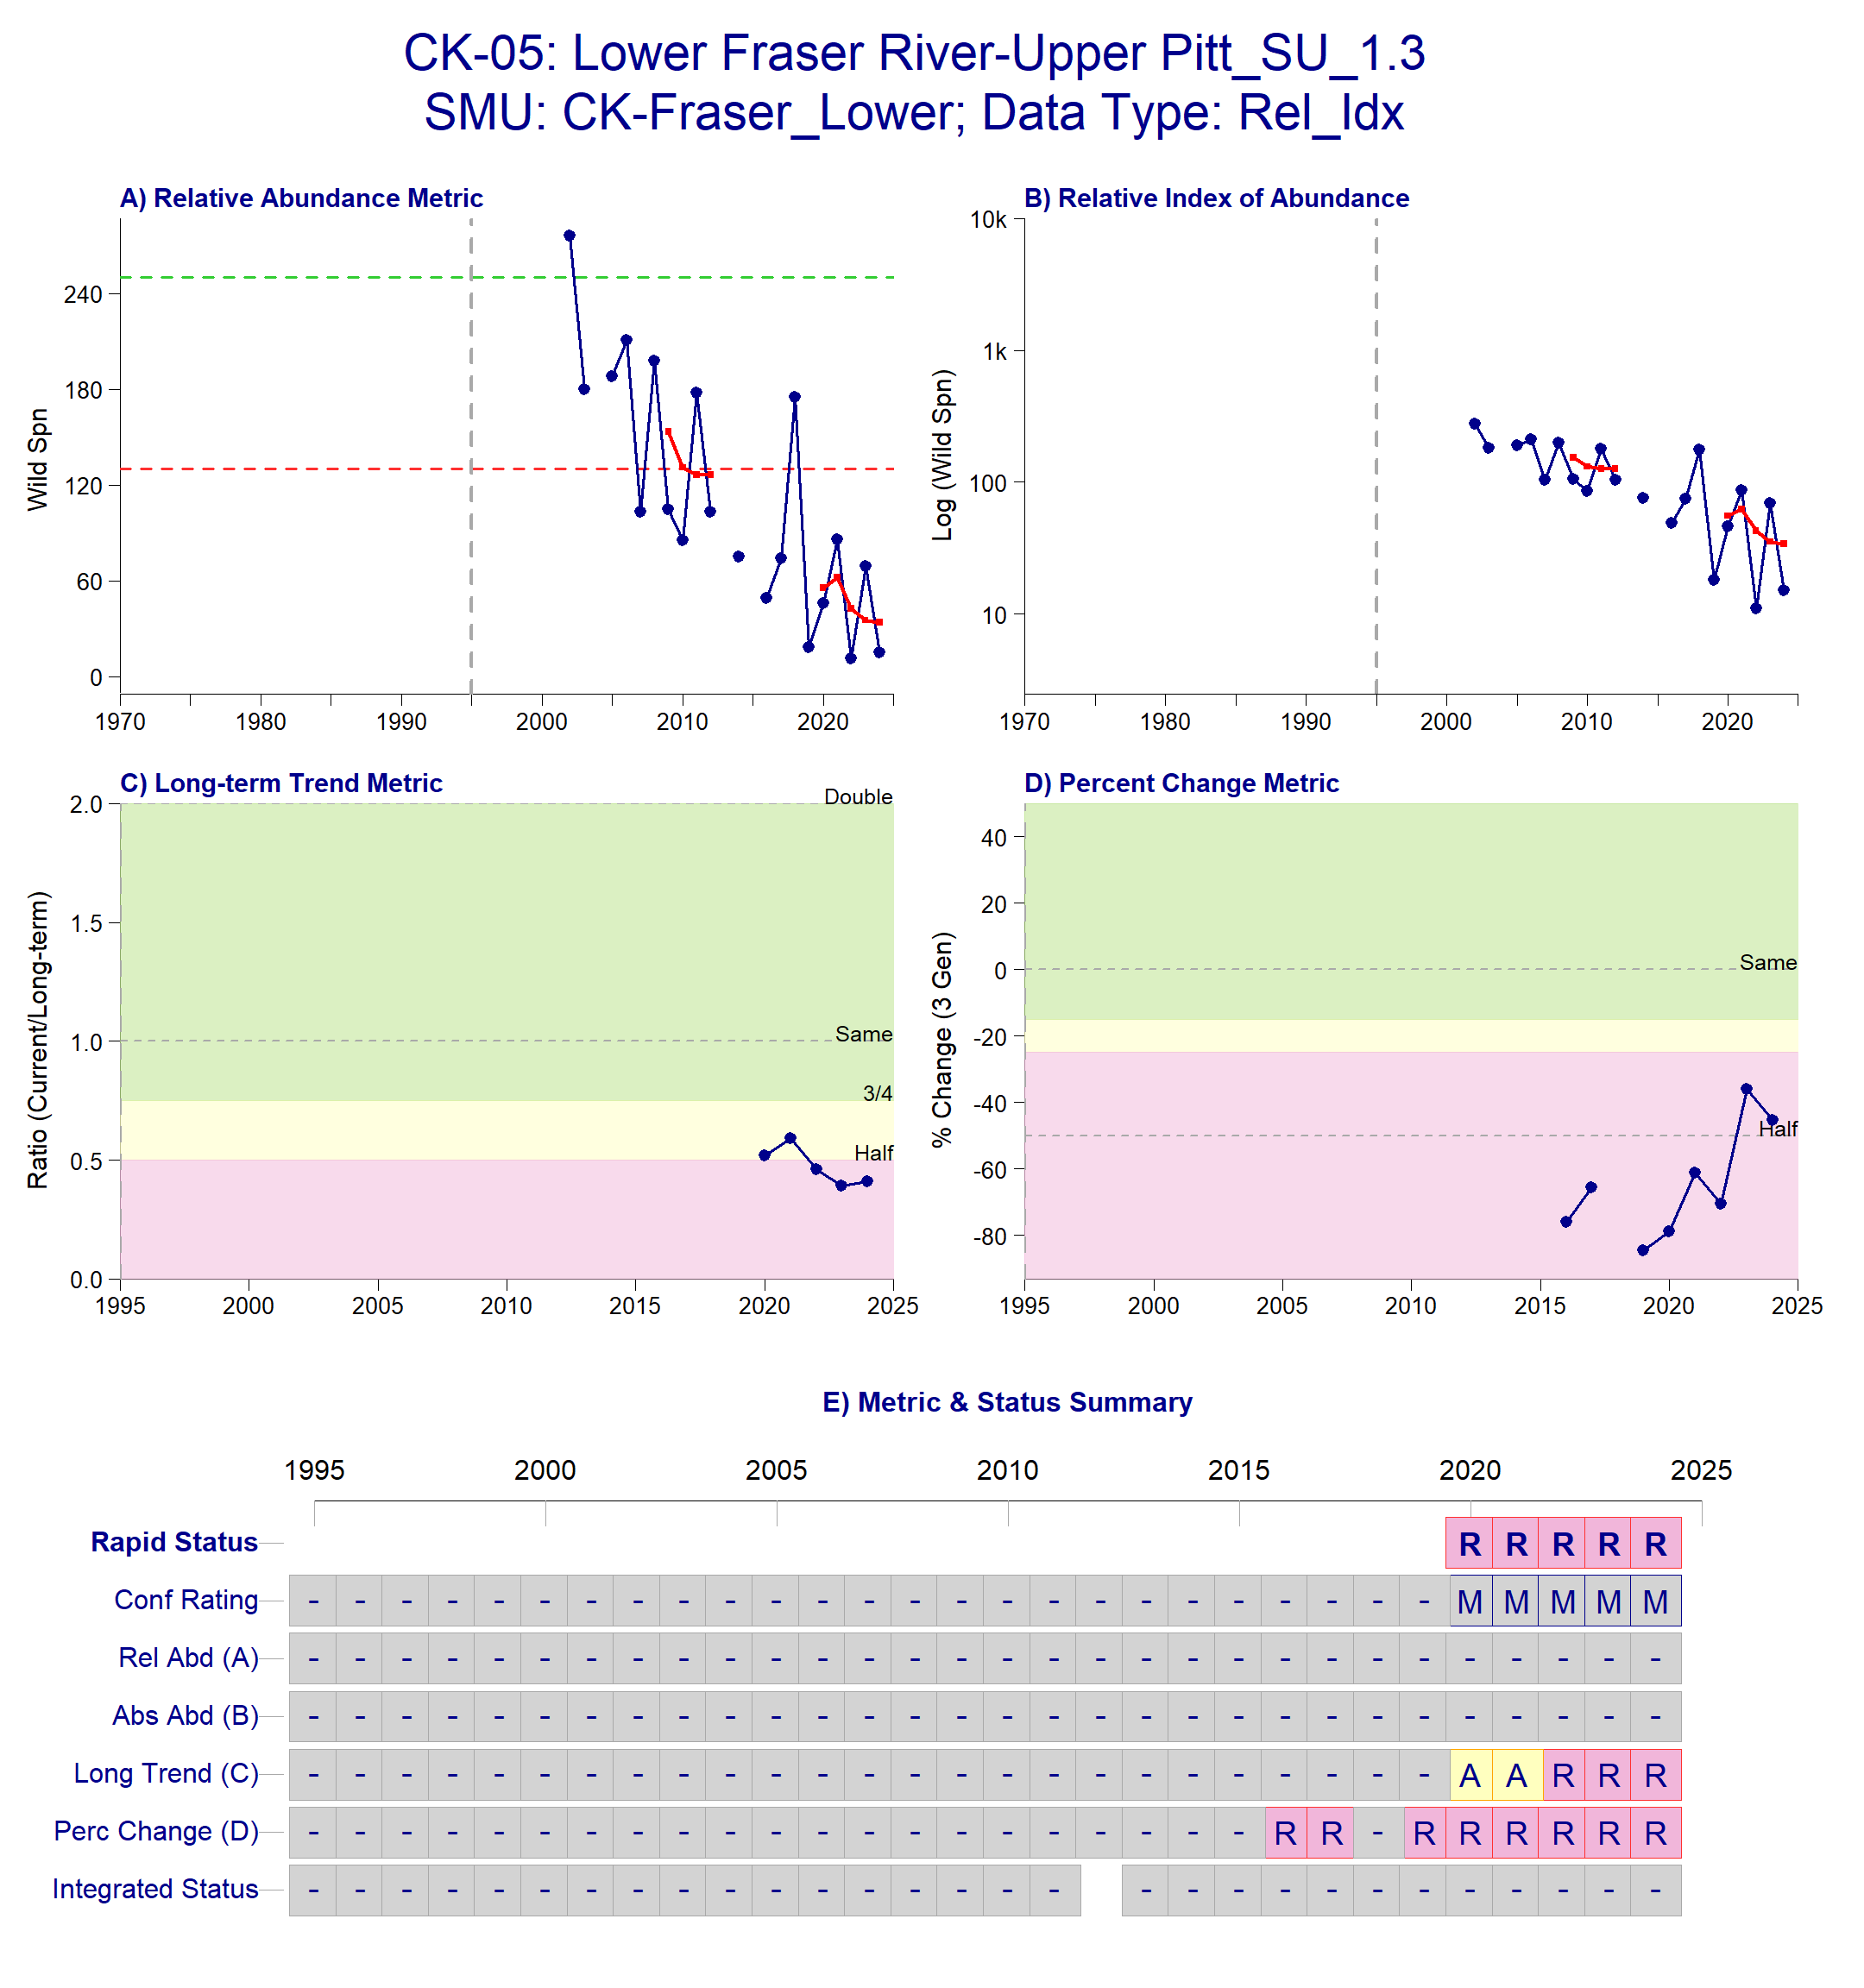
Figure B.2.1: Metrics and Status for Lower Fraser Upper-Pitt SU 1.3 (CK-05). Panels on top show the four standard WSP metrics, calculated based on the available time series of spawner abundances. Bottom panel summarizes the status for each individual metric and shows the resulting WSP rapid status for the CU with a confidence rating. If integrated WSP status assessments have been completed for this CU, they are shown on the last row (IntStatus). Note that metric benchmarks may differ from decision tree thresholds, since thresholds approximate the status determination process from past WSP integrated status assessments.
Table B.2.3. Decision tree path given data and metric values for the Lower Fraser-Upper Pitt SU 1.3 in 2024; this aligns with Figure B.2.1 above. For each node, the decision is made by comparing the CUs current metric value to the metric threshold and answering Yes or No, running through sequential nodes and decisions until the final WSP rapid status for that CU and year is reached.
Node | Metric | Metric Threshold | CUs Current Value | Decision
1 | Relative Index | <1,500 |  | NO, NO
2 | Relative Index | < 10,000 |  | NO, NO
4 | Relative abundance | Available? |  | NO
8 | Long term trend | <79% of long term average | 33 | YES
17 | FINAL STATUS NODE |  |  | RED, MEDIUM
Data Quality Filtering
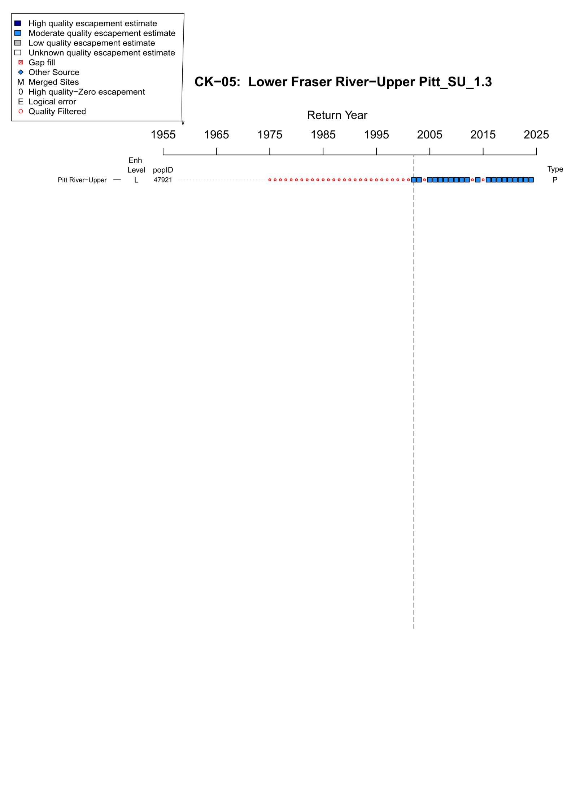
Figure B.2.2. WSP Rapid Status Assessment data quality filtering summary for Lower Fraser River – Upper Pitt Summer 1.3 (CK-05). The grey dashed line indicates the assigned start year for the rapid status assessment time series (2002). Enh level indicates the enhancement Rank (H = high, M = Moderate, L = Low, U = Unknown), popID refers to the site population identification number in the NuSEDS database, Type refers to the site designation ( P = persistent, DD = data deficient, AGG = aggregated, DEL = deleted or extirpated. As stated in the legend, dark blue squares indicate years with high quality escapement estimates (NuSEDS Types 1-2), light blue squares indicate years with moderate quality escapement estimates (NuSEDS Types 3-4), , red squares indicate years were gap filling was conducted, red open circles indicate years that were quality filtered (NuSEDS Types 5-6 or unknown).
Expert Consensus
During the January 2025 expert review meeting, it was noted that the area currently surveyed (Blue Creek) does not represent the entire spawning distribution of the population. This area is also subject to drought conditions that may affect fish migration, however, while adjusting the confidence rating for this CU’s status was discussed, it was concluded that it should not be changed at this time.

B.2.2 CK-06 Lower Fraser
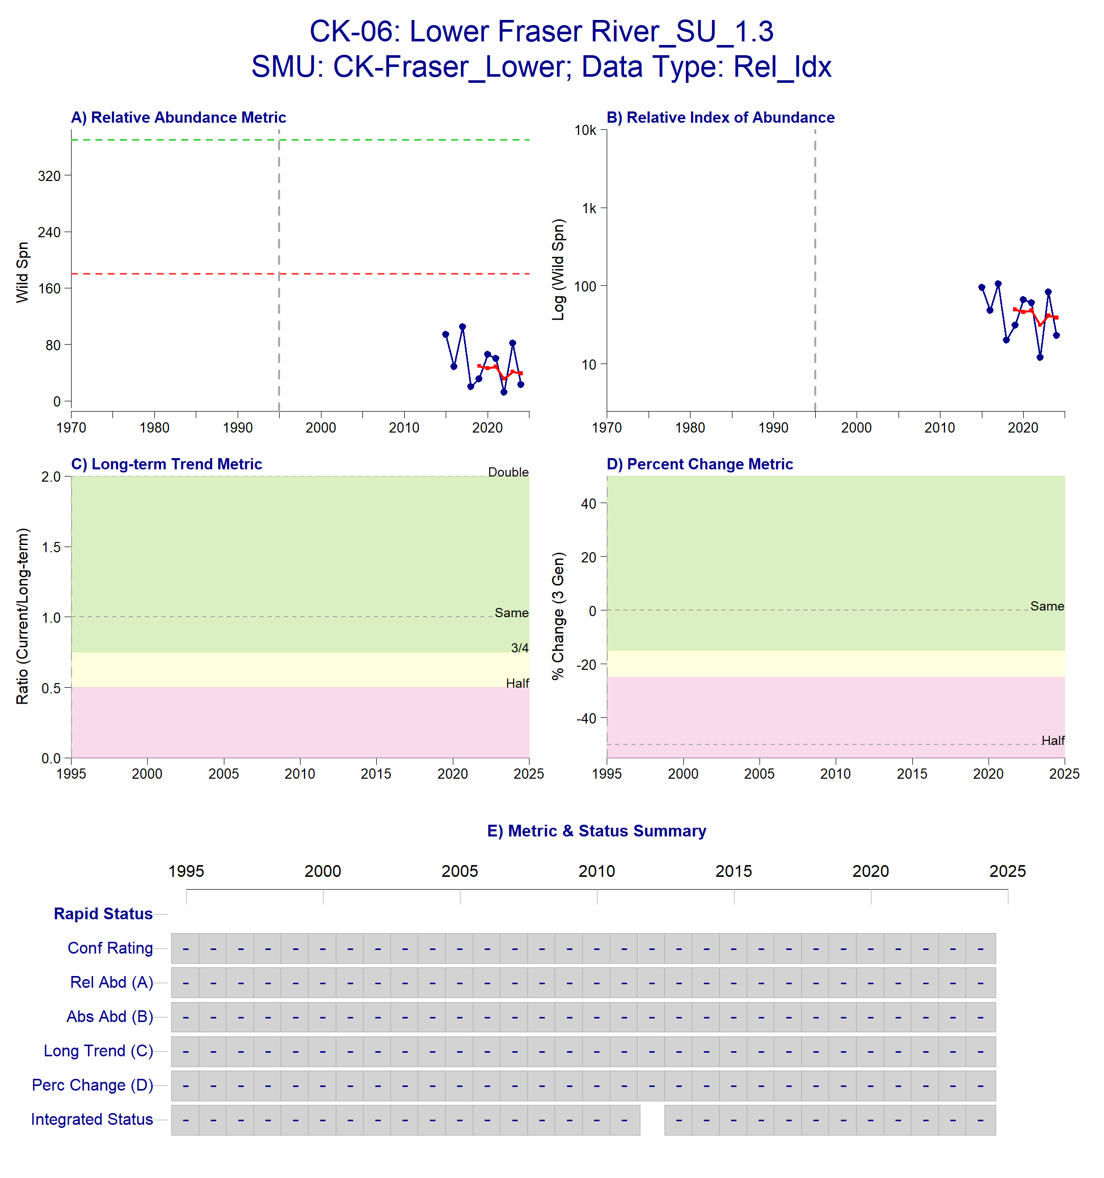
Figure B.2.3: Metrics and Status for Lower Fraser River SU 1.3 (CK-06). Panels on top show the four standard WSP metrics, calculated based on the available time series of spawner abundances. Bottom panel summarizes the status for each individual metric and shows the resulting WSP rapid status for the CU with a confidence rating. If integrated WSP status assessments have been completed for this CU, they are shown on the last row (IntStatus). Note that metric benchmarks may differ from decision tree thresholds, since thresholds approximate the status determination process from past WSP integrated status assessments.

Data Quality Filtering
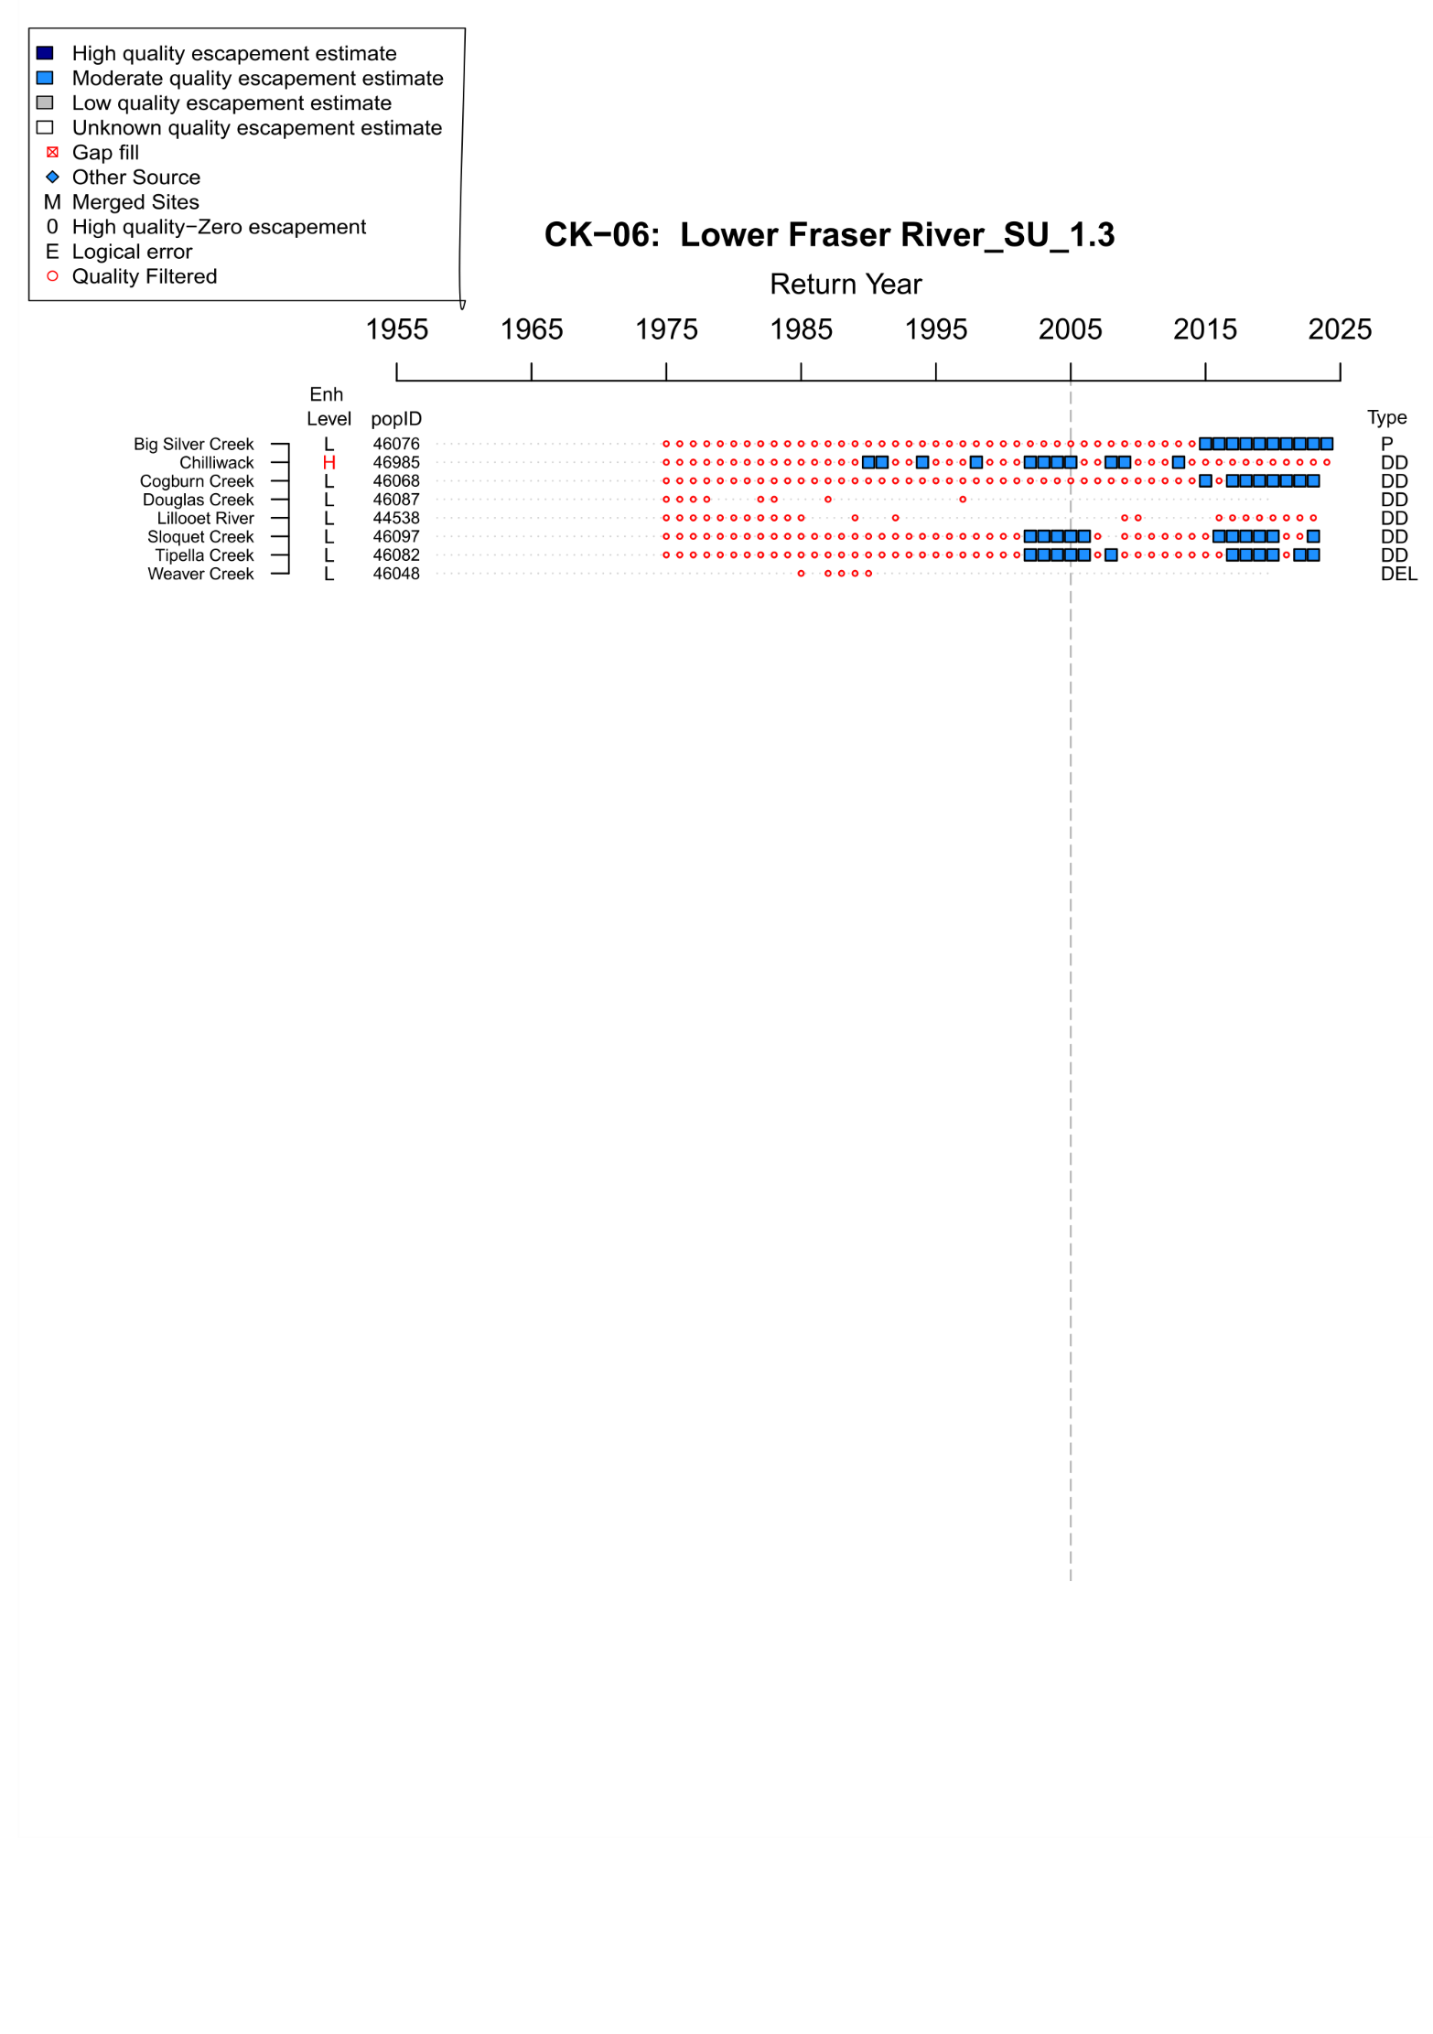
Figure B.2.4. WSP Rapid Status Assessment data quality filtering summary from 1975-2024 for Lower Fraser River Summer 1.3 (CK-06). The grey dashed line indicates the assigned start year for the rapid status assessment time series (2005). Enh level indicates the enhancement Rank (H = high, M = Moderate, L = Low, U = Unknown), popID refers to the site population identification number in the NuSEDS database, Type refers to the site designation ( P = persistent, DD = data deficient, AGG = aggregated, DEL = deleted or extirpated. As stated in the legend, dark blue squares indicate years with high quality escapement estimates (NuSEDS Types 1-2), light blue squares indicate years with moderate quality escapement estimates (NuSEDS Types 3-4), , red squares indicate years were gap filling was conducted, red open circles indicate years that were quality filtered (NuSEDS Types 5-6 or unknown).
Expert Consensus
During the January expert review meeting, it was discussed whether to apply absolute abundance metrics to this CU based on the confidence that there are less than 1,500 spawners. There was no strong agreement in favour of this change since there are many systems with no estimates available in this CU. A potential solution discussed was to modify the start year of the time series to include Cogburn, Tipella and Sloquet Creeks, however, this would shorten the overall timeseries. The status for 2024 remains data deficient because Chilliwack River is excluded due to high enhancement (Appendix F.2) and there is not a long enough escapement time series available for Big Silver Creek to calculate trend metrics.

B.2.3. CK-09 Middle Fraser River – Portage
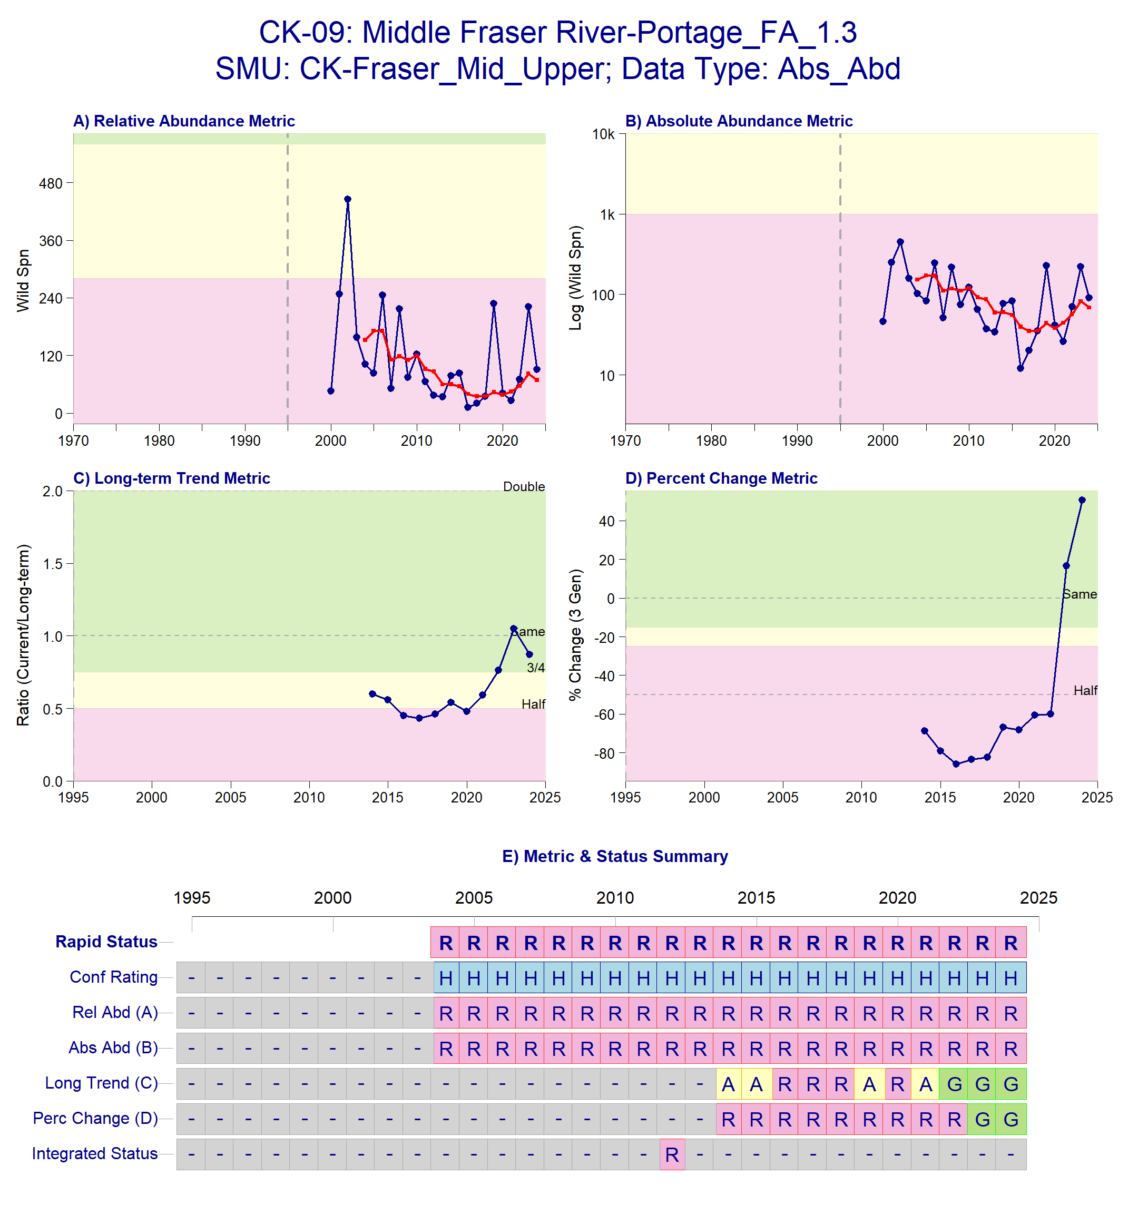
Figure B.2.5. Metrics and Status Middle Fraser River – Portage FA 1.3 (CK-09). Panels on top show the four standard WSP metrics, calculated based on the available time series of spawner abundances. Bottom panel summarizes the status for each individual metric and shows the resulting WSP rapid status for the CU with a confidence rating. If integrated WSP status assessments have been completed for this CU, they are shown on the last row (IntStatus). Note that metric benchmarks may differ from decision tree thresholds, since thresholds approximate the status determination process from past WSP integrated status assessments.
Table B.2.4. Decision tree path given data and metric values for the Middle Fraser River – Portage FA 1.3 in 2024; this aligns with Figure B.2.5 above. For each node, the decision is made by comparing the CUs current metric value to the metric threshold and answering Yes or No, running through sequential nodes and decisions until the final WSP rapid status for that CU and year is reached.
Node | Metric | Metric Threshold | CUs Current Value | Decision
1 | Absolute Abundance | <1,500 | 68 | YES, YES
3 | FINAL STATUS NODE |  |  | RED, HIGH
Data Quality Filtering
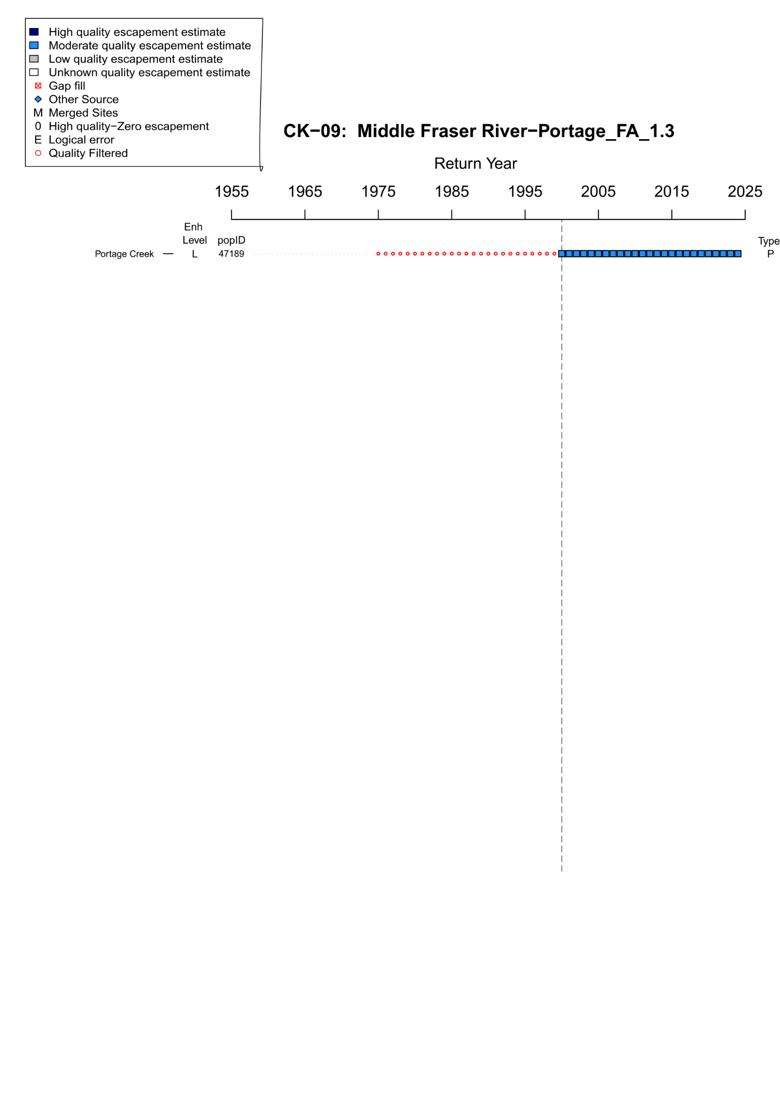
Figure B.2.6. WSP Rapid Status Assessment data quality filtering summary from 1975-2024 for Middle Fraser River – Portage Fall 1.3 (CK-09). The grey dashed line indicates the assigned start year for the rapid status assessment time series (2000). Enh level indicates the enhancement Rank (H = high, M = Moderate, L = Low, U = Unknown), popID refers to the site population identification number in the NuSEDS database, Type refers to the site designation ( P = persistent, DD = data deficient, AGG = aggregated, DEL = deleted or extirpated. As stated in the legend, dark blue squares indicate years with high quality escapement estimates (NuSEDS Types 1-2), light blue squares indicate years with moderate quality escapement estimates (NuSEDS Types 3-4), , red squares indicate years were gap filling was conducted, red open circles indicate years that were quality filtered (NuSEDS Types 5-6 or unknown).
Expert Consensus
During the January 2025 expert review, there was strong agreement to use absolute abundance metrics for this CU and change to Red status with High confidence because estimates are well below 1,500 spawners for the entire time series and reviewers have strong confidence that the real abundances of returning spawners are less than 1,500 individuals. The Portage population is enumerated using a stream-walk surveys which are likely to underestimate total abundance, however the uncertainty associated with these estimates is unlikely to exceed the benchmark threshold. Additionally, the size of the system and suitable spawning habitat is also unlikely to support a population larger than 1,500 spawners.

B.2.4. CK-11 Middle Fraser

Figure B.2.7: Metrics and Status for Middle Fraser River SU 1.3 (CK-11). Panels on top show the four standard WSP metrics, calculated based on the available time series of spawner abundances. Bottom panel summarizes the status for each individual metric and shows the resulting WSP rapid status for the CU with a confidence rating. If integrated WSP status assessments have been completed for this CU, they are shown on the last row (IntStatus). Note that metric benchmarks may differ from decision tree thresholds, since thresholds approximate the status determination process from past WSP integrated status assessments.
Table B.2.5. Decision tree path given data and metric values for Middle Fraser River SU 1.3 in 2024; this aligns with Figure B.2.7 above. For each node, the decision is made by comparing the CUs current metric value to the metric threshold and answering Yes or No, running through sequential nodes and decisions until the final WSP rapid status for that CU and year is reached.
Node | Metric | Metric Threshold | CUs Current Value | Decision
1 | Relative Index | <1,500 |  | NO, NO
2 | Relative Index | < 10,000 |  | NO, NO
4 | Relative Abundance | Available? | No | NO
8 | Long Term Trend | <79% of long term average | 11,807 | NO
16 | Percent Change | < 70% decline | 11,807 | NO
32 | Long Term Trend | < 233% of long term average | 11,807 | YES
65 | FINAL STATUS NODE |  |  | AMBER, LOW
Data Quality Filtering
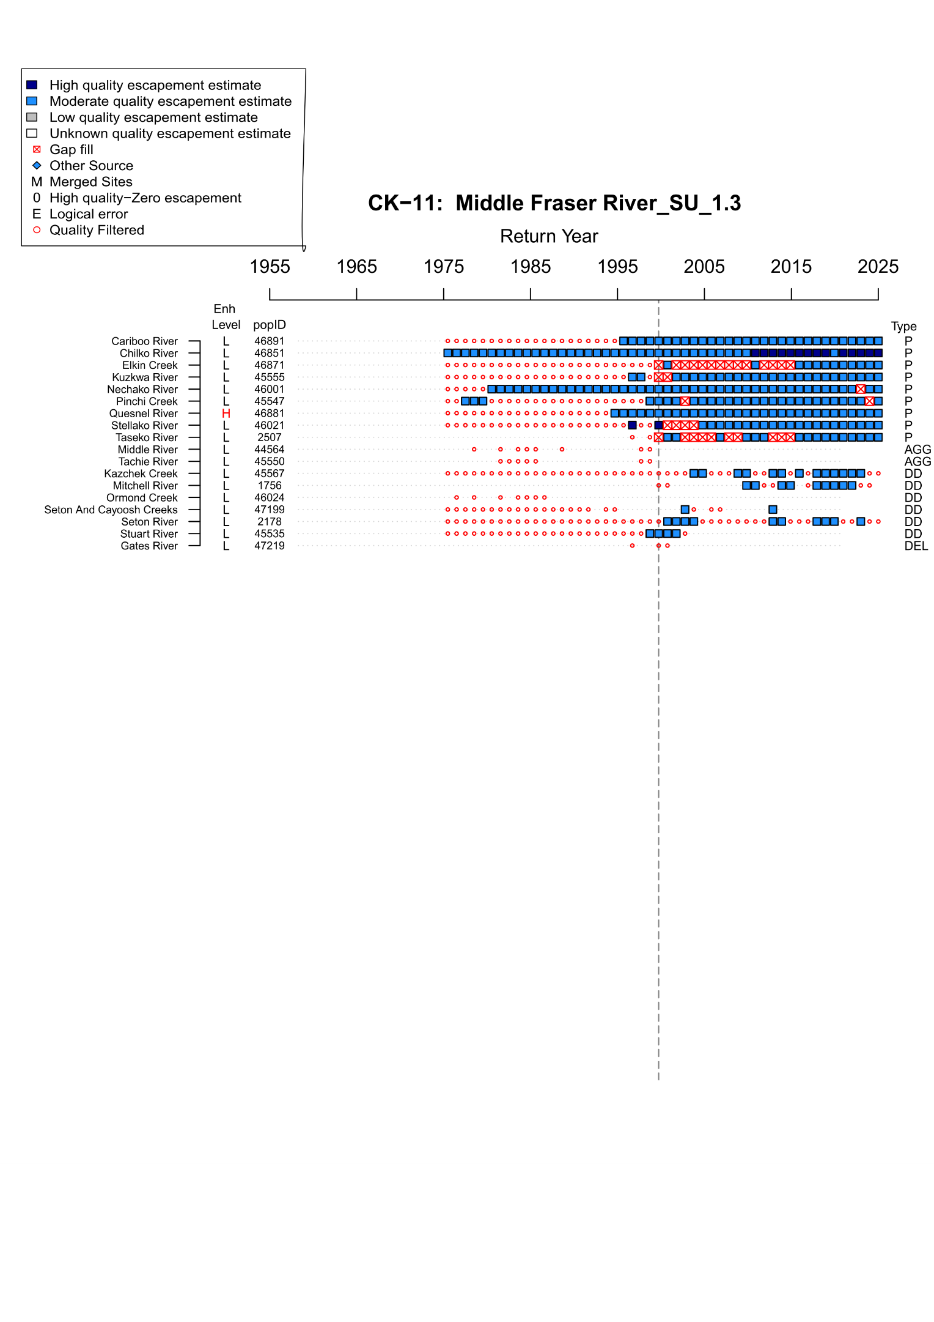
Figure B.2.8. WSP Rapid Status Assessment data quality filtering summary from 1975-2024 for Middle Fraser River Summer 1.3 (CK-11). The grey dashed line indicates the assigned start year for the rapid status assessment time series (1999). Enh level indicates the enhancement Rank (H = high, M = Moderate, L = Low, U = Unknown), popID refers to the site population identification number in the NuSEDS database, Type refers to the site designation ( P = persistent, DD = data deficient, AGG = aggregated, DEL = deleted or extirpated. As stated in the legend, dark blue squares indicate years with high quality escapement estimates (NuSEDS Types 1-2), light blue squares indicate years with moderate quality escapement estimates (NuSEDS Types 3-4), , red squares indicate years were gap filling was conducted, red open circles indicate years that were quality filtered (NuSEDS Types 5-6 or unknown).
Expert Consensus
During the January 2025 expert review meeting, it was noted that the Quesnel River population is likely the system driving down the percent change and long term trend metrics for this CU. However, after comparing the timeseries of spawner escapements for the contributing systems in this CU, the Quesnel River population alone is not enough to account for the generally negative trend. Chilko is the largest population and has also experienced declines since 1995.
For the 2024 assessment, Quesnel River was excluded due to consistent enhancement up to brood year 2004 (Supplementary Materials A, Appendix A.). Additional sensitivity tests were conducted to evaluate the impact on status if Quesnel remained included, but the start year was adjusted to 2008 to account for the enhanced years. This test resulted in the same output of Amber status with low confidence. For this reason, the decision was to remove Quesnel in favour of having a longer time series for the CU, which also includes more natural spawner data for the Chilko ERIS population.

B.2.5. CK-14 South Thompson
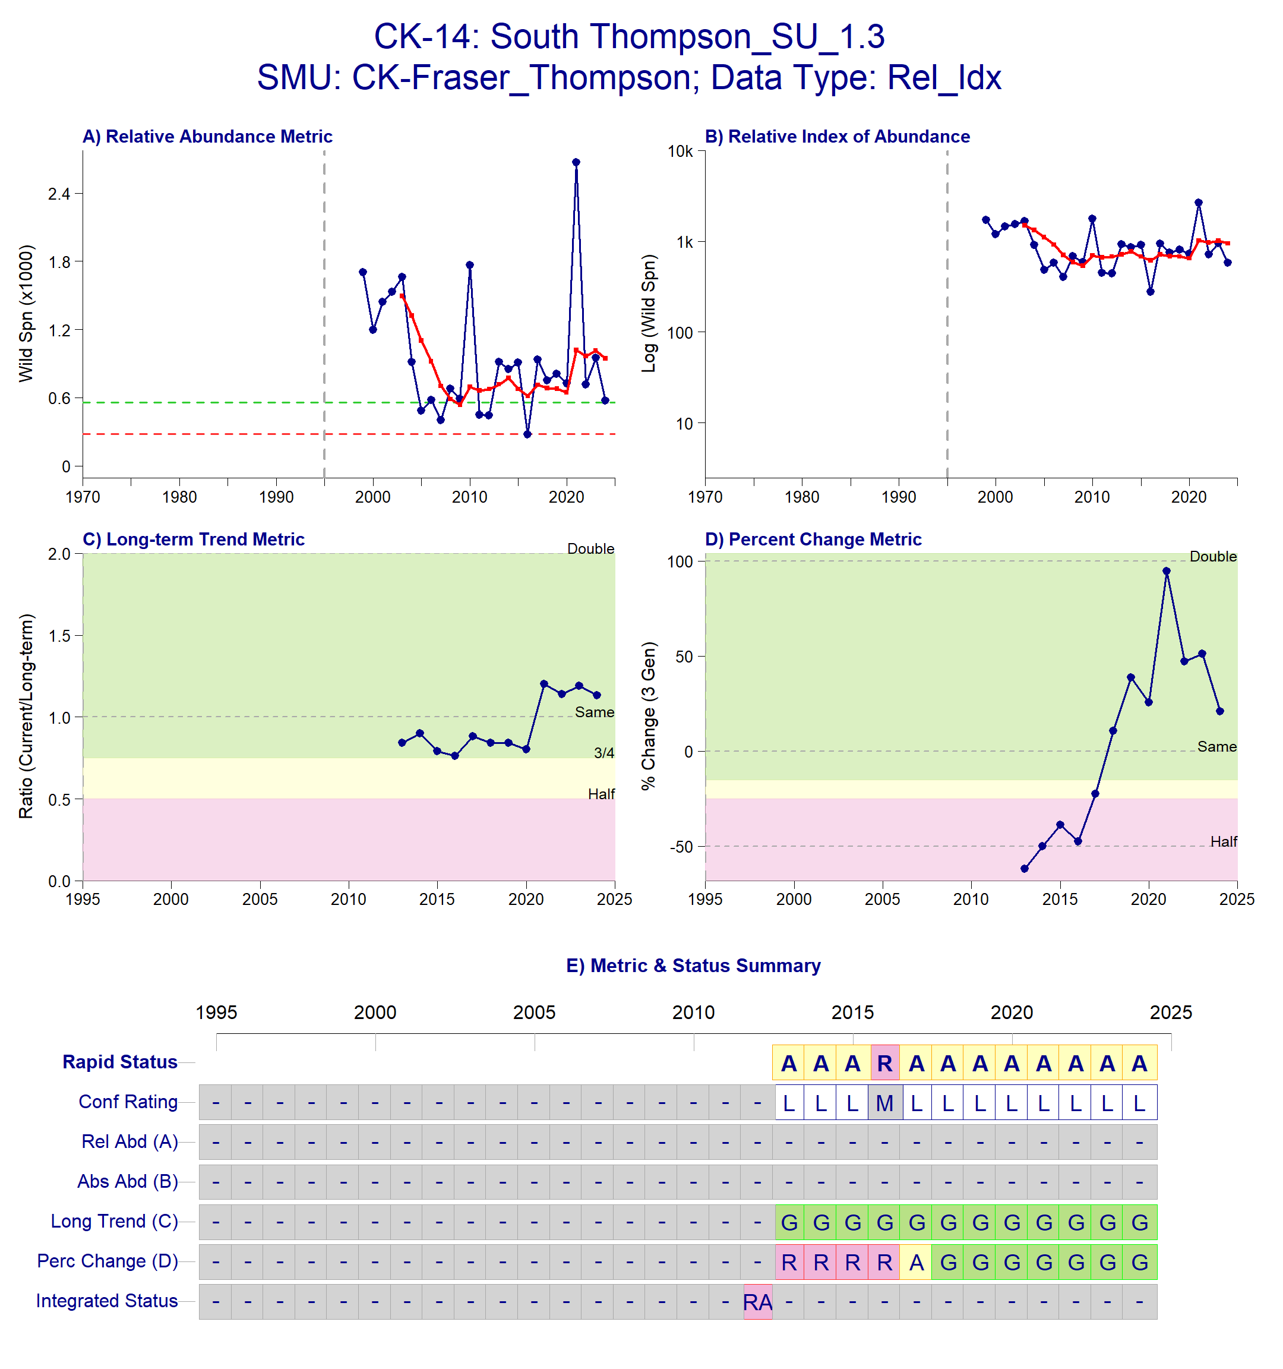
Figure B.2.9. Metrics and Status for South Thompson SU 1.3 (CK-14). Panels on top show the four standard WSP metrics, calculated based on the available time series of spawner abundances. Bottom panel summarizes the status for each individual metric and shows the resulting WSP rapid status for the CU with a confidence rating. If integrated WSP status assessments have been completed for this CU, they are shown on the last row (IntStatus). Note that metric benchmarks may differ from decision tree thresholds, since thresholds approximate the status determination process from past WSP integrated status assessments.
Table B.2.6. Decision tree path given data and metric values for South Thompson 1.3 (CK-14) in 2024; this aligns with Figure B.2.9 above. For each node, the decision is made by comparing the CUs current metric value to the metric threshold and answering Yes or No, running through sequential nodes and decisions until the final WSP rapid status for that CU and year is reached.
Node | Metric | Metric Threshold | CUs Current Value | Decision
1 | Relative Index | <1,500 |  | NO, NO
2 | Relative Index | < 10,000 |  | NO, NO
4 | Relative Abundance | Available? |  | NO
8 | Long Term Trend | <79% of long term average | 945 | NO
16 | Percent Change | < 70% decline | 945 | NO
32 | Long Term Trend | < 233% | 945 | YES
65 | FINAL STATUS NODE |  |  | AMBER, LOW
Data Quality Filtering
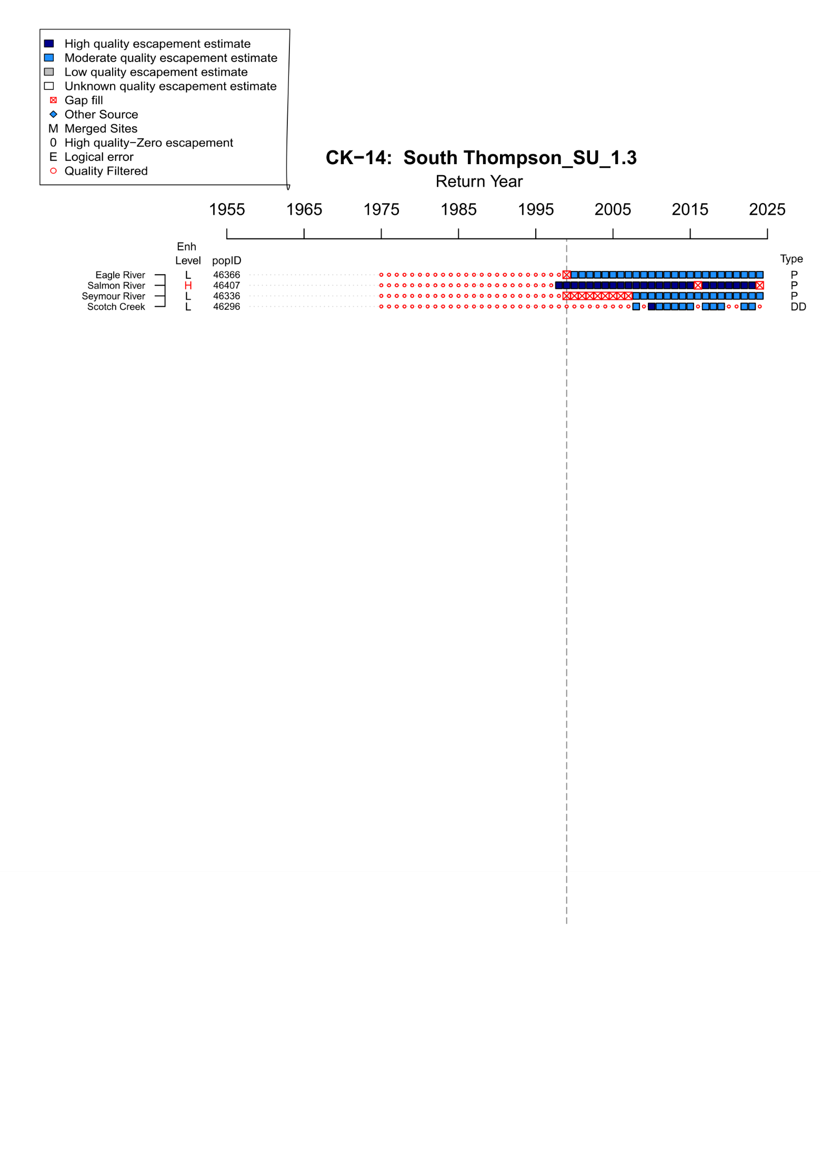
Figure B.2.10.. WSP Rapid Status Assessment data quality filtering summary for South Thompson Summer 1.3 (CK-14). The grey dashed line indicates the assigned start year for the rapid status assessment time series (1999). Enh level indicates the enhancement Rank (H = high, M = Moderate, L = Low, U = Unknown), popID refers to the site population identification number in the NuSEDS database, Type refers to the site designation ( P = persistent, DD = data deficient, AGG = aggregated, DEL = deleted or extirpated. As stated in the legend, dark blue squares indicate years with high quality escapement estimates (NuSEDS Types 1-2), light blue squares indicate years with moderate quality escapement estimates (NuSEDS Types 3-4), , red squares indicate years were gap filling was conducted, red open circles indicate years that were quality filtered (NuSEDS Types 5-6 or unknown).
Expert Consensus
Participants in the January 2025 expert review meeting expressed specific concern for this CU because the spawner abundances are dominated by the Eagle River Chinook population. Eagle River is very productive relative to the other systems that contribute to the CU-level spawner abundance total, thus trends in the Eagle River can mask trends in other systems within the CU. Additionally, the Salmon River (a drought-prone system with declining Chinook abundances) was excluded from the spawner abundances that contribute to this CU due to high hatchery influence (Supplementary Materials A, Appendix A) As a result, experts discussed the potential to use a spawner distribution metric to provide additional information about smaller populations whose trends are masked by large ones. Increasing efforts to determine the hatchery influence in the Salmon River was also discussed. The Salmonid Enhancement Program (SEP) does not currently mark fish in the Salmon River, but they have started parental based tagging (PBT). PBT is a method that estimates the proportion of unmarked hatchery spawners by using genetics to identify hatchery-origin spawners based on genetic samples of the parents that were spawned in the hatchery in previous years. Obtaining sampling rates from SEP may allow a natural origin spawner estimate to be calculated. Another possible solution to include additional systems was to infill Scotch Creek estimates so that it does not get quality filtered, which would require shortening the time series to begin around 2008. Ultimately, it was concluded that infilling would likely not have much influence on the overall status because Scotch Creek escapes much fewer spawners than Eagle River.
For the 2024 assessment, no additional changes were made to the systems included or the start year for the time series. The status remains Amber with low confidence. There is ongoing work to determine a natural spawner estimate for Salmon River that can be applied in future assessments.

B.2.6. CK-19 North Thompson
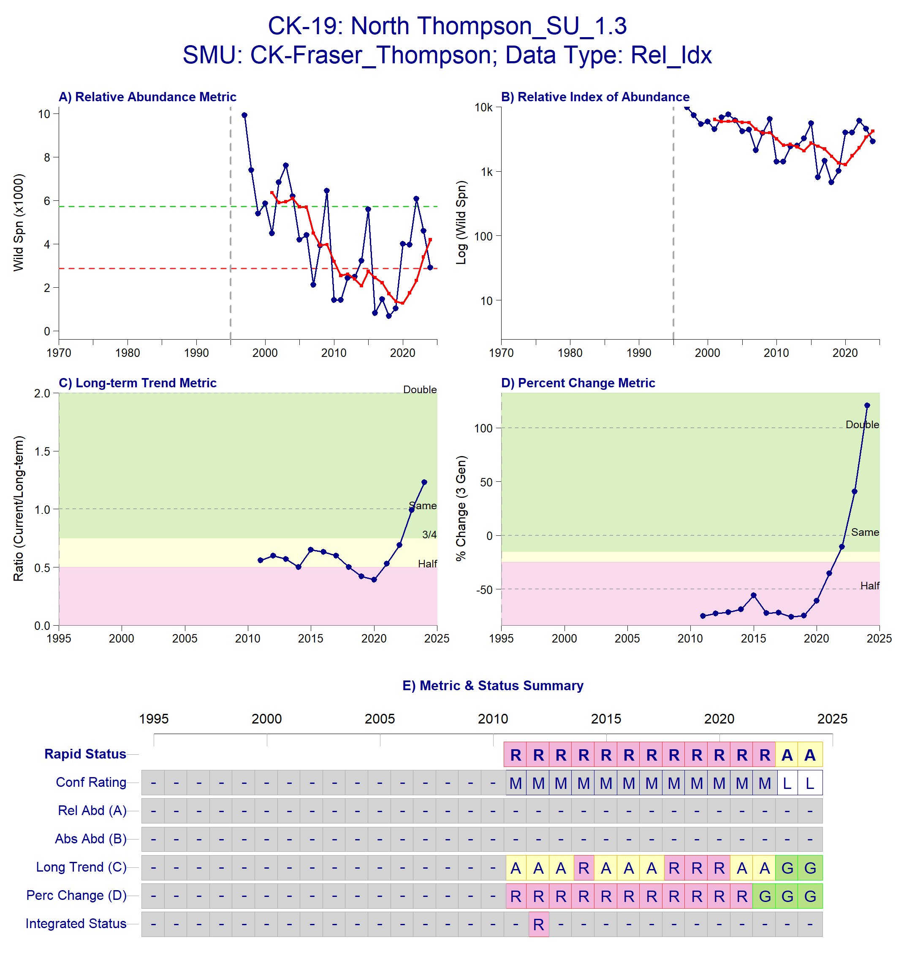
Figure B.2.11. Metrics and Status for North Thompson SU 1.3 (CK-19). Panels on top show the four standard WSP metrics, calculated based on the available time series of spawner abundances. Bottom panel summarizes the status for each individual metric and shows the resulting WSP rapid status for the CU with a confidence rating. If integrated WSP status assessments have been completed for this CU, they are shown on the last row (IntStatus). Note that metric benchmarks may differ from decision tree thresholds, since thresholds approximate the status determination process from past WSP integrated status assessments.
Table B.2.7. Decision tree path given data and metric values for North Thompson SU 1.3 (CK-19) in 2024; this aligns with Figure B.2.11 above. For each node, the decision is made by comparing the CUs current metric value to the metric threshold and answering Yes or No, running through sequential nodes and decisions until the final WSP rapid status for that CU and year is reached.
Node | Metric | Metric Threshold | CUs Current Value | Decision
1 | Relative Index | <1,500 |  | NO, NO
2 | Relative Index | < 10,000 |  | NO, NO
4 | Relative Abundance | Available? |  | NO
8 | Long Term Trend | <79% of long term average | 4,188 | NO
16 | Percent Change | < 70% decline | 4,188 | NO
32 | Long Term Trend | < 233% of long term average | 4,188 | YES
65 | FINAL STATUS NODE |  |  | AMBER, LOW
Data Quality Filtering
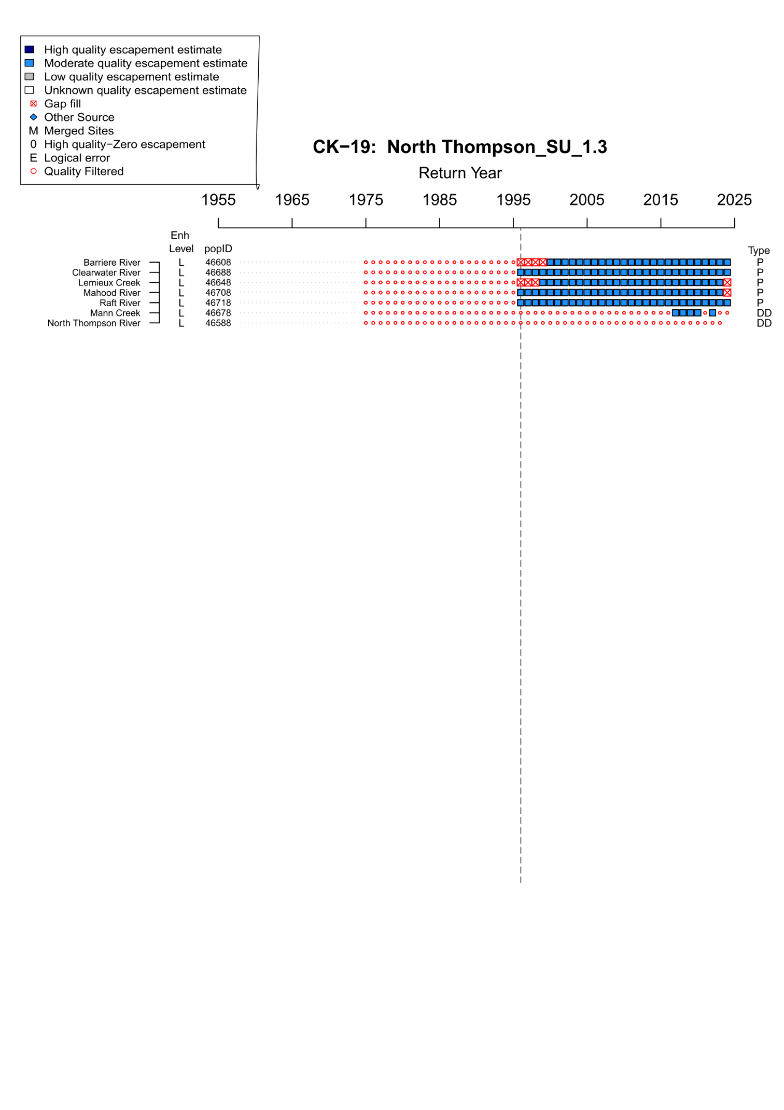
Figure B.2.12. WSP Rapid Status Assessment data quality filtering summary for North Thompson Summer 1.3 (CK-19).
Expert Consensus
There were some concerns over the Amber status assignment for this CU due to habitat and climate threats experienced by some of the component populations. It was recommended to determine if the Clearwater River population is the main contributor to the upward trend in status for this CU, as it may be masking habitat issues related to the smaller populations that may be in decline. Specifically, Lemieux Creek was mentioned as an example of a stream that is subject to severe drought conditions and other habitat issues. However, fish may facultatively spawn in the mainstem of the North Thompson River when water conditions are low and hot in the creeks, and it is unknown what proportion of fish may attempt to spawn in the mainstem (due to high turbidity), and what the relative juvenile production difference is between creek versus mainstem spawning habitats. Thus, more research is required to understand the degree to which low and hot water in the creeks changes spawner distribution and success, and the overall population-level impact of these conditions on creek-spawning Chinook.
For the 2024 assessment, no additional changes were made to the systems included or the start year for the time series. The status remains Amber with low confidence. There is ongoing work to develop a spawner distribution metric for future assessments.

Appendix C: Ricker Parameter Estimates
Table C.1. Mean and 95% credible intervals (CIs) of SMU-level Ricker α values for Fraser Spring and Summer 5₂ (1.3) Chinook SMUs estimated from the Nicola Chinook population α adjusted for proportional differences in fecundity.
SMU | Median | Lower 95% CI | Upper 95% CI
SP 1.3 | 0.98 | 0.37 | 2.08
SU 1.3 | 0.87 | 0.26 | 1.98
Table C.2. Median and 95% credible intervals (CIs) of CU-level Ricker β values for Fraser Spring and Summer 5₂ (1.3) Chinook SMUs based on accessible watershed areas, estimated using the Parken Habitat Model.
SMU | CU | Median | Lower 95% CI | Upper 95% CI
SP 1.3 | CK-04 | 0.00109 | 0.000384 | 0.00232
SP 1.3 | CK-08 | 0.000694 | 0.000251 | 0.00144
SP 1.3 | CK-10 | 0.0000354 | 0.0000128 | 0.0000783
SP 1.3 | CK-12 | 0.0000425 | 0.0000162 | 0.0000995
SP 1.3 | CK-18 | 0.000264 | 0.0000994 | 0.000575
SU 1.3 | CK-05 | 0.00164 | 0.000453 | 0.00374
SU 1.3 | CK-06 | 0.000108 | 0.0000327 | 0.000251
SU 1.3 | CK-09 | 0.000731 | 0.000249 | 0.00165
SU 1.3 | CK-11 | 0.0000200 | 0.00000554 | 0.0000493
SU 1.3 | CK-14 | 0.000259 | 0.0000799 | 0.000587
SU 1.3 | CK-19 | 0.0000699 | 0.0000211 | 0.000170

Appendix D: Chilko Survival Results
Table D.1. Distribution of Calendar Year Exploitation Rates among Individual-Stock-Based Management (ISBM), Aggregate Abundance-Based Management (AABM) Fisheries and Escapement (Esc.) in Canada and the U.S. for the Chilko Summer 1.3 Exploitation Rate Indicator Stock.
Catch Year | Estimated Number of CWT Recoveries¹ | Observed Number of CWT Recoveries | AABM U.S. |  | AABM Canada |  | ISBM U.S. |  | ISBM Canada |  | Esc.
2019 | 187 | 19 | 6.4% |  | 0% |  | 5.6% |  | 4.4% |  | 83.6%
2020 | 228 | 62 | 0% | 0% |  | 2.8% |  | 16.4% |  | 80.9%
2021 | 493 | 175 | 1.8% | 0% |  | 1.3% |  | 9.6% |  | 87.3%
2022 | 892 | 257 | 2.2% | 0.5% |  | 0.7% |  | 3.3% |  | 93.3%
2023 | 551 | 104 | 0.5% | 0% |  | 1.0% |  | 2.0% |  | 96.5%
2024 | 928 | 56 | 0% |  | 2.7% |  | 2.2% |  | 16.0% |  | 79.0%
1 CWT data includes fry and smolt recoveries at ages 3, 4, 5, and 6.

Appendix E: Fecundity-Based Expansion Validation

Methods
The fecundity-based approach to estimating Ricker α was assessed using two Fraser Chinook populations with robust stock-recruit timeseries and accompanying fecundity data. The Lower Shuswap River Chinook population is the ERIS for Fraser Summer 4₁ (0.3) Chinook, and the Harrison River Chinook population is the ERIS for Fraser Fall 4₁ (0.3) Chinook. Both SMUs have an ocean-type life-history (i.e., after hatching, they do not overwinter in freshwater before migrating to sea), although Lower Thompson juvenile Chinook generally arrive in the Fraser Estuary later, leave later, and spend less total time in the estuary than Harrison Chinook (Scott et al. 2024). Thus, these SMUs may experience similar mortality rates in their freshwater and early marine phases, increasing the likelihood that differences among their stock productivity parameters are driven by differences in fecundity.
Validation was conducted in 2 steps: 1) Ricker ln(α) was estimated for each ERIS using a Ricker stock-recruit function (as described in the Methods (Equation 1), using weakly informative priors shown below in Table H1); and 2) proportional differences in fecundity (as described in the Methods (Equations 2 & 3)) were used to re-estimate Ricker ln(α) for each ERIS using the original α estimate from the reciprocal ERIS (Bailey et al. 2026)
Table E1. Priors used in the Ricker stock recruit models fit to spawner and recruit data from the Lower Shuswap and Harrison rivers Chinook ERIS populations.
ERIS | Parameter |  | Distribution | Mean | Standard Deviation
Harrison | ln(α) |  | normal | 1 | 1
Harrison | 1/β |  | normal | 100000 | 50000
Harrison | ᵧ |  | normal | 0 | 1
Harrison | σ_{r} |  | half-cauchy | 0 | 2
Lower Shuswap | ln(α) |  | normal | 1 | 1
Lower Shuswap | 1/β |  | normal | 50000 | 25000
Lower Shuswap | ᵧ |  | normal | 0 | 1
Lower Shuswap | σ_{r} |  | half-cauchy | 0 | 2
Fecundity Data
Fecundities for the Harrison River and Lower Shuswap River ERISs were estimated differently. For the Harrison River, individual female chinook sampling in 2018 and 2019 was used to estimate a relationship between body length and fecundity (Weir et al. 2022) The fecundity ~ length relationship was then applied to brood year specific female size-at-age and proportions-at-age to estimate mean fecundity by brood year (Weir et al. 2022) For the Lower Shuswap River, fecundity was measured from female chinook collected for broodstock. Due to concerns that female broodstock collection was size-selective prior to 2020 (pers. comm. Michael Graham, Operations Manager, Shuswap Hatchery), fecundity data only from 2020 to present were used for the Lower Shuswap River.
Fecundity data for both ERISs were received as annual means, with the number of females sampled per year reported for the Lower Shuswap River. To estimate a fecundity distribution composed of individual fish for each ERIS, the variance in the measured fecundities from the 2018/2019 female Chinook sampled at Harrison River was applied to the annual fecundity means in both the Harrison and Lower Shuswap Rivers to simulate individual fecundities. In the case of the Harrison River, the number of individuals simulated per brood year was the sum of the individuals sampled in 2018/2019, and for the Lower Shuswap River, the number of individuals simulated per brood year matched the number of females sampled per brood year. Individual fecundities were simulated using the rnorm() function from the “stats” package in R ((Bailey et al. 2026) These individual-level simulated fecundity data were then used to estimate the f_{1.3} parameter described in Equation 2 in the Methods section for the Harrison and Lower Shuswap rivers Chinook.

Results
Ricker Stock Recruit Functions
The Ricker stock-recruit functions (Figures E1, H2) fit to the ERIS data for the Harrison and Lower Shuswap rivers without issue. Gelman-Rubin’s diagnostic test indicated convergence for both models (Rhat <1.01). The Harrison River Chinook population is larger and appears to be more productive (steeper curve at low spawner densities) than the Lower Shuswap River Chinook population.
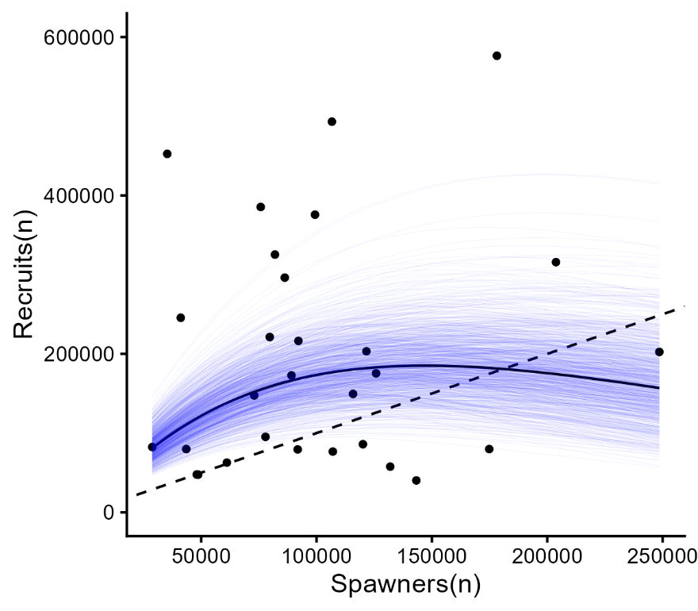
Figure E1. Ricker stock-recruit function fit to the Harrison River Fraser Fall 4₁ (0.3) Chinook ERIS dataset. Points represent individual spawner-recruit pairs linked by brood year. The solid black line shows the mean relationship between recruits and spawners. The thin blue trace lines show 1000 posterior draws sampled within the 95% CI of the Ricker ln(α) posterior, and the dashed black line shows the 1:1 line.
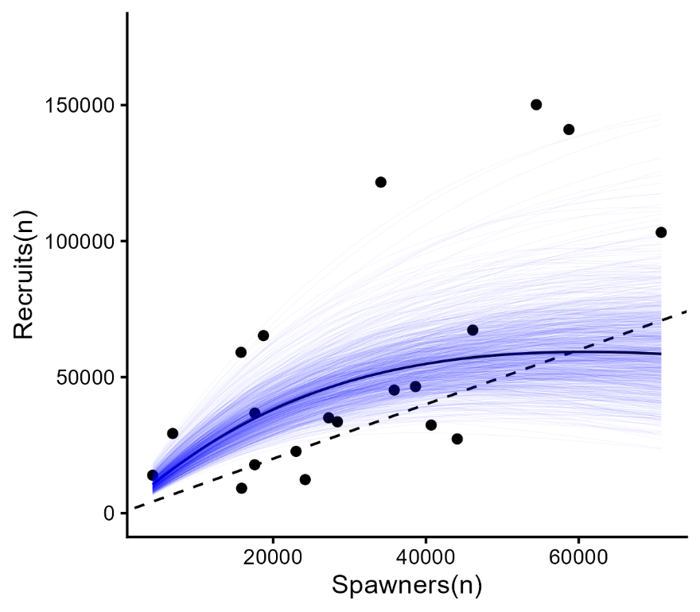
Figure E2. Ricker stock-recruit function fit to the Lower Shuswap River Fraser Summer 4₁ (0.3) Chinook ERIS dataset. Points represent individual spawner-recruit pairs linked by brood year, and the solid black line shows the mean relationship between recruits and spawners. The thin blue trace lines show 1000 posterior draws sampled within the 95% CI of the Ricker ln(α) posterior, and the dashed black line shows the 1:1 line.

Fecundity
Harrison River Chinook fecundity was on average lower and less variable than Lower Shuswap River Chinook fecundity (Figure E3). Harrison River Chinook estimated median fecundity was ~4140 eggs per female, while Lower Shuswap River Chinook females had a median estimated fecundity of ~4450 eggs (Figure E3).
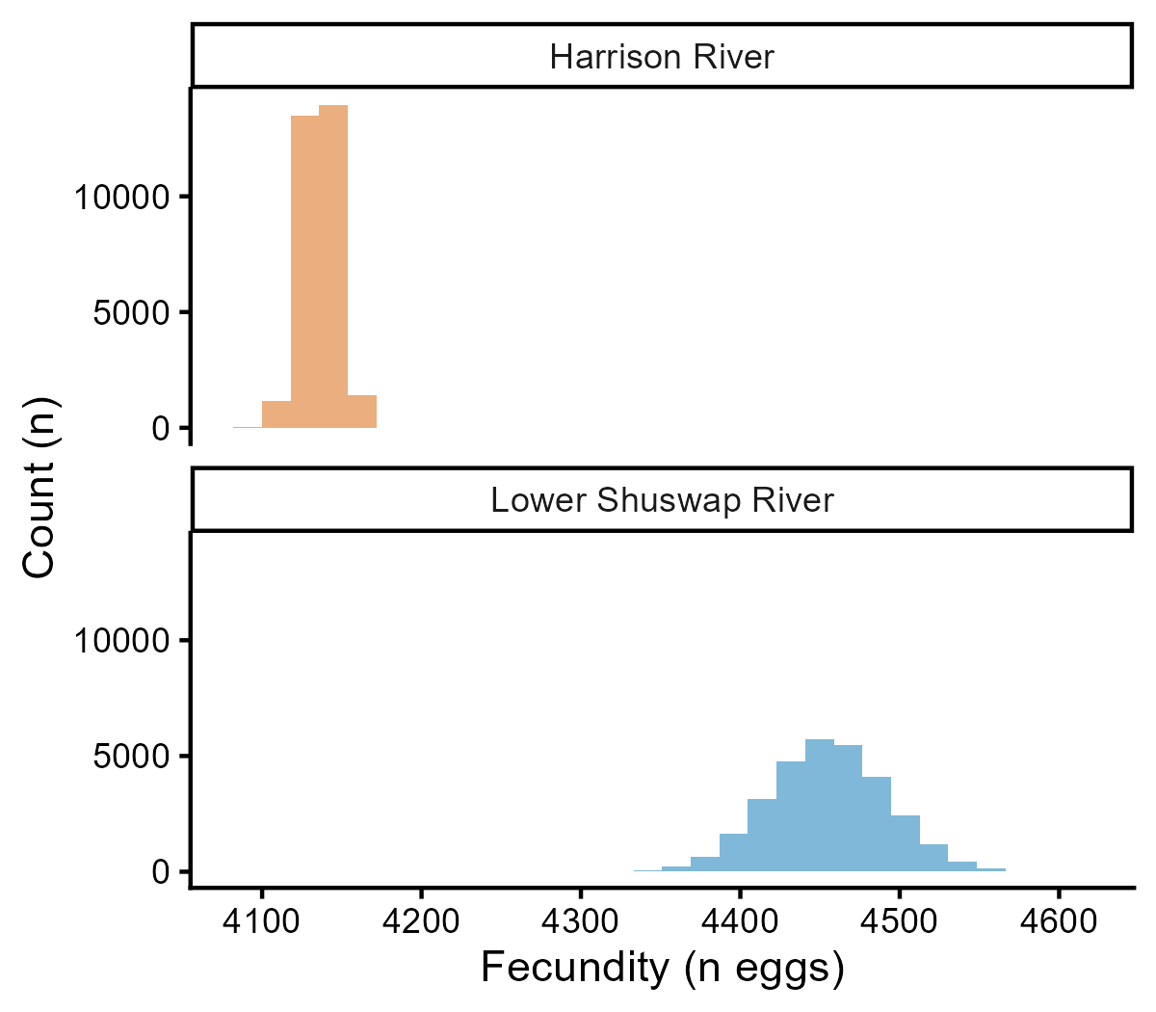
Figure E3. Fecundity of Fraser Fall 0.3 (Harrison River) and Fraser Summer 0.3 Chinook (Lower Shuswap River).

Ricker ln(α) Estimates
The 95% CIs of the fecundity-based and stock-recruit-based Ricker ln(α)s overlapped significantly for both the Harrison River and Lower Shuswap River Chinook populations (Figures E4, E5). Median fecundity-based Ricker ln(α)s were well within the 95% CIs of stock-recruit-based Ricker ln(α)s for both populations, suggesting that the fecundity-based method for estimating Ricker ln(α) may be credible (Figures E4, E5). However, counter to the hypothesis that productivity should scale with fecundity, stock-recruit-based Ricker ln(α) was higher for Harrison River Chinook than Lower Shuswap River Chinook (Figures E4, E5) despite Harrison River Chinook having lower fecundity (Figure E3). Thus, while the fecundity-based approach lands within the possible mean value of stock-recruit-based Ricker ln(α), it may produce biased results (Figure E6).
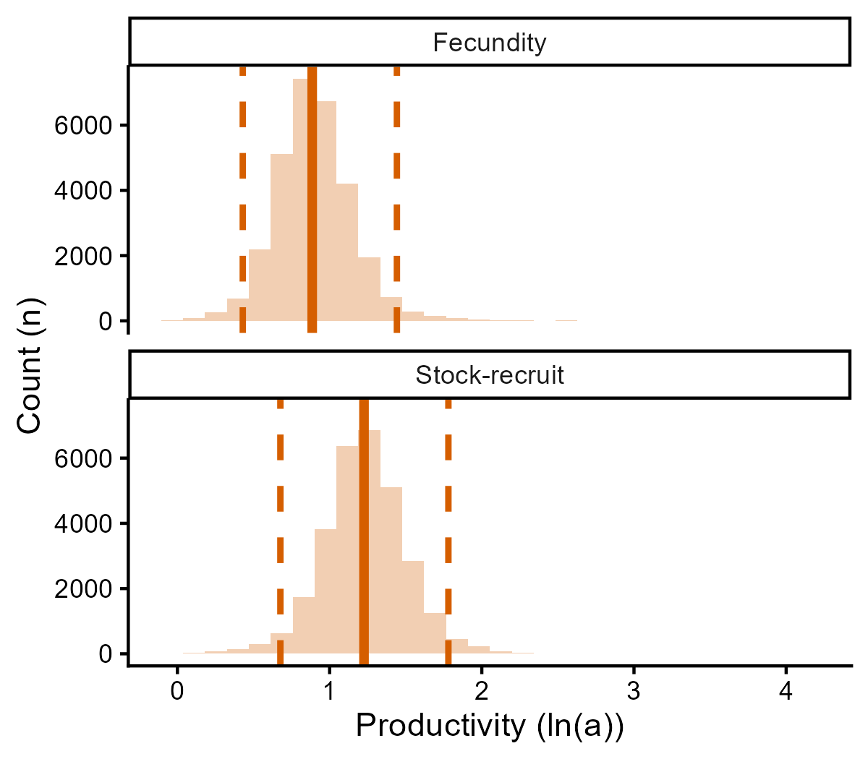
Figure E4. Fecundity-based vs Ricker stock-recruit-based estimates of Ricker ln(α) of Fraser Fall 0.3 Chinook (Harrison River) productivity. The fecundity-based Ricker ln(α) was estimated by taking the stock-recruit-based estimate of Ricker ln(α) from the Lower Shuswap River Chinook Ricker stock-recruit function and adjusting it based on the proportional difference in fecundity between the Harrison River Chinook population and the Lower Shuswap River Chinook population.
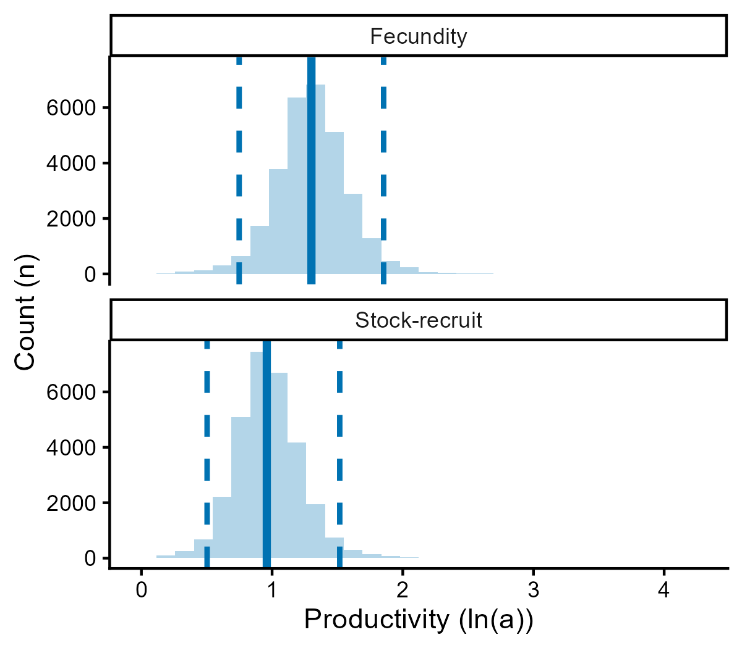
Figure E5. Fecundity-based vs Ricker stock-recruit-based estimates of Ricker ln(α) of Fraser Fall 0.3 Chinook (Lower Shuswap River) productivity. The fecundity-based Ricker ln(α) was estimated by taking the stock-recruit-based estimate of Ricker ln(α) from the Harrison River Chinook Ricker stock-recruit function and adjusting it based on the proportional difference in fecundity between the Lower Shuswap River Chinook population and the Harrison River Chinook population.
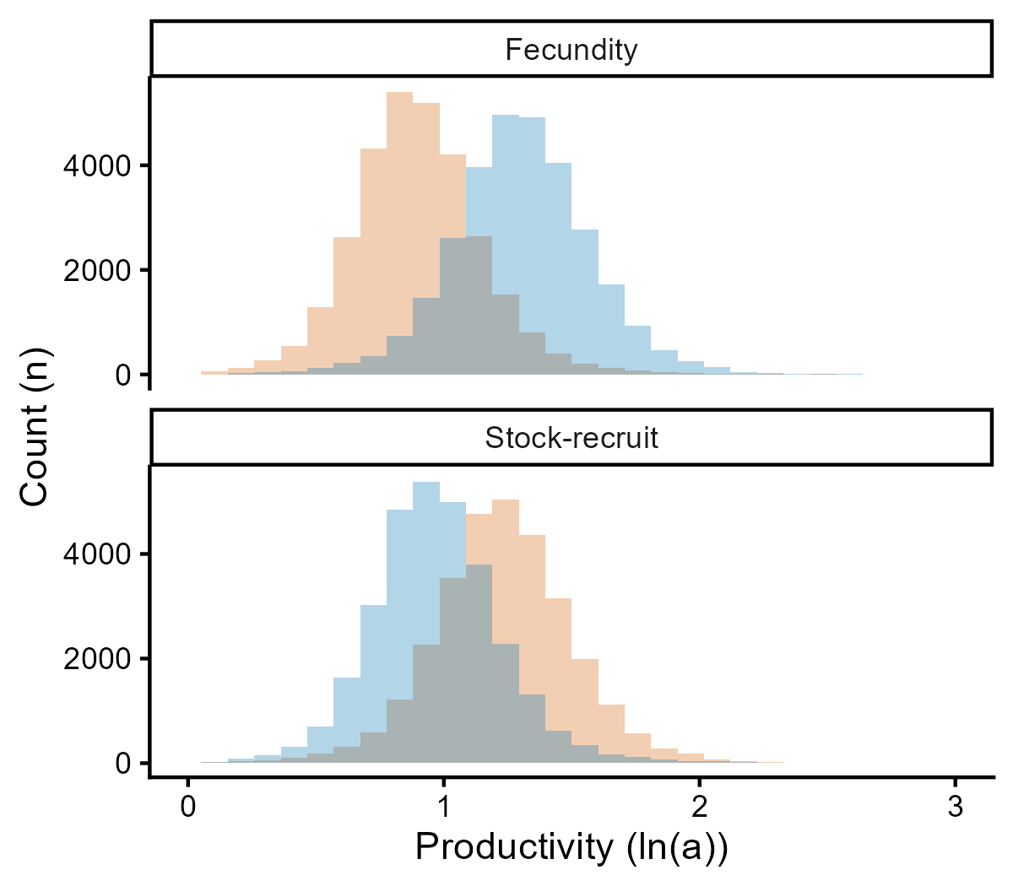
Figure E6. Ricker ln(α) estimates based on fecundity and Ricker stock-recruit curves. Orange represents Harrison Fall 0.3 Chinook and blue represents Lower Shuswap Summer 0.3 Chinook.

Discussion
Fecundity-based Ricker ln(α) was not statistically significantly different from the traditional stock-recruit-based method of estimating Ricker ln(α) for either Chinook ERIS. However, productivity was higher for the Harrison River Chinook ERIS than the Lower Shuswap River Chinook ERIS, despite the average female being less fecund. This may be explained by a more thorough examination of differences in life-history between these stocks. For example, Harrison River Chinook get more growing time in saltwater because they enter the Fraser Estuary earlier, and return to freshwater for spawning later. In addition, Harrison River Chinook have a much shorter migration than Lower Shuswap Chinook and do not need to pass through Hell’s Gate, a significant flow obstacle for Interior Fraser River fishes. Thus, although the mean fecundity of Harrison River Chinook is lower, the mass of their gonads is likely much greater relative to their body length because they have less energetic restraints on gamete production. Overall, the results of this validation exercise are inconclusive.

