Appendix E: Additional Simulation Results
E1. Spring 5₂ (1.3)
E1.1. Perfect Implementation Error
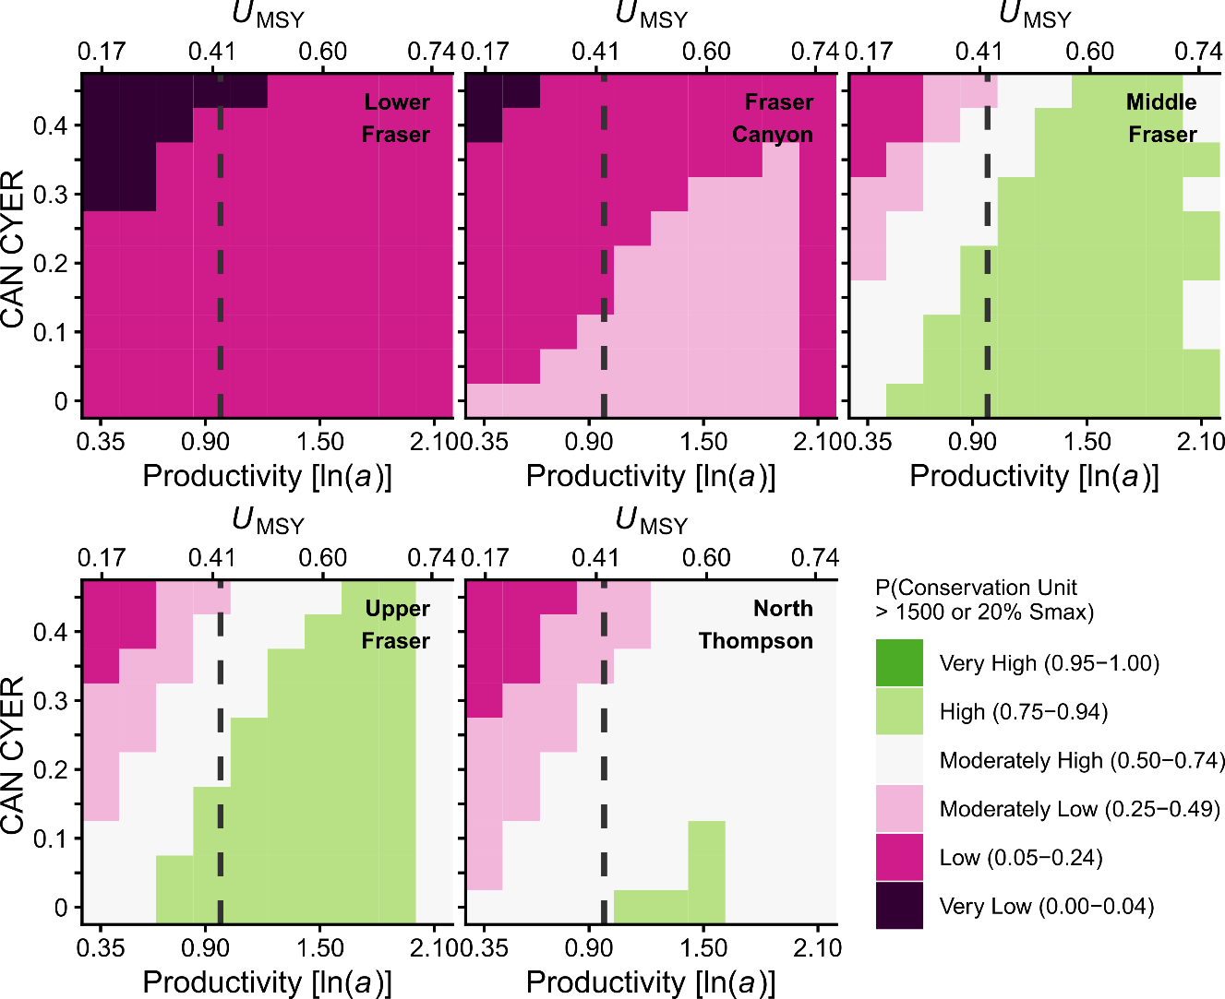
Figure E1.1.1. Simulated probability that CUs in the FR SP 1.3 CN meet or exceed lower biological benchmarks in the perfect implementation error scenario. Ice-cream plot results are based on CYER with implementation error (CV = 0) across a range of productivity values covering the 95% CI of estimated ln(alpha). Squares are colour-coded according to the probability that the geometric mean of the last generation (5 years) of spawner abundance for a given CU meets or exceeds 20% Smax or 1500 spawners, whichever value is greater.
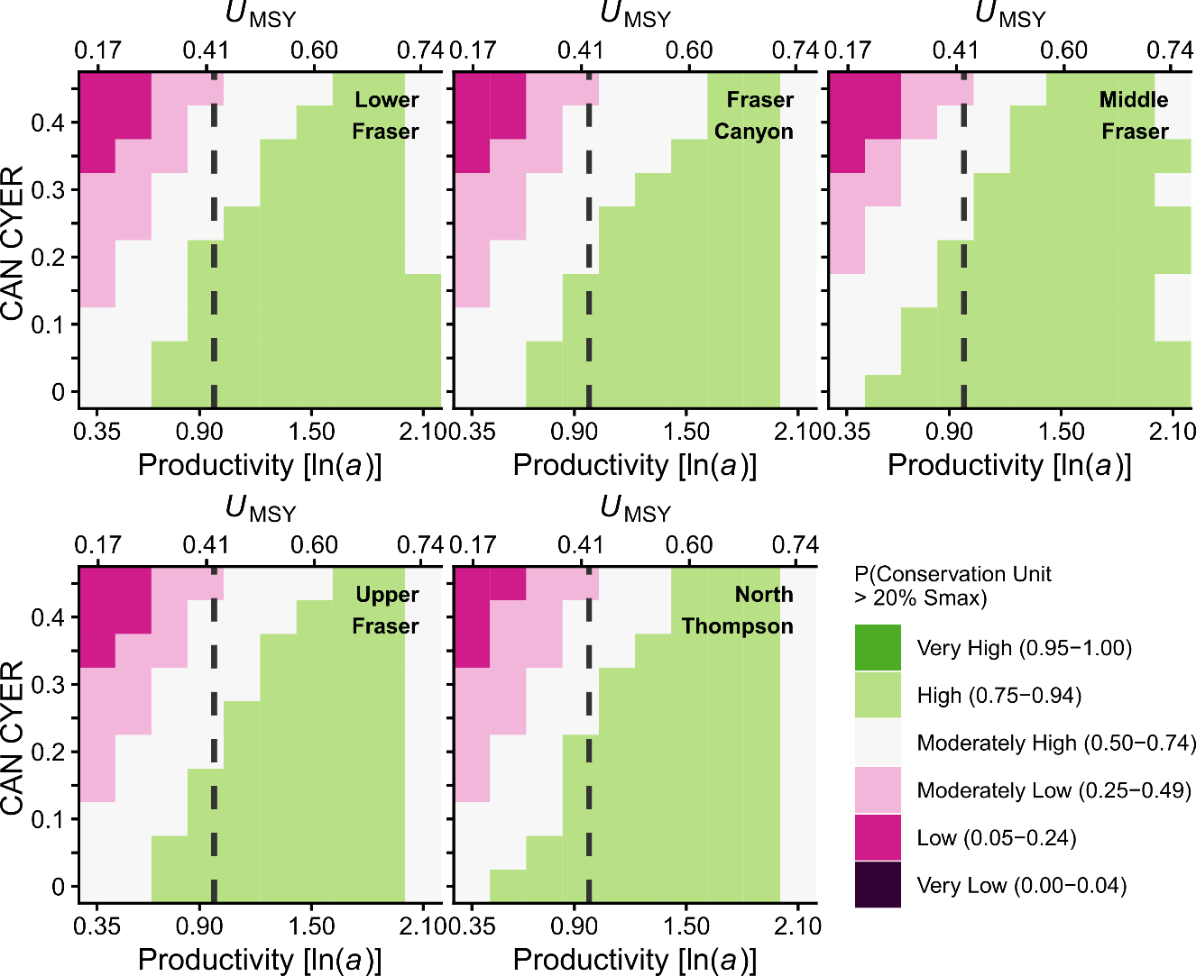
Figure E1.1.2. Simulated probability that CUs in the FR SP 1.3 CN meet or exceed quasi-extinction threshold in the perfect implementation error scenario. Ice-cream plot results are based on CYER with implementation error (CV = 0.1) across a range of productivity values covering the 95% CI of estimated ln(alpha). Squares are colour-coded according to the probability that the geometric mean of the last generation (5 years) of spawner abundance for a given CU meets or exceeds 50 spawners.
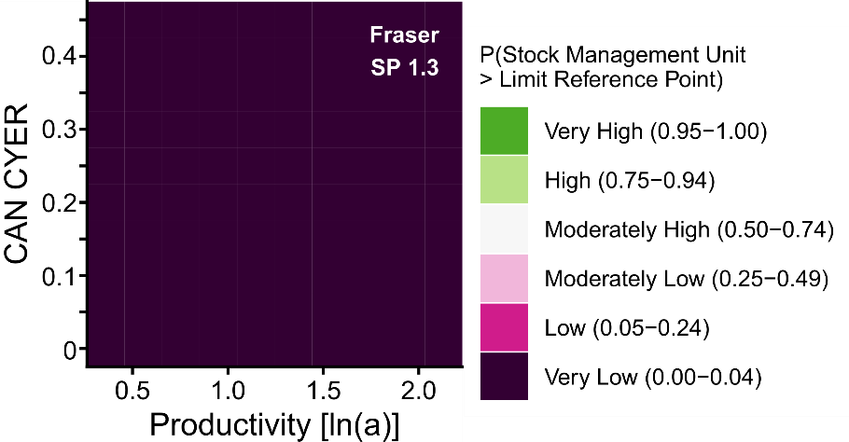
Figure E1.1.3. Simulated probability the FR SP 1.3 CN meets or exceeds the CU status-based LRP in the optimistic implementation error scenario. Ice-cream plot results are based on CYER with implementation error (CV = 0.1) across a range of productivity values covering the 95% CI of estimated ln(alpha). Squares are colour-coded according to the probability that the geometric mean of the last generation (5 years) of spawner abundance for all CUs meets or exceeds CU-specific 20% Smax or 1500 spawners, whichever value is greater.
E1.2. Pessimistic Implementation Error
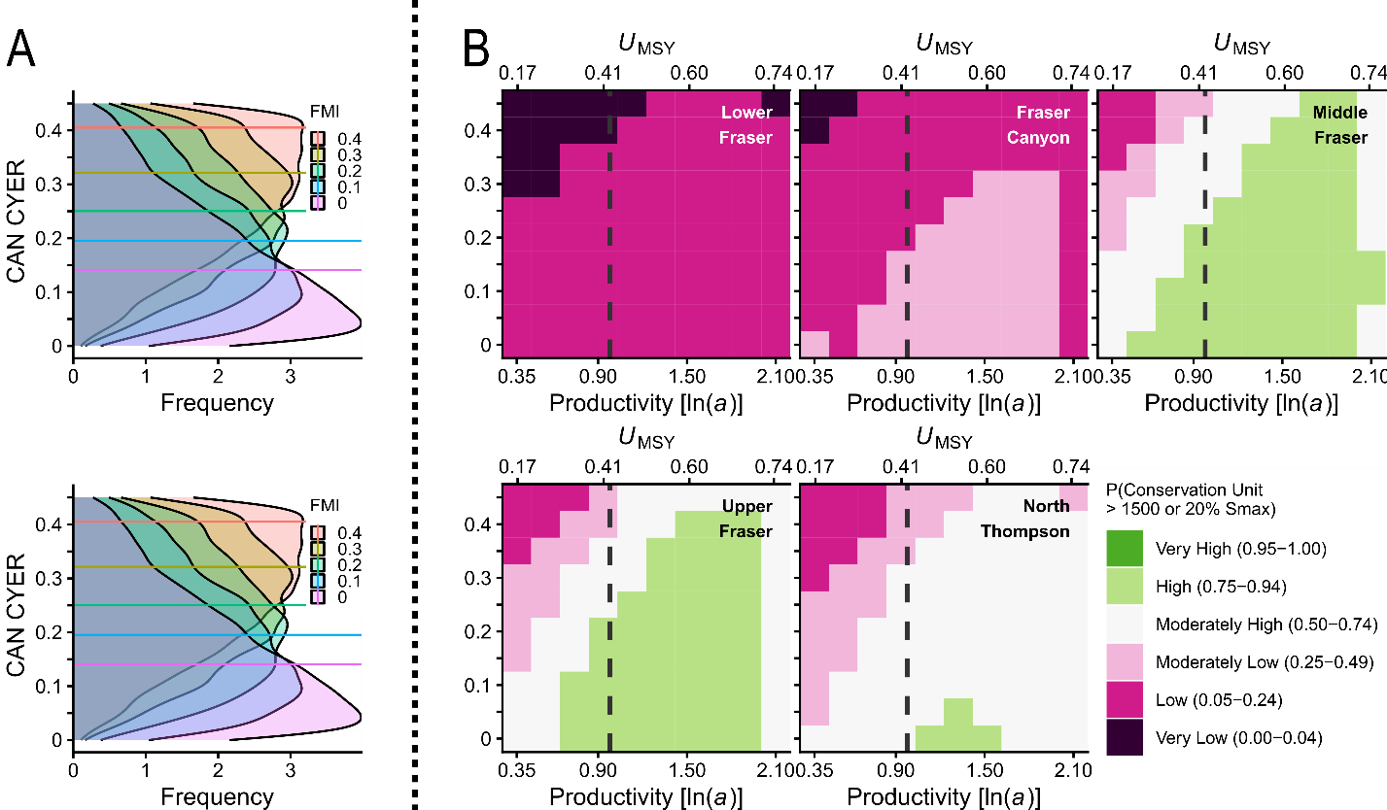
Figure E1.2.1. Simulated probability that CUs in the FR SP 1.3 CN meet or exceed lower biological benchmarks in the pessimistic implementation error scenario. Horizontal lines in the A side plots represent median values of CYER for a given value of FMI, with associated posterior distributions describing the range of possible CYER outcomes for a given target FMI. The A side plots are derived from a measurement error model of CYER ~ FMI assuming both indices include an observation error with CV = 0.3. B side ice-cream plot results are based on CYER with implementation error (CV = 0.3) across a range of productivity values covering the 95% CI of estimated ln(alpha). Squares are colour-coded according to the probability that the geometric mean of the last generation (5 years) of spawner abundance for a given CU meets or exceeds 20% Smax or 1500 spawners, whichever value is greater.

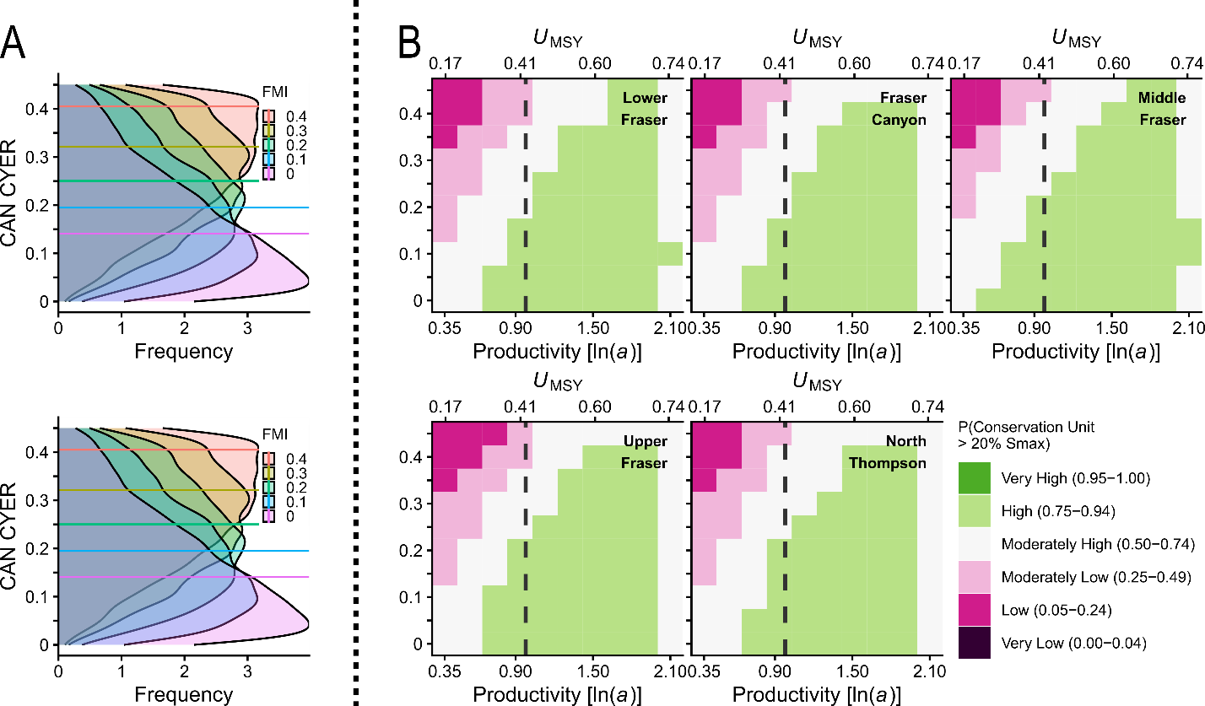
Figure E1.2.2. Simulated probability that CUs in the FR SP 1.3 CN meet or exceed quasi-extinction threshold in the pessimistic implementation error scenario. Horizontal lines in the A side plots represent median values of CYER for a given value of FMI, with associated posterior distributions describing the range of possible CYER outcomes for a given target FMI. The A side plots are derived from a measurement error model of CYER ~ FMI assuming both indices include an observation error with CV = 0.3. B side ice-cream plot results are based on CYER with implementation error (CV = 0.3) across a range of productivity values covering the 95% CI of estimated ln(alpha). Squares are colour-coded according to the probability that the geometric mean of the last generation (5 years) of spawner abundance for a given CU meets or exceeds 50 spawners.
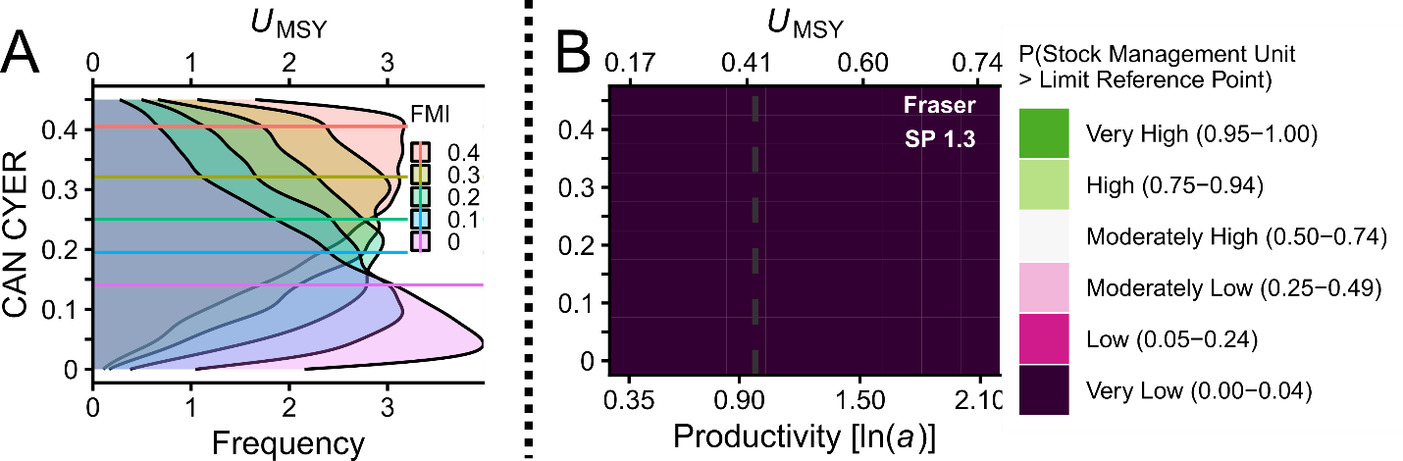
Figure E1.2.3. Simulated probability the FR SP 1.3 CN meets or exceeds the CU status-based LRP in the pessimistic implementation error scenario. Horizontal lines in the A side plots represent median values of CYER for a given value of FMI, with associated posterior distributions describing the range of possible CYER outcomes for a given target FMI. The A side plots are derived from a measurement error model of CYER ~ FMI assuming both indices include an observation error with CV = 0.3. B side ice-cream plot results are based on CYER with implementation error (CV = 0.3) across a range of productivity values covering the 95% CI of estimated ln(alpha). Squares are colour-coded according to the probability that the geometric mean of the last generation (5 years) of spawner abundance for all CUs meets or exceeds CU-specific 20% Smax or 1500 spawners, whichever value is greater.

E2. Summer 5₂ (1.3)
E2.1. Perfect Implementation Error

Figure E2.1.1. Simulated probability that CUs in the FR SU 1.3 CN meet or exceed lower biological benchmarks in the perfect implementation error scenario. Ice-cream plot results are based on CYER with implementation error (CV = 0) across a range of productivity values covering the 95% CI of estimated ln(alpha). Squares are colour-coded according to the probability that the geometric mean of the last generation (5 years) of spawner abundance for a given CU meets or exceeds 20% Smax or 1500 spawners, whichever value is greater.

Figure E2.1.2. Simulated probability that CUs in the FR SU 1.3 CN meet or exceed quasi-extinction threshold in the perfect implementation error scenario. Ice-cream plot results are based on CYER with implementation error (CV = 0.1) across a range of productivity values covering the 95% CI of estimated ln(alpha). Squares are colour-coded according to the probability that the geometric mean of the last generation (5 years) of spawner abundance for a given CU meets or exceeds 50 spawners.

Figure E2.1.3. Simulated probability the FR SU 1.3 CN meets or exceeds the CU status-based LRP in the optimistic implementation error scenario. Ice-cream plot results are based on CYER with implementation error (CV = 0.1) across a range of productivity values covering the 95% CI of estimated ln(alpha). Squares are colour-coded according to the probability that the geometric mean of the last generation (5 years) of spawner abundance for all CUs meets or exceeds CU-specific 20% Smax or 1500 spawners, whichever value is greater.

E2.2. Pessimistic Implementation Error
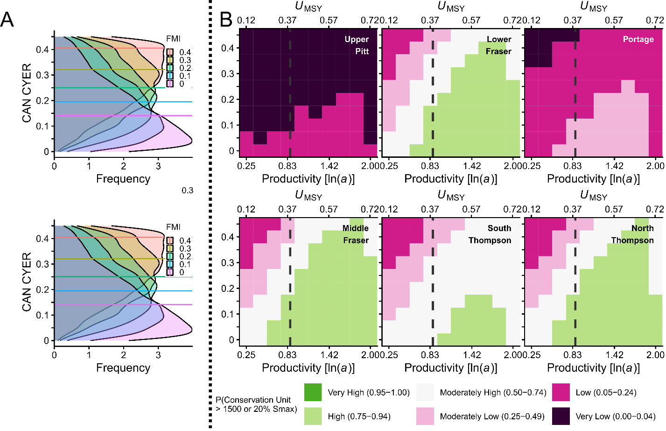
Figure E2.2.1. Simulated probability that CUs in the FR SU 1.3 CN meet or exceed lower biological benchmarks in the pessimistic implementation error scenario. Horizontal lines in the A side plots represent median values of CYER for a given value of FMI, with associated posterior distributions describing the range of possible CYER outcomes for a given target FMI. The A side plots are derived from a measurement error model of CYER ~ FMI assuming both indices include an observation error with CV = 0.3. B side ice-cream plot results are based on CYER with implementation error (CV = 0.3) across a range of productivity values covering the 95% CI of estimated ln(alpha). Squares are colour-coded according to the probability that the geometric mean of the last generation (5 years) of spawner abundance for a given CU meets or exceeds 20% Smax or 1500 spawners, whichever value is greater.
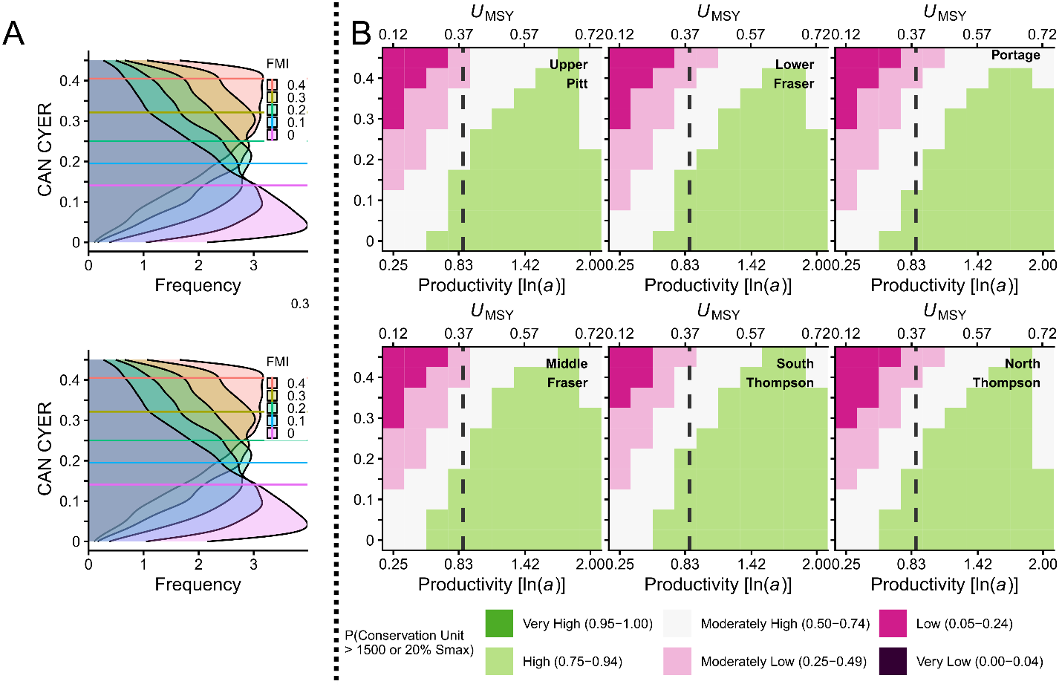
Figure E2.2.2. Simulated probability that CUs in the FR SU 1.3 CN meet or exceed quasi-extinction threshold in the pessimistic implementation error scenario. Horizontal lines in the A side plots represent median values of CYER for a given value of FMI, with associated posterior distributions describing the range of possible CYER outcomes for a given target FMI. The A side plots are derived from a measurement error model of CYER ~ FMI assuming both indices include an observation error with CV = 0.3. B side ice-cream plot results are based on CYER with implementation error (CV = 0.3) across a range of productivity values covering the 95% CI of estimated ln(alpha). Squares are colour-coded according to the probability that the geometric mean of the last generation (5 years) of spawner abundance for a given CU meets or exceeds 50 spawners.
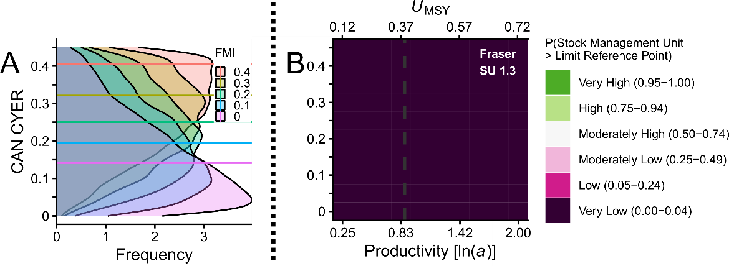
Figure E2.2.3. Simulated probability the FR SU 1.3 CN meets or exceeds the CU status-based LRP in the pessimistic implementation error scenario. Horizontal lines in the A side plots represent median values of CYER for a given value of FMI, with associated posterior distributions describing the range of possible CYER outcomes for a given target FMI. The A side plots are derived from a measurement error model of CYER ~ FMI assuming both indices include an observation error with CV = 0.3. B side ice-cream plot results are based on CYER with implementation error (CV = 0.3) across a range of productivity values covering the 95% CI of estimated ln(alpha). Squares are colour-coded according to the probability that the geometric mean of the last generation (5 years) of spawner abundance for all CUs meets or exceeds CU-specific 20% Smax or 1500 spawners, whichever value is greater.

