**How distributions for hierarchical variance parameter affects LRP estimates for Interior Fraser Coho**

***Prepared for the Limit Reference Point Technical Working Group (Aug 27, 2020)***

This note describes how the shape of the prior distribution for the variance parameter σα (which, is the variance of the hyperdistribution on productivity, α, in the hierarchical Ricker component of the integrated LRP model) can influence resulting LRP estimates for the Interior Fraser Coho case study.

Two distributions are considered in detail: The inv.gamma (0.01, 0.01) distribution shown in purple in the below figure and the inv.gamma (1,1) distribution shown in red. We do not show results specific to the inv.gamma (0.1, 0.1) distribution [grey line in plot] (which behaves similar to the inv.gamma (0.01, 0.01) distribution) or the independent model fit (which behaves similar to the inv.gamma (1, 1) distribution).

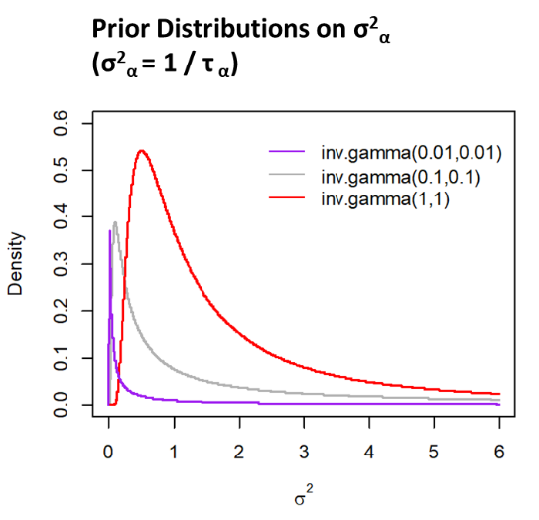

These prior distributions control the extent to which CU-level estimates of alpha deviate from the mean of the alpha hyperdistribution. The mode of the variance distribution for the red line is higher than the purple line and the probability is near zero at $σ^{2}$ <0.1 for the red line; thus, the red line allows for more deviation (larger $σ^{2}$) among CU-level alphas than the purple line.

For some CUs, the more diffuse inv.gamma (1,1) distribution leads to an increase in alpha compared to the tighter inv.gamma (0.01, 0.01) distribution (Fraser Canyon, North Thompson), while for others, it leads to a decrease in alpha (Middle Fraser, South Thompson). These results can be seen the below figure of CU-level alpha estimates for various prior scenarios. Note that the colour blocks in these plots show scenarios with different variance parameters (where σα = 1/τα) and have been selected to match the colour of the prior distribution curves in the above plot.

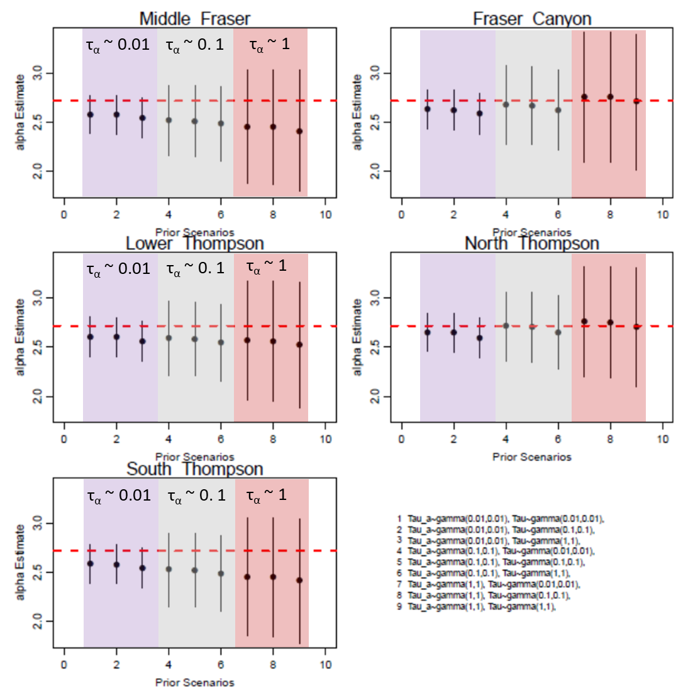

These CU-level changes in alpha lead to CU-level changes in Sgen, with some Sgen values increasing as the prior distribution on σα becomes more diffuse while others decrease. The Maximum Posterior Density ,MPD, Sgen estimates in 2018 using the inv.gamma (0.01, 0.001) and the inv.gamma (1,1) distributions are shown here:

|  |  |  |
| --- | --- | --- |
| CU | Sgen when σα , σ ~ inv.gamma (0.01, 0.01) | Sgen when σα , σ~ inv.gamma (1, 1) |
| Middle Fraser | 1492 | 1785 |
| Fraser Canyon | 608 | 476 |
| Lower Thompson | 1542 | 1583 |
| North Thompson | 2653 | 2249 |
| South Thompson | 2051 | 2410 |

As a result of the shift in Sgens when the prior distribution on σα is relaxed to inv.gamma (1,1), a smaller proportion of CUs are above their Sgen values in the years 1999, 2005, 2014, and 2015 (see right hand side of below logistic regression fits with data). These changes act to shift the fitted logistic curve used to derive LRPs to the right. Because aggregate escapement levels between 19,000 and 24,000 fish are now more likely to have CUs below Sgen, the estimated LRP also shifts to the right (i.e., gets higher).

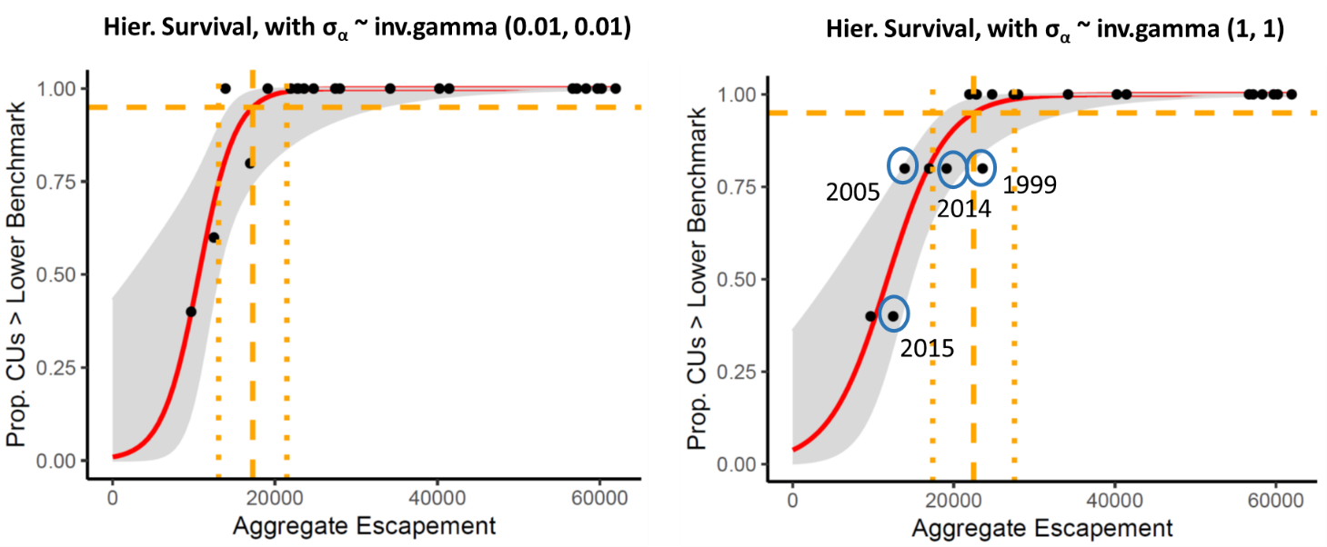

* In three of the four years with diverging estimates of the proportion of CUs > Sgen (2004, 2014, and 2015), the difference is due to the higher Sgen value for the South Thompson CU under the σα ~ inv.gamma (1, 1) assumption.

🡪 South Thompson escapements in 2005, 2014, and 2015 were above Sgen with σα ~ inv.gamma (0.01, 0.01), but below Sgen when inv.gamma (1, 1).

* The one remaining year with a diverging estimate of the proportion of CUs > Sgen was 1999. The shift in this year was due to an increase in the Middle Fraser CU’s Sgen estimate with inv.gamma (1, 1).
* Sgen did not always increase with σα ~ inv.gamma (1, 1) case. The North Thompson CU experienced a decrease in Sgen under the σα ~ inv.gamma (1, 1) case; however, this shift did not affect the logistic regression fit because escapements for this CU were always above Sgen in all years, regardless of the σα prior. It just happens that South Thompson and Middle Fraser escapements over the period we have data for where close to Sgen estimates than the North Thompson CU.