Coastwide analysis of forestry impacts on BC Pacific Salmon

March 2025

Table of Contents

# Models with forestry effects on productivity

## Beverton-Holt (BH):

Model with static productivity, forestry: $log\left(R_{t,r}/S_{t,r}\right)=α_{r}−log\left(1+\left(\frac{e^{α_{t}+α_{r}+β_{forestry,r}*Forestry_{t,r}}}{R_{k,r}}\right)*S_{t,r}\right)+β_{forestry,r}*Forestry_{t,r}+ρϵ_{t−1,r}$

Model with time varying coast-wide productivity, forestry:

Model with ocean covariates, forestry:

Model with time varying coast-wide productivity, forestry, without autocorrelation:

## Ricker:

Model with static productivity, forestry:

Model with time varying coastwide productivity, forestry:

Model with ocean covariates, forestry: $log\left(R_{t,r}/S_{t,r}\right)=α_{r}−\frac{S_{t,r}}{Smax_{r}}+β_{forestry,r}*Forestry_{t,r}+β_{npgo,r}*NPGO_{t}+β_{sst,r}*SST_{t,r}+ρϵ_{t−1,r}$

Model with time varying coast-wide productivity, forestry, without autocorrelation: $log\left(R_{t,r}/S_{t,r}\right)=α_{t}+α_{r}−\frac{S_{t,r}}{Smax_{r}}+β_{forestry,r}*Forestry_{t,r}+ϵ_{t,r}$

# Models with forestry effects on carrying capacity

## Beverton-Holt (BH):

Model with static productivity, forestry: $log\left(R_{t,r}/S_{t,r}\right)=log\left(r_{r}\right)−log\left(1+\frac{\left(r_{r}−1\right)}{K_{t,r}}*S_{t,r}\right)+ρϵ_{t−1,r}$

Model with time varying coastwide productivity, forestry:

Model with ocean covariates, forestry:

Model with time varying coastwide productivity, forestry, without autocorrelation:

## Ricker:

Model with static productivity, forestry:

Model with time varying coast-wide productivity, forestry:

Model with ocean covariates, forestry: $log\left(R_{t,r}/S_{t,r}\right)=r_{r}−\frac{r_{r}}{\left(K_{t,r}\right)}*S_{t,r}+β_{npgo,r}*NPGO_{t}+β_{sst,r}*SST_{t,r}+ρϵ_{t−1,r}$

Model with time varying coast-wide productivity, forestry, without autocorrelation: $log\left(R_{t,r}/S_{t,r}\right)=r_{t}+r_{r}−\frac{r_{t}+r_{r}}{\left(K_{t,r}\right)}*S_{t,r}+ϵ_{t,r}$

### Forestry effect on carrying capacity

$log\left(K_{t,r}\right)=log\left(K_{r}\right)+β_{forestry,r}*Forestry_{t,r}$

$K_{t,r}=K_{r}*e^{β_{forestry,r}*Forestry_{t,r}}$

# Chum and Pink salmon Watersheds

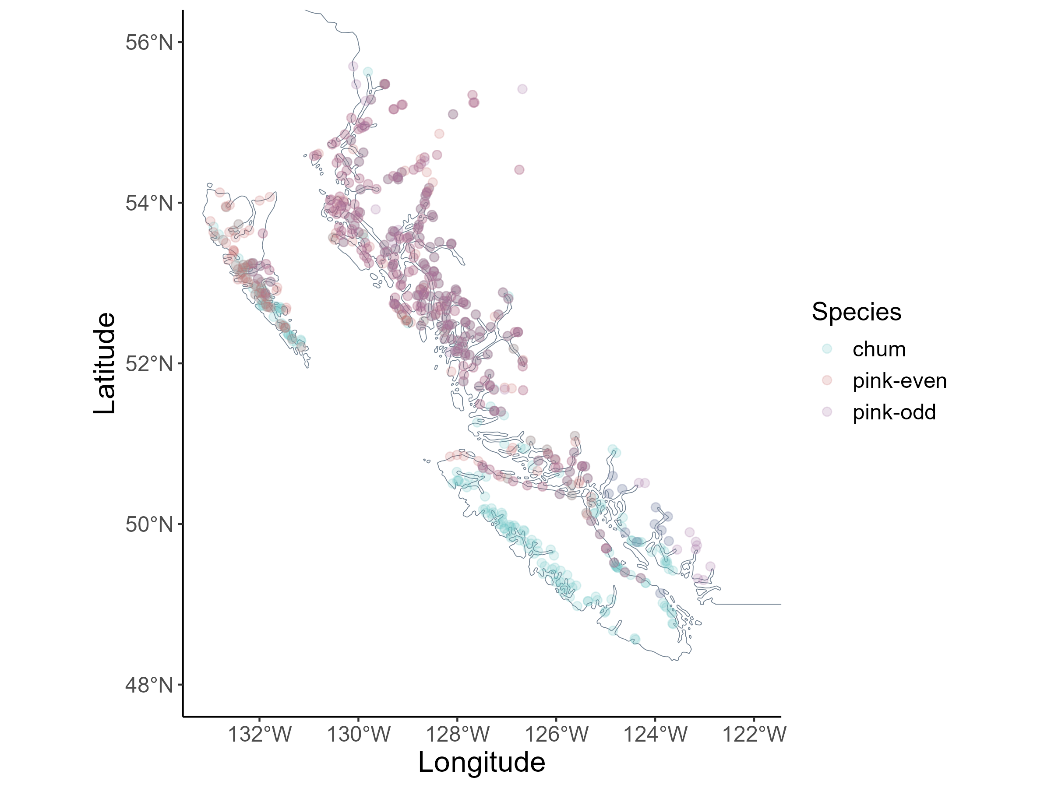

## Extended Reconstructed Sea Surface Temperature (ERSST)

