Coastwide analysis of forestry impacts on BC Pacific Salmon

Nov 2024

Table of Contents

# Chum and Pink salmon Watersheds

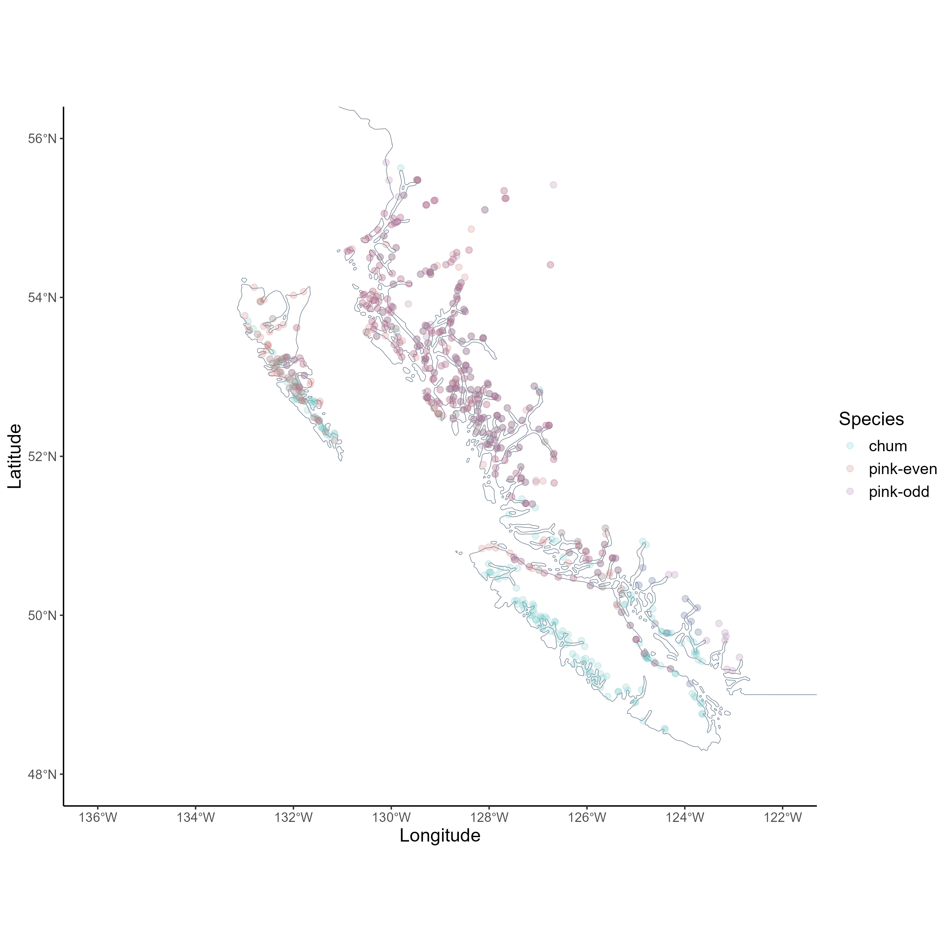

## ERSST

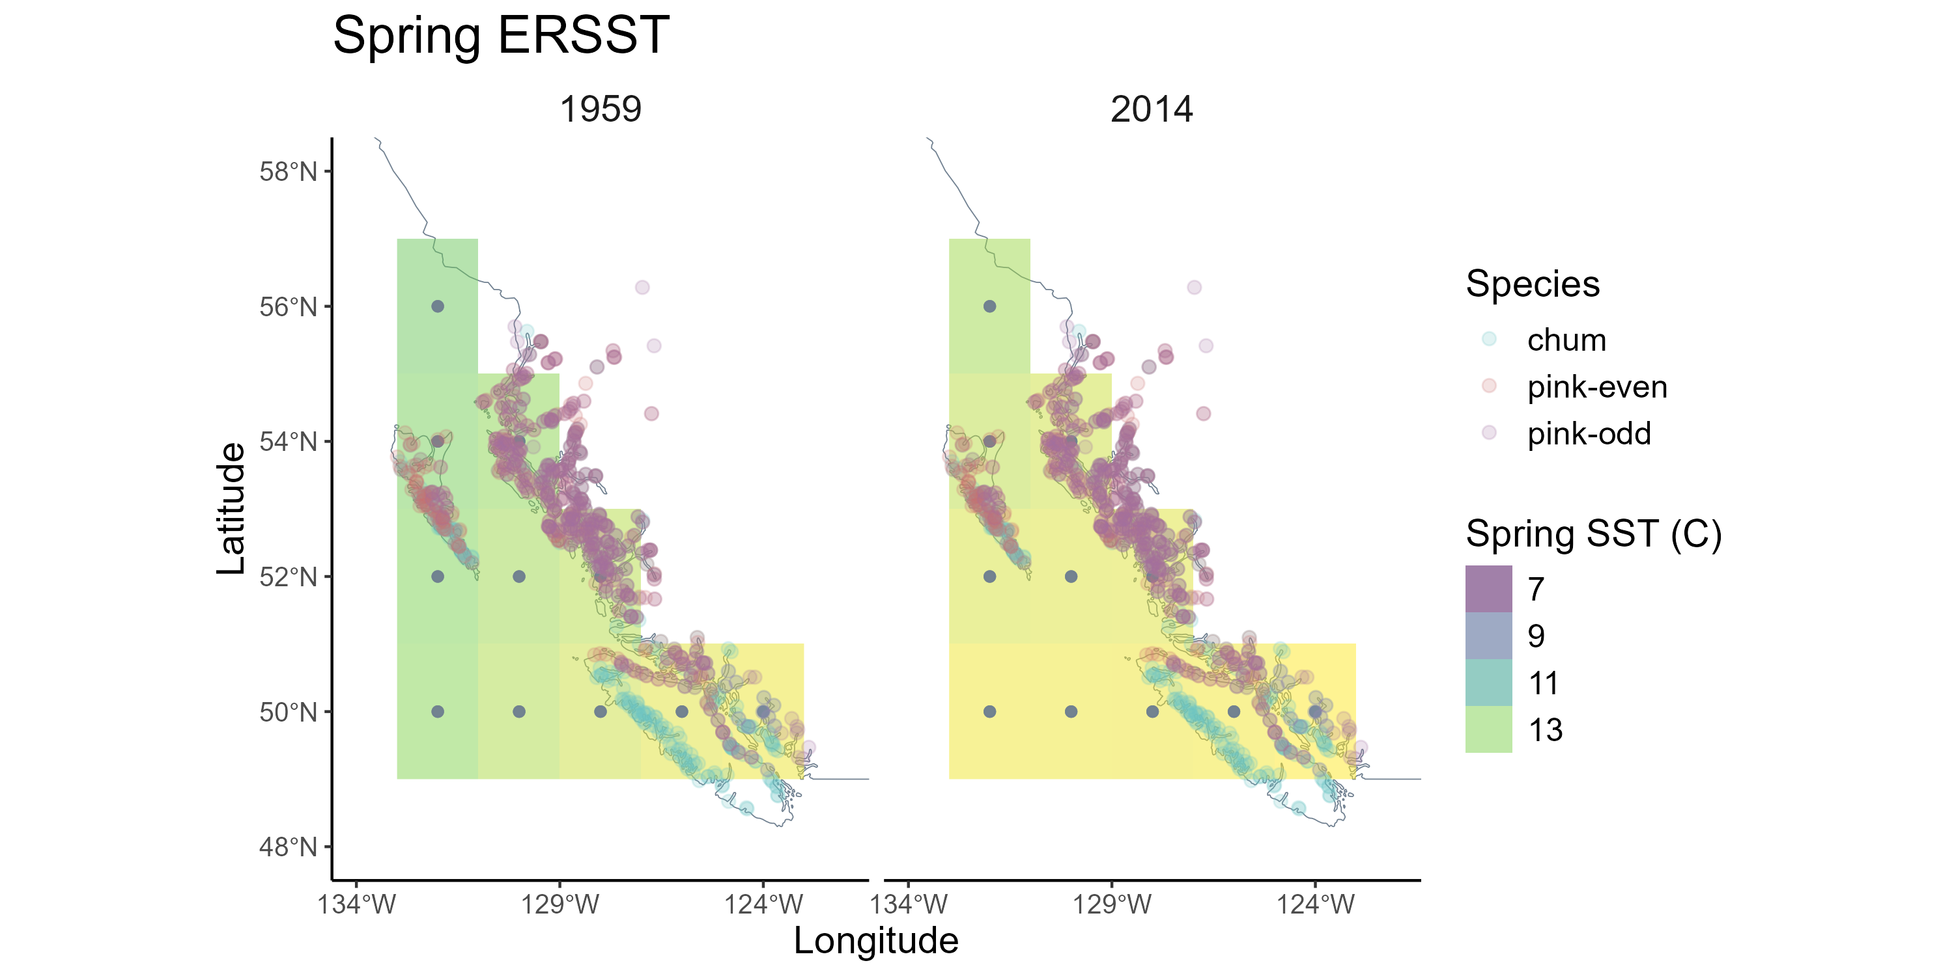

# Chum salmon

## Beverton Holt Models

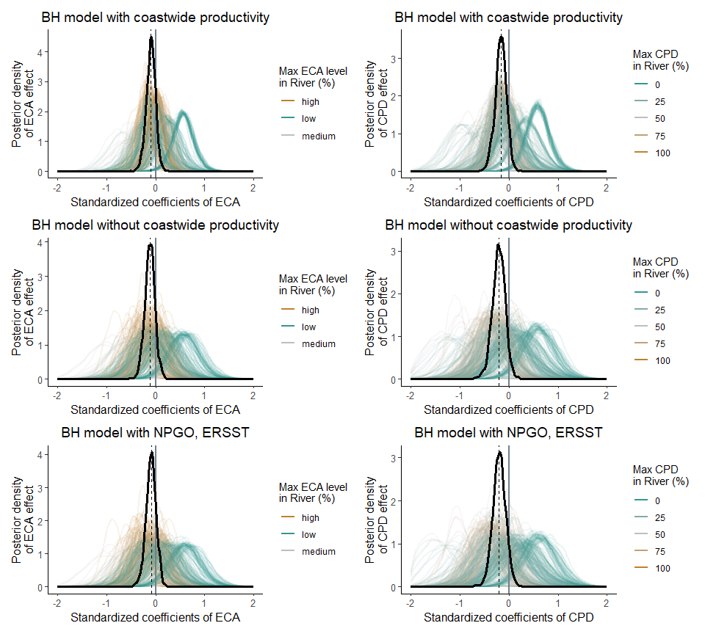

## Ricker Models

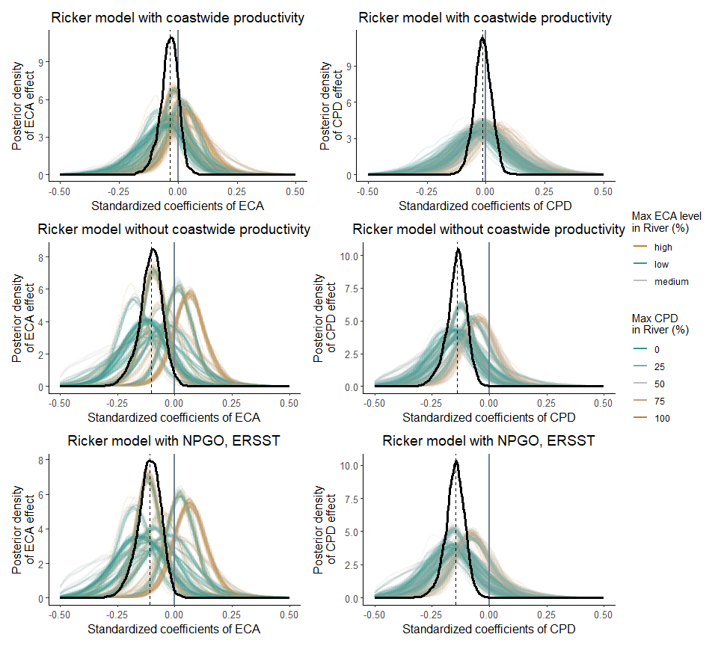

## Productivity decline

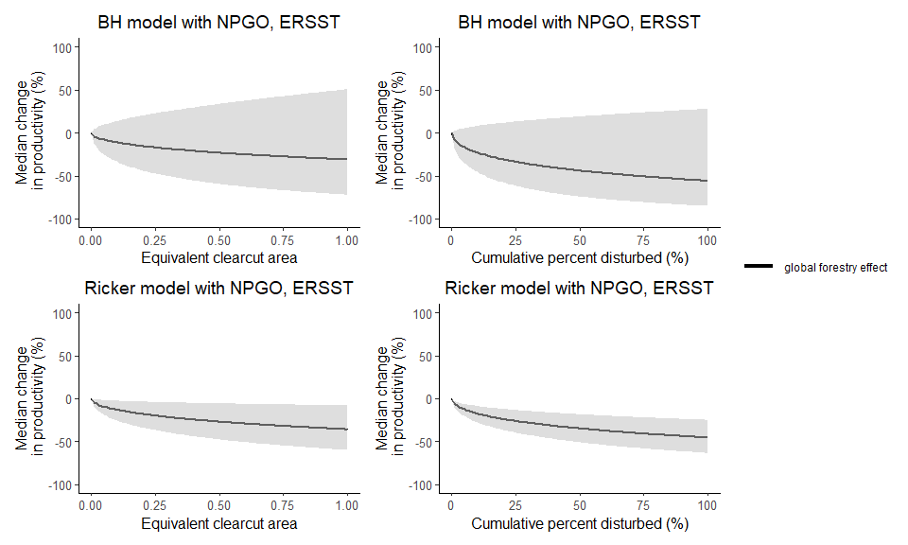

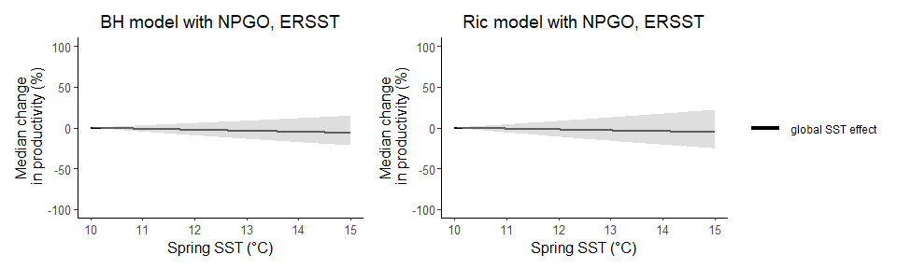

## Effect of SST

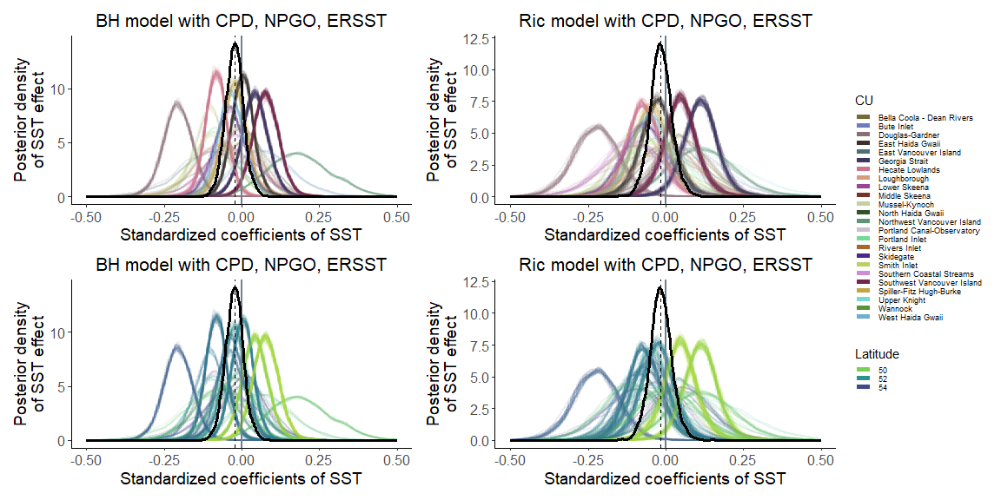

## Effect of NPGO

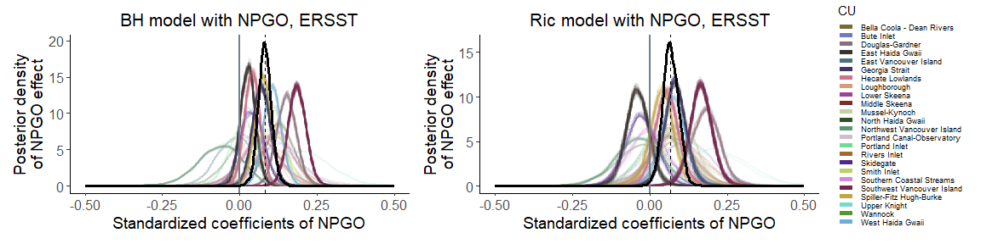

# Pink Salmon

## Beverton Holt Models

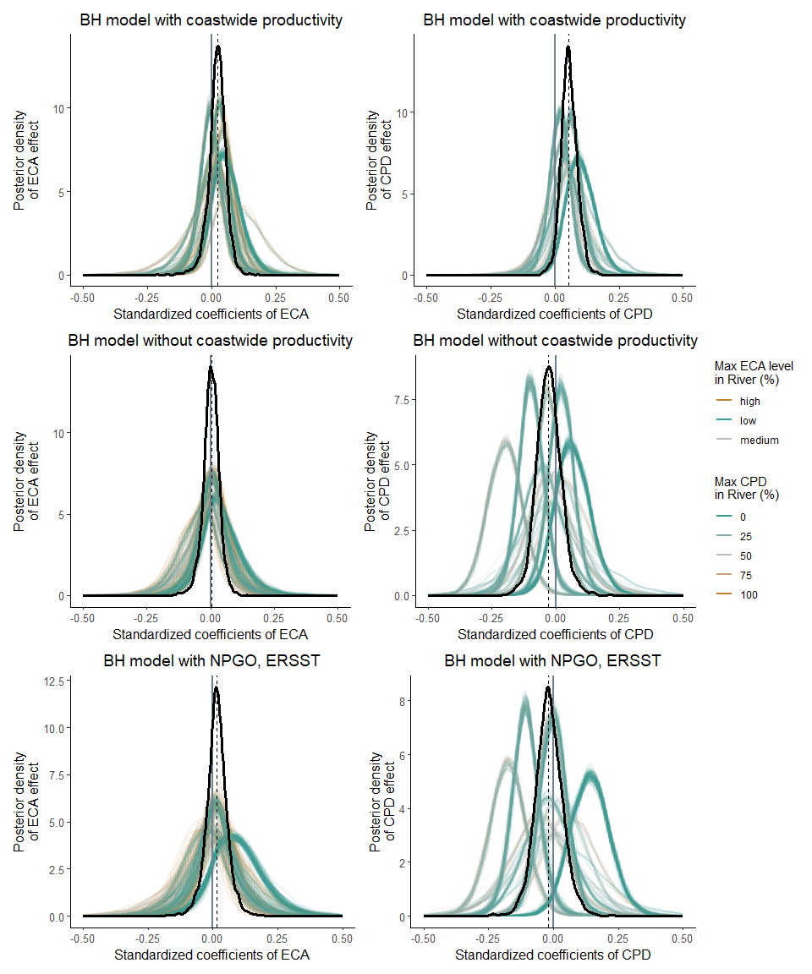

## Ricker models

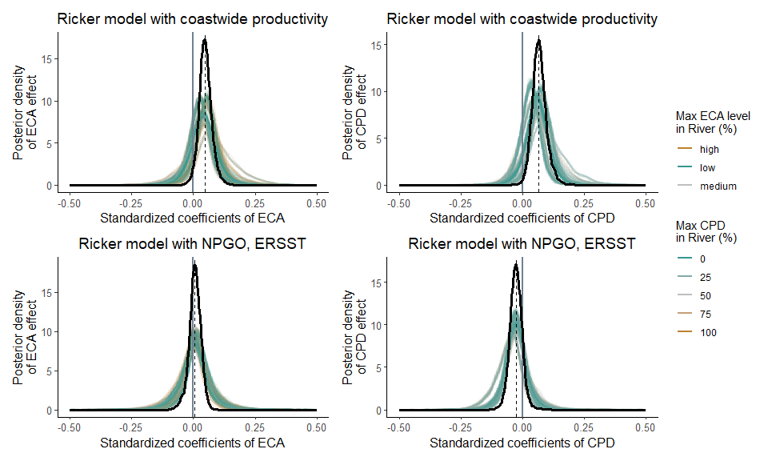

## Productivity Decline

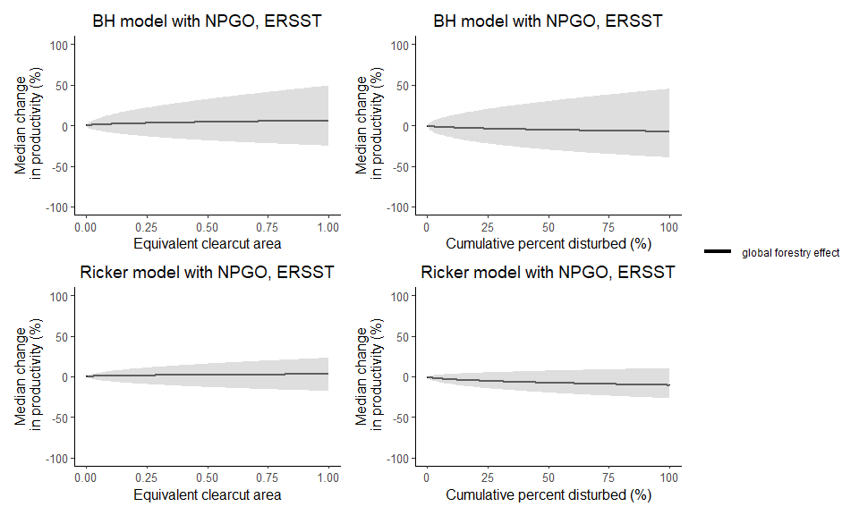

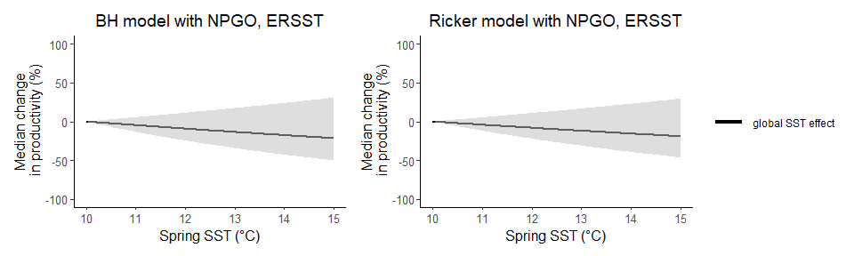

## Effect of SST

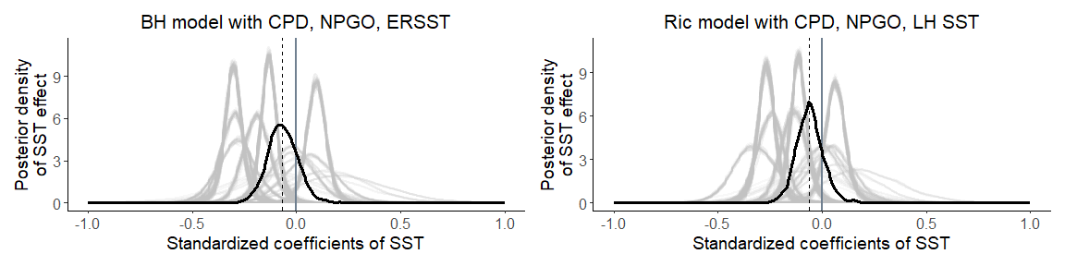

## Effect of NPGO

