Skipjack Survey and Assessment Programme

James Hogan, FAME - SPC

25 September 2024

### Skipjack science lifting economic ceiling

SPC’s Skipjack Survey and Assessment Programme (SSAP) ran from 1977 – 1981. SSAP’s excellent science measured for the first time the skipjack tuna fishery size. The SSAP researchers secured approximately $US3 million of donor funding (or 33% of SPC’s total funding at the time) to conduct the ambitious three-year project across SPC’s member EEZs.

At the time, SPC had no experience in undertaking such ambitious pieces of advanced applied scientific research. Nor was it organisationally equipped or experienced with undertaking this size of technical work.

### New science created new opportunity

SSAP greatly expanded the world’s knowledge of the biology of skipjack and other tuna species and quantified for the first time the large size of the skipjack resource in the Western and Central Pacific (estimated by SSAP at around 3 million tonnes).

The value of the 1977 work to pacific countries, producers and consumers has been immense. The overwhelming growth of the pacific activity is shown in Figure 1.

Figure 1: Number of Purse Seine Vessels Operating in the WCPFO Purse Seine Fishery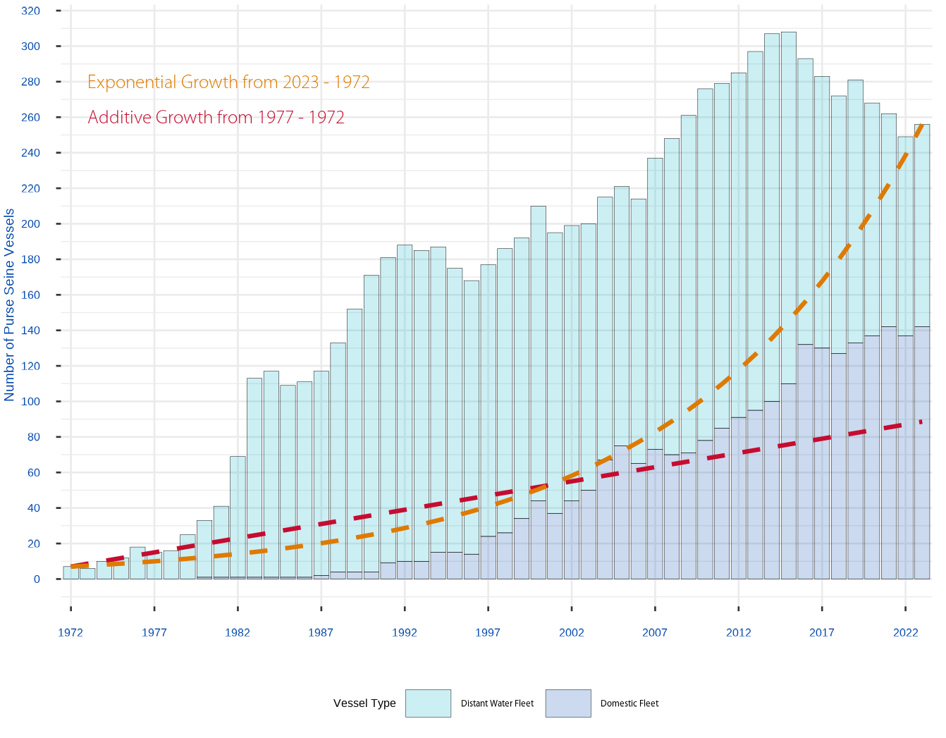

Between 1977 and 1980, the number of distant water nation purse seine vessels fishing the pacific increased from 15 to 33. Between 1980 and 1982, they had increased again by a further 36 vessels. And in 1983 the total number of purse seine vessels working the pacific became 113.

The growth in fishing activity far exceeded indicative comparative growth rates, either additive growth from the pre-SSAP (1972 – 1997) extrapolated into the future, or from exponential vessel growth rates between 1977 – 2023.

Increased fishing activity extracted increasing volumes of mainly skipjack tuna from the pacific, making the pacific the overwhelming source of the world’s tuna supply (Figure 2).

Figure 2: Global Annual Skipjack Tuna Catch Volumes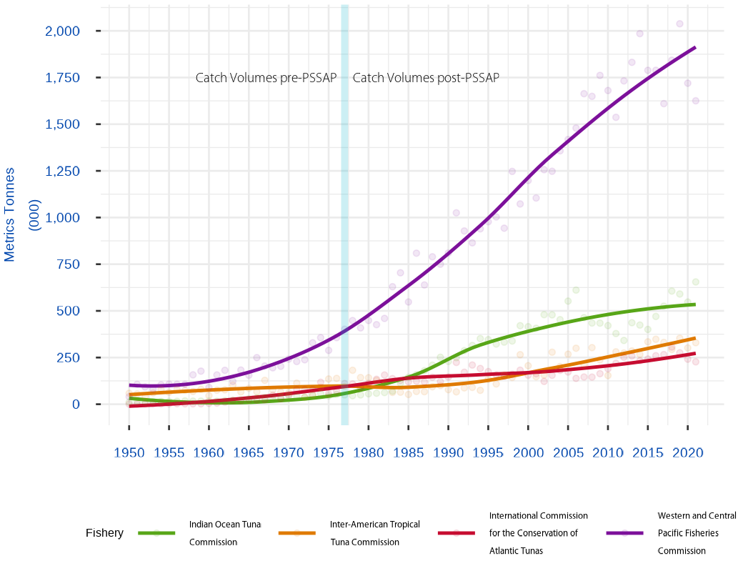

### The Value of Harvested Pacific Skipjack

The Pacific Island Forum Fisheries Agency (FFA) estimate the value of tuna extracted from the Pacific.[1] Unfortunately, value information prior 1997 is unavailable, so the FFA metrics only provide a partial picture of the value of the economic potential generated by the SSAP programme.

Table 1: Present Value of Historical Catch Value

| Year | Volume - Tonnes(Mill) | Value - USD(Mill) | Present Value - USD(Mill) at 2024 |
| --- | --- | --- | --- |
| 1997 | 933,912 | $1,167 | $2,592 |
| 1998 | 1,234,264 | $1,366 | $2,946 |
| 1999 | 1,065,651 | $911 | $1,907 |
| 2000 | 1,184,584 | $808 | $1,642 |
| 2001 | 1,091,485 | $934 | $1,843 |
| 2002 | 1,241,775 | $1,009 | $1,933 |
| 2003 | 1,235,177 | $942 | $1,752 |
| 2004 | 1,349,004 | $1,259 | $2,274 |
| 2005 | 1,413,215 | $1,288 | $2,259 |
| 2006 | 1,482,275 | $1,467 | $2,497 |
| 2007 | 1,673,462 | $2,247 | $3,714 |
| 2008 | 1,674,934 | $2,927 | $4,697 |
| 2009 | 1,788,036 | $2,192 | $3,415 |
| 2010 | 1,687,594 | $2,218 | $3,355 |
| 2011 | 1,544,851 | $2,671 | $3,922 |
| 2012 | 1,741,929 | $3,765 | $5,368 |
| 2013 | 1,848,614 | $3,822 | $5,291 |
| 2014 | 1,991,600 | $2,934 | $3,943 |
| 2015 | 1,795,007 | $2,229 | $2,908 |
| 2016 | 1,797,447 | $2,653 | $3,361 |
| 2017 | 1,618,962 | $2,980 | $3,665 |
| 2018 | 1,852,983 | $3,053 | $3,645 |
| 2019 | 2,035,695 | $2,873 | $3,331 |
| 2020 | 1,725,568 | $2,439 | $2,745 |
| 2021 | 1,683,528 | $2,378 | $2,599 |
| 2022 | 1,749,384 | $2,964 | $3,145 |
| **Total** | **40,440,936** | **$55,496** | **$80,750** |

Assuming a conservative 3% potential investment rate then, over the shortened timeframe of the available catch value statistics, the current day nominal value of the historically skipjack harvest since 1997 is approximately US$80,750 million in 2024.

In comparison, if the initial US$3 million SSAP investment made in 1977 was invested at 3% per annual, it would be worth US$12 million in today’s nominal dollars.

The initial US$3 million investment has generated a compounding average nominal rate of return of 20.6% per annum since 1977.

And that is without measure the value of the harvested skipjack between 1997 and 1997!

### Returning Value to Pacific Countries

Access fees received by pacific countries in 2021 (or the latest year for which data are available) were approximately US$515 million: approximately 26.8% of the value of the regional offshore catch. Table 2, from the Benefish Study 1[2] and 4[3] reports provide a partial picture into the growth in fishing-generated licensing fees.

Table 2: Access fees for offshore fishing 2007–202 (or latest year)

| **Pacific Island Country and Territory** | **1999 Access Fees** | **2007 Access Fees** | **2014 Access Fees** | **2021 Access Fees** | **% Change** |
| --- | --- | --- | --- | --- | --- |
| Cook Islands | 169,072 | 298,680 | 350,352 | 6,598,639 | 3803% |
| FSM | 15,400,000 | 16,823,232 | 19,733,651 | 72,300,000 | 369% |
| Fiji | 212,000 | 292,963 | 343,645 | 163,174 | -23% |
| Kiribati | 20,600,000 | 24,351,784 | 28,564,643 | 116,989,340 | 468% |
| Marshall Islands | 4,982,699 | 2,227,154 | 2,612,451 | 33,031,253 | 563% |
| Nauru | 3,400,000 | 5,868,605 | 6,883,874 | 42,165,943 | 1140% |
| Niue | 151,793 | 300,941 | 353,003 | 883,086 | 482% |
| Palau | 800,000 | 1,278,260 | 1,499,400 | 7,870,000 | 884% |
| PNG | 5,840,000 | 17,061,486 | 20,013,123 | 145,014,245 | 2383% |
| Samoa | 188,616 | 292,963 | 343,645 | 1,119,691 | 494% |
| Solomon Islands | 273,458 | 13,411,764 | 15,731,999 | 42,110,205 | 15299% |
| Tonga | 152,041 | 150,715 | 176,789 | 1,045,629 | 588% |
| Tuvalu | 5,900,000 | 3,927,731 | 4,607,228 | 31,650,914 | 436% |
| Vanuatu | 218,448 | 1,550,058 | 1,818,218 | 1,253,206 | 474% |
| Tokelau | Not Recorded | 1,685,691 | 1,977,315 | 12,600,000 | 647% |
| **Total** | **58,288,127** | **89,522,027** | **105,009,336** | **514,795,325** | **783%** |

No report prior to the Benefish Study 1 report compiled the fishing access fees from SPC countries into a single table. However, from Table 2, its clear that prior to the introduction of the Vessel Day Scheme (VDS) in 2007 significantly increased access fees.

Benefish Study 4 notes that although VDS commenced in December 2007, it wasn’t fully implementated until 2012.[4] Early in the scheme access fees were derived from predominately foreign fleets as governments sort to encourage their domestic offshore fishing industries. However, with the growth in the various domestic vessel numbers (Figure 1), governments are now receiving access fees from all vessels active in their waters.

# References

FFA. 2021. “Value of WCPFC-CA Tuna Fisheries 2023.” Pacific Island Forum Fisheries Agency. <https://www.ffa.int/download/wcpfc-area-catch-value-estimates/>.

Gillett, R, and M Fong. 2023. “Fisheries in the Economies of Pacific Island Countries and Territories (Benefish Study 4).” The Pacific Community. https:// purl.org/spc/digilib/doc/ppizh.

Gillett, R, and C Lightfoot. 2001. “The Contribution of Fisheries to the Economies of Pacific Island Countries.” The Asian Development Bank. <https://www.adb.org/sites/default/files/publication/28819/contribution-fisheries.pdf>.

1. FFA (2021)
2. Gillett and Lightfoot (2001)
3. Gillett and Fong (2023)
4. Gillett and Fong (2023) on page 495