**Title:** Climate and ecosystem indicators of the WCPO

State of the climate and ecosystem for the Western and Central Pacific Ocean 2025

**Authors:** Simon Nicol, Bernadette Sloyan, Nicholas Hill, Thomas Moore, Joanne Potts… etc

**Background/Introduction**

The environment and climate are continuously influencing tuna fisheries in the Pacific Ocean. Since 2015, the Scientific Committee (SC) has explored the development of ecosystem and climate indicators to help inform the management of fisheries targeting tuna and tuna-like species in the WCPFC (Anon 2015; Smith et al. 2016). A series of reports have subsequently been produced since SC11 in 2015 describing the objectives and testing criteria for these indicators, and a set of candidate indicators have been produced since 2019 at SC15 (Juan-Jorda et al. 2019; Allain et al. 2020; SPC 2021; SPC 2022; SPC 2023; SPC 2024).

This report represents a continuation of this work in presenting a set of updated ecosystem and climate indicators for adoption by the SC. These indicators will help inform SC and the WCPFC Commission on the current state of the climate and ecosystem of the WCPO and any prevailing trends that are likely to influence the sustainability and management of tunas, their fisheries and surrounding ecosystems. The intent of this report is that it will be adopted by the Commission and routinely produced to provide up-to-date information to the SC and WCPFC Commission to help inform decision-making and support its application of an ecosystem-based approach to fisheries management (EAFM).

Below is some text from previous SC papers that outlines the terms of reference and process for adopting these indicators (Smith et al. 2015; SPC 2022).

***Terms of Reference***

*A drafted terms of reference for the Ecosystem and Climate Indicators project was provided as Annex 3 to SC18-EB-WP-01 with the following specified objectives and scope of work:*

***Objectives***

* *Develop and test candidate ecosystem and climate indicators to track the impact of climate and ecosystem changes on WCPFC fisheries and ecosystems.*
* *Provide technical advice to the Scientific Committee on the suitability of criteria used for testing and evaluating the performance of candidate indicators.*
* *Support the Scientific Committee in developing tools to communicate ecosystem and climate change impacts to WCPFC and external stakeholders and interest groups.*

***Scope of Work***

* *Technical analyses to develop and test candidate indicators.*
* *WCPFC member and expert workshops to refine indicators.*
* *Scientific Committee reporting.*
* *Routine preparation of adopted indicators.*
* *Development of tools for communication to WCPFC and wider stakeholders.*

*The SSP was tasked by SC18 to develop a workplan for this project to be endorsed by SC19 and to develop an associated budget.*

***Process for adopting indicators***

*SC12 noted that developing a thorough understanding of how to interpret potential indicators, their appropriate reference levels and baselines, and how reliable they are for prediction were critical steps for indicator adoption by the WCPFC Scientific Committee (SC). Criteria for developing and testing candidate indicators has subsequently been proposed to the Scientific Committee:*

* *science and data based;*
* *characterize the states and trends of WCPFC marine ecosystems with respect to fishing activity and/or climate (including reference levels and baselines);*
* *reflect well-defined processes underlying fishing activity and fishery responses to climate;*
* *responsive to changes attributable to fishing pressure and climate (i.e. having minimal time-lags and capability to provide early warning);*
* *estimable on a routine basis with a historical data time-series available;*
* *cost-effectiveness;*
* *scalable across national, sub-regional and regional scales;*
* *linked to existing WCPFC models and decision-making processes (for inclusion in MSE scenarios, validation of predictions and testing of model assumptions);*
* *can be routinely estimated by members without reliance on the Science Service Provider.*

**Objectives**

The intent of this report is to present an up-to-date state of the climate and ecosystem report for the WCPO to help inform the management of tuna and tuna-like species by the WCPFC. The indicators intend to provide an outlook of the current state of the environment, natural variability and any underlying persistent changes across key oceanographic features and associated tuna fisheries that may affect their sustainability and management. Here, we present X indicators that summarise the climate and ecosystem of the WCPO including temperature, warm pool etc as well as several fisheries indicators that detail how the fishery is responding to the underlying climate/ecosystem.

For selection, indicators had to meet the criteria detailed above which required a combination of the indicator being reflective of the current environment, responsive to changes, cost effective, and science-based among others. Based on these criteria, the following indicators selected were:

* Area of the warm pool
* …

Below, a rationale for the inclusion of each indicator is given along with a summary of their status and trends over time.

**2024 summary**

In 2024, the warm pool was increasing/decreasing, El nino in X phase etc.

**Indicator X: Centre of gravity (COG) of the purse seine fishery**

**Rationale:** The WCPFC purse seine fishery predominately operates in the western pacific warm pool. The warm pool is a large, warm body of water at or above 28oC that sits in the equatorial western pacific. The warm pool naturally varies in size and extent with changes in the environment, and in particular with ENSO events, which influences where effort and catch consequently occurs in the purse seine fishery (Senina et al. 2008). The warm pool is also considered as an important spawning ground for tuna species, in particular skipjack tuna and so changes in its size, structure or position may also influence the productivity of tuna (Ashida 2020; Fujioka et al. 2024).

With the impacts of climate change, the warm pool is predicted to increase in size, driving a potential eastward shift in tuna biomass (Lehodey et al. 2013; Bell et al. 2021). By monitoring the centre of gravity (COG) of purse seine effort and catch, we can monitor if fisheries are responding to these predicted changes and by proxy tuna dynamics. Any shift in the location of the purse seine fishery is also relevant as it relates to income for PICTs when fishing occurs in their EEZ.

**Status:** For effort, there is a clear distinction in trends over time by set type (Figure 1). For free school sets, effort COG shows interannual variability but no clear underlying trend from 1990-2023. In contrast, there is a clear eastward shift in the COG of drifting FAD-associated sets over time. It is difficult to determine if this is a climate related shift in the warm pool and tuna dynamics, or if it is a shift in fishing behaviour driven by increased uptake of FAD-associated fishing. Equally, the lack of movement in the free school component of the fishery could suggest tuna haven’t shifted, or that the fishery has not yet adapted to change and may be driven by other factors such as distance to port.

For catch, there is an underlying eastward shift in all three tuna species, however the strength of these trends is variable (Figure 2). BET shows the most prominent eastward shift over time, followed by SKJ and YFT which show a very small eastward shift. Interannual variability is also present in the COG of catch of all three species as is present in effort. As with effort, it is difficult to disentangle shifts in tuna and changes in fishing behaviour to explain these underlying trends.

**Description:** Best estimates of total purse seine catches of BET, YFT and SKJ were used to determine the COG of catch, and best estimates of effort by set type for the COG of effort. Data used was extracted from SBEST databases using raised (aggregated) 1x1 degree purse seine fishery data where set type information was available. Catches and effort were constrained to WCPFC regions 6-8 (latitude: -20oS – 10oN, longitude: 140oE – 210oE) and from years 1990-2023 (Vidal et al. 2020). Catches and effort from domestic Indonesian, Vietnamese, and Philippines flagged vessels were also not considered given differences in vessel class and fishing strategy. Associated purse seine sets were considered as sets made on drifting FADs only, floating objects and anchored FADs were not considered in this analysis. The COG is an annual estimate of the weighted mean position of catch and effort where the number of sets is used to weight the effort COG, and catch to weight the catch COGs by species.

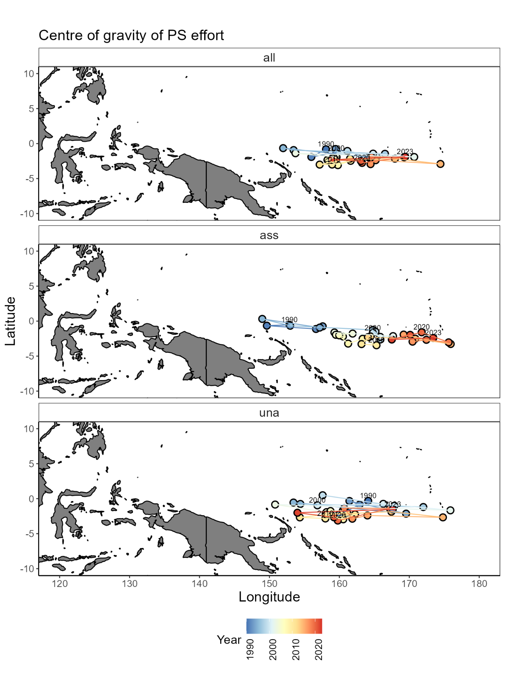

Figure 1: Centre of gravity of WCPFC purse seine effort by set type: all sets (all), drifting FAD-associated sets (ass), and free-school unassociated sets (una) from 1990-2023.

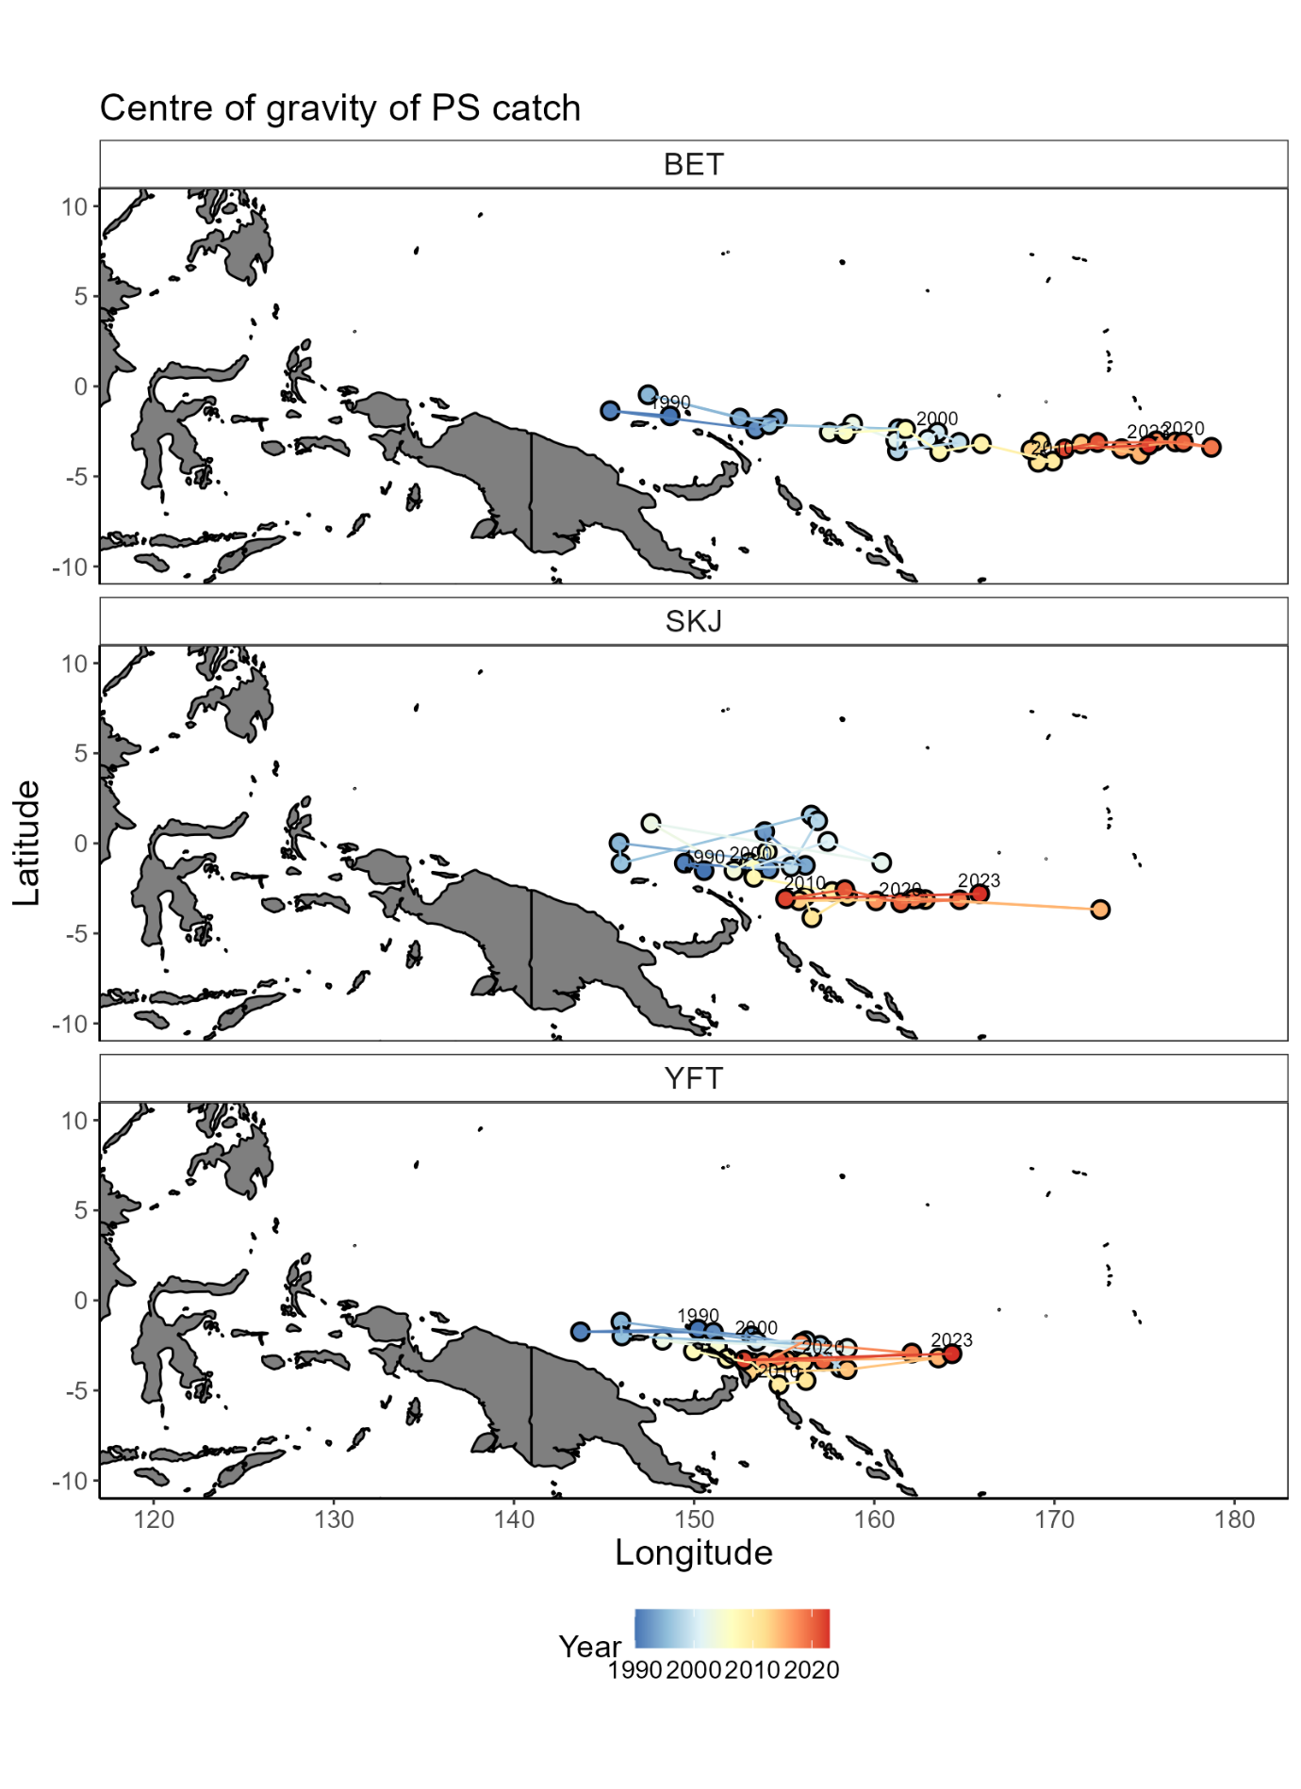

Figure 2: Centre of gravity of WCPFC purse seine catch of bigeye tuna (BET), skipjack tuna (SKJ), and yellowfin tuna (YFT) from 1990-2023. All sets?

**Indicator 2: Size structure of tunas**

**Rationale:** The size composition of a fish population is influenced by a range of factors including fishing and its environment. For example, changing oceanographic conditions could influence prey availability having knock-on effects to fish size composition. How the environment and climate change is influencing tuna size composition is not well known. However, by monitoring tuna size composition, any changes can be identified which can help determine sustainability of the fishery and inform management decisions.

**Status:** Trends in the size composition of tunas has varied throughout the timeseries from 1990-2023 (Figure 3). This is likely a reflection of several factors including changes in sampling design, fishing behaviour, and the underlying environment and populations.

For BET, their size composition has fluctuated over time rising to values above the 1990-2000 average of 122cm from 2007-2012 before declining to apprixmately 2018. In recent years, length composition hs improved and the mean length in 2023 of 125cm is above the historical mean. Throughout this time, most BET catches in the longline fishery are above the length at 50% maturity (Farley et al. 2017).

For SKJ, their size composition has been more variable which is likely a reflection of fishing and sampling programs. In recent years, SKJ size composition has declined with nearly 75% of the length composition below the historical mean length of 51.3cm in 2022. Unlike YFT and BET, catches have predominately been below the length at 50% maturity of 55cm which is in part due to the overwhelming majority of catch and sampling come from the purse seine fishery (Ohashi et al. 2019).

For YFT, a decline in their size composition since 2012 is apparent. From 2000-2010, they show a similar trend to BET where their size composition declined in the early 2000s before rising around 2010. However, in contrast their size composition has since declined and consistently remained below the historical mean value of 120.8cm since 2012, with a 2023 mean length of 113.9cm. Like BET, most of the size composition remains above the length at 50% maturity of 105cm (Magnusson et al. 2023).

For both BET and YFT, there is a slight upward trend in the proportion of small fish caught (<105cm), and a decrease in the proportion of large fish caught (>140cm) throughout the timeseries. However, this trend is not clear, and recent years have shown a shift in the opposing direction. This could be driven by fishing pressure and the removal of large individuals from the population, or an increase in small individuals in the population from enhanced recruitment for example. There were no clear trends in the size composition of SKJ. Proportion of big fish X%, small fish Y% etc.

**Description:** Length composition data for the three tuna species were derived from observer and port sampling programs from SPC databases for the years 1990-2023. Longline data was used for BET and YFT, and a combination of longline and purse seine data for SKJ. Where required, lengths were converted to for length measurements using well established conversion factors (Macdonald et al. 2023). Any outliers in the data were removed and length composition metrics extracted including the 20th, mean and 80th percentiles to represent small, mean and large fish in each species. By monitoring these three indicators rather than just the mean length, an improved understanding of a species size composition is gained. For example, a change in recruitment can be identified by changes in the proportion of small individuals.

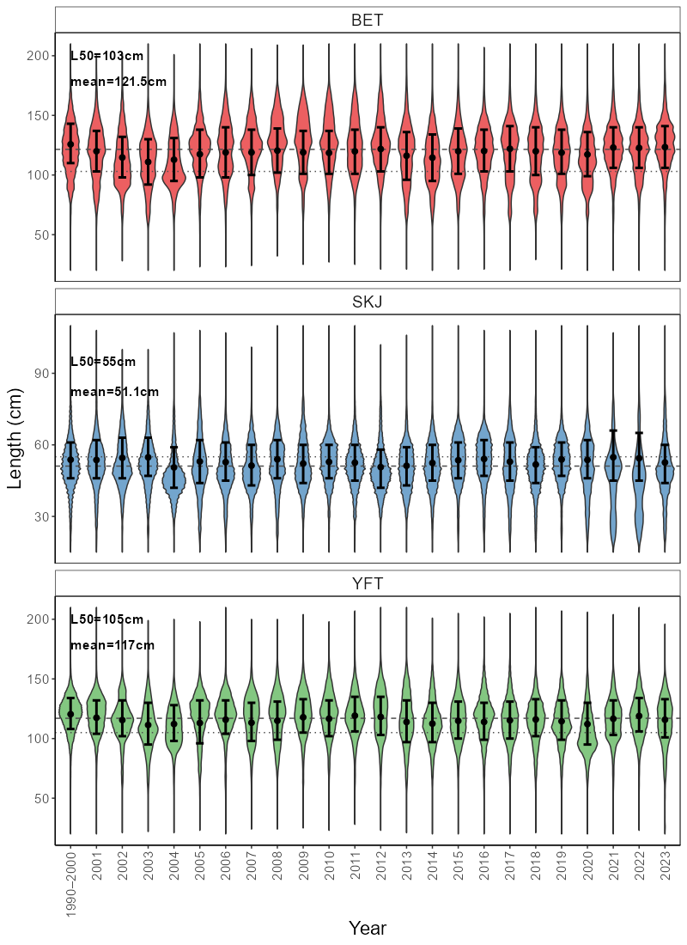

Figure 3: Length composition of bigeye tuna (BET), skipjack tuna (SKJ, and yellowfin tuna (YFT) in WCPFC longline fisheries (plus purse seine for SKJ) from 1990-2023. Dashed line = mean length from 1990-2000, dotted line = length at 50% maturity. Black dot = mean length with 25th-75th percentile error bars.

**Exploring evidence of climate change driven shifts in the longitude of WCPFC purse seine effort**

Climate change is impacting marine ecosystems and their associated fisheries (Hoegh-Goldberg et al. 2010; Poloczanska et al. 2013; Pecl et al. 2017; Antao et al. 2020). This includes impacts such as shifts in the ranges of species and ecosystems (Pecl et al. 2017; Pinsky et al. 2020), changes in species physiology (Agarwal et al. 2024), and in community compositions (Johnson et al. 2011; Poloczanska et al. 2013; Poloczanska et al. 2016). However, how these climate-induced impacts are manifesting themselves in individual species, ecosystems and fisheries are varied (Molinos et al. 2017).

The Western and Central Pacific Ocean (WCPO) supports the world’s largest and most valuable tuna fishery in the world (FAO 2024). The prominent oceanographic feature in this region is the western pacific warm pool which is characterised as a large body of water above 28oC that sits in the equatorial WCPO and is the main fishing grounds for the Western and Central Pacific Fisheries Commission (WCPFC) purse seine fishery. The warm pool shifts in size with natural climate variability, namely with El Nino Southern Oscillation (ENSO) events, which influences the strength of equatorial trade winds and surface currents dictating how contracted or spread out the warm pool is (Weller et al. 2016; Leung et al. 2022). Tuna and the purse seine fishery shift with the warm pool following favourable environmental conditions with several tropical tuna species also known to spawn in this region (Lehodey et al. 2003; Ohashi et al. 2019). With the effects of climate change, predictions suggest an eastward expansion of the western pacific warm pool and with it, an eastward shift in tuna biomass (Weller et al. 206; Bell et al. 2021). If tuna biomass does shift, this will have flow on effects to Pacific Island countries and territories (PICTs) which are highly dependent on fisheries for food security and as a source of income (Bell et al. 2015; Gillett & Fong 2023).

In response to climate change, fisheries administrations are increasingly looking at ways to monitor and adapt to its effects (Taylor & Walter 2024). Within tuna regional fisheries management organisations (RFMOs), climate and ecosystem indicator reports are now being regularly produced to monitor environmental conditions and to track if any underlying shifts in ecosystems, fisheries or species of interest are occurring (Griffiths & Fuller, 2019; Juan-Jorda et al. 2018; SPC 2023). Since 2015, the WCPFC has monitored the WCPO ecosystem and climate using a series of indicators that include catch and effort location, environmental indicators (e.g. sea surface temperature), and tuna biology (e.g. mean length of catch) which have been presented to the Scientific Commission to inform management (Anon 2015; SPC 2023). However, the empirical nature of many of these indicators make it difficult to disentangle natural climate variability, changes in fishing behaviour, and any underlying trends.

The centre of gravity (COG) for catch and effort for the purse seine fishery has been extracted in previous WCPFC ecosystem and climate indicator reports to explore shifts in the location of the purse seine fishery over time (SPC 2023). These COG indicators provide a simple, empirical indicator that can help to track underlying changes in catch and effort location and therefore potentially changes in tuna dynamics (Rufino et al. 2018; SPC 2023). However, there are myriad factors that influence where purse seine catch and effort occurs such as ENSO events, set type, vessel type and flag. For example, sets are likely to occur further eastwards with el nino events, than other ENSO events (Lehodey et al. 2003). When using COG only, these factors cannot be explicitly accounted for and so it is difficult to determine what is driving shifts in the purse seine fishery over time and whether there is a long term, underlying change occurring.

One such approach that could be used to overcome some of these issues is the use of generalised additive models (GAMs) to standardise out the effect of these variables similar to standardised CPUE approaches (Hoyle et al. 2024). There are a range of variables that influence catchability in the WCPFC purse seine fishery such as vessel size, environmental conditions, and technological capacity (e.g. sonar, helicopters, drifting-FADs). By using modelling approaches, analyses can better account for the effect such variables have on resultant indices and better understand both the effect these variables have on empirical indicators like COG, and if any underlying trends do exist. By attempting to understand effort dynamics, it also removes the need to accurately determine an index of abundance which has proven difficult for purse seine fisheries (Vidal et al. 2020).

The aim of this study was to model changes in the longitudinal position of WCPFC purse seine effort over time while accounting for variables known to influence catch and effort dynamics. GAMs were applied to both SBEST aggregated and logbook purse seine data from 1990-2023. Outcomes from these models help to explain how different variables influence the dynamics of the purse seine fishery, and to see if a clear, longitudinal shift over time is apparent. This will also improve the design of climate and ecosystem indicators for the WCPFC and inform how the purse seine fishery may be impacted by climate change going forward.

**Method**

**Data**

Both logbook and SBEST aggregated 1x1o tuna purse seine data were extracted from 1990-2023 and constrained to an area of -15o to 10 o degrees latitude, and effort beyond 130 o longitude. The SBEST data is aggregated to the 1x1o grid cell at a monthly timestep for each combination of flag and set type. Given that the SBEST data is aggregated and therefore each row is not a uniform amount of effort, this data was disaggregated by the set column so that each row reflected an equivalent amount of effort approximately. Logbook data was extracted at the operational set level. SBEST was used as the primary data source as it is more complete, with the logbook data used as a secondary source to test model robustness and reliability. As effort was being modelled, sets both with and without catch were included. Below is a summary of the variables chosen to model the data and data filtering required which is summarised in Table 1. The first step in this process involved removing rows with missing data for columns of interest, and rows with less than one set for the SBEST data.

What country a vessel originates from can be an important variable in determining fishing strategy. Flag is a routinely recorded field that is used to determine this. However, it is imperfect as vessels can change their flag for various reasons and have done so through time such as countries chartering vessels to fish their domestic waters. Given the inability to reliably disentangle this issue, flag is used herein as a proxy for this as a catchability variable. Due to poor temporal coverage of many flags, only 10 flags were included in the model: Federated States of Micronesia (FM), Japan (JP), Kiribati (KI), Korea (KR), Papua New Guinea (PG), Philippines distant water fleet (PH), Solomon Islands (SI), Taiwan (TW), United States of America (US), and Vanuatu (VU). Due to a lack of data, Philippines (PH) was also removed from the logbook data.

Set type is another important variable in determining fishing strategy. The most important distinguishing feature is whether the set was unassociated (i.e. a free school set), or associated with some object (i.e. log, whale, man-made FAD). In previous analyses, set type is either filtered to unassociated sets only (Teears et al. 2022), or set type is included as a variable with data grouped into associated or unassociated sets (Vidal et al. 2020). Given that the objective of this analysis was to model longitudinal shifts in effort distribution over time, three groups were assigned including unassociated sets, drifting-FAD associated sets, and anchored FAD associated sets. This allowed the distribution of drifting-FAD associated sets to differ from anchored-FAD sets which behave differently in terms of longitude. Given low sample sizes across time, sets made on animals (e.g. whale sharks) were omitted from the data.

ENSO is a large recurring climate pattern that drives changes in the distribution of warm waters in the WCPO. ENSO driven shifts in the warm pool drive concomitant changes in the distribution of purse seine effort and catch. Most notably, an eastward shift in purse seine catch and effort with the eastward expansion of the western pacific warm pool (Lehodey et al. 2013). Monthly oceanic nino index (ONI) data were downloaded and categorised into el nino, la nina, or neutral events to be used as a variable in the model (<https://psl.noaa.gov/data/timeseries/month/>).

For the final filtered datasets, SBEST had 37% of the raw data remaining (n = 1,173,475 entries), and 75% for the logbook data (n = 704740) (Table 1).

**Model**

Generalised additive models (GAMs) were applied in the R environment using the ‘*mgcv’* package with both logbook and SBEST aggregated purse seine data (R Core Team 2024; Wood et al. 2011). Use of GAMs allows the model to flexibly fit non-linear relationships to the data which were to be expected. Models were fit with longitude as the response variable, and a range of variables known to influence catch and effort (Table 2). Variables explored included set type, flag, ENSO phase, year, month, and latitude. A gamma distribution with log link was assigned for all models.

Several different ways of treating both year and flag were explored to see their effect on model performance. This included year as a linear variable and flag as a factor, year and flag as factors, year and flag as an independent interaction term, and year and flag as a common interaction term. Modelling year and flag with an independent interaction term was fit using thin plate regression splines and allowed the model to assume that each smooth term across years for each flag were independent with no information shared between them. In contrast, fitting year and flag with a common interaction term fits a smooth across years for each flag, but there is shared information with a factor-smooth interaction (Ref?).

Once a preferred model was identified, this model was run with several variations including: with logbook data instead of SBEST, with log catch per set as a weighting variable, and with free school sets only which more closely aligns with models undertaken for the skipjack tuna stock assessment (Teears et al. 2022). This was done to explore the robustness of the model results and how different data inputs influence them.

**Results**

Model performances are summarised in Table 3. Overall, all models provided relatively stable and consistent trends across the year effect and variable responses. model D using a year:flag common interaction term performed best with the lowest overall AIC across the four models that used the same input dataset, and the most deviance explained with 52.8%. Similar model results were achieved using log CPUE weights (modE), when running the model with unassociated sets only (modF), and with logbook data (modG) (Table 3).

Modelling outputs provide an improved, standardised index of predicted longitude over time in comparison to unstandardised outputs from the data (Figure 4). This shows an index fluctuating over time, with evidence of a shift eastwards from approximately 2005 onwards. Compared to the mean annual longitude from the data as the unstandardised index, it is apparent that the effects of other variables such as ENSO events and set type have been accounted for, providing an improved index.

Model D used a common interaction term between year and flag (Figure 5). This interaction term allowed the model to flexibly fit to flags which can have different operating behaviours within and across years, but assumes a common underlying trend across years between the flags. There were two prominent ‘modes’ identified across year and flag, with one group of flags (Kiribati, Korea, Taiwan, United State of America, Vanuatu) showing a slight trend eastwards which largely consisted of distant water fleets that are wide ranging and can flexibly move throughout the convention area. A second group of flags (Federated States of Micronesia, Japan, Papua New Guinea, Philippines, Solomon Islands) did not show this same trend eastwards and consisted of PICT flags, Japan which generally fishes a similar area each year, and the Philippines which focuses on the high seas pockets. Greater uncertainty in the smooths were apparent in early and late years of the timeseries where less data were present for certain flags including Vanuatu and Kiribati in early years, and Philippines in recent years.

Across the variables, several trends that were apparent in the raw data were effectively captured by the model (Figure 6). For example, the model successfully captured that effort shifts longitudinally during ENSO events, namely eastwards during el nino events. The model also showed that drifting-FAD associated sets occur further east than anchored-FAD and unassociated sets. Lastly, it captured a minor seasonal trend with an eastward shift in effort during the second half of the year.

**Discussion**

This analysis represents one of the first attempts to model long-term distribution shifts in effort of the WCPFC purse seine fishery to explore evidence of the impacts of climate change. Although preliminary, these results present a substantial step forward in understanding the underlying drivers of change in the spatial distribution of purse seine effort and will help inform ecosystem and climate indicator design. Results show disparate trends between two different ‘modes’ of vessel flag, with some flags showing an eastward shift which are generally distant water flags that can flexibly move throughout the convention area. The second mode showed no longitudinal trend over time and are generally static in their spatial distribution of effort. It remains somewhat unclear whether a climate-driven shift in purse seine effort is occurring and aligns with predictions (Bell et al. 2021), but results do suggest that if such a shift is occurring, that the ability of different vessels/fleets/flags to adapt will vary.

What drives fishing effort location in the WCPFC purse seine fishery is dynamic. This analysis identified that several of the major distant water flags have shifted eastwards in their effort distribution over time while accounting for several variables known to influence effort (text about VDS, country agreements etc here maybe?). For another mode of flags, the longitudinal distribution of effort was largely static over time. These flags were either PICT nations that largely fish within their own EEZs and regularly fish anchored FADs (e.g. PG, SI), or flags that are restricted in their spatial distribution for some other reason like the Philippines which largely fishes in the high seas pockets, and Japan whose fleet generally fishes a similar area most years.

As the WCPO continues to be impacted by climate change, the adaptability of the purse seine fishery and different flags will be variable. Those distant water fleets that flexibly move throughout the convention area will be able to follow favourable conditions for fishing, while the second mode of flags may be less able to do so. This may result in a ‘winners’ and ‘losers’ scenario where some vessels or flags are able to adapt to the impacts of climate change, while others are more susceptible to its impacts and see declines in catches or catch rates. To adapt to climate change, the WCPFC and member countries for example could consider updated arrangements that determine where and when vessels can fish to counteract shifts in tuna distribution (Bell et al. 2021).

Care needs to be taken when interpreting trends from simple, empirical climate and ecosystem indicators. Several variables known to influence purse seine fishing also influence the longitudinal distribution of purse seine effort. By modelling longitude while accounting for several of these variables, a more reliable index was developed. Outputs showed a smoother trend in longitude over time relative to catch and effort COG indicators, reducing the influence of variables such as ENSO and flag. However, the overall trend between the modelled index and COG of catch and effort are relatively similar, showing a variable trend with slight evidence for an eastwards shift over time. This shows that these climate and ecosystem indicators do have merit in being monitored, but that they can be improved. By exploring these indicators across various pertinent variable levels (e.g. set type), or by explicitly accounting for them in a model such as has been done herein, an improved understanding of both the fishery and how the climate and environment are impacting it can be achieved. Another option could be to explore the use of ‘indicator’ flags or fleets that can act as proxies to track changes in the fishery.

This analysis has several limitations. Firstly, is the overall difficulty associated with analysing purse seine data. It has proven difficult to determine a robust measure of effort and consequently CPUE for the purse seine fishery given continuous technological (e.g. drifting FADs) and management changes. This analysis relied on sets as the measure of effort which does not incorporate pertinent factors like search time (Teears et al. 2022). Secondly, is the quality and resolution of the aggregated and logbook input data. The aggregated data does not report information at the operational level which is important for identifying trends at an appropriate resolution while a lack of reporting means that the logbook data is incomplete. Other studies that have attempted to analyse the WCPFC purse seine fishery have generally relied on the more robust observer program data, but this information is only complete from 2010 onwards making it difficult to discern long term trends (Vidal et al. 2020; Teears et al. 2022). Given that this analysis only extends back to 1990, it will be important to continue monitoring these indicators so that a better understanding can be gained on how this index is influenced by other sources of variability, such as Pacific Decadal Oscillation which operates on longer timescales.

Another limitation is the use of the flag column as a variable to group fishing behaviour. Vessels can interchange their designated flag for various reasons depending on where they’re fishing, charter arrangements and so on. To overcome this, the analysis could use vessel ID as an alternative, but this would result in the fitting of hundreds of smoothers. Lastly, is that myriad variables influence where purse seine fishing occurs. Although this analysis represents a step forward in considering some of these variables, there are various others (e.g. VDS, management changes, environmental, vessel size) that have not been considered here that may also be influencing the longitudinal distribution of effort over time.

Recently, CPUE standardisation approaches have increasingly shifted towards spatiotemporal approaches (Anderson et al. 2022; Teears et al. 2022; Thorson 2019). Application of a spatiotemporal model could be explored which explicitly considers spatial and temporal correlation, and where centre of gravity metrics can be extracted directly using packages such as *sdmTMB* (Anderson et al. 2022). As the timeseries of the observer program increases, this data could also be incorporated into model exploration to see how outputs from it compare to the SBEST and logbook data. Lastly, incorporation of other pertinent variables such as environmental variables like sea surface temperature and thermocline depth could be incorporated into the model to see if it helps model performance and explanatory power.

This analysis presents a first attempt to explicitly model long-term changes in the longitudinal distribution of the WCPFC purse seine fishery. It identified two modes of vessel flag, showing two different trends in longitude over time with one mode shifting eastwards, and one remaining static. It also showed that despite empirical COG indicators being influenced by several other variables, they still captured broadly correct trends in longitude over time. These outcomes will not only help to inform the design of ecosystem and climate indicators going forward, it has shown that responses to climate change by the WCPFC purse seine fishery are likely to be variable, and that some flags/fleets/vessels will be more susceptible than others which has important management implications.

**References**

Allain, V., Macdonald, J., Nicol, S., Scutt Phillips, J. & Vourey, E. (2020) Ecosystem and Climate Indicators for Consideration within the WCPO. WCPFC Scientific Committee 16th Regular Session, WCPFC-SC16-2020/EB-IP-07, online. Oceanic Fisheries Programme, Pacific Community, Western and Central Pacific Fisheries Commission, 11-20 August 2020, online.

Anon. (2015). Report of the Eleventh Regular Session of the Scientific Committee of the Commission for the Conservation and Management of Highly Migratory Fish Stocks in the Western and Central Pacific Ocean. Western and Central Pacific Fisheries Commission, 3–8 August 2015, Pohnpei, Federated States of Micronesia.

FAO. 2024. The State of World Fisheries and Aquaculture 2024 – Blue Transformation in action. Rome. https://doi.org/10.4060/cd0683en

Farley, J., Eveson, P., Krusic-Golub, K., Sanchez, C., Roupsard, F., McKechnie, S., Nicol, S., Leroy, B., Smith, N. & Chang, S-K. (2017) Project 35: Age, growth and maturity of bigeye tuna in the western and central Pacific Ocean. WCPFC Scientific Committee 13th Regular Session, WCPFC-SC13-2017/ SA-WP-01. CSIRO Oceans and Atmosphere, Western and Central Pacific Fisheries Commission, 9-17 August 2017, Rarotonga, Cook Islands.

Juan-Jordá, M., Murua, H., Apostolaki, P., Lynam, C., Rodriguez, A., Barrionuevo, J., Abascal, F., Coelho, R., Todorovic, S., Billet, N., Uyarra, M., Andonegi, E. and Lopez, J. (2019) Selecting ecosystem indicators for fisheries targeting highly migratory species: An EU project to advance the operationalization of the EAFM in ICCAT and IOTC. WCPFC Scientific Committee 15th Regular Session, WCPFC-SC15-2019/EB-WP-12. Western and Central Pacific Fisheries Commission, 12-20 August 2019, Pohnpei, Federated States of Micronesia.

Macdonald, J., Williams, P., Hoyle, S., Chang, S.K., Roupsard, F., Ghergariu, M., Nguyen Cuu, S., Hosken, M., Sanchez, C., Contreras, R.B.B. and Nicol, S. (2023) Project 90 update: Better data on fish weights and lengths for scientific analyses. 19th Meeting of the Scientific Committee of the WCPFC, WCPFC-SC19. Oceanic Fisheries Programme, Pacific Community, Western and Central Pacific Fisheries Commission, Koror, Palau, 16-24 August 2023, WCPFCSC19/ST-IP-04. <https://meetings.wcpfc.int/node/19346>.

Magnusson, A., Day, J., Teears, T., Hampton, J., Davies, N., Castillo Jordan, C., Peatman, T., Scott, R., Scutt Phillips, J., McKechnie, S., Scott, F., Yao, N., Natadra, R., Pilling, G., Williams, P. & Hamer, P. (2023) Stock assessment of yellowfin tuna in the western and central Pacific ocean: 2023. WCPFC Scientific Committee 19th Regular Session, WCPFC-SC19-2023/SA-WP-04. Oceanic Fisheries Programme, Pacific Community, Western and Central Pacific Fisheries Commission, 16-24 August 2024, Koror, Palau.

Ohashi, S., Aoki, Y., Tanaka, F., Fujioka, K., Aoki, A. & Kiyofuji, H. (2019) Reproductive traits of female skipjack tuna (Katsuwonus pelamis) in the western central Pacific Ocean (WCPO). WCPFC Scientific Committee 15th Regular Session, WCPFC-SC15-2019/SA-WP-10. Western and Central Pacific Fisheries Commission, 12-20 August 2019, Pohnpei, Federated States of Micronesia.

R Core Team (2024). R: A language and environment for statistical computing (Version 4.3.1) [Software]. R Foundation for Statistical Computing. https://www.R-project.org/

Smith, N., Allain, V. & Pilling, G. (2016) Ecosystem indicators: moving forward to design and testing. WCPFC Scientific Committee 12th Regular Session, WCPFC-SC12-2016/EB WP-02. Oceanic Fisheries Programme, Pacific Community, Western and Central Pacific Fisheries Commission, 3-11 August 2016, Bali, Indonesia.

SPC (2021) WCPO Ecosystem and Climate Indicators from 2000 to 2020. WCPFC Scientific Committee 17th Regular Session, WCPFC-SC17-2021/EB-IP-09. Oceanic Fisheries Programme, Pacific Community, Western and Central Pacific Fisheries Commission, 11-19 August 2021, online.

SPC (2022) Ecosystem and Climate Indicators. WCPFC Scientific Committee 18th Regular Session, WCPFC-SC18-2022/EB-WP-01. Oceanic Fisheries Programme, Pacific Community, Western and Central Pacific Fisheries Commission, 10-18 August 2022, online.

SPC (2023) Ecosystem and Climate Indicators. WCPFC Scientific Committee 19th Regular Session, WCPFC-SC19-2023/EB-WP-01. Oceanic Fisheries Programme, Pacific Community, Western and Central Pacific Fisheries Commission, 16-24 August 2023, Koror, Palau.

SPC (2024) Ecosystem and Climate Indicators. WCPFC Scientific Committee 20th Regular Session, WCPFC-SC20-2024/EB-WP-01. Oceanic Fisheries Programme, Pacific Community, Western and Central Pacific Fisheries Commission, 14-21 August 2024, Manila, Philippines.

Vidal, T., Hamer, P. Excalle, L. & Pilling, G. (2020) Assessing trends in skipjack abundance from purse seine catch and effort data in the WCPO. WCPFC Scientific Committee 16th Regular Session, WCPFC-SC16-2020/SA-IP-09. Oceanic Fisheries Programme, Pacific Community, Western and Central Pacific Fisheries Commission, 11-20 August 2020, online.

Wood, S.N. (2011) Fast stable restricted maximum likelihood and marginal likelihood estimation of semiparametric generalized linear models. Journal of the Royal Statistical Society (B) 73(1):3-36.

Figure 4: Predicted longitude from model D from 1990:2023 for the WCPFC purse seine fishery compared to the unstandardised mean annual longitude of the data.

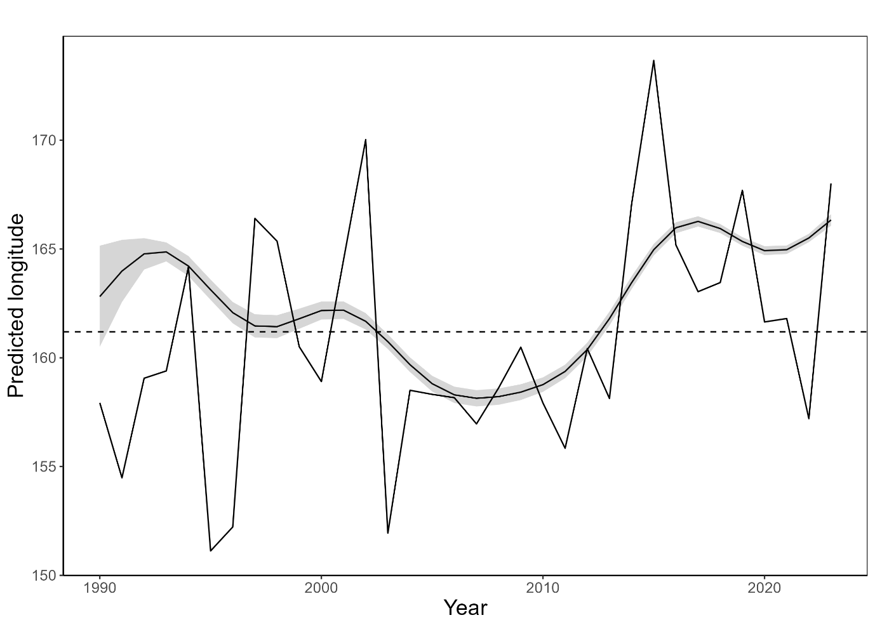

Figure 5: Year:flag common interaction smooths from model D split into flags that seem to show an eastward trend over time, and those where longitude has remained steady over time.

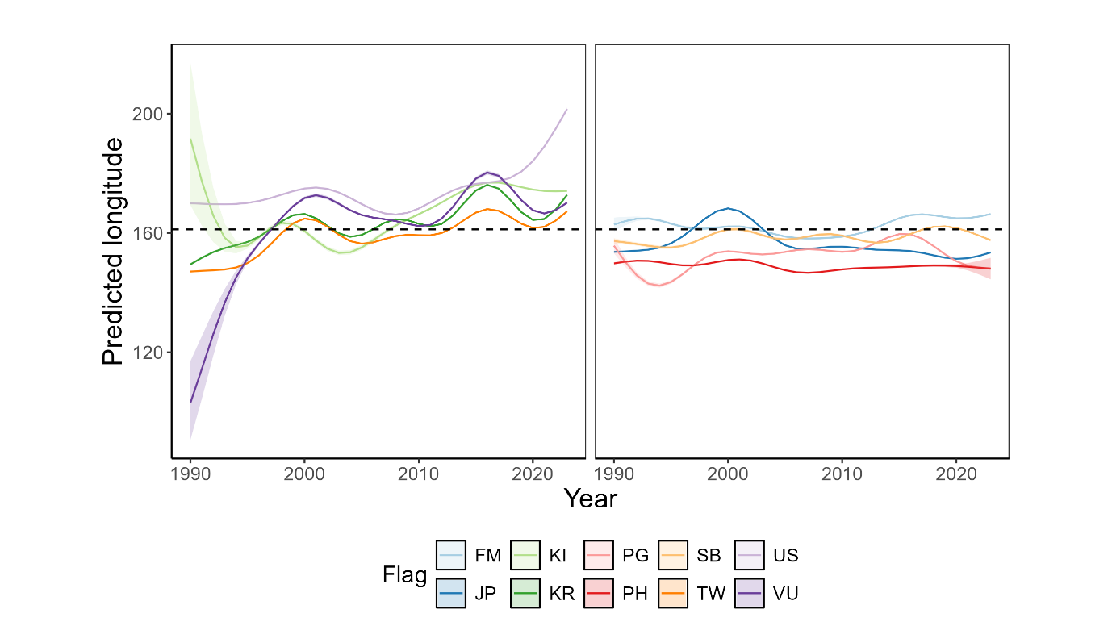

Table 1: Summary of data filtering process for both SBEST and logbook WCPFC purse seine data. Note that these show sequential steps in the data cleaning process.

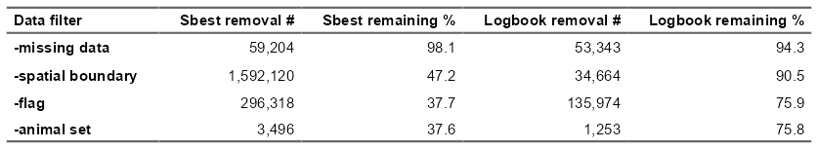

Figure 6: Variable response plots for model D including set type, month, and ENSO.

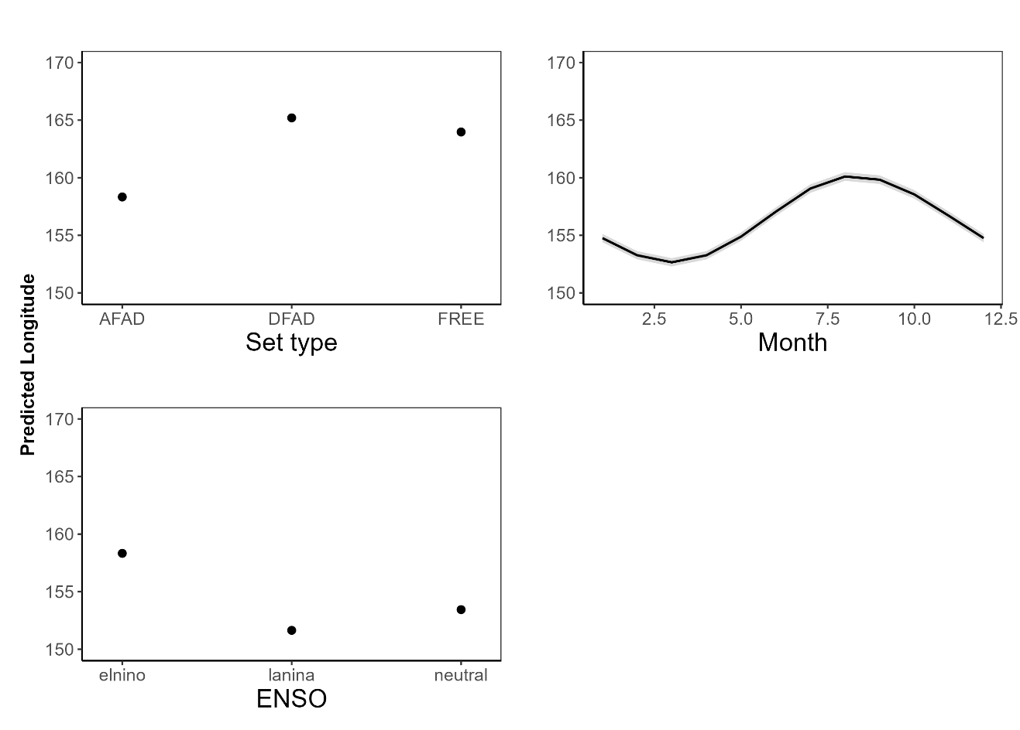

Table 2: Description of generalised additive models applied to determine shifts in the longitudinal position of WCPFC tuna purse seine fishery over time. Longitude was the response variable for all models, and all models had family = Gamma(link = ‘log”).

|  |  |  |  |  |  |
| --- | --- | --- | --- | --- | --- |
| **Model** | **Name** | **Data** | **Formula** | **Weights** | **Distribution** |
| **modA** | Linear | SBEST 1x1 | *lond ~ yy + s(mm, k = 6, bs ="cc") + flag + set_type + oniF + s(latd, k=5)* |  | Gamma(link = "log") |
| **modB** | Factor | SBEST 1x1 | *lond ~ yyF + s(mm, k = 6, bs ="cc") + flag + set_type + oniF + s(latd, k=5)* |  | Gamma(link = "log") |
| **modC** | Year:flag independent smooth | SBEST 1x1 | *lond ~ s(yy, by = flag) + s(mm, k = 6, bs ="cc") + set_type + oniF + s(latd, k=5)* |  | Gamma(link = "log") |
| **modD** | Year:flag common smooth | SBEST 1x1 | *lond ~ s(yy, flag, bs = ‘fs’) + s(mm, k = 6, bs ="cc") + set_type + oniF + s(latd, k=5)* |  | Gamma(link = "log") |
| **modE** | Year:flag common smooth wts | SBEST 1x1 | *lond ~ s(yy, flag, bs = ‘fs’) + s(mm, k = 6, bs ="cc") + set_type + oniF + s(latd, k=5)* | Log(cpue) | Gamma(link = "log") |
| **modF** | Year:flag common smooth FS | SBEST 1x1 (free school subset) | *lond ~ s(yy, flag, bs = ‘fs’) + s(mm, k = 6, bs ="cc") + set_type + oniF + s(latd, k=5)* |  | Gamma(link = "log") |
| **modG** | Year:flag common smooth logbook | Logbook | *lond ~ s(yy, flag, bs = ‘fs’) + s(mm, k = 6, bs ="cc") + set_type + oniF + s(latd, k=5)* |  | Gamma(link = "log") |

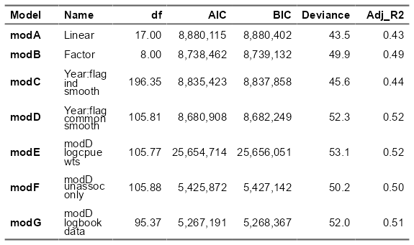

Table 3: Evaluation statistics of generalised additive models applied to determine shifts in the longitudinal position of WCPFC tuna purse seine fishery over time.