

SCIENTIFIC COMMITTEE
TWENTY FIRST REGULAR SESSION

Nuku’alofa, Tonga
13-21 August 2025
Summary report from the SPC Pre-assessment Workshop – April 2025
WCPFC-SC21-2025/SA-IP-01
25 June 2025

Report compiled by Paul Hamer

Oceanic Fisheries Programme (OFP),
Pacific Community (SPC), Noumea, New Caledonia
Contents
Pre-assessment Workshop Overview 2
DAY 1 4
Revision of the 2024 southwest Pacific striped marlin stock assessment 4
2025 southwest Pacific swordfish stock assessment 11
DAY 2 13
Southwest Pacific swordfish stock assessment – continued 13
Bait-associated bycatch risk of South Pacific swordfish in longline fisheries 16
Western and Central Pacific Ocean whitetip shark assessment 17
DAY 3 21
Oceanic whitetip shark stock assessment – continued 21
2025 stock assessment of skipjack tuna in the western and central Pacific Ocean 22
Update from the SPC otolith/schlerochronology lab 28
SEAPODYM – new skipjack model 29
DAY 4 30
Skipjack assessment continued 30
MFCL development updates 37
WCPFC Project 123 – next generation tuna models/MFCL succession 39
DAY 5 41
Harvest strategies/MSE 41
South Pacific albacore CKMR update 45
Return to stock assessment discussions 46
Skipjack 46
Striped marlin 48
Swordfish 49
Oceanic whitetip shark 49
Wrap-up 50
APPENDIX 1: Agenda 51
APPENDIX 2: List of participants 58
APPENDIX 3: Terms of Reference 60

Report from the SPC Pre-assessment Workshop (PAW), April 7-11th 2025

Pre-assessment Workshop Overview
To help guide stock assessments and related modelling work and analyses for the Western and Central Pacific Fisheries Commission (WCPFC), the Oceanic Fisheries Programme (OFP) of the Pacific Community (SPC) has sought input from regional (WCPFC CCMs) fisheries scientists, consultants, representatives from regional fisheries organisations and other interested stakeholders, through the SPC pre-assessment workshop (PAW) process. The seventeenth PAW was held from the 7th – 11th April 2025. The meeting was held under a hybrid format with approximately 80 people joining, including 17 external (non-SPC) participants travelling to Noumea to participate in-person. Twenty-two non-SPC organisations were represented, and five consultants, from across at least 17 countries.
Paul Hamer (PH) (OFP-SPC) chaired the meeting. The meeting agenda focused primarily on:
- Approaches for the 2025 stock assessments of skipjack tuna and oceanic whitetip shark in the Western and Central Pacific Ocean (WCPO), swordfish in the southwest Pacific Ocean, and the revision of the 2024 assessment of striped marlin in the southwest Pacific Ocean,
- Technical developments and work planning for Management Strategy Evaluation (MSE),
- Developments to the MULTIFAN-CL modelling framework in 2024 and the 2025 workplan,
- Exploratory modelling of effort creep on Japan pole and line abundance indices for the WCPO skipjack assessment and related MULTIFAN model experiments,
- Developments in age validation work and SPC’s enhanced capacity in fish aging research and development,
- Updates on WCPFC Projects:
  - Project 123: scoping study for the next stock assessment platform for WCPFC tuna assessments,
- Progress of the Close Kin Mark Recapture (CKMR) project for south Pacific albacore,
- Overview of the updated skipjack tuna SEAPODYM model for the Pacific.
- Several external presentations
The agenda is in Appendix 1, and list of attendees is in Appendix 2. The majority or presentations were made by SPC staff or consultants working with SPC. The meeting was chaired by Paul Hamer, Oceanic Fisheries Programme, SPC, and operated under the terms of reference provided in Appendix 3.
This report summarises the meeting presentations, discussion and recommendation, according to the agenda items. The report does not attribute comments to countries or individuals except for those that provided presentations, SPC staff and where the comment related to the agreement to provide data or to undertake particular analyses to support SPC’s work. The relevant stock assessment scientists will consider the discussions and recommendations from PAW as they develop the assessments and other research activities. The extent to which suggestions can be explored and/or incorporated into the stock assessments and MSE work prior to WCPFC SC21 will be constrained by the available time, complexity and prioritization by the SPC stock assessment scientists. The PAW is an advisory workshop and the final decisions on model development, data inputs, and characterising uncertainty rest with the SPC-OFP assessment team, and/or the SPC-OFP assessment team in consultation with external contractors involved in the assessments or supporting work. The SPC scientists will make effort to consult with particular members of the PAW who have strong interests in particular aspects of the assessments, or for more general consultation on problematic areas.
The outcomes of this meeting will be reflected in the various papers submitted to SC21. Links to copies of presentations are provided throughout the paper or can be obtained on request from paulh@spc.int or or at https://github.com/Paul-Hamer/SPC-PAW/
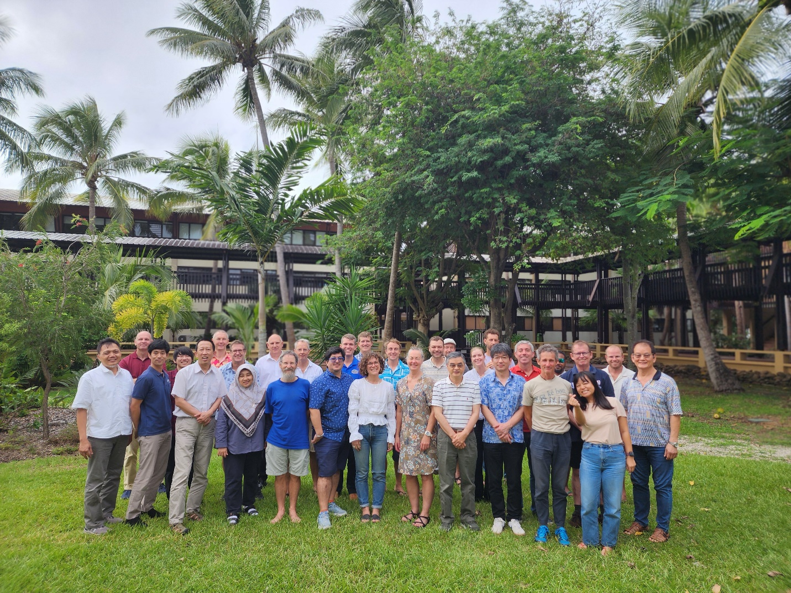
2025 SPC Pre-assessment workshop, in-person participants, SPC Noumea headquarters.

DAY 1

Revision of the 2024 southwest Pacific striped marlin stock assessment

The first part of day 1 focused on the work to revise the stock assessment of southwest Pacific striped marlin (Kajikia audax) being led by Claudio Castillo Jordan (CCJ) (OFP-SPC). This assessment was presented to SC20 in Manilla but was not accepted for management advice due to technical concerns. The SC requested that further work be conducted, and a revised assessment be presented to SC21 for consideration.
The session began with CCJ providing a background refresher on the 2024 assessment (P01_MLS2024_Recap_CCJ) that covered the key features and results of the 2024 assessment attempt, the issues faced and recommendations for further work and the concerns raised by SC20
As noted by SC20:
4.4.1.1 Stock assessment of Southwest Pacific striped marlin
248. SC20 thanked the SSP for conducting the stock assessment of the Southwest Pacific striped marlin (SC20-SA-WP-03) and acknowledged their transparency in outlining the issues of serious concern from the SC with the technical aspects of the assessment.
249. Noting the above, SC20 recommended that further work, including resolving the conflict between the size composition data and the CPUE indices, should be undertaken as part of a revision to the assessment for consideration at SC21.
250. SC20 acknowledged that further work on the assessment will place unplanned additional burden on the assessment team and welcomed the offer from the United States to provide in-kind support to SPC to moderate the impacts to other key SC21 deliverables.
While the SC20 recommendations focussed on the data conflict, other concerns raised by SC20 delegates included: overestimation of spawning potential, confidence and use of early data from Japan, why starting model in 1979, trend in recruitment, poor fit to CPUE with the revised growth curve, overestimation/poor fits to some size data, strong scaling effects driven by size data, fixed initial conditions, and likely overestimation the depletion level to be more pessimistic. Issue with the selectivity not working well with a new faster early growth curve, inability to estimate initial conditions using all the catch data.
The US delegation at SC20 generously offered to support a revision of the assessment through an in-person workshop in Hawai’i, which the SC20 accepted, and was hence conducted in January 2025. The outcomes of the workshop were reported in the next presentation by Nicholas Ducharme-Barth (NDB) (NOAA). The presentation and other information on the Hawai’i workshop are available at https://n-ducharmebarth-noaa.github.io/2025-swpo-mls-meeting/

The Hawai’i workshop attendees were Claudio Castillo Jordan (CCJ) (SPC) and Nicholas Ducharme-Barth (NDB), Felipe Carvalho (FC), Michelle Sculley (MS) and Rob Ahrens (RA) (NOAA PIFSC).
A key early point was made regarding issues with the annual model structure and the course resolution of the selectivity at age (annual) used in MFCL given the revised growth information indicating faster early growth. The model struggled to fit the smaller fish in size data. While a quarterly model helped to achieve a finer resolution to the selectivity ogive, a quarterly model estimated quarterly recruitment, which is not consistent with the annual spawning cycle of the species. The workshop decided to explore the SS3 platform given it’s size-based selectivity which could allow the desired resolution for the selectivity ogives but have an annual recruitment. The workshop made the decision to transfer the assessment from MFCL to SS3 and then focussed on developing the SS3 model. SC20 actually requested to shift the 2025 southwest Pacific swordfish assessment to SS3 and also expressed desire to move the next striped marlin assessment to SS3. This SC request to move billfish assessments to SS3 along with the greater familiarity and confidence of the workshop team and the lead assessor to work in SS3, further justified the decision to conduct the revised assessment in SS3 rather than continue in MFCL. This decision was supported by the PAW as an efficient way forward and provide the basis for the future assessments, consistent with the MFCL succession plan.
The key points and recommendations from the SS3 model explorations at the Hawai’i workshop are summarised below:
- SS3 model was developed and recommended to be used for a revised assessment.
- Refined length-based selectivity (double normal) was an improvement, but there remain issues with the appropriate specification of length-based selectivity depending on the growth – i.e. using CAAL and internal growth estimation (slower early growth) versus external input growth parameters (faster growth), and the misfits to smaller size fish in the observations. This aspect needs more work.
- Revert to 1952 start year, with unfished conditions assumed, apply catch uncertainty to early Japanese data.
- Exclude problematic/unrepresentative/small sample data for the size data inputs, achieved improved fits to the CPUE.
- It was also noted that a misfit to the Japan/TW CPUE index was related to conflict with Australian LL fishery weight data in region 2 (Fishery 6).
- It was recommended to develop alternative CPUE indices given that no individual flag/fishery covered the stock assessment region and coverage by flags varied over time.
- It was noted that there are limitations to the age-length data in that the sampling process selects the faster growing fish so it might bias growth rate higher. Issues with poor sample coverage and low sample size have been noted in every southwest Pacific striped marlin assessment, and there has been no improvements since the last assessment.
- Consider ensemble model approaches to capture uncertainty.
- Consider two sex model.
- Data weighting is still an issue that was not covered in the workshop.
It was noted that some aspects from the SC20 concerns appear to have been improved, but the assessment still needs a lot more work. Priorities for further work were suggested, initially with a focus on exploring alternative CPUE indices, and revising the size data inputs.
The PAW discussion made the following key points:
- Size based selectivity is a good advance, import to fit the size data well as much of the population scaling information is coming from size data
- Concern was raised regarding the early period where most of the change in the historic biomass occurs over a very short period. The early high catches (those uncertain Japanese catches off Australia) drive the biomass rapidly down to around 25% depletion and it never recovers. The point was made that (like tuna assessments) the early catches are high as the most catchable fish are removed (the early high CPUE for tuna assessment is not representative). In this case there is not much information to inform early scaling (no early CPUE), and it seems unreasonable the early catches would have depleted the stock so severely. Most the catches were localised off Australia. Later in time series the scaling information is coming from size data mostly, and the model is using high F to explain the size data. Combined with the other productivity parameters, the spawning biomass is estimated to be very low – probably implausibly low for entire southwest Pacific (i.e., <2,000 tonnes at end of assessment). Need to see fits to size data and profiles on size data to know which size data are driven the low population scale. (note – this is commented on later after some analysis of the SS3 assessment during the workshop that it does not appear that any particular fisheries size data are driving the low population scale)
- The importance of the growth curve in fitting the size data was also noted, different growth between males and OFPles – maybe a sex specific model is needed to fit data.
- It was also pointed out that although its difficult to address, and we don’t have the information –growth is likely to vary spatially and there maybe population structure not captured in the single region model, this may a big part of the issues. The estimates of the population scale don’t seem realistic.
NDB agreed with the concern on the big drop in biomass at the start and mentioned the idea of trying alternative selectivities. The PAW suggested that large striped marlin may have low catchability so the right had limb of the fisheries with asymptotic/logistic selectivity (i.e. to avoid cryptic biomass issues) catching the largest fish might be better allowed to decline below one, but just not to zero.
NDB suggests differences in the extreme initial decline between the 2019 MFCL model and SS3 might relate to differences in how early recruitment is dealt with in MFCL and the way in which depletion is calculated.
The PAW noted the importance of the move to the SS3, as it facilitates collaboration etc. but there is a need to understand these issues, and work on improving the issue in the SS3 assessment. Structural issues may still be problematic irrespective of model platform.
The PAW commented on CPUE – the catch per hook metric and the increased hook numbers with longlines now fishing deeper and most hooks not available to the surface species like MLs – this needs to be addressed more fully. Encouragingly, the CPUE analysis was shown to demonstrate that the standardisation index had a strong impact of the HPB covariate, but more work could be good.
The PAW commented on the CAAL data in the model, noting that it’s a good way to do it, and should help correct the selectivity bias due to larger faster growing fish be caught preferentially. NDB suggest however that assuming growth is variable the data itself will be biased because it does not include the full range of ages at particular lengths, and the CAAL won’t be able to fix everything. A difficult issue because of the sampling method. The PAW re-iterated the inadequate data set on age and length (<100 samples) for striped marlin across the model region.
The PAW commented positively of the Hawai’i workshop collaboration, acknowledging the concern about the big early changes in biomass estimates, and the CPUE data that showed a notable recent kick up. Note: more recent updates to CPUE analysis from Australia show the increased CPUE has been maintained over two years.
The PAW noted the SC recommendation for a revised assessment and the expectation it would be done in MFCL. But agreed the shift to SS3 makes sense and is consistent with Project 123 but asked if the projections can also be done that were requested by SC. SPC responded that they will be aiming to do the projections and exploring options that are already developed for the stochastic projections. But also acknowledge that the additional workload was an issue, and there are still problematic areas of the assessment that are not resolved.
The next presentation from Paul Hamer (PH) (SPC) covered a deeper exploration of the size data inputs for the MLS assessment (P03_striped_marlin_size_data_PH). The presentation provided background to issue of size data (i.e., weight v length) conflict in the assessment and general size data conflicts with CPUE emphasizing the need to better understand the size data inputs. The sources of size data for weight and length were discussed, noting the variety of flags/programmes and methods for providing size data in recent decades, but also that the early data are dominated by Japan and some NZ recreational data. There is no consistent coverage of size data for any fishery. Mixed flag fisheries in the model are patchworks of data across time and flags, and sample sizes are highly variable by flag and time, which can create non-representative variation and changes in average size compositions. Conflict within fisheries was also pointed out between the weight (i.e. Fishery 7 – Australian LL) and length data (i.e. Fishery 12 All longline). Key issue that need to be considered in the size data revision included: measurement methods (some are uncertain), conversion factors (document these better, make sure they are appropriate and from known source etc.), consider data coverage and representativeness (improve this, remove non-representative data), sort out issue with assigning Australian LL weight data between model subregions 2 and 3, clarify an uncertain issue of Japanese weights – whether they are individual or average weights.
An issue that was raised in 2024 in relation to conversion factors was the potential for variation in the length-weight (L-W) relationship, both in space in time. If the L-W conversion was misspecified it could be causing issues. This was explored with the available data, and there was no clear evidence for variation in the relationship between samples from Australia, Fiji and NZ, but noting there are no data from further east which might be an issue. Conversion factors still need attention and data across a broader geographic range.
A principled approach to guide revision of the size inputs was presented for later discussion, and the data available for each model fishery were discussed, comparing catches and size data samples by flags. The recommendation from the Hawai’i workshop were noted and consolidated with recommendations for this deeper size data review. Improvement to the assignment of the Australian longline weight data between subregions 2 and 3 was shown, and concerns related to bias between Australian weight data converted to length versus actual length data for the same time periods were raised. This later concern was followed up post – PAW with Australian scientists (Ashley Williams, CSIRO) and the recommendation was to not use the length data due to potential biases in the observer sampling and coverage. The weight data is of much better quality and almost full coverage of the catches.
The uncertainty over whether the Japanese weight data were averages or individual weights was also discussed and has since been resolved post-PAW with input from Japan FRA staff (Naoto Matsubara and Hidetada Kiyiofuji). The weight data used in the assessment is from Japan port sampling where individual fish are measured. Weight data are also provided from Japan longline logbooks but these are average weights per set, these are not used in the assessment. Japan also noted very early Japanese sampling where measurement was by eye orbital to fork length (EO), which is consistent with the contemporary approach, so we can expect Japan has always measured billfish using eye orbital to fork length.
The discussion posed:
- Any concerns with proposed approach/changes?
- Clarifying Japanese average weights method – done, port sampling is individual weights.
- Use both length and weight data when both are available and reasonable amounts? Or choose one or the other. e.g. resolve data conflicts
- After remove all the unreliable data and unrepresentative flag specific data – apply a minimum samples size per year/quarter strata per fishery (e.g. 10 used in previous – too low?)
- What to do if we can’t understand the bias in AUS LL weight – converted to length? Correct it somehow and run sensitivity?
  - Is the issue the trunk weight to whole weight conversion????
  - Can you measure PF on trunks – length to length conversions should be better.
- Should future assessments switch to LJFL?
The need for a more repeatable statistical approach for improving size composition representativeness for mixed flag fisheries was discussed. The PAW suggested a model-based approach could be used to improve this and SPC to follow-up with Phil Neubauer of Dragonfly.
The PAW noted the issue with potential bias in the size data conversions is important, and it is best to use one data type as much as possible. If data types change overtime this can create issues with changes in model scaling. One data type is better, even if it has a bias, it will be less influential on scaling.
The PAW noted the need to better understand time varying size compositions along with the time varying flag effects on the size data, they can be confounded.
The observation that Japanese weight and length data occur in different periods was noted, but comparison suggested no clear biases in weights converted to length versus lengths.
The PAW suggested that it is best just to drop or downweight any unreliable/representative size data.
The L-W relationship was raised again noting that some more recreational data was now available from the NZ recreational fishery (John Holdsworth) that could be included, which also has lower jaw fork length and EO, and whole weights. The NZ recreational weight data is mostly >60kg, summer fishery, weighed on certified scales, and these fish move north in cooler months. The recreational data is measured by tapes though, and it would have some curvature biasing in the lengths versus callipers, EO to FL might be less curved. It was also noted that the L-W relationship also changes during the fishing season – when MLS arrive off northern NZ after spawning their condition is worse than when they leave – their weight to length increases. Length is better for the assessment. It was suggested the best way to deal with variable L-W relationship could be to convert the weights to lengths outside the assessment model. The PAW provided some support for this approach if there is evidence for variation. There aren’t really any major issues with conversions outside the model, and those issues are not as important as the issue of a misspecified L-W relationship.
Finally, the issue of a common length measure was discussed, noting even if size data are in length, conversions are still required when different programs/flags measure fish lengths differently. Perhaps there are more advantages to measuring EO to FL rather than lower jaw to fork length. Worth to compare tapes v callipers for EO v LJFL. But much of the historic length data is LJFL and observers are already accustomed to this method, with the exception of Japan.
The next presentation provided by CCJ focussed on CPUE analysis (P04_MLS_CPUE_CCJ), mostly the work done since the Hawai’i workshop. This involved exploring and comparing CPUE from Japan longline for subregion 2, Australia longline, Japan and Australia combined subregions 2 and 3, and the NZ charter fishery index, with the original overall sdmTMB Japan/Taiwan longline index.
The PAW questioned to use of the CPUE index for the DW fleets (JP/TW), noting that, although the CPUE is not applied until 1979, the nominal Japan CPUE in the 1950s when the highest catches were supposedly taken was low and CPUE actually increases in the 1960-70’s which must indicate an improvement in catchability (but could also be unreliable reporting – a reason why the early CPUE was not included). The sdmTMB model does not have the range of operational covariates that the spatial restricted Australian and NZ recreational fishery analysis do. It was suggested that it could be better to focus on the latter indices. CCJ also indicated that SPC would explore the observer based CPUE indices based on EEZ level observer programs, similar to the approach used for sharks by Dragonfly which can incorporate more operational covariates.
The PAW noted the time lag that would be expected for the NZ recreational index compared to the longline indices, because it targets older fish. This is consistent with the lags shown in the CPUE comparison plot. Also, the tag data suggests that the NZ recreational fishery likely catches fish that move to and from subregion 4 and the French Polynesia region, rather than Australia/Coral Sea region. The NZ CPUE due to being localised might however be more variable due to interannual variation in movements.
The spike in 1998 for the Japanese CPUE data was raised as an issue with the sdmTMB analysis, as not a lot of data around the area where this spike originates, so it influences a much larger region. The spatiotemporal distant water fleet indices might be more variable due to these spatial effects. The consistencies among the alternative CPUE was however noted, especially the NZ recreational index. The Australian index seems to be more different than the others. Australian scientists noted that the Australian index does include a lot more covariates than other indices, but they are still looking to improve the treatment of spatial factors in future.
The PAW supported the idea to explore the Pacific Island observer CPUE data, and the addition of the Australian longline and NZ recreational charter CPUE indices.
The striped marlin session returned to consider the issue of the estimated rapid decline in biomass when starting the model in 1952. An MFCL approach was developed using the orthogonal polynomial recruitment to create a quarterly (one quarter per year) recruitment pattern that could be fixed to a stable level for the early time period when no size data are available. The model also separated the CPUE into individual quarterly CPUE indices. The MFCL model is essentially doing something similar to the SS3 model and also shows the same big decline in biomass in the early years as the SS3 model does. Therefore, it was noted that both packages when set up similarly estimate that big decline to fit the data, irrespective if this seems implausible. Both MFCL and SS3 are trying to fit the size data, and the CPUE are relatively stable in the second half of the time series. No clear resolution to this issue proposed.
The discussion then turned to data weighting. The PAW noted issues with data weighting in the 2024 assessment using the Francis method, but that the Dirichlet weighting would also tend to overweight the size data. Two stages in the weight process, relative weight through time, followed by the previous mentioned methods. Number of trips might be useful to provide variation in weights through time, maybe could also consider spatial coverage and consistency overtime. Weighting based on bootstrapping according to available strata (i.e., months, spatial cells with samples etc.) to look at uncertainty in size distribution could be considered and ultimately arbitrary weights by fishery can be applied. Ultimately you want to fit the CPUE, and if you can’t do that you may need to downweigh the size data.
The overriding influence of the Australian weight data was noted by PAW, and that his would really only create issues if it is in conflict with other data, which is the case. You could set up models with alternative data weighting on different size data by fishery but still aiming to fit the CPUE.
The uncertainty grid was then discussed, with the proposal that the following factors be included/explored: steepness, M, CPUE alternatives, growth, data weighting and model filtering.
The PAW suggested that the previous multivariate prior approach really makes sense when there are multiple axis in that prior. In this case with just two prior distributions (steepness and M), reverting back a more standard grid by using the quantile values of the priors and weighting them accordingly, would allow more scope to explore the other axis, such as CPUE.
The CPUE uncertainty was discussed again, and the PAW raised the concerns on the distant water indices and the importance of having a reliable trend in the CPUE indices. Given the targeting shifts, gear changes and limits to the operational variables, these indices might not have reliable trends. The Australian and NZ indices although localised are more targeted with better operation variables and likely to have more reliable trends although due to the localised nature might be more variable at shorter time scales. But better to get the trend closer to reality. Observer data options (i.e, New Caledonia, Fiji, Tonga, French Polynesia) also good to explore. It is reasonable to include different indices if indexing different size groups. The PAW followed up on the NZ index – noting the environmental influence on the movement into the NZ fishery region. Probably want to explore the oceanographic/temperature covariates.
The PAW recommended on focussing on the Australian, NZ, Pacific observer and overall JP/TW index (but acknowledging the caveats on this latter index).
Growth – CAAL, but external in two sex model? The question was asked about the growth – is it a step or a grid axis. The PAW suggested it was a step, and go to CAAL, but be wary of the model trying to use the internal growth estimate to fit the size data better. Might be possible to do a CAAL growth, incorporating selectivity, outside the model? The PAW cautioned that before deciding on growth treatment as a step there is a need to do more exploration. Also, data weighting sensitivity of CAAL data etc.. PAW suggested to increase the age structure from 10 years out the 15-16 years to perhaps improve the CAAL fits and important to get the Linf right as it can impact scaling.
The MLS session was then parked until a revisit later in the week.

2025 southwest Pacific swordfish stock assessment
The 2025 southwest Pacific striped marlin assessment will be conducted by Jemery Day (JD) (OFP-SPC) who provided a brief background presentation on the previous assessment conducted in 2021 (P06a_SWO_assessment_background_JD). The 2025 assessment will have a terminal year of 2023. The presentation noted the spatial and fishery structure, CPUE and size data fits, stock status results, uncertainty (ensemble approach) and the SC17 recommendations/issues, including; reliability of CPUE indices (i.e. no indices effectively cover large areas of the stock consistently, changes in gear/targeting etc.), movements and spatial population structure, and low absolute population size. The 2021 assessment suggested that in relation to the MSY default reference points the stock was not overfished and overfishing was not occurring.
PAW noted that the SC20 recommended the 2025 assessment be moved to Stock Synthesis as part on the MFCL transition and WCPFC Project 123. JD provided a presentation on the preliminary work to move the assessment from MFCL to SS3 (P06b_SWO_StockSynthesis_Conversion_JD) and some thoughts about options for improving the assessment in this process, including:
- Estimate additional CPUE variance (auto-weighting the CPUE)
- Double normal selectivity rather than splines
- Size-based selectivity rather than age-based selectivity
- Two-sex model option
- Weighting of size composition data (Dirichlet multinomial, Francis, or ad hoc by fishery)
- Estimate growth using conditional age-at-length (but noting the limited data)
- Implement variable bin width for weight composition data (higher resolution for smaller fish, lower for larger fish)
JD provided an update on progress in getting a working SS3 model running on the input data from the 2019 assessment. He discussed some preliminary model results, noting the preliminary nature of the SS3 model and focussed on some fits to CPUE data and problematic aspects of the size composition, including multimodal distributions and periodic large spikes of smaller fish that are very difficult to fit and unclear what is responsible for them – sampling issues, recruitment.
The PAW questioned the large ‘seasonal’ cycles in CPUE, particularly in the model region 2 indices from NZ and the EU fleets. These indices only index a subarea within a very large region and it is not likely that the seasonal CPUE changes are related to movement between region 1 and 2, more likely seasonal availability/catchability related to north-south movements in the areas covered by these index fisheries. The PAW asked how is the model going to deal with this in SS3, can you implement seasonal catchability?
JD responded that he agreed that the seasonal fluctuations would not be explained by movements between the model regions, so he will need to think about options such as seasonal catchability.
The PAW suggested that it could be simplified by just fitting to CPUE for one quarter, to track the annual dynamics. The trends seem consistent across the seasonal dynamics. JD agreed this is a good idea to look into.
The PAW explained how SS3 interprets quarterly CPUE in an annual model is that it interprets it as a movement of fish rather than a biomass decline. Perhaps deal with it by calculating an annual CPUE and assign that to the period when there are the highest catches for the index fishery.
The PAW also questioned not estimating recruitment until the age comps are turned on and suggested to help populate the model you should estimate recruitment for at least one life cycle prior. JD noted he did try to estimate recruitment deviations for 5 years prior to the size data being available, but the model did not behave. Need to explore further.
JD then provided a presentation to guide discussion of key areas for discussion and decisions. He set the scene with a presentation on the history of the southwest Pacific swordfish assessment, dating back to the first assessment at SC1 back in 2005 (P07_SWO_assessment_histroy_2025_plan_JD). The historical journey provided a useful insight into the challenging nature of the assessment, the many spatial configurations that have been applied and that despite 20 years since that first assessment the core problematic biological uncertainties (growth, movement/population structure, natural mortality), while there is some increased knowledge, are still core uncertainties. The problematic data issues are largely unresolved – i.e., developing CPUE indices that reliably represent regional abundance trends and collection of representative size composition across the stock assessment region for each fishery, are still data issues.
JD pointed out that the 2025 assessment confronts a similar set of questions to address as the previous assessments, including; deciding spatial structure/subregions, CPUE indices to use, choice and treatment of size composition data, and biological uncertainties. The previous (2021) assessment dealt with these uncertainties in a more comprehensive way, using an ensemble approach, but the uncertainties remain and the biological sampling and analysis has not expanded much beyond the western half of the stock assessment region, and the available data on growth are still quite limited.
This concluded day 1.

DAY 2

Southwest Pacific swordfish stock assessment – continued
The morning session continued with the swordfish discussions, beginning with a presentation from PH (SPC-OFP) on the size data for the SWO assessment (P09_swordfish_size_data_review__PH). The presentation summarized the various size data available (length and weight data) including data collection across the model region, different flags and sampling programs and across time, size measurement methods and conversion factors. PH pointed out the data conflict in the last assessment – i.e. weight data conflicting with length data and CPUE, and poor fits to time series trends of both length and weight data for some model fisheries. The presentation provided summary tables of the weight and length data with details on proportions of samples and catches attributed to the different flags within the defined fisheries, noting the challenges of getting representative size compositions for the mixed flag fisheries in the model. Suggestions for triaging the size data were proposed for discussion, including concerns about different flag size compositions in mixed flag fisheries and biases between length data and weight converted to lengths for the two fisheries with significant weight and length data (AUST and NZ).
Jed Macdonald (JM) (OFP-SPC) presented a few slides on the work to estimate the SWO length (LJFL) – whole weight relationship from data collected off NZ (most of the data) and AUST, and across two different periods (1988-2008, and 2011-2023) (P08_observer_data_2025_SWO_LWRs_JM). Overall, around 7,000 samples available. Data since 2011 (LL4 form) has sex information. There is no difference between the L-W relationship between the two data sets. For the new assessment JM suggested to create a sex aggregated L-W relationship using all the data and sex disaggregated using only the 2011-2023 samples, also only use samples with both LJFL and whole weight on the same fish (do not want to use other length-length conversions), apply the bias correction, and consider whether Bayesian or Frequentist approach.
The PAW asked JM on whether spatial variation might be occurring as the L-W conversion is especially important for the Australian weight data. JM responded that it could be possible with available data to explore differences between AUST and NZ.
PAW commented on other conversion factors, and Michelle Sculley (MS) (NOAA - PIFSC) indicated she could make the conversions factors used in the north Pacific assessment available.
The PAW noted that two data sources are for available for SWO size data from NZ longline catches, observer data on length and market data on weights from licenced fish receivers. Reasonably high coverage of the catches in recent years (SPC noted that we’ll need information to confirm that the sampling is representative – i.e. small fish caught also make it to the market sampling). This weight data should be available since 2011 to current, SPC need to check why this is not loaded. Observer length sampling is going to reduce overtime as EM comes in.
The PAW commented that the approach with the size data, looking at the issues rather than the fishery specific data summary plots, is useful. Lots of questions/issues raised and noted the Indian Ocean size data review as a source of information. In future it would be good to show plots of the size distributions in space and also consider the influence of operational covariates on catch size data.
The issue of the weight data conflict (driven by Australian data) and bias in the weights converted to length was raised again and the need to understand the potential spatial bias in the L-W relationship, noting that most of the L-W conversions data comes from NZ and the bias was not so evident in the NZ comparison.
The PAW questioned on the two step conversions – involves processed (trunk of some form) to whole weights first in the SPC database, so the bias could be due to this conversion rather the L-W.
The meeting them moved to CPUE analysis with separate presentation from Australia (Ashley Williams (AW) – CSIRO) and NZ (Britt Finucci (BF) – NIWA) on their CPUE standardisations for SWO.
The Australia presentation by AW (P11_SWO_Australian_cpue_AW) outlined the purpose (i.e., for harvest strategy) and methods for the SWO CPUE standardisation in Australia. The fishery background (East Coast Tuna and Billfish Fishery) and noted that that number of sets has dropped over the last two decades, but the total hook effort has not declined so much and been stable over the last decade due to increased hooks per set (almost doubled over 20 year). Tends in catch were noted and COVID drove a catch reduction due to a reduced market demand. He noted that reported discards have increased rapidly in the last few years due to more small fish and but probably also better report under EM, 90% of discarding is due to small size. Catch areas have changed overtime so core areas are used for the CPUE analysis. GAMs are now used instead of GLMs, many operational and environmental covariates available. The current analysis dopped some environmental covariates that were not influential. Annual index is used for the harvest strategy but can easily produce a quarterly index for the stock assessment. There are quite strong standardisation effects that seem to relate to targeting shifts, and there is a decadal cycle in the CPUE. Quarter 3 and 4 tend to have higher CPUE than quarter 1 and 2. The updated standardised CPUE (mean centred) is very similar to the previous analysis. Key influential covariates were noted.
The PAW asked about discarding and the influence on index and size data, and the EM influence on reporting quality. AW replied that discard reporting has likely improved overtime, but implications on the size data and CPUE are unclear. Could be possible to try adjusting for discard reporting.
The PAW asked about SWO targeting by Australian longlines, and AW replied the data used are a mixture of all the longline data, but that targeting SWO is typically done with shallower night sets. A follow-up question regarded how the fishing operations change to target SWO at night and then why not just use data for night-time sets only for SWO? AW indicated that most of the data is actually nighttime due to filtering on fishing strategy.
The PAW asked about the core fleets area designations and environmental covariates (SST and SOI). AW explained the core areas are based on regular catches of SWO in every year/quarter, and the consistency in magnitude of nominal CPUE.
Discarding was brought up again – be good to have information on discard rate and size data – an ongoing issue that needs more work/data. Small fish are not discarded due to TAC – they don’t even get close to the TAC. The recent increase in SWO discarding was not observed in MLS.
The PAW asked the distant water country representatives regarding discarding practices. Chinese Taipei indicated that mostly their vessels will retain SWO but tend to discard the small ones.
BF provided the NZ surface longline SWO CPUE analysis which is part of a broader SWO fishery characterisation (P10_NZ_SWO_CPUE_BF). The fishery background information noted the influence of TAC allocation in 2004 in driving targeting and at least partly can explain the increasing CPUE trend from 2004 to 2013, CPUE having declined to pre-quota levels since then. Catches mostly taken around the north island and west coast of South Island. Catches have declined since mid-late 2000s, but CPUE increased. Highest catches in quarter 1 and 2. CPUE data filtering and standardisation methods were described. GAMs were used with operational and environmental covariates. All vessel and core fleets models and short and long time series (i.e., separate analysis post quota introduction). Indices were all very similar and trends consistent with previous analysis. Night fraction and light sticks have increased overtime and are key variables in the CPUE models.
The PAW asked about the increased CPUE until 2013 – the increase seems consistent with other series from Australia and the EU indices. The PAW was interested in comparing designated target information versus the cluster analysis allocation.
Arni Magnusson (AM) (SPC-OFP) gave a brief presentation to guide the discussion on CPUE workplan for the 2025 assessment (P09_Swordfish_2025_CPUE_AM). The presentation covered previous assessment CPUE, Australia, NZ and EU, and the use of alternative CPUE in the ensemble models. The sensitivity of the model estimates to CPUE was noted, emphasising the importance of the CPUE analysis. Options for indices were noted; including: Australia, NZ, EU, DW (Japan/Chinese Taipei), and observer based for selected PICTs.
The PAW noted the issue of the distant water fleet CPUE due to SWO being a bycatch and the specific requirements required to target SWO. If decide to use the distant water fleet CPUE use it as sensitivity but focus on the Australian, NZ and EU. There was general agreement not to spend much effort on the distant water fleet CPUE.
The PAW also suggested that the high catch area in the northeast region, and even catches north on 15°S could be removed from the core model region, and added as sensitivities. But this this was not generally supported by all the PAW – noting that the stock structure is still very uncertain.
The PAW also noted the seasonality of the indices needs to be further considered regarding the modelling approach.
JD raised the prospect of using CPUE from PICT observer data as an alternative. Concerns over NZ CPUE dominating the region 2. It’s probably ok, but depends if the fish are doing cyclical migrations north and south. Also need to consider different selectivities, as alternative CPUE might be out of phase slightly due to selectivity differences. Given the Australian and NZ indices are provided, the Initial focus of the CPUE work would be to update the EU Index and consider doing the PICT observer indices.

Bait-associated bycatch risk of South Pacific swordfish in longline fisheries
The next presentation was provided Yi-Jay Chang (YC) of the Institute of Oceanography, National Taiwan University. The presentation was titled “Assessing the bait-associated bycatch risk of South Pacific swordfish in longline fisheries using observer and logbook data” (P12_SWO_bycatch_risk_and_bait_YC). The study was focussed on Taiwan longline data collected from observers and logbooks. The increasing issue of SWO bycatch in the northeast of the stock assessment region has been raised at WCPFC. This is the Tiawan fleets targeted bigeye fishing region. The objectives of the study were:
- To classify the dominant bait type for each longline fishing set in the observer data using cluster analysis;
- To analyze the spatial distribution of SWO-BET CPUEs and species composition across different bait types.
- To analyze SWO-BET co-occurrence in longline fisheries using sdmTMB with observer and logbook data, examining influences of bait type (spatial bait-fleet), lightsticks, season, SST, moonlight, and HPB.
- To assess the spatial bycatch risk of SWO coincides with low BET density across different bait types, seasons, and other factors.
The key results indicated:
- There are spatial differences in both species composition and catch among bait types.
- Swordfish have higher occurrence in certain areas and clearer seasonal variation than bigeye, the northeast region of the assessment from 0-5°S has highest occurrence in general and is highest during quarter 4, also high occurrence east of French Polynesia.
- East of 140°W and north of 5°S, all bait types (mackeral, scad, squid, saury, sardine) are associated with a higher swordfish bycatch risk.
- Fleets primarily using mackerel bait exhibit a high SWO bycatch risk in most areas.
- In regions where bycatch risk overlaps among bait-fleets -> recommendations for management might be possible?
- For areas with high bycatch risk linked to specific bait types, a closer examination of gear characteristics may be necessary.
The point was made in the discussion that the hot-spot region in the northeast corner was not really continuous to further south.
The PAW noted the value of the study for potentially contributing to the bycatch management in tuna target fishery. The observation that mackerel rather than squid was a common/dominate bait in swordfish bycatch was raised, but it was noted that they use various baits together on same sets. It might be an artifact. Bait information has been collected to a degree by the observers back to the beginning of the program but it was just analysed since 2014 for this study. PAW asked about the start of the observer data – it was suggested to be 2008. The PAW asked about discarding practices and related data, these are recorded by observers, and discards are usually the small fish. Suggestion to follow-up with YC on the potential for a Chinese Taipei longline index using their observer data.
The PAW recommend that it is too early to drop the catches for the northeast region, no tagging data or other definitive information to support his. Also, the recent drop in Chinese catches is questioned, because it is not observed in other flags – why might this be the case, is it unreported discards? Chinese representatives were not available not respond. SPC suggested its possibly related to Chinese vessels moving further south in recent years to target albacore.
Plan to revisit the swordfish assessment again on Friday.

Western and Central Pacific Ocean whitetip shark assessment
The stock assessment of oceanic whitetip shark (OCS) in the western and central Pacific was next, with the first presentation provided by Kath Large (KL) of Dragonfly who will be conducting the assessment with Phil Neubauer (PN). The presentation (P14_OCS_background_recap_workplan_KL_PN) provided a background on the previous assessments, a recap of the data inputs work done so far (phase 1) and the proposed workplan for the assessment modelling (phase 2). The overall approach for the assessment involves:
- Include/build on the developments from previous shark assessments (blue, mako, silky shark)
- Implement a staged timeline, following the new 2-year approach as per silky shark assessment, noting that the data exploration is in 2024 with data used up to 2022 as it depends on both observer and longline operational data. This needs updating to 2023 for the full assessment done in phase 2 (2025):
2024 (SC20 – phase 1):
- Investigate data inputs, quality and trends, work on catch reconstruction and CPUE
- Present at SC20 meeting for review and feedback
2025 (SC21):
- Conduct an integrated stock assessment
- Conduct a dynamic surplus production (BDM) model (i.e., following SC20 recommendation as per silky shark approach)
The considerable progress made over the preceding year was summarised.
There have been two previous assessments for OCS in WCPO:
- Rice and Harley 2012 [SC8]
- Tremblay-Boyer et al. 2019 [SC15] (the first assessment since CMM2011-04)
Key features, biology and outcomes of these prior assessments were presented. Both assessments suggested that the stock status was overfished and undergoing overfishing based on depletion and MSY-based reference points. The 2025 assessment will build off the 2019 assessment done in Stock Synthesis in a stepwise fashion.
The more recent study on future stock projections by Bigelow et al. (2022) was also summarised. Noting the range of projected outcomes depending on the projected fishing mortality (various scenarios of post release and handling mortality under non-retention), but that very low catches were required to see notable rebuilding out to 2030. This assessment will hope to provide some new information on the recent catches and stock trends since the non-retention was implemented.
There were no comments from PAW after the background presentation.
KL then provided a presentation on the revised/updated data inputs work (P15_OCS_revised_data_inputs_KL_PN). The presentation recapped the phase 1 work, including fishery characterisation, stock structure and biology (including review of any recent studies), analysis of length composition data (still requires updating for 2023) including the model based scaling approach for capture and index fisheries for longline data (insufficient samples from purse seine for this). Noting the long-term stability in the length composition data, given the suggested major stock decline. Previous assessments only used LFs for capture fishery and assumed same LFs applied to the index, this assessment will move to separating LFs and selectivities for index and capture fisheries (as done for silky shark assessment). The catch reconstruction and CPUE analysis for longline and purse seine with updates to 2023 were presented. The updated longline catch reconstruction showed a declining trend since 1995 from around 200,000 interactions per year, stabilising since the late 2010’s at around 50,000 interactions. The reconstructed catch levels were similar to Peatman et al. (2018), but lower than used in the 2019 assessment by Tremblay-Boyer et al. (2019). This was noted as an important difference due to the previous assessment using imputed effort and assigning higher catches to the western equatorial archipelagic waters. This is an important sensitivity to consider in the assessment. The longline catch reconstruction trends are heavily driven by the distant water longline fleets. The purse seine catch reconstruction had not been updated to 2023 yet, but interactions have declined (recently several 1000 interactions/year across both set types).
The PAW had some discussion on the stability of the size composition data, especially the stability in the right tail, the larger fish. PN noted the dome shaped selectivity applied – so the model does not struggle with this lack of trend. We don’t really know whether the big sharks are there, vulnerable to the gear and sampling or if they are not there due to high mortality. There is no fishery in the model with a logistic selectivity. Next steps will try and develop alternative catch using (imputed?) archipelagic effort to explore differences between Laura’s analysis and our more recent analyses. PS catch needs updating; some issues with early effort in previous dataset but probably inconsequential.
PN then discussed further work to build the fate/discarding modelling component into the total catch (fishing mortality) estimates. This is important to appropriately estimate how many of the interactions result in mortality, historical sharks were often released and now its mandatory to release, so incorporating discard mortality is important. Also handling practices and fates can vary between fleets and across time. The approaches to this modelling were described using ‘condition’ data from observers and post-release mortality from tagging studies. The modelling is done across fleets due to the different practices. The modelling results showed the sensitivity to the discard mortality assumptions, which is important to consider in the assessment.
The PAW asked about the shark target fishery that may have occurred historically, which was previously separated, but what was the selectivity in the past? Even if that fishery no longer exists, targeting fishing used wire traces etc, presumedly large shark were caught and measured. PN replied that previously the target shark fishery was dome shaped selectivity and the bycatch was logistic, so the opposite of expected, but the model was not sensitive to removing this fishery and there is no size data anyway for the target fishery.
The PAW asked about how to account for observer reporting changes or fleet behaviour overtime as non-retention is now universal, is discard mortality modelled as dynamic or consistent across time/fleets, is it worth exploring time varying post-release mortality? PN replied that discard rates are time varying. Maybe issues with cutting free and these fish not being reported – perhaps more an issue for CPUE as they probably have high survival.
KL then went on to discuss the CPUE analysis for longline and purse seine. The longline CPUE analysis is considering two data sets: Full data set with all observer programmes, and the TB2019 dataset with some additional longer running programmes added, both analysis start in 1995. Analyses of the two data sets show similar trends, with decline in CPUE from the early 2000s, stabilising at low level from around 2008, but some slight recent increase in the TB2019 analysis with the additional long-term observer programs. No recent increase in the Full data set and the Full data set indicated higher peaks in CPUE in the late 1990s. The strong peak in late 1990’s was driven by only a couple of observer programmes, and likely is not representative of the stock, possibly related to some shark targeting. Filtering out the very high catch rates provided an alternative data set, that moderated the large 1990’s spike and seems more appropriate (referred to as All data, filtered (CPUE 1.1) v CPUE 1.0 all data). Analysis of the data with the long running observer program added, with (CPUE 3.1) and without (CPUE 3.0) filtering, were also presented as alternatives, these two series are very similar, without strong CPUE peak in late 1990’s, but with increasing trend over last 5 years.
The purse seine CPUE is only available from 2009 when the observer coverage was increased. Both free school and associated data sets show increasing trends from 2016, with stronger increase for associated. The NINA4 covariate was important in standardisation. The increasing trend is consistent across all observer programs. The next work will involve the stepwise/alternative model runs with CPUE 1.1 and 3.1 and running assessment models with purse seine CPUE to check internal consistency.
The PAW asked about any historical information on abundance of OCS, given the uncertainty on the early CPUE (1990s) prior to the decline which is providing the critical stock trend information. Is there any historic information to support a much higher abundance of OCS in the WCPO historically?
PN replied they had not review historic information, but previous assessment discussion recollect anecdotes about OCS catches being high as the longline fishery developed. It was notable the early decline (1990s-early 2000s) is pretty consistent across all the observer programmes, the uncertainty relates to low observer coverage in the early years.
The PAW asked about the treatment of the Hawai’i data – shallow versus deeper set, shallow set fishery was closed for a period and reopened with very different operation characteristics. Deep set has been consistent since 2000, shallow set consistent since 2005. Discussion on this noted alternative ways to explore this, nothing definitive suggested.
The PAW asked about vertical behaviour and covariate influences. PN noted the standardisation moderated the CPUE overall, not strong effects, and the large peak in 1990s is biological implausible as a biomass signal.
KL and PN then provided a presentation on the assessment modelling work so far (P16_OCS_modelling_progress_KL_PN), recapping SC20 discussions and outlining the modelling workplan, considering both the integrated Stock Synthesis and biomass dynamic production models. Results of the stepwise development (7 steps) so far with SS3 were shown, including model fits to longline CPUE (no models with PS CPUE yet). F relative to FMSY was sensitive to the CPUE used with the CPUE options 3 and 3.1 providing more optimistic results (closer to FMSY rather than Fcrash). Better fits to CPUE in the updated model. PN was concerned with the assumption of fixed productivity parameter, and will explore this more.
PAW asked about how the initial conditions are being treated. PN suggested they are fixed with alternative initial Fs, similar to the 2019 assessment. In silky the initial F was estimated and seemed to work.
PAW asked is the initial equilibrium recruitment accounting for the steepness? If that setting is turned on SS3 reuses the same code for the initial equilibrium and the MSY, so it kind of hardwires the MSY. PN – I will need to follow-up on that and check the SS control file – he confirmed it is turned off.
The integrated assessment workplan was outlined:
- Index and capture fisheries LFs;
- Update selectivities based on reformulated LF
- Survival based SRR; estimate steepness/compensation?
- Determine 2025 base model
- Data and model sensitivities
  - Alternative models (SS vs BDM)
  - Alternative CPUE, Catch (Discards)
- Uncertainty characterisation (estimated productivity and/or grid)
  - Estimate other productivity parameters?
  - Follow WCPFC Proj113 guidelines/recommendations where possible.

DAY 3

Oceanic whitetip shark stock assessment – continued
Day 3 started with a presentation from PN on the development of the biomass dynamics model (BDM) (P16_OCS_modelling_progress_KL_PN). The approach was developed for the 2019 OCS assessment and developed further for the silky shark assessment last year. The BDM was updated to 2023 with recent catches, and discard mortality scenario. It achieved better fit to CPUE and was better with discard assumptions, indicated very slight improvement in stock status. But it is sensitive to CPUE, if we use the 3.1 CPUE (versus the 1.1) we get F < FMSY and slightly better depletion. With the new 2025 BDM even for the most pessimistic assumptions – F is mostly < Fcrash. The next steps were outlined:
Alternative CPUE series - ensemble over data?
- Use Purse Seine
Alternative initial depletion priors - no info in data about initial state; current wide “prior” leads to consistent depletion picture.
- Force lower initial status;
- Higher initial status may not be realistic given high initial F
Estimating PE (process error) SD? Probably lower than current fixed value.
Diagnostics (Retros, MASE etc) –
- Preliminary work suggests low PE - suggests trends consistent with production assumptions;
- Should result in good retrospective and predictive diagnostics
The PAW asked if the estimated depletions from the BDM and SS3 models are consistent given different initial conditions assumption? PN replied that they are remarkably close. Probably because the SS3 model has no recruitment variation and is like an age structures production model.
The PAW asked for a reminder why the BDM was chosen over the SS3 model for silky shark management advice. PN explained the issues with SS3 model convergence with using time varying selectivity. The BDM seemed more parsimonious given the issue with the SS3 convergence and wasn’t that different to SS3. Not likely to be the same for OCS as the size data is very stable and not requiring large recruitment variability, it seems more production than recruitment driven.
The PAW noted that given the reduction in data on size composition etc., with non-retention, it is probably worth focusing more on the BDM type work and focussing on areas such as catch reconstruction and post-release mortality. Worth to promote this discussion at SC, so good to capture this in the SC report for this assessment to promote this.
PN to chase up effort data from SPC for archipelagic waters. Also need to follow up on the Chinese growth study. PAW noted that it would be good if that Chinese growth work can be an SC paper. The OCS shark assessment will reopen again for discussion on Friday.

2025 stock assessment of skipjack tuna in the western and central Pacific Ocean
Thom Teears (TT) (OFP-SPC) provided a background on the previous assessment in 2022 to start the skipjack sessions (P18_SKJ_assessment_background_TT). He noted the spatial and fishery structure, new approaches used in the last assessment, the uncertainty grid and key results. TT spent some time to explain the new individual based dispersal model approach used to provide with tag mixing periods. He then went on to provide a recap of the follow-up work done on the skipjack assessment diagnostic model in 2023. This 2023 updated diagnostic model was presented to SC19, and the improvements including positive definite Hessian were noted, while the depletion levels were almost the same as the 2022 diagnostic model. The 2023 diagnostic model provides the basis for the 2025 assessment. The SC18 recommendations were noted, including:
- Hyperstability and effort creep in the CPUE indices, and incorporation of CPUE uncertainty in assessment results (i.e., inclusion as an axis in the structural uncertainty grid), including alternative model assumptions related to regional scaling.
- Data conflicts that affect assessment outcomes, and approaches to resolving them.
- Review the model specification with the goal of conforming to a set of diagnostic criteria that determine whether an assessment model is suitable to provide management advice – this was improved in 2023 revised model – positive definite Hessian
- Assumptions dealing with the parametrization of key model settings, such as the fishing effort regression used in the catch-conditioned approach to minimize their impact on estimates of stock status – this was addressed for the 2023 revised model, the fishing effort regression is not required for the catch conditioned assessment model.
- Tag mixing, including estimation using observed data, simulation, and simulation validation.
- Further development of ensemble model approaches for presenting stock assessment uncertainty – depending on time, this can be improved, but time is the issue, model run times >10 hours, timing of data finalisation/updates.
- Exploring evidence and mechanisms for a long-term increasing trend in recruitment – paper presented to SC20
- The development and modelling of defensible effort creep scenario – paper presented to SC20, effort creep scenarios discussed this PAW and will be included in this assessment.
TT discussed his exploration of fishery groupings for the Dirichlet MN in relation to previous data conflicts, and suggested an improved approach is to ungroup the purse seine and the pole and line fisheries. Further, ungrouping all fisheries compared to just separating the purse seine and pole and line made no difference to results, for only minor improvements in fit, so the 4 fishery groups for the Dirichlet MN are recommended. TT described further model improvements that look promising including: removing recruitment trend, growth (i.e. explore Richards), Lorenzen M, SEAPODYM movement and recruitment distribution, orthogonal polynomial recruitment.
The PAW asked for more information on treatment of recruitment, the detrending penalty. Does this work in the different region etc. SPC replied that the detrending recruitment MFCL feature is not likely to used, but we have used if for exploration on the issue. We hope other changes will reduce the increasing recruitment trend such as implementation of effort creep on CPUE.
The PAW asked about additional checking on the Dirichlet MN performance, how does it compare to Francis iterative reweighting etc. and other model diagnostic checks. SPC responded that we are still exploring this aspect, including the Francis weighting.
The PAW asked about the longline length comps – they are only in the model to define a logistic selectivity, to allow other fisheries to be dome shaped. But there are a lot of other time series data for longline that might have influence on population scaling and dynamics. Given the intent behind including these longline fisheries, would it be better to group the longline size data into a specific time period. SPC replied that the longline size data is included to anchor the selectivity of the other fisheries, but probably does have some impact on scaling, we will think about the suggested option – it’s worth considering. The PAW further suggested the grouping option could be a good approach, given some notable historical changes in size of longline fish due to sampling differences.
The PAW asked about the mixing period assumptions. Are the alternative mixing periods leading to different weights on the tag data, which might influence the model fits to other data and stock biomass estimates due this data weighting influence. Can you explore likelihood profiles for the different tag mixing assumptions. SPC agreed that this was a good idea and we should look at doing it.
The next presentation (P19_Skipjack_Growth_AM_JM, P19_Skipjack_Growth_extra_slides_AM_JM) started the session on biology. Jed Macdonald (JM) and Arni Magnusson (AM) (OFP/OFP-SPC) discussed the recent work on the development of an external growth curve for skipjack using tag-recapture growth increment and otolith daily aging data (https://github.com/PacificCommunity/ofp-sam-skj-2022-tag-growth-public) .The work included the development of an R package fishgrowth (https://github.com/arni-magnusson/fishgrowth). The updated external growth differs from the previous version used in the 2022 assessment, in excludes the daily ages for fish over 45 cm, and implements a modified Richards growth curve. It does not resolve the issue of incorporating fish as small as the smallest size in the size composition data for age 1 quarter fish, but see below.
Before group discussion on the growth modelling, Hidetada Kiyofuji (HK) from Japan Fisheries Research and Education Agency (FRA) provided a short update on recent skipjack ageing methodology work being done in their lab. The research shows how the daily increments differ between transverse versus surface (sagittal) sections, the transverse count underestimated age, the surface sections were suggested as better, and recommend as a more suitable method for aging skipjack up to 40 cm FL. SPC also spoke about their studies that also looked at different aging methods and found different results and suggested that a workshop on skipjack aging methods etc. is critical to reach a consistent best practice approach.
The PAW asked about further work on the aging of small skipjack, are there samples less than 18 cm available? Also Indonesian delegated asked for more information on the etching methods to help with their aging. SPC noted their regular sampling program was collecting very small fish 11-30 cm in Philippines. The size data for the assessment has a lot of small fish 15-20 cm, so we need a growth curve that goes down to 10 cm. HK offered to provide the etching and aging protocols to Indonesia scientists.
JH suggested there is issues with truncating the age to 3 years for the tag recapture growth and it likely leads to biased growth parameters. Can we expand the tag dataset to get more larger and older fish? JM, suggested possibly we can find some larger fish that were filtered out, we can check.
The PAW asked about random effects for age and length models with tag data – you don’t know the true age so it is perhaps better treated as a latent effect, also the observation error in measurements. AM responded good point, we tried the random effects, but it didn’t seem to work well, could explore further, but more stable as fixed effects. Other ideas were raised such as the possible influences of spatial/temporal differences in sampling for the otoliths and tag-recaptures, which could influence difficulties in fitting through the tag and otolith growth data. JM replied it was a good point, and they are really trying to expand spatial coverage of the otolith sampling, getting lots more smaller fish and some larger fish from longlines into the samples, and working on aging validation methods. Various other sources of observation error were discussed including recapture measurements from fish freezing effects etc., and also potential tag effects on growth. PAW also recommended if you could include observation error it will open up the potential for a lot more tag-recapture data to be used. Tag shrinkage can be looked at from tag seeding data also. PAW mentioned earlier studies (Francis) that looked at short-term growth stunting from tagging and earlier studies where SPC did try to look at this effect.
There was a long discussion on the growth work and various things to explore were mentioned, acknowledging a lot more work is required to understand skipjack growth, but some good initiatives are happening that should lead to improved knowledge by next assessment. PAW noted the key recommendation for a skipjack age and growth workshop to be organised in the near future – well before the next assessment in 2028 if possible.
There was further discussion on the size at which fish are allocated as one quarter in MFCL. This was smaller (21 cm) than fish available in the external grow curve. AM explained how adjustments were therefore required to implement the external growth curve in MFCL. Addition of very small fish to the growth curve is recommended. Skipjack growth is still a work in progress, and the external growth curve has now been modified by this recent work, so the PAW was questioned if the internal growth is still the best growth and what alternative options to include for growth.
The next presentations focussed on remaining biology aspects including natural mortality and reproductive biology (P20_SKJ_M_repro_biology_TT). TT presented the plan to implement a Lorenzen formulation of M-at-age, following recommendations from the recent CAPAM workshop. Recent explorations were discussed involving applying a Lorenzen curve with the shape parameter is fixed at M proportional to 1/mean length at age, an age constant M, and with the shape parameter estimated. Interestingly, the model where the shape parameter was estimated, estimated a flat M-at-age similar to the age constant M, with similar likelihood, which was slightly better than the estimated parameter model. The main sensitivity to these alternative approaches was that the recruitment estimates were much higher when the shape parameter is fixed (M proportional to 1/mean length at age).
Reproductive biology was then discussed, including the typical continuous spawning in warm tropical wasters, but seasonal spawning in the warmest months in sub-tropical regions. Sex ratio seems to be consistent 50:50 with size, sex ratio and fecundity have not been used in previous assessment for determining spawning potential. In the 2019 assessment the maturity ogive was based on the tropical region samples where most biomass occurs (excluded data from sub-tropical seasonal spawning areas), same approach was applied in 2022, and is planned for 2025.
HK from Japan FRA provided some results of new work to estimate reproductive traits, including fecundity. Samples were analysed from temperate, subtropical and tropical areas. The work confirmed the 50:50 sex ratio across all size samples, summer spawning in the temperate waters, and all year spawning in the tropical and subtropical region below 30°N. Spawning frequency is around 2 days. Batch fecundity and spawning potential is higher in tropical than subtropical waters which is higher than temperate waters. The results can provide more complete information on reproductive traits for the assessment.
The PAW asked if fecundity information from the Japan studies would be available to include in the assessment, as we currently just assume fecundity is proportional to body weight at length, and we don’t take account of the – big fat OFPle – scenario. HK suggested that the fecundity with size data might support this and can be provided. PAW noted this could be quite important for the spawning biomass calculation.
The PAW commented that it preferred the Lorenzen form and cautioned the use of the estimates derived from with the MFCL model. Estimating M internally in MFCL can be very unstable when other data components change. Better to go for a more biologically well-grounded and researched form for M-at-age.
The workshop then moved to the discussion on CPUE based abundance indices with the first presentation from Makoto Nishimoto (MN), Japan FRA, covering the work being done to develop the updated Japanese pole and line CPUE indices (P21_JPPL_skj_CPUE_MN). The Japan pole and line operational data is not available to SPC. This year it was decided to work with Japan FRA to transfer the pole and line CPUE standardisation to FRA scientists, as it was become too difficult for SPC staff to run this analysis without access to the data. MN outlined his work so for, guided by SPC staff, to recreate the previous VAST indices and then transition the analysis to sdmTMB. The work is well progressed and shows that VAST and sdmTMB produce similar results, but issues with computer memory are preventing running the full time series model with the year-quarter time step as done previously. Converting to a yearly model with a monthly term included as a cyclic random effect allowed the model to run and converge. There were some spatial patterns in the residuals, with greater uncertainty on the margins of the main long-term effort areas. Overall, the work showed that the switch to sdmTMB is suitable for the ongoing analysis. More work is required including updating the data for the assessment.
The PAW raised some issues about the drawbacks of the VAST/sdmTMB approach for these large spatial data sets. While they are good for providing regional scaling, they are computationally expensive, and can struggle to adequately account for covariate effects, for example you expect the month effect should be different between areas, but it is not possible to include month-area interaction terms due to computation issues. Separating the analysis by sub-area, can allow more important covariate effects, but you lose the regional scaling information. Probably need to be doing both individual area analysis to better estimate abundance trends and overall global VAST/sdmTMB analysis to provide the regional scaling information.
The PAW considered this concern further in relation to operational covariates that factors that might be more important in some areas than others can get washed out by the analysis. Going back to smaller spatial areas, building in spatial interactions might be possible by reducing the mesh knots to reduce overall number of random effects.
The PAW questioned whether the single spline for month might not be so good where you have more seasonal fisheries in the temperate area and little seasonality in the tropical areas. It was suggested that if you can save some parameters by reducing the mesh knots, it might be possible to have monthly splines estimated for the MFCL regions? Also with the annual model, this is complicated for MFCL which has to allocate indices to a particular month in the year, so we would need a prediction of the index in a particular month, the months can differ among regions, and perhaps align them with the months with higher catches for each region. Finally, the PAW noted the indices presented extended through to 2022 for all regions, where as in the last assessment the region 8 was truncated to the 1990s as there are few data over the last few decades, how did you deal with this?
TT replied that we can specify the month for each region. While the model is predicting the CPUE right through to the end, we can truncate the indices as we did last assessment, based on thresholds for a certain amount of data coverage (e.g. 20%). MN suggested he can try the monthly spline for the regions. sdmTMB does have the capacity to do spatial varying covariates, but the computational burden might be an issue. There was some uncertainty of categorical fixed effects interactions versus the spatially varying covariates, do they do the same thing?
TT then provided a presentation on his work to improve on the purse seine CPUE abundance index based on free school purse seine data (P22_SKJ_PS_CPUE_TT). This index was initially developed and applied in the last assessment for the model region 6, 7 and 8. The presentation provided a recap of the catch and effort data for free school sets and the rational for using continuous daytime travel distance between sets from VMS, and removing FAD specialists, and the spatial temporal modelling approach. The work so far has moved the analysis from VAST to sdmTMB and in doing so made some improvements to the mesh structure. The issue of targeting was discussed, noting that including target clustering can lead to confounding with abundance, so this was removed and flag added as a covariate, which did not have notable effects on the results. The issue of yellowfin dominated sets was also considered. Previous analysis considered sets with <5 tons of tuna were considered skunks and not used, but this could retain sets dominated with yellowfin and <5 tons of skipjack. It was decided to change this to <5 tonnes of skipjack being excluded, as yellowfin dominated sets are not indicative of skipjack schools. This change resulted in some slight differences. Removing zero skipjack catches in this process means we just have a gamma model. We compared the gamma with a lognormal and the lognormal has better diagnostics, so this is recommended. We have also received queries around the thresholds used to define FAD specialist vessels, so we ran some sensitivities on this and found the estimates were insensitive to values for 50 to 100% of sets on FADs, so it is suitable to continue with the original threshold. The issue of preferential sampling is also being explored noting areas of the equatorial model regions, especially south of 10°S and north of around 5°N where there is just no data, no free school fishing. The spatio-temporal model still estimates abundance in these regions using the information from the covariates and spatial correlation structure, but we don’t really know if this is appropriate. Are there few fish there and that’s why no fishing occurs there (i.e. preferential sampling – assumes low fishing effort means low abundance) or they just don’t fish there for other reasons (i.e. economic, access restrictions etc.), but there are fish there? Neither of these are probably reality. TT did some sensitivities by removing cells with different levels of fishing effort – from 0% effort coverage to 40% coverage. The results show that the CPUE trends are not sensitive, but the regional scaling is sensitive to these assumptions. He also included detection methods to the analysis, it didn’t change the results (trends or scale) but the fit improved slightly. Sonar was suggested the more important detection method rather than helicopter. The updated region 5 Philippines purse seine index was presented, using the same methods as previous assessment. TT asked for feedback from PAW on:
- Inclusion of detection method?
- How to deal with preferential sampling in CPUE and/or stock assessment?
- Discussion on proposed changes
- Improved mesh
- Targeting
- Removal of yellowfin sets
- Improved model error structure
- Preferential sampling
- Include PH PS CPUE as done in 2022?
Japan FRA were asked for updates on the pole and line data availability. HK responded that they would only be able to provide complete data for the pole and line index including 2023. The PAW noted that this means the pole and line CPUE time series would not be available for the last year of the assessment (2024). But the purse seine CPUE indices, including region 5, would include 2024.
The PAW supported focusing on the free-school specialists for the CPUE. Several questions were raised including:
- How could a vessel be classified as a FAD specialist in one year but not the next?
- Removing skunk sets seems counter intuitive in relation to FAD specialist who would be expected to have more skunk sets and so these (proportion of skunk sets) could be taken into account for determining FAD specialists.
- Could be good to focus down to a core group of FAD specialists over a longer period and drop these.
- Removing yellowfin dominated sets – how is this done? Should you remove the distance to a yellowfin dominated set and perhaps use a straight line bypassing the yellowfin set to the next skipjack set? Suggestion was that a yellowfin set introduces bias to travel distance.
TT responded that consideration of longer-term FAD specialist is worth exploring. In relation to travel associated with yellowfin sets being excluded, I would think if a vessel is searching for tuna they would set on a school irrespective of yellowfin or skipjack, so the searching is still relevant – they happened to come across a yellowfin school, so the distance to the next skipjack school should still include the distance to the prior yellowfin school. Straight line has problems, it does not measure the searching effort.
The PAW commented that including all the search distance should be included, that the new approach to clustering makes sense, removal of yellowfin dominates set versus ‘tuna’ skunks sets might need some more thought. TT was concerned with information related to zero sets for purse seine methods and that not including zeros was a better way to go.
The PAW asked again about the yellowfin sets, and that they use information to search and might target them, it just not random search all time, there might be targeting of yellowfin, you might be overinflating effort by including travel/search for yellowfin dominated sets. Perhaps just use distance from consecutive skipjack sets but this may underestimate effort– no clear advice.
NOTE: post PAW SPC asked several industry contacts about free school yellowfin targeting. The general response was that purse seiners don’t typically discriminate, if they find a suitable tuna school they set on it irrespective of species. Market doesn’t really come into this and they can separate the species in the vessel holds. There are some areas closer to archipelagic waters (PNG/Solomon’s) where they can encounter more yellowfin schools, and they can increase their yellowfin catches in these areas, but they typically still wouldn’t avoid setting on a good skipjack school.
So we don’t think that excluding the search distance to a yellowfin set or bypassing with straight-line is supported by this. SPC will maintain the approach of including all the search distance.
The meeting had to move on to some external/online research presentation next but would revisit CPUE the next morning.

Update from the SPC otolith/schlerochronology lab
Allen Andrews (AA) (OFP-SPC) provided a presentation to update on the SPC otolith age validation and other otolith research (P23_SPC_otolith_aging_research_AA). He provided background to the bomb radiocarbon methods and examples, including north Atlantic albacore, trevally, grouper and swordfish. He also discussed exploration of otolith weight as an age proxy and a potential new otolith ageing axis in skipjack otoliths. He also noted the desire to get new coral cores from certain western Pacific areas, and collaboration opportunity with IRD, to support the work. He also noted work happening on oceanic whitetip shark vertebrate. Hope is to get close to a max age estimate for skipjack before next assessment.
HK from Japan FRA provided a summary on lab experiments to understand skipjack egg hatching time and success in relation to water temperature. The results provided evidence of optimal temperatures for skipjack eggs between 24-31°C, with shorter hatch times in warmer temperatures.

SEAPODYM – new skipjack model
Following this Inna Senina (IS) (OFP-SPC) provide a presentation of the work to develop an updated and improved SEAPODYM model for skipjack tuna in the Pacific Ocean (P24_SEAPODYM-skipjack_IS). Key conclusions from the improvement work included:
- Including the historic Japanese larval data (Nishikawa data set) in the likelihood allowed a better observation of spawning stock (the early-stage larvae indicate the spawning distribution) and shorter time window in optimization;
- For all data types, the new solutions are quantitatively better than the previous reference model;
- Overall, the model is robust for the tropical region, but there was insufficient improvement in sub-tropical regions (above 30N);
- Comparisons with the MFCL stock assessment model shows consistency only in the recent period (1994-2019);
- Further revisions will focus on the following: updated growth and maturity, estimation of the link between early life stage mortality and environment, revision of vertical structure (to improve migrations into warm current systems), others?
AA commented that skipjack is the most tropical of the tropical tuna. Observations of low radiocarbon values in some skipjack cores from the western Pacific suggest they could have an EPO origin. Radiocarbon might therefore be a useful tracer.
The PAW commented about the capability of SEAPODYM to show processes for movement and recruitment influenced by environmental variables, and asked could these relationships be used for simulation projection work into the future using models such as MFCL? IS indicated that yes this is possible and a key benefit of SEAPODYM.
The PAW commented about the good fits in areas with more data (tropical region), but worse in other areas, and asked about coupling with Ikamoana and issue with entrainment and stickiness around FADs and islands etc.. IS replied the model is too course to capture such fine scale dynamics and is not a current objective, the SEAPDOYM moves large areas of biomass.
The PAW was interested in the reason for the much better match between SEAPODYM and MFCL biomass levels and trends from mid-1990s onwards, what was different before and after this transition point? IS replied, she thinks it relates to the fact that catch and effort data going into MFCL is sampling the population more concentrated to the west prior to the mid-1990s, whereas SEAPDOYM can estimate biomass levels further to the east where there was very low fishing and predicts higher overall biomass. After the mid-1990s the purse seine fishing develops and expands east leading to higher and more similar biomass estimates between MFCL and SEAPODYM.

DAY 4

Skipjack assessment continued
Day 4 started by returning to the skipjack CPUE discussion. A recap was provided by PH, including responding to a question of SST masking for unsuitable skipjack habitat <18°C. Both the masking and the SST covariate are applied in the 2025 pole and line CPUE analysis, but in the 2022 analysis the masking was not done, probably an oversight and should have been done. The approach this year is consistent with 2019 in the use of SST.
The PAW asked about how the flags operate in terms of using devices to find free schools. The purse seine is a more complex fishing operation than pole and line. TT responded regarding inclusion of detection methods from the observer data, not a huge impact and sonar seemed most important. More exploration of interactions between detection methods and flags could be interesting. PAW suggested exploring patterns among flags in terms of detection methods.
HK noted that Japanese purse seines use SST and sea surface height to locate fishing areas and then helicopter to find schools and keep track of the moving school. Japan introduced helicopter in 2010, other flags used helicopter from early 2000s. PAW commented that flags can be an amorphous categorisation– flags change a lot, vessel get reflagged, need to be careful using flags, better to use vessel IDs.
JH commented we do include the search path for yellowfin sets, we assume that if a vessel come across a skipjack school before ultimately setting on a yellowfin school, they would set on the skipjack. If this is the case including all the search distance is appropriate.
The PAW provided further queries, including; effort definition and the increased use of communication/oceanographic data in relation to effective effort. Also considering the search distance, support to include all the distance irrespective of the catch composition, but perhaps still need to include the zeros for skipjack in yellowfin sets. IS suggested to consider using exploitable skipjack density from SEAPODYM? PAW further agreed to use all the search effort in the free school index. Vessel effects might account for any targeting. Maybe modelling the separate components of the catch process might be better.
TT noted vessel is a random effect, and a lot of information is soaked up in the vessel effects (i.e. detection methods), there is a risk of overfitting. sdmTMB can be run as a GLM also. We can explore breaking the model into smaller regions.
The PAW asked about removing species cluster – and the implications of targeting, which might occur at different scales, i.e. years. In the Indian Ocean there are yellowfin specialist vessels. TT replied we can look into the targeting issue (but see previous comments above from industry). JH suggested that at some times and places yellowfin can be more abundant, but even if skipjack are less abundant, we should still be recording all the search distance. PAW noted stickiness of some vessel in the west and there can be more targeting of yellowfin in that area, still some concerns expressed around removing the target cluster effect.
The PAW noted the use of communication and oceanographic data was around well before 2010 and used by purse seine vessels, so maybe unlikely to have had much impact since 2010. Different flags might use these benefits differently, so flag effects might be interesting in the analysis (noting the caveats about flag as a category and that vessel ID is already included).
PAW was informed that there are negligible free school sets by Philippines vessels that are all FAD dependent and do use lights at night.
The PAW raised the preferential sampling issue and implication for regional scaling. TT clarified how he did the preferential sampling experiment by removing the data completely from the modelling. The PAW commented on the alternative approach that retains all the spatial data, this work needs care to avoid not missing local depletion. The issue of vessel effects and model overspecification and diagnostics was noted. The large spike in 2022 was questioned, and has it been drilled into to understand. TT replied he had not looked into this in detail yet, and that we really need to get this preferential sampling modelling done right, his approach was a quick approach to start exploring, and sdmTMB currently doesn’t have preferential sampling capability.
PAW suggested an alternative for the poorly sampled areas could be to assign them the minimum values for the sampled areas rather than averages being estimated by the model. Also asked, can you get estimates of relative abundance from SEAPODYM for these areas for comparison? TT replied we could explore assigning lower values from sampled cells, but could be tricky to integrate into the analyses workflow, and the SEAPODYM comparison is a good idea to explore the preferential sampling issue.
The PAW raised an idea on how you might be able to use the actual paths travelled between sets as a kind of continuous sampling, assuming that if they intercept a tuna school they set on it. The paths provide information that there were no schools, and across all the vessel paths you might be able to develop spatial data on presence/absence of schools?
The next presentation continued from TT on the skipjack assessment size data inputs (P27_SKJ_fisheries_size_data_summaries_TT). Plots of the catch history, size data summaries for purse seine, longline and pole and line and summaries of the raw size data available by each model extraction fishery were presented and discussed. The process to filter and reweight the size frequency by catches for the extraction fisheries and the CPUE for the index fisheries was noted and will be similar to the previous assessment, perhaps with some different filtering/pre-processing following the billfish work.
The PAW noted the usefulness of the plots. Also useful to review the model fits to the processed (reweighted) data. The PAW noted there are issues for some of these data where the sampling programs change and the size data changes over time. Because the selectivity is not time varying, these changes will be influential, and the model can change aspects of the population to fit those changes. It is important to deal with these shifts and filter out data that is unreliable due to sampling methods or consider time varying selectivity. Fishery 17 was noted as an example, the model can’t fit the data but tries to change the population scale, also fishery 10 and 12. Dirichlet groupings can also cause problems if fisheries with good data are grouped with fisheries with poor data, the poor data will be weighted too high. Need to closely review the size data and if you are not certain about data better not to use it.
JH noted that the Philippines data in fishery 17 would seem to be an error, and should just use the Japan data. The PAW noted some Japan data may be from research/training vessels which could be measured differently. The PAW was supportive of time spent on closer review and cleaning of the size data. Remove poor data, split the fisheries, consider time varying selectivity.
The next presentation started the discussion on tag data and was provided by Joe Scutt Phillips (JS) (OFP-SPC) (P28_2025.SKJ.tagging.data.and.mixing.analyses_JS). The tag data presentations from JS covered:
- Updated Data
- Tagging Effects
- Tag Reporting Rate Estimates
- Tag Mixing Analysis
The objectives of the PTTP (Pacific Tuna Tagging Program) were noted:
- To inform and reduce uncertainty in WCPO stock assessments, exploitation rates and connectivity
- Better understand interactions between tuna species and major fishing gears to better interpret fisheries data
Since the 2022 Assessment there have been:
  - One archipelagic WP cruise 2022
~17,000 releases (98% SKJ)
~44% recapture rate!
  - One central Pacific cruise 2023
~11,000 releases (7% SKJ)
~6.5% recapture rate (47 SKJ tags)
Around 8,000 new release-recaptures available, but only around 900 with time at liberty greater than 1 quarter.
The tagger effects analysis was described, noting:
  - 2022 analysis included separate events, taggers, fish condition, length, tagging quality and station
  - Resulted in ~20% reduction in effective tag releases across RTTP and PTTP-WP (western Pacific releases only)
  - Total RTTP correction was applied to SSAP releases
  - Total PTTP-WP correction was applied to JPTP and central Pacific releases
The 2025 analysis will be broadly similar, but:
  - Will now use a multi-species modelling approach
  - YFT and BET tagging effects models selected for some species-specific covariates
  - Will permit estimation of tagger effects for the central Pacific skipjack releases
Report Rates estimation was then described using tag seeding experiments.
  - Fishery-level reporting rate penalty distributions estimated using tag seeding experiments
  - Used to inform MFCL reporting rate estimates
  - No large changes in this analysis are anticipated for 2025
  - The recent upscaling of tag seeding by observer programmes was noted resulting in ~10x increase in the number experiments annually, this is a strong response to recommendations from recent assessments
  - These data will be available for future WCPO tuna assessments
The summary noted that:
  - 7784 new SKJ tags potentially available
  - ~900 recapture with time-at-liberty > 1 quarter
  - Tagging effects will use new multi-species approach
  - May select for some species-specific effects
  - Allow parameter estimates for central Pacific releases
  - Tag reporting rates paper will include preliminary results from more recent tag seeding experiments
  - Plan to explore potential new covariates for influencing reporting rates with the improved data set
The PAW asked about the tag usability corrections and recaptures outside of the model area. JS suggested that similar to previous, tags recapture out of the assessment area just removed.
The PAW asked for clarification on the tagger effects corrections for the central Pacific when you can’t estimate the parameters. JS indicated the western Pacific pole and line estimates were used in the last assessment for the central Pacific, but this time with the multispecies model we hope to estimate parameters specific for central Pacific releases.
The next presentation (P28_2025.SKJ.tagging.data.and.mixing.analyses_JS) from JS described the tag mixing modelling first done in 2022 and the background to tag mixing and how it has been assumed in the past stock assessments, including the sensitivity of the assessments to tag mixing. Mixing periods are dependent on the release groups, but in the past they were fixed across all groups. The new modelling approach aims to provide mixing period estimates for each release group, using an individual based modelling approach, Ikamoana informed from SEAPODYM. The modelling method was described in detail and how the simulated tagged fish were compared with simulated untagged fish in terms of their cumulative recapture probabilities to determine (using the D-statistic) when the tagged fished were likely mixed enough (i.e. have similar recapture probability to the untagged fish).
The potential improvements for 2025 that were discussed, include:
1. Update of Ikamoana with latest SEAPODYM Pacific skipjack solution
  - CLTE-JRA Improved parameter estimates
  - Provides more recent environmental forcing for most recent SKJ releases
  - May improve mixing statistics for regions with previously highly levels of cryptic biomass (more tagging data included in assessment)
2. Revisit calculation of dissimilarity, raised at SC18
  - Previous analysis used Kolmogorov dissimilarity metric to compare distributions at end of simulation
  - Is there an alternative way to quantify the degree of mixing, and provide scenarios for assessment sensitivity analyses
Finally, the planned workshop with DTU Aqua to explore the potential for a WCPO Neilson/Mildenberger spatiotemporal tagging model (currently used by IATTC) was mentioned (Note: this in-person workshop has since been conducted in May).
The PAW asked about the dissimilarity threshold, and how good we want the mixing to be, given complete mixing may be unreasonable, and suggested to assess how leverage in the assessment and conflicts with other data sources are alleviated by increased mixing periods. The question was asked, are the seeded untagged particles random or in relation to biomass distribution. JS responded they are seeded in relation biomass distribution from SEAPODYM. The PAW asked about the sliding window approach used in the yellowfin assessment to allocating release quarters for tags released near the end of a quarter period, or recaptured at the start of a quarter. TT responded that while being aware of the issue – have not thought through the approach to this issue for this assessment yet. The issue was discussed as being problematic but manipulating the data is a problem and can cause other issues. Not a clear solution.
The PAW commented about the potential for the mixing simulation to have bias if they don’t deal with some of the behavioural aspects such as attraction to FADs, islands etc. that aren’t modelled in the simulations. Much of tagging is close to islands so the mixing may be overestimated. Also, this interacts with the fisheries that recapture the tags, which have changed overtime also – pole and line was the most important recapture fishery earlier and operated close to tag releases near islands and then more recently it is purse seine that is more widely dispersed away from islands. This could result in underestimating biomass in the early years and overestimating in later years. The PAW suggested as in previous assessment to look at other information in the actual tag data. The issue of good enough mixing was noted as an ongoing issue – the modelling being done by Mildenberger et al. is a good approach to use and should be further explored, MFCL model regions are too large to achieve mixing. Finally, the PAW suggested to carefully consider the use of the early SSAP data, it would have a strong influence on population trend and even recruitment, but given the changes noted above may cause problems.
JS responded that 1 degree resolution of the model and lack of the behavioural aspects is a downside, but we don’t have the information or model resolution to do it. Could look at the tag density plots as done for yellowfin and bigeye. Really support the exploration of the Mildenberger/Neilsen model – but noting that it still requires advection/diffusion parameters, is also at 1 degree resolution and cannot resolve the behavioural aspects around islands/FADs etc. – so these will always be an issue. The PAW further emphasised the benefits of the Mildenberger spatio-temporal tagging model in how it uses the tag data, and extracts more information from it by using all the tags. The SSAP issue was raised again, and it is a valid point that we will be considered with the stock assessment team, try models with removing it.
JH raised the question on how SEAPODYM is probably doing something similar to the Mildenberger approach, and we should also explore this more. IS commented on the consistency between Ikamoana and SEAPODYM. SEAPODYM is not a simulation, it fits to the data, we make sure the distributions from Ikamoana match the distributions from SEAPODYM.
The PAW came back to repetitiveness of the simulations from Ikamoana, and asked is it possible to provide diagnostics, by comparing simulations of individual release events (i.e., predicted recapture distribution) with the actual tag recaptures for those releases, at different recapture periods (i.e., quantile residuals). The D-statistic previously was based on the cumulative recapture probabilities at the end of the simulation for each mixing period, and then the mixing period assigned for each release group was determined based on qualitative choice of D values (thresholds) that indicated different levels of mixing (i.e. low D=0.2-0.3, medium, D=0.1-0.2, high D<0.1, mixing assumptions). The PAW suggested that rather than calculating the D statistic based on the end (or the start) of the simulation for each mixing period, it might be better to integrate/average across the entire simulation trajectories for each tag/untagged particle and compare those distributions to calculate the D statistics.
JS responded we could do this and it could be a good approach, perhaps also consider other ways such as the highest point, which is shortly after the mixing begins. The issue of the diagnostics/quantile residuals was further discussed and the need to also consider the distribution of fishing effort was raised, but there is possibility to do this type of comparison. The PAW asked about perhaps somehow using the D statistic to adjust number of recoveries? JS will need to go and meditate on this idea.
The next presentation provided by MN of Japan FRA started the session on effort creep (P30_JPPL_skj_effort_creep_modelling_MN). He presented his work on industry surveys on technology uptake and state space modelling to estimate catchability (q) trends in the Japanese pole and line and fishery as a basis for effort creep scenarios to adjust the CPUE time series used in the assessment model. The published article on this work is available at https://doi.org/10.3389/fmars.2024.1458257 . The results of the work indicated that much of the modern technological uptake was in the 1980s to early 1990s. An S-shaped scenario for catchability change was supported with the median estimate of catchability change from 1972 to 2022 being around 4 times or approximately a 2.8% increase in q per year. Future work is planned to refine the analysis, but the results can provide a scientific basis for considering effort creep scenarios for Japan pole and line CPUE index in the 2025 assessment.
JH asked if we should apply a constant 2.8% per year increase, or should apply varying rates across time? MN indicated that no, the rate of increase varies over time in an s-shape and this can be used rather than a straight linear rate. The PAW noted the estimated catchability changes seem reasonable and consistent with other work.
In the next presentation Kyuhan Kim (KK) (OFP—SPC) described his developing work on MFCL skipjack model exploration of effort creep scenarios (P31_SKJ_EffortCreep_modelling_experiments_KK). He has developed an efficient and repeatable experimental modelling pipeline for these explorations, and has been learning MFCL along the way, being new to SPC. His work aims to explore the implications of applying effort creep adjustments to CPUE (adjusting effort in the CPUE) in the MFCL skipjack model. This is in response to recommendation from the last assessment/SC18. The work is ongoing and preliminary results were presented and discussed. An early issue was noted that the model was not really getting much information from CPUE as it was not fitting the CPUE very well, so the initial exploration of the effort creep scenario had little impact. The model had to be modified to increase the influence of the CPUE by applying lower CVs to the CPUE indices. An experiment was run with 12 different effort creep scenarios that included adjustment to CPUE CVs and both pole and line and the free school purse seine CPUE. The effort creep scenarios are all positive, leading to increased declines in CPUE over time. Adding the effort creep scenarios actually tilts the depletion trend so the stock starts less depleted and ends more depleted. In terms of biomass, the increased effort creep for the pole and line impacts the biomass trends, but some strange results were obtained and require more exploration. Also, with effort creep the recruitment trend does flatten out, and can actually decrease when a tight CV is placed on the CPUE.
The summary noted:
- Different effort creep assumptions had a noticeable impact across model scenarios until the late 2000s; however, depletion trajectories converged within a certain range thereafter.
- Within the same model scenario, effort creep led to higher depletion levels. Applying effort creep to both PL and PS, and PL only, showed the largest deviations, but recent upticks partially offset earlier declines.
- Some estimates (e.g., biomass and recruitment) from models with tighter CV on PL (both PL and PS and PS only) appeared questionable and difficult to interpret.
- Recruitment became detrended in the “base” model when PL effort creep was applied, but the model showed poor fits to PL CPUEs in some regions.
- Need to explore likelihood profiles and more model diagnostics.
KK noted that this exploration is not so straight forward and raised these questions for the PAW:
- Current approach explores effort creep scenarios under a fixed model structure (likelihood weights are not estimated).
- This may contribute to poor fits in some cases.
- Should we instead search for a well-fitted model under each effort creep scenario, where likelihood weights are also estimated?
- That would require more work — essentially developing a diagnostic model for each effort creep assumption.
- Additional effort creep scenarios to consider?
  - Makoto-san’s paper used a model without age structure (i.e., no selectivity modelled)
  - If selectivity is included, catchability estimates could differ significantly?
The PAW suggested there is an issue that the biomass trends are kind of locked at both ends of the time series by the tagging data. The SSAP makes it low at start and the RTTP and PTTP make it higher at the end. So, when you add effort creep you increase the tension between the tag programs, and this may explain the funny results like recruitment spiking. There are lots more tags in PTTP, so this is why the early part of the time series goes up. You could explore a Piner plot on the tagging programs. Also try taking out one of the tag programs at start or end so your trend is not influenced by the tag programs, but is influenced by the CPUE. The tag programs are of concern and need careful thought in this work. KK noted he will explore this.
The PAW supported to include the effort creep in the structural uncertainty grid this assessment and that no effort creep was not realistic. Suggested 1-2 % / year plus the new estimates of 2.8%. The PAW asked about the model fits with effort creep, and it was noted that the base models with effort creep were a worse fit.
JH reminded on the SSAP that it has uninformative priors, so if there was other information in the model that wanted a high early biomass the model has freedom to follow that and reduce the SSAP reporting rates. The likelihood profile can inform this. It was also suggested that it might be worth truncating region 7 pole and line index like we do with region 8 so it does not overlap with the purse seine index and avoid have competing trends in the same region. Finally, usually we should constraint the final recruitments as not much information to estimate these. The PAW responded that the SSAP reporting rate is on upper bounds, so it kind of caps the biomass and can’t be adjusted away a suggested.
While adding effort creep scenarios is clearly supported to go into the grid, the way to do this and have a sensible model is perhaps not so straight forward. The PAW supported the suggestion of not using the early and late tagging programmes together as a model option. Also suggest accounting for the higher and lower effort creep rates from the Japanese modelling presented by MN.

MFCL development updates
The next presentation was from TT/JH on the testing of the orthogonal polynomial recruitment (OPR) feature in MFCL (P32_SKJ_OPR_exploration_TT_JH). The method and benefits in terms of large parameter reductions were outlined, with examples, and the user flexibility for specification of the effects/polynomial order from constant recruitment to fully saturated quarterly by region was noted. A preliminary exploration has been conducted with varying OPR configurations, 216 models, and compared to the original recruitment deviations model. OPR models give results similar to each other and to Rec Devs model in quantities of management interest. The OPR would be considered for this assessment and the question on whether addition of the OPR would be a model development step or grid option was raised. The PAW suggested that it would seem to be a model development step.
The next presentation was from Nick Davies (ND) (MFCL development consultant for SPC). ND provided an overview of the key MFCL development work over the last year and plans for 2025 (P25_mfcl_update_2025_ND). Key developments included:
- Non-decreasing time-variant selectivities
- Terminal catchabilities for effort conditioned projections
- Diagnostic model can be intact with catchability regression estimated
- Input of sigma for non-concentrated CPUE likelihood
- Lorenzen natural mortality includes growth offsets
- Sex-disaggregation in the catch-conditioned model
ND briefly described each of these key developments and noted other developments including:
- Simulation CPUE pseudo-observations without error
- Additional parameters and matrix/array indices added to independent variables report
- Tags inform movement only - reinstated the grouped case
- SSMULT_RE – enabled estimation of additional coefficient
- Catch-conditioned projections with all projection fisheries being effort-conditioned
Importantly the MFCL manual has had a substantial update with documentation added for:
- SMULT size compositions – likelihood formulation
- Censored gamma tagging likelihood; long-term tag loss
- Catch-conditioned method
- CPUE likelihood
- Model and Hessian diagnostics
- Variances of more dependent variables
- Output reports - descriptions
- Catch-conditioned operating model projections and simulations
The ongoing workplan for 2024-2025 includes:
- Catch-conditioned model
- enable estimation of selectivity deviate coefficients
- review the operation of existing control phase routines
- apply q-regression estimation conditional on a fish_flags(fi)
- correction of simulation pseudo-observations of tagging data
- Richards curve implementation for multi-species/sex
- Independent variables report – extend to full range; add
- Correct discrepancy between F_{recent}/F_{MSY} in variance report and Fmult in plot.rep
- Dependent variables variance: include the iTRP metrics
- Tags inform movement only – testing and documentation
- Recruitment constraints over defined periods
- Support for MSE developments of parallel OM
- Size based selectivity
- YFT2020 Review recommendations…

WCPFC Project 123 – next generation tuna models/MFCL succession
The next presentation from Arni Magnusson (AM) (OFP-SPC) provided an update on WCPFC project 123 which is working on the succession from MFCL and the next generation models for tuna assessments (P26_Project.123_Scoping_Project_AM). The project information can be found at https://github.com/PacificCommunity/ofp-sam-transition-plan. AM provided latest ideas on directions, noting this is a shared process with the SC, requiring continuous communications, and adaptive strategy with WCPFC providing guidance. SPC will conduct and coordinate the work, engage with tuna RFMOs and various research labs. Swordfish and striped marlin assessments are now migrating to from MFCL to Stock Synthesis 3 in 2025. Tuna assessments will continue in MFCL for the near future, but currently evaluating alternative platforms and development options. He noted some core objectives/principals to achieve with the succession/transition:
- Scientific quality: has good estimation performance, makes good use of available data, allows spatial and temporal variability in processes, model run fast.
- Beginner friendly: new staff scientists can conduct a stock assessment in their first year of contract, configuring and understanding the models. Noting the regular staff changes at SPC.
- Widely used: large development team and user community beyond SPC, new staff scientists can find expert help outside of SPC, tools to work with model input and output are feature complete and maintained outside of SPC, external reviewers have a good understanding of model configurations and options.
2024 activities included:
- Scoping project launched (Feb)
- PAW discussion (Mar)
- International expert meeting (May–Jun)
- SC20 discussion (Aug)
- Developer workshop (Aug)
- Follow up with tuna RFMOs and research labs (Dec)
2025 activities to include:
- Evaluation of RTMB as a development platform (Jan–Feb)
- PAW discussion (Apr)
- Follow up with tuna RFMOs and research labs (Apr)
- Spatio-temporal tagging model workshop with DTU (May)
- SC21 discussion (Aug)
- Model development workshop, FIMs, Gadget etc… (Quarter 4)
2026 might look like this:
- Evaluation of external analysis of tagging data (Quarter 1)
- PAW discussion (Apr)
- Model development workshop (Quarter 2)
- Follow up with tuna RFMOs and research labs (Quarter 2)
- SC22 discussion, final report of P123 (Aug)
- ⇒ Launch a project similar to P123, coordinating activities related to
the migration of assessments and related research & development
- ⇒ Launch collaborative projects conducting work related to the
development of next-generation assessment models
Between PAW (April) and SC21 (August) the project aims to elaborate on the benefits, drawbacks, uncertainties, and required resources related to the options: 1. MFCL → Stock Synthesis → Next-generation and 2. MFCL → Wait . . . → Next-generation, but also now exploring the possibility of analysing the tagging data outside the assessment model in collaboration with DTU (workshop with Nielsen/Mildenberger), evaluate features and capabilities that will be important in future tuna assessments, i.e. age-length structure, Gadget exploration, re-engage the other RFMOs on their visions for future software use, and have a technical in-person workshop with the FIMs development team.
The PAW commented about on when you’re developing software you want to be leveraging and leaning on other software and codes. The RTMB is the right way to go, but you might want to be working on smaller bespoke models, rather than aiming for a behemoth that is out of date before you even finish it, and too difficult for anyone to use.
The PAW commended on the scoping time as being very important and encouraged to include younger next generation scientists in this work and developments. Accessibility is critical, more than just GitHub. Not much has come from the CAPAM next generation modelling meeting. Modular approaches are the future.
The PAW commented that the flipside is the more people involved slows down progress and makes it inefficient. Is it perhaps better to hire a core developer(s) and project manager and just get cracking with RTMB. And perhaps better actually to have someone outside of SPC doing the development, not too different to how SPC works with Nick Davies and worked with Dave Fournier anyway.
The PAW asked about the SC20 recommendations from the small working group. These were not discussed in the presentation, i.e. applying the simplified yellowfin data set in other software. AM noted we are working on that yellowfin single region model.
The PAW also noted that FIMs is actually motoring now with Kelli Johnston now leading and an independent review planned. Suggested the possibility to be added to their regular email communications.

DAY 5

Harvest strategies/MSE
Day 5 started with a presentation from Rob Scott (OFP-SPC) on the WCFPC harvest strategy workplan and technical support required from SPC as tasked from SC20 (P34_Harvest_strategy_workplan_2025_RS).
The key WCPFC harvest strategy workplan objectives for 2025 are:
- South Pacific Albacore: continue refine MPs, adopt an MP, (implement an MP?)
- Skipjack: Provide the interim MP Monitoring Strategy report (which requires the 2025 stock assessment), reviewed by SC21 and TCC, noting skipjack MP needs to re-run in 2026 and work is required on this
- Bigeye: agree on the OMs; identify a TRP; develop MPs, some members pushing to adopt MP in 2025 (unlikely, probably 2026)
- Yellowfin: develop the mixed fishery MSE framework, this needs yellowfin OMs
Work is backing up now due to failure of the WCPFC to adopt a south Pacific albacore MP last year. Now there is urgency to adopt a south Pacific albacore MP in 2025, and also to implement it by May 2026 otherwise many south Pacific fisheries will lose MSC accreditation. RS noted that 2026 is looking scary as we have bigeye and yellowfin MP (mixed fishery MSE), stock assessments for these two species, plus the tropical tuna measure to be renegotiated, and we are required to do a lot of work to support that process also.
The work on the skipjack MP will include:
- Evaluation of FAD closure scenarios: no closure, 1.5 month and 3 month closure,
- CPUE exploration – improvements to pole and line for future use given effort contraction and understand and remedy inconsistencies between MP and dry run versions
Aiming for nine SC papers this year:
- Skipjack Monitoring Strategy report- IP
- Skipjack Estimation Method analyses – pole and line CPUE - WP
- Skipjack Management Procedure – impacts of FAD closure - IP
South Pacific albacore MP evaluation
  - Mixed fishery scenarios – BET MP and SPA MP interactions – WP
- Bigeye Target Reference Points – through MP evaluations - WP
- Bigeye Operating Models - WP
- Bigeye Management Procedure – design - WP
- Bigeye MP evaluations - WP
Mixed fishery
- Minimal YFT assumptions to allow mixed fishery analyses - IP
The PAW asked about the south Pacific albacore MP evaluations, noting that there were a few other options raised in SC20, is there plans to explore any other? RS replied that the limited discussions at SC/WCPFC did not provide clear instructions on further evaluations. So, we are moving to consider a mixed fishery approach with whereby north of 10°S the albacore catch/effort by longline would be controlled by the bigeye MP and south of 10°S the albacore catch/effort by longline and troll would controlled by the albacore MP. This requires work to set up the bigeye operating models with the mixed fishery MSE framework. WCPFC Secretariat will release a communique to members on the workplan.
The PAW asked if any decisions have been made about how to treat the catches from the EPO as there was no SC guidance about this either. RS replied that in the absence of further suggestions from WCPFC we will continue to apply the assumptions that were applied in the 2024 MSE work. The issue of work piling up in 2026 was again raised as a big concern if progress by WCPFC is not made this year. There will need to be some prioritisation by WCPFC for 2026.
The PAW asked about the additional MP tests required to account for the application of the albacore MP only south of 10°S. What is the process for members of WCPFC to request additional scenarios to evaluate? RS noted we already have 18 MP options and potentially catch and effort for each of these – we don’t really know how WCPFC is going to get feedback or manage requests for additional scenarios, the science services provider is not really in a position or accept or reject additional requests from members. The challenge is keeping things tractable and avoiding factorial explosion of models given the limited the time available and limited member capacity to take in large amounts of results. But we hope we can provide enough information for members to make decisions.
The PAW asked the about the assumptions for yellowfin tuna in the mixed fisheries analysis. RS indicated we’d need a minimal set of assumptions for this species, but as yet it is undecided and will need input.
The next presentation was from Nan Yao (NY) (OFP-SPC), on the exploration of the Japan pole and line CPUE for the skipjack MP (P35_JPPL_CPUE_for_skipjackMP_NY). The background and timing of the MP development was described in the context of the stock assessments. Noting that the 2019 assessment and associated CPUE analysis were the basis for the MP estimation method. A dry run of the MP occurred in 2022 the same year as the last stock assessment was conducted. The MP was adopted at WCPFC19 in 2022 and then run for the first time in 2023, with the MP recommended fishing levels applied for 2024-2026. The MP will be run again in 2026 to set the fishing levels for 2027-2030. During this process there was an issue identified in that the dry run example in 2022 had some differences to the official 2023 MP run in that the dry run estimation method had a different formulation of the Japan pole and line CPUE index. SPC was requested to look into the reason for this discrepancy and also look at the longer term suitability of the Japan pole and line CPUE index for the MP estimation method given the contraction of this fishery away from the equatorial region.
The investigation found some issue with the CPUE used in the dry run, most notably the penalty terms applied in the MFCL estimation method were over inflated in recent years for the equatorial regions where there was little pole and line data and therefore very low confidence in the indices – the penalties applied in the MFCL estimation model should been very low, but the weren’t. This issue seems to have come from a difference in how the MFCL penalties were calculated in the dry run estimation method compared to the official 2023 running of the MP. The dry run applied the incorrect method. This 2026 running of the MP will apply the correct penalty method as applied in the 2023 formal MP run, but will also shift the Japan pole and line CPUE analysis from VAST to sdmTMB, as was done for the 2025 assessment. The change from VAST to sdmTMB should have minor implication, but sdmTMB is a more user-friendly package and will be more easily repeatable in future by Japanese FRA scientists who hold the data. The other issue that was found was that the dry run CPUE applied SST as a covariate in the VAST model but did not also apply a mask to remove areas from the index where SST was lower than 18°C, considered unsuitable for skipjack. The consistent approach should have applied both the SST covariate and the mask for SST <18°C, as was done in the original MP testing, the 2019 assessment and the 2023 formal running of the MP. This approach will be applied in the 2026 MP run, irrespective of the approach used in the 2025 stock assessment, although the SST mask should also be applied along with the covariate. The next piece of work is to explore the implications of the declining pole and line data for the performance on the MP estimation method in the near future. This is a concern because of the poor reliability of the pole and line index for the equatorial region over the last decade or more and this will only get worse. We will also be exploring alternative CPUE, including the free school purse seine, that will be more reliable in the future.
The PAW had no questions or comments on the skipjack MP update and CPUE exploration.
The next presentation provided by Finlay Scott (FS) (OFP-SPC) was an update to the mixed fishery MSE analysis (P37_P39_mixed_fishery_and_spa_FS) FS discussed the background and rational behind the mixed fishery MSE method and provided a conceptual description of the approach and which fisheries would be managed under which species specific MPs, noting that MPs respond to stock status of particular species, but different fishery components in different or the same area (i.e. purse seine, longline, troll, other, tropical, northern and southern regions) can be managed under different species MPs. In the current framework there is no specific MP based on yellowfin stock status, so it is assumed the yellowfin stock will be adequately managed under the MPs for the other species through the controls on the fisheries that take yellowfin. Yellowfin stock status is a byproduct from managing the other three tuna stocks. This is yet to be tested. Archipelagic waters and territorial seas not under direct control of WCPFC CMMs would be expected to implement compatible management measures consistent with the WCPFC MPs. FS outline the proposed order of running MPs that avoids running two species MPs in the same year. Noting we are now in a position due to the south Pacific albacore MP not being adopted in 2024, that bigeye and south Pacific albacore MPs need to be developed at the same time, so if it was possible, it could be good to run bigeye projections to determine the effort to meet the current bigeye objectives, and from this estimate the albacore catch for the tropical longline fishery and feed that into the south Pacific albacore MP evaluation that controls southern longline and southern troll. Adjustments/rescaling to the current south Pacific albacore candidate MP(s) may then be required to meet the albacore management objectives (TRP) when the south Pacific albacore catches north of 10$°$S are controlled by the bigeye MP. The alternative is to just make some reasonable assumptions about albacore catches north of 10°S and input these into the south Pacific albacore MP evaluations, likewise for the EPO catches. Either way, this year there will be a need to develop the bigeye OMs and MSE and run some candidate MP evaluations.
The PAW asked about the evaluation sequence and are there feedback loops between MPs. FS replied that we have tried to avoid any feedback loops, the MPs are run independently and the outputs in terms of catch or effort are fed into the sequential evaluations. There maybe a kind of manual feedback in relation to modifying MPs so that they achieve objectives for multiple species.
The PAW noted the evaluation sequence was a tractable approach but was concerned for 2025 that if we don’t have the tropical longline effort/catch levels from the bigeye MP feeding into the albacore evaluations we could be stuck with moving forward on albacore. It is possible that we could run albacore MP evaluations and fix the tropical longline albacore catches at reasonable alternative levels. FS agreed this is the most tractable option and may be required given the time available. The PAW supported the separation of the tropical longline fishery from the south Pacific albacore MP.
The PAW asked about how the sequential approach to the MP management has taken relative productivity levels into account, i.e., assuming the species that are lower down the hierarchy, such as bigeye tuna in the purse fishery, yellowfin in both the purse seine and longline, can be managed to objectives according to the stock status/MPs of the other species. FS indicated that it really needs to be tested, it was designed as a practical approach, as a first pass, we are hopeful it will work.
The PAW raised the issue of what to do/or assume for the fisheries that do not come under control by the WCPFC adopted MPs, that take a lot of yellowfin and skipjack, but also bigeye. We will need to be determining catch/effort assumptions for these fisheries to build into the MSE evaluations and we will need inputs from countries such as Philippines, Vietnam and Indonesia. The PAW noted the need for better understanding by the WPEA (Indonesia, Philippines, Vietnam) countries on the mixed fishery methods and how to account for the archipelagic waters, noting those countries would prefer to manage on catch rather than effort. An upcoming stock assessment and harvest strategy training workshop in Sydney as part of the WPEA project will provide an important opportunity for more detailed discussion on the mixed fishery approach with SPC scientists.
FS then provided a presentation of the plan and work so far for the bigeye OM development and MP evaluations. He described the approach to building the OM projection framework in R and C++, implementing biological and fisheries dynamic equations from Multifan-CL. This gives greater flexibility and control over the projections. Although a Multifan-CL bigeye model fit is still used for conditioning – this approach is not building a SA model, there is no need to have all the minimisation and parameter estimations like in a stock assessment. The basic concept is working and tested to reproduce MFCL like projections for YFT and BET. It still needs to work on observed data generation which are the inputs for EM. The EM itself requires development now to also the complete the MSE loop. The proposed OM grid capturing the uncertainty was discussed based on the 2023 work but will require further discussion and endorsement along with the addition of the robustness set. Preliminary results for the OM projections were shown.
The PAW commented on the catch or effort controls and how that works in terms of catchability assumptions. FS explained the work that was done to allow the catch conditioned MFCL models to estimate catchability in the terminal years by including effort data for a period at the end of the assessment model.
The PAW asked from clarification on how the FAD closure is managed in relation to the skipjack status and MP output. FS noted the FAD closure is an option to manage bigeye catch, but how this would be managed/adjusted is unclear, what levers would be used to adjust the FAD closure are unclear. The FAD closure is not directly linked to the skipjack MP.
The PAW further commented on the discussion of the lever for implementing MP outcomes, FAD closure etc. noting it would be expected to be through the tropical tuna measure.

South Pacific albacore CKMR update
The next presentation from Giulia Anderson (GA) (OFP-SPC) provided an update on the Close Kin Mark Recapture (CKMR) study for south Pacific albacore (P40_CKMR_SPalb_update_GA). She provided a background on the CKMR approach and what it can provide, i.e., estimates for absolute (adult) abundance and mortality of a fish stock, without the various assumptions intrinsic to traditional tagging-based estimates. She noted the importance of high-quality tissue samples for the work and that for the south Pacific albacore study 40,000-85,000 samples were likely need over 3 years to achieve around a 15% CV on the abundance estimate. So far 34,172 samples had been collected across nine Pacific EEZs, this is also ‘total’ samples not necessarily ‘viable’ samples. Fifteen CKMR/biological sampling training events occurred in 2024, that trained 145 in-country samplers (234 people have now been trained). Now the laboratory analysis is ramping up with a goal to send 15,000 samples for sequencing by June, and the first results coming soon in an SC paper, including information on sample viability rates.
The PAW asked about the sampling target, it depends on the scaling of the population which is one of the things we want to learn, so having some insights earlier would be useful, rather than collecting all the samples and then realising you didn’t need so many. Is this a purpose of the initial analysis of the 15,000 samples. GA responded that this was case to get some insights from this smaller sample set.
The PAW questioned about the ability of CKMR study to provide information on the WCPO-EPO connectivity. And is there utility to provide stock structure information. GA noted that if you assume a whole new stock hypothesis in the EPO you need to open a whole other sampling front for CKMR in the EPO. It’s really a different analysis to tackle the connectivity question, we have started a bespoke kind of study to look at this, before we consider a whole of south Pacific CKMR for albacore, which incidentally could also answer population connectivity questions. But at this stage we are keeping the CMKR aspect focussed on the WCPO.
The PAW asked about skipjack. It was suggested that it was not viable that a CKMR estimator would be feasible for skipjack, mostly due to the sequencing bills to analyse possibly millions of samples required due to large population size. Connectivity questions could be tackled though with distant kin type analysis and whole genome studies. For skipjack we’d be focussed more on epigenetic aging and connectivity, CKMR type work is a long way off, if ever.
The PAW was wondering why we are not covering the entire south Pacific, including the EPO, consistent with stock assessment. GA responded regarding the practical sampling reasons and the feasibility study work that lacked the information to understand the sampling needs for the EPO. In this first pass we need to understand the stock structure before launching into a large-scale EPO sampling program.
The PAW raised that a request was made at WCPFC for IATTC to help with samples in the EPO, but IATTC indicated better to go direct to the country fleets such as China.
PH (OFP-SPC) then provided a brief background on the new WCPFC scoping/feasibility project to developing a genetic study to improve understanding of the connectivity of yellowfin and skipjack between the WPEA country regions (Indonesia/Vietnam/Philippines) and the wider western and central Pacific populations. The scoping project is being done under contract by CSIRO, led by Bradley Moore (BM) who a gave further insight into the workplan, including the upcoming technical planning workshop in association with the WPEA workshop in Sydney. An SC paper including a proposal/TOR for the larger project will be provided to SC21.

Return to stock assessment discussions

Skipjack
TT provide a recap of the skipjack discussions noting some of the features/areas that could be used or done differently in this assessment, including:
- Natural mortality (M)
- Growth
- Tag mixing period
- SEAPODYM
- Recruitment
- Orthogonal polynomial recruitment (OPR)
- Detrending recruitment
- CPUE
  - Purse seine
  - JPPL
  - Effort creep
- Data weighting
  - Dirichlet??
- Uncertainty characterisation
To inform the discussion he provided slides to refresh the PAW on each of these options and the proposed work.
Finally, he provided some suggested sensitivities:
- Removing SSAP data
- Use of fecundity and size data, and maturity from the Japanese studies
And a draft uncertainty grid was presented:
Uncertainties | Value
Tag mixing (3 discrete categories based on D-statistic similar to 2022) | Longer mixing, intermediate mixing, short mixing period
Growth (2 discrete categories) | Internal model estimated, external estimation
Steepness and M distributions | Range h (0.65–0.95)  Range M (max age based?)
JPPL effort creep | 3 of scenarios (2.8%/year, lower CI, and upper CI from Makoto et al. paper)
Regional scaling | SEAPODYM, sdmTMB (alternatives)

PH pointed out some key issues to discuss around the CPUE regional scaling issue, comparing SEAPODYM, and what to do about the unsampled areas etc., comparing some regional focused CPUE analysis to the global model. Growth, still apply the internal growth but also what about the new growth form. Tag mixing is a similar approach to last assessment. Effort creep for pole and line has a basis, but what about PS free school index. Steepness and M – may or may not be possible to do as a distribution sampling method (ensemble) due to model run time but could capture the range of likely distributions and weight the options according with their biological likelihood. JH suggested that it could be worthwhile to consider a more structured way to integrating SEAPODYM information into the assessment. He gave a suggested approach to do this as food for thought, and depending on other priorities.
The PAW commented that regional scaling is important and it was good to see it considered in the grid, supportive of using options from SEAPODYM and sdmTMB models. In terms of effort creep, good to have a range and do not apply zero as an option, also support to remove one to the tag programs as suggested. Growth probably the external growth as a sensitive, the model will likely have some trouble fitting the smaller sizes, stick with the internal estimation and that will naturally incorporate uncertainty. Distributions of M and steepness – computational feasibility is likely an issue – maybe just do quantiles and median from a prior. Work on the size data grooming.
Regarding the growth JM noted that they are exploring the Japanese data and removing the perhaps less reliable aging based on transverse sections. It is looking promising with a Richards curve and the Japanese data do have some very small fish, so we should keep our options open.
The PAW suggested that it would be good to run likelihood profiling on the different tag mixing scenarios, which might provide insights into data conflicts.
The PAW commented on the purse seine effort creep – that 2.8% over 15 years could be important, so worth to consider this. PH replied that we would run effort creep sensitivity on the free school purse seine index, and these may require more consideration regarding inclusion in the grid. The PAW again came back to this and noted that SC has probably never added a sensitivity to a grid, so if there is evidence probably you should include it. PH noted that there are others putting cases forward that free school CPUE may have experienced negative effort creep as a result of external factors related to management changes. JH reminded that the purse seine CPUE effort metric is based on searching track which is very different to vessel day or set, where effort creep has been more typically associated with. The PAW noted that search distance would also be sensitive to effort creep from technology and communications. The issue of effort creep inclusion in the assessment uncertainty grid for purse seine CPUE was left there.

Striped marlin
The striped marlin assessment recap was then provided by CCJ. He started on the CPUE inputs as an important area for advice. There is the Australian index, the NZ recreational index, the sdmTMB index from JP/TW longline and now the observer-based indices from selected Pacific Island programs, i.e., FJ, NC, TO, PF. Other suggestions included to extend the max age to 15 or 16, try to fix/understand the issue of the implausible large drop in biomass when the model starts in 1952 and the sustained low population size/high F even when catches reduced, check the selectivities, do likelihood profiles on the length data, improve and revise size data inputs, and data weighting remains an issue and may need to go back to arbitrary weights. Also, what to do about Australian length and weight data conflict and possible bias. Weight is suggested by Australia to be the best data, so perhaps drop the length data, which is not considered as representative. Growth was noted as an ongoing uncertainty, and that a sex disaggregated model is unlikely this time.
PH asked PAW about growth, is the CAAL going to be the only growth or apply external growth?
The PAW commented that deciding on an uncertainty grid is very difficult because the model is still behaving strangely, dropping to such low levels, and still not being able to fit the size data. The catch and recruitment likelihoods are preventing the population from going lower to fit the size data. It seems there is something wrong with productivity parameters in combination with the selectivities. The fishing mortality is about twice the natural mortality which should crash the population, but it doesn’t. The suggestion to perhaps come up with a prior for population size was raised. But ultimately there are still major issues with this model that prevent decisions on what to include in an uncertainty grid.
NDB noted further recent exploration that suggests that the biomass scale is set from the size composition data in general, but not just one particular fishery data. The model is also sensitive to growth and selectivity, particularly the descending limbs. In terms of an ensemble, multiple CPUE were supported, priors of M and steepness not necessary – you can use the quantiles (and weight them accordingly), CAAL is good if the model is stable – but this model may not be, could develop an internal growth then take it out and use an external input. Size data and selectivities need more focus.

Swordfish
JD provided the recap on swordfish. He was focussed on spatial structure, CPUE, size data and selectivity options, considering a two sex model, an using an updated length-weight relationship. In relation to spatial structure, some options include reduce the model region by removing the northeast region under the assumption that it is part of a different stock, return to a single region fleets as areas, drop the overlap region, remove areas in east where the data is poor, remove regions 2N and or 1N? Or just continue with the structure from the last assessment that has already had a reasonable amount of previous consideration. He was struggling with a way forward on this aspect and not really that satisfied with any of the options, given the poor population structure information. With regards to CPUE, he proposed to use Australian and NZ indices – but as to others; JP, TW, ES, an observer based indices are all up for consideration. Size composition needs a more judicious review and remove poor unreliable data. In terms of data weighting, the first option would be Dirichlet, than might consider Francis and if these don’t seem satisfactory, ad hoc weights by fishery based on data quality and other considerations, good fits to CPUE. Plan to try CAAL, but growth is an issue of concern also.
The PAW supported a two sex model and that it is not that hard in SS3 (Michelle Sculley offered help). In terms of stock structure for swordfish, the previous review work is the basis for the current assessment stock structures in the Pacific, no new information to warrant changes, but acknowledge uncertainty remains. The region in the central equatorial Pacific (northeast corner of the southwest Pacific assessment region) is probably a mixing region for all stocks, so including some of that catch in the different assessments is reasonable but also worth to run sensitivities without it. The discussion on the northeast region catches continued and ultimately, it concluded that it would be safer to retain it, rather than remove it, but run a sensitivity.
The PAW further supported to include the northeast region, suggesting there is enough evidence to show there is movement between the southern and northern regions. JD came back to his concerns around the size of region 2, its too big. If he can’t remove conflict, could try a model only for the region 1?

Oceanic whitetip shark
PN then provided a recap on the oceanic whitetip shark assessment. He noted the plans to explore further options for the catch (interactions) estimations considering effort in archipelagic areas, remove the exceptionally high CPUE points such as 1999, and modification to fate/survival models as no survival is not realistic from what we now know. For CPUE indices, more work is required on the 1.1 option (i.e., where large short-lived CPUE spikes are filtered out), and an alternate CPUE series with additional gear/effort variables for the Hawaiian fleet and other fisheries, plus inclusion of the purse seine CPUE. There will be various additional model explorations with these alternative data series, initial equilibrium F assumptions, selectivity and life-history parameters, including M and the stock recruitment relationship.
The was some discussion on the notable recent increases in purse seine CPUE that were not matched in the longline. Some concern that improved observer programs and reporting might have contributed to this. PN/PH to follow up on this concern and ask observer program coordinators at SPC. There was no further discussion on the oceanic whitetip assessment work.

Wrap-up
PH wrapped up the meeting thanking participant, in-person and online, thanking the presenters and SPC staff for the preparation work and contribution to the meeting, Karen Kaspan (SPC) for her support in organising the meeting and peoples travel arrangements. PH would aim to generate a meeting summary by late May, all going well, and communicate assessment progress to the PAW participants again prior to SC.

APPENDIX 1: Agenda

2025 SPC Pre-assessment Workshop Agenda (version 8 – end of workshop version)

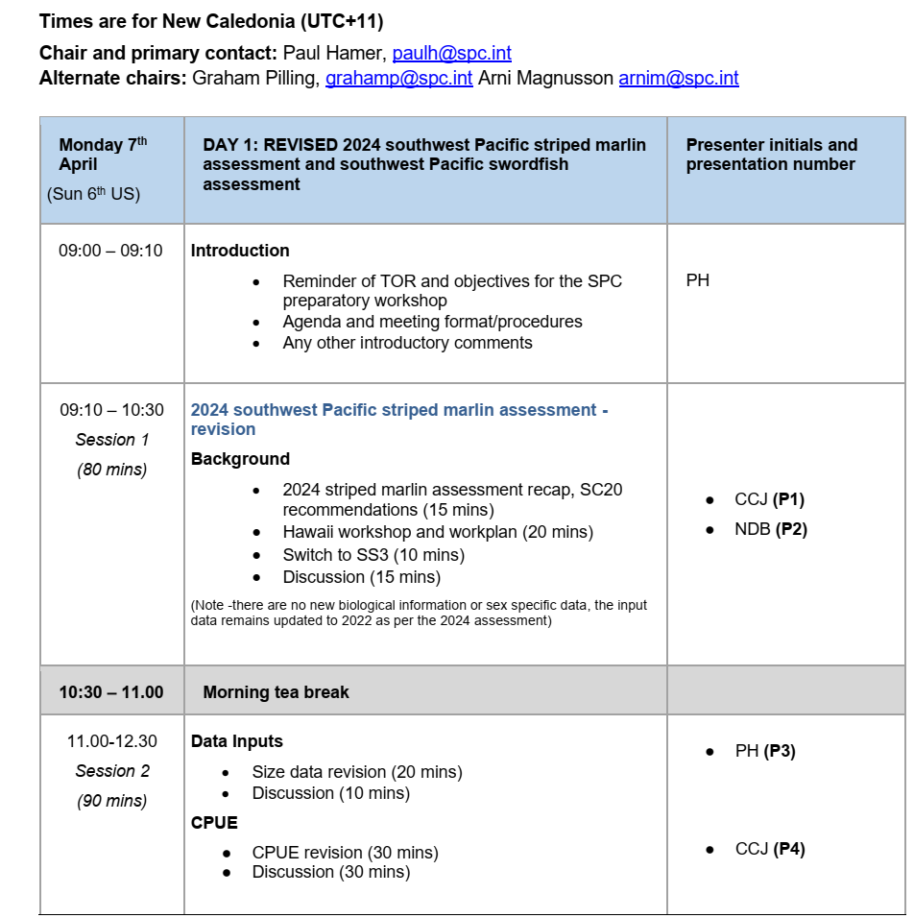

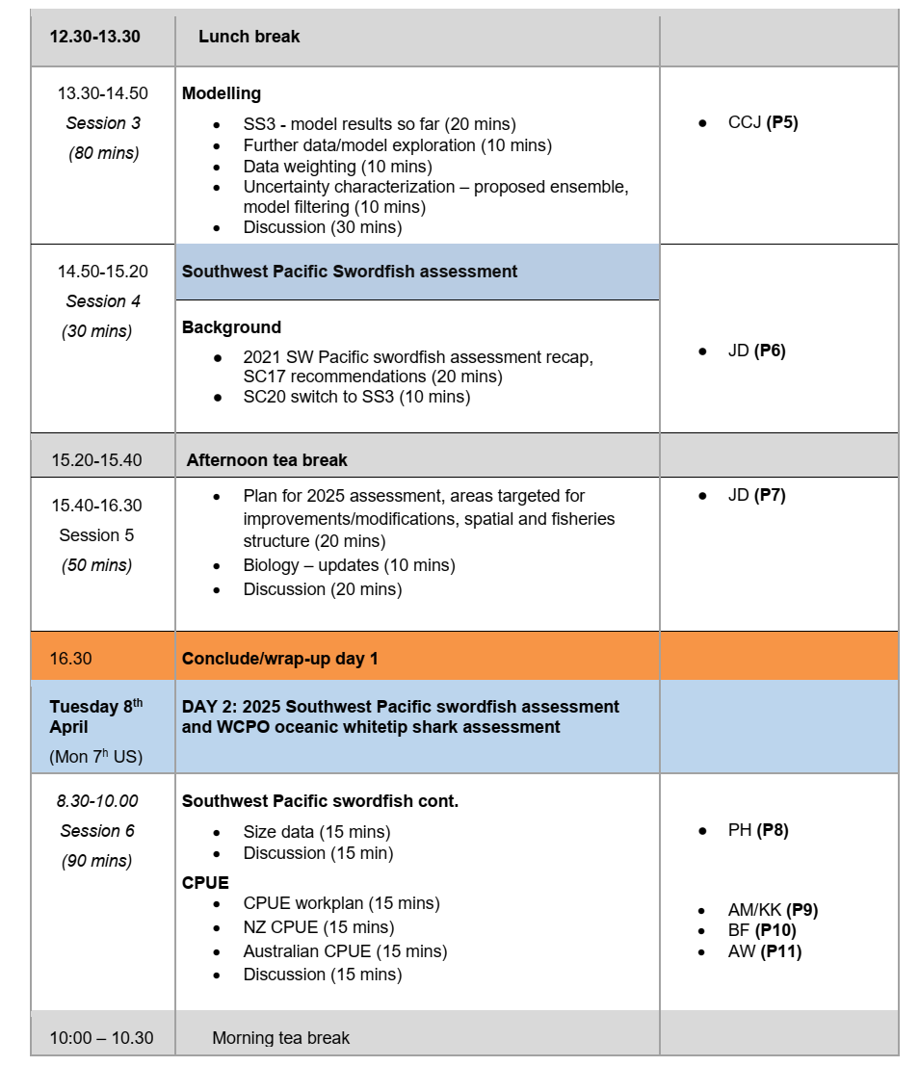

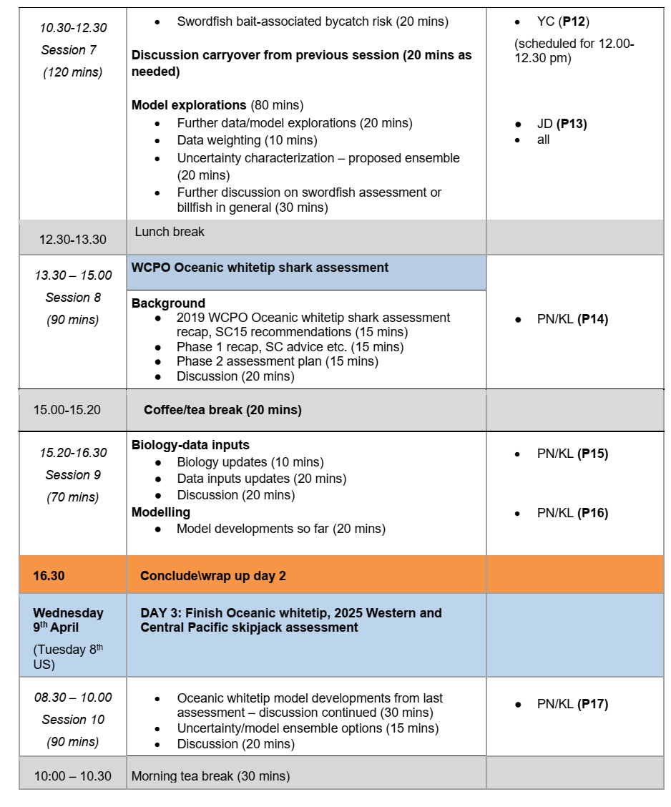

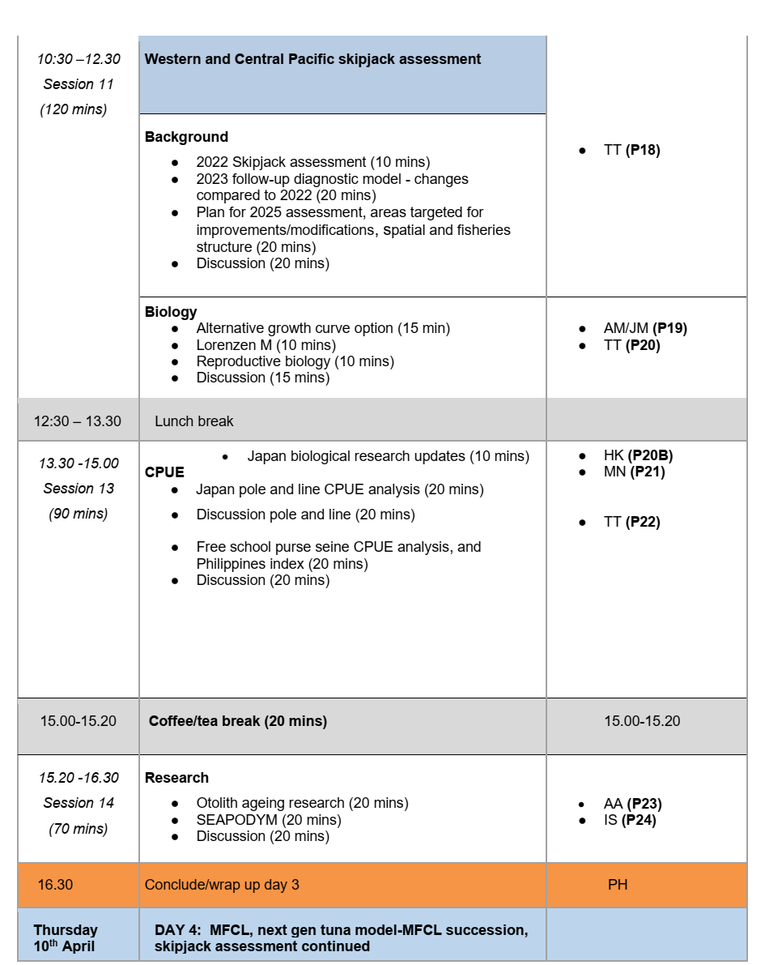

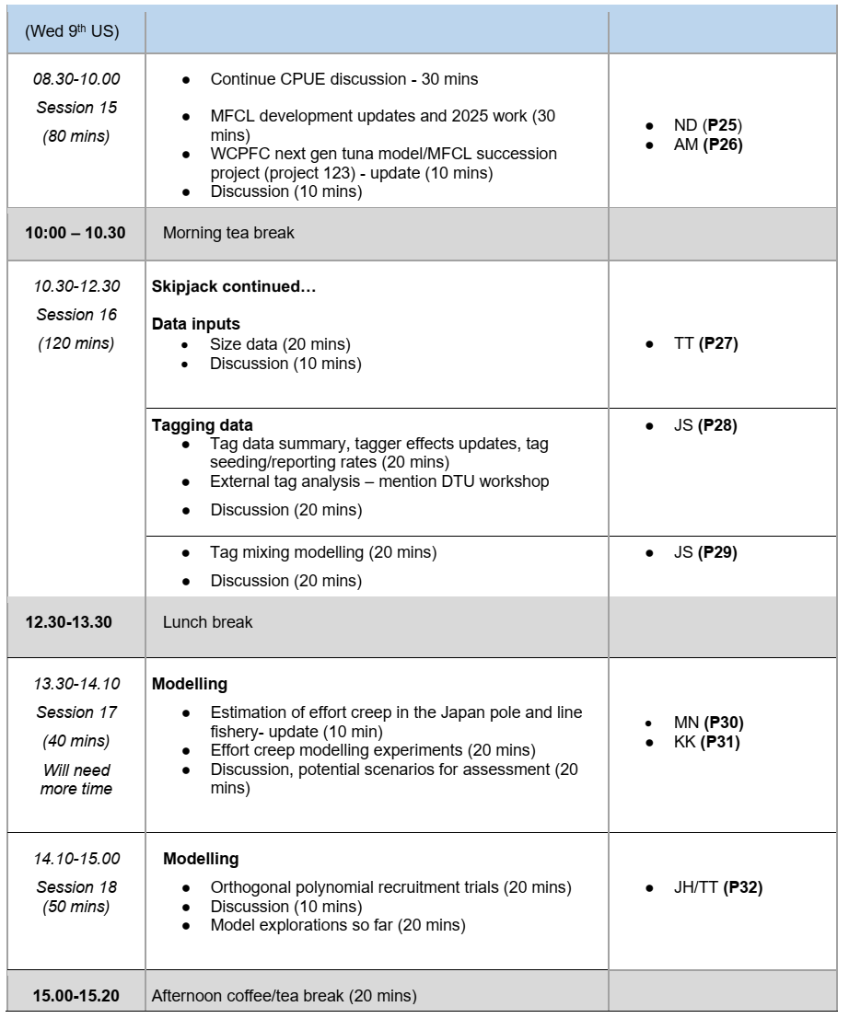

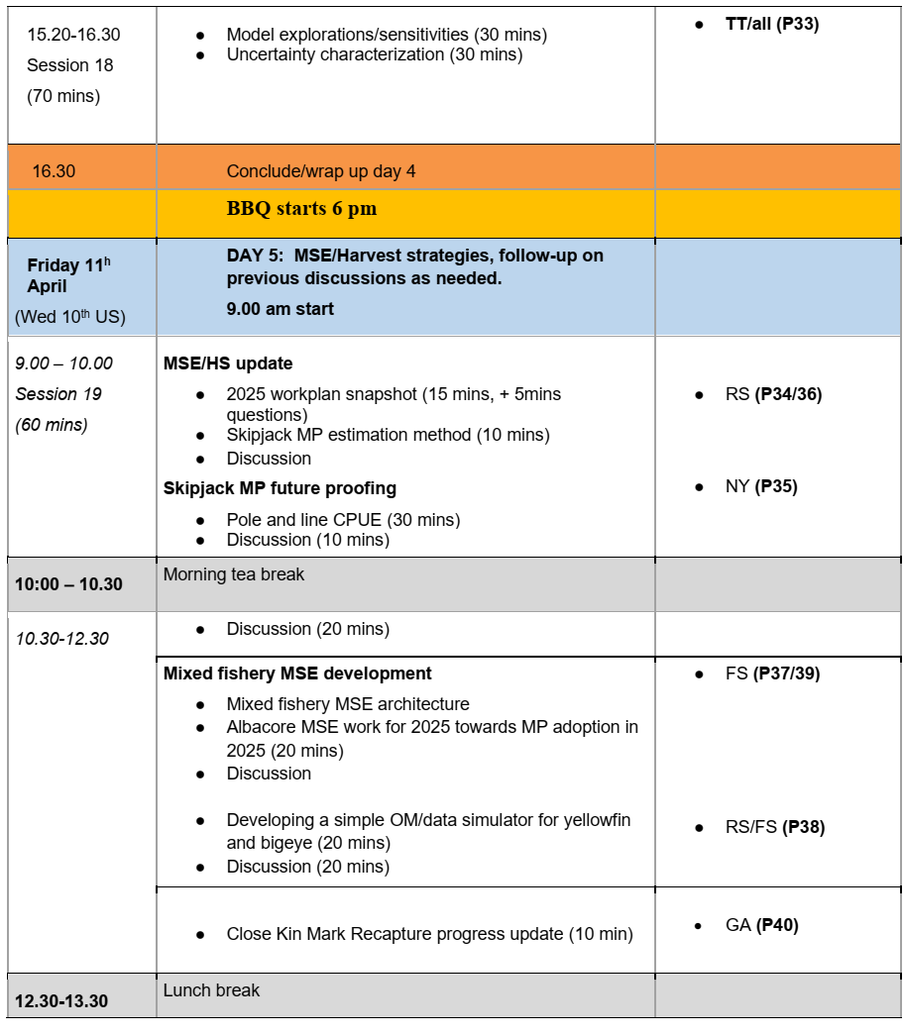

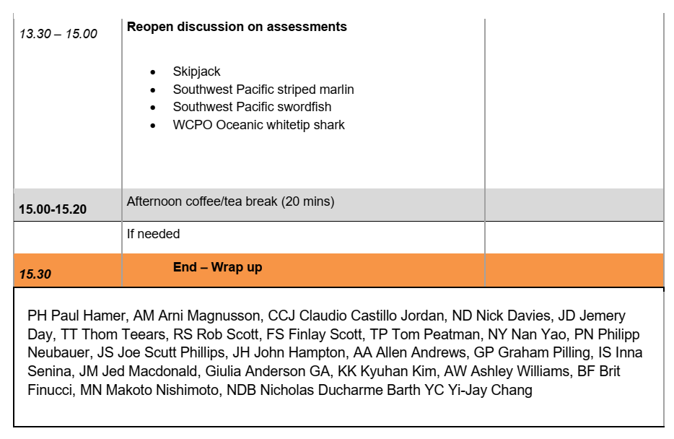

APPENDIX 2: List of participants
Name | Affiliation | In person (IP) / Online (O) | Email
Leyla Knittweis | Ministry for Primary Industries, NZ | O | Leyla.Knittweis@mpi.govt.nz
D’Arcy Webber | Quantifish, NZ | O | darcy@quantifish.co.nz
Britt Finucci | NIWA, NZ | O | brit.finucci@niwa.co.nz
Simon Hoyle | Consultant, NZ | O | simon.hoyle@gmail.com
John Holdsworth | Consultant, NZ | O | john@bluewatermarine.co.nz
Philipp Neubauer | Dragonfly Data Science | IP | philipp@dragonfly.co.nz
Kath Large | Dragonfly Data Science | IP | kath@dragonfly.co.nz
Steven Brouwer | Sagittas LTD | O | Steve@saggitus.co.nz
Nick Davies | Takina LTD, consultant | IP | nd200806@gmail.com
Jessica Farley | CSIRO, AU | O | Jessica.Farley@csiro.au
Ashely Williams | CSIRO, AU | O | ashley.williams@csiro.au
Bradley Moore | CSIRO, AU | O | Bradley.Moore@csiro.au
Brent Wise | ABARES - Department of Agriculture, Fisheries and Forestry, AU | IP | Brent.Wise@aff.gov.au
James Larcombe | ABARES - Department of Agriculture, Fisheries and Forestry, AU | O | jwp.larcombe@gmail.com
Conor Clayton | ABARES - Department of Agriculture, Fisheries and Forestry, AU | O | Conor.Clayton@aff.gov.au
Heather Patterson | ABARES - Department of Agriculture, Fisheries and Forestry, AU | O | Heather.Patterson@aff.gov.au .
Adele Dutilloy | FFA | IP | adele.dutilloy@ffa.int
Ludwig Kumoru | FFA | IP | ludwig.kumoru@ffa.int
Berry Muller | Marshall Islands Marine Resources Authority | O | bmuller@mimra.com
Brian Kumasi | PNAO | O | brian@pnatuna.com
Michelle Sculley | NOAA (Pacific Islands Fisheries Science Centre), US | O | michelle.sculley@noaa.gov
Nicholas Ducharme-Barth | NOAA (Pacific Islands Fisheries Science Centre), US | IP | nicholas.ducharme-barth@noaa.gov
Felipe Carvalho | NOAA (Pacific Islands Fisheries Science Centre), US | O | felipe.carvalho@noaa.gov
Carolina Minte-Vera | IATTC | O | cminte@iattc.org
Moses Mataika | Fiji Fisheries | IP | mataika.moses@gmail.com
Mickael Lercari | New Caledonia | IP/O | mickael.lercari@gouv.nc
Fayakun Satria | Indonesia | IP | fsatria70@gmail.com
Lilis Sadiyah | Indonesia | IP | sadiyah.lilis2@gmail.com
Eric Chang | National Sun Yat-sen University, TW | IP | eric.skchang@g-mail.nsysu.edu.tw
Yi-Jay Chang | National Sun Yat-sen University, TW | O | yijay.chang@gmail.com
Wei-Chuan Chiang | TW | O | wcchiang@mail.tfrin.gov.tw
Jia-Rong Wu | TW | O | wujiarong@ofdc.org.tw
Ren-Fen Wu | TW | IP | fan@ofdc.org.tw
Hidetada Kiyofuji | Japan Fisheries Research and Education Agency | IP | kiyofuji_hidetada20@fra.go.jp
Makoto Nishimoto | Japan Fisheries Research and Education Agency | IP | m.nishimoto103@gmail.com
Naoto Matsubara | Japan Fisheries Research and Education Agency | IP | matsubara_naoto84@fra.go.jp
Yasuko Semba | Japan Fisheries Research and Education Agency | O | semba_yasuko25@fra.go.jp
Mi Kyung Lee | Korea | O | ccmklee@korea.kr
Heewon Park | Korea | O | heewon81@korea.kr
Jong Ho Park | Korea | O | marinebio@korea.kr
Domingo Ochavillo | American Samoa | O | ochavill@gmail.com
Francisco ‘Curro’ Abascal | EU | IP | francisco.abascal@ieo.csic.es
SungKwon Soh | WCPFC Secretariat | IP | SungKwon.Soh@wcpfc.int
Elain Garvilles | WCPFC Secretariat | O | Elaine.Garvilles@wcpfc.int
Glen Holmes | PEW | O | gholmes@pewtrusts.org
Rebecca Scott | The Ocean Foundation | O | rscott@oceanfdn.org
Isidro Tanangonan | Philippines (BFAR) | O | itanangonan@bfar.da.gov.ph
Mr. Joeren S. Yleaña | Philippines (BFAR) | O | jyleana@bfar.da.gov.ph
Francisco Torres Jr. | Philippines (NFRDI) | O | franciscojr.torres@nfrdi.da.gov.ph
Suzette Barcoma | Philippines (BFAR) | O | suzettebarcoma@gmail.com
Julie Ahnne Fruelda | Philippines (BFAR) | O | jfruelda.office@gmail.com
Mary Charn Baculio | Philippines (BFAR) | O | marycharnb@gmail.com
Jennifer Laureniano | Philippines (BFAR) | O | jslaurenciano1997@gmail.com
Allen Andrews | SPC | O | allena@spc.int
Claudio Castillo Jordon | SPC | IP | claudioc@spc.int
John Hampton | SPC | IP | johnh@spc.int
Graham Pilling | SPC | IP | grahamp@spc.int
Sam McKechnie | SPC | IP | SamM@spc.int
Rob Scott | SPC | IP | robertsc@spc.int
Finlay Scott | SPC | IP | Finlays@spc.int
Nan Yao | SPC | IP | nany@spc.int
Montana Wickens | SPC | IP | montanw@spc.int
Kyuhan Kim | SPC | IP | kyuhank@spc.int
Jemery Day | SPC | IP | jemeryd@spc.int
Arni Magnusson | SPC | IP | arnim@spc.int
Thom Teears | SPC | IP | thomast@spc.int
Paul Hamer | SPC | IP | paulh@spc.int
Joe Scutt Phillips | SPC | IP | joes@spc.int
Jed Macdonald | SPC | IP | JedM@spc.int
Joanne Potts | SPC | O | joannep@spc.int
Victor Odongo | SPC | IP | victoro@spc.int
Inna Senina | SPC | IP | innas@spc.int
Sebastian Gislard | SPC | IP | sebastieng@spc.int
Simon Nicol | SPC | IP | simonn@spc.int
Marino Wichman | SPC | IP | marinow@spc.int
Giulia Anderson | SPC | IP | giuliaa@spc.int
Nick Hill | SPC | IP | nickh@spc.int

APPENDIX 3: Terms of Reference
The Oceanic Fisheries Programme (OFP) of SPC is contracted by WCPFC to undertake stock assessments. The results of these assessments will be presented at the WCPFC Scientific Committee. In preparation for these assessments, OFP is hosting a pre-assessment workshop to discuss key issues related to the assessments. The terms of reference for this workshop are provided below.

Terms of Reference
- Review the most recent completed assessments, in particular, any concerns, suggestions and/or recommendations raised by the Scientific Committee, the Commission, research providers, individual CCMs, or any independent reviews;
- Review preliminary work undertaken by the service provider relating to the stock assessments, including any proposed:
  - revisions to biological parameters
  - revisions to historical data
  - changes to structural assumptions in the model
  - methodological issues, e.g., characterization of uncertainty
  - standardized CPUE analysis
  - incorporation of tagging data or other auxiliary data
- Provides guidance to the OFP on:
  - the suitability of any proposed changes and any suggested additional work
  - a minimum set model runs to be undertaken, in particular the range of key sensitivity analyses
  - desired model diagnostics to be presented.
  - alternative modelling approaches that could be considered

The outcomes of the meeting will be documented in two ways, a report of the meeting and in the assessment working papers themselves. The report of the meeting will be distributed to workshop participants for comment within 10 working days of the meeting and revised and provided to WCPFC Scientific Committee members 30 days after the meeting. It will also be submitted to the next Scientific Committee as a Working Paper. Many of the matters discussed to the workshop will be the subject of meeting papers to the Scientific Committee.

Due to the timing of the meeting, any model runs presented will be based on previous assessment data sets, and therefore no preliminary stock assessment runs will be undertaken. Further, the workshop will occur prior to the submission of data and completion of supporting analyses (e.g., CPUE analyses). Therefore, any major changes to historical data submitted by CMM’s, or new data could result in a need to consider alternative model runs or structures not considered previously. In such instances, supporting documentation will be provided to the SC via working papers to allow the SC to determine the merits of any proposed changes.

The consultation will be open to participation by all CCMs and to other experts, by invitation. CCMs will be expected to fund their participation although SIDS and participating territories may seek support from the Commission’s Special Requirements Fund or other sources, as appropriate.

