

SCIENTIFIC COMMITTEE

ELEVENTH REGULAR SESSION

Pohnpei, Federated States of Micronesia

5{13 August 2015

Analysis of stock status and related indicators for key shark species of the Western Central Paci c Fisheries Commission

WCPFC-SC11-2015/SA-IP-05

Joel Rice1, Laura Tremblay-Boyer2, and Shelton Harley

1Joel Rice Consulting Ltd.

2Oceanic Fisheries Programme, Secretariat of the Paci c Community

Contents

|  |  |  |  |
| --- | --- | --- | --- |
| 1 | Introduction | | 8 |
|  | 1.1 | Report Layout  . . . . . . . . . . . . . . . . . . . . . . . . . . . . . . . . . . . . . . . | 8 |
| 2 | Description of Data | | 8 |
|  | 2.1 | Longline Fishery Data . . . . . . . . . . . . . . . . . . . . . . . . . . . . . . . . . . . | 9 |

1. Purse Seine data  . . . . . . . . . . . . . . . . . . . . . . . . . . . . . . . . . . . . . . 13

|  |  |
| --- | --- |
| 3 Description of Indicator Analyses | 15 |

1. Distribution Indicators . . . . . . . . . . . . . . . . . . . . . . . . . . . . . . . . . . . 15  3.1.1 Methods . . . . . . . . . . . . . . . . . . . . . . . . . . . . . . . . . . . . . . . 15

3.1.2  Results  . . . . . . . . . . . . . . . . . . . . . . . . . . . . . . . . . . . . . . . 15

1. Conclusions . . . . . . . . . . . . . . . . . . . . . . . . . . . . . . . . . . . . . 16

3.2 Observed Species Composition Indicator Analyses  . . . . . . . . . . . . . . . . . . . 16

* 1. Conclusions . . . . . . . . . . . . . . . . . . . . . . . . . . . . . . . . . . . . . 17

1. Catch Per Unit E ort indicator analyses . . . . . . . . . . . . . . . . . . . . . . . . . 18
   1. Methods . . . . . . . . . . . . . . . . . . . . . . . . . . . . . . . . . . . . . . . 18

3.3.2  Results  . . . . . . . . . . . . . . . . . . . . . . . . . . . . . . . . . . . . . . . 20

* 1. Conclusions . . . . . . . . . . . . . . . . . . . . . . . . . . . . . . . . . . . . . 21

1. Biological indicator analyses . . . . . . . . . . . . . . . . . . . . . . . . . . . . . . . . 22
   1. Methods . . . . . . . . . . . . . . . . . . . . . . . . . . . . . . . . . . . . . . . 22

3.4.2  Results  . . . . . . . . . . . . . . . . . . . . . . . . . . . . . . . . . . . . . . . 23

1. Conclusions . . . . . . . . . . . . . . . . . . . . . . . . . . . . . . . . . . . . . 23

|  |  |  |  |  |
| --- | --- | --- | --- | --- |
| 4 | Feasibility of Stock Assessments | | | 27 |
| 5 | Impact of Recent Shark Management Measures | | | 27 |
| 6 | Recommendations for Future Indicator Work | | | 27 |
| 7 | Management Implications | | | 27 |
| A | CPUE Indicators. Model diagnostics and extra plots | | | 27 |
|  | A.1 | Longline Fishery Data . . . . . . . . . . . . . . . . . . . . . . . . . . . . . . . . . . . | | 27 |
| B | Distribution Indicator Analyses | | | 42 |
|  | B.1 | Introduction . . . . . . . . . . . . . . . . . . . . . . . . . . . . . . . . . . . . . . . . . | | 42 |
|  | B.2 | Methods . . . . . . . . . . . . . . . . . . . . . . . . . . . . . . . . . . . . . . . . . . . | | 42 |
|  | B.3 | Results . . . . . . . . . . . . . . . . . . . . . . . . . . . . . . . . . . . . . . . . . . . . | | 42 |
|  |  | B.3.1 | Blue Shark  . . . . . . . . . . . . . . . . . . . . . . . . . . . . . . . . . . . . . | 43 |
|  |  | B.3.2 Mako Shark . . . . . . . . . . . . . . . . . . . . . . . . . . . . . . . . . . . . . | | 45 |
|  |  | B.3.3 | Silky Shark . . . . . . . . . . . . . . . . . . . . . . . . . . . . . . . . . . . . . | 45 |
|  |  | B.3.4 | Oceanic Whitetip Shark . . . . . . . . . . . . . . . . . . . . . . . . . . . . . . | 45 |
|  |  | B.3.5 Thresher Shark . . . . . . . . . . . . . . . . . . . . . . . . . . . . . . . . . . . | | 45 |
|  |  | B.3.6 | Hammerhead Shark  . . . . . . . . . . . . . . . . . . . . . . . . . . . . . . . . | 45 |
|  |  | B.3.7 | Porbeagle Shark  . . . . . . . . . . . . . . . . . . . . . . . . . . . . . . . . . . | 45 |
|  | B.4 | Conclusions . . . . . . . . . . . . . . . . . . . . . . . . . . . . . . . . . . . . . . . . . | | 45 |

2

|  |  |  |  |  |
| --- | --- | --- | --- | --- |
| C | Observed Species Composition Indicator Analyses | | | 45 |
|  | C.1 | Introduction . . . . . . . . . . . . . . . . . . . . . . . . . . . . . . . . . . . . . . . . . | | 45 |
|  | C.2 | Methods . . . . . . . . . . . . . . . . . . . . . . . . . . . . . . . . . . . . . . . . . . . | | 45 |
|  | C.3 | Results . . . . . . . . . . . . . . . . . . . . . . . . . . . . . . . . . . . . . . . . . . . . | | 45 |
|  | C.4 | Conclusions . . . . . . . . . . . . . . . . . . . . . . . . . . . . . . . . . . . . . . . . . | | 61 |
| D | Catch Per Unit E ort indicator analyses | | | 67 |
|  | D.1 | Results . . . . . . . . . . . . . . . . . . . . . . . . . . . . . . . . . . . . . . . . . . . . | | 69 |
|  |  | D.1.1 | Blue Shark  . . . . . . . . . . . . . . . . . . . . . . . . . . . . . . . . . . . . . | 69 |
|  |  | D.1.2 | Mako Shark . . . . . . . . . . . . . . . . . . . . . . . . . . . . . . . . . . . . . | 69 |
|  |  | D.1.3 | Silky Shark . . . . . . . . . . . . . . . . . . . . . . . . . . . . . . . . . . . . . | 73 |
|  |  | D.1.4 | Oceanic Whitetip Shark . . . . . . . . . . . . . . . . . . . . . . . . . . . . . . | 73 |
|  |  | D.1.5 | Thresher Shark . . . . . . . . . . . . . . . . . . . . . . . . . . . . . . . . . . . | 73 |
|  |  | D.1.6 | Hammerhead Shark  . . . . . . . . . . . . . . . . . . . . . . . . . . . . . . . . | 73 |
|  |  | D.1.7 | Hammerhead Shark  . . . . . . . . . . . . . . . . . . . . . . . . . . . . . . . . | 73 |
| E | Biological indicator analyses | | | 80 |
|  |  | E.0.8 | Species Distribution Maps . . . . . . . . . . . . . . . . . . . . . . . . . . . . . | 82 |

3

List of Figures

|  |  |  |  |
| --- | --- | --- | --- |
| 1 | Map of WCPO and regions used for the analysis.  . | . . . . . . . . . . . . . . . . . . | 10 |
| 2 | Map of WCPO and observed e ort.  . . . . . . . . . | . . . . . . . . . . . . . . . . . . | 11 |
| 3 | Logsheet e ort by month.  . . . . . . . . . . . . . . . | . . . . . . . . . . . . . . . . . . | 12 |
| 4 | Absolute percent di erence in e ort between reported | (logsheet) e ort and observed |  |
|  | e ort.  . . . . . . . . . . . . . . . . . . . . . . . . . . | . . . . . . . . . . . . . . . . . . | 13 |
| 5 | CPUE indicators, nominal CPUE in the purse seine fishery, Unassociated Sets, Re- | |  |
|  | gion 3.  . . . . . . . . . . . . . . . . . . . . . . . . . | . . . . . . . . . . . . . . . . . . | 24 |
| 6 | Median length (in fork length) for both sexes (combined) of silky sharks in Regions | |  |
|  | 3 and 4 based on samples taken from the purse seine fishery, 1995-2014. The 5th | |  |
|  | and 95th percentiles of the data are shown with dashed lines. Size at maturity is | |  |
|  | represented by the solid horizontal line. The sample size is shown in the inset to | |  |
|  | each plot.  . . . . . . . . . . . . . . . . . . . . . . . . | . . . . . . . . . . . . . . . . . . | 25 |

* Median length (in fork length) for both sexes (combined) of oceanic whitetip sharks  in Regions 3 and 4 based on samples taken from the purse seine fishery, 1995-2014.  The 5th and 95th percentiles of the data are shown with dashed lines. Size at

|  |  |  |
| --- | --- | --- |
|  | maturity is represented by the solid horizontal line. The sample size is shown in the |  |
|  | inset to each plot.  . . . . . . . . . . . . . . . . . . . . . . . . . . . . . . . . . . . . . | 26 |
| 8 | Map of WCPO and observed e ort.  . . . . . . . . . . . . . . . . . . . . . . . . . . . | 28 |
| 9 | Total number of hooks shed by flag (for the top four fishing nations, and all others |  |
|  | combined) based on aggregated (5x5 degree square) data, for six regions of the |  |
|  | WCPFC Statistical Area.  . . . . . . . . . . . . . . . . . . . . . . . . . . . . . . . . . | 29 |

1. Total number of reported sharks by flag (for the top four fishing nations, and all  others combined) based aggregated (5x5 degree square) data, for six regions of the  WCPFC Statistical Area. . . . . . . . . . . . . . . . . . . . . . . . . . . . . . . . . . 30
2. Total number of hooks observed by flag (for the top four fishing nations) based  on longline observer records held by the SPC-OFP, for six regions of the WCPFC

Statistical Area  . . . . . . . . . . . . . . . . . . . . . . . . . . . . . . . . . . . . . . 31

1. Logsheet e ort by month.  . . . . . . . . . . . . . . . . . . . . . . . . . . . . . . . . . 32
2. Observed e ort by month.  . . . . . . . . . . . . . . . . . . . . . . . . . . . . . . . . 33
3. Absolute percent di erence in e ort between reported (logsheet) e ort and observed  e ort. . . . . . . . . . . . . . . . . . . . . . . . . . . . . . . . . . . . . . . . . . . . . 34
4. aggregate e ort by region.  . . . . . . . . . . . . . . . . . . . . . . . . . . . . . . . . 35
5. Observed purse seine in the WCPO showing the top four fishing nations and all  others combined. . . . . . . . . . . . . . . . . . . . . . . . . . . . . . . . . . . . . . 36
6. Absolute percent di erence in e ort between reported (logsheet) e ort and observed  e ort. . . . . . . . . . . . . . . . . . . . . . . . . . . . . . . . . . . . . . . . . . . . . 37
7. Comparison by region and flag of purse seine e ort (in sets) associated sets using  aggregated (5x5 degree square) data for six regions of the WCPFC Statistical Area,  excluding data from Indonesia, Vietnam, and Japan coastal waters. . . . . . . . . . 38
8. Comparison by region and flag of purse seine e ort (in sets) unassociated sets using  aggregated (5x5 degree square) data for six regions of the WCPFC Statistical Area,  excluding data from Indonesia, Vietnam, and Japan coastal waters. . . . . . . . . . 39
9. Total sharks recorded on logsheets (in number of sets recording at least one shark  interaction), for associated sets. . . . . . . . . . . . . . . . . . . . . . . . . . . . . . 40
10. Total sharks recorded on logsheets (in number of sets recording at least one shark  interaction), for unassociated sets. . . . . . . . . . . . . . . . . . . . . . . . . . . . . 41

4

1. Blue shark distribution indicators. Proportion of positive sets, observer data.  . . . . 43
2. Blue shark distribution indicators. Proportion of 5 degree squares having CPUE  greater than 1 per 1000 hooks region, observer data. . . . . . . . . . . . . . . . . . . 44
3. Mako shark distribution indicators. Proportion of positive sets, observer data.  . . . 45
4. Mako shark distribution indicators. Proportion of 5 degree squares having CPUE  greater than 1 per 1000 hooks region, observer data. . . . . . . . . . . . . . . . . . . 46
5. Mako shark distribution indicators. Proportion of positive sets, observer data.  . . . 47
6. Silky shark distribution indicators. Proportion of 5 degree squares having CPUE  greater than 1 per 1000 hooks region, observer data. . . . . . . . . . . . . . . . . . . 48
7. Oceanic whitetip shark distribution indicators. Proportion of positive sets, observer  data. . . . . . . . . . . . . . . . . . . . . . . . . . . . . . . . . . . . . . . . . . . . . 49
8. Oceanic whitetip shark distribution indicators. Proportion of 5 degree squares having  CPUE greater than 1 per 1000 hooks region, observer data. . . . . . . . . . . . . . 50
9. Thresher shark distribution indicators. Proportion of positive sets, observer data.  . 51
10. Thresher shark distribution indicators. Proportion of 5 degree squares having CPUE  greater than 1 per 1000 hooks region, observer data. . . . . . . . . . . . . . . . . . . 52
11. Hammerhead shark distribution indicators. Proportion of positive sets, observer  data. . . . . . . . . . . . . . . . . . . . . . . . . . . . . . . . . . . . . . . . . . . . . 53
12. Hammerhead shark distribution indicators. Proportion of 5 degree squares having  CPUE greater than 1 per 1000 hooks region, observer data. . . . . . . . . . . . . . 54
13. Porbeagle shark distribution indicators. Proportion of positive sets, observer data.  . 55
14. Porbeagle shark distribution indicators. Proportion of 5 degree squares having CPUE  greater than 1 per 1000 hooks region, observer data. . . . . . . . . . . . . . . . . . . 56
15. Catch Composition Indicators. Sharks Per. 1000 hooks by region, observer data.  . . 57
16. Catch Composition Indicators. Sharks Per. 1000 hooks by region, deep sets observer  data. . . . . . . . . . . . . . . . . . . . . . . . . . . . . . . . . . . . . . . . . . . . . 58
17. Catch Composition Indicators. Sharks Per. 1000 hooks by region, shallow sets  observer data. . . . . . . . . . . . . . . . . . . . . . . . . . . . . . . . . . . . . . . . 59
18. Catch Composition Indicators. Proportional catch of main species and other sharks

by retions.  . . . . . . . . . . . . . . . . . . . . . . . . . . . . . . . . . . . . . . . . . 60

1. Catch Composition Indicators. Sharks per set, observer data.  . . . . . . . . . . . . 61

41  Catch Composition Indicators. Sharks per set, associated sets, observer data  . . . . 62

1. Catch Composition Indicators. Sharks per set, unassociated sets, observer data.  . . 63
2. Catch Composition Indicators. Catch composition by proportion , observer data.  . 64
3. Catch Composition Indicators. Catch composition by proportion, associated sets,  observer data . . . . . . . . . . . . . . . . . . . . . . . . . . . . . . . . . . . . . . . . 65
4. Catch Composition Indicators. Catch composition by proportion, unassociated sets,  observer data. . . . . . . . . . . . . . . . . . . . . . . . . . . . . . . . . . . . . . . . 66
5. CPUE indicators, nominal CPUE in the purse seine fishery, all sets, Region 3.  . . . 67
6. CPUE indicators, nominal CPUE in the purse seine fishery, all sets, Region 4.  . . . 68
7. Blue shark CPUE indicators. Proportion of positive sets, observer data.  . . . . . . 69
8. Blue shark CPUE indicators. Nominal CPUE, sharks per 1000 hooks, observer data.  70
9. Mako shark CPUE indicators. Proportion of positive sets, observer data.  . . . . . . 71
10. Mako shark CPUE indicators. Nominal CPUE, sharks per 1000 hooks, observer data.  72
11. Silky shark CPUE indicators. Proportion of positive sets, observer data.  . . . . . . 73
12. Silky shark CPUE indicators. Nominal CPUE, sharks per 1000 hooks, observer data.  74
13. Oceanic whitetip shark CPUE indicators. Proportion of positive sets, observer data.  75

5

1. Oceanic whitetip shark CPUE indicators. Nominal CPUE, sharks per 1000 hooks,  observer data. . . . . . . . . . . . . . . . . . . . . . . . . . . . . . . . . . . . . . . . 76
2. Thresher shark CPUE indicators. Proportion of positive sets, observer data.  . . . . 77
3. Thresher shark CPUE indicators. Nominal CPUE, sharks per 1000 hooks, observer  data. . . . . . . . . . . . . . . . . . . . . . . . . . . . . . . . . . . . . . . . . . . . . 78
4. Thresher shark CPUE indicators. Proportion of positive sets, observer data.  . . . . 78
5. Thresher shark CPUE indicators. Nominal CPUE, sharks per 1000 hooks, observer  data. . . . . . . . . . . . . . . . . . . . . . . . . . . . . . . . . . . . . . . . . . . . . 78
6. Thresher shark CPUE indicators. Proportion of positive sets, observer data.  . . . . 78
7. Thresher shark CPUE indicators. Nominal CPUE, sharks per 1000 hooks, observer  data. . . . . . . . . . . . . . . . . . . . . . . . . . . . . . . . . . . . . . . . . . . . . 79
8. Species distribution, blue shark observed in the longline fishery.  . . . . . . . . . . . 82
9. Species distribution, blue shark observed in the longline fishery by observer program.  83
10. Species distribution, silky shark observed in the longline fishery.  . . . . . . . . . . . 84
11. Species distribution, blue shark observed in the longline fishery by observer program.  85
12. Species distribution, mako shark observed in the longline fishery.  . . . . . . . . . . . 86
13. Species distribution, blue shark observed in the longline fishery by observer program.  87
14. Species distribution, oceanic whitetip shark observed in the longline fishery.  . . . . 88
15. Species distribution, blue shark observed in the longline fishery by observer program.  89
16. Species distribution, thresher shark observed in the longline fishery.  . . . . . . . . . 90
17. Species distribution, blue shark observed in the longline fishery by observer program.  91
18. Species distribuion, hammerhead shark observed in the longline fishery.  . . . . . . . 92
19. Species distribuion, porbeagle shark observed in the longline fishery.  . . . . . . . . . 93

6

Executive Summary

7

* Introduction

The status of the many shark species, and in particular those designated as key shark species (blue, mako, thresher, silky and oceanic white tip sharks) in the western and central Pacific Ocean (WCPO) underwent a comprehensive review in 2011 (?). In that review a number of indicators were developed to inform on the status of those shark stocks and their response to fishing pressure. The indicators were developed around information available from operational-level data and included information on the geographic range of catches for each of the species considered; temporal trends in catch composition and catch rates, and in key biological indicators of fishing pressure such as mean size and sex ratio. This study provides an update of many of those indicators and extends the species indicator analyses to include hammer head and porbeagle sharks.

Sharks are often caught as bycatch in the Pacific tuna fisheries (though some directed/mixed species fisheries, sharks and tunas/billfishes, do exist). This paper presents an analysis of Secretariat of the Pacific Community - Oceanic Fisheries Programme (SPC-OFP) data holdings for sharks taken in longline and purse seine fisheries in the Western and Central Pacific Ocean (WCPO). The framework for the analysis is a series of indicators of fishing pressure and stock status that were first described in the Shark Research Plan presented to the sixth meeting of the Western and Central Pacific Fisheries Commission's (WCPFC) Scientific Committee (SC6; Clarke and Harley 2010). A preliminary indicator-based analysis of SPC data holdings was presented to the Commission in December 2010 (Clarke et al. 2010) with an extensive review of the fisheries and data sources presented to SC7 (Clarke et al. 2011).

related to the stocks general trend, whether it has changed from the previous indicator analysis and, in such cases where further analysis is proposed, it provides recommendations on how to undertake that analysis. Uncertainty regarding any species population level mechanisms that drive any individual analysis is qualitatively expressed by species and stock in order to represent the uncertainty in the underlying data. – not sure whether to keep or lose

1. Report Layout

This report is necessarily large. To assist the reader it has been structured along the following lines. Following a brief description of the available data in section 2, each of the four indicator analyses are described and results summarized in section 3. Section 4 presents a consideration of the feasibility of conducting a formal stock assessment for each of the shark species discussed in this report. In Section 5, we review the impact of recent shark management measures and, in section 6, recommend future work to extend and improve the indicator analysis approach. Finally, section 7 discusses the management implications arising from the results of the work presented here.

* Description of Data

The primary source of catch information regarding sharks is the SPC-held observer database which, despite low coverage in all regions (Table 1 %Observer coverage by region), has a substantial amount of information regarding operational characteristics as well as fate and condition data on captured sharks. In addition to the observer data, SPC holds operational logsheet and aggregate data on shark catches by longline fisheries. The operational data submitted to the SPC are at a higher spatial resolution than the aggregate data, and are useful for catch estimation, but in practice their utility is limited by the lack of data provision by species for shark (Table 2 Logsheet coverage by region % that ID sharks to species), especially in equatorial regions where the majority of the longline effort occurs

Aggregate coverage rates are on par with the coverage rates of the operational logsheet data sets, although coverage differs greatly by region (Table 3). Historical coverage rates are poor partly because prior to February 2011 sharks were not amongst the species for which data provision was required (WCPFC 2013); since that time, data provision for 13 species designated by WCPFC as key shark species is mandatory . Under CMM 2007-01, required levels of Regional Observer Programme (ROP) coverage in longline fisheries are set to rise to 5% from June 2012 in most areas, but annual average values have been <1% in recent years (for the entire WCPO). With some notable exceptions (e.g. northeast and southwest of Hawaii), most observed sets occurred within Exclusive Economic Zones (EEZs). A thorough examination of the SPC-held fisheries data and its utility for shark related analyses can be found in Clarke et al. (2011).

Building on the work of Clarke et al (2011), this indicator analysis uses the six WCPFC statistical areas as defined in the 2010 WCPFC bigeye tuna stock assessment (Figure 1) As noted in Clarke et al. (2011), these regions are somewhat arbitrarily assigned to the key shark species. However, given the fact that the predominant source of fishing mortality for these species is the longline fishery targeting tropical tunas (as well as billfishes and occasionally sharks), these regions adequately capture the important characteristics of the fisheries. Therefore, for purposes of comprehension and comparison to the previous analysis, we opted to keep the same regions.

1. Longline Fishery Data

Ideally, indicator analyses would be based on operational-level data as its higher spatial resolution permits more comprehensive and nuanced analyses, however SPC’s operational level data is geographically limited with respect to provision of shark data. Figure 2 illustrates the geographic distribution of sets for which SPC holds operational data (blue dots) and sets with at least one recorded shark are overplotted (in orange). However, this picture is somewhat misleading as only 41% of the operational-level sets plotted recorded any sharks. This is in contrast to the observer data in which 93% of the sets recorded at least one shark (overplotted in red).

This is not necessarily due to misreporting. Prior to February 2011, sharks were not amongst the species for which data provision was required (WCPFC 2011); since that time data provision for the 13 species designated by WCPFC as key shark species has been mandatory. Figure 2 does not distinguish between key shark species and other shark species because only 16% of the reported sets recorded any species-specific shark catches. Clarke et al. (2011b) note that most historical species-specific shark catch data are provided by a small number of flag States (Clarke et al. 2011b).

Given the relatively low level of coverage in the operational-level logsheets, a more complete characterization of the longline fishery requires the use of the SPC-held aggregated (5x5 degree grid) data. Effort and reported shark catch data by flag at the aggregated level have a lower degree of spatial resolution but in most cases are raised to represent the entire WCPO longline fishery. Sets with observer present onboard, are shown for comparison (Figure 3) but have a finer degree of spatial resolution due to observer record keeping. Following CMM 2007-01, required levels of Regional Observer Programme (ROP) coverage in longline fisheries were set to rise to 5% in June 2012 but annual average values have been on the order of 1-2%.

A comparison of longline effort by flag and the number of sharks recorded in logsheets was constructed (Figure 4) by showing the top four fishing nations (in the WCPO as a whole) and aggregating the rest of the flag states to another group. If the fishing practices and reporting practices were more or less consistent across flags the numbers of sharks reported would be proportional, by flag, to the effort.

Comprehensive data on shark catches at high spatial resolution are available from observer data held by the SPC-OFP but, as described above, the overall coverage of these data is low, and less than the required levels of ROP coverage. In addition, a comparison of longline effort and longline observer coverage (Figure 5) reveals that the latter is disproportional by region and flag and thus cannot be considered representative of the fishery as whole.

Another aspect of the low data coverage problem is that a temporal representativeness on a month/year basis of the observed effort. A comparison of the annual proportion observed by month - on a regional basis - shows significant fluctuations in the relative coverage of the observer data compared to the logbook data (Figure 6).

1. Purse Seine data

Similar to the longline fishery, SPC-OFP holds logsheet data on shark catches by purse seine fisheries at both the operational and aggregate levels. However, operational-level coverage for the purse seine fishery (87%) is considerably higher than for the longline fishery (23%). This factor, in combination with the more limited geographic range of the purse seine fishery, contributes to more representative operation-level coverage in the purse seine fishery than in the longline fishery.

Following implementation of the WCPFC ROP on 1 January 2010, in combination with prior observer coverage commitments by Parties to the Nauru agreement (PNA) members, 100% purse seine observer coverage is now required (except for vessels fishing exclusively in one Exclusive Economic Zone (EEZ)). Historical observer coverage in the purse seine fishery has varied between EEZs. Coverage rates were low, generally less than 10%, for the years 1995-2002, with coverage increasing to 10-18% for the years 2003-2009. Recent (2010-2013) annual averages are between 42-56% in total.

While observer coverage of the purse seine fishery is not uniformly representative (Figure 7, orange points), it is more representative than observer coverage of the longline fishery, owing to both higher coverage levels and the more limited geographic range of the fishery (Lawson 2011). Regions 3 and 4 contain 98% of the operational-level reported purse seine sets, and 99% of observed sets and are thus the only regions for which purse seine analyses will be meaningful. Shark interactions are recorded in just 2.5% of purse-seine operational logsheets (Figure 7, red points), a value far lower than the 41% recorded in longline operational-level logsheet. As a result, it is not possible to assess the number of shark interactions by set or the species involved using purse seine logsheet data.

A comparison by flag of purse seine effort and the number of purse seine sets reporting at least one shark interaction was constructed for associated (floating object) and unassociated (free-swimming) sets based on aggregated logsheet data (Figure 8). For each panel, flags were ranked by number of sets and the top four flags were plotted separately with all remaining flags aggregated into an "Other" category. Although estimated shark catches in the purse seine fishery are considerably lower than shark catches in the longline fishery (SPC 2008, Lawson 2011), it would still be expected that purse seine shark interactions are proportional to purse seine effort. However, from the discrepancies observed between the left and right panels, it appears that some major fishing nations are not submitting or are under-reporting their shark interactions.

* Distribution Indicator Analysis
  1. Introduction

Distribution indicators provide one means of monitoring spatial and temporal trends in distribution and, potentially, abundance. For example, an increase in overall stock abundance might be signalled by a range expansion which could be picked up in commercial catch records. Similarly, range contraction might portend stock decline (Worm and Tittensor 2011 – maybe this reference applies?). The indicators presented below are based on observer data and thus patterns in fishing effort and/or observer coverage may bias the results. These results should therefore be taken as an initial indication of the location and intensity of interactions between these species and WCPO longline fisheries. They can be updated over time to determine if the spatial patterns change or temporal trends develop. More complex methodologies might also be applied to remove potential sampling biases.

* 1. Methods

In this study, we calculated four Distribution Indicators.

* Species occurrence. This indicator summarizes the occurrence of a species in any longline set monitored by an observer. A positive value at any given location simply indicates that the species in question was observed at least once, without regard to annual frequency or fishing effort.
* Proportion-presence. This indicator provides a rough indicator of the frequency of occurrence of each shark species in each region and trends in presence over time. Using observer data, the indictor is computed by dividing the total number of sets with at least one occurrence by the total number of sets in each region/year combination.
* High-CPUE. This indicator is intended to illustrate which regions and years have shown relatively high CPUE values for the different species. The index is constructed, again on the basis of observed longline sets, by computing mean CPUE within each 5°x5° cell within each of the six regions, and then calculating the proportion of cells within a region that are above a specific threshold. For this analysis, the threshold was set at 1 shark per 100 hooks for blue shark and at 1 shark per 5000 hooks for the other species.
* Hot spot analysis. FOR LAURA.
  1. Results

The four sets of Distribution Indictors are grouped in Appendix A, as follows: Species occurrence (Figures IA_01 to IA_07), Proportion-presence (Figure IA_08), High-CPUE (Figure IA_09), Hot spot analysis (Figures IA_10 to IA_16). Species-specific results below reference these sets of figures.

3.3.1 Blue Shark

3.3.2 Mako Shark

3.3.3 Silky Shark

3.3.4 Oceanic Whitetip Shark

3.3.5 Thresher Shark

3.4 Conclusions

Interpretation of distribution indicators is complicated by the influence of changes in fishing effort, observational coverage operational factors influencing selectivity and catchability (e.g. depth and leader material) and potentially by changes in community composition. As such, these indicators are best used for identifying the areas in which species-fishery interactions take place and as supporting information for interpreting other patterns and trends. With the exception of 2014 total effort in the longline fleet has increased, through the study period (1995-2014) to approximately 800 million hooks annually with nearly half occurring in regions 3 and 4. With the exception of blue shark the high-CPUE indicator more or less steady trends for all species in all regions, however this analysis was hampered by the lack of data throughout the region for species. Notably the proportion of high-CPUE cells for blue shark was decreasing thought the study period for regions 3,5,and 6 with steady or slightly decreasing trends in region 3 and 4, region 1 was data deficient. Interestingly the percentage of positive sets indicator for blue shark showed the opposite trends, increases in regions 3,5, and 6 with steady trends in regions 2 and 5. For silky shark there seems to be a slight downward trend in the core regions of 3 and 4, while oceanic whitetip sharks show stable to slightly increasing trends trends throughout all of the regions. Porbeagle sharks in region 5 and 6 show slightly increasing to stable trends. Mako sharks show slightly increasing trends in region 5 and 6, stable trends in regions 3 4 and a slightly decreasing trend in region 2, though data is lacking for years 2012-2014. The proporiton of positive sets for thresher sharks showed steady trends throughout the regions, however region 4 is where the majority of the observed threshers occured, in recent years an increase in the proportion of positive sets was evident. Hammerhead sharks had consistent, near zero proportion of positive sets.

Interpretation of fishery interaction indicators is complicated by the influence of changes in fishing effort, and perhaps other operational factors influencing selectivity and catchability (e.g. depth and leader material). Furthermore, samples sizes for length and sex information are quite limited for some species. As such, these indicators are best used for identifying the areas in which species-shery interactions take place and as supporting information for interpreting other patterns and trends.

1. Observed Species Composition Indicator Analyses

The species composition of the catch, as recorded by longline and purse seine observers, was exam-ined to identify any apparent changes over time. This type of analysis reinforces the species-speci c fishery interaction information above, but supplies more detail on interactions by separating long-line sets by depth and purse seine sets by type of school association. Another important reason for examining catch composition indicators is to assess changes in the percentage of unidenti ed shark species over time. Improvements in the observers' ability to identify sharks could contribute to increasing occurrences of species-speci c records in the observer database and could bias temporal trends.

While this analysis provides information on the relative proportions of the key species within the observer samples, estimation of total catch composition and quantity is complicated by issues of observer sample coverage and representativeness (see Section 2) and is the subject of a separate analysis (Lawson 2011). Regardless of whether catch composition indicators are based on observer samples or the entire catch, changes in species composition over time can suggest relative popula-tion increases or depletions. However, species-speci c catch rate analyses should be performed to directly assess whether actual abundances for individual species have changed (see Section 5).

Longline

As expected, blue sharks dominated the shark records from the longline fishery, comprising on av-erage 69-91% of the observed catch in Regions 2, 4, 5 and 6 for 1995-2014 (Figure 14, top panel). In Region 3 silky sharks were the most frequently encountered sharks comprising 64% of the observed catch in 1995-2014. Small numbers of mako and oceanic whitetip sharks were recorded in temperate and tropical areas respectively. Thresher sharks, predominantly bigeye threshers, comprised on av-erage 12% of the observed catch in Region 4 but were rarely recorded in other regions. The non-key species observed in Regions 5 and 6 were primarily composed of porbeagles, roughskin dog sh (Cen-troscymnus owstoni) and tope shark (Galeorhinus galeus), and in Region 3 were primarily composed of unidenti ed hammerhead, grey reef (Carcharhinus amblyrhynchos) and blacktip (Carcharhinus limbatus) sharks. Unidenti ed sharks comprised no more than 1.6% of the recorded sharks in any of the regions.

Species composition is plotted by set depth in the lower panel of Figure 8, using hooks per basket as a proxy variable to separate shallow (<11 hooks per basket) from deep sets (>=11 hooks per basket). This comparison illustrates that although there were more deep sets conducted in Region 3 than shallow sets (n=3,318 versus n=2,181), most of the silky sharks in Region 3 are caught in the shallow sets. The vast majority of sets in Regions 4 and 6 were deep sets and it is these sets which produced the catches of blue and thresher sharks. Shifts in Regions 2 and 5 from shallow to deep sets may re ect changes in fishery regulations in Australia (AFMA 2008) and the US (Walsh et al. 2009), but both types of sets catch primarily blue sharks.

Purse Seine

Plots of the catch composition as recorded by observers in the purse seine fishery indicate that unlike for longlines, a non-negligible portion of the sharks recorded in the rst half of the time series (1995-2003) were not identi ed to species (i.e. UID; Figure 9). As discussed in Section 2, this is probably a function of the practical dif culties in recording purse seine-caught sharks which are not hauled onboard, but the problem appears to have been resolved in recent years. Overall, approximately 70% of the observer-recorded catch was silky shark; the next most abundant species was oceanic whitetip shark which comprised 7% of the records. The numbers of sets shown in the lower panels illustrate that associated sets comprised 67% of the observer samples in Region 3 and 59% of the samples in Region 4, but recorded 88% and 93% of the sharks respectively. It is also noted that oceanic whitetip sharks were observed in substantial numbers only in associated sets and only until 2004-2005.

1. Conclusions

The observed longline catch composition plots illustrate that blue shark dominate in most regions. An exception to this pattern is Region 3 where silky sharks, primarily from shallow sets, are the most frequently observed species. Although there are some minor differences in species composition between observed shallow and deep sets in other regions (e.g. Regions 2 and 4), these may be related to sampling representativeness. Analysis of observed purse seine shark catches reveals that silky sharks predominate with the majority of these found in associated sets. In previous years, oceanic whitetip shark was the second-most commonly identi ed shark in associated sets but this species has been only rarely observed in recent years. Substantial numbers of sharks caught by purse seines were unidenti ed until 2002-2003.

Catch Per Unit E ort indicator analyses

This paper follows from the previous indicator based analysis presented to the Western and Central Paci c Fisheries Commission (WCPFC) Scienti c Committee (SC7, Clarke et al. 2011), stock assements (Rice et al. 2014, Rice et al.2013, Rice et al.2012) (cite the standardization papers cite ISC work?). The developments presented here include additional analyses of the Secretariat of the Paci c (SPC) data holdings for silky caught in longline and purse seine sheries in the Western and Central Paci c Ocean (WCPO), though we note that some previous data (Japan) was not available for this e eort. Standardized catch per unit of e ort (CPUE) series are developed for the main shark species.

The framework for the analysis is not to construct inputs for stock assessment or estimate catch, it is designed to illustrate general population trends via catch rate. It is recommended that infrence to develop catch estimates or other stock assessment inputs be conducted independently. The SPC longline observer database contains records from 1985 to recent years, however silky sharks were not routinely identi ed to species until 1995, hence the dataset used in this analysis spans the years 1995-2014. Recent work by Clarke et al. (2011) noted gaps in observer data in terms of time and space continuity, reporting rate, and identi cation with respect to sharks. Silky and oceanic white tip sharks are observed mainly in the equatorial waters in the purse seine fishery (Figure 1), and from about -25??S to 25??N in the longline fishery (Figure 1). Silky and oceanic white tip sharks have been assessed (Rice et al 2012, Rice et al 2013) as a single stock in the WCPO, and are presented in this analysis ass one stock (not regionally). Thresher, mako and blue sharks are more common in cold and temperate waters, and generally believed to constitute two seperate stocks, in the north and south. Blue shark in the north paci c have been subject to multiple stock assessments as a single stock. These temperate species stocks will be presented as individual stocks.

CPUE data for species such as sharks often have a large proportion of observations (or sets) with no catch, and also include observations with large catches when areas of higher densities are encountered; this is typical of bycatch species (Ward and Myers 2005). The signals from the nominal CPUE data can be heavily influenced by factors other than abundance and therefore a procedure to standardize CPUE data for changes in factors (e.g. fishing technique, season, bait type) that do not re ect changes in abundance is usually recommended. Nominal CPUE data for bycatch can be more variable than expected (i.e., overdispersed) with many outlying data points from uncommonly high catch rates. These outlying data points can sometimes be a function of shark targeting.

1. Methods

This analysis follows the work of Clarke et al., (2011, 2011b), Walsh and Clarke (2011), Rice and Harley (2013) however the regions for this study di er slightly. Because silky sharks are tropical species this led to the analysis being considered for one region, from 25??S to 25??N and bordered on the east and west by the WCPFC Statistical Area. A comprehensive overview of the observer logsheet data and a characterization of the sheries in which each species is caught is presented in the preious sections, what follows is a summary of the methods used in this analysis.

The data were validated and trimmed (records with missing values for key explanatory variables removed) to include only relevant data from the species 'core' habitat. This was done to reduce the already excessive number of zeros in the data, i.e. zero catch where you would not reasonably expect to catch silky sharks.

Because silky sharks are an epi-pelagic tropical species, all sets that occurred in water colder than 25

Latitude and longitude were truncated to the nearest 1

Although a much smaller proportion of the overall dataset (6.5% of the sets), the targeting sets represent signi cant shark catch (82% of the total silky shark catch). Therefore the dataset was examined with respect to variables relating to whether sharks were the intentional target of the set. Silky shark CPUE was plotted as a function of the variables sharkline, shark bait, shark target flagainst date of set (Figure 3). Inspection of these covariates led to the separation of shark-targeting sets and non-targeting (bycatch) sets. Shark targeting sets were deemed to be sets where the observer had marked that the set was intentionally targeting sharks of any species, whether shark bait was used, or whether shark lines were used. The results of these ltering rules are in Table XXX.

Purse Seine data preparation

The only restriction placed on the purse seine observer data was that the set occurred within the rectangle de ned by

CPUE standardization methodology

CPUE is commonly used as an index of abundance for marine species. However, it is important that raw nominal catch rates be standardized to remove the e ects of factors other than abundance. Further, catch data for non-target species (and sharks in particular) often contain large numbers of observed zeros as well as large catch values which need to be explicitly modelled (Bigelow et al. 2002; Campbell 2004, Ward and Myers 2005; Minami et al. 2007). Standardized CPUE series for all sheries (bycatch and target longline; associated and un-associated purse seine sheries) were developed using generalized linear models. In the longline analyses the number of hooks in a set was the e ort measure, whereas for purse seine it was simply the set. It is notoriously di cult to come up with accurate estimates of the true e ort that relates to a purse seine set (Punsly, 1987).

Overview of GLM Analyses

The ltered datasets were standardized using generalized linear models (McCullagh and Nelder 1989) using the software package R (www.r-project.org). Multiple assumed error structures were tested including; The delta lognormal approach (DLN) (Lo et al. 1992, Dick 2006, Stefansson 1996, Hoyle and Maunder 2006): this approach is a special case of the more general delta method (Pennington 1996, Ortiz and Arocha 2004), and uses a binomial distribution for the probability w of catch being zero and a probability distribution f(y), where y was log(catch/hooks set), for non-zero catches. An index was estimated for each year, which was the product of the year e ects for the two model components,

The negative binomial (Lawless 1987): is typically more robust to issues of overdispersion (overdis-persion can arise due to excess zeros, clustering of observations, or from correlations between observations) was also used. This model has been advocated as a model that is more robust to overdispersion than the Poisson distribution (McCullagh and Nelder 1991), and is appropriate for count data (Ward and Myers 2005), but does not expressly relate covariates to the occurrence of excess zeros (Minami et al. 2007).

The main advantage of the zero in ated approach is that these techniques can model the overdis-persion in both the zeros and the counts as opposed to just the counts (negative binomial) and deal with overdispersion better than other models (such as the quasi-Poisson). A drawback of the zero in ated approach is that it is data intensive and the models often fail to converge.

Multiple methods of calculating the indices of abundance and con dence intervals exist depending on the model type (Shono H. 2008, Maunder and Punt 2004). In this study estimates were calculated by predicting results based on the tted model and a training data set that included each year e ect and the mean e ect for each covariate (Zuur et al 2009). Con dence intervals were calculated as SE, where SE is the standard error associated with the predicted year e ect term. Appendices hold the model diagnostics.

3.3.2 Results

1. Conclusions
2. Biological indicator analyses

Previous analysis Clarke et al. (2011) examined trends in median length of the key shark species and found signi cant declines in most combinations of spatial strata and sex for blue and mako sharks, as well as . As the sizes of sharks di er by sex (females typically grow larger and heavier than males), it is important to examine indicators on a sex-speci c basis where possible (Clarke et al. 2011).

Length is a better measure of size than weight because the former does not uctuate with repro-ductive or other seasonal factors. As noted in Francis et al 2014 the median length is preferred over the mean length as the median is less likely to be influenced by outliers.

The sex ratio of a shark population may also be a useful indicator of its status. Heavy exploitation could lead to a preferential loss of females because they tend to be larger and older than males.

Thus if the median length in a population declines, it may also impact on the sex ratio. Additionally, male and female sharks often segregate spatially (Mucientes et al. 2009), and this has been reported in HMS sharks in New Zealand waters: in South region, blue shark catches are dominated by females and mako shark catches by males (Francis 2013). If fishing activity is concentrated in areas favoured by one sex, then an imbalance in the sex ratio could be created. In this section we analyse trends in median length and the proportion of males over time.

1. Methods

Trends in a standardized measure of sh size can indicate changes in the flage and size composition of the population, in particular, a decrease in size is expected in a population under exploitation (Goodyear 2003). The magnitude of such change can, in theory, provide information on the level of exploitation that a sh stock is experiencing (Francis and Smith 1995). As the size of sharks differs by sex, it is important to examine indicators on a sex-speci c basis where possible. Length, rather than weight, is preferred as a standardized measure of size because it is not as likely to uctuate with reproductive or other seasonal factors. The median is preferred over the mean as it is less likely to be influenced by outliers. In addition to identifying trends in size, length data can be used to assess whether the catch sample is sexually mature by comparing to species-speci c lengths at maturity from the literature.

For the nominal analysis, length data from longline andpurse seine sheries recorded in total length were converted to fork length using conversion factors given in Table 1 (see Section 3.2). Literature-based length at maturity values are also shown in Table 1. Those 5x5 degree cells for which the sample size was less than 20 individuals were removed from the analysis. In the purse seine dataset, sexes were not usually recorded and only oceanic whitetip and silky sharks in Regions 3 and 4 had su cient data for analysis (Figure 19). Results of the nominal analysis of size data for the longline fishery are shown in Annex 7. Due to small longline fishery sample sizes for long n makos, and for bigeye, common and pelagic threshers, results for makos (two species plus unidenti ed) and threshers (three species plus unidenti ed) were grouped. Length at maturity data for short n mako and bigeye thresher were chosen to represent each group, respectively, as both observer data and literature sources were greatest for these species. While length at maturity and conversion factors might be expected to vary by region within the WCPO, insu cient data were available to support regional analysis.

In addition to the nominal analysis, and in order to account for potential influences on shark size due to changes in sampling e ort, fork lengths from the longline fishery (only) were standardized. This was accomplished using a generalized linear model based on a normal distribution with factors year and 5x5 degree cell. The estimated model coe cients were used to predict shark lengths for each year for an arbitrarily chosen cell lying near the centre of each region. As the model was unable to estimate coe cients for those species, sex, region and year combinations which were not adequately supported by the data, results were only produced for Regions 3-6.

In order to the summarise the trends from the length data further, linear models were t to the year coef cients produced by the standardization models applied to lengths recorded in longline and purse seine samples. The slopes of these linear models were used to identify significant trends in median lengths over time. Models were run separately for each species, sex, region and fishery and a p-value of 0.05 was used to indicate a trend significantly different from zero (Annexes 8 and 9). One important caveat when interpreting the results is that linear models generalize the direction and magnitude of the trend over the entire time series. Therefore, a size trend that rises at the start of the time series and decreases in the later part of the time series may be characterized as having no trend through time. A summary of the results of the linear model ts by species, sex and region is shown in Figure .

1. Results
2. Conclusions

23

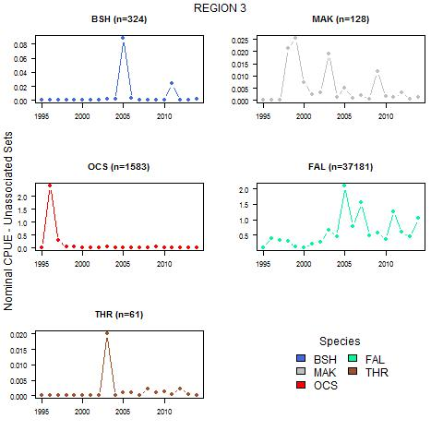

Figure 5: CPUE indicators, nominal CPUE in the purse seine fishery, Unassociated Sets, Region 3.

24

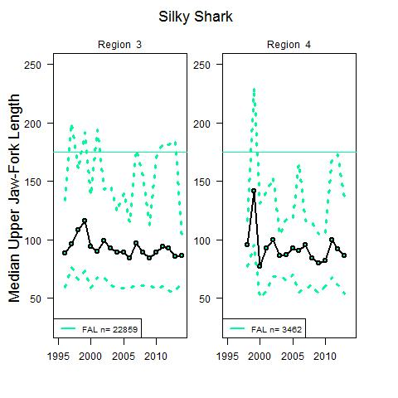

Figure 6: Median length (in fork length) for both sexes (combined) of silky sharks in Regions 3 and 4 based on samples taken from the purse seine fishery, 1995-2014. The 5th and 95th percentiles of the data are shown with dashed lines. Size at maturity is represented by the solid horizontal line. The sample size is shown in the inset to each plot.

25

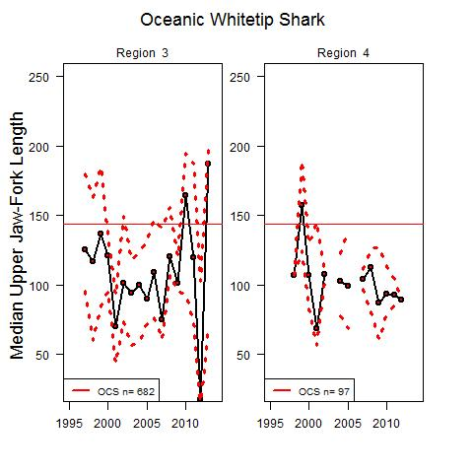

Figure 7: Median length (in fork length) for both sexes (combined) of oceanic whitetip sharks in Regions 3 and 4 based on samples taken from the purse seine fishery, 1995-2014. The 5th and 95th percentiles of the data are shown with dashed lines. Size at maturity is represented by the solid horizontal line. The sample size is shown in the inset to each plot.

26

* Feasibility of Stock Assessments

5 Impact of Recent Shark Management Measures

6 Recommendations for Future Indicator Work

7 Management Implications

Acknowledgements

* CPUE Indicators. Model diagnostics and extra plots

Blue Shark model diagnostics and extra plots

Silky Shark model diagnostics and extra plots

Oceanic Whitetip Shark model diagnostics and extra plots

Thresher Shark model diagnostics and extra plots

A.1 Longline Fishery Data

27

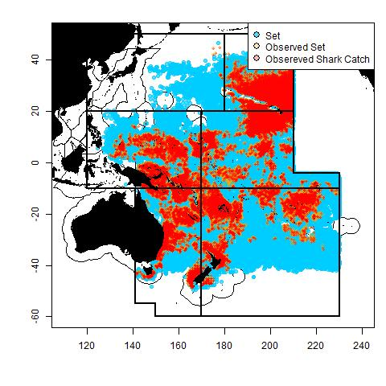

Figure 8: Map of WCPO and observed e ort.

28

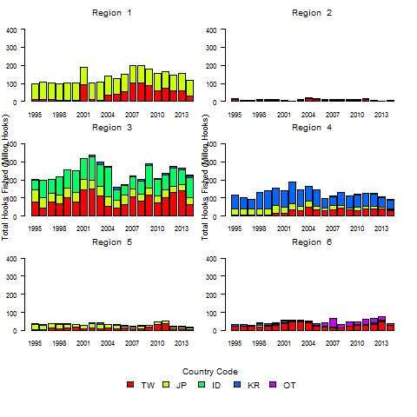

Figure 9: Total number of hooks shed by flag (for the top four fishing nations, and all others combined) based on aggregated (5x5 degree square) data, for six regions of the WCPFC Statistical Area.

29

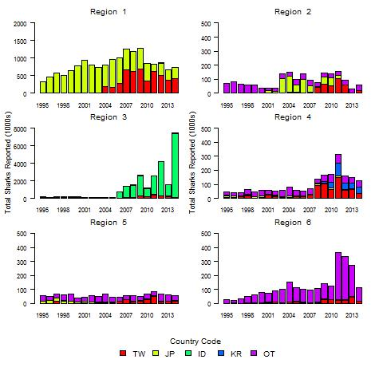

Figure 10: Total number of reported sharks by flag (for the top four fishing nations, and all others combined) based aggregated (5x5 degree square) data, for six regions of the WCPFC Statistical Area.

30



Figure 11: Total number of hooks observed by flag (for the top four fishing nations) based on longline observer records held by the SPC-OFP, for six regions of the WCPFC Statistical Area

31

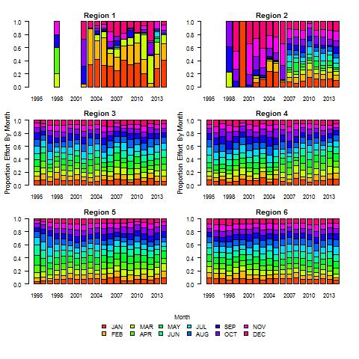

Figure 12: Logsheet e ort by month.

32

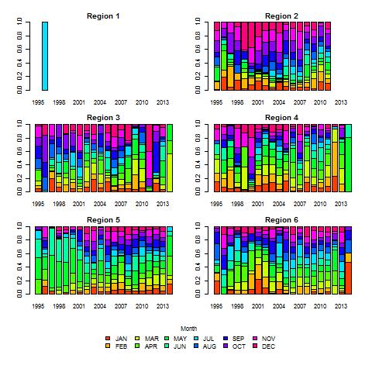

Figure 13: Observed e ort by month.

33

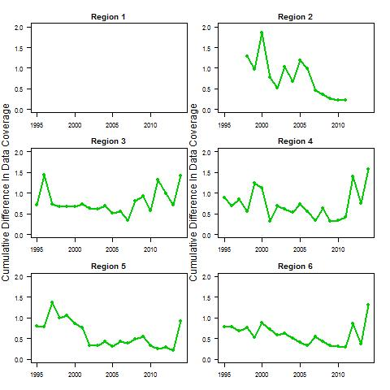

Figure 14: Absolute percent di erence in e ort between reported (logsheet) e ort and observed e ort.

34

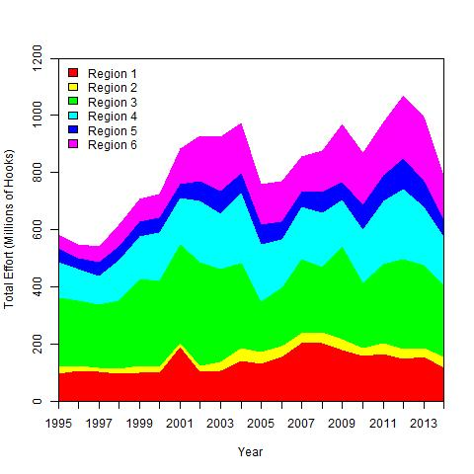

Figure 15: aggregate e ort by region.

Fishing E ort- Purse Seine

35

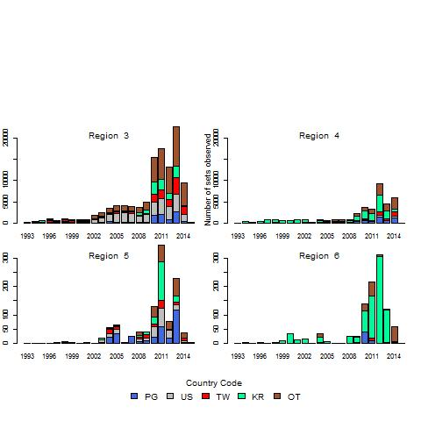

Figure 16: Observed purse seine in the WCPO showing the top four fishing nations and all others combined.

36

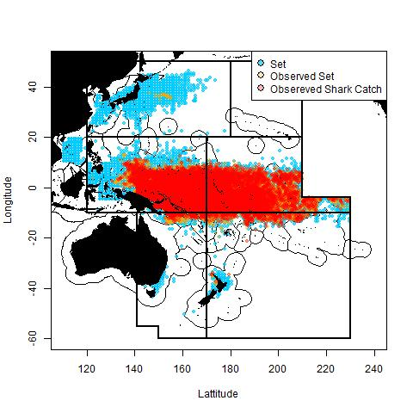

Figure 17: Absolute percent di erence in e ort between reported (logsheet) e ort and observed e ort.

37

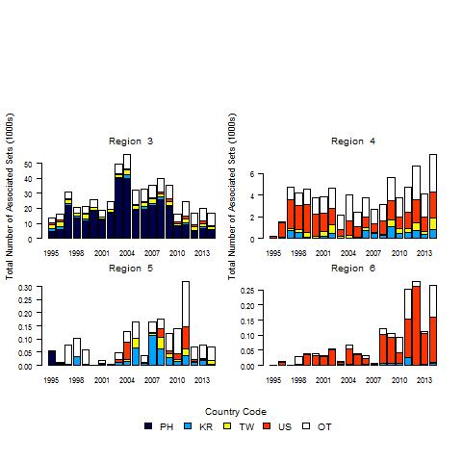

Figure 18: Comparison by region and flag of purse seine e ort (in sets) associated sets using aggregated (5x5 degree square) data for six regions of the WCPFC Statistical Area, excluding data from Indonesia, Vietnam, and Japan coastal waters.

38

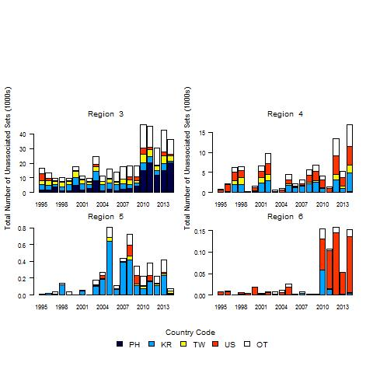

Figure 19: Comparison by region and flag of purse seine e ort (in sets) unassociated sets using aggregated (5x5 degree square) data for six regions of the WCPFC Statistical Area, excluding data from Indonesia, Vietnam, and Japan coastal waters.

39

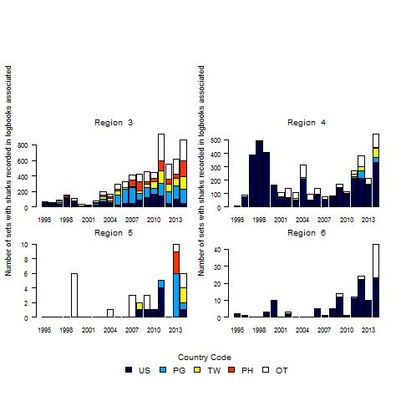

Figure 20: Total sharks recorded on logsheets (in number of sets recording at least one shark interaction), for associated sets.

40

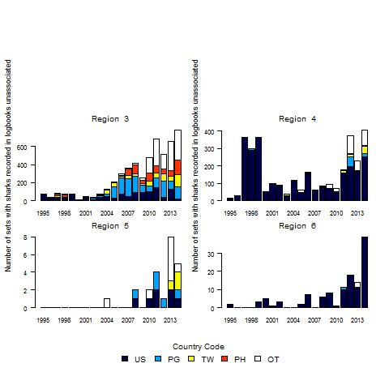

Figure 21: Total sharks recorded on logsheets (in number of sets recording at least one shark interaction), for unassociated sets.

41

* Distribution Indicator Analyses

B.1 Introduction

B.2 Methods

B.3 Results

42

B.3.1 Blue Shark

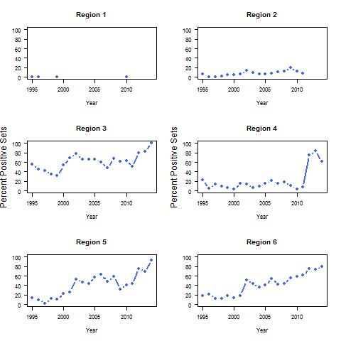

Figure 22: Blue shark distribution indicators. Proportion of positive sets, observer data.

43

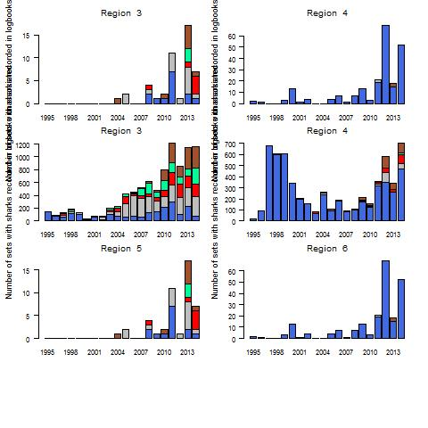

Figure 23: Blue shark distribution indicators. Proportion of 5 degree squares having CPUE greater than 1 per 1000 hooks region, observer data.

44

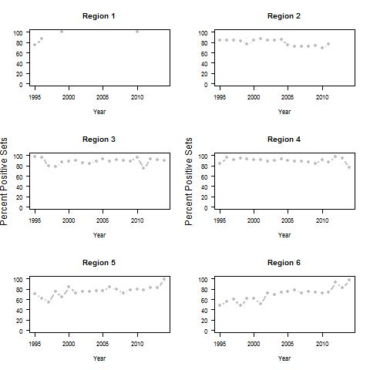

Figure 24: Mako shark distribution indicators. Proportion of positive sets, observer data.

B.3.2 Mako Shark

B.3.3 Silky Shark

B.3.4 Oceanic Whitetip Shark

B.3.5 Thresher Shark

B.3.6 Hammerhead Shark

B.3.7 Porbeagle Shark

|  |  |  |
| --- | --- | --- |
| B.4 Conclusions | 45 |  |
|  |  |

* Observed Species Composition Indicator Analyses

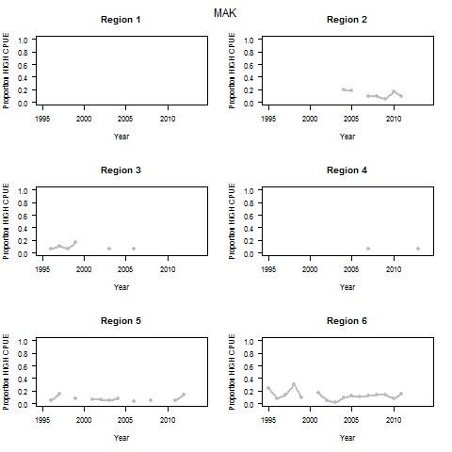

Figure 25: Mako shark distribution indicators. Proportion of 5 degree squares having CPUE greater than 1 per 1000 hooks region, observer data.

46

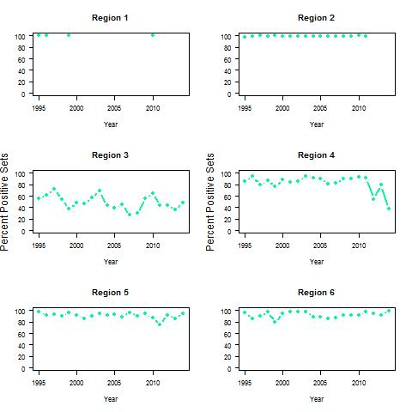

Figure 26: Mako shark distribution indicators. Proportion of positive sets, observer data.

47

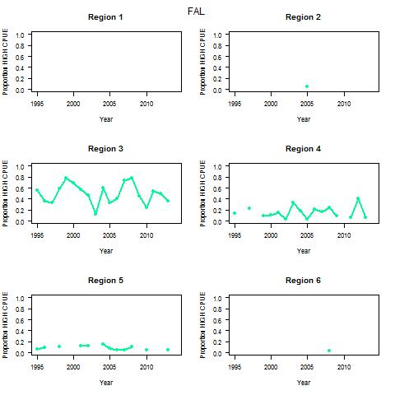

Figure 27: Silky shark distribution indicators. Proportion of 5 degree squares having CPUE greater than 1 per 1000 hooks region, observer data.

48

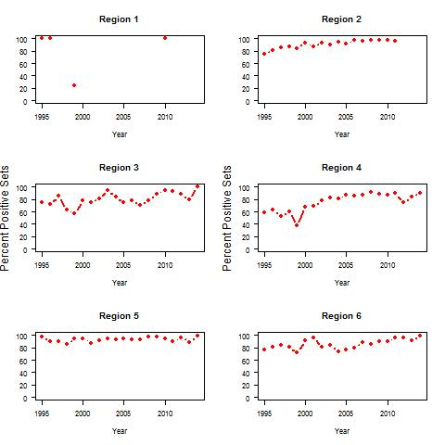

Figure 28: Oceanic whitetip shark distribution indicators. Proportion of positive sets, observer data.

49

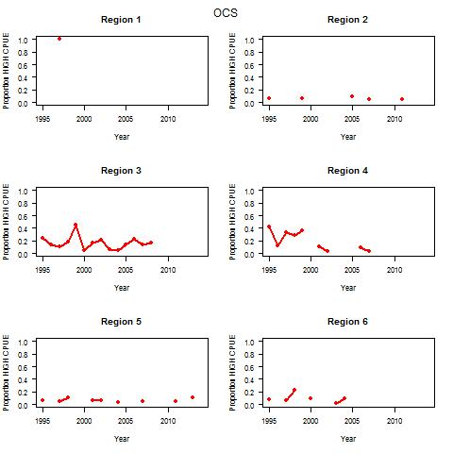

Figure 29: Oceanic whitetip shark distribution indicators. Proportion of 5 degree squares having CPUE greater than 1 per 1000 hooks region, observer data.

50

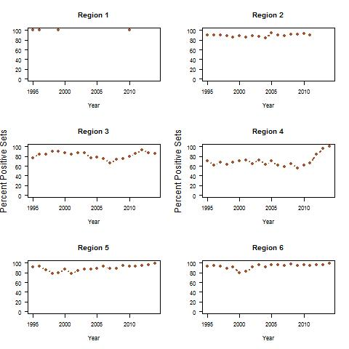

Figure 30: Thresher shark distribution indicators. Proportion of positive sets, observer data.

51

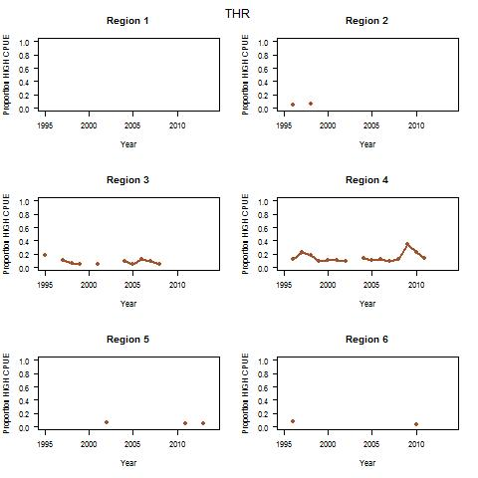

Figure 31: Thresher shark distribution indicators. Proportion of 5 degree squares having CPUE greater than 1 per 1000 hooks region, observer data.

52

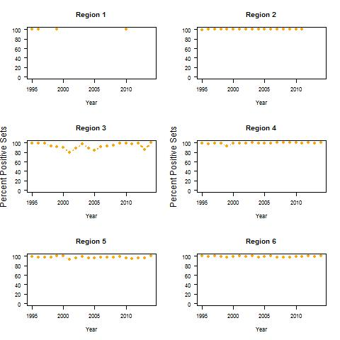

Figure 32: Hammerhead shark distribution indicators. Proportion of positive sets, observer data.

53

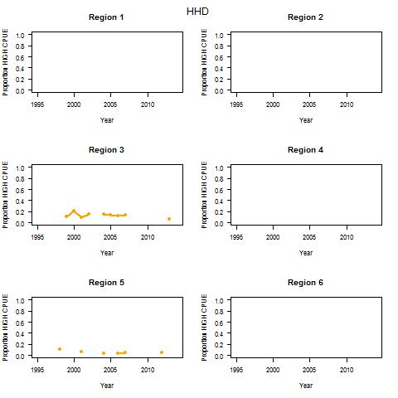

Figure 33: Hammerhead shark distribution indicators. Proportion of 5 degree squares having CPUE greater than 1 per 1000 hooks region, observer data.

54

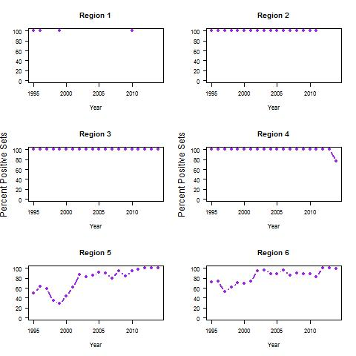

Figure 34: Porbeagle shark distribution indicators. Proportion of positive sets, observer data.

55

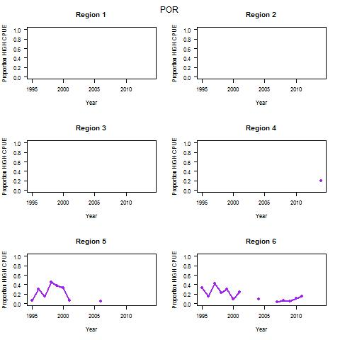

Figure 35: Porbeagle shark distribution indicators. Proportion of 5 degree squares having CPUE greater than 1 per 1000 hooks region, observer data.

56

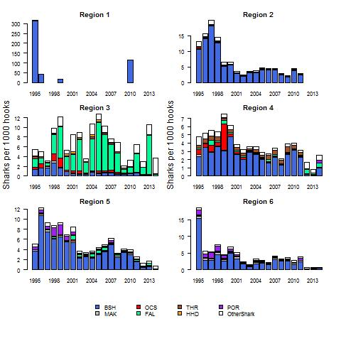

Figure 36: Catch Composition Indicators. Sharks Per. 1000 hooks by region, observer data.

57

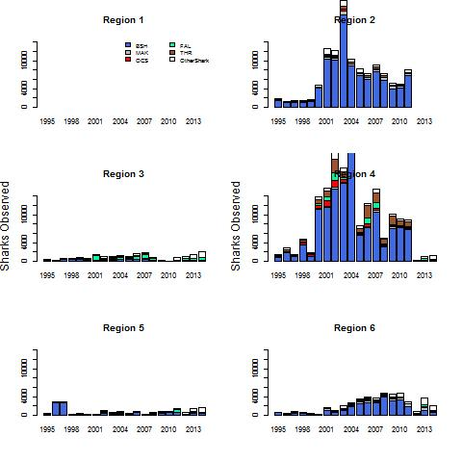

Figure 37: Catch Composition Indicators. Sharks Per. 1000 hooks by region, deep sets observer data.

58

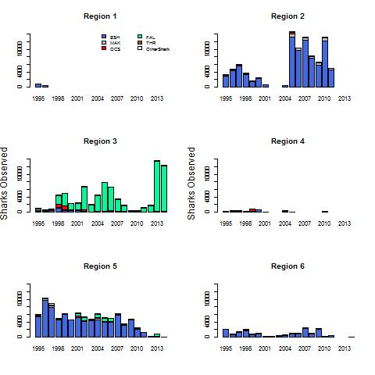

Figure 38: Catch Composition Indicators. Sharks Per. 1000 hooks by region, shallow sets observer data.

59

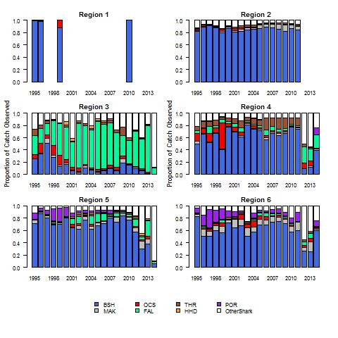

Figure 39: Catch Composition Indicators. Proportional catch of main species and other sharks by retions.

60

Purse Seine

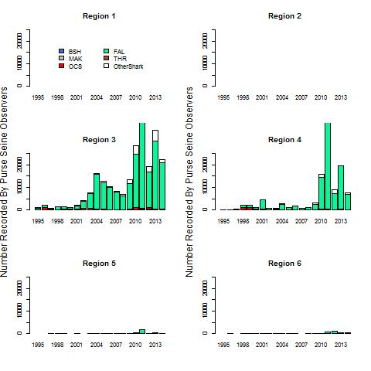

Figure 40: Catch Composition Indicators. Sharks per set, observer data.

C.4 Conclusions

61

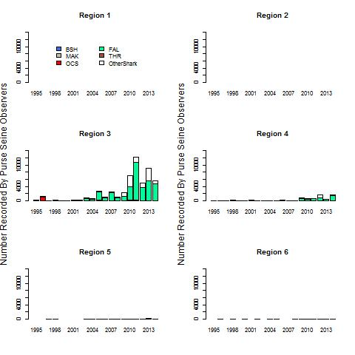

Figure 41: Catch Composition Indicators. Sharks per set, associated sets, observer data

62

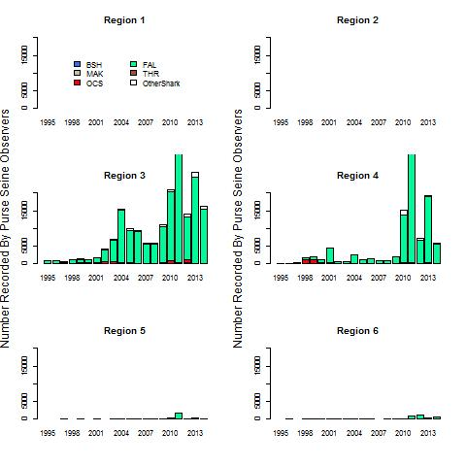

Figure 42: Catch Composition Indicators. Sharks per set, unassociated sets, observer data.

63



Figure 43: Catch Composition Indicators. Catch composition by proportion , observer data.

64

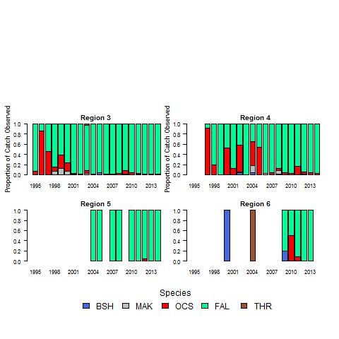

Figure 44: Catch Composition Indicators. Catch composition by proportion, associated sets, ob-server data

65



Figure 45: Catch Composition Indicators. Catch composition by proportion, unassociated sets, observer data.

66

* Catch Per Unit E ort indicator analyses

Purse Seine data preparation

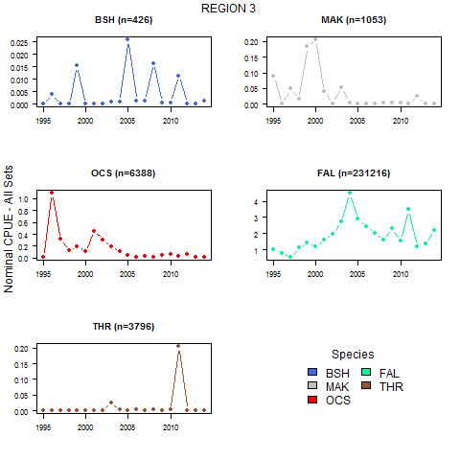

Figure 46: CPUE indicators, nominal CPUE in the purse seine fishery, all sets, Region 3.

67

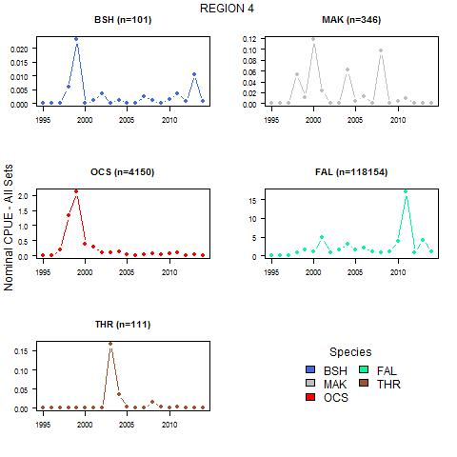

Figure 47: CPUE indicators, nominal CPUE in the purse seine fishery, all sets, Region 4.

68

D.1 Results

D.1.1 Blue Shark



Figure 48: Blue shark CPUE indicators. Proportion of positive sets, observer data.

D.1.2 Mako Shark

69

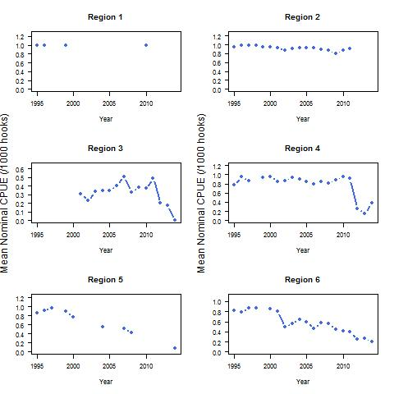

Figure 49: Blue shark CPUE indicators. Nominal CPUE, sharks per 1000 hooks, observer data.

70



Figure 50: Mako shark CPUE indicators. Proportion of positive sets, observer data.

71

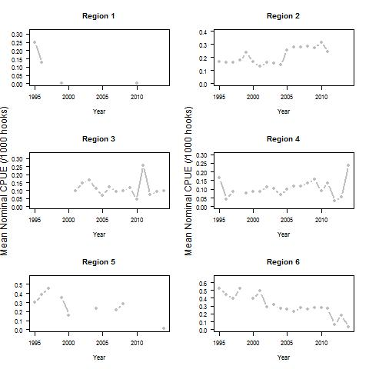

Figure 51: Mako shark CPUE indicators. Nominal CPUE, sharks per 1000 hooks, observer data.

72

D.1.3 Silky Shark



Figure 52: Silky shark CPUE indicators. Proportion of positive sets, observer data.

D.1.4 Oceanic Whitetip Shark

D.1.5 Thresher Shark

D.1.6 Hammerhead Shark

D.1.7 Hammerhead Shark

73

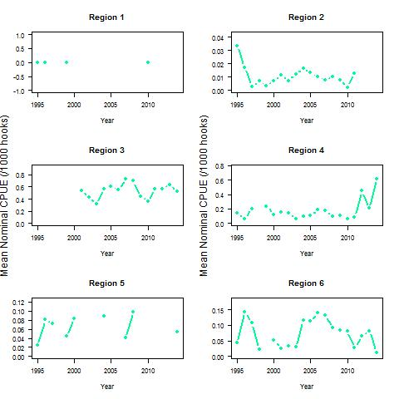

Figure 53: Silky shark CPUE indicators. Nominal CPUE, sharks per 1000 hooks, observer data.

74



Figure 54: Oceanic whitetip shark CPUE indicators. Proportion of positive sets, observer data.

75

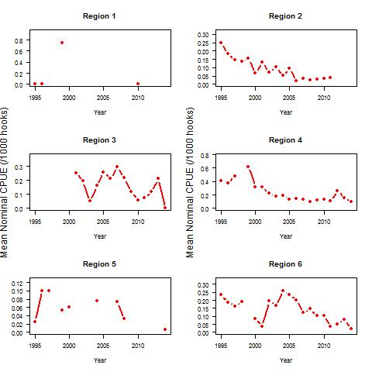

Figure 55: Oceanic whitetip shark CPUE indicators. Nominal CPUE, sharks per 1000 hooks, observer data.

76



Figure 56: Thresher shark CPUE indicators. Proportion of positive sets, observer data.

77

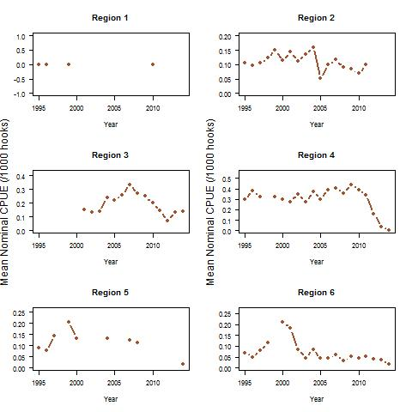

Figure 57: Thresher shark CPUE indicators. Nominal CPUE, sharks per 1000 hooks, observer data.

Figure 58: Thresher shark CPUE indicators. Proportion of positive sets, observer data.

Figure 59: Thresher shark CPUE indicators. Nominal CPUE, sharks per 1000 hooks, observer data.

Figure 60: Thresher shark CPUE indicators. Proportion of positive sets, observer data.

78

Figure 61: Thresher shark CPUE indicators. Nominal CPUE, sharks per 1000 hooks, observer data.

79

* Biological indicator analyses

80

Blue Shark model diagnostics and extra plots

Silky Shark model diagnostics and extra plots

Oceanic Whitetip Shark model diagnostics and extra plots

Thresher Shark model diagnostics and extra plots

81

E.0.8 Species Distribution Maps

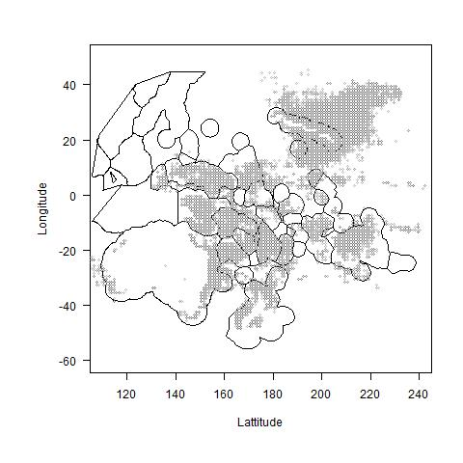

Figure 62: Species distribution, blue shark observed in the longline fishery.

82

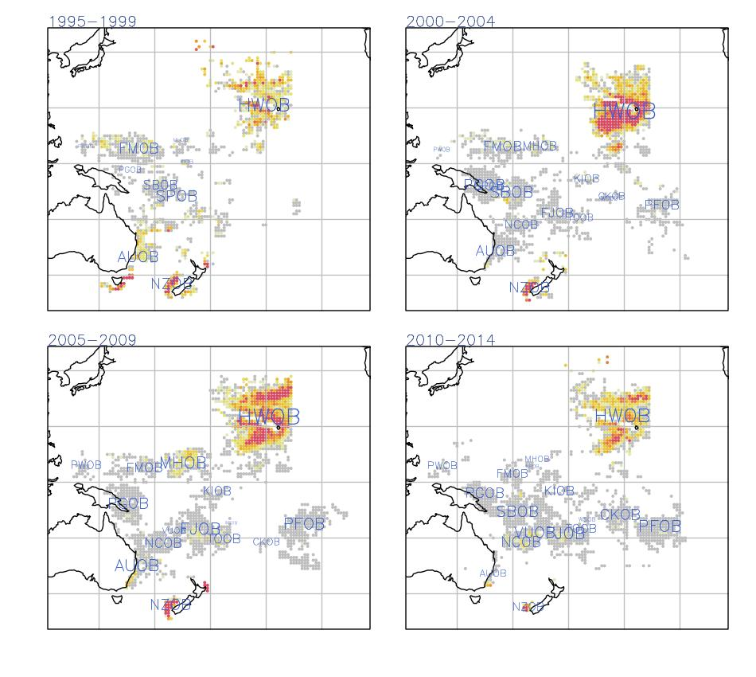

Figure 63: Species distribution, blue shark observed in the longline fishery by observer program.

83

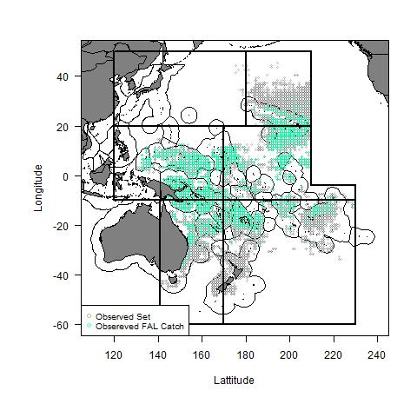

Figure 64: Species distribution, silky shark observed in the longline fishery.

84

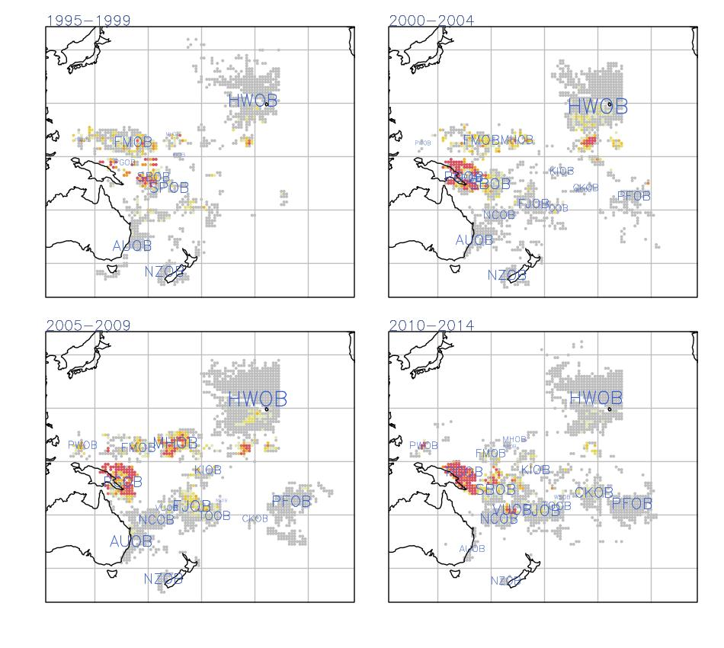

Figure 65: Species distribution, blue shark observed in the longline fishery by observer program.

85

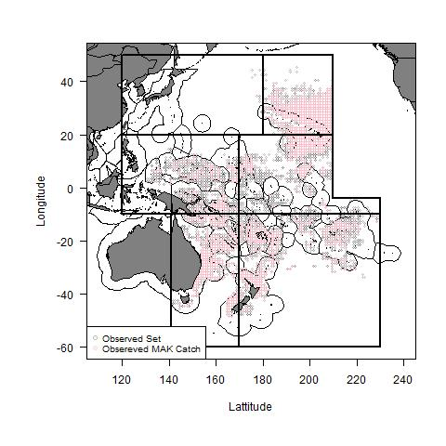

Figure 66: Species distribution, mako shark observed in the longline fishery.

86

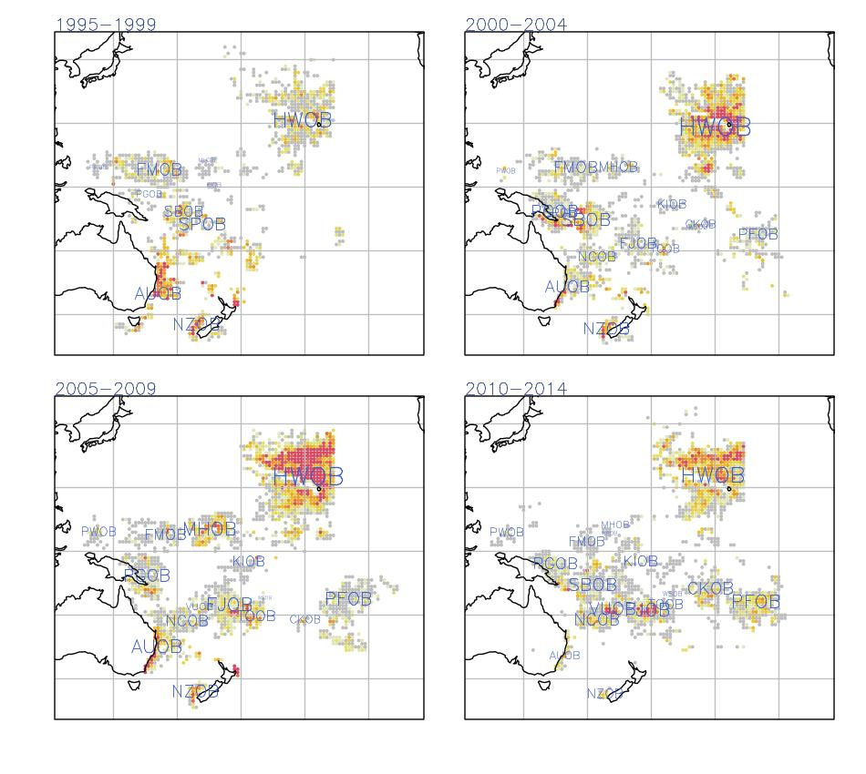

Figure 67: Species distribution, blue shark observed in the longline fishery by observer program.

87

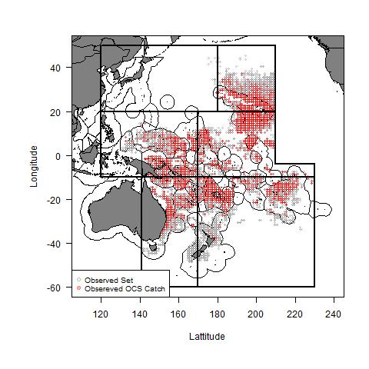

Figure 68: Species distribution, oceanic whitetip shark observed in the longline fishery.

88

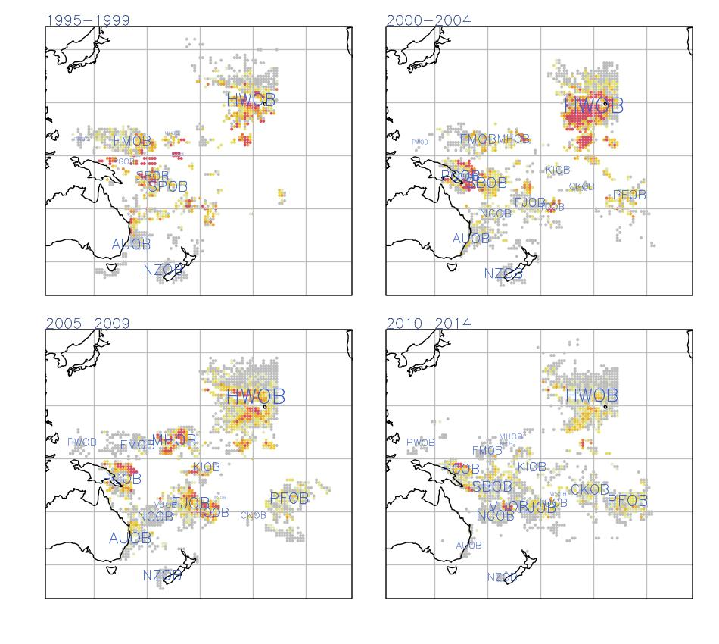

Figure 69: Species distribution, blue shark observed in the longline fishery by observer program.

89

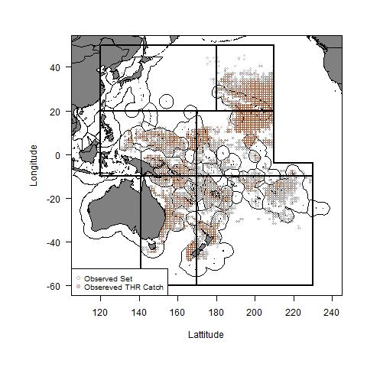

Figure 70: Species distribution, thresher shark observed in the longline fishery.

90

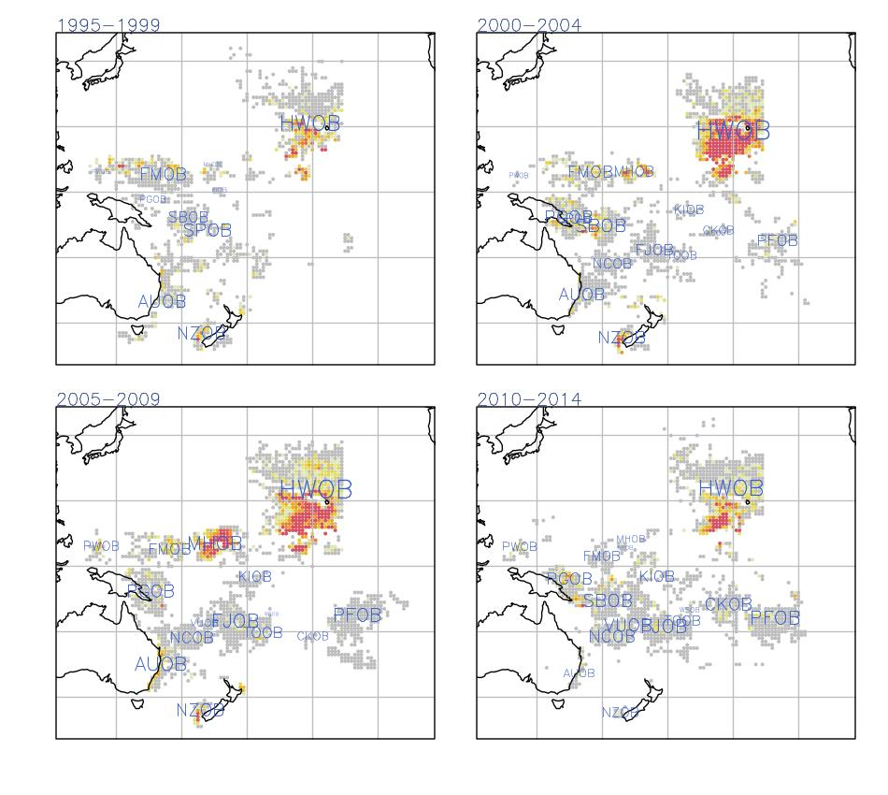

Figure 71: Species distribution, blue shark observed in the longline fishery by observer program.

91

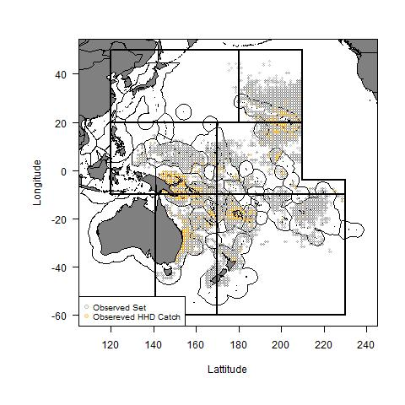

Figure 72: Species distribuion, hammerhead shark observed in the longline fishery.

92

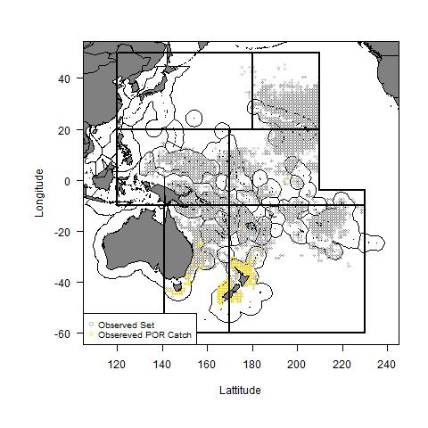

Figure 73: Species distribuion, porbeagle shark observed in the longline fishery.

93