# Single-region YFT2023 model

## Summary

As part of the P123 project “Scoping the next Stock Assessment software”, a step includes the preparation of a simplified tuna stock assessment model and input data set. This report presents the preliminary results for the yellowfin tuna stock assessment model as undertaken in 2023. The original model was spatially stratified into 5 defined regions. A simplified version was developed having no spatial stratification (a single region), while retaining the original fisheries definitions (37 fisheries) and fishery-specific input data structures. The model was fitted and achieved convergence, and a comparison with the original multi-region model is presented here.

## Method

The existing YFT2023 example model that employs the catch-conditioned method was used for preparing the input data, and to demonstrate the application of MULTIFAN-CL to a spatially unstratified tuna data set.

### De-stratification of model configuration and observations

The input files that specify the spatial stratification, recruitment and movement parameterisations (*.ini, *.frq) were duly modified to define a single region with no movement diffusion coefficients or spatial recruitments. All fisheries were defined to occur in the same single region. All tagging release events were defined to occur in the same single region 1. All other fishery-specific observations (size compositions, catch, effort, CPUE, conditional age-length data) were retained without modification as these were not specific to model regions.

The initial “-makepar” operation was completed, and the input 00.par file structure was assessed to correctly exclude all spatial stratification or movement parameterisation. All phases of the doitall minimization that originally included spatial parameter estimation, were modified to de-activate the estimation of these parameters. The phase 1 operation was successfully completed, and then all subsequent phases of the minimization run to convergence.

## Results

Table 1. Comparison of selected model quantities, parameters and negative log-likelihood terms for the multi-region (**mult_regs**) and single-region (**sngl_reg**) models.

|  |  |  |  |
| --- | --- | --- | --- |
| **Model quantity** | **mult_regs** | **sngl_reg** | **%diff** |
| **MSY** | 169800 | 144000 | -15.19 |
| **Ccurr.MSY** | 4.221 | 4.968 | 17.69 |
| **Fmsy** | 0.073 | 0.068 | -6.51 |
| **Fmult** | 1.677 | 1.128 | -32.74 |
| **Fcurr.Fmsy** | 0.596 | 0.887 | 48.67 |
| **B0** | 8515000 | 7331000 | -13.90 |
| **Bmsy** | 2338000 | 2121000 | -9.28 |
| **Bcurr** | 4649499 | 2932813 | -36.92 |
| **SB0** | 5350000 | 4961000 | -7.27 |
| **SBmsy** | 1072000 | 1060000 | -1.12 |
| **SBcurr** | 2404955 | 1478269 | -38.53 |
| **Bcurr.Bmsy** | 1.989 | 1.383 | -30.47 |
| **SBcurr.SBmsy** | 2.243 | 1.395 | -37.84 |
| **SBcurr.SBcurrF0** | 0.455 | 0.271 | -40.40 |
| **SBlatest.SBlatestF0** | 0.429 | 0.261 | -39.34 |
| **obj_bhsteep** | 0.311 | 0.467 | 50.10 |
| **obj_lencomp** | -154969.8466 | -153243.124 | -1.11 |
| **obj_wtcomp** | -610342.221 | -609810.819 | -0.09 |
| **obj_tagdata** | 13216.668 | 14515.258 | 9.83 |
| **obj_agelngdata** | 2480.536 | 2448.515 | -1.29 |
| **obj_cpue** | -1157.205 | 1872.950 | -261.85 |
| **Obj** | -750515.788 | -744076.435 | -0.86 |
| **No. parameters** | 1901 | 445 | -76.59 |
| **gradient** | 0.0119610 | 0.0007190 | -93.99 |
| **Lmin** | 19.800 | 19.800 | 0.00 |
| **Lmax** | 141.958 | 141.319 | -0.45 |
| **K** | 0.132 | 0.133 | 0.58 |

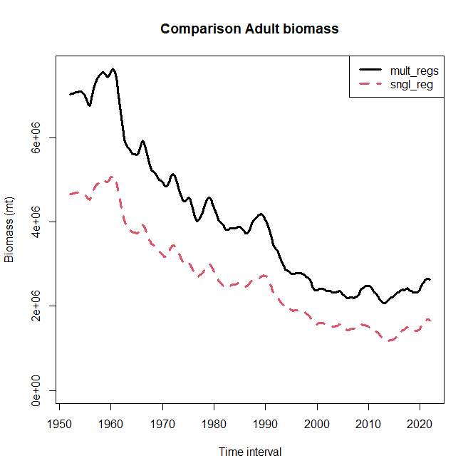

**Figure 1. Comparison of adult biomass between the multi-region (mult_regs) and single-region (sngl_reg) models.**

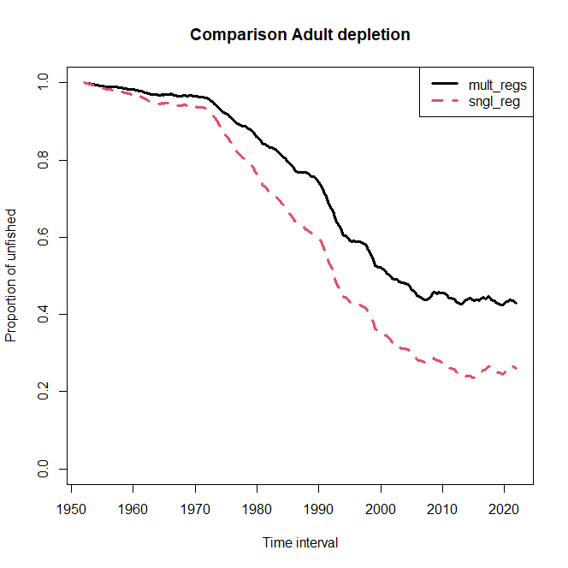

**Figure 2. Comparison of adult biomass depletion between the multi-region (mult_regs) and single-region (sngl_reg) models.**

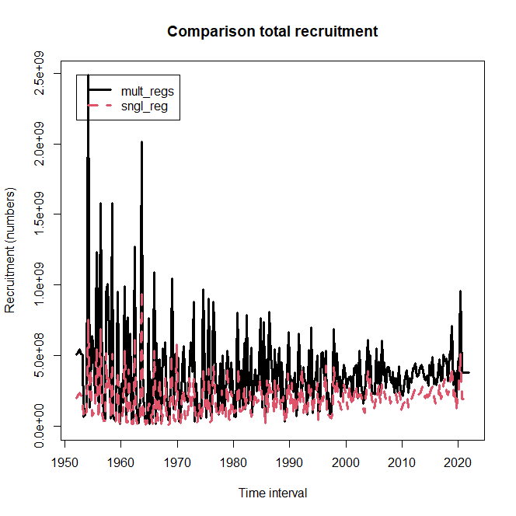

**Figure 3. Comparison of estimated absolute recruitment between the multi-region (mult_regs) and single-region (sngl_reg) models.**

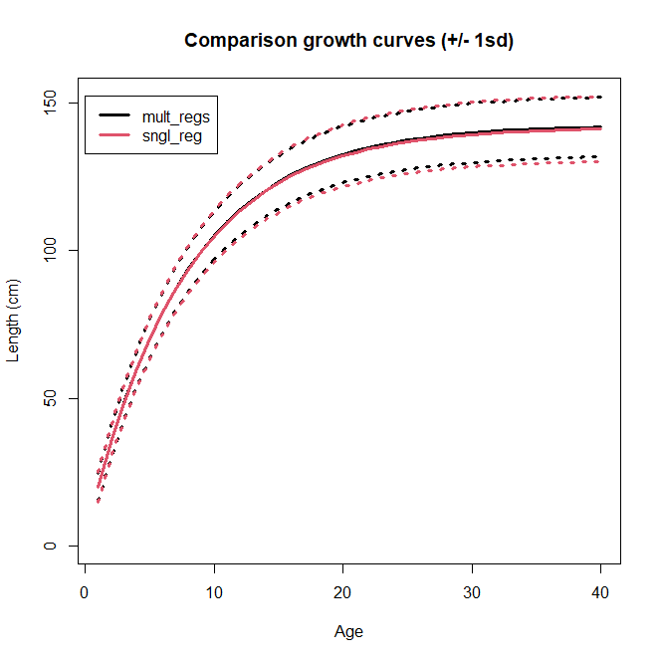

**Figure 4. Comparison of estimated von Bertalanffy growth between the multi-region (mult_regs) and single-region (sngl_reg) models.**

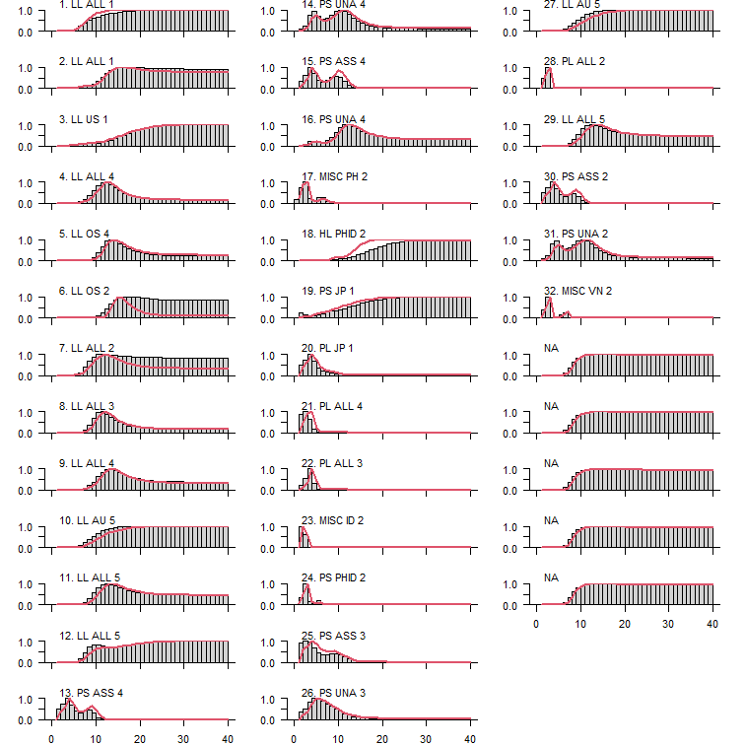

**Figure 5. Comparison of estimated selectivity-at-age between the multi-region (mult_regs) and single-region (sngl_reg) models.**