**Pushkaraj Chavan TCC 58**

**Assignment No.A1**

**Title: Lab Assignment on Unit I: (Mandatory Assignment)**

**Part A:** Setup a wired LAN using Layer 2 Switch and then IP switch of minimum four computers. It includes preparation of cable, testing of cable using line tester, configuration machine using IP addresses, testing using PING utility and demonstrate the PING packets captured traces using Wireshark Packet Analyzer Tool.

**Part B:** Extend the same Assignment for Wireless using Access Point

Date:-

Marks:- Signature:-

**Commands to install Wireshark**

[root@localhost ~]# yum install wireshark

[root@localhost ~]# yum install wireshark-gnome

[root@localhost ~]# setcap 'CAP_NET_RAW+eip CAP_NET_ADMIN+eip' /usr/sbin/dumpcap

[root@localhost ~]# chmod 755 /usr/sbin/dumpcap

[root@localhost ~]# wireshark

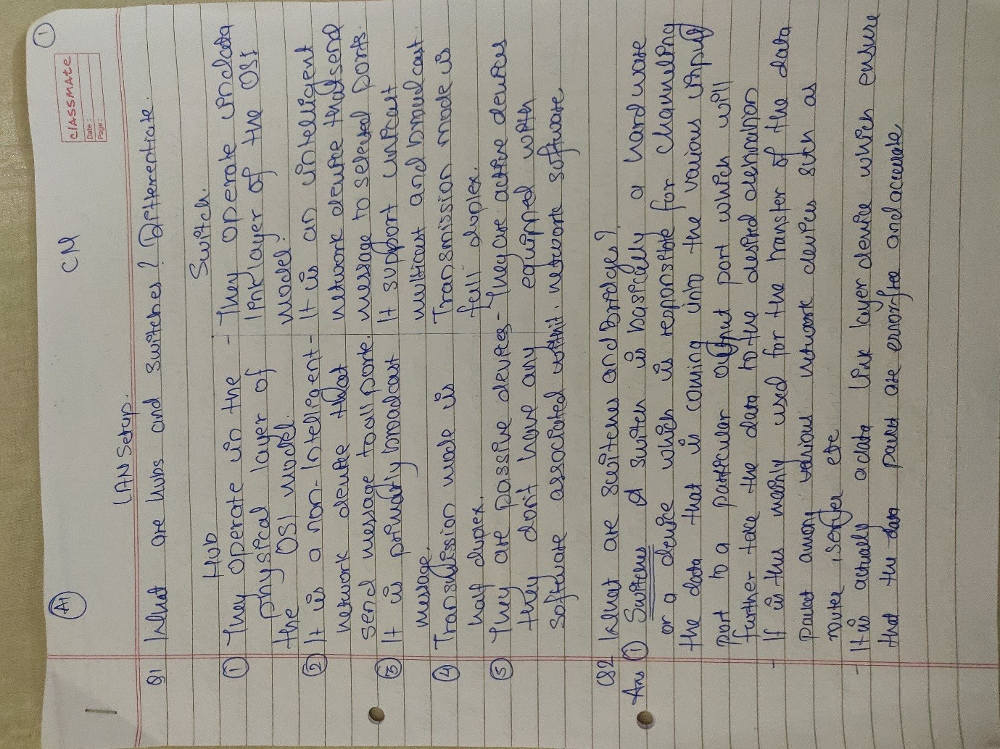

**Pushkaraj Chavan TCC 58**

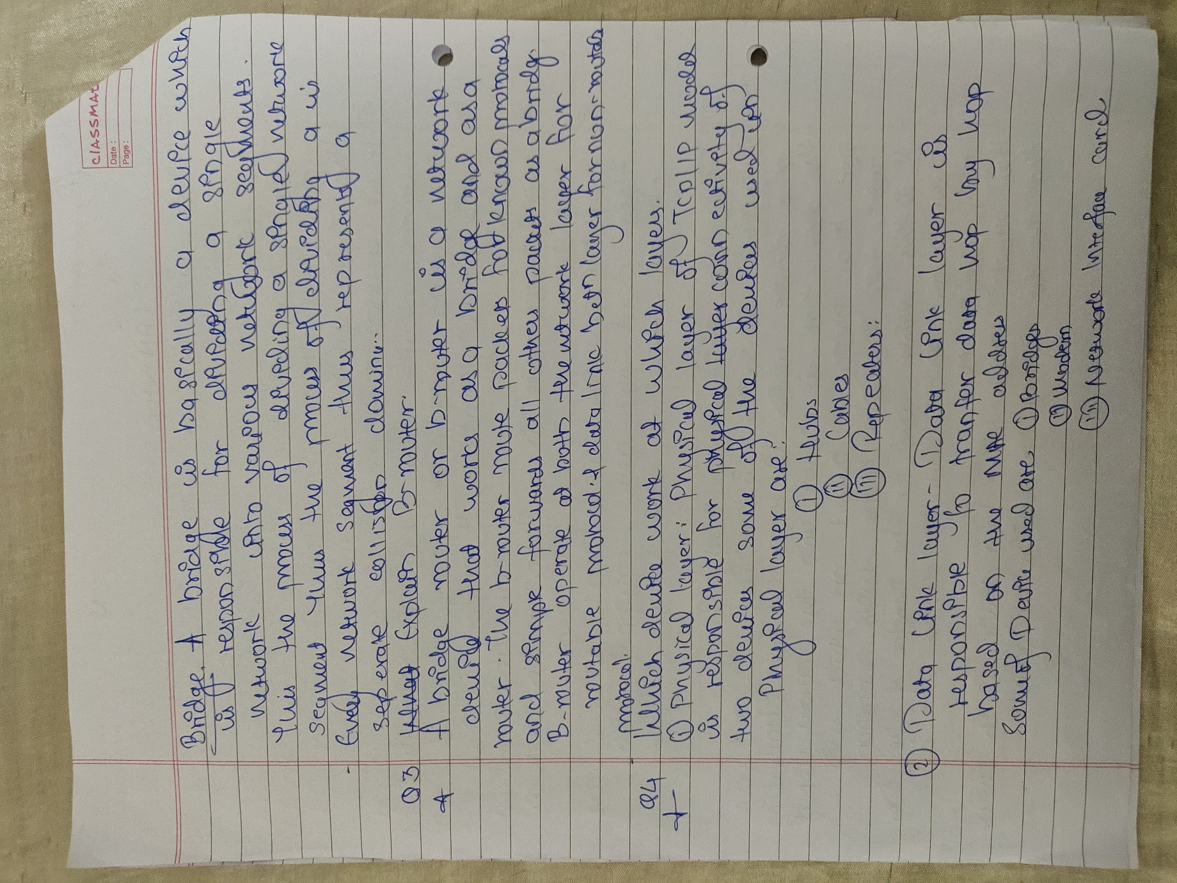

**Pushkaraj Chavan TCC 58**

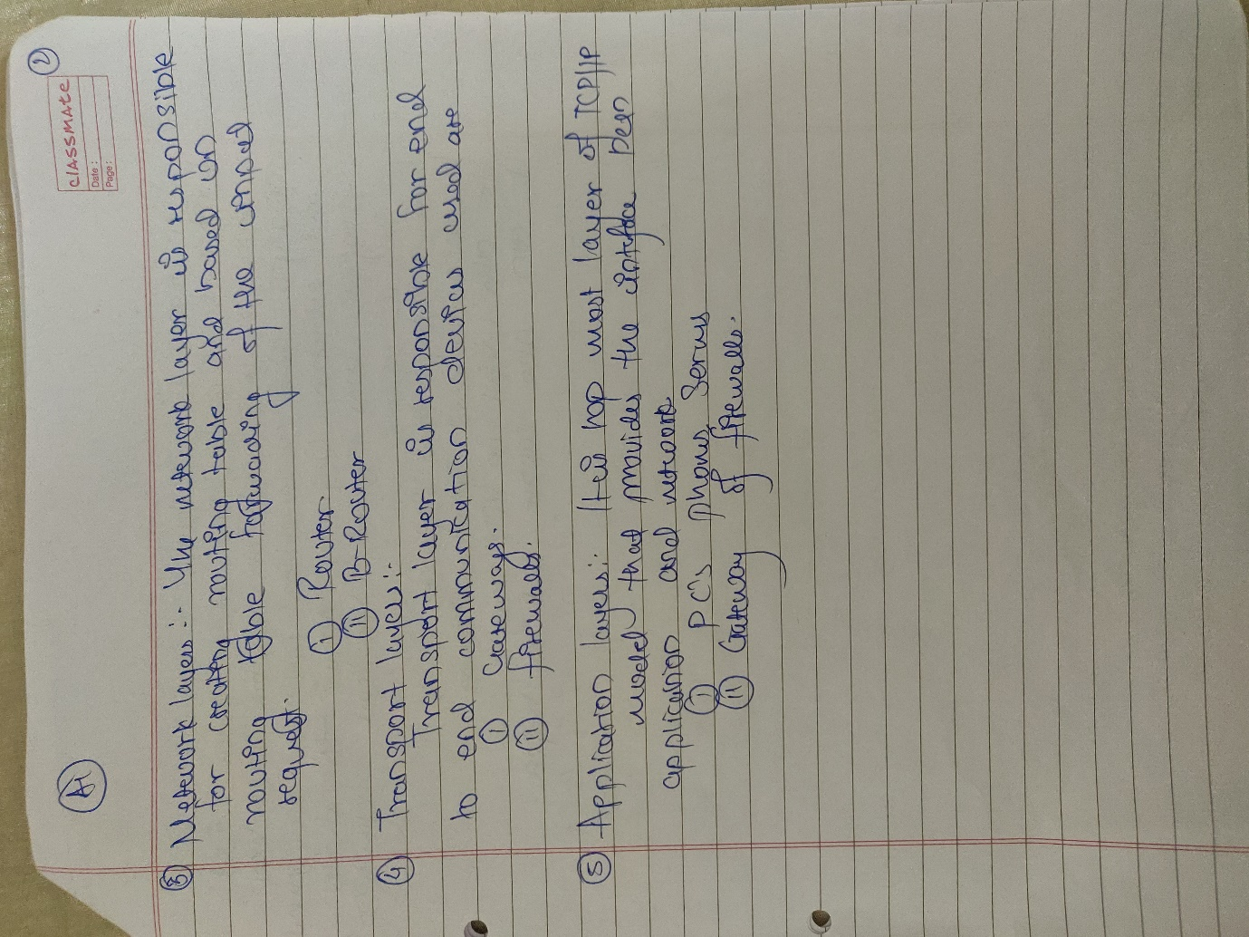

**Pushkaraj Chavan TCC 58**



**Pushkaraj Chavan TCC 58**