* In ASP.NET Core, middleware are C# classes that can handle an HTTP request or response

Each middleware component chooses

* Whether to pass on the incoming HTTP request to another middleware in the pipeline (with or without any modification)
* Pass on the outgoing HTTP response to another middleware (or the ASP.NET Core web server) in the pipeline (with or without any modification)
* The EndpointMiddleware is perhaps the most important piece of middleware.
* This middleware class normally generates all HTML pages and API responses.
* Like the image-resizing middleware, it typically receives a request, generates a response, and then sends it back to the user, as shown in figure 1.

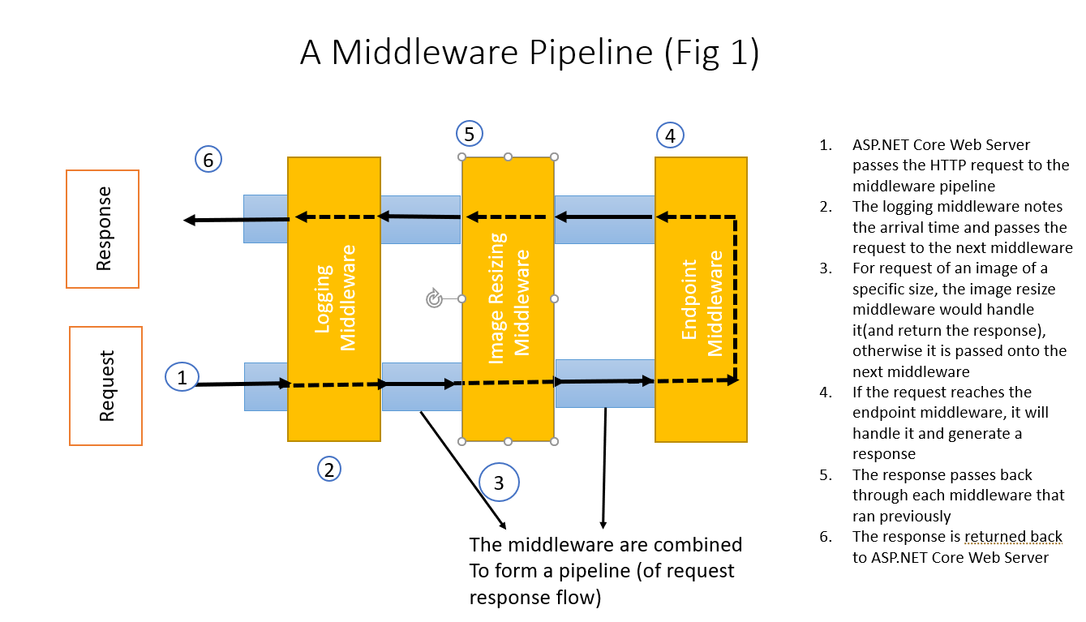

Common Use Cases of Middleware:

* Irrespective of the resource requested(from the pipeline) or even the specific request path, there are common concerns for our application as follows:
  + Associating a request with the relevant user
  + Setting the language for the current request
  + Logging each request
  + Adding security headers to the response

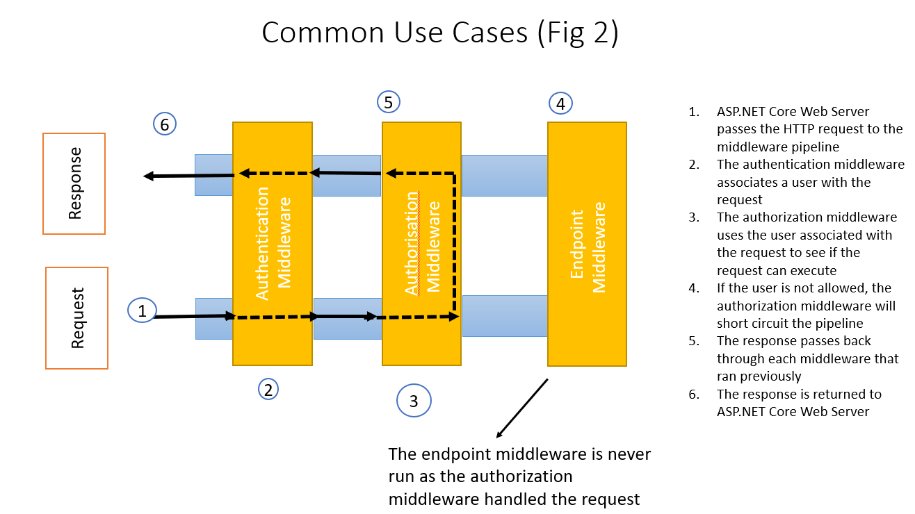

* From the previous fig (Fig 2) and its discussion, we have an important point to consider, which is that the pipeline is two-directional
* The request passes through the pipeline in one direction till it is handled by a middleware, in which case a response is generated, and the flow is reversed through the pipeline
* It passes through each piece of the middleware a second time, reaching the first piece of middleware (This means the middleware that was next to a middleware when the request was flowing through them, becomes the previous middleware while the response travels back)
* Finally, the first(last in the reverse direction) middleware will pass the response back to the web server