1

Using All of the AutoCAD Interface

The out-of-the-box AutoCAD interface is a generic compilation of the most commonly used features, which may or may not be the right combination for you. Whether you are a novice or an experienced user, it is important that you learn the different methods for using this interface.

In this chapter, you will learn how to modify the default interface components and how to expose some hidden interface features to better match your use of the software. You will start by learning how to modify the display and functionality of the default windows. Then, you will see how to optimize your coordinate input to match your use of AutoCAD. Next, you will move on to learn about the usage of hidden shortcut keys. Then, you will see how to control object selections and the associated display options. Finally, you will customize the default Status Bar.

In this chapter, you will cover the following topics:

* Taking Advantage of the New Features
* Controlling the Command Line
* Useful Dynamic Input
* Using the Clipboard Efficiently
* Using Temporary Overrides
* Cycling in AutoCAD
* Hidden in the ViewCube
* Tailoring your Options
* Using File and Layout Tabs

By the end of this chapter, you will be able to optimize the interface to work more efficiently within your own work environment.

Technical requirements

You will need a computer with either Windows or macOS to complete this chapter's exercises. I will be using the Windows environment for these examples. Any version of AutoCAD will work, but it is recommended that you use the latest version so your software matches the examples as closely as possible. I will be using AutoCAD 2025 throughout this book, and you can refer to the following link to confirm your hardware requirements:

<https://www.autodesk.com/support/technical/article/caas/sfdcarticles/sfdcarticles/System-requirements-for-AutoCAD.html?us_oa=dotcom-us&us_si=9b630dac-e4eb-4e94-b32d-01c1026e2a72&us_st=system%20requirements%20for%20autocad>.

Formatting found in this document

COMMAND NAME: such as LINE, POLYLINE, and ERASE

Mouse Controls: such as right-click, left-click, and left-click and drag

Keyboard Shortcuts: such as Ctrl + F, Shift, and Esc

Key-in Commands: such as **COMMANDS** and **COMMAND OPTIONS**

Command Locations

This table displays the various locations where you can find the command discussed. You should select the command location that best suits your method of using AutoCAD.

Example:

|  |  |
| --- | --- |
| **COMMAND NAME** | **Command Locations** |
| Ribbon | Ribbon Tab Name | Ribbon Group Name | Command Name |
| Right-click Menu |  |
| QAT | DDL | COMMAND NAME |
| Command Line | COMMAND (COMMAND ABBREVIATION) |

|  |  |
| --- | --- |
| **MATCHPROP** | **Command Locations** |
| Ribbon | Home | Properties | Match Properties |
| QAT | Drop-Down-List | Match Properties |
| Command Line | MATCHPROP |

|  |  |
| --- | --- |
| **CUI** | **Command Locations** |
| Ribbon | Manage | Customization | User Interface |
| Menu |  |
| Command Line | CUI (CUI) |

System Variables

This table will display each system variable as it is used throughout the book. It includes the description, settings, and all the available variable options.

Example:

|  |  |
| --- | --- |
| **VARIABLE** **NAME** | |
| Description  Type: Variable Type  Saved in: Saved Location | |
| Value 1 | Setting description |
| Value 2 | Setting description |
| Value 3 (default) | Setting description |
| **SELECTIONPREVIEW** | |
| Objects are highlighted when the pickbox cursor rolls over them. The highlighting indicates that the object would be selected if you clicked it. The setting is stored as a bitcode using the sum of the following values:  Type: Bitcode  Saved in: Registry | |
| 0 | OFF (will improve the performance of AutoCAD) |
| 1 | ON when no commands are active (the list dialog does not display) |
| 2 | ON when a command prompts for object selection (the list dialog displays the selected objects that you can cycle through) |
| 3 (default) | ON when you “hover” over an object |

To get the most out of this book

This book assumes you are reading it chronologically. If a topic is explained earlier in an exercise, it might not be repeated again later.

This document has some conventions that you should know to help you understand and follow the steps provided.

You can download the complete profile and exercises on GitHub at the following URL:

<https://github.com/PacktPublishing/AutoCAD-2025-Best-Practices-Tips-and-Techniques>.

Taking advantage of the new features

In this section, we will learn how to use the new interface features found in the most recent versions of AutoCAD. Using the newest features can improve your overall use of the software.

First, let’s examine the new “floating” or “undocked” drawing windows to take advantage of large and multiple monitor configurations.

Floating Drawing Windows

In this exercise, we will discuss how to take advantage of using more than one monitor. With multiple monitors, you might prefer to “float” your drawing windows to take advantage of that second monitor. The benefit of a “floating” drawing window may not be immediately apparent, so let me demonstrate how it can help you with your workflow:

* You can take advantage of multiple monitors by placing separate drawing windows on each monitor. This is more efficient than just stretching a single drawing window across multiple monitors.
* You can use floating windows to run commands between two drawing files.

Each of the floating windows has its own Command Line dialog. To demonstrate this feature, we need to have two drawings open and follow these steps:

1. Open the 1-1_Floating Windows 1.dwg and 1-1_Floating Windows 2.dwg files. Both files are now visible in the File Tabs area.
2. Using the File Tabsarea, left-click and drag the 1-1_Floating Windows 1.dwg file tab into the view window and release the mouse button.

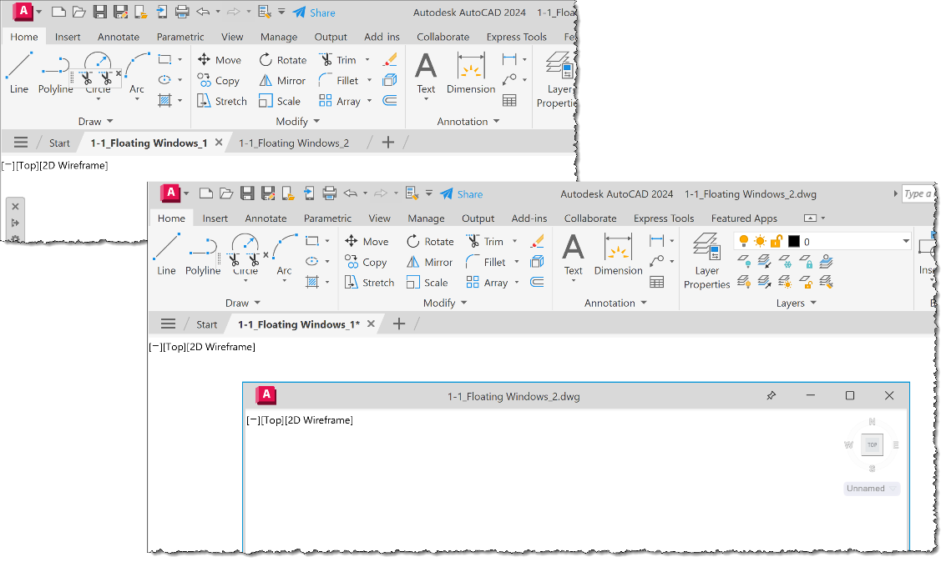

Figure 1.1: Floating Windows or Tabs

1. This file is now a “floating” drawing window that can be moved to either monitor and maximized or tiled as needed.

Note

This is a great feature for those familiar with other applications that take advantage of multiple monitors.

In the next exercise, we will examine how to PIN and RESTORE the “floating” view windows.

Pin and Restore

Once the file window is “floating”, you can control the display order of the window using one of the following methods:

* Pin the windows to control the display order
* Tile the windows side by side

In this exercise, we will discover how to PIN and TILE the “floating” drawing view windows:

1. First, use the PIN icon A black and white image of a pin

   Description automatically generated found in the floating file’s titlebar to force that file on top of the AutoCAD application. The PIN icon will change to a blue-colored icon when activated. Resize the “floating” file window to one-half of the screen display. This prevents you from using the Ctrl + Tab shortcut key to toggle between open drawing files.

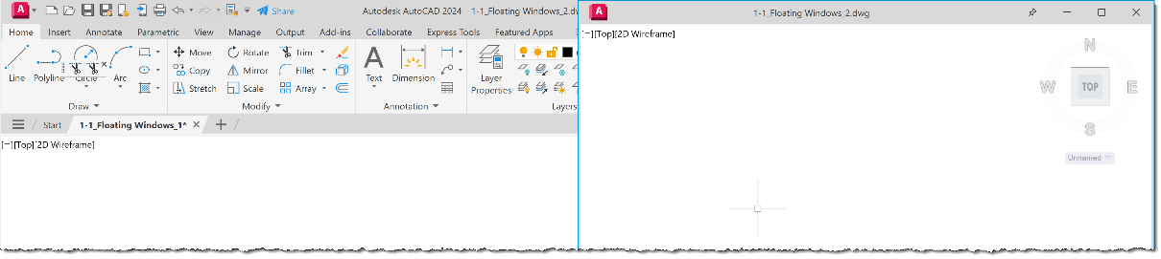

Figure 1.2: Floating drawing window in Tile mode

1. Next, left-click and drag the file to the right-side of the screen until you see it lock in place in TILE mode:
2. Left-click and drag the 1-1_Floating Windows 2.dwg file to the left-side of the screen until you see it lock in place in TILE mode.

Figure 1.3: Floating drawing windows resized for ribbon display

1. Resize both files to see the AutoCAD application ribbon bar.
2. Use the PIN icon on both files to force the drawing view windows to remain above the application window.

|  |  |
| --- | --- |
| **MATCHPROP** | **Command Locations** |
| Ribbon | Home | Properties | Match Properties |
| QAT | Drop-Down List | Match Properties |
| Command Line | MATCHPROP (MA) |

1. Using the Quick Access Toolbar (QAT), turn ON the icon for the Match Properties command.
2. Use the QAT drop-down list to add a checkmark to the Match Properties command.

`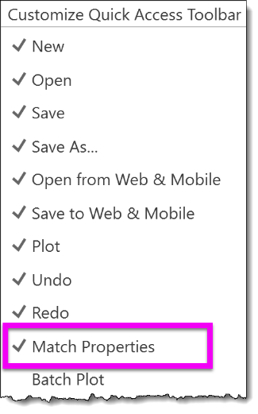

Figure 1.4: Quick Access Toolbar | Match Properties

1. Select the 1-1_Floating Windows 1.dwg file and select the MATCH PROPERTIES command from the QAT. Left-click on a ROOM NAME (LAUNDRY) object to match the properties of the text object in this file.
2. Select the 1-1 Floating Windows 2.dwg file and select a ROOM NAME (BEDROOM) text object in this view. The text object in this file will change to match the text object properties from the first file.

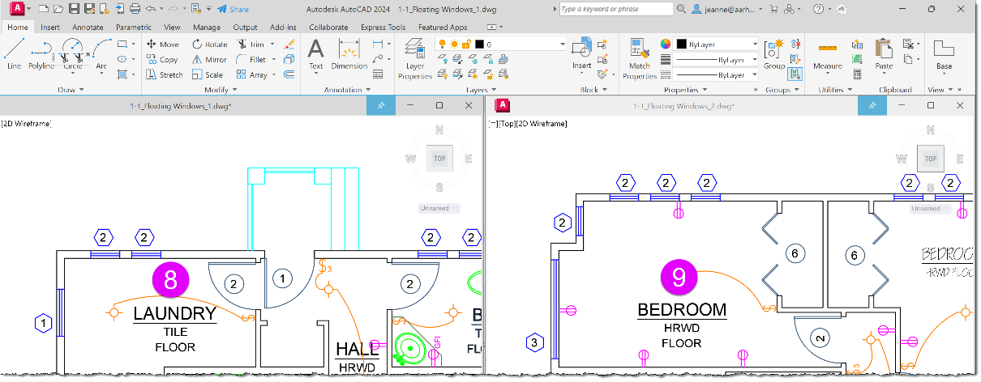

Figure 1.5: QAT Match Properties

You can re-dock a “floating” drawing window using left-click and drag to drop the file’s titlebar back into the File Tabs area and then release the mouse button.

Note

Did you notice that each file has its own Command Line when working with “floating” view windows?

You can control this new feature using the SYSFLOATING system variable:

|  |
| --- |
| **SYSFLOATING** |
| Controls the dock state of the drawing file tabs.  Type: Integer  Saved in: Registry |

|  |  |
| --- | --- |
| 0 (default) | Drawing file tabs are docked. |
| 1 | Drawing file tabs are floating |
| -1 | The floating drawing file tab feature is disabled. |

On completion of this exercise, you should now be able to control the display of the drawing to take advantage of your hardware configuration and customize your QAT to include the MATCH PROPERTIES command.

Controlling the Command Line

In this exercise, we will learn how to control where your Command Line dialog “lives” and how to find it when it goes “missing”.

Lost Command Line?

Have you ever lost the Command Line window? I guess yes, since it occasionally disappears while working in the interface. You can use the following two options to recover the Command Line from its hiding place.

Option 1 – Using a Keyboard Shortcut

The first option is to use the built-in Ctrl + 9 shortcut key to toggle the command window ON and OFF. This will bring the Command Line dialog to the front of the application window from wherever it is hiding.

Option 2 – Using the CUI Dialog

The second option is to use the CUSTOMIZE USER INTERFACE (CUI) command to turn the command window ON or OFF.

The CUI command is available at the following locations:

|  |  |
| --- | --- |
| **CUI** | **Command Locations** |
| Ribbon | Manage | Customization | User Interface |
| Command Line | CUI (CUI) |

Using the following steps, you can gain control of your Command Line dialog. To demonstrate this functionality, you need to be in a drawing file:

1. Open the 1-0_BLANK.DWG file.
2. Start the CUI command, and using the Customize User Interface dialog, select the (current) workspace.
3. Click the Customize Workspace button at the top of the right panel. This will turn all the menu items blue.
4. Expand the Palettes item and select the Command Line palette.
5. Using the Properties panel in this dialog, modify the Orientation setting to a different orientation using the Floating, Top, Bottom, Left, Right, or Do Not Change options. Click the Apply button and close the dialog.

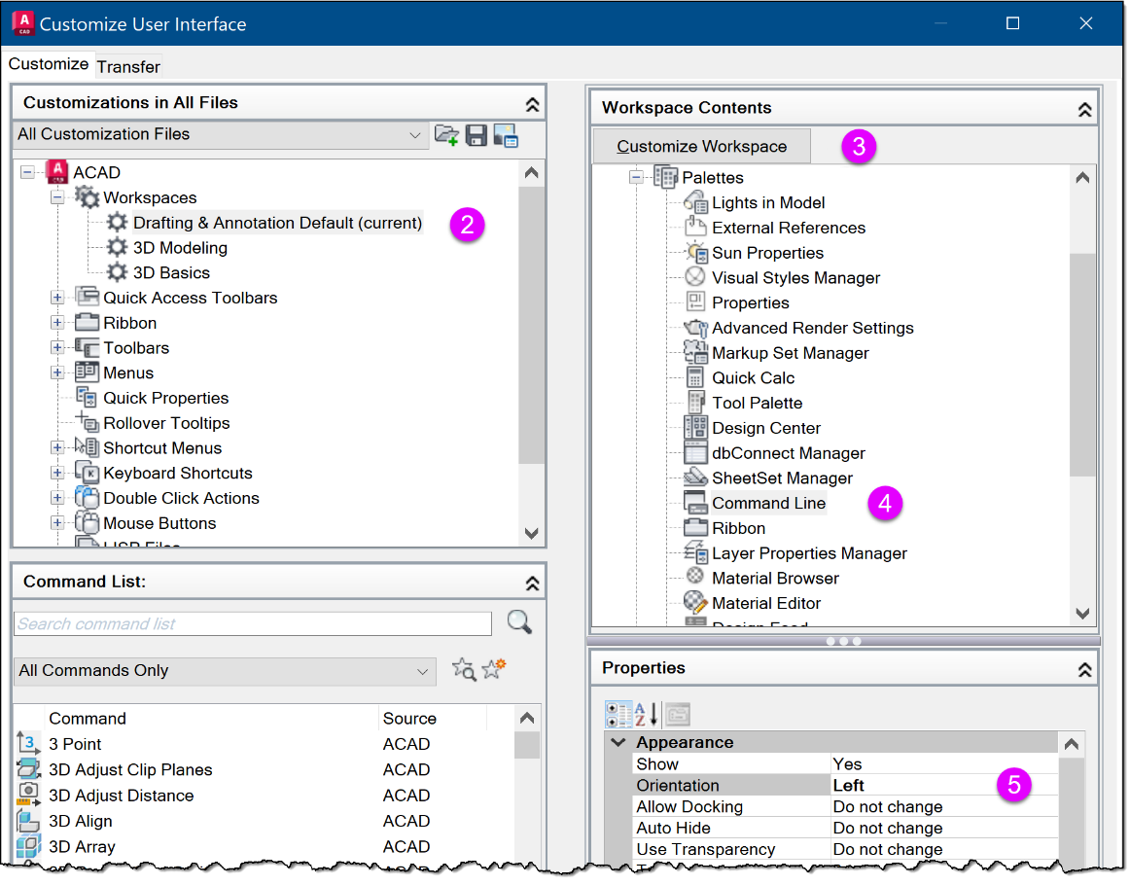

Figure 1.6: CUI dialog results

The Command Line should appear at your selected location. I selected the LEFT command-line location.

On completing this exercise, you can control the location and display properties of your Command Line to improve your overall use of your screen real estate.

Does your Command Line keep moving

Are you having problems with your Command Line not “sticking” at your preferred location? Me too, and it can be very annoying!

Locate and size your Command Line as needed and use the Ctrl key when dragging it to the desired location. Holding the Ctrl key while moving the Command Line dialog disables the “magnet” or “docking” capability for the positioning of the Command Line dialog and forces the location to be memorized.

Use the following steps to prevent the Command Line dialog from moving around in the interface:

1. Continue using the 1-0-BLANK.DWG file.
2. Select the Command Line using the “dotted” end of the title bar, then left-click and drag it to a new location while holding the Ctrl key. If you drag the dialog down into the Status Bar area of the interface, you will see that it no longer forces the “docking” functionality.
3. Drag the Command Line dialog to your preferred location and re-size it to one line to minimize the required screen real estate. As an experienced AutoCAD user, you probably don’t need to see more than one line of the Command Line dialog, and you can always use the F2 key to review additional lines when needed.

Control the Command Line Search Options

You can control what commands appear in the Command Line suggestion list using the INPUTSEARCHOPTIONS system variable. This variable allows you to control the following options:

AutoComplete

Controls if the commands are automatically completed as you type. You can determine if a MID-STRING KEY-IN is allowed or if you wish to have the suggestion list sorted based on the FREQUENCY OF COMMAND USAGE or ALPHABETICALLY.

AutoCorrect

Enables spellcheck on the commands as you type.

System Variables

This controls whether system variables are included in the suggestion list. When they are, you need to press Tab key to expand the list.

List Time Delay

Controls how long the delay is before the suggestion list is displayed as you type. This time is entered in milliseconds.

Filter Named Objects

Controls whether named objects such as blocks, layers, hatches, and styles are displayed in the suggestion list. You can determine which types are included and control their priority by using the arrow buttons to change the order of the list.

1. Continue using the 1-0-BLANK.DWG file.
2. Using the Command Line left-click on the WRENCH icon  to access the Input Search Options… command.
3. Using the Insert Search Options dialog, review the settings and make any desired changes.
4. Click OK to close the dialog and save your changes.

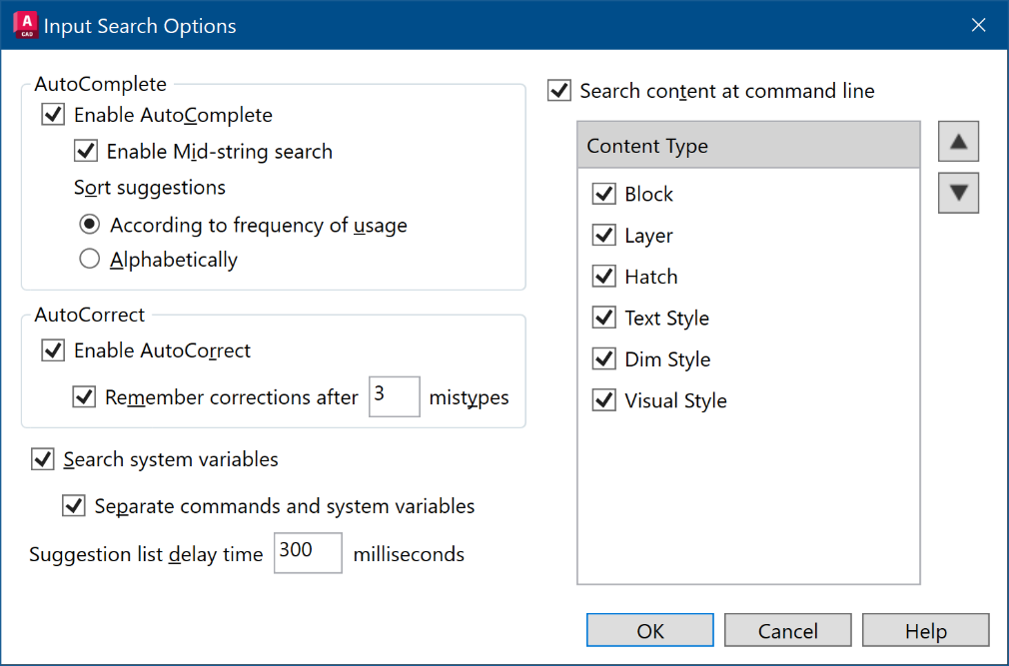

Figure 1.7: INPUTSEARCHOPTIONS settings

After completing this exercise, you will be able to control the location of your Command Line with more precision and disable the “docking” functionality when needed to make the most of your screen real estate. Using these skills you can customize what content is displayed in your Command Line using the suggestion list options.

Useful Dynamic Input

In this exercise, we will learn how to use Dynamic Input and clipboard shortcuts to improve your productivity using precision input and Dynamic Input.

Know your Dynamic Input rules

Have you ever wanted to input Absolute coordinates using the new Dynamic Input feature? First, let’s verify that you have your Dynamic Input enabled.

1. Open the 1-2_KNOW YOUR COORDINATES.DWG file.
2. Using the Status Bar, left-click on the “hamburger” icon A black and white text box

   Description automatically generatedand select Dynamic Input from the list to turn it ON in the Status Bar.
3. This will turn ON the Dynamic input icon. 

First, let’s review the basics of AutoCAD coordinate input:

* Relative Coordinates: 2,20 is relative to the previous coordinate location
* Absolute Coordinates: #2,20 is an absolute coordinate location in the current UCS
* World Coordinates: *2,20 is a world coordinate location

Once you understand these rules, you can input them using two methods.

Method 1

For the first example, we want to add an object vertex at the absolute coordinate of 0,0 using Dynamic Input. When using Dynamic Input, if you key in 0,0 the coordinate is interpreted as a “relative” coordinate from the current cursor location. If you key in #0,0 it is interpreted as an “absolute” coordinate.

Use this override setting when inputting the coordinate values by typing in a # character before the coordinate.

1. Select the LINE command and left-click inside the SQUARE object to start the line.
2. Drag the cursor to the left-side of the SQUARE object, key in **#0,0**, and press Enter to complete the command.
3. Drag the cursor to the topside of the SQUARE object, key in **0,0**, and press Enter to complete the command. Notice that the line is not continued using this key-in, as it is interpreted as X=0 and Y=0 from the current location.
4. Use Esc to cancel the current command and Ctrl + Z shortcut key to UNDO the previous lines.

Next, let’s look at another method to input coordinates.

Method 2

If you key in ABSOLUTE coordinates more than RELATIVE coordinates, you will want to change your input settings when using Dynamic Input to avoid using all the # characters during input.

Let’s change our default input settings before we draw the next line. Follow these steps:

1. Continue using the 1-2_KNOW YOUR COORDINATES.DWG file.
2. To access the Dynamic Input Settings, right-click on the Dynamic input icon in the Status Bar and select the Dynamic Input Settings command.
3. Using the Enable Pointer Input, select the Settings button.
4. Using the Pointer Input Settings dialog, select the Absolute coordinates format for our X,Y,Z key-ins.

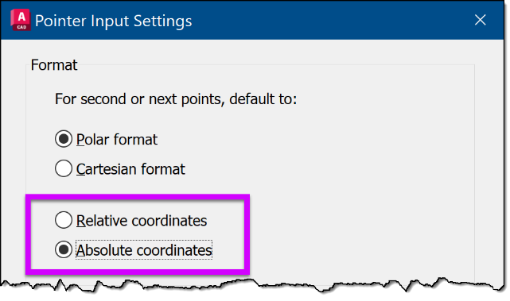

Figure 1.8: Absolute Pointer Input Settings

1. Click OK to save your selection and click OK again to close the Dynamic Input Settings dialog.
2. Select the LINE command and left-click inside the SQUARE object to start the line.
3. Drag the cursor to the left side of the SQUARE, key in **0,0** and press Enter to complete the command. This time, the LINE is drawn to the ABSOLUTE X,Y coordinate without using the # prefix.

After completing this section, you can use these rules and settings for your coordinate input. You can control and simplify your coordinates more easily and still take advantage of Dynamic Input.

Using the Clipboard Efficiently?

Everyone knows you can use the Ctrl + C Windows shortcut keys to copy objects to the clipboard and Ctrl + V to paste them back into a drawing. These are wonderful shortcuts, but they have a “flaw” in our AutoCAD workflow. These methods don’t allow you to define a base point to control the insertion point for the paste portion of these actions. Instead of using the typical Windows shortcuts, use the COPY WITH BASE POINT clipboard command to control your base point.

|  |  |
| --- | --- |
| **CLIPBOARD** | **Command Locations** |
| Ribbon | Home | Clipboard | Copy | Copy with Base Point |
| Command Line | COPYBASE (COPYB) |
| Right-Click Menu | Clipboard | Copy with Base Point |

Copy with a base point

In this exercise, we will use the Ctrl + Shift + C shortcut to define a base point and copy objects to the clipboard, which is quicker than using the right-click menu to access this command.

1. Open the 1-3_KNOW YOUR COORDINATES.DWG file.
2. Select the ARROW object and right-click to access the Clipboard | Copy With Base Point command.
3. Using the ENDPOINT osnap, left-click at the tip of the arrowhead to define the base point.
4. Next, use the Ctrl + V shortcut to PASTE the clipboard contents into the drawing using the newly defined base point.

Note

You can also use the Ctrl + Shift + X shortcut to CUT objects from a drawing to the clipboard and define a base point.

Paste and rotate from the Clipboard

Another clipboard option that is “hidden” from many users is the ability to rotate the clipboard contents during PASTE operation.

1. Continue using the 1-3_SMARTER CLIPBOARD.DWG file.
2. Use the Ctrl + V shortcut to PASTE the ARROW graphics again, and key in **R** to pre-define the desired angle of the ARROW graphics.

Note

The “R” command option is “hidden” and is NOT displayed in the Command Line but is available to use.

1. Key in **90** to rotate the new ARROW graphics 90 degrees and left-click in the drawing view to place the new rotated graphics.

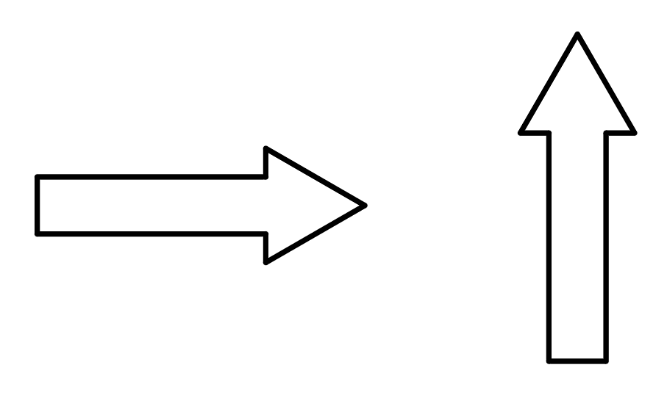

Figure 1.9: Paste and Rotate

Paste as a block from the Clipboard

In this exercise, we will continue to use PASTE from the clipboard contents and convert all graphics as a BLOCK object during the PASTE process:

1. Continue using the 1-3_SMARTER CLIPBOARD.DWG file.
2. Use the Ctrl + Shift + V shortcut to PASTE the clipboard graphics as a BLOCK.
3. The resulting BLOCK object will be an ANONYMOUS BLOCK with an A$C…. block name.
4. Using the Command Line, key in **RENAME** to give this new block a logical name.

|  |  |
| --- | --- |
| **RENAME** | **Command Locations** |
| Command Line | RENAME (REN) |

Figure 1.10: Renaming the Block

Upon completing this section, you should be able to use the clipboard more efficiently to copy and paste drawing objects and place them correctly during the clipboard commands.

Using Temporary Overrides

In this section, we will use several keyboard overrides to override command functionality on-the-fly to help control the placement and editing of objects in the drawing file.

Shift for ORTHO

In this first exercise, we will learn to use the Shift key to automatically apply the ORTHOGONAL (ORTHO) angle lock without using the F8 function key. The Shift key will apply ORTHO as a temporary override while executing a command:

1. Open the 1-4_Shortcuts.dwg file.
2. Select the LINE command and left-click in the view window to start the LINE object.
3. Drag the cursor to the right and up at approximately 45 degrees. By default, POLAR is turned ON, and you can draw the line at any angle.
4. Hold down the Shift key to force ORTHO to be applied, limiting your angle options to “0” or “90” degree angles.
5. Release the Shift key to return to the previous POLAR angle options.

Shift + A for OSNAPS

In this second exercise, we will learn to use the Shift + A keys to temporarily disable OSNAPS without using the F9 function key. The Shift + A key will disable the OSNAPS as a temporary override while executing a command:

1. Continue using the 1-4_Shortcuts.dwg file.
2. Select the LINE command and left-click in the view window to start the LINE object.
3. Drag the cursor to the upper left corner of the shape
4. Hold down the Shift + A keys to disable OSNAP, allowing you to avoid accidentally snapping to the shape object.
5. Release the Shift + A keys to enable OSNAPS again when needed.

Cycling in AutoCAD

For several years now, the ability to perform object cycling between objects using the mouse and keyboard shortcuts has been available to assist in selecting specific overlapping objects. In the newer versions of AutoCAD, you can use the new Selection Cycling tool available in the Status Bar. In the next example, let’s look at both methods for object cycling.

Object Cycling “the Legacy way”

When you Hover over overlapping objects, you can use the Shift + Spacebar shortcut to cycle between all the overlapping objects. Once the object you need is highlighted, you can left-click to select it.A green square with a plus and a square

By default, the SELECTIONPREVIEW system variable is set to 3, which allows a preview of the object under the cursor location. Other settings are available as shown in the following table:

**SELECTIONPREVIEW**

|  |  |
| --- | --- |
| Objects are highlighted when the pickbox cursor rolls over them. The highlighting indicates that the object would be selected if you clicked it. The setting is stored as a bitcode using the sum of the following values:  Type: Bitcode  Saved in: Registry | |
| 0 | OFF (will improve the performance of AutoCAD) |
| 1 | ON when no commands are active (the list dialog does not display) |
| 2 | ON when a command prompts for object selection (the list dialog displays the selected objects that you can cycle through) |
| 3 (default) | ON when you “hover” over an object |

Use the following steps to use the “LEGACY” method for cycling between overlapping objects.

1. Open the 1-5_Object Cycling.dwg file.
2. Hover the mouse over the overlapping objects at P1 and use Shift + Spacebar to cycle between the objects at that location. You will find that there are four objects at this location:

LINE, LINE, POLYLINE, POLYLINE

1. Use Shift + Spacebar to toggle the highlight between all four objects. When the object you want to select is highlighted, release Shift + Spacebar and left-click to select that object.
2. Use the Esc key to clear the active selection set.

Next, let's learn how to use the new method for controlling the selection of overlapping objects.

Object Cycling “the New way”

In this exercise, we will look at the dialog option provided by newer versions of AutoCAD to assist with selecting overlapping objects using the SELECTION CYCLING tool in the Status Bar. Use this method if you struggle to see the highlighted objects demonstrated in the previous method:

1. Continue using the 1-5 Object Cycling.dwg file.
2. By default, the Selection Cycling tool is turned OFF. Using the Status Bar, left-click on the “hamburger” icon A black and white text box

   Description automatically generatedto turn on Selection Cycling. A green square with a plus and a square

   Description automatically generated
3. Hover the mouse over the overlapping objects at P1 and make note of the Cursor Badge that informs you of the overlapping objects at this point.
4. Select the overlapping objects at P1, and a Selection dialog opens to display all objects at that location.

Note

You can turn off the display of the cursor badges using the CURSORBADGE system variable.

|  |  |  |
| --- | --- | --- |
| **CURSORBADGE** | | |
| Determines which cursor badges are displayed in the drawing area when hovering on an object.  Type: Integer  Saved in: Registry | | |
| 1 | Turns OFF cursor badges used in the following commands: AREA, COPY, DIST, ERASE, ID, LIST, MASSPROP, MEASUREGEOM, MOVE, ROTATE, SCALE, TRIM, and ZOOM |
| 2 (default) | Turns ON all cursor badges |

Selection Cycling Settings

You can control how the selection cycling dialog appears and what it contains using the Selection Cycling Settings.

1. Using the Status Bar, right-click on the Selection Cycling button  to access the Selection Cycling Settings.
2. Using the Drafting Settings dialog, use the Quadrant and Distance settings to define where and how far away the dialog appears from your cursor. You can also choose the Static location, and the dialog will appear at the same location regardless of your cursor location.
3. You may also prefer to turn OFF the Titlebar, as it is unnecessary.

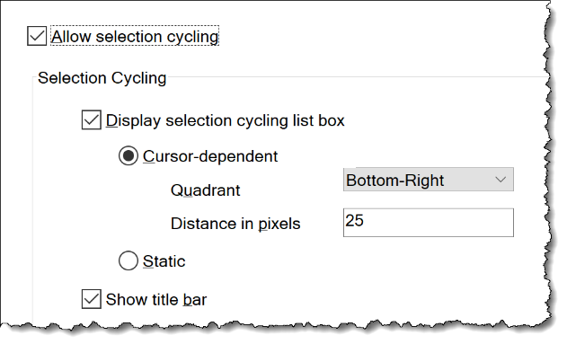

Figure 1.11: Selection Cycling Settings

In this exercise, we learned how to better control the selection of overlapping objects using both legacy and new methods.

Next, let’s learn how to control OSNAP Cycling.

OSNAP Cycling

In this exercise, let’s investigate how to control the use of our running OSNAPs to better control which OSNAP method is applied. Do you know all the shortcuts available to simplify your daily use of OSNAPs?

1. Open the 1-6 OSNAP Cycling.dwg file.

Before we begin these next few examples, we need to verify which OSNAPs are currently running.

1. Using the Status Bar, left-click on the OSNAP icon  drop-down-listand verify that you have the following OSNAPs turned ON:

Figure 1.12 Running OSNAPS

1. For this example, we must turn OFF the DYNAMIC INPUT setting  in the Status Bar. The DYNAMIC INPUT functionality prevents this method from working.
2. Select the LINE command and Hover the mouse over the Center point of the circle.
3. Use the Tab key to toggle between the various running OSNAPs. Each object and OSNAP mode will display and highlight to confirm which snappable point is identified. Issue a left-click when the correct snappable point and object is displayed.

In this exercise, you learned how to control your OBJECT and OSNAP cycling to gain more control over your drawing and editing processes.

File Cycling

In this exercise, let’s look at the alternative options available to switch between open files in an AutoCAD session. If screen real estate is a problem, you can turn off the File Tabs and use the Ctrl + Tab shortcut to cycle between open files.

First, how do you turn off File Tabs? Use the following FILETABCLOSE and FILETAB commands to control the display of File Tabs.

|  |  |
| --- | --- |
| **FILETABCLOSE**  **FILETAB** | **Command Locations** |
| Ribbon | View | Interface | File Tabs |
| Command Line | FILETABCLOSE, FILETAB |

Open the 1-7_File Cycling 1.dwg and 1-7_File Cycling 2.dwg files.

You can use the Ctrl + Tab, Ctrl + Shift + Tab, and Ctrl + Home shortcuts to navigate through the File Tabs. Let’s look at these commands in detail:

* Ctrl + Tab: Use the Ctrl + Tab keys to cycle to the next open File Tab.
* Ctrl + Shift + Tab: Use the Ctrl + Shift + Tab to cycle to the previous open File Tab.
* Ctrl + Shift + Home: Use the Ctrl + Shift + Home to cycle to the starting File Tab.

Note

Use the FILETAB command to turn the display of the File Tabs on again.

Using these keyboard shortcuts will simplify your navigation of open files and eliminate the need to display File Tabs, letting you save that screen real estate.

Viewport Cycling

Have you ever been stuck in a viewport that was erroneously or intentionally created inside of another viewport, creating a “nested” viewport? How do you access a “nested” viewport?

1. Open the 1-8_Viewport Cycling.dwg file.
2. Double left-click in the larger viewport to activate that viewport.

If you try to double-left-click to activate the smaller viewport, it doesn’t work. However, if you use the Ctrl + R shortcut, you can toggle between all viewports, including the embedded viewport, to gain the ability to activate any viewport in this paper space.

1. Use the Ctrl + R shortcut to activate the smaller viewport that is embedded in the larger viewport.
2. Continue using Ctrl + R to toggle between viewports in this layout.

In this exercise, you learned how to control your FILE and VIEWPORT cycling to gain more control over your drawing and editing process.

Hidden in the ViewCube

Not everyone uses the ViewCube in AutoCAD, but even if you do, there are some hidden features that you may not be aware of. Most users use the ViewCube for 3D work, but did you know you can also use it for 2D?

Let me demonstrate how you can take advantage of the ViewCube's hidden features, even in 2D.

Zoom to Selected Objects

Do you know how to get AutoCAD to perform a ZOOM EXTENTS to a selection only? Using the ViewCube, you can ZOOM EXTENTS to just the selected objects.

1. Open the 1-9_ViewCube 2D.dwg file.
2. Using the Lasso selection method, select Lots 9-15 between RAY BLVD and HAYDEN DR.

Note

If you are not familiar with the LASSO selection option, left-click and drag the cursor around the objects to select. Release the left-click when the bounding selection box is complete.

1. Double-left-click the mouse wheel to access the Zoom Extents command. As anticipated, it disregards the selected items and zooms out to show the entire drawing's contents.
2. Repeat the previous selection command, and using the ViewCube, select the TOP edge. This time, the selected objects are recognized and the view zooms to just the selected objects.

Note

Disable the ZOOM EXTENTS functionality using the ViewCube settings in the next section.

Save View as Home

In this exercise, we will learn how to save a common view of a drawing so that it can be easily recalled. Yes, we could use Saved Views, but there is also another method for saving common views.

Let's begin by discovering how to use the ViewCube to create a Home view quickly.

1. Continue using the 1-9_ViewCube 2D.dwg file.
2. Using the mouse, double-click the wheel to access the Zoom Extents command which will fit the drawing contents in the current view.
3. Using the Zoom Window command, zoom in on Lots 8-13 between HAYDEN DR and STRATTON DR.

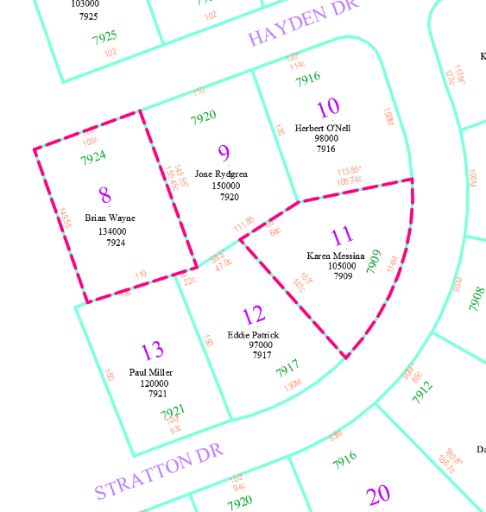

Figure 1.13: Zoom window results

1. Hover the mouse over the ViewCube until you see the Home icon, A blue house with a door

   Description automatically generatedthen left-click to select it. By default, it will rotate to an isometric view, which would be great if we were working in a 3D file.
2. Use the Undo command (Ctrl + Z) to return the view to the previous flat view.
3. Again, Hover over the ViewCube and right-click on the HOME icon. Select the Set Current View As Home command.
4. Double-click the mouse wheel to access the ZOOM EXTENTS command.
5. Use the new HOME icon definition to set the current view to your preferred Home view.

Now, we can look at the remaining ViewCube customizable settings to suit your preferences.

ViewCube Settings

Use the ViewCube Settings to control the display and functionality of the ViewCube.

1. Continue using the 1-9_ViewCube 2D.dwg file.
2. Hover the mouse over the ViewCube and right-click to access the ViewCube Settings command.

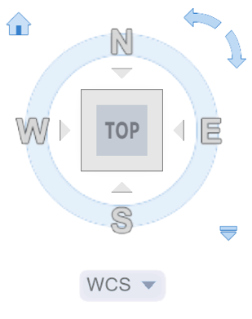

Figure 1.14: Default ViewCube

1. Using the ViewCube Settings dialog, use the following settings to change the functionality of the ViewCube:
2. Use the On-screen position to control where the ViewCube is displayed. The Top Right location may not be best for your use.
3. Use the ViewCube Size settings to change the overall size of the ViewCube in your view window.
4. Use the Show UCS Menu toggle to turn off the UCS drop-down list if you do not use the User Coordinate System.

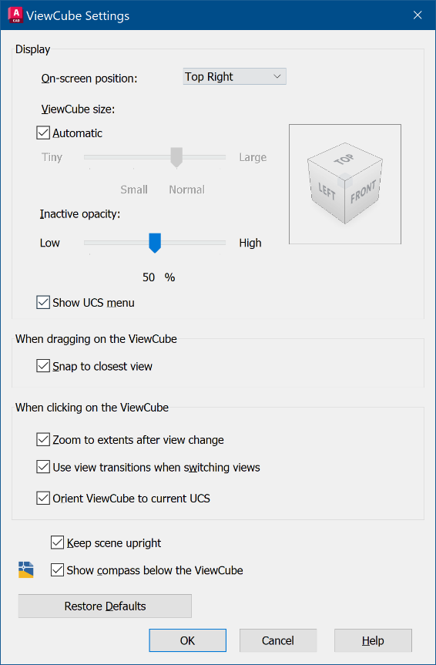

Figure 1.15: ViewCube Settings dialog

In this section, you learned how to take advantage of the hidden features and settings in the ViewCube.

In the next section, we will look at how you can change the appearance of AutoCAD using the OPTIONS command.

Tailoring your Options

Do you need to use AutoCAD for presentations at work? The OPTIONS settings have several controls that you can use to improve the visibility of your cursor and command prompts, making those presentations easier for your audience to follow.

Colors and Sizes

First, let’s look at the options for the size and color of the Command Line and Dynamic Prompts.

Command Line Font and Size

To modify the font and size of the Command Line, follow these steps:

1. Open the 1-10_Options.dwg file.
2. Place the cursor in the middle of the view window and right-click to access the Options command.
3. Using the Options dialog, select the Display tab, then select the Fonts… button.
4. Using the Command Line Window Font dialog, set the Font Style and Size options as needed.
5. Click Apply & Close to save your changes.
6. Click OK to close the dialog and review the changes to your Command Line.

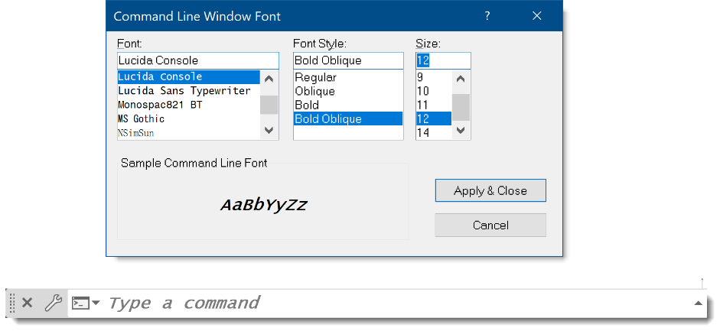

Figure 1.16: Command Line Window Font

Command Line Color

To modify the color of the Command Line, follow these steps:

1. Continue using the 1-10_Options.dwg file.
2. Using the Options dialog, select the Display tab, then click the Colors… button.
3. Using the Context: section, select Command Line, and using the Interface Element section, select the Active prompt background (WHITE by default). Change this background color to stand out as needed. I will change it to a YELLOW highlight color.
4. Using the Color: drop-down list,select the Select Color… option, and choose your preferred color. Select a base color and use the True Color tab to modify the actual color using R,G,B values. I used 255,255,185 for this example.



Figure 1.17: Command line highlight color

1. Click OK to close the dialog.
2. Click Apply & Close and OK to save your changes.

Next, let’s modify the size and color of your Dynamic Input appearance.

Dynamic Input size and color

I recommend changing the color of your Dynamic Input as well as the Command Line:

1. Continue using the 1-10_Options.dwg file.
2. Using the Status Bar, right-click on the Dynamic Input icon A blue and black symbol

   Description automatically generated with medium confidenceand select the Dynamic Input Settings command.
3. Using the Drafting Settings dialog, select the Drafting Tooltip Appearance button.
4. Select the Colors… button, and using the Drawing Windows Color dialog, select the Context | 2D model space and Interface element | Drafting tooltip background.
5. Using the Color: drop-down list, select your preferred color using the Select Color… option. Select the base color and use the True Color tab to tweak the actual color using R,G,B values. I used 250,210,250 for this example.
6. Click Apply & Close to save your changes.
7. Use the Size setting to increase the text size for the Dynamic Input prompts.
8. Modify these settings to apply to the Dynamic Input tooltips only.
9. Click OK to save these changes and close the dialog, then OK again to complete the changes.

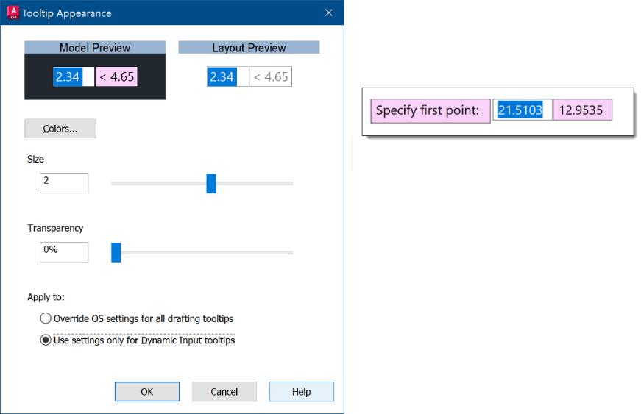

Figure 1.18: Dynamic Input color and size

Next, we will modify the color of the polar tracking and auto-tracking lines so they are easier to see with a dark background.

Polar tracking and auto-tracking lines color

In this exercise, we will modify the color of the polar tracking and auto-tracking lines as needed to make them more visible against your background:

1. Continue using the 1-10_Options.dwg file.
2. Using the Options dialog, select the Display Tab and select the Colors… button.
3. Using the Context section, select 2D Model Space. Then, using the Interface Element section, select Autotrack vector. Change the background color to one that stands out against your background view color (1,152,1 is the default). I will change it to a yellow-highlight color that stands out nicely against the default dark gray background.
4. Using the Colors… drop-down list,select the Select Color… option, and choose your preferred color. Select the base color and use the True Color tab to tweak the actual color using R,G,B values. I used 255,255,185 for this example.

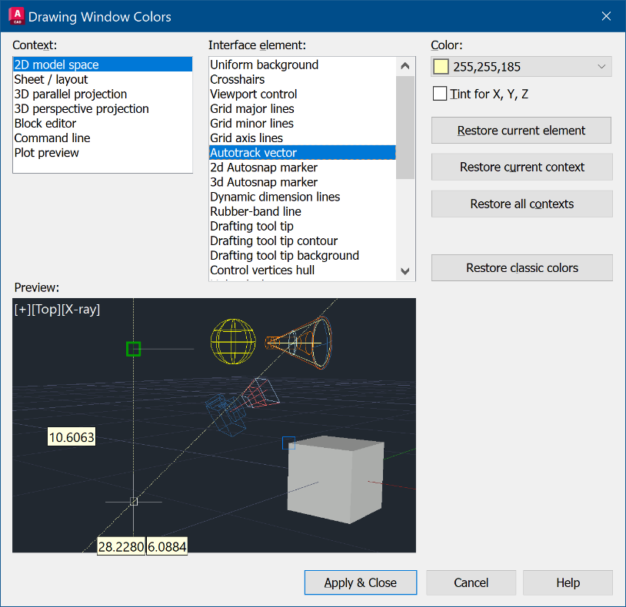

Figure 1.19: Polar and Autotrack Color

Note

You should also consider modifying the 2D and 3D Autosnap markers. It's worth exploring all the options available.

In this exercise, you learned to modify your AutoCAD display options to improve your presentations and possibly your daily work environment by changing the size and color of many aspects of the interface.

Using File Tabs

In this exercise, you will learn to use all the features of the file tabs to reduce the number of clicks required and to save time.

Close All and Close All Other Drawings

When working on a project, it’s common to find you have more files open than you intended. Here’s how to solve that problem quickly:

1. Open the 1-12_Using Tabs 1.dwg and 1-12_Using Tabs 2.dwg files.
2. Right-click on any drawing File Tab, and select Close All or Close All Other Drawings to quickly close the files you are finished working with.

Another command located under the File Tab that is easily overlooked is the SAVE ALL command.

Save All

Use the SAVE ALL command to quickly save all open drawings:

1. Open the 1-12_Using Tabs 1.dwg and 1-12_Using Tabs 2.dwg files.
2. Right-click on any drawing File Tab, and select Save All to save all open files.

Figure 1.20: File tab commands

Another command located under the File Tab is the OPEN FILE LOCATION command.

Open File Location

Use the OPEN FILE LOCATION command in the OPEN WINDOWS EXPLORER command. This will open a new Windows Explorer dialog in the project file location:

1. Continue using the 1-12_Using Tabs 1.dwg and 1-12_Using Tabs 2.dwg files.
2. Right-click on any drawing File Tab and select Open File Location to open a Windows Explorer dialog in that file's location.

Another command under the File Tab is the COPY FULL PATH command.

Copy Full Path

Use the COPY FULL PATH command to copy the drawing file path to the clipboard, which can then be used in documentation or other Windows dialogs:

1. Continue using the 1-12_Using Tabs 1.dwg and 1-12_Using Tabs 2.dwg files.
2. Right-click on any drawing File Tab, and select Copy Full Path to capture the drawing file location to the clipboard.

You can also use the new File Tab menu in AutoCAD 2024 to access the various file commands.

File Tab menu

The new File Tab menu can be used to switch between open drawings and create, open, save all, or close drawing files:

1. Continue using the 1-12_Using Tabs 1.dwg and 1-12_Using Tabs 2.dwg files.
2. Left-click on the “hamburger” icon A black and white text box

   Description automatically generatedtab to access the new file tab menu.

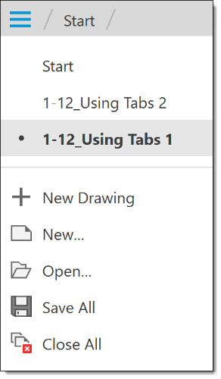

Figure 1.21: New file tabs menu

By using these file commands, you get access to updated and more efficient options for managing frequently used file commands.

In the next section, we will learn to fully use layout tabs.

Using Layout tabs

In this section, we will discover new options for controlling the appearance of the layout tabs. Are you using all the features of your layout tabs? Using these features can save you considerable clicks.

Dock above Status Bar

Use the DOCK ABOVE STATUS BAR option to separate the layout tabs from the Status Bar. If your project files contain multiple layouts and you need more space to display them all, separate the layout tabs from the Status Bar.

Dock Inline with Status Bar

To save screen space and have both the layout tabs and Status Bar share the same screen space, use DOCK INLINE WITH STATUS BAR:

1. Open the 1-12_Using Layout Tabs.dwg file.
2. Right-click on any Layout tab, and select Dock above Status Bar.



Figure 1.22: Default Layouts docked above the status bar



Figure 1.23: Modified Layouts docked Inline with the status bar

Note:

When using the Dock Inline with Status Bar, you may need to use the Layouts “hamburger”  button to swap between layouts.

Quickly Copy or create New Layouts

You can quickly COPY or create NEW Layout tabs using the Ctrl key.

1. Continue using the 1-12_Using Layout Tabs.dwg file.

For this example, we want to change the layout to DOCK ABOVE STATUS BAR to display the results more visually.

1. Right-click on the Architectural layout and select the Dock Above Status Bar command.
2. Select the Architectural tab and hold down the Ctrl + left-click to select the Architectural Layout tab. Drag the layout copy to the desired location and release the Ctrl + left-click.
3. You can double-left-click on the new layout to easily rename the layout.

Copy Layout from another Drawing

Do you have a layout already set up in another drawing, and do you want to use it in this drawing? You can import a layout from any drawing file.

1. Continue using the 1-12_Using Layout Tabs.dwg file.
2. right-click on any layout in this drawing file and select the From Template command.
3. Navigate to the location of the file containing the completed layout and change the Files of Type to .DWG if needed.
4. Select the Borders file, which contains all the standard layouts for this course, and click Open.  
    **…\ACAD_TipsTricks\Exercise_Files\refs\Agency XYZ_Borders.dwg**
5. Using the Insert Layouts dialog, select the B-Border XYZ Sheet layout and click OK to import the layout.

In the next section, we will learn to use some of the selection tools' “hidden” features.

Bonus commands

In this section, we will examine how to control some of the interface's more obscure aspects, such as the Status Bar, how to use the Quick Properties dialog to easily edit some of those hard-to-find dimension settings, and how to minimize the appearance of the AutoCAD tooltips.

First, let’s look at how to control the “blinky” Status Bar and what causes this problem.

Blinky Status Bar?

Do you ever experience a “blinky” Status Bar when working in AutoCAD? Yes, it can be very distracting and needs to be addressed when it occurs. This problem is caused by the COORDINATES display in the Status Bar when it is too full of other icons and settings.

To avoid this problem, turn off the COORDINATES display in the Status Bar:

1. Open the 1-16_QUICK PROPERTIES.DWG file.
2. Using the Status Bar, left-click on the “hamburger” icon A black and white text box

   Description automatically generatedand select the Coordinates setting to turn OFF this option in the Status Bar.

By default, the COORDINATES are turned ON in the Status Bar. Depending on each individual user’s Status Bar and screen width, having the COORDINATES turned ON may exceed the minimum width and cause this small display issue. If you need the COORDINATES to display, use the Dock above Status Bar layout setting to gain more display space for your Status Bar.



Figure 1.24: Default coordinates display

1. Right-click on any layout tab and select Dock above Status Bar to separate the display of the Status Bar and layout tabs.

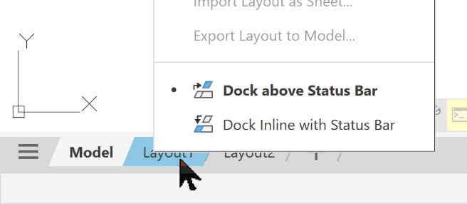

Figure 1.25: Status bar and layout tabs control

In the next exercise, we will learn how to use the “hidden” Quick Properties dialog.

Quick Properties

Users always ask me how to improve the availability of object properties for those objects that need to be edited on a regular basis. When I ask if they are using QUICK PROPERTIES, many users do not know what I am talking about.

Here are a couple of quick examples that demonstrate how you can use QUICK PROPERTIES to simplify your daily drafting workflow:

1. Continue using the 1-16_QUICK PROPERTIES.DWG file.
2. Using the Status Bar, left-click on the “hamburger” icon A black and white text box

   Description automatically generatedand select Quick Properties.
3. This will turn ON the Quick Properties icon A blue square with a black and grey square with a black line on it

   Description automatically generated with medium confidencein the Status Bar.
4. With Quick Properties enabled, “hover” on the new icon and right-click to access the Quick Properties Settings.
5. Using the Drafting Settings dialog, review the settings to control what properties are displayed and where in the Quick Properties dialog.
6. Click CANCEL to retain the default settings.
7. Select the DIMENSION object and notice the new Properties dialog that displays to the top-right of the cursor.
8. This dialog may not display all the commonly used properties you need to review and modify, so let’s change it to provide the properties we need for a TOLERANCE DIMENSION object.

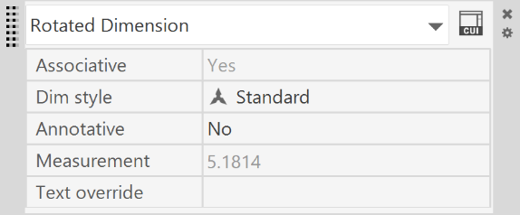

Figure 1.26: Default Quick Properties dialog

Tolerance Dimensions

So, let’s assume you need to edit the tolerance value in an existing dimension. When you double left-click on the dimension text, the entire text value is highlighted, which prevents you from just editing the tolerance values.

We need to add the TOLERANCE LIMITS and TOLERANCE PRECISION properties to the Quick Properties dialog:

1. Continue using the 1-16_QUICK PROPERTIES.DWG file.
2. Run the CUI command and use the Customize User Interface dialog to select the (current) workspace from the top-left All Customization Files panel.
3. Select the Quick Properties item in the list. This changes the display of the right panel in the dialog.
4. Using the right panel, select the Rotated Dimension object type and turn ON the Tolerance limits and Tolerance precision properties.
5. Click APPLY and OK to save our changes and close the dialog.
6. Select the DIMENSION object, and using the Quick Properties dialog, modify the Tolerance limit values as needed.

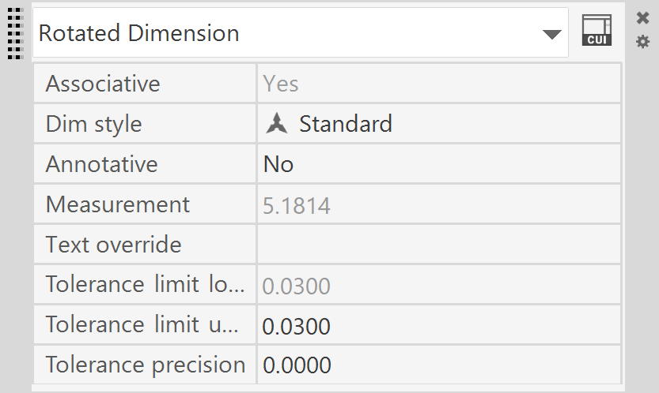

Figure 1.27: Modified Quick Properties dialog

In the next exercise, we will learn how to change the display of the default tooltips.

Dynamic tooltips

Use the TOOLTIPMERGE system variable to merge the “dynamic” tooltips together into a single tooltip. They are smaller and easier to read, and you won’t see all those tooltips flying around your cursor!

|  |  |
| --- | --- |
| **TOOLTIPMERGE** | |
| Combines drafting tooltips into a single tooltip.  Type: Integer  Saved In: Registry | |
| 0 (default) | Drafting tooltips are separate |
| 1 | Drafting tooltips are merged |

1. Open the 1-1 TOOLTIPS.DWG file.
2. Run the LINE command and left-click in the view window to start the LINE object.
3. By default, the tooltips are all separated, as shown below.
4. Using the Command Line, key in TOOLTIPMERGE and Enter. Key in the value of **1** to turn ON the merge effect.
5. Run the LINE command again and left-click in the view window to start the LINE object.

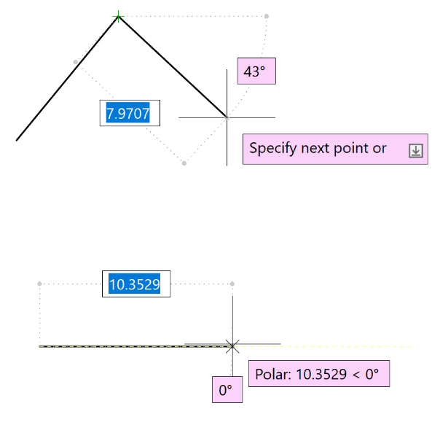

Figure 1.28: Default tooltip merge

///

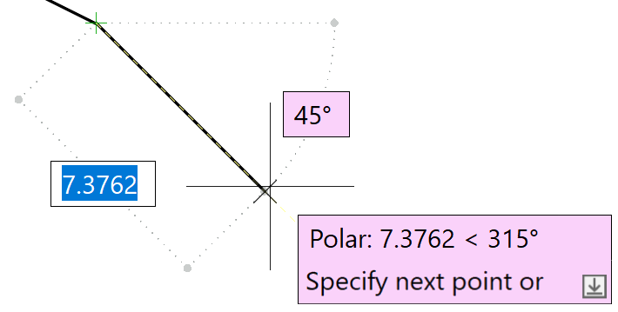

Figure 1.29: Merged dynamic tooltips

In these exercises, you learned some of the lesser-known interface options to customize your interface using the Status Bar, the Quick Properties dialog, and the Dynamic Input tooltips.

Summary

In this chapter, we examined how to use the newest features of the AutoCAD interface, including the new floating windows and customizing the command-line appearance and location. We learned how to use Dynamic Input more efficiently using key-ins that are not known to the majority of users. We reviewed how to use some useful keyboard shortcuts to simplify our daily workflow, and how to assign custom keyboard shortcuts when needed. We learned how to make the most out of our selection commands, and how to use more mouse controls, such as drag and drop for working with files.

Finally, we finished the chapter by reviewing some of the more obscure interface commands such as Quick Properties and customized tooltips.

In the next chapter, we will look at how to take advantage of some of the advanced annotation features including full control of text editing in the Mtext editor, controlling the appearance of our text objects, using fields for “smarter” text objects, and more controls for using annotation scale on objects.