1
Game Development Basics
In this chapter, we will cover the basic concepts that you need to know to kick-start your career in games development. You will learn how to:
- Install IDE on Windows
- Choose the right source-control tool
- Understand the need for multiplayer
- Use call-stacks for memory storage
- Use recursions cautiously
- Use pointers to store memory address
- Cast between various data-types
- Manage memory more effectively using dynamic allocation
- Use bitwise operations for advanced check and optimisation

- Introduction

The first step before a person starts coding, is to install an IDE. Nowadays there are few online IDEs that are available but we are going to use an offline standalone IDE, Visual Studio. The next most important thing which many programmers do not start using at an early stage is a revision control software.
A revision control software helps to back-up the code in one central location, it has a historical overview of the changes that are made which you can access and revert to if needed and it also helps to resolve conflicts between files which have worked upon by different programmers at the same time.
The most useful feature of C++ in my opinion is memory handling. It gives the developers a lot of control of how memory must be assigned depending on the current usage and need of the program. As a result of that, we can allocate memory when there is a need and de-allocate them accordingly.
If we do not de-allocate memory, we might run out of memory very soon especially if we are using recursion. We do however have pointers at our disposal for dynamically allocation memory.
Sometimes there is a need to convert from one data type to another to prevent loss of data, to pass the correct data type in a function, etc. C++ provides us few ways by which we can do those castings.

The recipes in this chapter will primarily focus
on the above mentioned topics and deal practical ways to implement them.

Install IDE on Windows
Throughout the following recipes, we will use Visual Studio as our main IDE to build any kind of application or to explain any kind of technique. So you should first install the IDE on your windows computer to get things started.

Getting ready
To step through this recipe, you will need a machine running Windows. No other prerequisites are required.

How to do it...
- Go to https://www.visualstudio.com
- Click on the Download Visual Studio Community
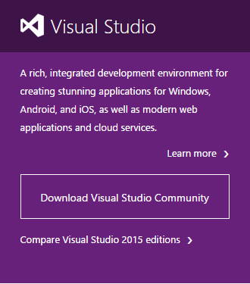

Illustration 1: Connect via MySQL Administrator
Insert Image: 7962_08_01.png
Illustration 1: Download Visual Studio Community

- This should download an .exe
- After it downloads, double click to start the installations
- Make sure you have all the updates necessary on your Windows machine.
- You can also download any version of Visual Studio or Visual C++ express.
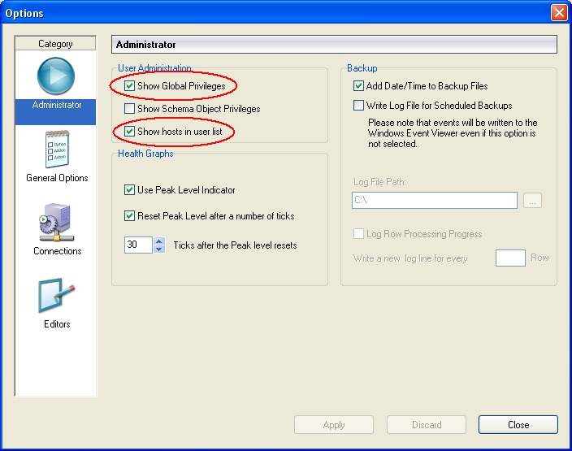
- If it asks for a starting environment settings, select C++ from the available options
- Note: There are other free IDEs for C++ like NetBeans, Eclipse, Code::Blocks.
- Note: While Visual Studio works only for Windows, Code::Blocks and other IDEs such are cross platform and can work on Mac and Linux as well
- For the remaining on this chapter, all code examples and snippets will be provided using Visual Studio.

How it works...
An IDE is a programming environment. An IDE can consists of various functionalities and can vary from one IDE to another. However the most basic functionalities that are present in all IDEs are: a code editor, a compiler, a debugger, a linker, and a GUI interface builder.
A code editor or a source code editor as they are otherwise known is useful for editing code written by programmers. They provide features such as auto-correct, syntax highlighting, bracket completion and indentation, etc. An example snapshot of the Visual Studio code editor is given below
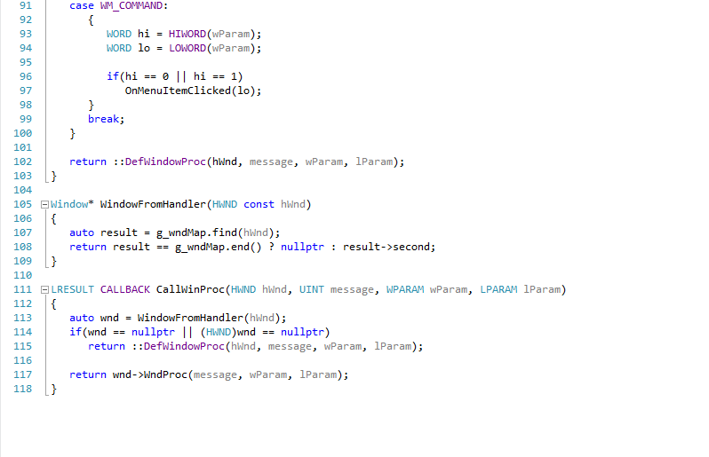
Illustration 2: Visual Studio Code Editor
A compiler
A debugger
A linker
A GUI interface builder

Define a specific user for administrative tasks

During MySQL installation, an account for user root is created. This account receives simply all privileges, period. In most installations, this configuration is basically left unchanged, which makes the root account a very rewarding target for attacks. An attacker will not have to guess a user name and a corresponding password – the password alone will do, because it is a safe bet to imply existence of a user name root. This is why we recommend that you create an administration account with a different name.
This recipe will show you how to create a user account that can act as a replacement for the root user.

Getting ready
You are going to need a catchy user name for your administration account and a corresponding password. When making up the password, keep in mind the typical password recommendations for good passwords (hard to guess, but easy to remember; should contain upper and lower case letters, numbers and special characters). Throughout this recipe, we will assume a user name admin4mysql and a password As,ysp4M (“A simple, yet strong password for MySQL”) throughout this recipe.
Additionally, you will have to make sure that manipulation of global privileges is enabled in MySQL Administrator options. Please refer to “Configure MySQL Administrator to display global privileges recipe” if in doubt.
Finally, you have to think about from which host you are going to connect to your MySQL instance to perform administrative tasks. In most cases, this will be localhost, which we assume as host in the following recipe. In some situations, however, this might differ, for example if you have no login rights on the database host itself. In these situations, you should define a certain host as your base for administration tasks. Have its host name or IP address ready for the following tasks.
The steps below will guide you through the process of creating an alternative administration account.

How to do it...
- Start MySQL Administrator. Connect to your database using the root account.
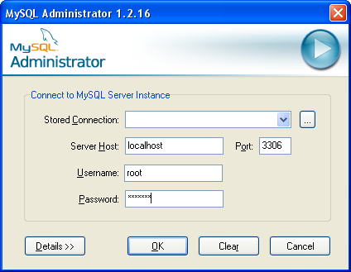
- Select the entry “User Administration” either from the list on the left or from the “View” menu
- Click the “Add new user” button
- Enter the basic user information (user name, password, contact information), followed by a click on the “Apply changes” button

- Right click on the new user admin4mysql (in the user list to the lower left) and choose the option “Add host from which the user can connect”
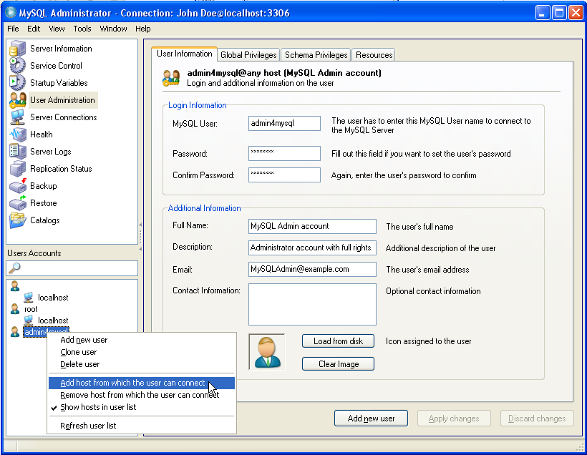
- In the following form, enter the host from which you are going to perform your administration tasks (typically “localhost”)
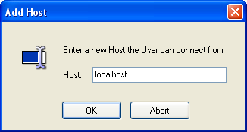
- Select the tab “Global Privileges”. Choose the “<<” button to grant all global rights to the user, followed by the “Apply changes” button
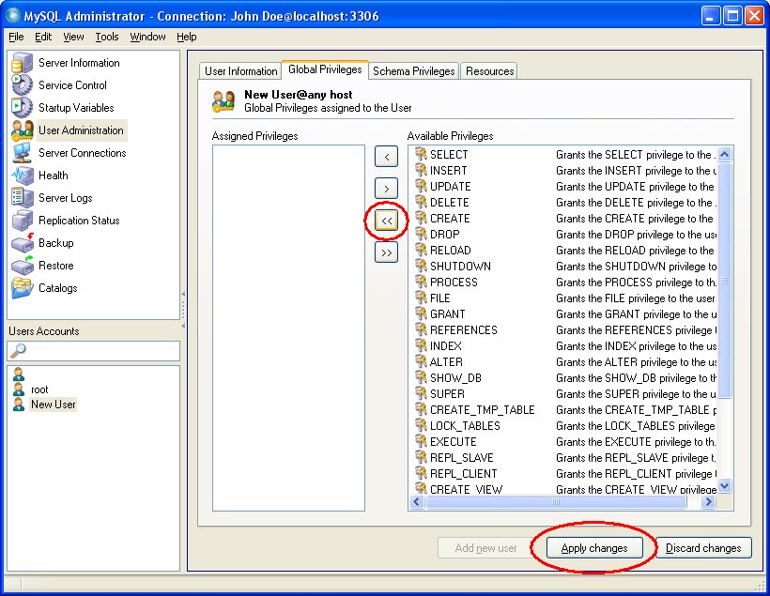

- Right click on the “admin4mysql” entry on the user list and select “Remove host from which the user can connect” from the context menu

- Confirm the message box indicating “The any-host (%) entry has been deleted”, followed by the “Apply changes” button
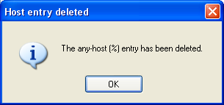

How it works...
Let's take a look what we did throughout the above recipe. In steps 1 through 4 we created a new user named “admin4mysql”. At this point, this user could connect to the database from any host, but as new users have no initial rights whatsoever, he would not be able to actually do anything. With steps 5 and 6 we define a specific host from which the user will be allowed to log on. Step 7 finally assigns all rights to the newly created user.
With steps 8 and 9 the user admin4mysql is no longer able to connect from any host other than localhost. This makes it necessary for a possible attacker to login on the the host itself before he can try to gain access to the database, which in turn ensures brute force attacks on the MySQL server via network from a random host for this user will not be successful.

There's more...

Create the account without using MySQL Administrator
MySQL Administrator features a graphical user interface, it is not the tool of choice in some situations, for example if scripting capabilities are needed. In these circumstances, a single SQL script will perform the same changes as the above recipe. This script could be executed e.g. by using the MySQL command line client:
grant all privileges on *.* to 'admin4mysql'@'localhost'
identified by 'As,ysp4M' with grant option;

The values for password and maybe host name have to be adapted according to your choices.

See also
- Configure MySQL Administrator to display global privileges and hosts
- Avoid plain text passwords in scripts

Disable the default accounts

In the previous recipe, we created a new user for administration tasks as a replacement for the default root user. If – and only if – another user with full rights is available, we can can discard the default users that were created during MySQL installation. This helps hardening your MySQL installation against possible intruders, who will not be able to attack well known account names.

Getting ready
You have to assure yourself that you have a second user with full rights (in addition to the root user) at your disposal. By deleting the root account, you risk a database with no means of basic administration - unless there is an equivalent user available. This is why MySQL Administrator won't let you delete this user – so we will have to resort to the command line client to delete the root account.
The following steps will show you how to remove the default accounts.

How to do it...
- Connect to your database with the MySQL command line client using the additional administration account (admin4mysql).
- To delete the root user, issue the following commands:
DROP USER 'root'@'localhost';
DROP USER 'root'@'%';
- To delete the anonymous user, execute these commands:
DROP USER ''@'localhost';
DROP USER ''@'%';

How it works...
MySQL creates one to four default accounts, depending on the choices made during installation. These four accounts use two user names, namely root and the anonymous user with an empty user name. For each user name the two hosts localhost and % are defined, with the latter being the place holder for any host. Thus the default accounts are as follows:
- 'root'@'localhost'
- 'root'@'%'
- ''@'localhost'
- ''@'%'
The first account 'root'@'localhost' is always available, while the other three are only created in certain installation scenarios.
With the commands in the above steps, all possible default accounts will be deleted. If these users do not exist, you will receive an error message (error code 1396 “operation failed”) indicating that the account does not exist. After having executed all of these commands, you can be sure that no unwanted default accounts are left.
You can control the effect of the steps performed by using MySQL Administrator. The entries of the root user and the anonymous user (with the empty name) will be gone in the User Administration view if you reconnect to your database.

See also
- Regain access to your database in case of lost account information

Create a basic user
If installed from scratch, MySQL does not provide a default user suitable for everyday use. You could of course use the root user or an alternative administrative user (e.g. admin4mysql) with full rights. However, this is strongly discouraged for security reasons, especially if you have different users and/or applications that need access to your MySQL database. In the following recipe, we will show you how to create a typical user that has full access to a certain database (schema) .

Getting ready
You will need some information before stepping through this recipe:
In the first place, you will need a user name and a password. If the user is a person who is going to use the database interactively, you will mostly use his or her real name as the login name; for accounts that will be used by applications, it is typically a good idea to include the application (and – if applicable – the role for which the account will be used) in the account name. Examples would be john_doe, hotelbooking or carrental_stdusr. Keep in mind, however, that the length of the user name is limited:
The length of a MySQL user name must not exceed 16 characters!
Second, you should find out about which database of your MySQL installation has to be accessed by your user. This database has to exist already, otherwise you will not be able to assign the respective rights using MySQL Administrator (however, the script solution in the “There's more...” section would even work without an existing target schema).
Throughout this recipe, we will show you how to create a basic user sample_stduser with read-write access to a database named sample and a password S4mpl3-Pw. As a prerequisite, we assume that the database sample already exists.

How to do it...
- Start MySQL Administrator. Connect to your database using the admin4mysql account.
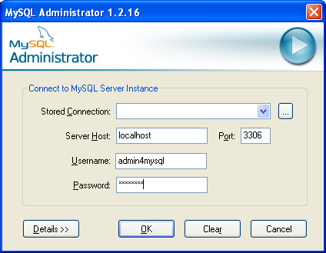
- Select the entry “User Administration” either from the list on the left or from the “View” menu
- Click the “Add new user” button
- Enter the basic user information (user name, password, contact information), followed by a click on the “Apply changes” button
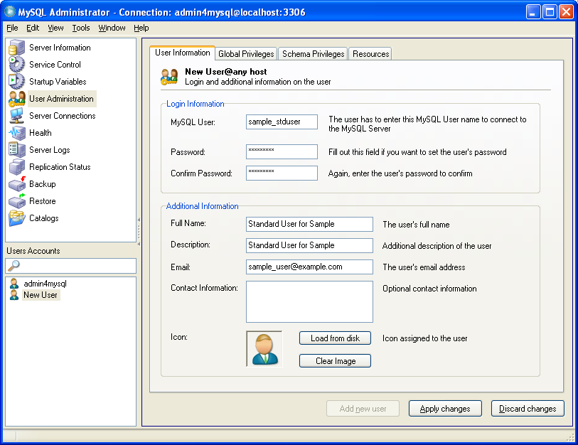

- Select the tab “Schema Privileges” and select the schema sample from the Schemata list on the left. Select the privileges SELECT, INSERT, UPDATE, DELETE, CREATE TEMPORARY TABLES, LOCK TABLES and EXECUTE from the Available Privileges list on the right, and for each selected privilege press the “<” button. Choose the “Apply changes” button afterwards.
To select and assign more than one privilege at once, hold down the Control key while selecting the privileges
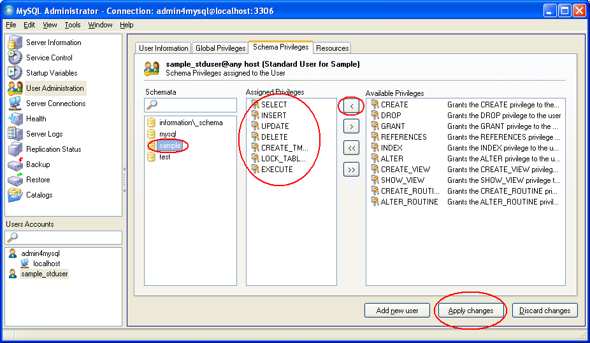

How it works...
Step 4 creates a new user which is allowed to connect from any host, but which has no privileges whatsoever. By assigning the privileges in step 5, the user is granted the rights to read (SELECT) and change (INSERT, UPDATE, DELETE) data from any table in the sample schema. These are the most basic rights that are typically necessary for a basic user.
Additionally, we grant the CREATE TEMPORARY TABLE privilege. This sometimes comes in handy for complex statements, and the corresponding risks are typically acceptable. Temporary tables are not visible to other users and are limited to the database connection by which they are created. Moreover, they are purged as soon as the connection is closed. So typically, it is not a problem to grant this right. However, as with all privileges the basic security rule holds true for this rights as well:
Don't assign unnecessary privileges!
If you are sure that this privilege will not be used, it is recommended not to assign it to the user you created.
The LOCK TABLES privilege allows the user to explicitly lock tables. This is sometimes helpful to coordinate concurrent access to date by different sessions, and is needed by some applications which make use of LOCK TABLES statements to prevent concurrent data modifications. On the other hand, this privilege enables a user to block read and write access to all tables at discretion, which might basically render the database useless to other users in case of extensive or incautious use of of LOCK TABLES statements. If you are sure that your user won't need such statements, it is recommended not to assign this privilege.
Finally, the EXECUTE privilege gives the user the right to call stored routines. As the user is not granted the rights to create or change such routines, granting this privilege does not pose a noteworthy additional risk even if there are no stored routines to execute. If there are any, the EXECUTE privilege has to be assigned for the user to be able to call these stored routines. Some applications make use of stored routines, so this right was included for typical users. But as stored procedures and functions are still a fairly new feature of MySQL, they are not very widely used yet. So in many cases, you can do without this privilege.
With this set of privileges, we created a user which has full access to all tables in our schema. This account is a reasonable compromise between rights granted and restrictions still in place; however, you will need a corresponding installation user that can be used to set up the schema in the first place. The creation of this user is described in the following recipe.

There's more...

Create the account without using MySQL Administrator
If you want (or need) to avoid using MySQL Administrator for creating this account, you can alternatively issue a single SQL statement instead (the values for password and database name have to be adapted according to your choices):
grant SELECT, INSERT, UPDATE, DELETE, CREATE TEMPORARY TABLES, LOCK TABLES, EXECUTE on sample.* to 'sample_stduser'@'%' identified by 'S4mpl3-Pw';
This is helpful if you need a scripting solution for user definitions, but it also gives you the possibility to create the user before the target database schema exists. With MySQL administrator, you have to define the schema first, because it will only let you assign rights for existing databases. This script could be executed for example by using the MySQL command line client.

See also
- Define a specific user for administrative tasks
- Avoid plain text passwords in scripts

Create an installation user
In the previous recipe we discussed how to define a typical user for accessing a certain database schema. Additionally, there is an administration user account with full rights. For installations that are managed by one single administrator, this might be sufficient. But often, you do not want to perform all administration tasks by yourself. For example, you might want to delegate the task of defining the database structure to a different person. Some applications also have their own installation routines which require rights to set up a database schema. For these tasks, you should consider creating a specific installation user for certain databases. This user should not have global rights, but should be restricted to changes to his specific database. This way, you can delegate certain administration tasks without the risk of users tampering with other databases that are not their business.
Even if you manage your database installation all by yourself, it might be a good idea to use a specific account to perform these tasks, as this helps preventing accidental changes to other databases.
This recipe will guide you through the steps of creating such an installation user for a certain database (schema) .

Getting ready
For this recipe, you will again need to come up with a user name (remember the 16 character length limit), a password, and the name of the database that will be accessible to the. As before, this database should already exist, otherwise you have to resort to the scripting solution from the “There's more...” section.
We will assume sample_install as the user name, sample as the database and 1n5t4ll-Pw as the password.

How to do it...
- Start MySQL Administrator. Connect to your database using the administration account (admin4mysql).
- Select the entry “User Administration” either from the list on the left or from the “View” menu
- Click the “Add new user” button
- Enter the basic user information (user name, password, contact information), followed by a click on the “Apply changes” button
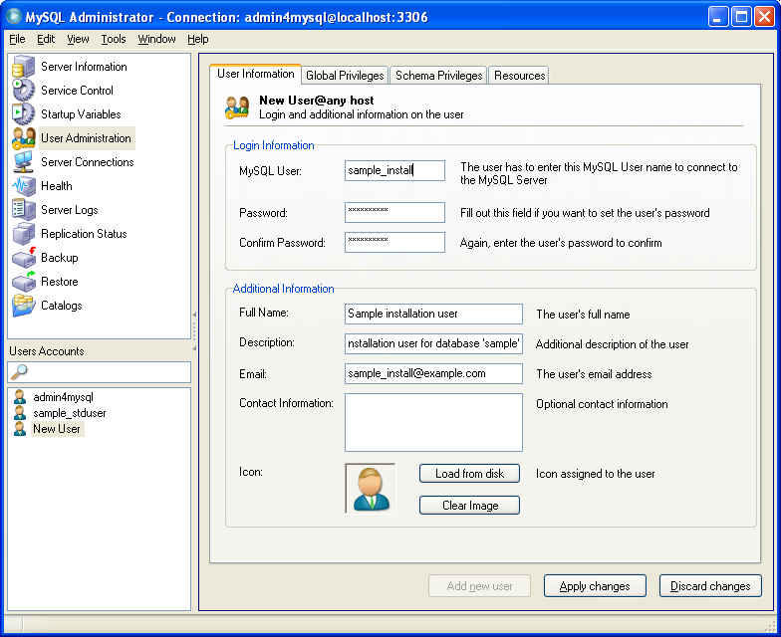

- Select the tab “Schema Privileges” and select the schema sample from the Schemata list on the left. Press the “<<” button to assign all privileges on the sample database. Next, select the GRANT privilege from the Assigned Privileges list and press the “>” button to exclude the GRANT right. Choose the “Apply changes” button afterwards.
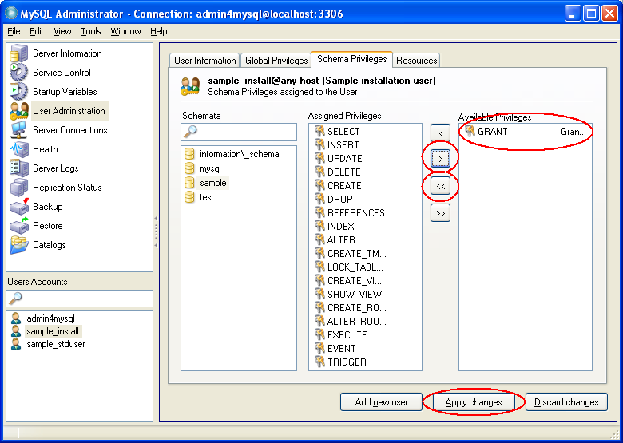

How it works...
The new user is created in steps 1 through 4, while step 5 assigns all rights on the sample database to the user, with the GRANT privilege being the only exception (also see “There's more” on this).
This user has basically full rights on the whole database schema. This account can be used to set up the database, which might for example involve creation, deletion or changes of tables, management of stored routines, or definition of views. However, it is not recommended to use such a powerful account for normal operations. You should preferably stick to a basic user for this instead, as we defined in the previous recipe.

There's more...

Create the account without using MySQL Administrator
You can also create the account without having to use MySQL Administrator by issuing the following SQL command (adapt the values for password and database schema name accordingly):
grant ALL PRIVILEGES on sample.* to 'sample_install'@'%' identified by '1n5t4ll-Pw';
As mentioned before, this allows for scripting as well as definition of the account without having to create the database beforehand. You could for example use the MySQL command line client to execute this script.

Permit management of user rights
Some applications feature highly sophisticated installation routines which try to perform as many tasks automatically. In some cases, they also try to define MySQL user rights themselves to make sure they have the correct set of privileges. If this is the case, you might need to permit privilege management for the installation user.
As another example, you might want to delegate not only the responsibility of managing a database, but also the (sometimes tedious) task of maintaining the privileges of the corresponding user accounts.
In both situations, you should consider assigning the GRANT privilege to the installation user. This right allows to grant those rights to other users (or revoke it from them) that you are granted yourself. As a result, the GRANT privilege will not allow the installation user to extend his rights.
To assign the GRANT privilege using MySQL Administrator, select the sample_install user in the User Administration view, switch to the Schema Privileges tab, select the sample schema, and assign the privilege by selecting it and pressing the “<” button, followed by the “Apply Changes” button:
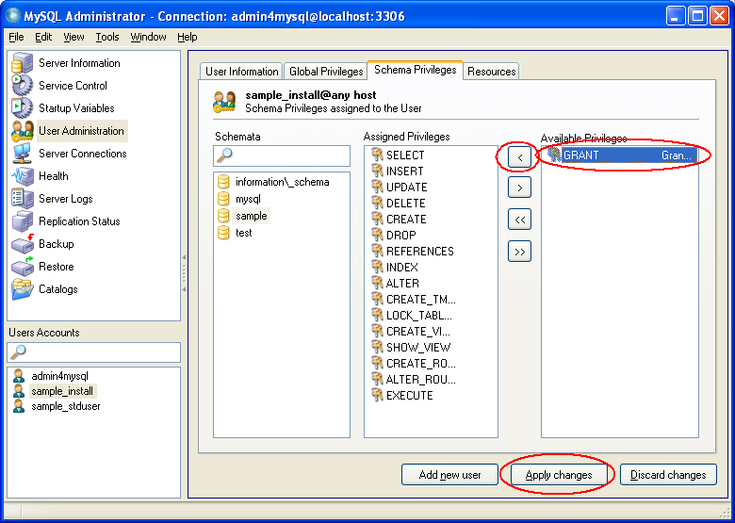
Alternatively, you could issue the following SQL command:
grant ALL PRIVILEGES on sample.* to 'sample_install'@'%' identified by '1n5t4ll-Pw' WITH GRANT OPTION;
Please note that the GRANT privilege itself does not allow you to create users! For being able to do so, an administration user has to have write access to the mysql database. Unfortunately, this allows for manipulation of all user accounts regardless of their scope, so a user with mysql write access is not restricted to managing its separate database any more. Because of this, we recommend to leave creation or deletion of the accounts to the main administration user. The installation user is then able to assign the specific rights for the database he is responsible for to the user.
Example: Let the admin4mysql account create a user with
GRANT USAGE ON *.* to 'john_doe'@'%' identified by 'Confidential';

The installation user sample_install (if he has the GRANT privilege) can then assign specific rights to the user at his own discretion:
GRANT SELECT ON sample.* to 'john_doe'@'%';

See also
- Define a specific user for administrative tasks
- Avoid plain text passwords in scripts

Create a guest account
In the previous recipes we presented how to define users for different roles: global administration, setting up a specific database, and basic access. Another typical role for users is the guest user, that typically is limited to read only operations. Credentials for such an an account can be passed on to different people without risking data accidental or deliberate data manipulation. In this recipe we will show you how to define such a read only user account.

Getting ready
Think of a catchy user name, a password, and the name of the database schema for which the user will have read access. In addition, this schema should already exist. You will have to use the SQL statement alternative from the “There's more...” section otherwise.
We will assume sample_guest as the user name, sample as the database and R34d-0nly as the password.

How to do it...
- Start MySQL Administrator. Connect to your database using the administration account (admin4mysql).
- Select the entry “User Administration” either from the list on the left or from the “View” menu
- Click the “Add new user” button
- Enter the basic user information (user name, password, contact information), followed by a click on the “Apply changes” button
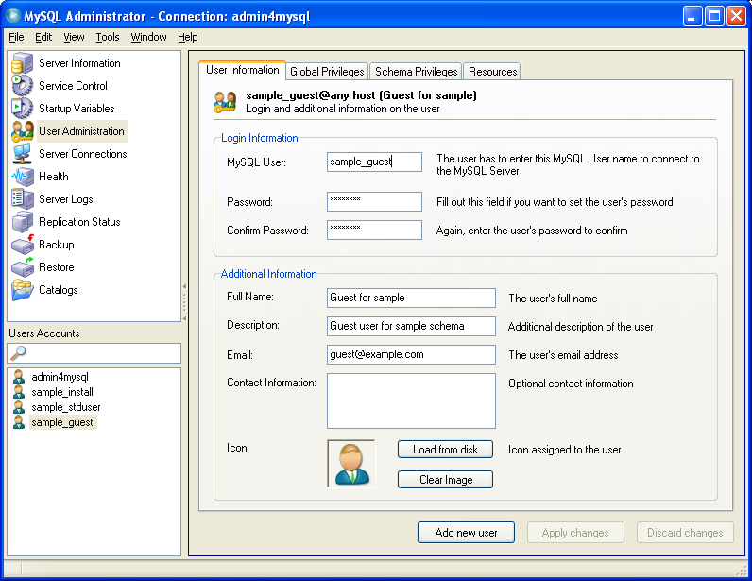

- Select the tab “Schema Privileges” and select the schema sample from the Schemata list on the left. Click on the SELECT privilege from the Available Privileges list on the right, and press the “<” button to assign this privilege. Choose the “Apply changes” button afterwards.
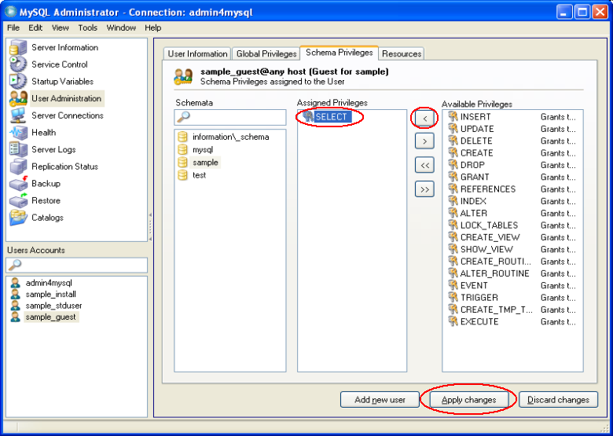

How it works...
Steps 1 through 4 create the user without any privileges; step 5 assigns the SELECT right on the sample database to the user.
With these settings, this user is not able to make any changes to the database. Nevertheless, we strongly recommend to not communicate the user name and the password for this guest account too laxly. In many cases, a database contains valuable or sensitive information. If the credentials of a guest user account are common knowledge (or too easy to guess, like the infamous user name 'guest' with exactly this password), your data will be an easy prey for any possible intruder.

There's more...

Create the account without using MySQL Administrator
To create the guest account without using MySQL Administrator, execute the following SQL command:
grant SELECT on sample.* to 'sample_guest'@'%' identified by 'R34d-0nly';
This command will also work if the sample database was not created in advance.

Allowing for stored procedure calls
Some database designers try to encapsulate complex statements in stored routines (functions or procedures). Some of these routines could also be very helpful for a guest user, so he can resort to predefined logic and does not have to try and construct complex queries by himself. For this reason, it might make sense to also assign the EXECUTE privilege to the guest user. But please be aware that assigning this privilege might have an unexpected side effect:
A guest user with EXECUTE rights can perform changes to the database!
If a stored routine performs changes to the database, like an update or a delete statement, it will execute flawlessly even if the user who calls this routine does not have any other rights but EXECUTE. This does not typically pose a serious risk, because the guest user is not able to define new routines on his own. But as soon as there are stored procedures in place that perform changes to the database, the EXECUTE privilege should be granted with care.

See also
- Define a specific user for administrative tasks
- Avoid plain text passwords in scripts

Define a specific user for backup
Even though many people have a tendency to ignore the possibility of unpleasant future events, one of your duties as a database administrator is to take reasonable precautions to minimize the negative effects of a disaster. Or, in short: it is your job to perform backups.
There are some strategies on how to best back up your database, and there also are different tools on the market that promise to help you do so. Basically, the different backup strategies can be divided into two groups: hot and cold backup. While cold backup can simply be done by copying and saving files, hot backups are not as easy to perform.
There are some tools available which promise to do file based hot backups. However, if you want or need to resort to the MySQL tools , you will typically have to do a database dump (for example using myqsldump) to back up your data during normal operations (if all your tables are MyISAM tables, you could use the mysqlhotcopy tool instead).
To perform a database dump, you will need a user to connect to your database. We recommend to define a user that is specifically suited for this task, and the following recipe will show you how to create such an account. Please note that this user is suited for backup purposes only; the recovery task should be performed by an administrator user, because you typically need full access to the database for this.

Getting ready
Again, you are going to need a user name and a password. We will use backup_usr as the user name and B4ckM3Up! as the password.

How to do it...
- Start MySQL Administrator. Connect to your database using the admin4mysql account.
- Select the entry “User Administration” either from the list on the left or from the “View” menu
- Click the “Add new user” button
- Enter the basic user information (user name, password, contact information), followed by a click on the “Apply changes” button

- Right click on the new user backup_usr (in the user list to the lower left) and choose the option “Add host from which the user can connect”
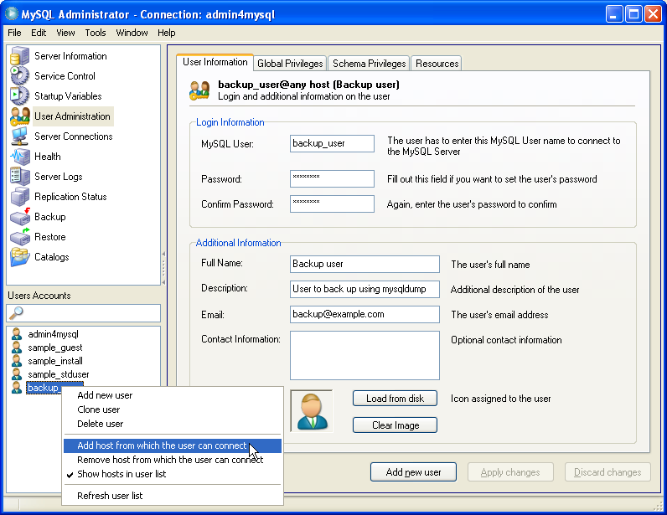
- In the following form, enter the host from which you are going to perform your backups (typically “localhost”)
- Select the tab “Global Privileges”. Choose the SELECT, RELOAD, LOCK_TABLES, and REPL_CLIENT privileges from the “Available Privileges” list to the right, press the “<” button for each of them, and click on the “Apply changes” button
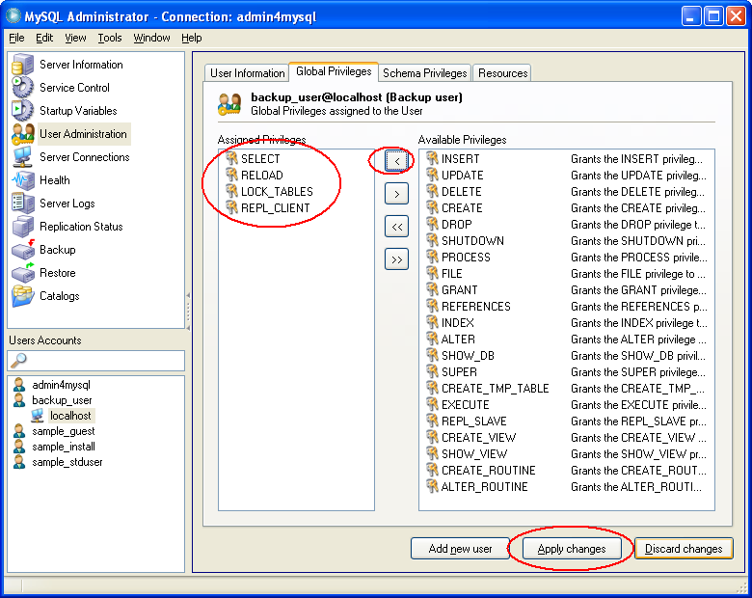

- Right click on the backup_usr entry on the user list and select “Remove host from which the user can connect” from the context menu
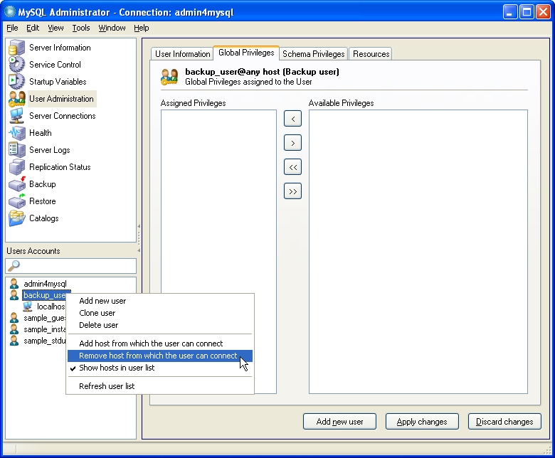
- Confirm the message box indicating “The any-host (%) entry has been deleted”, followed by the “Apply changes” button

How it works...
Let's take a look at the steps of this recipe. By following steps 1 through 4 a new user named backup_usr is created. At this point, he does not have any rights, but could successfully connect from any host. Steps 5 and 6 define a specific host (localhost) from which the user will be allowed to log on. Step 7 finally assigns the rights that are necessary to perform backups using the mysqldump command.
With steps 8 and 9 the user is no longer able to connect from any host other than localhost. This makes an attack harder, because a possible intruder would first have to to login to the host itself before he can access the database.
The first (and most important) privilege that was assigned is the SELECT privilege, which is used to read the data; otherwise we would not be able to write it to the dump file. Because this user is allowed to read all data from all databases, you should not forward the user credentials of this user.
The second privilege is LOCK_TABLES. It is needed because mysqldump locks the tables before dumping their data. This privilege is not required when the mysqldump options
--single-transaction or --master-data are used, but it is recommended to assign this right just in case a dump without one of these options has to be done.
Finally, the privileges RELOAD and REPLICATION_CLIENT are required for the mysqldump option –master-data. As this option is used frequently if you have to recover databases that are configured as replication clients, assigning these privileges allows you to use this option as well.

There's more...

Create the account without using MySQL Administrator
MySQL Administrator is not always the proper tool for user definition (e.g. in a scripted environment). An alternative to constitute an account for backup tasks is execution of the following SQL command:
grant SELECT, LOCK TABLES, RELOAD, REPLICATION CLIENT on *.* to 'backup_user'@'localhost' identified by 'B4ckM3Up!';

See also
- Define a specific user for administrative tasks
- Configure MySQL Administrator to display global privileges and hosts
- Avoid plain text passwords in scripts

Define a specific user for replication
In some cases, the MySQL replication mechanism is a very helpful feature, e.g. to horizontally scale your read loads, or to provide redundancy for improved robustness. If you plan to use this feature, you have to define a user on the replication master for this. This recipe will show how to create this user.

Getting ready
To step through the recipe, you will need a user name, a password, and the host on which the replication slave will be located. We will use repl_user as the user name with Pw_4_R3pl as the corresponding password, and we will assume that the replication slave will be located on host bluebox.

How to do it...
- Start MySQL Administrator. Connect to your database using the admin4mysql account.
- Select the entry “User Administration” either from the list on the left or from the “View” menu
- Click the “Add new user” button
- Enter the basic user information (user name repl_user, password Pw_4_R3pl, contact information), followed by a click on the “Apply changes” button
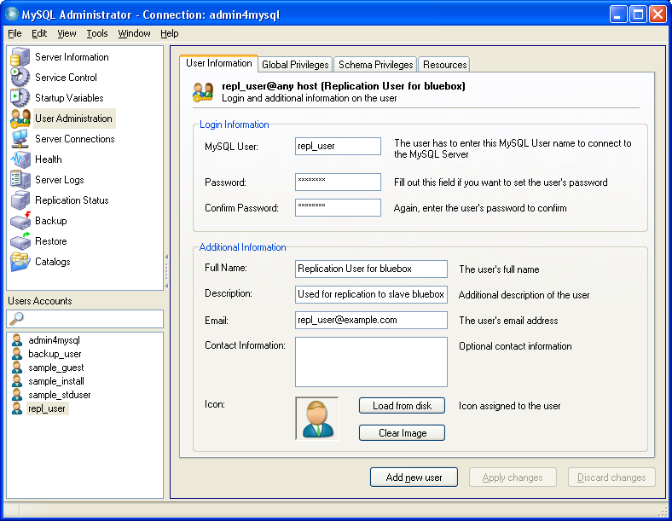
- Right click on the new user repl_user (in the user list to the lower left) and choose the option “Add host from which the user can connect”
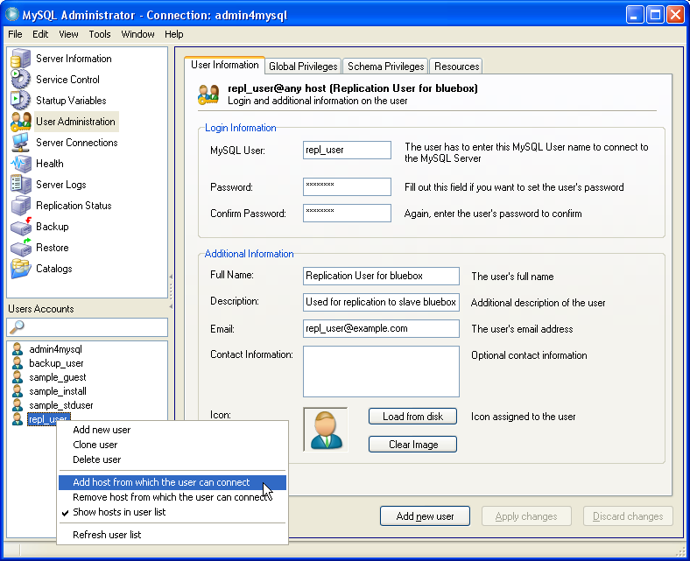

- In the following form, enter the host from which you are going to perform your backups (here: bluebox)
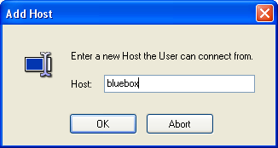
- Select the tab “Global Privileges”. Choose the REPL_SLAVE privilege from the “Available Privileges” list to the right, press the “<” button, and subsequently click on the “Apply changes” button.
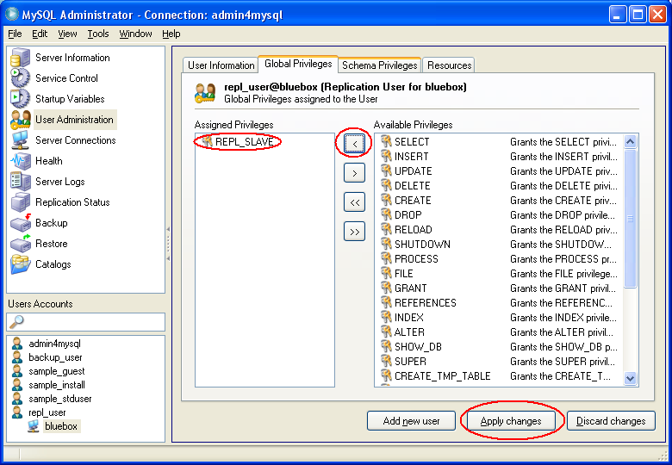

- Right click on the backup_usr entry on the user list and select “Remove host from which the user can connect” from the context menu
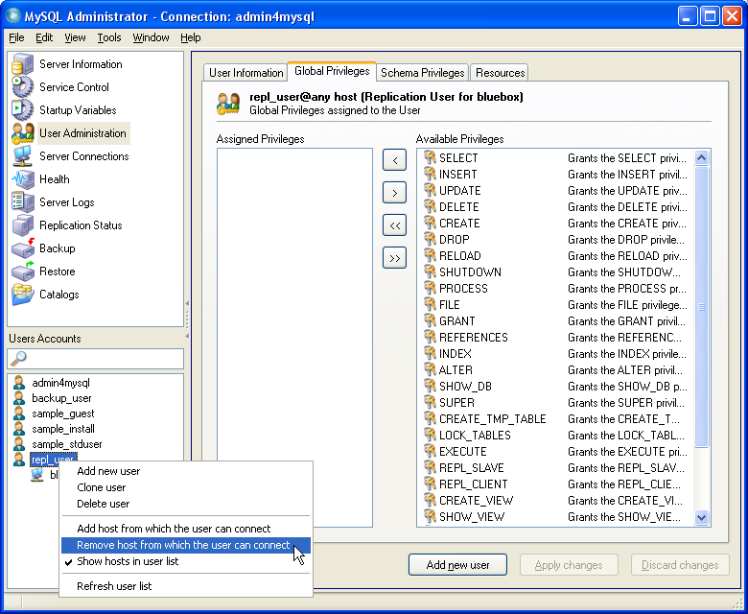

- Confirm the message box indicating “The any-host (%) entry has been deleted”, followed by the “Apply changes” button

How it works...
Let's inspect the steps of the above recipe: in steps 1 through 4 we defined a new account named repl_user, which at this point has no privileges at all, but could connect to the MySQL from any host. With steps 5 and 6 we define the specific host from which the user will be allowed to log on (in this case this is the host which runs the replication slave). Step 7 assigns the privilege necessary for the replication slave to the new account.
With steps 8 and 9 the account repl_user is changed in a way that it can no longer be used from any host (actually, the account repl_user@% is removed, while a second account repl_user@bluebox stays intact). A possible attacker would have to login to the replication slave host to make use of this account.

There's more...

Create the account without using MySQL Administrator
To create the replication account without resorting to a GUI tool, you can alternatively use an SQL command:
grant REPLICATION SLAVE on *.* to 'repl_user'@'bluebox' identified by 'Pw_4_R3pl';

See also
- Define a specific user for administrative tasks
- Configure MySQL Administrator to display global privileges and hosts
- Avoid plain text passwords in scripts

Allow access from specific hosts only
When creating a user account using MySQL Administrator, the user is by default entitled to log in from any host. If the account will be used on specific clients only, it is advisable to modify the account in a way that login is restricted to these clients. This helps to reduce the chance of successful attacks against your database server, because a possible intruder will not only have to get hold of (or guess) the proper credentials, but also has to seize control of one of the registered clients.
The following recipe will guide you through the steps of restricting a user account to a specific host.

Getting ready
For the following steps, we assume that an account with user name example has already been defined, and that this account is enabled for login from any host. We furthermore assume that this account should be changed in a way that it can only be used to login from host client1.mycompany.com.

How to do it...
- Start MySQL Administrator. Connect to your database using the admin4mysql account.
- Select the entry “User Administration” either from the list on the left or from the “View” menu
- Right click on the user account you want to change in the “User Accounts” list on the left and choose the option “Add host from which the user can connect”
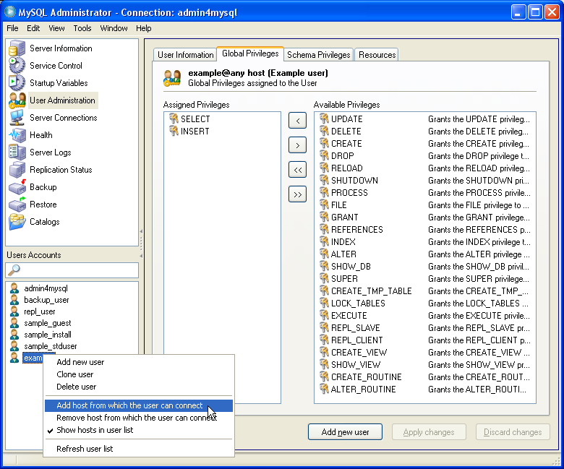

- In the following form, enter the host from which the user will be able to connect (here: client1.mycompany.com)
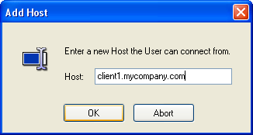
- Save the changes by clicking on the “Apply changes” button
- Select the tab “Global Privileges”. Left click on the user entry example on the list to the lower left. Note the privileges that are listed in the “Assigned Privileges” List (in the example screen, we assume that global privileges SELECT and CREATE TEMPORARY TABLE are assigned to the user).
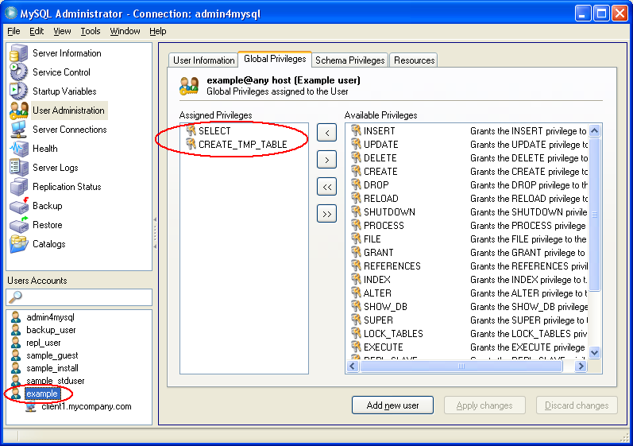
- Switch back to the new host by clicking on the host name client1.mycompany.com to the left. Assign the same privileges noted in the previous step (in this example: SELECT and CREATE TEMPORARY TABLE) by selecting them from the list of available privileges on the right and selecting the “<” button, followed by the “Apply changes” button.
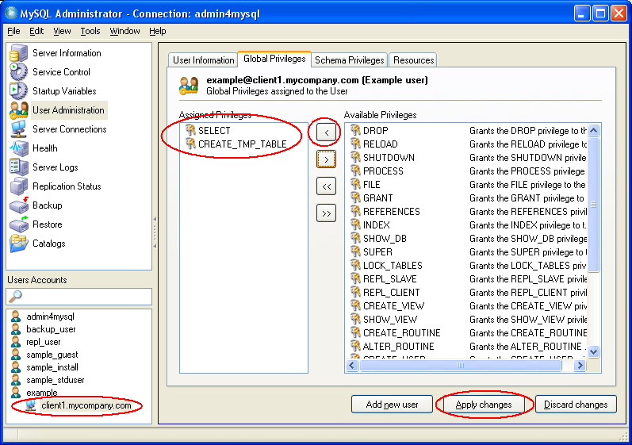
- Choose the tab “Schema Privileges”, and select the first schema from the Schemata list.
- Select the entry example from the User Accounts list to the lower left. Note the privileges that are assigned for the selected schema.
- Switch to the new user by selecting the host name client1.mycompany.com to the left. Assign the privileges noted in the previous step (by selecting them from the list on the right and clicking the “<” button), then choose “Apply changes”.
- Select the next schema and repeat steps 9. and 10. for every entry in the Schemata list.
- Right click on the example entry on the user list and select “Remove host from which the user can connect” from the context menu
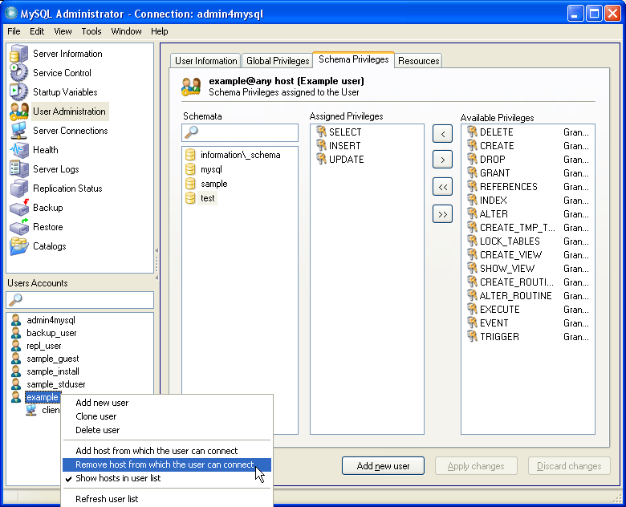

- Confirm the message box indicating “The any-host (%) entry has been deleted”, followed by the “Apply changes” button

How it works...
Let's have a look at what we did throughout this recipe.
In steps 1 through 5 we added the new host to which the account should be restricted (to be precise, we created a new account example@client1.mycompany.com).
Steps 6 and 7 are performed to copy the existing global privileges, while steps 8 through 11 do the same for the schema level privileges. With these operations the user will be granted the same permissions also when logging in from the newly defined specific host (this recipe does not take into account any schema object privileges).
Within steps 12 and 13 the permission to log on from any host is withdrawn by deleting the host from the account (technically speaking, the user example@% is deleted).
With these steps, we created a copy of the existing example account which is restricted to a specific host, and disabled the possibility to login from any other machine.

There's more...

Create the account without using MySQL Administrator
If you want to restrict access of an account to a client machine, but you do not want to sue MySQL administrator for this, the following steps lead to identical results:
- Connect to your database as as administrative user (admin4mysql) using your favourite SQL client (e.g. MySQL Query Browser).
- Find out about the current privileges by issuing the following command:
mysql> show grants for 'example'@'%';

- The result of the above query will be a list of one or more SQL statements. Modify these statements by replacing the user name 'example'@'%'by the new name 'example'@'client1.mycompany.com',
- Execute each of the modified statements from the previous step (you will have to put a semicolon at the end of each statement).
- To deny login from any host, execute the following command:
mysql> drop user 'example'@'%';

Allow access from a group of hosts
The above recipe is suited for accounts that are restricted to login from a specific client machine. In some cases however, you do not want to allow access from any host, but it is not possible to restrict connections to a single client machine either.
As long as the number of clients is reasonably low, it is possible to individually register the respective machines. For this, the mechanism outlined in the above recipe can be used: you will have to adapt steps 6 and 9 by selecting the appropriate template user, and you typically will skip steps 12 and 13.
As soon as the number of clients exceeds a certain limit, it is no longer feasible to register them separately. For these cases, the wildcard feature of MySQL might be a valid alternative for you.
MySQL allows the use of wildcard operators when defining host names of user accounts. Let's assume you have a set of client machines client01.mycompany.com through client99.mycompany.com. These clients should be able to access the database, but you do not want to allow access from any other machines. In this case, you would restrict access of your account to host client%.mycompany.com (note the % character). The percent sign acts as a wildcard that can be replaced by any character string. With this definition, login from host client57.mycompany.com will be successful, but a connection attempt from alien1.mycompany.com will be refused.
Please be aware that the use of wildcards does not necessarily allow for the exact restrictions you might want to define. In the above example, there are some unwanted machines that are still able to access the database: a machine named clientfake.mycompany.com would match the host definition as well. To minimize the wrong matches, you could use the host definition client__.mycompany.com instead (with _ being a placeholder for exactly one arbitrary character), but a machine clientXY.mycompany.com would still be able to establish a connection.
The host definition for MySQL user accounts can also be used to provide IP addresses instead of machine names. If you are able to assign similar IP addresses to all machines that should be able to access your host, you can provide a host name like 192.168.1.%. This example value would enable access for all clients with an IP address from 192.168.1.0 through 192.168.1.255.
The use of the single character wildcard is possible with IP addresses as well: a host value of 192.168.1.1__ will allow login from clients with IP addresses 192.168.1.100 through 192.168.1.199.
An alternative to wildcards is to group possible clients in a common subnet. You can then make use of a notation which allows to define IP ranges using the base address of the range combined with the corresponding netmask: if you set the host of a MySQL account to <subnet prefix>/<subnet mask>, connections from any IP address within this subnet will be accepted by MySQL.
If, for example, you want to allow login from four client machines whose IP addresses are in the range from 192.168.1.100 to 192.168.1.103, you could set up an account with the host set to 192.168.1.100/255.255.255.252, which will enable login for just the range you intended to.
This behaviour is somewhat contradictory to the MySQL manual, which states:
“The netmask can only be used to tell the server to use 8, 16, 24, or 32 bits of the address.”
If this statement was true, the only possible subnet masks were 255.0.0.0, 255.255.0.0, 255.255.255.0, and 255.255.255.255 (in the latter case the subnet mask would be skipped for sake of brevity) . However, experience shows that other subnet masks work just as well, but you have to make sure that the IP address given before the subnet mask is the pure subnet prefix. Any address from within the subnet would cause the connection to be refused.
To clarify that, we will inspect the example from the MySQL manual, which tries to prove that different netmasks do not work. The manual states that a host value 192.168.0.1/255.2552.55.240 (28 bits) will not work – which is basically correct! But the reason for that is not that handling of a 28 bit netmask (255.255.255.240) is generally unsupported., but that the IP address 192.168.0.1 is an address from the subnet, and not the subnet prefix itself. The correct subnet prefix would be 192.168.0.0 – and with a host of 192.168.0.0/255.255.255.240 every client from the subnet, i.e. with an IP address from 192.168.0.0 to 192.168.0.15 would be accepted for connections.
Generally, if you define the host with the <subnet prefix>/<subnet mask> notation, any client address is tested against this value according to the following rule (the operator “&” stand for the bitwise AND operation):
<client address> & <subnet mask> = <subnet prefix>
If this equation is true, the client address is accepted.

See also
- Define a specific user for administrative tasks
- Configure MySQL Administrator to display global privileges and hosts
- Avoid plain text passwords in scripts

Regain access to your database in case of lost account information
Of course, you want to protect your database against attacks in every possible way. However, from time to time you might find yourself in a situation in which you have to act as an attacker yourself – for example if you forgot the user credentials for the administration user, or if you accidentally deleted the root user account without having created an equivalent user beforehand. But do not worry – we will show you a way to regain control of your database without losing any data (not even your existing user accounts).

Getting ready
This recipe involves steps to edit the MySQL configuration files and to restart your MySQL server. Therefore you will need access to the host your database runs on. You also need the rights to start and stop the MySQL instance at your own discretion. Furthermore, you should know the location of the MySQL configuration file (typically my.ini), and you should have the rights to change this file.
The recipe allows you to both create a new user and to change the password of a user that already exists. In our example, we will change the password of the user admin4mysql to As,ysp4M, and we will create a new user root with r00t_pw as a password.
Before execution of the following instructions, you should make sure that no users – or processes – access your database.

How to do it...
- Open a text editor and create a file with the following content:
SET PASSWORD FOR 'admin4mysql'@'localhost' = PASSWORD('As,ysp4M');
GRANT ALL PRIVILEGES ON *.* TO 'root'@'localhost' IDENTIFIED BY 'r00t_pw' WITH GRANT OPTION;
Make sure that the SET command and the GRANT command are each written on a single line.
- Save the file in a location of your choice (e.g. C:\temp\mysql-init.sql).
- Open the MySQL configuration file (e.g. C:\Program Files\MySQL\MySQL Server 5.1\my.ini) in a text editor. Find the line which reads [mysqld] and add the following line below (if a line starting with init-file= already exists, change it accordingly):
init-file="C:/temp/mysql-init.sql"
Use the location of the file you saved in step 2. Please note the use of simple forward slashes instead of backslashes.
- Save the MySQL configuration file.
- Restart your running MySQL instance (e.g. by restarting the Windows service: net stop MySQL & net start MySQL)
- Open the MySQL configuration file in a text editor again to revert the changes made in step 3. Remove the init-file line from your configuration file (or disable it by putting a hash character # in front) and save it.

How it works...
The file created in steps 1 and 2 contain the SQL commands by which the password of user admin4mysql is reset and a user root is created. In the scenario of lost account information for the administration user, these commands can't be executed as usual (e.g. via a MySQL client). To have these commands executed despite the lost credentials, we change the MySQL configuration in steps 3 and 4 in order to have these commands executed on the next MySQL start. Step 5 initiates a restart of the MySQL server, which causes the commands to be executed. Step 6 reverts the configuration changes of steps 3 and 4, so the command file won't be repeatedly executed on every subsequent MySQL start.
The content of the initialization file as listed in step 1 has to be adapted according to your specific needs. As you might have guessed already, this mechanism is also suitable to change your actual database content, not only user information. It allows for basically every change imaginable to your database, so you should make sure that access to the MySQL configuration file is restricted to authorized persons. The init-file option might be used otherwise to tamper with your data, create user accounts for future unauthorized access, or render your system inoperable.

There's more...
A different alternative to reset passwords is to start your MySQL database server using the option --skip-grant-tables. With this setting, any login will be successful, and full rights will be granted – regardless of the user credentials specified. In fact, this option is often referenced as the preferred way to change your user accounts without need for proper credentials. Nevertheless, we strongly recommend not to use this approach, as there are some limitations and drawbacks.
While the --skip-grant-tables approach enables you to reset a forgotten password, it does not allow to create a new user account right away, as any attempt to grant rights using the GRANT statement will at first be refused with reference to the disabled grant tables:
ERROR 1290 (HY000): The MySQL server is running with the --skip-grant-tables option so it cannot execute this statement
You have to issue a FLUSH PRIVILEGES statement first in order to have MySQL accept a GRANT command. While this is a way to create a new user account with full rights, it is a bit cumbersome.
More importantly, use of the --skip-grant-tables is a major security issue, because as long as the database runs with this option enabled, anybody can connect to the database without having to provide any credentials at all, which enables free access for all possible intruders. While this might not be critical for your personal development database, it is absolutely intolerable for production use or other databases with sensitive data. To prevent unauthorized access while the grant tables are disabled, it is strongly recommended to accompany this configuration with the option –-skip-networking (on Windows machines, you have to additionally provide one of --shared-memory or --named-pipe options). Unfortunately, this actually deactivates access for most regular clients as well, which is equivalent to a service interruption until the database is relaunched in the regular configuration.
In conclusion, the --skip-grant-tables option makes it necessary to restart the database twice (as opposed to once with the --init-file variant), and there will be a service interruption between the two restarts due to the network cut-off that is necessary for security reasons (while the --init-file approach allows for continued access except for the moment of the first restart). This is why we strongly recommend to use the method described in the above recipe instead.

Avoid plain text passwords in scripts
In many of the above recipes, we also showed how to define user permissions using SQL commands. As such statements can easily be executed in scripts, these are well suited to produce scripts for automated definition of MySQL accounts. While it is generally a good idea to reduce the manual tasks in database administration, on should keep in mind that such scripts contain information that is extremely useful for possible attackers: one can extract the defined users, their specific rights, the hosts from which access is granted, and typically even the corresponding passwords. This way, such user definition scripts often contain all information necessary to access your database, which makes them extremely sensitive. The risk that somebody coincidentally trips over such a script should not be underestimated – and an open door may tempt a saint...
The most critical portion of such scripts are of course the passwords. In this recipe we will show how to create user definition statements without the need to give a plain text password.

Getting ready
To step through this recipe, you will need a running MySQL database server, and a SQL client (we are going to use the MySQL command line client). You should also have a working SQL script which defines the accounts (using plain text passwords). No other prerequisites are required.

How to do it...
- Connect to your database with the MySQL command line client.
- For a plain text password in your script, give the following command and make a note of the encoded result:
SELECT PASSWORD('<Your plain text password>');
- Replace the IDENTIFIED BY '<Your plain text password>' portion of the script by IDENTIFIED BY PASSWORD '<Encoded result>'
- Repeat steps 2 and 3 for all passwords in your script

How it works...
MySQL needs to store its passwords to be able to verify user credentials. This information is not stored in plain text, but as a so called hash value. A hash value is a value that represents a password, but which is not reversible, so it is basically impossible to find the actual password for a given hash value.
To check whether a given password is correct, MySQL calculates the hash value for it and compares it with the stored value. If these values are identical, the password is verified.
When creating a user account using the IDENTIFIED BY '<Your plain text password>'syntax, MySQL calculates the hash code and stores the resulting value in its user data. The IDENTIFIED BY PASSWORD '<hash value>'syntax stores the hash value immediately. In both cases, the effects of the script are identical, but with the second variant no plain text password is accidentally exposed.

Example
Let us assume the following script:
grant all privileges on *.* to 'admin4mysql'@'localhost' identified by 'As,ysp4M' with grant option;

Execute the following command on the MySQL command line:
mysql> SELECT PASSWORD('As,ysp4M');
+-------------------------------------------+
| PASSWORD('As,ysp4M') |
+-------------------------------------------+
| *46FFD1D6944482DFCCD3B31AC500199AFDE515F7 |
+-------------------------------------------+
1 row in set (0.00 sec)

Replace the password in the script:
grant all privileges on *.* to 'admin4mysql'@'localhost' identified by password '*46FFD1D6944482DFCCD3B31AC500199AFDE515F7' with grant option;

There's more...
The SET PASSWORD command is another common place for use of plain text password. To prevent use of plain text password altogether, you should replace all SET PASSWORD […] = PASSWORD('<plain text password>') expressions in your scripts by the corresponding variant using hash values directly (without using the PASSWORD() function): SET PASSWORD […] = 'Encoded password'

