**Cookies**

**What are Cookies?**

You may have heard of the term cookies before but what exactly are they and how can they affect the security of your computer?

A cookie is a text file which is placed on your computer whenever you visit a website. This cookie allows the website to keep track of your visit details and store your preferences. The main objective here is to increase the speed with which you visit that same website again. At the same time, they are very useful for advertisers who can match the ads to your interests after they see your browsing history.

Usually, cookies and temporary files may affect your privacy since they disclose your online habits, but it is possible to modify your web browser preferences and set a limit.

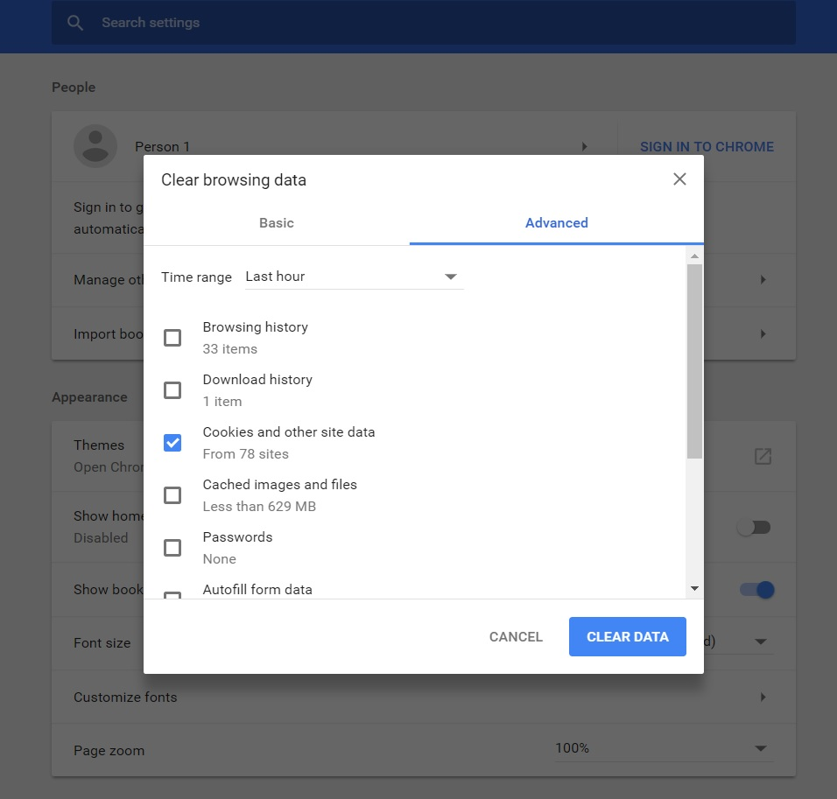cookies can be cleared from your browser

**SUPER COOKIES**

A very special type of cookie is called the super cookie and an example of such is the 'evercookie'. As the name suggests, this particular cookie is ever present in your computer despite your attempts to get rid of it. Its able to achieve this because unlike regular cookies that are stored in one location, the evercookie stores cookie data in several places – for example, in Flash cookies, your browsing history, and HTML5 local storage.

A very clever tracking method the evercookie employs is to assign a unique color value to a few pixels every time a new user visits a website. The different colors are stored in each user’s browser cache and can be loaded back. The color value of the pixels is a unique identifier that identifies the user.

When a website notices that you’ve deleted part of the super cookie, the information is repopulated from the other location. For example, you might clear your browser cookies but not your Flash cookies, so the website will copy the value of the Flash cookie to your browser cookies. Super cookies are very resilient.

Some of the best methods of fighting against super cookies is to avoid running Adobe Flash or Microsoft Silverlight in your browser as these two apps are used by super cookies to replicate themselves. Using VPN services like [Tunnel Bear](https://www.tunnelbear.com/) or [Tor](https://www.torproject.org/download/download-easy.html.en) is perhaps the best way of fighting cookies.