Installing & Configuring Nexus Root Toolkit

Section 2, Lecture 3

We will use [Nexus Root Toolkit](http://www.wugfresh.com/nrt/) to unlock, root and install NetHunter on our Nexus device.

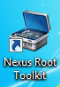

1. Download the Toolkit from [this page](http://www.wugfresh.com/nrt/).

2. Double click the installer and install the program.

3. Start the NetHunter Installer from the desktop shortcut or from the start menu.

4. Select your device and software version, to get your device version go to settings >> about this device.

I will select my device which is Nexus 7 with KitKat 4.4.4.

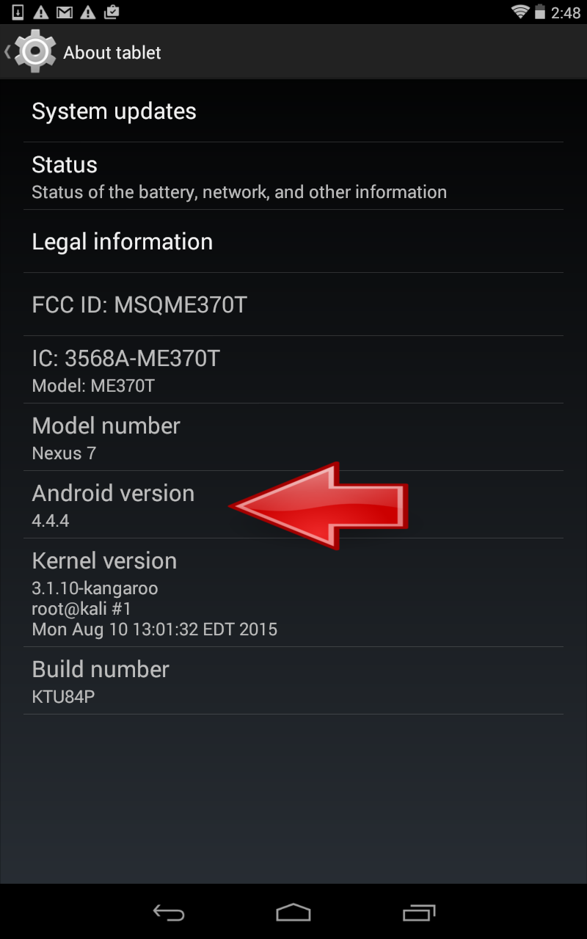

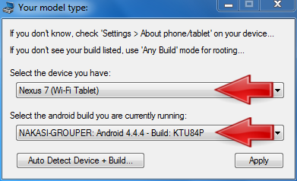

5. Now it's going to ask you to enable USB debugging on your device, just follow the steps and click o.

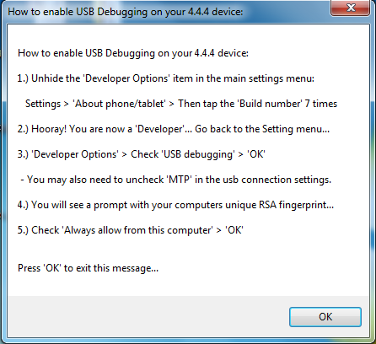

6. Now its going to check if you need to download any dependencies, just click on *Download + Update All File Dependencies*

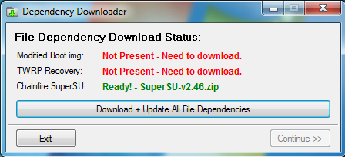

7. Now the toolkit have been installed and configured properly. Next we will install device drivers so that we can communicate with the device.