Unlocking & Rooting The Device

Section 2, Lecture 5

**Warning: Following the instructions in this lecture will wipe all of your date, so make sure you backup your data first.**

Now that the drivers are installed successfully, we are ready to root it and install NetHunter.

1. Before we can root the device, we need to unlock the bootloader, to do this click on *Unlock*from the main window.

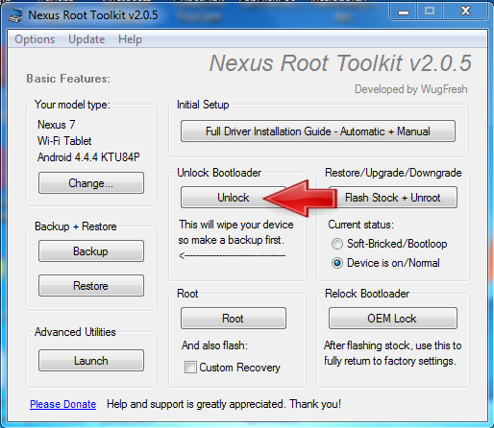

Then click on *yes*to tell the installer to automatically put the device in bootloader modeNow wait for the device to boot back and follow the instructions given by the installer.

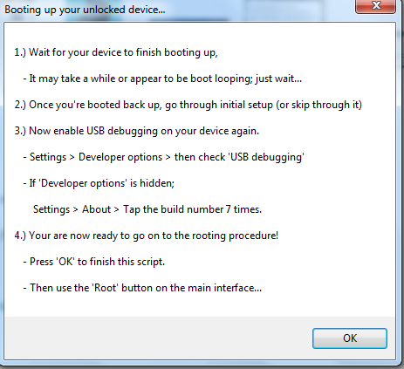

At this stage I like to flash stock Android by click on *Flash Stock + Unroot*, you don't have to do this but I recommend it.

2. Now let's root the device, this will install a root account on the device which gives us full unrestricted access to all resources on the device. To do this click on *root*from the main window.

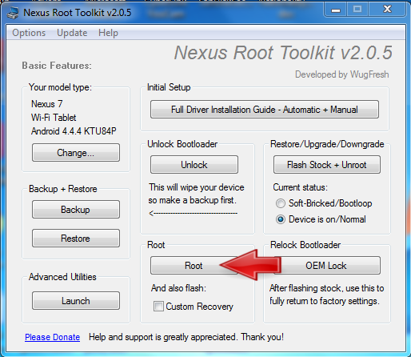

3. Again wait for the device to boot back up and follow the instructions in the pop up.

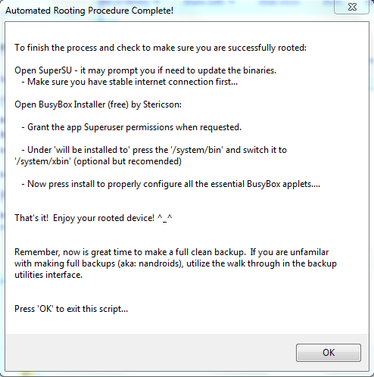

Browse Q&A

Continue

  Show curriculum navigation

Go to Dashboard