## Installing Cloudera VM 5.10 on Oracle VirtualBox

### Pre-requisites

* These 64-bit VMs require a 64-bit host OS and a virtualization product that can support a 64-bit guest OS.
* We need to have a minimum of 16GB RAM on the Desktop to be able to use this Cloudera VM:

For more information, <https://www.cloudera.com/downloads/quickstart_vms/5-10.html>

### Downloading and installing

#### Downloading & Installing Oracle Virtual Box

1. Go to <https://www.virtualbox.org/wiki/Downloads>
2. Click on your preferred host under ‘VirtualBox 5.1.22 platform packages’. In our case, it is ‘Windows hosts’.
3. The downloading starts.
4. After download completes, click on it. The installation will start.

#### Downloading & Installing Cloudera VM 5.10

1. Go to <https://www.cloudera.com/downloads/quickstart_vms/5-10.html>
2. Select ‘QuickStarts for CDH 5.10’ in ‘Version’.
3. Select ‘Virtual Box’ in ‘Select a Platform section’.
4. Click on ‘Get it Now’.

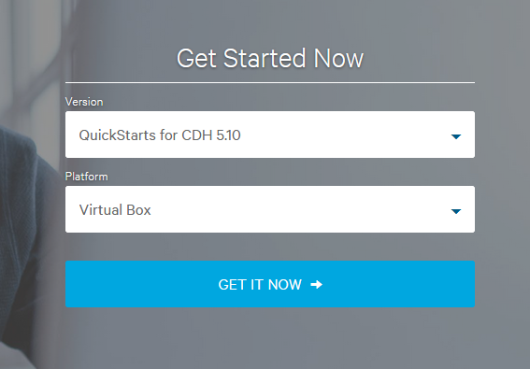

1. A menu appears, give your basic details or credentials, if you are an existing user.
2. Accept the terms & conditions if asked.
3. The downloading starts.
4. After downloading completes, extract its contents.
5. Click on the image of type ‘Virtual Machine Disk Format’ (one with blue cube icon). If prompted to select a program then, choose Oracle Virtual Box VM
6. Click on ‘import’ to import the VM.
7. VM is ready to use. Although, there are a few VM settings mentioned below for better experience.

#### VM Settings

When making any of the below changes, ensure that the VM is shut down/ closed.

1. In Oracle VM VirtualBox Manager, right click on you VM’s name and select ‘settings’.

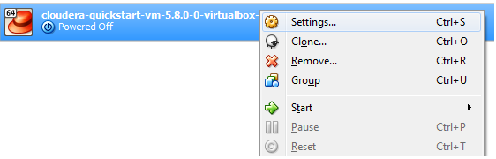

1. Go to General >> Advanced. Make ‘shared clipboard’ and ‘Drag n Drop’ as ‘Birectional’.

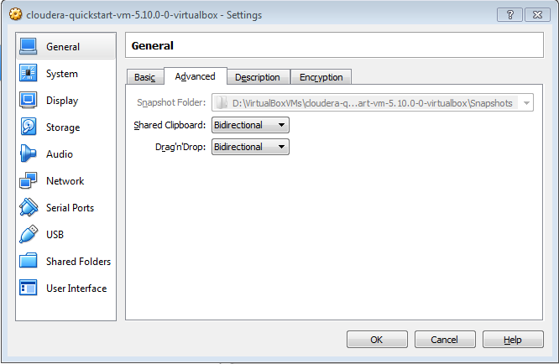

1. Go to System >> Motherboard. You change the RAM of the VM in ‘Base Memory’ section.

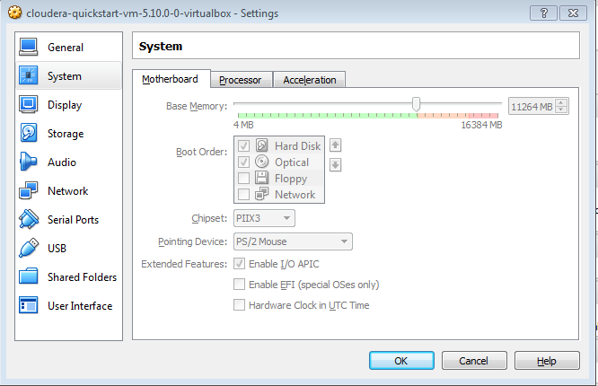

1. Go to Network >> Adapter 1. The ‘Attached to’ should be set as ‘NAT’.

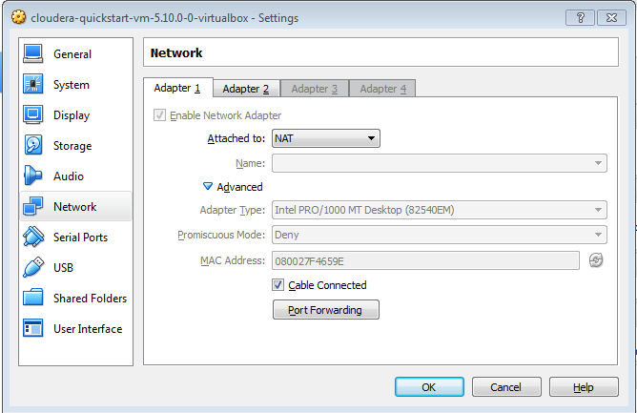

1. Go to Network >> Adapter 2. The ‘Attached to’ should be set as ‘Host-Only Adapter’.

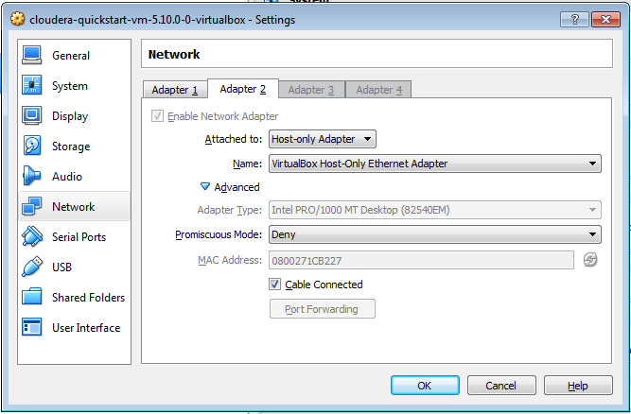

### Accounts

* Once you launch the VM, you are automatically logged in as the cloudera user. The account details are:

Username: cloudera

Password: cloudera

* The cloudera account has sudo privileges in the VM. The root account password is cloudera.
* The root MySQL password (and the password for other MySQL user accounts) is also cloudera.
* Hue and Cloudera Manager use the same credentials.

### Services provided

Services provided by Cloudera VM:

1. Cloudera Management Service
2. ZooKeeper
3. HDFS
4. Solr
5. Flume
6. HBase
7. Key-Value Store Indexer
8. MapReduce or YARN
9. Hive
10. Impala
11. Oozie
12. Sqoop
13. Hue

For stopping services on Cloudera VM, <https://www.cloudera.com/documentation/enterprise/5-4-x/topics/cdh_ig_services_stop.html>

For more information, <https://www.cloudera.com/documentation/enterprise/5-7-x/topics/cdh_ig_cdh_services_start.html>