
Slide 1
Text Captions: Adobe Media Encoder CC 2018
The demonstration


Slide 2
Slide notes: Want to insert a video in Captivate?
Great idea! Video will make your e-learning content much more engaging and fun!
But before you can import a video file in Captivate, you must first convert it into a video format that the Flash player or the HTML 5 browser can read!
The Adobe Media Encoder is an application that has been designed to convert video and audio files to the proper format for your projects.
The good news is, the Adobe Media Encoder is part of your Captivate installation at no extra cost!
Want to know how it works? Just click on the continue button.
Text Captions: Video in Captivate?
Your video file needs to be converted into the proper format.
The Adobe Media Encoder converts any video file to and from a wide range of formats
Adobe Media Encoder CC 2018 is part of the Captivate installation package.
Continue
Continue
Continue
Video in Captivate?

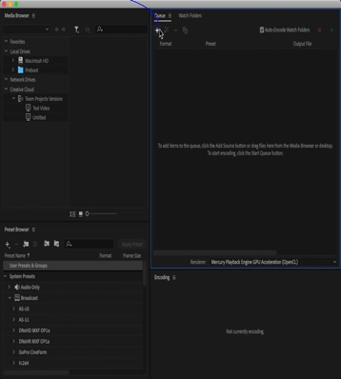
Slide 3
Text Captions: Under the Queue panel, click the + icon on the top left corner.

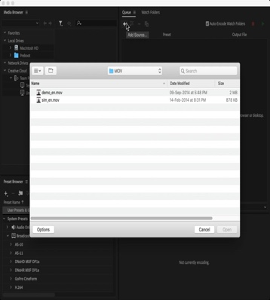
Slide 4
Text Captions: Browse to the Chapter08\video\MOV folder of the exercise files.

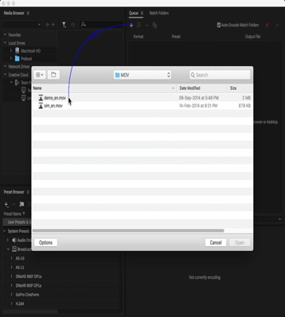
Slide 5
Text Captions: Select the demo_en.mov QuickTime movie.

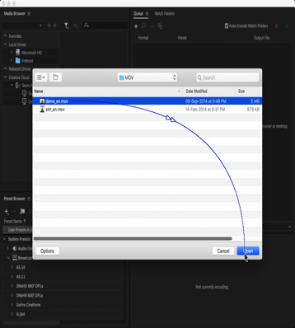
Slide 6
Text Captions: Click Open.

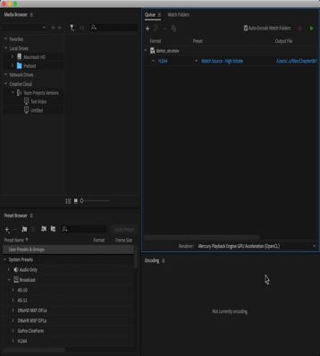
Slide 7
Text Captions: The Add Items to Queue window opens.

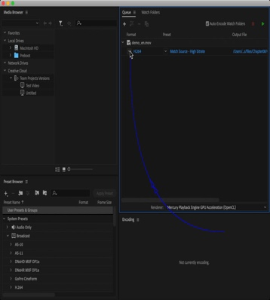
Slide 8
Text Captions: Open the Format drop-down list.

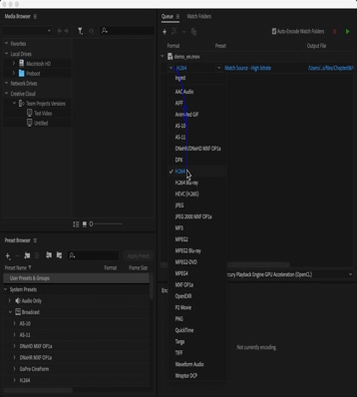
Slide 9
Text Captions: Select the H.264 format.

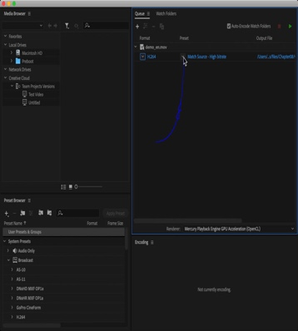
Slide 10
Text Captions: Open the Preset drop-down list.

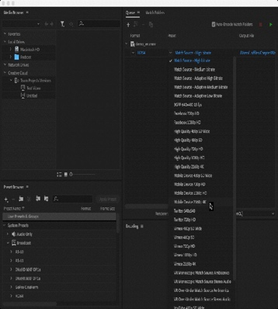
Slide 11

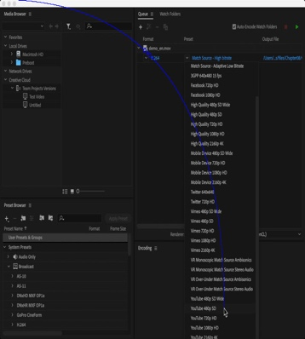
Slide 12
Text Captions: Select the YouTube 480p SD preset.

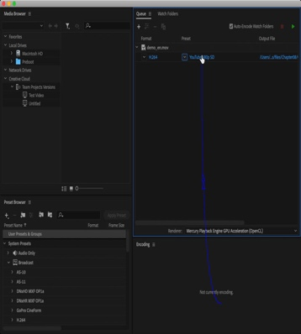
Slide 13
Text Captions: Click the preset name to open the Export Settings dialog.

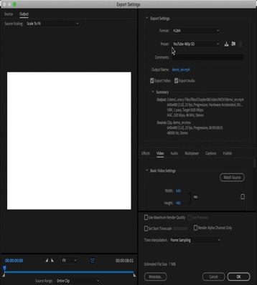
Slide 14
Text Captions: Go to the Video tab in the lower right area of the Export Settings dialog.

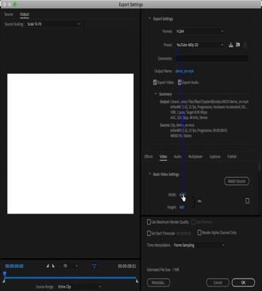
Slide 15
Text Captions: Change the width of the video to 400-pixels.

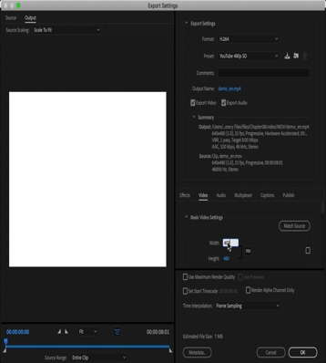
Slide 16

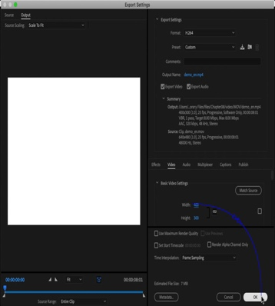
Slide 17
Text Captions: Click OK.

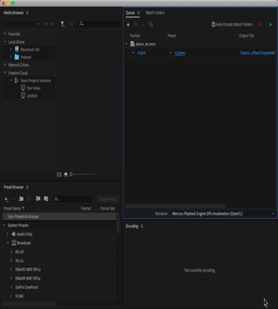
Slide 18
Text Captions: Click the Start Queue button.

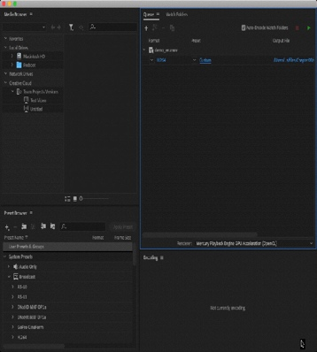
Slide 19

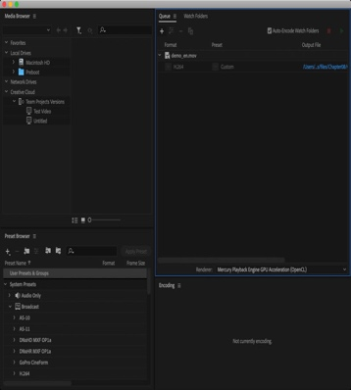
Slide 20

Slide 21
Text Captions: Thanks for watching this demonstration
Adobe Media Encoder CC 2018

