# **EXERCISE 1: Creating a Build Environment**

In this exercise we will create an environment where we can build an rpm-ostree image, a virtual machine image, or a custom OS installer ISO.

**Technical requirements:**

At minimum, a single running Fedora Workstation machine (virtual or physical) where you have root access, the web console (cockpit) is installed and fully enabled.

As root, let’s start installing our required packages.

**# dnf install -y osbuild osbuild-depsolve-dnf osbuild-luks2 osbuild-lvm2 \**

**osbuild-ostree osbuild-selinux osbuild-composer**

There’s still more software to install. As root, continue with the installation of packages.

**# dnf install -y composer cockpit-composer composer-cli nodejs \**

**npm gpgme-devel btrfs-progs-devel device-mapper-devel**

Restart cockpit for the changes to take effect.

**# systemctl restart cockpit.socket**

Open a browser, on your Fedora Workstation or a machine with network access to the Fedora Workstation. Open up the web console (AKA cockpit) by using the URL https://(your hostname or IP):9090 . You will most likely be prompted with security warnings as the system won’t have a publicly verifiable certificate. Continue on anyways - it’s OK in the lab.

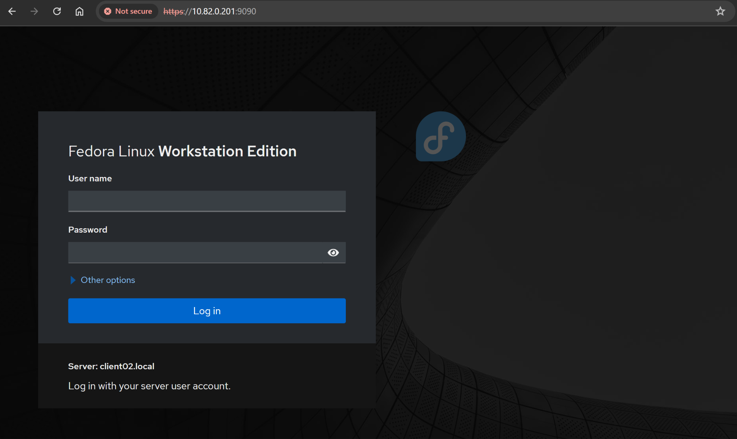

Log in with your standard user account. Once logged in, Click on the button “Turn on Administrative Access”. You may be prompted for a password. Enter it.

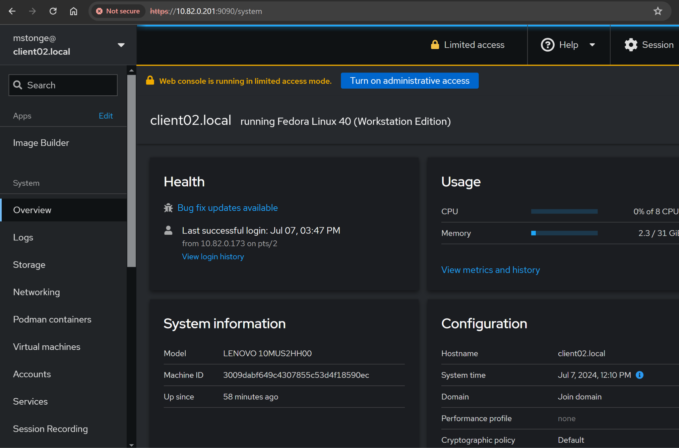

Now that you’re logged in with administrative level access. Let’s browse the left sidebar and Click on Image Builder.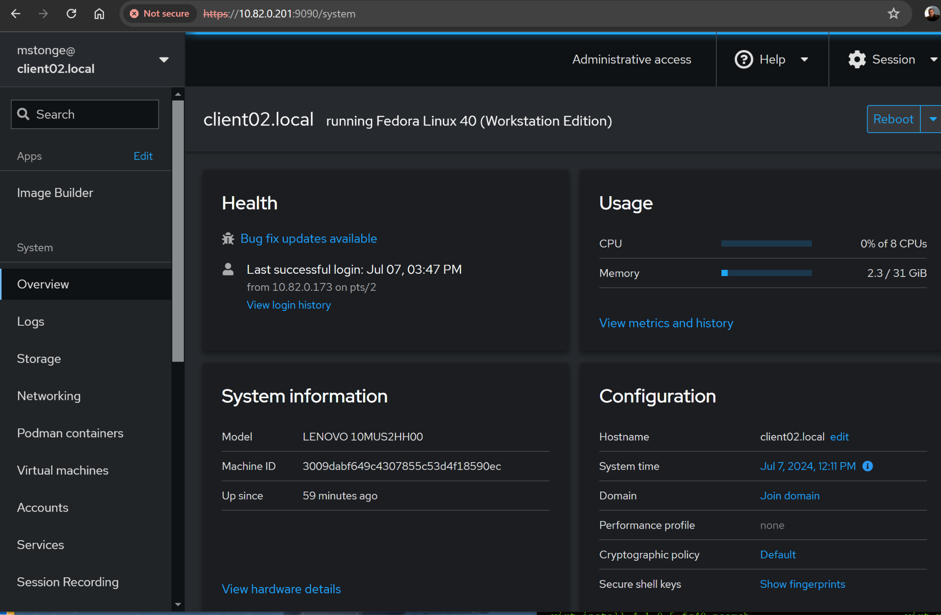

To complete the build environment setup. Click on the Start Socket button which will enable OSBuild Composer.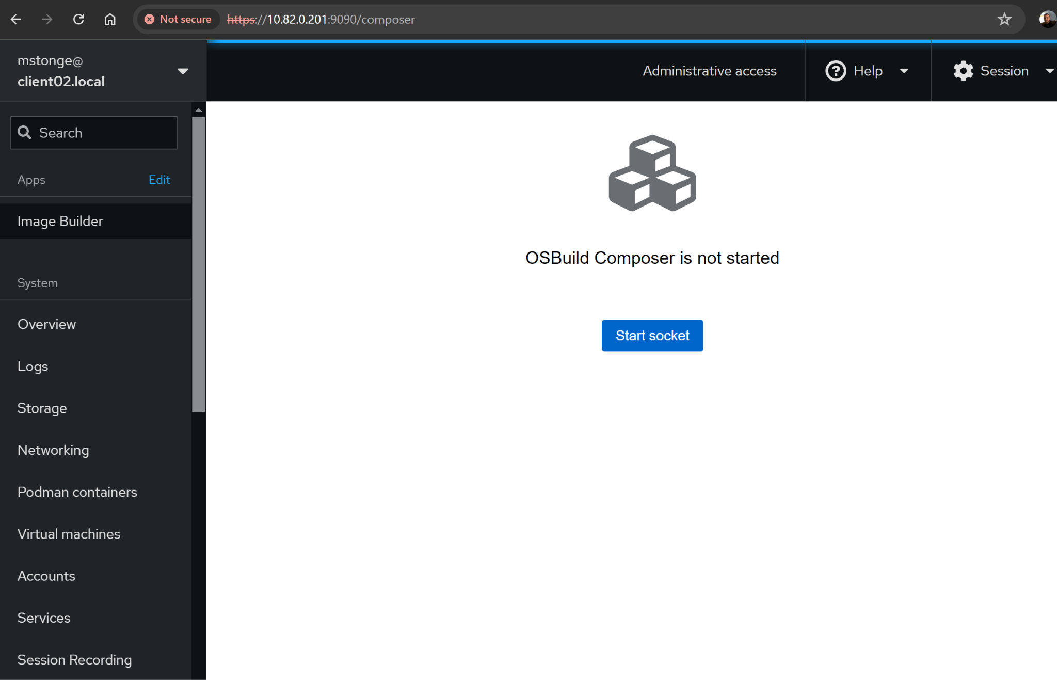

You are now all set to use the web console (AKA cockpit) for building images. This completes this exercise.

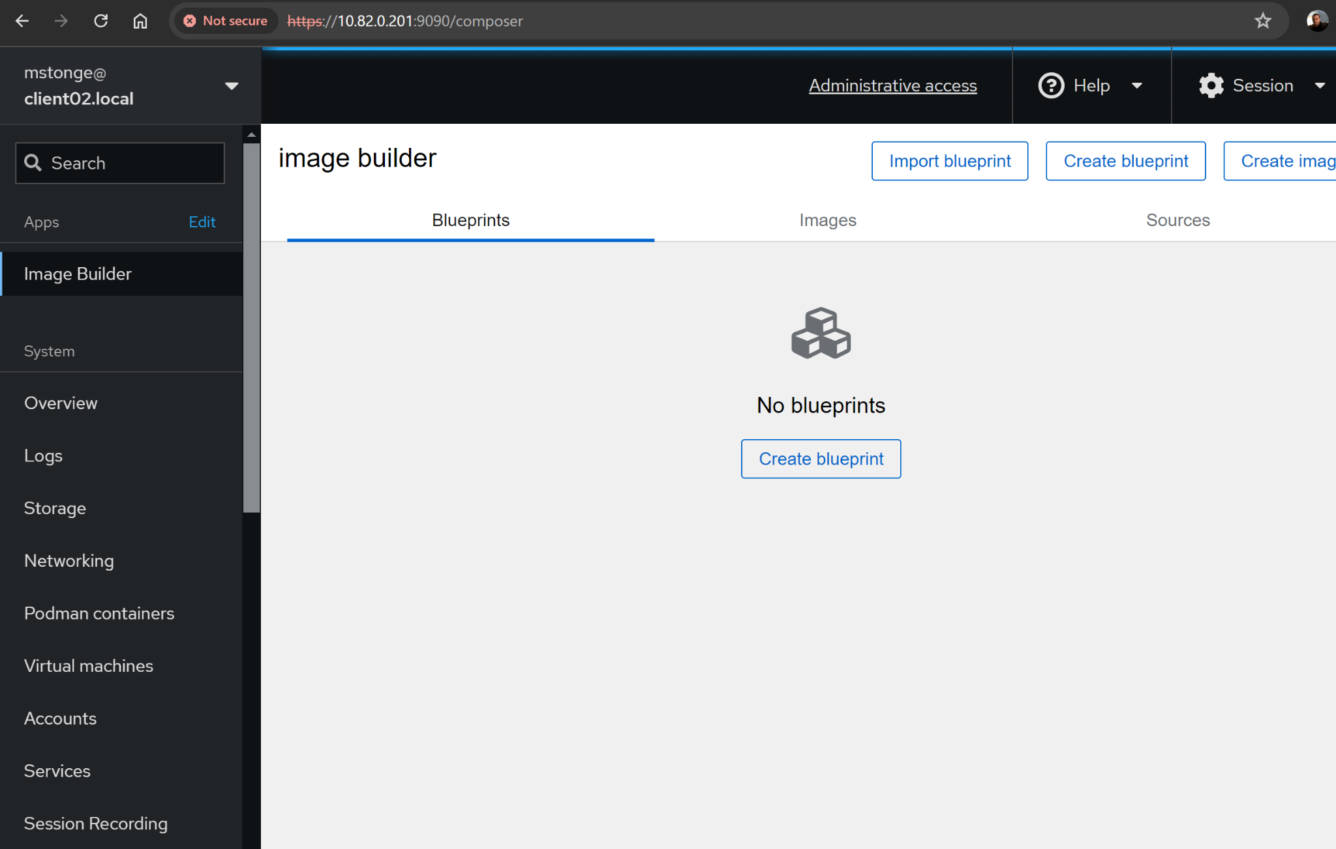

Your linux system is now ready to start building rpm-ostree images from the command line or via the web console.