# **EXERCISE 1: Creating a Build Environment**

In this exercise we will create an environment where we can build an rpm-ostree image, a virtual machine image, or a custom OS installer ISO image (and much more).

**Technical requirements:**

At minimum, a single running RHEL 9 machine (virtual or physical) where you have root access, the web console (cockpit) is installed and fully enabled.

As root, let’s start installing our required packages. (output not shown)

**# dnf install -y osbuild osbuild-depsolve-dnf osbuild-luks2 osbuild-lvm2 \**

**osbuild-ostree osbuild-selinux osbuild-composer**

There’s still more software to install. As root, continue with the installation of packages.

**# dnf install -y composer cockpit-composer composer-cli nodejs \**

**npm gpgme-devel device-mapper-devel**

Restart cockpit for the changes to take effect.

**# systemctl restart cockpit.socket**

Open a browser, on your RHEL system or a machine with network access to the RHEL system. Open up the web console (AKA cockpit) by using the URL https://(your hostname or IP):9090 . You will most likely be prompted with security warnings as the system won’t have a publicly verifiable certificate. Continue on anyways - it’s OK in the lab.

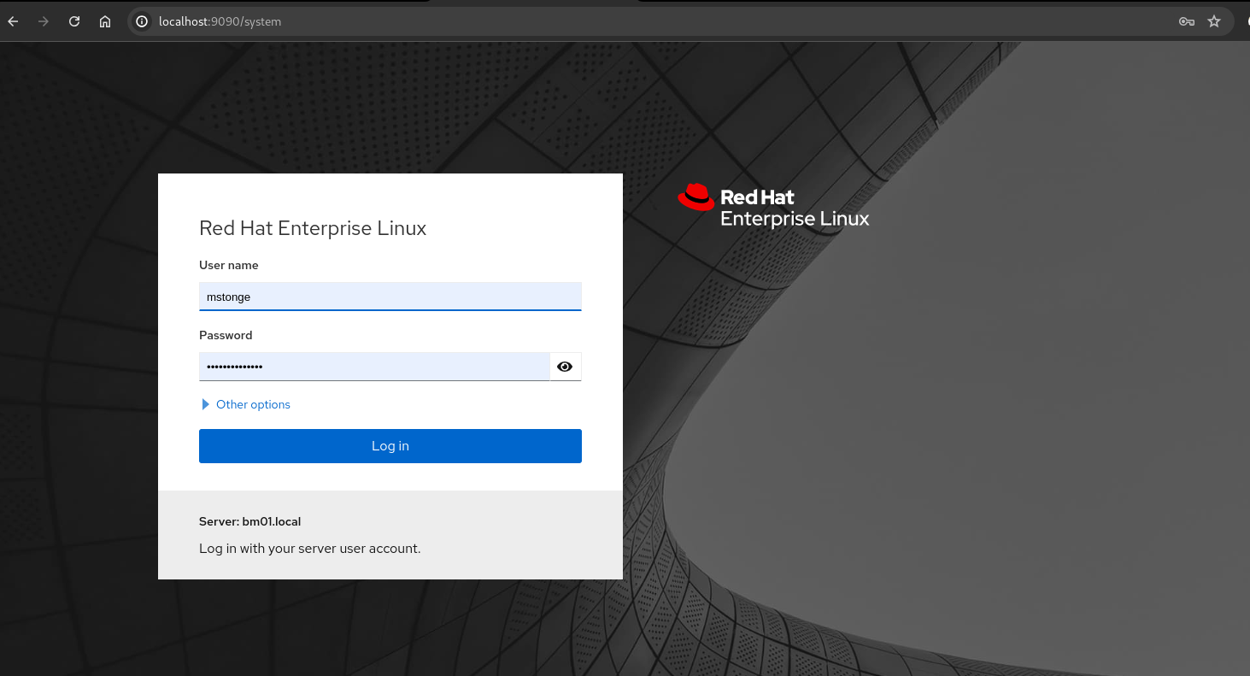

Log in with your standard user account. Once logged in, Click on the button “Turn on Administrative Access”. You may be prompted for a password. Enter it.

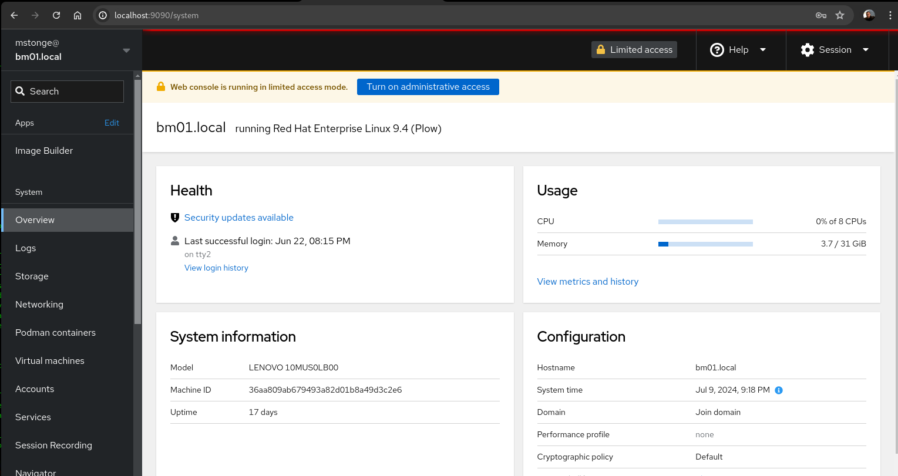

Now that you’re logged in with administrative level access. Let’s browse the left sidebar and Click on Image Builder.

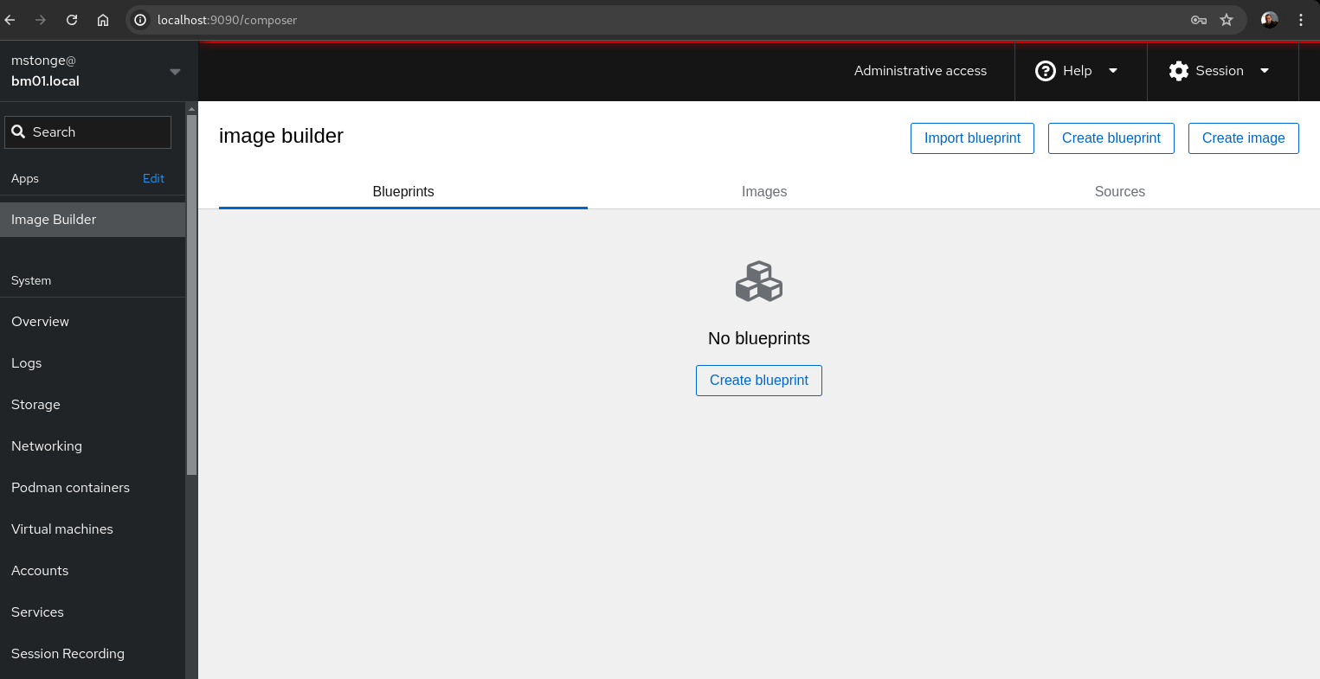

You are now all set to use the web console (AKA cockpit) for building images. This completes this exercise.

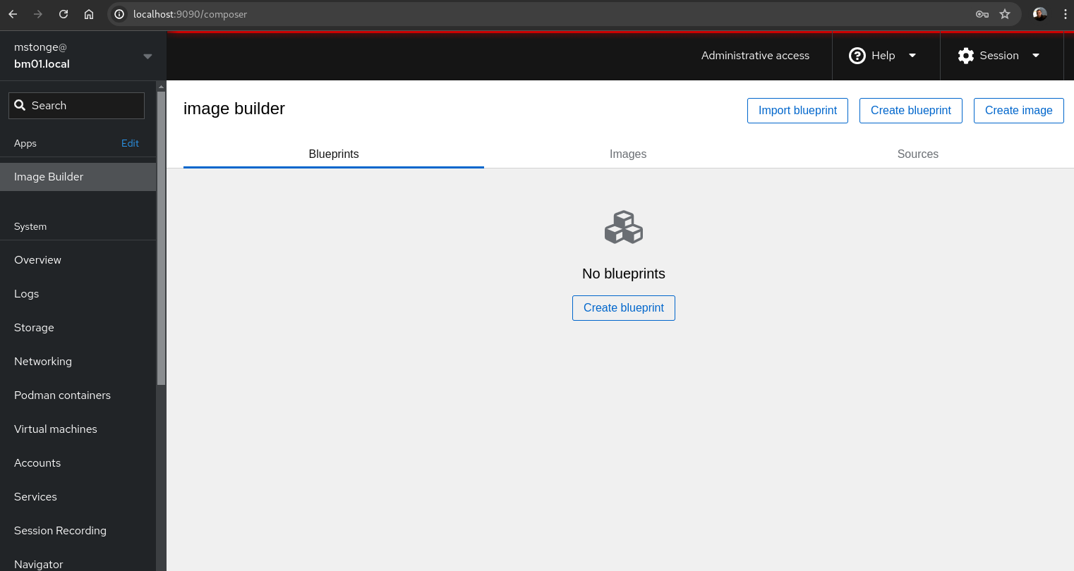

Your linux system is now ready to start building rpm-ostree images from the command line or via the web console. Let’s move onto our next exercise.

**End Exercise**